
Surrey Police
Medium Term Financial Plan
2026-2030
March 2026

Achieving financial excellence | finance department
Official

Contents
- Summary
- Context
- Introduction
- Funding
- High level Budget Planning & Strategy
- Investments and Commitments
- Force Fit for the Future
- Savings Programme
- Headcount Impact
- Capital Strategy
- Assumptions
- Risks
- Reserves
- Appendices
A – Medium term financial forecast
B – Savings plan
C – Financial assumptions
D – Capital programme & financing
E – Risk analysis
- Glossary

Contacts

Document Owner
Peter Appleton
Executive Director of Commercial & Finance Services
Document Editor
Bev Foad
Head of Business Partnering and Support

- Summary
The Medium-Term Financial Plan supports the delivery of the Police and Crime Commissioner’s Police and Crime Plan, the Chief Constable’s Force Plan and the Force Management Statement priorities. The assumptions used are based on a prudent assessment of the future but are only a prediction. A base scenario had been prepared based on these assumptions, the base scenario, but the plan also includes an illustration of the financial impact of changes in these assumptions.

- The funding settlement for 2026/27 and forward outlook;
The financial settlement for Policing for 2026/27 was announced by the Government on 28th January 2026, the key elements were;
    - Overall funding for the policing system in England and Wales, including to police forces and wider system funding, will be up to £21.0 billion, an increase of up to £1.3 billion when compared to the 2025-26 funding settlement, representing a cash funding increase of 6.7% and a real terms increase of 4.4%.
    - Total funding for Territorial Police Forces and Counter Terrorism Policing will be up to £19.6 billion in 2026–27, an increase of £848 million compared with the 2025–26 police funding settlement. This represents a 4.5% increase in cash terms and a 2.2% increase in real terms for policing.
    - Within this, total funding to Territorial Police Forces will be up to £18.4 billion, an increase of £796 million compared with the 2025–26 settlement, representing a 4.5% cash increase and a 2.3% real terms increase for police forces.
    - Of the £796 million increase in force level funding, £432 million is additional Government grant funding to police forces. This includes an additional £50 million to support the Government’s neighbourhood policing objectives above that announced at the provisional police funding settlement in December 2025. Plus, it includes up to £364 million in additional funding for forces in England and Wales from council tax precept, compared to 2025-26. As confirmed in the Provisional local government finance settlement published on 17 December 2025, Police and Crime Commissioners in England will have the flexibility to increase the police precept by up to £15 for a Band D property in 2025–26. This assumes PCCs make use of the full precept flexibility of £15 for English forces.
    - Nearly 46% of the funding increase is from local council taxpayers.
    - Funding for Counter-Terrorism Policing will increase by at least £52 million to £1.2 billion in 2026–27. PCCs will receive separate, confidential notification of force level CT allocations, which are not published for security reasons.
    - It is not known but assumed the funding settlement does not include the officer pay award.
    - The Op Uplift Performance Grant has been retired along with the requirement to meet officer number targets. The two parts to this grant have been amalgamated with the 2025-26 Neighbourhood Grant and labelled Additional Rule 2 Grant. From this grant the 2026-27 Neighbourhood Grant allocations have been made leaving a balance in Additional Rule 2 Grant, free of conditions.
    - There is only one conditional workforce grant in 2026–27: the Neighbourhood Policing Ringfence Grant, totalling £363 million. Forces can receive this funding if, by March 2027, they increase the number of officers and PCSOs working in neighbourhood policing including those in training, in line with their locally set neighbourhood policing target.
    - The national target increase for 2026-27 is 1,750 in officers or PCSO’s assigned to neighbourhood policing (as measured by CIPFA 1a).
    - The settlement continues the £230.3 million to compensate territorial forces for the costs of the change to the employer National Insurance Contributions from 2025-26.
    - The Home Office published a Police Reform White Paper in January 2026 which set out a vision to bring policing into the modern age with the technology, innovation and structures they need to ensure policing can focus on the crimes that matter to the public and to drive out waste and inefficiency.
    - This settlement underpins these plans with £1.4 billion of Home Office investment in the wider policing system which will:
    - Kick-start delivery of the programme of police reform with a £119 million investment in 2026-27. This first-year investment will deliver new police capabilities: establishing a new national centre for AI in policing - Police.AI – which will enable the rapid and responsible adoption of AI across policing, national rollout of live facial recognition, and investment to strengthen the use of data across policing.
    - Support the delivery of Major Law Enforcement Programmes which will modernise national mission-critical systems, tackling a range of threats and make our streets safer and without which policing cannot operate effectively.
    - Invest in tackling knife crime, through continued funding for serious violence reduction programmes in every force area, including in 20 Violence Reduction Units, and over £28 million dedicated investment to policing through our County Lines Programme which has closed thousands of county lines, protected thousands of criminally exploited children and is delivering significant reductions in in knife stabbings in key force areas.
    - The level of Reallocations (Top Slice) in 2026/27 is detailed in the table below. Police Reform and Exceptional Financial Support are new, a significant increase in capital allocation as per the table above, also no allocation to Regional Organised Crime Units.

- In 2025/26, funding for areas including Arms-Length Bodies, Cyber Crime, Forensics, Fraud, Police Productivity and Innovation and Tackling Exploitation and Abuse (including Violence against Women and Girls) will be decided as part of the Home Office’s wider budget allocation process, with funding arrangements for specific programmes confirmed in due course.

The efficiency savings requirement;
As costs are rising at a faster rate than resources the Force will need to find savings to enable it to deliver a balanced budget. Any savings required will need to take account of the continued challenges facing policing such as maintaining the capacity to meet new crime threats in public protection such as domestic abuse, child sexual exploitation and vulnerable adults. Investment is also needed to enable opportunities from digital ways of working and to meet the threat from the growth in digital crime.
For the planning period 2026/27 to 2029/30 it is estimated that savings of £13.5m will be required with £5.4m needed for 2026/27.
The efficiency plan;
The Force continues to develop a robust and achievable saving plan to balance the budget. Work is ongoing to identify savings against the pressure in recent years of having to recruit officers to maintain uplift numbers and deliver the neighbourhood guarantee. The Op Uplift maintenance targets have now been replaced with a target for Neighourhood policing which the force will now need to meet in order to receive the full grant.
Op Solve is working to modernise the way in which we work to ensure the Force is in the best possible position to meet the policing challenges of today. To deliver an operating model that has people in the right place, with enough and be prepared for the future enabling our policies, procedures and structures evolve with more agility to match the ever-increasing complexities of policing, shifts in national priorities and changes in partnership landscapes.
  - Transformation Programme
Surrey Police initiated a transformational programme of work in June 2022, in conjunction with Sussex Police, with the aim of addressing a significant forecasted funding gap. It was clear through early investigation that the force could not close their gap through existing planned changes, and that a more ‘transformational’ approach was required if it was to deliver this aim without impacting on service to the public.

Due to the Financial pressures faced by police forces nationally, which Surrey Police are also experiencing, and with both devolution and the National Police Reform on the horizon, the transformational work within Surrey Police will continue for the foreseeable future to ensure a value for money service and a police force that is fit for the future.

The reserves plan;
This budget for 2026/27 assumed there would be no use of general reserves to balance the budget. It was however planned to use PCC Cost of Change reserve to meet the costs of transformation during the year.
The reserves policy remains - maintaining them at a level of 3% of the net annual budget in line with CIPFA guidance.
The capital plan;
Capital reserves generated through asset disposals are being strategically accumulated to provide a partial funding source for the Estates Transformation Programme. While these reserves will offset a proportion of the capital requirement, additional borrowing will still be necessary to deliver the programme in full. Any new borrowing, however, must remain within the organisation’s affordability parameters, considering future revenue implications arising from interest and Minimum Revenue Provision (MRP) charges.
The requirement to fund short-life assets directly from revenue further constrains the revenue budget, reducing flexibility and increasing the pressure on operational finances. To ensure the capital programme remains financially sustainable, upper limits have been established on the total level of capital investment that can be supported within available funding streams. Consequently, capital schemes are being prioritised in line with financial robustness, strategic alignment, and the extent to which they deliver quantifiable efficiencies or long-term cost reductions. This approach ensures that investment decisions are both financially prudent and aligned with organisational priorities.

- Context
Inflation
Over the last few years prices of both goods and services have risen sharply leading to an increase in the rate of inflation. For Policing we have seen this impact in areas such as salaries, fuel, IT licenses, forensics and services. The rate of increase in our funding from taxpayers and the Government has not kept pace with inflation and in particular the increase in wages which is our biggest cost. This fundamentally has led to the increasing budget gap over time which can only be addressed by finding savings.
As an illustration to the change in inflation the Consumer Prices Index (CPI) rose by 3.0% in the 12 months to January 2026, down from 3.4% in the 12 months to December 2025. The last 6 years are shown in the graph below:
Table CPI Inflation 6 Years – Source ONS
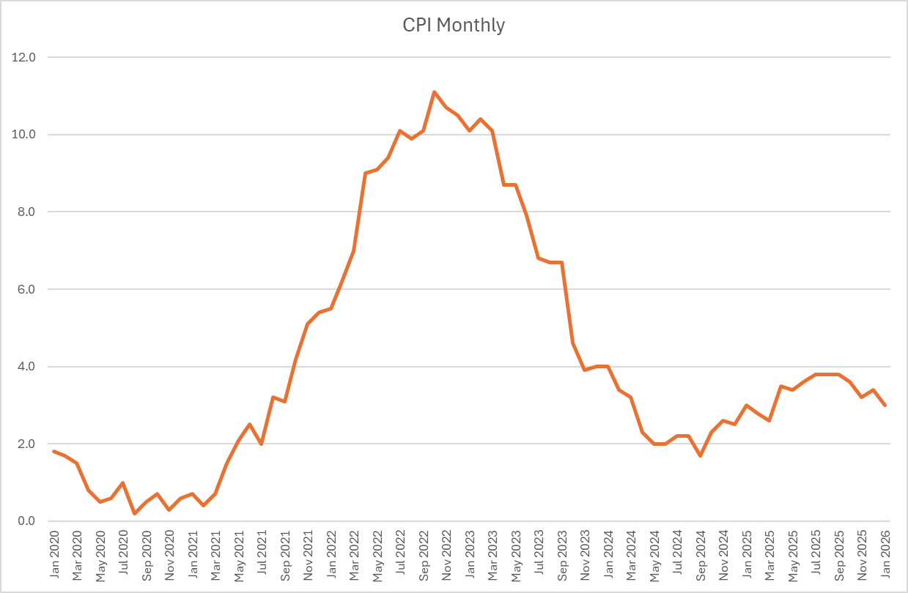
Inflation (and hence the rise in pay) continues to be of particular concern as we plan for the next 4 years with the Bank of England’s prediction of a Consumer Prices Index (CPI) figure of 3.0% Q1 2026 moving to target of 2% during the year; December CPI was 3.4%. These figures need to be seen in the context of the recent geopolitical turmoil which will inevitably have an impact on these forecasts. These risks have been considered and are included in the financial risk assessment in Appendix E.
Demand and Productivity
Surrey Police continues to focus on making Surrey a county that is safe and feels safe. The Chief Constable plan entitled “Our Plan” sets out the force’s strategy and its commitment to our communities, our force and our people. The Force will use this framework to focus activity over the next four years:
Surrey Police fights crime and protects people. We strive to earn the trust and confidence of all our communities. Here for everyone who needs us, we put service before self.
- We prevent crime and solve problems
- We investigate crime thoroughly
- We pursue criminals relentlessly
- We provide outstanding victim and witness care
- We act ethically with the highest standards
- We strive to reflect our communities, with a welcoming workforce where people feel they belong
- We work productively and spend public money wisely
- We respond promptly and according to need
- We are resilient and prepared
- To reduce the risks associated with policing and maintain a resilient crime-fighting workforce, we keep ourselves and each other as healthy, fit and safe as we can
This strategy has started to deliver dividends in terms of improved public contact times and increases in the number of criminals apprehended and charged. However, the volume and complexity of crime of crime continues to increase and so even though improvements are made the demand continues to rise.
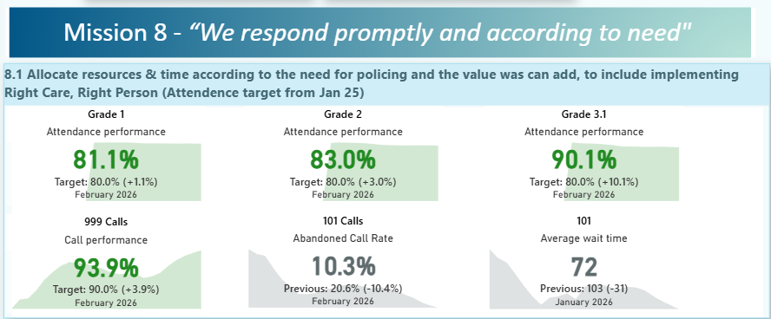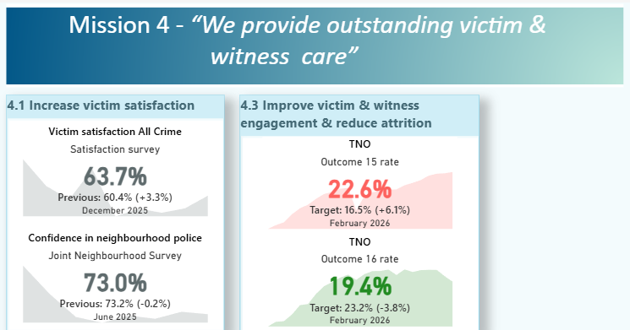
Funding Formula
The previous Government commissioned a review of the national funding formula in order to make it “fairer”. Unfortunately, due to the election they were unable to consult on any changes and so the work did stall. Both the National Audit Office and the Public Accounts Committee have both criticised the Home Office for their lack of understanding of police demand and that the current funding formula doesn’t reflect policing needs. Through the Police Reform White Paper, the government have committed to reviewing the police funding formula once police reform is underway and reconsidering the distribution of funding between local forces. The next steps of this work will be informed by the Independent Review into police force structures later this year. That said any formula will only looks at relative rather than absolute demand when compared with other Forces. Given Surrey is relatively safe this could result in less rather than more funding for the Force. The fundamental issue which no formula review can address is that there simply is not enough money in Policing to meet demand.
- Introduction
This paper provides the latest projections on the financial position for each of the financial years up to 2029/30. It also goes on to summarise progress with the Force’s strategic efficiency saving programmes and the likely effect this may have on employee numbers throughout the period.
This version incorporates unavoidable costs from 2025/26, pay inflation and other unavoidable cost pressures, such as funding for IT licences, national charges, salary increments, fuel and utility increases, increase in SEROCU contributions. Forensic fees, legal fees, Estates Strategy funding costs and the revenue contribution need to fund capital costs.
An estimated phased capital programme has been included in this document however the timing may change over time as the program is reviewed. The Police Capital grant from Government to individual PCC’s ceased in 2021/22 and was instead used on national programs as follows:
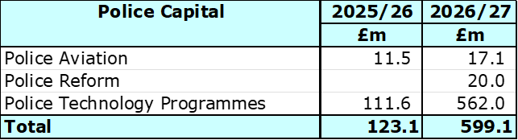
- Funding
Council Tax

The Medium Term Financial Plan (MTFP) contains a number of assumptions around income. A key assumption is the level of precept increase that can be expected in future years. Each year the Government sets an upper level of increase over which a referendum is required. In 2026/27 this was set at £15 for a Band D taxpayer. The Police and Crime Commissioner following a consultation with Surrey residents and a discussion with Chief Constable on the operational impact of a lower increase decided to increase the precept by the maximum amount. This was in line with government expectations and virtually all PCCs and Mayors across the country. This resulted in the Council Tax requirement and the Collection Fund per District as set out in the table below.

55% of the core funding for Policing in Surrey comes from residents through Council Tax with only 45% funded by direct Government Grant. This is the lowest proportion of government funding for Policing in the country.

As a result of Surrey has amongst the lowest level of Government funding per head and the highest level of Council Tax in England. This is shown in the graphs below:
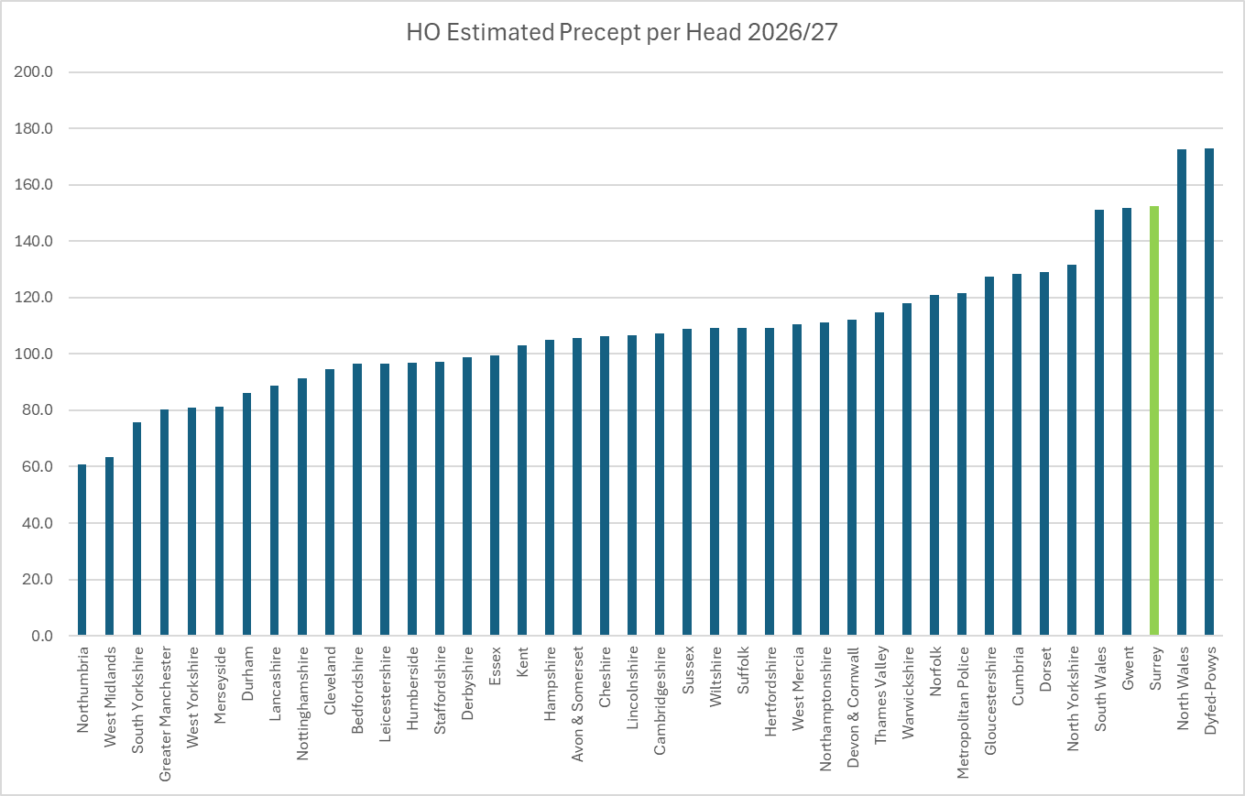
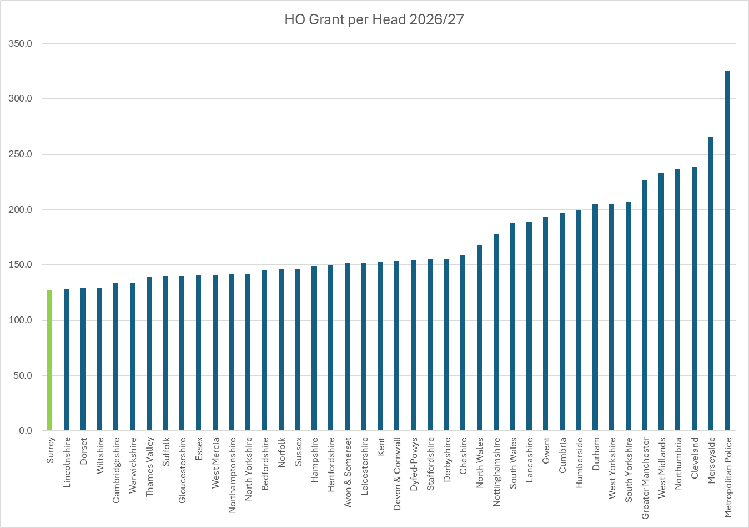
If Surrey were to receive the average level of funding from Government given to other county forces (i.e. excluding the highly populated cities) this would provide the Force with an additional £30.7m which is far larger than the savings we need to find and leave money over to improve services. This does illustrate the inequitable position of police funding from a Surrey perspective. Any change to this situation is highly unlikely and the burden will therefore have to continue to fall on Surrey residents. It has therefore been assumed for the MTFP that Government funding will remain static and that Council tax will continue to increase by £14 in 2027/28 & 2028/29 then 2% per annum.
Real Terms Funding Reduction
Surrey Police had experienced a real terms funding reduction of 8.2% over the previous 10 years (2010/11 to 2020/21) which the Force has filled with savings whilst trying to maintain front line service delivery. The chart below demonstrates the reduction in government grant until recently and the compensating effect of the precept increases over the latter years, whereby the precept makes up 55% of the Forces funding.
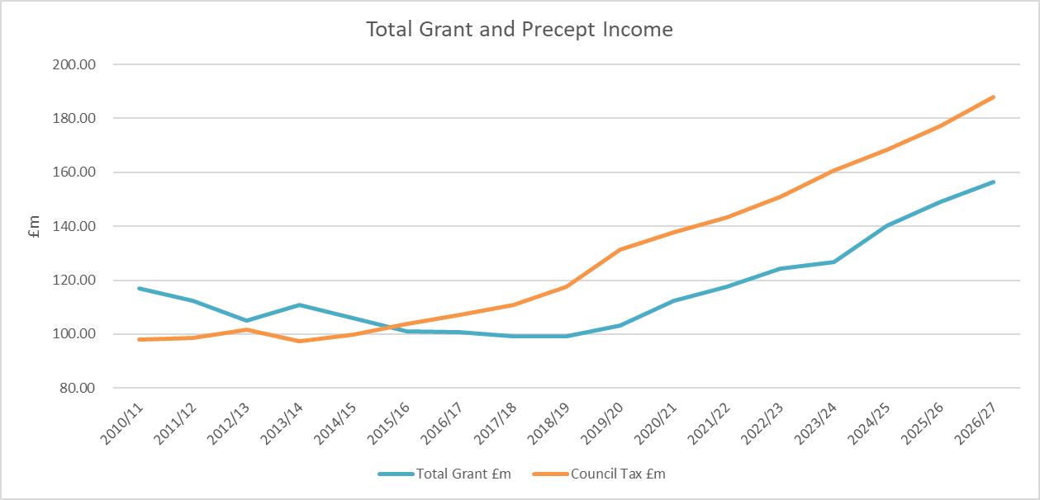
Financial Settlement 2026/27
This MTFP incorporates the police grant settlement for 2026/27 as laid before Parliament on 28th January 2026. The Settlement also confirmed that PCCs would have the option to increase council tax precept by £15 which would provide an additional £329.8m nationally when compared to 2025/26. In Government funding announcements it was assumed that the maximum precept increase would be taken.
Table 1 below shows a breakdown of funding for 2025/26 and 2026/27 based on the announcements made. This assumes an increase in precept of £15 coupled with the increase in core and neighbourhood Policing grant.

Table 1
Nationally the Home Office top sliced or made reallocations of the Police allocation by £1,391.8m in 2026-27, an increase of £477.5m including the new capital reallocations of £131.3 for Police Reform and Exceptional Financial Support. This is set in Table 2 below.

Table 2
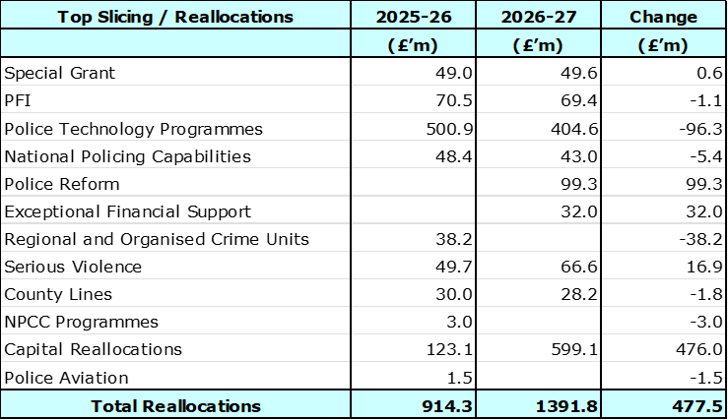

The national funding is being used as follows:
- The Police Technology Programmes caters for the new Emergency Services Network which will provide 4G access to officers that will bring productivity and operational benefits, Home Office Biometrics and National Law Enforcement Police database.
- Arms Lengths Bodies includes the Independent Office for Police Conduct, the HMICFRS PEEL Inspections, the College of Policing Direct Entry scheme and the Gang Masters Labour and Abuse Authority.
- Regional Organised Crime Units – funding to support the specialist regional functions.
- Serious Violence Strategy – to tackle issues such as knife crime.
- The Police Special grant caters for national events or incidents that require additional police support.
Whilst there has been considerable investment in policing there is also significant focus on how policing can improve the outcomes it delivers for the public. A review was conducted on policing productivity, commissioned in 2022, to help identify and deliver tangible improvements to the frontline; the changes already agreed in terms of how policing responds to mental health calls and how crime is recorded are freeing up over one million hours. The Home office believes that further productivity gains can be achieved and so for 2025/26 it confirmed £11.0m of funding for Police Productivity and Innovation.
Funding beyond 2026/27
For the period from 2027/28 to 2029/30 it is more difficult to predict what the funding could be as the Government, has not so far, announced funding settlements in advance. Given that the Government has said that public expenditure will be tight it has been assumed that Government funding will remain cash flat or static for the remainder of the MTFP period. In respect of Council Tax is has been assumed that increases will be capped at 2%, the historical cap. There is a risk that the Government may reduce the level of the grant, say by offsetting perceived efficiency gains, or alternatively permit a larger than 2% increase in Council Tax, which has been the case in recent years. The impact of these changes is included in the sensitivity analysis later in this document. The table below shows the estimated future funding for the PCC Group

Table 2

- High level budget planning and strategy
The budget projection for the MTFP period has been prepared based on a number of assumptions as set out in Appendix C. This has led to a savings requirement of £13.5m over the whole period and this is set out in Appendix A and B.
The anticipated Government Reform white paper intends to drive quality, consistency and efficiency in policing. Devolution and Local Government Reorganisation in Surrey has determined that from 2027 there will be 2 unitary authorities: East Surrey and West Surrey to replace the existing 12. Under the new banner of Op Solve, Surrey Police is also planning structural change re-organisation to 2 Divisions replacing the current 3 Divisions. This will provide the basis for further changes to the operating model, with plans that will develop to reflect the national direction and continue to deliver the Force’s strategy within the funding available to us.
The Force is continuing to seek out efficiencies to redirect resources into priority areas and will also have to consider further wide-ranging cashable efficiencies to bring about a sustainable financial position. In 2025/26 the Force identified additional savings of £0.9m which have been used to offset the savings requirement for 2026/27. These additional savings have come from Enabling Services £0.4m and Contact Centre £0.5m. Additional savings requirements have been slipped into 2026/27 as recorded in the Medium Term Financial Plan. (See section 7 Savings Programme for more detail).
The Surrey Estates Strategy is currently under review and the last approval is included in the MTFP. The Estate Board is due to meet during Q1 of 2026/27 to review the next steps for the overall Estate Strategy Programme and so this may have an impact on the MTFP.
An integral part of the MTFP is the need for capital spend and how this can be funded. As there is no capital grant and capital receipts are being used for estates this can only come from revenue funding thereby increasing financial pressures. Borrowing can be used to fund the Estate Strategy but this will incur interest and repayment costs which impact revenue albeit over a longer period.
Transformation of service delivery is seen as the main way savings can be delivered. This seeks to align the Force’s resources with its strategic priorities by improving skills and professional capabilities, the ability to exploit digital technology and address the changing shape of the force (higher ratios of officers to staff). This should ensure future resources are in the right place and savings can be delivered.
- Budget Gap
The MTFP has a total budget gap of £13.5m. This is based on the following assumptions:
- Flat Grant over the four year period.
- Precept – £15 for 2026/27 then £14 for 2026/27 and 2027/28 then 2% in 2029/30.
- Pay inflation – 4.2% for officers Apr 25 to Aug 25 then 3% to Aug 26, 2.5% to Aug 29 then 2% to Mar 30.
- Non-pay inflation – 3.5% all years.
In order to close the savings gap of £5.4m, which include unachieved savings carried forward from 2025/26 of £2.1m which were beyond our control, £0.9m of savings were identified in 2025/26, together with savings achieved from reductions in overtime budgets, use of reserves and realignment/deferment of other costs. The profile of savings are after deploying reserves in 2026/27 to manage the budget gap over the planning period as shown in the table below:

- Investment
Government Priorities

The Government has said it has provided forces with the certainty and investment needed to strengthen neighbourhood policing, modernise frontline capability, and ensure policing can meet the demands of today and the future.

The 2026/27 Final Settlement was announced on 28 January 2026 in a written statement by the Minister of State for Policing and Crime, Sarah Jones. The Police Grant Report (England and Wales) 2026/27 was laid before Parliament. The Report sets out the Home Secretary’s determination for 2026/27 of the aggregate amounts of grants that she proposes to pay under section 46(2) of the Police Act 1996.

The key elements are:

- Overall funding for the policing system in England and Wales, including police forces and wider system funding, will be up to £21.0 billion, an increase of up to £1.3 billion when compared to the 2025-26 funding settlement, representing a cash funding increase of 6.7% and a real terms increase of 4.4%.
- Total funding for Territorial Police Forces and Counter Terrorism Policing will be up to £19.6 billion in 2026–27, an increase of £848 million compared with the 2025–26 police funding settlement. This represents a 4.5% increase in cash terms and a 2.2% increase in real terms for policing.
- Within this, total funding to Territorial Police Forces will be up to £18.4 billion, an increase of £796 million compared with the 2025–26 settlement, representing a 4.5% cash increase and a 2.3% real terms increase for police forces.
- Of the £796 million increase in force level funding, £432 million is additional Government grant funding to police forces. This includes an additional £50 million to support the Government’s neighbourhood policing objectives above that announced at the provisional police funding settlement in December 2025. Plus, it includes up to £364 million in additional funding for forces in England and Wales from council tax precept, compared to 2025-26. As confirmed in the Provisional local government finance settlement published on 17 December 2025, Police and Crime Commissioners in England will have the flexibility to increase the police precept by up to £15 for a Band D property in 2025–26. This assumes PCCs make use of the full precept flexibility of £15 for English forces.
- Nearly 46% of the funding increase is from local council taxpayers.
- Funding for Counter-Terrorism Policing will increase by at least £52 million to £1.2 billion in 2026–27. PCCs will receive separate, confidential notification of force level CT allocations, which are not published for security reasons.
- The Op Uplift Performance Grant has been retired along with the requirement to meet officer number targets. The two parts to this grant have been amalgamated with the 2025-26 Neighbourhood Grant and labelled Additional Rule 2 Grant. From this grant the 2026-27 Neighbourhood Grant allocations have been made leaving a balance in Additional Rule 2 Grant, free of conditions.
- There is only one conditional workforce grant in 2026–27: the Neighbourhood Policing Ringfence Grant, totalling £363 million. Forces can receive this funding if, by March 2027, they increase the number of officers and PCSOs working in neighbourhood policing including those in training, in line with their locally set neighbourhood policing target.
- The national target increase for 2026-27 is 1,750 in officers or PCSO’s assigned to neighbourhood policing (as measured by CIPFA 1a).
- The settlement continues the £230.3 million to compensate territorial forces for the costs of the change to the employer National Insurance Contributions from 2025-26.
- As per recent years there are no local allocations of capital. The table below details the capital allocations, with an increase for technology and the inclusion of Police Reform.

Force Priorities – Our Plan

During 2025/26 the Chief Constable set out his vision and ambition for the Force entitled into ‘Our Plan’. This strives to improve trust and confidence in Surrey Police through purposeful action to fight crime and protect people, focusing on being here for our communities when they need us.

Under the banner of Op Solve, Surrey Poli

Other Investments
Over the planning period the following investment plans have been incorporated into the MTFP;
- The Estate Strategy, which includes the redevelopment of the headquarters at Mount Browne.
- The ICT Strategy which sets out the plans for investment in IT and will be revisited periodically.
- The Fleet Strategy which is predominantly the capital investment for replacements and future enhancements to vehicles such as telematics and cameras. Project Thrifty will be adopted which will see the rationalisation and increased utilisation of vehicles.
There are some commitments or unavoidable costs that the Force has provided for, with the new police constable pay scales there has been an expectation for a cost pressure from incremental salary growth and an amount is included to mitigate this risk.
The next Force Management Statement and the results of the PEEL inspection could lead to re-engineering or moving resources to meet new priorities and conversely reducing them in others.

- Savings and Efficiency Plans
The multi-year change continued to deliver complex transformation across Surrey Police during 2025/26. The savings will continue to be required. Savings of £5.4 are required in 2026/27 after the use of reserves to balance the budget and £8.1m in the following three years.
The table below shows the planned efficiency savings for the period of the MTFP grouped by risk of delivery category.

The Force identified a plan for 2025/26 to achieve a balanced budget which continues for 2026/27. Work is continuing to identify further savings whilst seeking to minimise the impact on operational policing.
Service Transformation Programme
A service transformation programme was set up in June 2022 in conjunction with Sussex Police, with the aim of addressing a significant forecasted funding gap. It was clear through early investigation that the force could not close their gap through existing or planned changes, and that a more ‘transformational’ approach was required if it was to deliver this aim without impacting significantly on service to the public. The programme will conclude in 2026/27.
Savings can only come from reducing the cost of services and reducing staffing numbers. Officer numbers could not be reduced whilst it was a condition of the Government uplift grant that numbers be maintained. The Op Uplift Performance Grant together with the requirement to meet officer number targets has now been retired by the government.
Surrey Police will continue to deliver the remaining parts of the established transformation programme (in partnership with Sussex Police) as well as continue to explore further areas to deliver transformation projects, noting these cost money and take time to deliver. This will support the Force with the opportunities to improve its ability to modernise processes and exploit digital technology and address the changing shape of the Force being driven through Op Solve and the priorities of Surrey Police ‘Our Plan’ to ensure future resources are in the right places.
Savings Plan
The savings plan developed by the Force will focus on:
- Delivery of remaining transformation projects
- Reductions and re-prioritisation of budgets
- Headcount Reduction
- Enhanced scrutiny to reduce non-essential spend
- Contract reviews to assess requirement and service levels

The Force will also need to consider a range of future measures to reduce costs including reprioritisation linked to force priorities, and delay or descope projects to reduce revenue spend continue to identify efficiency savings, both cashable and non-cashable in order to invest into the priorities and improve service to the Surrey residents.
The chart below shows that savings of £38.4m have been achieved during the last 10 years (2016/17 to 2025/26). Given the savings already found the scope for finding new savings, as set out in the blue bars, is becoming increasingly difficult.
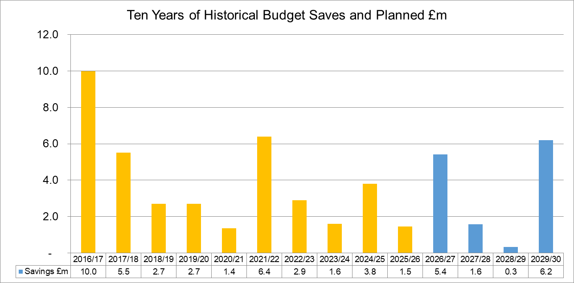

- Headcount Impact
Payroll costs account for over 80% of the Force budget. Consequently, significant savings can really only be delivered by reducing headcount. Officer numbers used to have to be maintained as a condition of the Government Op Uplift grant, this has now been removed however the Force will wish to maintain officer numbers to support front line service to the Surrey public.
The graph below assumes that 50% of all the savings will come from Police Staff while the balance is from savings in non-employee costs such as through contract reductions, so this modelling must be viewed as worse case. The FTE (full time equivalent) could change in future years as the savings from transformation projects progress.
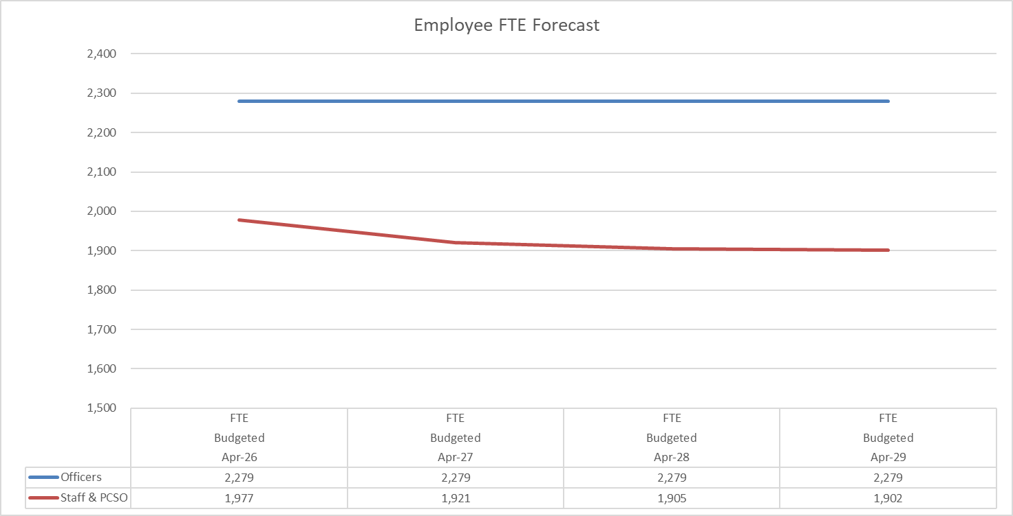

- Capital Strategy
The proposed capital programme for 2026/27, along with the associated funding approach, is detailed in Appendix D. Continued investment in essential operational assets will be supported through a combination of borrowing and revenue contributions. While this remains necessary to maintain an effective policing infrastructure, it also introduces additional pressure on the revenue budget and may impact the resources available for frontline service delivery.
To ensure long-term financial sustainability, the force has established clear limits on the overall size of the capital programme. All investment proposals must demonstrate alignment with strategic policing priorities and meet the agreed governance and assurance criteria before approval is granted. This robust approach ensures that capital decisions are evidence-based, affordable, and focused on strengthening operational capability and public safety.

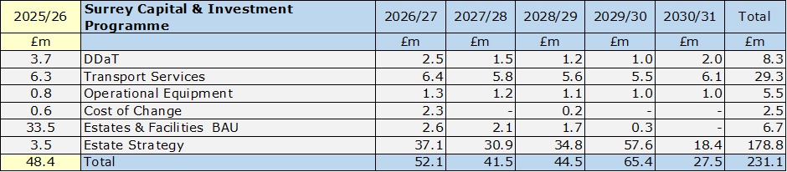

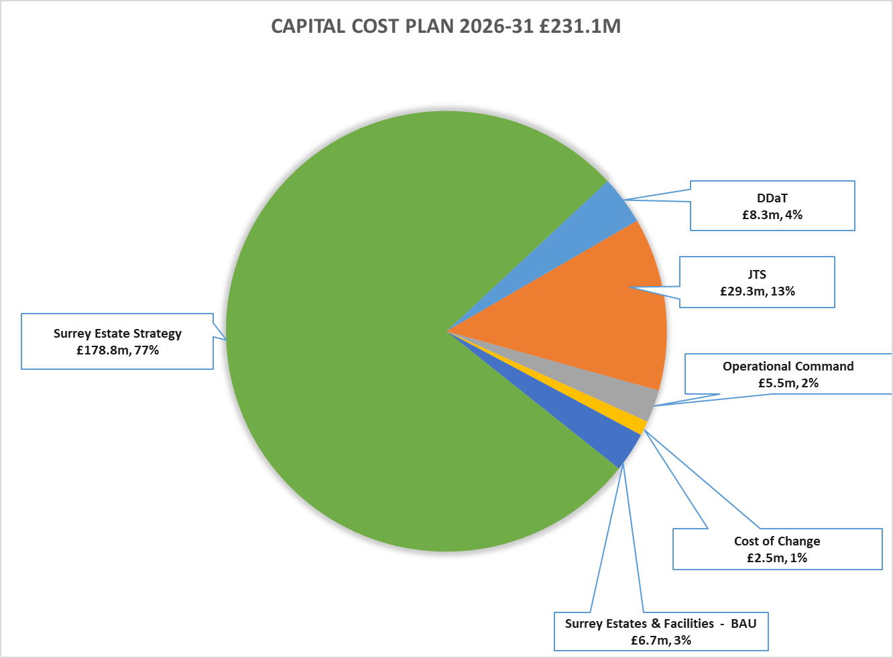
- The 2026/27 capital programme prioritises investment across the key operational areas of Digital, Data and Technology (DDaT), Transport Services, Estates & Facilities, the Surrey Estates Strategy, and essential policing equipment. These investment streams are critical to maintaining operational effectiveness and ensuring that officers and staff have access to the necessary tools, technology, and infrastructure to deliver high-quality policing services.

- The DDaT capital programme is primarily directed towards the renewal and upgrading core systems to maintain digital resilience and operational continuity. The programme also includes a small number of targeted new initiatives, such as enhancements to database management and expanded cloud-based storage solutions, all of which support the force’s wider digital transformation objectives.

- The Transport Services (Fleet) allocation continues to be driven by the Fleet Asset Management Plan, ensuring that vehicles are replaced in line with operational need and lifecycle considerations. The programme also reflects efficiency gains delivered through telematics, providing improved vehicle utilisation, enhanced deployment capability, and better long-term cost management.

- The operational equipment capital programme ensures that officers have access to essential protective and specialist equipment required for safe and effective deployment. This includes personal protective equipment, operational tools, and other assets fundamental to maintaining high professional standards in service delivery.

- The Estates and Facilities BAU capital programme delivers the essential maintenance, repairs, and lifecycle replacements needed to keep the force’s estate safe, compliant, and operationally fit for policing. It covers statutory works, planned and reactive maintenance, and minor improvements that support day-to-day service delivery, helping maintain asset condition, ensure business continuity, and provide reliable environments for frontline officers and staff.

- The Surrey Estates Strategy formerly known as the Building the Future programme represents a major long-term commitment to modernising the force’s physical estate. The associated financial requirements have been incorporated into the capital plans from 2025/26 onwards to ensure transparency and strong forward planning.

Financing the Capital & Investment Programme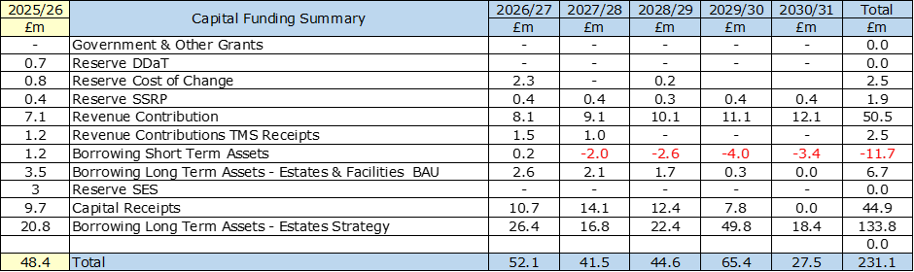
Capital Programme is financed through a combination of government grants, capital receipts, revenue contributions, and borrowing. In accordance with the current capital plan, and as previously indicated, a requirement for external borrowing is anticipated to support both the Estates Strategy and the wider capital programme.
The Police and Crime Commissioner (PCC) currently hold external borrowing from the Public Works Loan Board (PWLB) relating to prior land acquisitions, while internal borrowing has been utilised to finance certain short-life assets. Over the Medium Term Financial Plan period, revenue contributions to capital are projected to increase, thereby placing additional pressure on the revenue budget and increasing the level of savings required to maintain financial balance.
The definitive funding mix for capital expenditure will be determined by the Chief Finance Officer (CFO) and will be reviewed and adjusted as part of the established in year financial monitoring and governance processes.

Other Points to note:
- The Short-Term Assets programme comprises essential investment across DDaT, Transport Services, and Operational Equipment that require regular replacement to sustain operational capability and ensure assets remain within their optimal lifecycle profiles. Funding for these assets continues to be primarily sourced from revenue contributions and the relevant earmarked reserves, reflecting good financial practice in matching short-term funding to short-life assets. For 2026/27, a small borrowing requirement of £0.2m is identified, however over the subsequent four years the programme generates a negative balance, representing surplus revenue contribution once short-term asset needs have been met.

- This surplus position will be reviewed in-year to determine whether it should be redirected to support long-term asset financing or carried forward to meet future short-term asset requirements. This assessment will consider the relative affordability and timing of borrowing, recognising that delaying the application of revenue funding may be more cost-effective where interest rates remain elevated, and ensuring that financing decisions support the wider Treasury Management Strategy and overall MTFS sustainability.

- The Cost of Change programme will be financed through the Cost of Change Reserve.

- The Estates and Facilities BAU programme is fully dependent on borrowing to meet its capital investment requirements, reflecting the long-life nature of these assets and the scale of planned expenditure. However, as part of annual financial planning and in-year monitoring, a decision may be taken to utilise any surplus revenue contributions—arising after Short-Term Assets funding commitments have been met—to support the BAU programme in place of borrowing. Doing so would reduce future debt levels and associated interest and MRP costs. This decision will be reviewed each year in line with affordability assessments, interest rate conditions, and the wider Treasury Management Strategy, ensuring that the most cost-effective balance between revenue funding and borrowing is achieved while maintaining overall financial sustainability within the MTFS.

- The Surrey Estates Strategy will be financed through a combination of long-term borrowing and capital receipts, with the associated borrowing costs fully reflected within the revenue budget. Borrowing for the Estates Strategy is planned over a 30-year term, aligning the financing horizon with the long-life nature of the estate assets being developed or modernised. Over the next five years, the total borrowing requirement is forecast to be £133.8m, contingent on the successful delivery of an estimated £44.9m in capital receipts. These receipts form a critical part of the overall funding model, reducing the scale of borrowing required and mitigating future revenue pressures. The strategy ensures that investment in the estate portfolio can proceed in a financially sustainable way, while the long-term repayment profile distributes costs appropriately across the lifecycle of the assets.

- Borrowing periods have been aligned to asset lifecycles, with Short-Term Assets financed over 5 years, Estates & Facilities BAU over 20 years, and the Surrey Estates Strategy over 30 years. Based on PWLB rates as at March 2026, and applying a 0.20% certainty-rate reduction, the assumed borrowing rates are 5.22% for 5-year borrowing, 5.74% for 20-year borrowing, and 6.06% for 30-year borrowing. These rates provide the basis for affordability modelling within the MTFS and ensure borrowing assumptions remain proportionate to asset longevity and reflective of current market conditions.
- The form of the additional borrowing is a decision of the Chief Finance Officer whether it can be internal borrowing, subject to cash flow, or external borrowing.

- Assumptions
Assumptions used in the MTFP are set out in Appendix C. Some of the key ones are detailed below:
- The core government grant is increased by 3.9% for 2026/27 and will then remain flat in future years.
- The agreed savings plans are realised in delivered in year.
- A Band D Council Tax precept increase of £15 in 2026/27 with increases of £14 in 2027/28 and 2028/29 and 2.0% thereafter. Any surplus on the Collection Fund is directed towards a specific reserve to cater for one off costs. The tax base has an estimated growth rate of 1.2% in 2026/27 and 0.5% thereafter. No surplus or deficit on the collection fund has been assumed. In reality a surplus is used for one off costs and a deficit would add to the savings required
- For pay inflation Officers were granted an increase of 4.2% and Staff 3.0% in 25/26. For 27/28 to 28/09 and it has been assumed that pay will rise by 2.5% in future years then 2% thereafter. Officer pay is determined by the pay review body and in previous years the Government has provided a grant to fund some of the increase – but this is not guaranteed. Staff pay increases were locally determined, but as a result of the 2026/27 Pay Negotiations, the annual pay award will be aligned to the agreements reached by the Police Staff Council (PSC) during the agreed period of 5 years (reviewable at 3 years) which are generally in line with Police officer pay. These increases are not usually funded by Government.
- Non pay inflation has been budgeted at 3.5% for the MTFP period, however one of the financial interventions used in the past has been to ask budget holders to absorb inflation unless there was a contractual commitment in place, this option has been used for 2026/27.
- The police staff pension scheme is part of the Local Government Pension scheme and unlike the Police Officer Scheme is funded scheme which relies on underlying assets to support future liabilities. Any deterioration in asset values may increase the level of contributions and conversely a surplus could lead to a reduction. The costs reduced by 1% from 6.5% to 6.4%. The next valuation is due in 2028/29.
- The police officer pension is a pay as you go unfunded scheme in that any difference between the cost of pension paid and contributions collected in any individual year is underwritten by Government. The fund following a valuation process the employers’ contribution rate increased to 31% in 2019/20. The employers’ contribution rate was increased to 35.3% in 2024/25 and the increase was covered by Home Office Grant. The Police Pension Scheme is valued triennially.
- The MTFP is built on the basis that the reserves strategy of maintaining general reserves at no lower than 3% of budget is in place for the planning period.
- The last approved estimates in relation to the Surrey Estates Strategy has been incorporated which includes capital and revenue impact.
- Risks
There are a number of risks which can impact the MTFP and these are set out below:
- The government have over the last few years employed top slicing to fund national initiatives or growth in national functions. This has been increasing each year and remains a distinct possibility that this approach may result in further reduction on the level of funding to police forces. The Emergency Services Network is due to be implemented during the planning period and the funding required to implement to new service is being drawn from the national police allocation.
- Inflation has been seen as a key risk with significant hikes on fuel and energy prices. The Bank of England expects inflation to rise temporarily this year to 3.7% due to higher energy prices but is expected to fall back again to 2% after that.
- As Surrey is more dependent on local funding than most Forces we could face a higher percentage funding impact if there were any changes to reduce the referendum limit.
- Revaluation of properties for Business rates due to be done in 2026 could result in and increase or decrease in business rates costs.
- Increase in the costs for the Joint Vetting Unit following the outcome of recent HMICFRS review and Angelini reports following Carrick and Couzens cases.
- Overspend in the legal cost budget following the new legal budget contract with suppliers with increase rates of charging and increased levels of demand in legal advice and support across operation and functional areas of the force. This though is being managed through having a tougher gateway process to access legal advice
- Increasing demand on policing with the changing nature of crimes stretching resources. This may mean that resources will need to be prioritised if services are to be maintained at the same level.
- The introduction of national systems and infrastructure changes could result in increased national charges being levied on the Force.
- Government funding for Policing may reduce in the Spending review as national resources are diverted to other areas such as the NHS and defence. The formula review could also result in a reduction in grant.
- A strategy is being developed through the joint Surrey and Sussex Environmental Board with the aim of making the organisation carbon-neutral. This is unlikely to be achieved without incurring additional costs - at least in the short term.
A full financial risk analysis schedule is provided at appendix E. This is reviewed and updated during the year as new risks become apparent during the year.
- Reserves
Reserves are held by the PCC to cover contingencies, deal with unbudgeted expenditure and also for specific projects and activities
The general reserves strategy is to maintain the level at a minimum of 3% of annual revenue budget. In reality the general reserve is maintained slightly above 3% to allow a contingency in case there is a delay in savings being delivered. This contingency also allows the Force to cover any in-year budget pressures which may arise.
The chart below shows the general reserve level is forecast to be at 3.4 % in April 2027 and reducing to 3.3% by 2029/30, there is no use of general reserve to support the funding position however specific reserves are in place to manage future financial risks. The PCC has approved the general reserve strategy will be maintained plus specific reserves have also been created to assist the financial plan over the next few years. The full reserves strategy is on the PCC website.
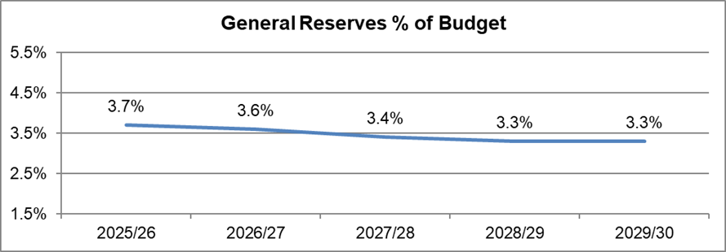
There are specific reserves in place to meet known risks and planned spending requirements. An Estate Strategy Reserve is in place to fund building works, along with a Cost of Change Reserve which have been allocated to essential programmes. An OPCC Operational Reserve, a Chief Constable Operational Reserve, and Chief Constable Extraordinary Investigations reserve cater for unexpected demands in-year as they arise, and long term or historic investigations to minimise impact on policing requirements.

Planned use of reserves has been allowed for in the MTFP as required.

- Scenario Planning
The MTFP has been prepared based on the most prudent assessment of a number of parameters that are included within the assumptions.
The table below shows the impact of changes in some of these assumptions

As can be seen a small change can have a large impact on the level of savings required.
- Appendices - Appendix A
Base Scenario Medium Term Revenue Financial Forecast
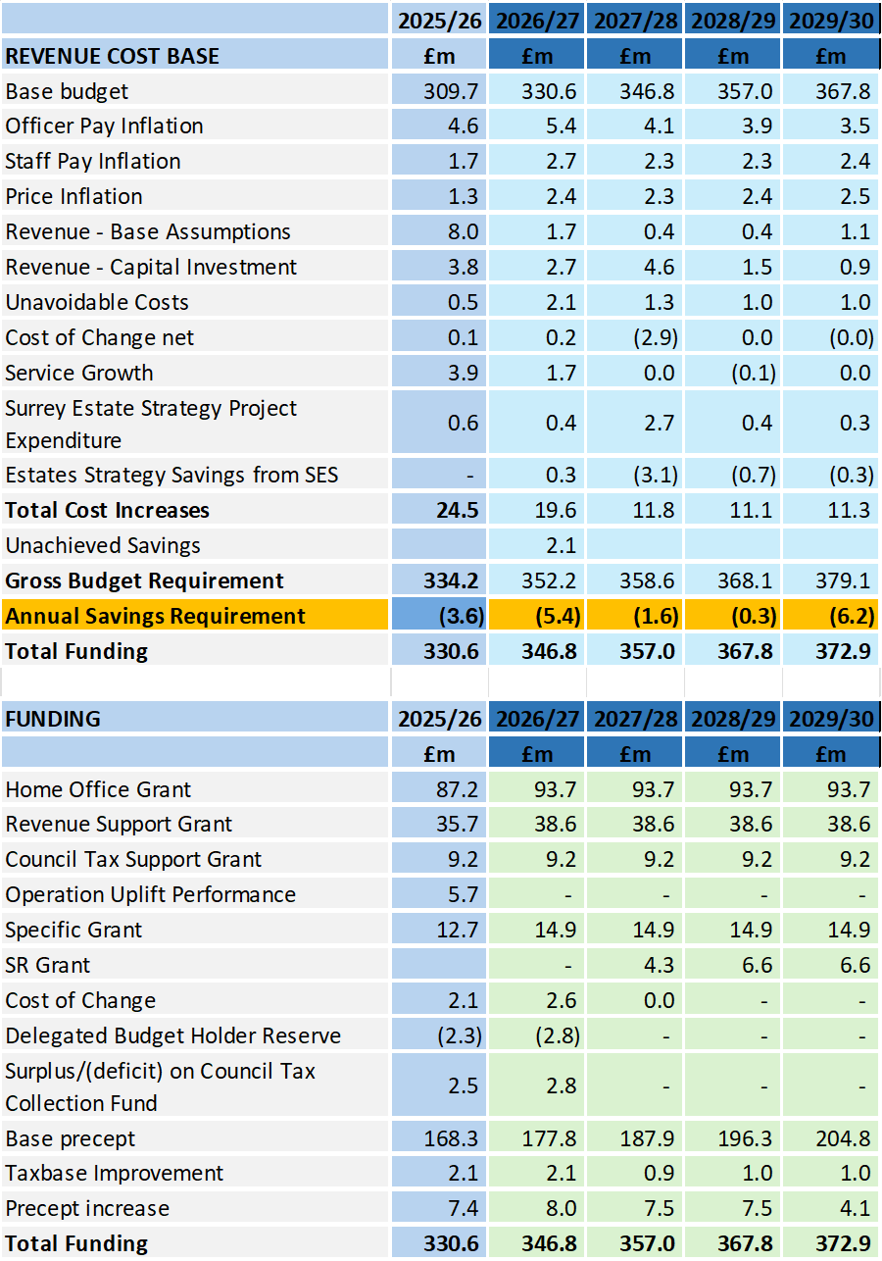
Appendix B - Efficiency Savings Plan

Appendix C – Financial Assumptions

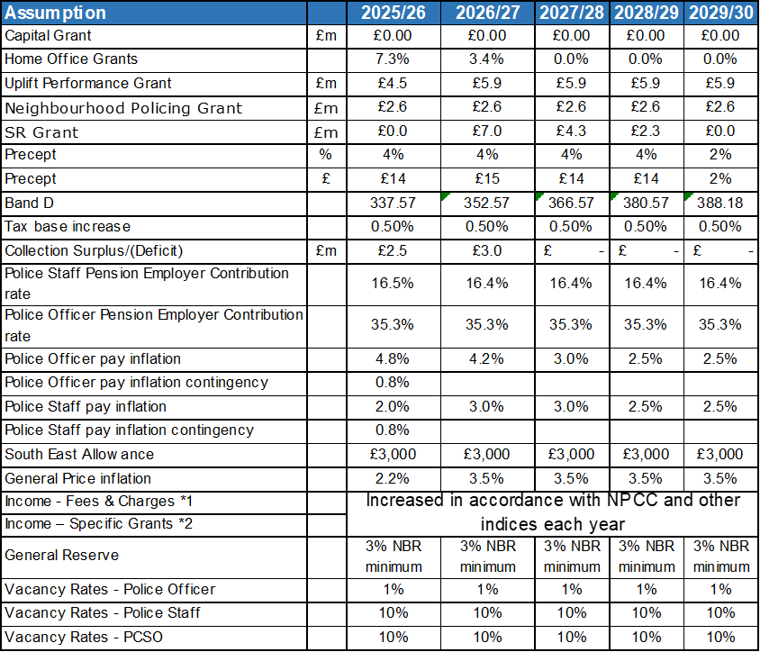

Appendix D – Capital Programme (Funding)

Appendix D – Capital Programme (Expenditure)

Appendix E Surrey Financial Risk Analysis

Title | ASSUMPTION | COMMENT
Title | SURREY | COMMENT | Date Updated / Reviewed
Pay and price budgets and establishment control  [Top 5 Risk – No. 1]  Including:  Neighbourhood Guarantee | Provision for Officer national pay awards of 4.2% for 2026/27 Apr to Aug, 3% Sept to April, 2.5% thereafter  Provision for Staff pay awards of 3% for 2026/27 2.5% thereafter  Staff turnover and increments based on detailed analysis of current staff profile and trends. | Risk of pay requirements exceeding the budget provision.  Whilst the number of police officer leavers is difficult to predict, recruitment and promotions are managed during the year to match staffing needs and resources to budget.  Detailed analysis of employee costs is carried out in setting the budget with close monitoring of the overall budget and management action to maintain financial discipline is particularly important to ensure resources are deployed to achieve the most effective and efficient service delivery. The DCC Strategic Planning Board / Force Organisational Board will monitor all aspects of the financial and human resources including the recruitment progress and report to the PCC.  Any increase above the rates budgeted will need to be funded from a combination of use of an earmarked reserves, tactical one-off savings, cashable savings and efficiencies from service changes as there is no further government grant or precept available to meet the costs.  Loss of or reduced grant due to not achieving and maintaining required Neighhourhood Policing targets | 03/02/2026
Neighbourhood Guarantee | Full Grant will be received | A financial risk exists as costs being incurred and grant is not paid until officers are in Neighbourhoods 1a. To mitigate the Forces, need to post officers above the respective target, to mitigate attrition, into 1a in line with their locally set neighbourhood policing target.  This will be monitored on an ongoing basis. | 03/02/2026
Non-Pay Inflation  [Top 5 Risk – No. 2] | Current inflation planning is 3.5% over the medium term plan | Risk of non-pay inflation exceeding the budget provision.  Any significant fluctuation in costs will be monitored through the monthly forecasting process and at the Financial Risk Meetings attended by the PCC CFO's.  Risk of third (3rd) party suppliers ability to deliver on contracts. Due to the current economic market there is a risk that 3rd party suppliers are unable to deliver services or goods contracts. Organisations facing increasing costs, such as fuel and source material national shortages, alongside a labour market buoyancy leading to potential staff shortages, these factors could lead to inability to service contract requirements or demand to the force/s.  All know inflationary increases have been included in the MTFF through the unavoidable cost pressure process | 03/02/2026
Savings Plan  [Top 5 Risk – No. 3] | Budget includes savings | Risk the MTFF savings requirement is not met.  Recognising the need for future savings the Force has set up a Service Transformation Programme to review and identify where saving can be made. In addition to this the Tactical Savings Working Group continues to review other areas where savings can be generated.  The savings planned in the first year of the four-year plan are within the reserves available but would be exceeded in subsequent years if not delivered.  Decision were made during 2025/26 back out some savings resulting in an in-year savings deficit which will be carried forward into 2026/27. | 08/01/026
Interest rates, investment and borrowing  [Top 5 Risk – No. 4] | Interest rates assumptions  Borrowing at fixed rates. | Forecasts of investment income for 2026/27 onwards are based on estimated cash balances and interest rate forecasts as set out in the treasury management strategy. A prudent position has been adopted about anticipating future increases in interest rates, to address the risk of interest rates being lower than expected, from a very low base.  The risk of investment fund loss due to collapse of the financial institution where the deposit is placed, is limited by controls within the Treasury Management Strategy which focus on security rather than returns. Potential impact is mitigated by a diverse portfolio with top credit rated institutions.  As part of the borrowing strategy in support of financing long term assets the ability to employ internal and external borrowing has been established which will be instigated by the Chief Finance Officer for the PCC.  For 2025/26 both Surrey & Sussex having increased the investment income budget due to the high interest rates with a corresponding increase to the revenue to capital contribution | 04/02/2026
Threat to the sum of core government funding received by the PCC following a change in the police funding formula  [Top 5 Risk – No. 5] | Review and initial consultation expect in the future | A review of the grant distribution method, known as the ‘formula review’, has been in planning for several years. Significant work has already been undertaken by PCCs and police to provide the body of evidence that will be required to convince HM Treasury of the financial requirements for policing bodies. The Home Office has now opened the review again.  No assumptions regarding a change to grant levels has been included in the MTFF, it is expected that transitional arrangements will be implemented by the Home Office to manage any changes to allocated grant resources.  It is also unknown how funding will be allocated to the new National Police Service announced in the police reform white paper. | 10/02/2026
Police Pension | Pension Scheme valuation change – cost neutral | Pension Scheme Valuation Change – Cost Neutral  When reforms or valuation changes occur, the government typically seeks cost neutrality. This means any increase or decrease in scheme costs must be offset by adjustments, ensuring there is no overall financial impact on stakeholders.  Challenges of Cost Neutrality in Valuation Changes  Impact of Reforms (e.g., McCloud Remedy):  The McCloud Remedy requires recalculating benefits for members affected by age discrimination, creating retrospective liabilities.  To achieve cost neutrality, liabilities may need to be offset through higher contributions (employer or member) or reductions in future benefit provisions.  Economic Factors:  Valuations are sensitive to assumptions such as discount rates and life expectancy.  Lower discount rates or longer life expectancy increase scheme costs, requiring balancing measures to avoid excessive burdens on taxpayers or members.  Contribution Rate Adjustments:  One approach is altering contribution rates:  Raising member contribution rates reduces take-home pay.  Increasing employer contributions impacts public service budgets.  Benefit Modifications:  Adjusting scheme benefits can also restore balance, for example through changes in accrual rates, normal retirement ages, or pensionable pay definitions.  Strategies for Achieving Cost Neutrality  Balancing Member and Employer Contributions:  Cost-sharing ensures both employers and members bear changes proportionally, in line with pre-agreed ratios.  Spreading Costs Over Time:  Phasing adjustments gradually helps avoid sudden financial shocks.  Using Surpluses or Reserves:  Where available, surpluses from prior valuations may be allocated to offset cost increases and reduce the need for immediate contribution or benefit changes.  Potential Impacts on Police Pension Scheme Members  Increased Contributions: Members may face higher deductions from salary.  Reduced Benefits: Future accrual or benefit calculation changes may limit long-term entitlements.  Administrative Complexity: Implementing cost-neutral measures increases administrative and communication challenges.  Conclusion  A cost-neutral approach to Police Pension Scheme valuation changes requires a careful balance of contributions, benefits, and funding assumptions. Effective collaboration between government, employers, and scheme administrators is essential to maintain financial sustainability while minimizing adverse impacts on members. | 12/01/2026
Police Pension | McCloud Implementation | Pension Remedy Implementation  1. Compliance and Legal Risks  • Legal Obligations: Employers and administrators must ensure compliance with new legislation or regulatory guidance, which can be complex and time-consuming.  • Litigation Risk: Failure to implement remedies correctly could lead to further legal challenges from affected members.  2. Administrative Risks  • Data Challenges: Remedy implementation often requires historical data, which may be incomplete, inconsistent, or difficult to retrieve.  • System Upgrades: Pension administration systems may require significant updates to accommodate retrospective changes in benefits.  • Increased Workload: Adjustments to records, recalculations of benefits, and member communications significantly increase administrative burdens.  3. Funding and Financial Risks  • Cost Implications: Pension remedies can lead to increased liabilities for schemes and higher contribution requirements from employers.  • Uncertainty in Valuations: Actuarial valuations might be affected, particularly if the financial impact of the remedy is uncertain or still being calculated.  4. Member-Related Risks  • Dissatisfaction: Members may feel unfairly treated if the remedy process is delayed or unclear, particularly those awaiting recalculated benefits or repayments.  • Communication Challenges: Explaining complex remedies and options to members, especially if retrospective choices are involved, can be difficult and prone to miscommunication.  5. Operational Risks  • Implementation Delays: Coordinating changes across multiple stakeholders, including employers, administrators, and government bodies, can lead to delays.  • Training and Expertise: Staff may need additional training to handle the complexities of implementing the remedy correctly.  6. Reputational Risks  • Public Perception: If the remedy is perceived as slow, unfair, or poorly implemented, it could harm the reputation of the pension scheme and participating employers.  • Erosion of Trust: Prolonged uncertainty or mismanagement could reduce members’ trust in the scheme’s governance.  Example: McCloud Remedy Risks  The McCloud Judgment ruled that transitional protections in public sector pension reforms were discriminatory based on age. The UK government’s Pension Remedy involves recalculating benefits to provide equitable treatment for members in scope. Risks specific to this include:  • Retrospective Adjustments: Recalculating benefits for periods going back years is administratively challenging.  • Member Options: Offering members a choice of benefits (e.g., final salary or career average) may confuse members and increase errors.  • Implementation Delays: The remedy is complex, with many schemes still awaiting full implementation guidance.  Mitigating Pension Remedy Risks  • Clear Communication: Transparent, plain-language updates to members can mitigate dissatisfaction and confusion.  • Efficient Data Management: Investing in robust systems to manage historical data can ease the burden of recalculations.  • Collaboration: Employers, administrators, and policymakers should work closely to ensure timely and accurate implementation.  • Contingency Planning: Preparing for unexpected delays or challenges helps minimize operational disruptions.  Understanding these risks is essential for all stakeholders, including pension administrators, employers, and members, as they navigate the complexities of implementing pension remedies effectively. | 12/01/2026
Maintaining & improving service performance levels | Resources sufficient to meet targets and priorities in the Police and Crime Plan and Chief Constable Priorities | There is a risk that the Force is unable to maintain & improve service performance levels  The Chief Constables believe that there are sufficient resources to deliver future Police & Crime Plan priorities, Chief Constable Priorities and Strategic Policing Requirement. However there remains risk from the cost of major operations including counter-terrorism, major incidents including pandemics, particularly if these are not fully funded nationally. The detail of the new National Police Service announced in the police reform white paper is also unknown. | 10/02/2026
Limits to Precept Increases | £15 in 2026/27  £14 SR assumption  Future precept planning assumption of a 2% increase. | There is a risk that precept funding is reduced on a permanent basis through precept limits or PCC decisions.  The 2026/27 Police Funding Settlement allow PCC's the flexibility to increase the amount of precept by £15.  The Localism Act 2011 gives a statutory obligation for council tax referendums to be held should a precept higher than prescribed be approved by the PCC. The Secretary of State for Communities and Local Government set the level above which a referendum would be required.  An increase in excess of the referendum level or precept ‘cap’ would result in the requirement to hold a referendum and the costs met by the OPCC  There is also a risk that PCC's set a zero precept or less than the maximum permitted  During the year the MTFF has various scenarios regarding the precept increase. During 2025/26 the scenarios included precept increase of £14, £13 & £12, the base assumption was a 2% increase | 04/02/2026
Grant Levels | Main police revenue grant | Financial planning is changeling with Home Office grant funding being confirmed in December/January for the next financial year. | 06/02/2026
Council Tax | Collection rates advised by individual billing authorities | The risk of council tax collection rates being lower than expected could impact on the collection fund balances and any surpluses payable to the PCC. Billing authorities’ factor in prudent collection rates to mitigate this risk. The PCC works closely with billing authorities to monitor their key collection rates and contributes financially towards the costs of reviews of discounts, including the single person discount, and exemptions.  The tax base is normally expected to increase during the MTFS period, but the assumptions could be impacted by changes to the mix of dwellings, discounts and the impact of unemployment numbers within billing authorities council tax reduction schemes or changes to the proportion of support provided.  Future tax base increase assumptions are included in the MTFS at 0.5% for Surrey and 1.0% for Sussex. | 06/02/2026
Budget Estimates (Expenditure) | Provision for specific on-going cost pressures | The budget estimates including all identified additional costs for 2026/27, supported by input and review by the Chief Financial Officers.  All cost pressures are scrutinised internally by the Chief Finance Officers and also the DCC Strategic Planning Board / Force Organisational Board before inclusion in the financial plan.  Risks of budget overspend are mitigated by the monthly budget monitoring process and formal monitoring reports to the PCC.  The external auditors review the MTFF as part of the annual VFM audit | 06/02/2026
Levels of Reserves | Forecast to reduce over the term of the MTFS  To mitigate this risk, the General Reserve is kept at a minimum of 3% of revenue expenditure. | Risk that reserves levels are inadequate  Currently used to finance the capital and investment programme and cost of change programmes. It remains a risk that the level of reserves is adequate to meet unplanned demand and unexpected costs. Reserves have been earmarked as a last resort to cover any delays in delivering savings over the medium term period.  An annual review of all reserves is undertaken at budget setting along with a post year-end review and update to the MTFS. Now that our budget is increasing further contributions are required to reserves in order to meet the stated limits over the period of the MTFS. Specific reserves are being employed to reduce the pressure on the revenue budget.  A reserve by its nature can only be employed as a one off cash injection The savings planned in the first year of the four year plan are within the reserves available but would be exceeded in subsequent years if not delivered. | 10/02/2026
Riot Compensation | No additional provision | Last year a review of the potential implications of claims under the Riot Compensation Act 2016 was completed and concluded that the General Fund reserves are sufficient to cover the costs of a single riot event. Should a significant event occur, the PCC will re-evaluate the risk and the need for future external insurance. There is no change to this risk assessment in this iteration of the MTFS. | 06/02/2026
LGPS Pension | LGPS reform changes | LGPS Reform Changes  Funding and Investment Risks  • Valuation Impacts: Changes in scheme benefits or contribution levels could affect the funding position of LGPS funds.  • Market Volatility: Reform-driven shifts in investment strategies may expose funds to higher market risks.  • Employer Contributions: Reforms might lead to increases in employer contributions, putting financial strain on local authorities and other participating employers.  Regulatory and Legal Risks  • Uncertainty Around New Rules: Delays or lack of clarity in reform implementation can create compliance challenges.  • Litigation Risks: Controversial reforms might lead to legal challenges, such as disputes over fairness or adherence to established pension rights. | 21/01/2026
Overtime | Additional cost of overtime and associated costs | Whilst action will be taken to mitigate the overtime and other additional costs relating to policing public order operations, significant costs may be incurred in-year. For 2026/27 reducing overtime costs continues to be key focus which has been scrutinised through the DCC board for each force. | 06/02/2026
Capital Programme | Latest plans | There is a risk of the capital programme being understated, or that over spending occurs, resulting in insufficient funding being available as planned. Slippage may also impact on operational demands. The capital plan is reliant on several sources of funding including capital receipts which are at risk of not being achieved either in quantum or timing. These risks are mitigated by regular review of all major projects including the Estates Strategy and DDaT projects, focus on key priorities agreed in advance, together with monthly budget monitoring and regular monitoring reports to the PCC.  The Portfolio Strategic Board will review all capital requests for 2026/27 along with cost of change requests | 06/02/2026
Capital Financing | MRP is calculated on an asset by asset basis | This Capital Financing risk is of charges being greater than budgeted. This is mitigated by considering revenue and capital implications of major project spend within the capital and investment planning process and inclusion within the MTFF. The MRP debt repayment provision is calculated on individual assets using PLWB rates at the time of modelling the project. Borrowing is planned to finance the capital programme within this MTFF. | 10/02/2026
Regional Partners | Investment plans | The risk is that all regional partners are not aware of each partner’s investment plans, estate strategy etc. which can lead to unplanned expenditure within the year.  The requirements under the new National Police Service announced in the police reform white paper are also unknown. | 10/02/2026
NPAS | Latest plans | There are ongoing discussion on this collaboration agreement which may impact budgetary requirements with replacing the fleet.  The new National Police Service announced in the police reform white paper may also impact NPAS. | 10/02/2026
National ICT Programmes | Latest plans | There is a risk that delays to the implementation of national DDaT schemes including ESMCP and NLEDS present significant risk. These risks will be managed by regular review of all these major projects at both the Strategic Change Board and the DCC Strategic Planning Board / Force Organisational Board.  Delays with ESMCP have been mitigated by renewing airwave devices  There is also a risk that budget for national ICT programmes will increase in the future resulting in a higher level of top slicing.  NPS Procurement: We must prepare to migrate our commercial and IT services to the NPS, which will implement a "buy once" strategy for technology and equipment to leverage economies of scale. | 06/02/2026
Local ICT Programmes | Project transition | There is a risk of local ICT Programmes being underestimated or implementation being delayed, or the ongoing costs of maintaining and licensing the new systems are not understood or forecast in future budgets. | 10/02/2026
Risk Management | Risk Register | Financial consequences could result if all major risks have not been identified when the budget has been set. This is mitigated by robust risk management arrangements in place with formal reporting to the Joint Audit Committee, Organisational Reassurance Board chaired by the Deputy Chief Constable; comprehensive insurance arrangements in place; and an adequate reserves policy and reserves (including the insurance and general reserve balances). | 10/02/2026
Digital Forensic Costs | Outsourcing costs | Digital Forensics outsourcing is an area that continues to overspend, SCC were originally working towards a 30% reduction but this has since been changed to a specific figure based on set initiatives that will provide an absolute target. These are to be submitted to the Forensic Accountability Board (FAB) to approval to proceed by ACC Jones.  There will be cost reductions made in 2026/27 with a target date for achieving the savings in 2028/29.  How forensics will be managed with the new National Police Service announced in the police reform white paper is currently unknown. | 10/02/2026
Business Rates Revaluation | Revaluation of properties | Risk that police premises could see an increase in rate costs. On the other side, a potential benefit that rateable values could reduce.  Increases where known have been included in the budget setting process. | 04/02/2026
Increased cost of vetting | No provision | Risk that costs in Joint Vetting increase due to the impact of the Carrick case at the MET and HMICFRS report into the Wayne Couzens case resulting in vetting for both Officer and Staff to be checked against national police database. The financial risk is for the future size of the vetting team.  A paper regarding the permanent size of the vetting team is being progressed. | 04/02/2026
Time off in Lieu | No provision | Sussex: There is a risk that there is a large amount of TOIL accumulated for officers that will have a financial impact for the force.  The DCC's decision was to tolerate this risk | 10/02/2026
Dogs & other seized Animals | No additional provision | Issue raised of increasing kennelling costs for seized animals - The budget for both forces continues to be increased to meet requirements, however this remains a high demand area.  A small amount of one off funding was received in relation to XL Bully Dogs from DEFRA during 2025/26. | 04/02/2026
ERP | No additional provision | There is a risk that the cost of licences will increase due to a restatement fee to enable the contract to state that Oracle licencing can be used by both Surrey and Sussex staff. | 04/02/2026
Firearms Training | No additional provision | The federation have raised an issue where officers can claim mileage and overtime when attending firearms training. Potential costs up to £600k for claims going back 6 years for both forces.  The Federation have asked for a standstill agreement to be put in place, which has been completed via Weightmans. | 04/02/2026
SAP | N/A | Risk that the pension costs are incorrect in Sussex due to an error on SAP. An upgrade was successfully applied late in 2025, however there is still ongoing corrective work to retrospective values. | 08/01/2026
Evidential Property | No additional provision | There is an issue in both forces with cash being held in property stores in terms of length of time, value of cash and records being held - being reviewed under Op Coral | 10/02/2026
Staff Vacancy Rate | No additional provision | There is a risk that the vacancy rate is too high, this is being highlighted during the year with pay overspends forecast. Recruitment authorisation has been implemented in both forces along with a temporary recruitment freeze in Surrey. | 08/01/2026
CJ functions | No additional provision | Risk that additional investment is required due to increasing significantly - volume and complexity of case file and other CJ activity, and supporting victims and witnesses - (from FOB FMS Observations) | 04/02/2026
National Policing Service | No additional provision | A new National Police Service will be set up as announced in the police reform white paper.  Further information is required to quantify this risk. | 10/02/2026
Crowborough asylum site  [Top 5 Risk – No. 6] | N/A | Risk that Sussex Police will have to fund some or all the cost associated with Crowborough asylum protests (Rainhill) as well as the wider community tensions related to Crowborough (Burcott).  A costing model has been created based on estimated resourcing requirements and there is ongoing dialogue with the Home Office.  The Home Office agreed to pay £790k to cover 2025/26 however there is still an ongoing risk regarding future activity | 22/04/2026
Iran War | No additional provision | There are several emerging risks and issues from war in Iran with the biggest being the increase in the cost of oil. | 19/03/2026

- Glossary
PCC – Police and Crime Commissioner
ICT – Information Communication Technology
DDaT – Digital Data and Technology
HMICFRS – Her Majesty’s Inspectorate of Constabulary & Fire and Rescue Services
SOCU – Serious Organised Crime Unit
FTE – Full Time Equivalent
FMS - Force Management Statement
MTFP – Medium Term Financial Plan
PEEL – Police Efficiency, Effectiveness & Legitimacy
NCA – National Crime Agency
ROCU – Regional Organised Crime Unit
CPS – Crown Prosecution Service
ESN – Emergency Services Network
ESMCP – Emergency Services Mobile Communication Programme
NPCC – National Police Chiefs Council
NLEDS – National Law Enforcement Data Service
CT – Counter Terrorism
CIPFA – Chartered Institute Public Finance Accountants

