 | Surrey Joint Audit Committee  Chief Constable Expenses

Required for: | Joint Audit Committee (JAC) 22 June 2026
Security Classification: | Official
Handling information if required: | For publication
Suitable for publication: | Yes
Title: | Chief Constable Expenses
Version: | 1.0
Purpose: | To report to JAC the Chief Constable Expenses
ACPO / Strategic Lead: | Chief Constable
National Decision Model compliance: | Yes
Date created: | 20th May 2026
Date to be reviewed:

AUTHOR:
Name: | Claire McDonnell
Job Title: | Chief of Staff
Telephone number: | 07967986979
Email address: | claire.mcdonnell@surrey.police.uk
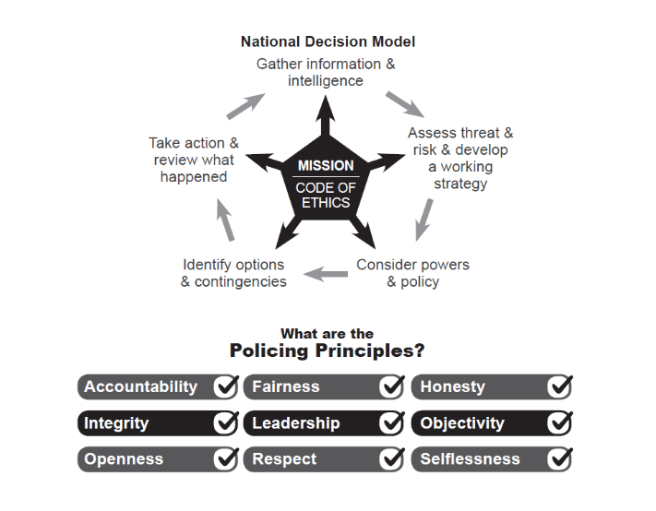

Chief Constable Expenses

To: Joint Audit Committee
Date: 20th May 2026
By: Chief Constable

Title: Chief Constable’s Expenses
___________________________________________________________________

Purpose of Report/Issue:

To update the Committee on any expenses incurred by the Chief Constable in 2025/26 and any hospitality received.

It is a standing item on the agenda of the Joint Audit Committee that the Chief Constable present his expenses.
The table below shows expenses claimed between 01 April 25 and 31 March 2026 and submitted for approval via Exclaim to the Office of the PCC.
___________________________________________________________________

Expenses Claimed:

Date | Amount (£) | Details | Commitment
27/11/2025 | £145.40 | Airport Parking | Chief Constable’s Council
02/12/2025 | £3.49 | Subsistence | Chief Constable’s Council
02/12/2025 | £17.55 | Subsistence | Chief Constable’s Council
02/12/2025 | £17.60 | Taxi Fare | Chief Constable’s Council
03/12/2025 | £15.90 | Subsistence | Chief Constable’s Council
04/12/2025 | £12.15 | Subsistence | Chief Constable’s Council
04/12/2025 | £2.49 | Subsistence | Chief Constable’s Council
04/12/2025 | £17.40 | Taxi Fare | Chief Constable’s Council
30/01/2026 | £6.50 | Subsistence | Sentencing Council
30/01/2026 | £9.20 | Car Parking | Sentencing Council
03/02/2026 | £10.00 | Taxi Fare | Criminal Justice Coordination Committee
03/02/2026 | £22.60 | Subsistence | Criminal Justice Coordination Committee
04/02/2026 | £7.15 | Subsistence | Criminal Justice Coordination Committee
04/02/2026 | £48.00 | Train Ticket | Criminal Justice Coordination Committee
04/02/2026 | £13.80 | Taxi Fare | Criminal Justice Coordination Committee
04/02/2026 | £2.69 | Subsistence | Criminal Justice Coordination Committee
06/02/2026 | £10.10 | parking | Criminal Procedure Rule Committee
24/02/2026 | £17.80 | Taxi Fare | The Times Crime and Justice Commission Event
24/02/2026 | £10.10 | Car Parking | The Times Crime and Justice Commission Event
24/02/2026 | £12.40 | Taxi Fare | The Times Crime and Justice Commission Event
13/03/2026 | £10.10 | Car Parking | Sentencing Council
17/03/2026 | £16.65 | Subsistence | Chief Constable’s Council
18/03/2026 | £16.70 | Subsistence | Chief Constable’s Council
19/03/2026 | £74.00 | Train Ticket | Chief Constable’s Council
Hospitality

Date | Amount (£) | Commitment
03/09/2025 | £20 | High Sheriff’s Summer Celebration
04/10/2025 | £80 | Lord Lieutenant’s Lunch

___________________________________________________________________

Recommendation

The Committee is asked to note and agree the expenses:
__________________________________________________________________

Contact details:

Name Claire McDonnell
Job Title: Chief of Staff to the Chief Constable
Telephone number: 07967986979
Email address: claire.mcdonnell@surrey.police.uk

