

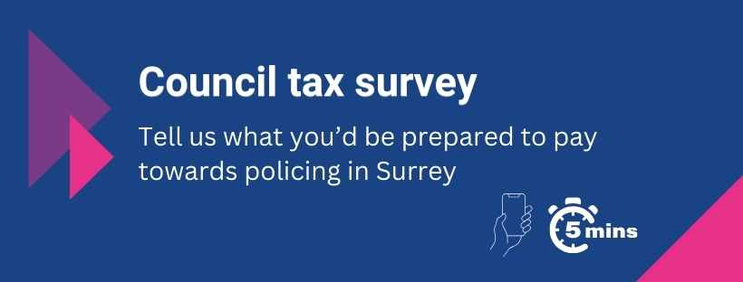
PUBLIC REPORT:
Police and Crime Commissioner for Surrey Council tax consultation 2026/27
As required by the Police Reform and Social Responsibility Act 2011, the Office of the Police and Crime Commissioner for Surrey carried out a consultation on the proposed level of Surrey council tax that will be raised for Surrey Police and the Office of the Police and Crime Commissioner during the financial year 2026/27. The consultation was carried out over five weeks, during December 2025 to January 2026.
Summary
The consultation received 2,403 responses and 1124 comments. 56.5% of respondents said that they would support an increase in the policing part of council tax equivalent to £14 a year, based on an average Band D Property which equates to £1.16 a month for an average household or 4.3% across all council tax bands.
Just under half of residents left a comment with their response, in line with previous surveys. Focus areas highlighted by the survey and comments include police visibility, affordability and comments around various crime types such as anti-social behaviour, drug use and dealing, and road safety.
The responses to this year’s survey were lower than in 2025/26 but in line with the average number of responses to council tax surveys held over the last five years.
Question
This year’s survey contained the introduction (below) from the Police and Crime Commissioner and one question about whether the respondent was willing to support an increase in council tax or not. The survey also asked where the respondent lived in Surrey and how they heard about the consultation.
The survey was launched on December 12th on the basis of what had previously been indicated by the government - that PCCs would be given the ability to raise a maximum of £14 extra on a Band D property. In fact, when the Government settlement was announced later in December – they gave PCCs the ability to raise an extra £15 - £1 more than had been anticipated.
The survey had already been launched at that point to enable enough time for it to run before the PCC’S proposal was submitted to the Police and Crime Panel. So the survey remained the same for the rest of its duration, however a note explaining this was added to the survey introduction.

Message from Police and Crime Commissioner for Surrey Lisa Townsend
Surrey Police has made amazing strides over the last two years in tackling those crimes you’ve told me are important to you.
Burglary and vehicle crime is falling, police teams have been cracking down on anti-social behaviour hot-spots and charges for shoplifting have risen by over 400%.
This is fantastic news but the Chief Constable has told me he wants to do even more to make our towns and communities feel safer for residents. I want to support him in that quest, but we need your help.
I want to hear your views in our brief survey on whether you agree with my proposal to pay a little extra on your council tax bill over the coming year to support our brilliant policing teams.
One of my key tasks as Commissioner is to set the Surrey Police budget which includes determining the level of council tax charged to residents for policing in the county.
The Government sets a cap for the maximum increase in council tax, although they assume in their police funding announcements that all PCCs will increase to the maximum limit. At the moment we are waiting to hear what that limit will be, but we anticipate it is likely to be in line with last year at £14 for an average Band D property. This equates to just over £1 a month and is what I am basing this year's survey on.
Despite repeated lobbying to get a fairer share of police grant funding, Surrey Police remains one of the most poorly funded forces in the country. Every £1 of precept amounts to an extra half-a-million pounds in the policing budget and I'm afraid that an increase of some kind will be needed to ensure drastic cuts to our workforce are avoided.
Your money will go towards not only giving the Chief Constable the resources to maintain our level of service but to also continue the impressive results he has achieved since taking up the role two years ago.
The number of charges across the board has more than doubled and 40% more crimes have been solved. Burglary rates have reduced by 14% over the last year while vehicle crime is down by 36%. The number of charges for rape has doubled while there has been a 465% rise in charges for shoplifting to combat the growing trend of retail crime.
This has all been made possible by the contributions you, the Surrey public, make through your council tax.
But there is always more to do. I want to continue tackling anti-social behaviour and drug related crime which can cause misery for our communities and to make sure we invest in those fantastic services in the county that provide truly life-changing support to victims of crime in Surrey. Over the last year our policing teams have been successfully carrying out hot-spot policing in areas where ASB has been an issue and working with our partners on ‘Clear Hold Build’ projects in targeted areas in an effort to rid communities of ongoing crime.
We need more of this but in order to maintain this momentum, protect victims and take the fight to the criminals, we desperately need funding to ensure all the hard work over the last two years isn’t undone.
Please do take a couple of minutes to fill in our brief survey below and let me know whether you would be willing to pay a little extra to support our policing teams and make our communities safer over the coming year.
Thank you.
Lisa Townsend
Police and Crime Commissioner for Surrey

Comments
46% of residents submitted a comment with their survey vote (1,124 people). Although the overall survey vote supported an increase in council tax the majority of those that left a comment were not supportive. Some comments specifically related to visibility of officers (12.88%), affordability (5.79%), waste and efficiency (3.13%) and comments relating to the dissatisfied service received from Surrey Police following a report of crime (3.2%).
In terms of crime types – there were 162 comments where specific crimes were mentioned (14.4% of the total comments). It is important to note that these comments vary in terms of context – for example there were comments on ‘speeding’ where some raised concerns about lack of police action where others complained that police were focusing too much on catching speeding drivers. An additional 39 comments (3.5%) referenced woke policing, diversity or two-tier policing.
Main comment topics in 2026/27:

Comments by crime type in 2026/27:

Responses by area
The largest number of survey responses came from Surrey Heath closely followed by Reigate and Banstead. The fewest responses were received from Epsom and Ewell. 31 people (1.3%) said they did not live in Surrey:

Just over a quarter of respondents (26.6%) were made aware of the survey through the Office of the Police and Crime Commissioner’s newsletter and email list followed by Surrey Police ‘In the Know’ messages (18.4%), social media (14%) and Neighbourhood Watch (12.3%):

Engagement
Online and print versions of the survey were shared widely using the Office of the Commissioner’s online channels and stakeholders including commissioned services, local councillors, resident groups and partner organisations,
The following methods and channels were used to promote the survey:
- PCC website
- Surrey Police intranet and internal email
- Media releases
- PCC Newsletter and emails
- ‘In the Know’ messages from the OPCC and Surrey Police
- Social media: Facebook, X (Formerly Twitter), Threads, Nextdoor, LinkedIn and Instagram
- Partner organisations including funded services
- Neighbourhood Watch and Residents’ Groups
Get in touch with our Office at surrey-pcc.gov.uk or call us on 01483 630200. You can also write to us using the address below or follow us online:
Office of the Police and Crime Commissioner
PO Box 412
Guildford
Surrey GU3 1YJ


