

Surrey and Sussex Police:
Chief Constables’ Scheme of Delegation


Contents
SECTION 1: INTRODUCTION 3
SECTION 2: BUDGET DELEGATION 4
SECTION 3: DELEGATED BUDGETS 8
SECTION 4: AUTHORISATION OF EXPENDITURE 10
SECTION 5: FINANCIAL SETTLEMENT OF CLAIMS 11
SECTION 6: PAY, ESTABLISHMENT CONTROL AND PENSIONS 12
SECTION 7: INCOME 13
SECTION 8: BUSINESS CASES AND FINANCIAL APPRAISALS 14
SECTION 9: OTHER DELEGATIONS 14
SECTION 10: RECORDING OF APPROVALS 15

Section 1: Introduction

Summary

This document sets out the responsibilities, delegated authority and control framework that applies to staff employed by the Chief Constables of Surrey Police and Sussex Police. The Chief Constables Scheme of Delegation supplements the Police and Crime Commissioner’s (PCC) Scheme of Delegation, which includes the delegated authority granted to the Chief Constable.Background

  - Surrey Police and Sussex Police are each a corporation sole (legal entity) and as such must establish a financial framework to ensure good governance, financial control and value for money. The Police Reform and Social responsibility Act 2011 requires each Chief Constable to appoint a person responsible for the proper administration of financial affairs of the Chief Constable, the “Chief Finance Officer”.

  - For the purpose of this document, references to CFO means the Chief Constable’s Chief Finance Officer for for Sussex and Surrey, with the Service Director, Finance & Regional Services acting as deputy for both Sussex and Surrey.
  - The Scheme provides a framework to ensure clear governance and accountability for decision making whilst ensuring business is carried out efficiently i.e. decisions should not be unnecessarily delayed.

Purpose and Scope
  - The purpose of the Scheme is to set out the responsibilities and flexibilities the Chief Constable has delegated to their command teams and budget holders. This includes any limitations on designated powers, including requirements to report back and the extent to which powers designated can be further delegated to others. The Scheme sets out the framework for budget management and promotes good financial management and the effective use of resources by budget holders.
  - This scheme applies to all staff and police officers employed by the Chief Constables of Surrey and Sussex and applies to all individual Surrey and Sussex services and all joint Surrey/Sussex services (as defined under the Section 22A agreement). Financial Regulations allow appropriate Surrey and Sussex staff to manage budgets of either Force in line with this Scheme. The collaboration Finance Protocol sets out the framework for specific financial arrangements for joint Surrey/Sussex services.

  - The Scheme predominantly relates to financial responsibilities but includes other delegations from the Chief Constables. The Scheme does not include specific operational responsibilities established by statute.

  - The authority delegated by the Chief Constables in this Scheme should be exercised in line with any other legal or operational requirements and with reference to Financial Regulations, Contract Standing Orders, Risk Management Strategy, Medium Term Financial Plan and other policies, procedures, plans and budgets.

Urgent Matters
  - If any matter which would normally be referred to the Chief Constable for a decision arises and cannot be delayed, the matter may be decided by the appropriate chief officer, in conjunction with the Force CFO, if the matter has cost implications
  - The appropriate chief officers authorised to decide urgent matters are the:

Deputy Chief Constable (all issues)
CC’s Chief Finance Officer for Surrey and Sussex Police (financial and related issues)
  - Urgent decisions taken must be reported to the Chief Constable as soon as practically possible.

General Principles of Delegation
  - The following general principles apply:
    - The Chief Constable may at any time ask that a specific matter is referred to her/him for a decision and not dealt with under powers of delegation.

    - The scheme does not list all matters which form part of everyday management responsibilities of the Chief Constable.
  - In this document, reference is made to delegated budget holders who will have their responsibilities set out in the annual letter of financial accountability.

  - When a delegated budget holder is considering a matter that is outside their area of professional expertise and responsibility, they should consult with the appropriate individuals who have the relevant professional expertise before authorising.

  - All decisions specified post holders make under powers delegated to them by the Chief Constable must be properly documented and available for inspection at any time by the Chief Constable or audit personnel.
  - Delegated budget holders are responsible for making sure that the members of staff they supervise know about the provisions and obligations of this Scheme.

  - With the exception, of those matters that cannot be delegated by the Chief Constable, the Scheme allows any person, with appropriate authority, to delegate that power further.

  - The Chief Constables Scheme of Delegation will be reviewed at least annually.

Section 2: Budget Delegation

Summary
  - The PCC holds their Chief Constable to account to provide an efficient and effective police service and provide the financial resources in the form of the annual budget. The PCC holds their Chief Constable to account for delivering the priorities of the Police and Crime Plan within the approved revenue and capital budget. The PCC will allocate an annual revenue and capital budget to the Chief Constable. This will be notified in the February proceeding the start of the next financial year 1 April. The PCC will also indicate the resources available for the following three financial years as included in the Medium Term Financial Plan; these are not permission to spend. The Chief Constable must not exceed the budgetary total and can only change the planned use of resources of the annual budget within the limits set out in Financial Regulations.
  - The Chief Constables delegate both revenue and capital budgets to Portfolio Holders and Delegated Budget Holders, who may further delegate responsibility but remain accountable for their budget in total.

Approach to Budget Delegation

  - The purpose of devolving budgets is to aid operational decision making on using resources, however spending decisions are subject to approval process and procedures described in this document.

  - Delegated budgeting is the decentralisation of responsibilities for budget management from the centre of the organisation to individual cost centres i.e. Divisions and Departments. The process of delegation aims to introduce an environment where managers at all levels have:

    - well defined responsibilities for making the best use of their resources;
    - a clear view of their objectives; and
    - information and training needed to exercise their responsibilities.
  - The CFO for Surrey and Sussex Police review the level of delegation annually as part of the budget setting process and make recommendations on changes to the Chief Constables.

  - Delegation will only be applied where there is a clear benefit (operationally and financially) and where:

    - expenditure on items directly relates to activities which can be controlled by the budget holder;

    - financial information is available on costs incurred; and
    - appropriate operational decision making is matched to financial resource allocation.

  - The basic principle underlying delegation is “that procedures should be simple, with restrictions kept to a minimum, allowing budget holders sufficient flexibility in decision making to deliver performance outcomes whilst ensuring the efficiency and effectiveness of their divisions or departments”.

  - Portfolio Holders and Delegated Budget Holders are accountable to the Chief Constable, for delivering performance objectives and targets within their delegated budget. This is best achieved by allowing budget holders sufficient flexibility to make the most effective and efficient use of the resources at their disposal.

Portfolio Holders
  - The Chief Constables delegate responsibility for the provision of services for each Force or joint service to a nominated Chief Officer . For the purposes of the Scheme these are termed Portfolio Holders.

Budget Responsibilities of Portfolio Holders
  - Portfolio Holders are required to be proactive in holding their direct reports to account for budget and performance management. The Scheme allows Portfolio Holders the freedom to transfer (virement) funding between budgets under their control, following discussion with budget-holders,
i.e. an underspend in one area can be transferred to support an operational need in another area of the portfolio, subject to requirements and limits set out in this Scheme of Delegation and the Investment Process (see appendix B).

  - Portfolio Holders are required to manage expenditure within their total delegated budget for the year in accordance with the financial governance framework (Financial Regulations, Contract
Standing Orders and associated Financial Policy and Procedures).

  - Portfolio Holders are required to sign a letter confirming their budget accountability at the beginning of each financial year and advise on any changes to their Delegated Budget Holders during the year.

  - Portfolio Holders are required to ensurethey:
    - actively promote good financial governance, i.e. proper control and management of budgets; ensuring value for money and efficient use of resources;
- deliver agreed saving plans as set out in Change Delivery plans; authorise expenditure and income commitments in accordance with force policy and procedures;
    - minimise expenditure and maximise income generation; and

    - evidence budget management performance as part of regular individual and command team performance and resourcing meetings

Delegated Budget Holders
  - Portfolio Holders delegate responsibilities to achieve specific objectives of each of their services to their respective Heads of Division or Department. For the purposes of the Scheme these are termed Delegated Budget Holders.
  - Delegated Budget Holders are encouraged to further delegate responsibilities (within the limits set out in this Scheme) as appropriate to their service area. Finance Business Partners will advise budget holders to ensure further delegation is appropriate and adds value to local budget management and accountability. Where further delegation takes place, the individual must hold the necessary skills and be provided with the relevant information and training.

Budget Responsibilities of Delegated Budget Holders
  - Delegated Budget Holders are required to manage expenditure within their total delegated budget for the year in accordance with the financial governance framework (Financial Regulations, Contract Standing Orders and associated Financial Policy and Procedures) and delivering services in accordance with the Police and Crime Plan and local operational plan within this budget.
  - Delegated Budget Holders are required to sign a letter confirming their budget accountability at the beginning of each financial year (this includes their annual budget and establishment) and provide a list of officers and staff that have been given delegated budget responsibility.

  - Budgets allocated are a fixed annual amount (cash limited) and include a provision for inflation, a vacancy factor and agreed savings. Budgets will not normally be adjusted during the course of the year, where adjustments are made they must be in accordance with this scheme of delegation and the Investment Process.
  - Expenditure is to be managed within the approved budget allocated, there is no automatic carry- forward of unspent budget from one year to another. In exceptional circumstances underspends and overspends may be carried forward at the discretion of the Chief Constable and/or approval by the PCC.

  - All purchases must be made in accordance with the Contract Standing Orders (CSO’s)

  - Delegated Budget Holders will be required to attend Financial Performance and Planning Board to
explain any significant budget variances or financial risks for their service area and associated action plans to address. Specifically all Delegated Budget Holders are required to:
    - monitor expenditure throughout the year in close consultation with their Finance Business Partner including reporting to the Portfolio Holder or Chief Officers;
    - report their financial position on a monthly basis including accurate forecasts of income and expenditure, key variations and financial risks in accordance with monitoring procedures and guidance (to be included in reports to Chief Officers, the PCC and the Finance Performance and Planning Board);
    - identify any potential under or over spends and prepare plans accordingly to bring their spending into line with the annual budget if necessary;
    - manage their delegated budget within a ±1% or £100,000 (whichever is the lower) tolerance over the financial year. Portfolio Holder approval is required for any delegated budget holder to go above this level of variation and must be reported to the CFO;
    - to use the prime system and related systems as designated by the CFO to produce budget monitoring reports, order goods and raise invoices;
    - ensure that they maintain staff numbers within the Budgeted Workforce (in consultation with HR Business Partners);
    - consult with Finance Business Partners on any financial decisions pertaining to the budget holders responsibilities; and
ensure all business cases are signed off by their Finance Business Partner.

Responsibilities of Finance Business Partners
  - Finance Business Partners will support Portfolio Holders and Delegated Budget Holders to exercise their responsibilities set out in this Scheme by:
    - advising budget holders on their arrangements to meet specific requirements set out above and other recommended practice issued by the CFOs ;
    - assisting in monthly reporting in accordance with monitoring procedures and guidance;
    - attending/contributing to relevant Divisional or Departmental performance or resourcing meetings (level of attendance to be agreed with CFOs); and
    - advising on financial implications of new service demands and requirements from inspecting bodies such as External Audit or Her Majesty’s Inspectorate of Constabulary and Fire & Rescue Services (HMICFRS).
  - Finance Business Partners are required to
    - inform the CFO of any significant changes (+/- 1% of budget) in spending plans, potential over spends or other risks, issues or difficulties at an early stage.
    - attend the Finance Performance and Planning Board, as required, to discuss financial issues and arrangements for their relevant service areas.
    - sign off all relevant business case proposals prior to formal approval as part of the Investment Process.
    - authorisation of one off spend within the delegated limits as set out in the Investment Process

Responsibilities of the CFO
  - The CFO has responsibility for overall financial management for Surrey and Sussex Police and advising their Chief Constable. In relation to this Scheme this means:

    - developing the annual budget setting process and medium term financial plans for the Force in conjunction with the key stakeholders;
    - reporting to the Chief Constable and Chief Officer teams on the overall Budget position, making recommendations to ensure a balanced budget for the current year and medium term;
    - developing and updating this Scheme, associated budget management guidance and all other finance policy and procedures;
    - promote the adoption of efficient financial practices that support organisational performance; and
    - establishing the appropriate control framework to ensure compliance with this Scheme and associated finance policy and procedures.

Section 3: Delegated Budgets

Summary
  - The majority of budget lines (expenditure and income types) are delegated to Portfolio Holders and Delegated Budget Holders. All other budgets are managed centrally either as a:
    - corporate budget managed by the appropriate Head of Service as part of their delegated budget only, e.g. IT, Learning & Development; legal costs and premises; or
    - force level budgets that are completely non delegated and are managed by the Chief Constable, Deputy Chief Constable and Executive Director of Commercial & Finance Services e.g. police officer pay and operational contingency budgets.

  - All force level budgets will wherever possible be visible to budget holders in their reports.

Capital Budgets
  - Capital expenditure is included within the scope of the delegated budget scheme. Capital allocations are considered as part of the annual capital budget setting process, and the Investment Process (Refer to Financial Regulations) and allocated to specific named project leads.

  - Capital budget holders are expected to manage schemes within the total scheme provision over the life of the capital programme and meet all requirements as set out for delegated budget holders in this Scheme. In addition, capital budget holders are required to:

    - report formally to the Finance Performance and Planning Board on progress and expenditure of each capital scheme each quarter;
    - set realistic profiles of expenditure at the beginning of each financial year and reviewing these regularly during the year (in consultation with their Finance Business Partner); and
    - identify any potential re-profiling of budget across financial years for a capital scheme at the earliest opportunity to their Finance Business Partner.

Pay Budgets

  - With the exception of externally funded functions all police officer pay budgets are held and
managed centrally and treated as non-delegated, i.e. budget variances will be managed at force level and not the responsibility of Delegated Budget Holders. Collaborated Surrey/Sussex services are not treated as externally funded functions i.e. the cost of police officers is shared (where there is a cost sharing agreement) but managed centrally.

  - Decisions on the use of police officer pay budget including new recruitment, changes in officer rank or mix will be made by Chief Officer teams.
  - Budget holders can propose civilianisation or changes to organisation rank structure subject to the establishment control procedures.
  - The Director of People Services will manage the total police officer numbers (recruitment, transferees, promotions and postings) for both Forces to ensure actual numbers of officers are in line with establishment and expenditure is within the police officer pay budget for each Force.
  - The Director of People Services will manage all internal police officer transfers and postings as a result of organisation change and decisions made by Chief Officer teams, with the aim of maintaining police officer numbers within an agreed establishment tolerance for each Division/Department (subject to Chief Officer priorities). This may mean transferring officers between Divisions and Departments.
  - All police staff and PCSO budgets are currently delegated i.e. budget variances will be managed at Delegated Budget Holder level. Budget holders can make decisions on appointments to established police staff posts subject to funding being available and establishment control procedures. For proposed permanent changes to posts, delegated Budget Holders are expected to consult with their portfolio holder, HR and Finance Business Partners, as appropriate. All workforce changes must be made in accordance with the Workforce Change Process.

  - Overtime budgets for Police Officers, Police Staff and PCSOs are fully delegated, this budget is however ringfenced and as such cannot be transferred to another budget heading.

  - A summary of pay and non-pay delegated budgets for each Portfolio Holder and Delegated Budget Holder are set out in the annual budget accountability letter issued at the beginning of each financial year.

Virement
  - The term virement means transfer and in this context is the temporary or permanent transfer of planned financial resources between delegated and non-delegated budgets, in response to an approved change in expenditure requirement. All other budget movements will be agreed in line with the limits set out at Appendix A, with Chief Constable’s CFO (or their Deputy) approving transfers between delegated budgets.

  - Revenue budgets are delegated to departments by Cost Centre and then classified into several “subjective” account categories (police officer pay, police staff pay, other employee costs, premises, supplies and services, transport, capital charges and income & grants).

  - Each ”subjective” category is broken down further into specific nominal account codes, for example supplies and services will include items such as stationery, office furniture, IT equipment, book & publications, consultants, subscriptions etc.

  - Financial resources can be vired between revenue budget codes, between capital budgets codes or from revenue to capital but no budget may be vired from capital to revenue.

  - Chief Constables CFO (or their Deputy), can approve virements in accordance
with the schedule at Appendix A. All other virements above £500K, including transfers of funding from revenue to capital, require PCC endorsement. Virements exceeding £500k will be reported within the monthly finance monitoring report.

  - Portfolio Holders may approve virement of budgets between any nominal account code or any cost centre, within their portfolio, in line with the limits set out in Appendix A and the Investment Process.
  - Delegated budget holders may approve budget virements between any nominal account code or cost centre within their delegated budget in line with the limits set out in Appendix A and the Investment Process.

  - In accordance with the Investment Process the Finance Business Partner must be consulted in the first instance when a new investment requirement is identified. The Finance Business Partner will also authorise the process for budget virements to be actioned.

Corporate Over-ride
  - Within the framework there is a need to maintain a corporate approach with the Chief Constable having the ability to exercise an effective level of resource redistribution as required during the year to ensure that:
    - certain ‘business critical’ common standards and operational practice are applied across the force, for example minimum numbers of warranted officers in specific units; consistent grading for posts with similar roles;
    - budget holder priorities are not considered more important than those facing the force as a whole;
    - any new significant financial pressures or risks emerging during the year are effectively managed e.g. public order operations;
    - resources are available to support policing together and other major change investments.

  - The Chief Constables will manage their overall force wide budget variations and new financial pressures and risks on this basis during the year.

Section 4: Authorisation of Expenditure
  - All expenditure will be authorised in accordance with the levels set out at Appendix A.
  - To safeguard the Force’s budget Delegated Budget Holders are responsible for ensuring effective systems are in place for:

    - approving requisitions and/or orders for all goods and services and ensuring the correct finance codes are used;
    - checking and certifying that goods are received are of correct quality; quantity and price and prompt notification is given to the Finance Operations Team of the receipt of goods and any variation;
    - adhering to the process of raising a purchase order or making a payment for goods using the government procurement card;
    - ensuring the proper separation of duties i.e. the person who requisitions the goods or service must not be the same person who certifies their receipt;
    - approval of requests and claims for subsistence, expenses, mileage, GPC, overtime, and their allowances by line managers is in line with policy and procedures; and
    - all appointments are made against the approved Budgeted Workforce.
  - Budget holders should make use of all existing contracts or frameworks in place for the purchase of good and services. If budget holders identify new contract requirements or wish to use alternative contractual arrangements they should refer to Contract Standing Orders and/or seek advice from the Head of the Joint Procurement Service before making any significant procurement decisions. This will ensure consistency with the procurement strategy, compliance with Contract Standing Orders and achieve value for money.

  - Where the Joint Procurement Service awards a contract, and where that awarded contract creates a defined commitment, the Joint Procurement Service may facilitate the creation of a purchase order directly on behalf of the Budget Holder. This purchase order may be for the entire duration of a contract, and where appropriate cover multiple years.

  - The budgetary approval granted as part of the contract award approval process is both the approval for the contract award and for any subsequent purchase orders raised, in so far as any purchase orders wholly align with the contracted commitments at the point of contract award, or as subsequently amended through contract variations, where such variations are either within a permitted tolerance for inflation (see 4.7) or where the requisite authority has been granted for the variation by the budget holder.

  - The Joint Procurement Service will facilitate the amendment to a purchase order it initiated where a change to the contract has occurred (e.g. a variation to contract for addition or removal of requirements, price review etc.).

  - Any amendment to a purchase order relating to a price review would not require any further budgetary approval where any uplift is a contract obligation (e.g. linked to an index such as CPI), or where the price review is in line with, or below, current inflation (i.e. CPI).

Section 5: Financial Settlement of Claims

Compensation Payments
  - A compensation payment is a payment made in circumstances where Surrey or Sussex Police has a legal liability to settle a claim for property, accident damage, motor claim, personal injury or financial loss. Claims can relate to employees, organisations or the public. In order for a compensation payment to be made, Surrey or Sussex Police has to have acted negligently in the course of its duties and the claimant has to have suffered a loss.
  - In these cases, the overall settlement includes claimant’s costs where applicable.

  - The Deputy Chief Constable or the CFO can approve the financial settlement of all claims or requests for compensation felt to be non-significant in line with limits set out in Appendix A and conditions set out in Financial Regulations.
  - The Head of Joint Insurance Services, Sussex Claims Manager and Heads of PSD may authorise claims in line with limits set out in Appendix A and conditions set out in Financial Regulations.

Ex Gratia Payments
  - Ex gratia payments are made in respect of loss or damage where no liability or legal obligation on the part of the Chief Constable is accepted but where there is assessed to be a moral or other responsibility to meet the cost of a claim.
  - The Deputy Chief Constable or Chief Constables CFO (or their Deputy) can approve ex gratia payments in line with limits set out in Appendix A and conditions set out in Financial Regulations.

  - Portfolio Holders and Delegated Budget Holders may authorise lower value claims in line with limits set out in Appendix A and conditions set out in Financial Regulations.

Employment Related Compensation Payments
  - Early retirement and redundancy payments can only be approved by the Director of People Services in line with the limits set out in Appendix A.
  - If agreed, in cases where a budget holder has proposed the redundancy/early retirement, any costs will be met by the budget holder. Where a redundancy/early retirement is as a result of an approved change process or business case, funding will be identified as part of this approval.

  - Director of People Services may approve the settlement of employment tribunal cases and grievances of staff and other employee related compensation payments for staff under the direction and control of the Chief Constable with the exception of those cases felt to be exceptional as defined in financial regulations
  - All employee related payments over £50,000 may only be approved after consultation with the Chief Constables CFO or DCC.

Section 6: Pay, Budgeted Workforce Control and Pensions

Summary
  - Police pay budgets are non-delegated and managed centrally. Police staff and PCSO budgets are delegated. This section sets out the level of delegation and control framework for the management of the establishment (funded posts) and appointment (permanent and temporary) to these posts.

  - The Budgeted Workforce (funded posts) for each force is managed and maintained by the CFO. Any changes to the Budgeted Workforce are subject to approval as set out below and detailed within the Budgeted Workforce Control Policy. The Budgeted Workforce for collaborated teams is also managed by the CFO.
  - Budget holders have a responsibility to ensure Force systems are kept up to date by providing timely notification of staff joiners, movements and leavers.
  - The management of payroll and pensions is the responsibility of the Director of People Services.

Police Officers
  - The police officer pay budget is centrally managed and not delegated. This means that any expenditure variance is not the direct responsibility and cannot be used by the budget holder.

  - The only exception to this is externally funded functions, e.g. Gatwick, where the limits and approvals for police staff (set out below) apply. Collaborated Surrey and Sussex services are not treated as externally funded.

  - Police officer pay budget is based on the agreed Budgeted Workforce at average pay scale for each role less % vacancy factor assumption (set as part of annual budget setting process).

  - Any changes to the police officer Budgeted Workforce, after consultation with Finance and HR Business Partners, must be agreed by Chief Officers.
  - All changes to the Budgeted Workforce must be reported to Chief Constables CFO in line with the Budgeted Workforce Control Policy.

  - Officer headcount is monitored by the Home Office at specific points during the year. The agreed headcount needs to be maintained to avoid any financial penalty of the Uplift Performance Grant.

Police Staff
  - The Police Staff and PSCO budget is fully delegated. This means that:
    - all pay and allowances, sick and maternity/paternity/adoption pay will be met from within the delegated budget;
    - any underspend may be used for other purposes on a short-term basis (in year only);
    - any overspend must be met from within the overall delegated budget.
  - Police staff budget is based on the agreed Budgeted Workforce at average pay scale for each role less % vacancy factor assumption (set as part of annual budget setting process). Budget holders may appoint to these posts with permanent or temporary staff providing this is within their overall
delegated budget for the year.

  - Delegated Budget Holders may vary the mix of current police staff posts within their Budgeted Workforce, in consultation with their Finance and HR business partners, providing that this change does not increase/decrease the on-going annual financial commitment by more than £25,000 and any increase can be funded within their overall delegated budget.

  - Portfolio Holders can approve a variation of current police staff posts within their Delegated Budget Holders establishment providing that this change does not increase/decrease the on-going annual financial commitment by more than £50,000 and any increase can be funded within their overall delegated budgets.
  - All changes in mix of current posts are subject to consultation with Finance and HR Business Partners before they are actioned.

  - Any other proposed changes to Police Staff and PCSO posts (including creation of new roles and posts, deletion of existing posts or requests for funding increases above £50,000) must be approved by the Chief Constables CFO and in accordance with the Investment Process with an appropriate business case and financial appraisal (see section 8). Significant business cases may require Chief Officer and/or PCC endorsement in accordance with this scheme of delegation.
  - For Business Cases exceeding £500k, following force approval Finance will forward the Business Case to the PCC CFO for their approval.

Section 7: Income

Summary
  - The PCC is the recipient of all income from any source in relation to policing or related activity. The majority of estimated income is allocated to the Chief Constable’s as part of the approved annual budget.

  - The majority of income is delegated to budget holders. Any additional income received from existing income generating activities can be used to fund other short term/ non recurrent commitments in year.
  - The approval limits for agreeing unplanned income or a new income-generating initiatives including income from joint working funding is set out in Appendix A.

  - To safeguard the Force’s budget Delegated Budget Holders are responsible for complying with force policy of income generation and charging and ensuring effective systems are in place to:

    - approve events where full charging or abatement applies;
    - agree service provision and charges prior to services being delivered;
    - sign invoice requests and ensure the correct finance codes are used;
    - adhere to the fees and charges policy or otherwise and to consult with Finance Business Partner for setting of charges;
    - ensure the proper separation of duties; and
    - seek approval for write off of bad debt or waiver of income from the CFO.

Section 8: Business Cases and Financial Appraisals

  - Delegated Budget Holders are responsible for ensuring they prepare an appropriate business case for approval of a change programme or investment project. New investments with an estimated cost of over £25,000 (Delegated Budget Holder limit - based on the full cost of change) require approval as per the Investment Process. All business cases and financial appraisals must be in line with the DCC Strategic Planning Board and broader oversight and reporting mechanisms determining force priorities. The financial appraisal template issued through the Change Governance process must be used to reflect all implementation and ongoing costs that relate to a change programme or investment, which must be included within each business case.
  - Finance Business Partners MUST be a signatory to all business cases.

  - Business cases must include the plan for changes in the Budgeted Workforce. For collaborated Surrey/Sussex services this plan should be based on the principle of maintaining posts in a ratio of Sussex to Surrey at the cost sharing ratio.
  - All costs are shown gross including the direct cost of implementation. Savings and income streams are to be shown separately.
  - To ensure decision makers are aware of the whole cost of change all resources required should be included within the implementation costs irrespective of whether additional funding is required; for clarity this includes opportunity and overhead costs and ongoing revenue costs.
  - Approval limits for agreeing business cases is set out in Appendix A. Portfolio Holders and Delegated Budget Holders are required to consult with HR and Finance Business Partners before agreement of any business case and consider consultation with other key stakeholders or Boards as required these are set out in the Investment Process.
  - Progress on projects are reported through the Change Governance process, with Budget Holders being responsible for the budget and forecasting as described throughout this document.

Section 9: Other Delegations

Procurement
  - The Head of Joint Procurement Service will undertake the day to day management of the Joint Procurement Function in accordance with Contract Standing Orders and the PCC Scheme of Delegation.
  - All contracts will be in the name of the Police & Crime Commissioner.
  - Authorisation limits for contract approval, sign off and ordering of goods and services are set out in Appendix A.

Property and Assets
  - The Service Director of Estates and Facilities will undertake the day to day management of the property function and property assets subject to the provision of Financial Regulations and the PCC Scheme of Delegation.

  - The Service Director of Estates and Facilities may approve purchase and disposal of freeholds and leaseholds in consultation with The Police and Crime Commissioner, up to the values in Appendix A, these must be reported to the Estates Board in the relevant force.
  - The Service Director of Estates and Facilities must keep a register of all property and major assets owned by the Police and Crime Commissioner or leased by him/her in line with the values set out in Appendix A.
  - The Service Director of Joint Transport Services will undertake day to day management of the transport function, vehicles and related equipment.
  - The Service Director of Joint Transport may approve the disposals of assets in accordance with limits in Appendix A.

  - The Service Director of Joint Transport must keep a register of all vehicle assets and equipment owned by the Police and Crime Commissioner or leased by him/her in line with Financial Regulations.

Insurance
  - The Service Director, Finance & Regional Services will undertake day to day management of the insurance arrangements in line with Financial Regulations.

Partnerships
  - The PCC and the CC provide distinctive leadership roles within the community to make Surrey and Sussex safer through effective and efficient delivery of the right police services for the county. This role can be enhanced though working in successful partnership with other organisations.
  - A Memorandum of Understanding (MOU) setting out appropriate governance for partnership projects should be drawn up by the relevant lead and signed by the relevant Chief Officer.

  - The relevant CFO may approve partnership agreements with a financial contribution of up to
£500,000 (in cash or equivalent resourcing costs in kind) over the term of the agreement.
  - Delegated Budget Holders may approve partnership agreements in accordance with limits in Appendix A and conditions set out in Financial Regulations.

Section 10: Recording of Approvals
  - All post holders identified in this Scheme are required to properly record and maintain an audit trail for approvals, which is available for inspection by internal or external audit and to provide a summary of any significant approvals during the year in accordance with instructions of relevant CFO(s).

  - Any decisions or actions requiring PCC approval should be identified at the earliest opportunity and the relevant Portfolio Holder, DCC or CFO notified in order that these can be managed within the arrangements for PCC decision making in each Force.

Section 11: Accepting Liability in Contracts (including Memorandums of Understanding and Service Level Agreements)
  - Where a contract is entered into, and howsoever it is entered into, no liability cap should be granted to a supplier that is lower the limits in the table below without prior discussion with Head of Insurance Services to understand the full extent of risk to the Force.
  - Minimum levels of insurance cover are also included in the table below, and any proposed acceptance of a lower limit should be discussed with the Head of Insurance Services prior to acceptance.

  - Where a product is being provided by a supplier, they may also need to provide product liability insurance, liaise with the Head of Insurance Services.
  - Any proposal to accept risk at a greater level than specified below or disregard the advise of the Head of Insurance Services, must be approved by, at least, Portfolio Holder level, and recording in writing as a risk at departmental / or Force Risk register as appropriate.

Type of risk | Minimum Liability Cap | Minimum Insurance Cover
Contracts for Works, and design of works
For damage to property | £5,000,000 | Public Liability - £5,000,000 any one claim
For design | £5,000,000 | Professional Indemnity - £5,000,000 in the aggregate
Contracts for Digital Systems
For risk of data breach | £1,000,000 | Cyber / Public Liability - £1,000,000 any one claim
Contracts for Services (provided on premise)
For damage to property | £5,000,000 | Public Liability - £5,000,000 any one claim
Contracts for Services (provided remotely)
For advice | £5,000,000 | Professional Indemnity - £5,000,00 in the aggregate
Contracts for goods or Services (where there is no interaction with our Estate, advice being provided or Sensitive / Personal Information shared)
 | 125% of annual charges | Public Liability - £2,000,000 any one claim

Summary of Authorisation Levels APPENDIX A

 | Fin Reg/ (CSO  )  Ref | Local Discretion | Delegated Budget Holder | Portfolio Holder | Head of Joint Procurement | Head of Data & Technology | Head of Joint Insurance  / Claims Manager (Sussex) | Head of PSD | Service Director Joint Transport | Service Director EsBev tates & Facilities | Director of People Services | DCC | CFO | Gold Commander | Chief Offic er On Call
Virements | 2.3 |  | £25,000 | £50,000 |  |  |  |  |  |  |  | £100,000 | £500,00 0
Business case approval (revenue & capital) | 2.3 |  | £25,000 | £50,000 |  |  |  |  |  |  |  | £100,000 | £500,00 0
Disposal of vehicles and plant | 3.8 |  |  |  |  |  |  |  | £10,000 |  |  |  | £50,000
Write off surplus obsolete assets | 3.8 |  |  |  |  |  |  |  |  |  |  |  | £50,000
Write off surplus, lost or obsolete stock/equipment | 3.8 |  | £10,000 |  |  |  |  |  | £10,000 |  |  |  | £50,000
Capital Project & WIP Abortive Costs | 3.8 |  |  |  |  |  |  |  |  |  |  |  | £50,000
Provision of policing services – external | 4.2/5.3 |  | £50,000 | £100,000 |  |  |  |  |  |  |  | £250,000 | £500,00 0
Provision of policing services – other | 4.2 |  |  | £100,000 |  |  |  |  |  |  |  | £250,000 | £500,00 0
Provision/ request for mutual aid | 4.2 |  |  | £100,000 |  |  |  |  |  |  |  | £500,000
Write off bad debt –  individually | 4.2 |  |  |  |  |  |  |  |  |  |  |  | £10,000
Write off bad debt –  cumulatively | 4.2 |  |  |  |  |  |  |  |  |  |  |  | £25,000
Purchase Order Requisitions | Section 4 | £25,000 | £50,000 | £50,000 |  |  |  |  |  |  |  |  | No limit
Approve Orders (on ERP systems) | CSO  3.1.3 | £5,000 | £25,000 | £50,000 | No Limit |  |  |  |  |  |  |  | No limit
Authorising the creation of Vendors (total aggregate spend, not per annum) |  |  | £25,000 | £25,000 | No Limit |  |  |  |  |  |  |  | No Limit

 | Fi n Re g  Re f | Local Discretion | Delegated Budget Holder | Portfolio Holder | Head of Joint Procurement | Head of Data & Technolo gy | Head of Joint Insurance / Claims  Manager (Sussex) | Head of PSD | Service Director Joint Transport | Service Director Estates & Facilities | Director of People Services | DCC | CFO | Gold Commander | Chief Officer On Call
Ex Gratia payments | 4.7 |  | £1,000 |  |  |  |  |  |  |  |  | £5,000 | £10,000
Compensation claims –  accident | 4.7 |  |  |  |  |  | £25,000 | £50,000 |  |  |  | £250,000 | £250,000
Compensation claims –  non accident | 4.7 |  |  |  |  |  | £25,000 | £50,000 |  |  |  | £100,000 | £100,000
Employment tribunal or grievance | 4.7 |  |  |  |  |  |  |  |  |  | No limit
Early retirement or redundancy | 4.7 |  |  |  |  |  |  |  |  |  | No limit
Gifts, loans sponsorship and donations | 4.8 |  | £1,000 |  |  |  |  |  |  |  |  |  | £50,000
Partnerships | 5.1 |  | £50,000 | £100,000 |  |  |  |  |  |  |  |  | £500,000
External Agencies – agreement for provision of police services | 5.3 |  | £50,000 | £100,000 |  |  |  |  |  |  |  | £250,00  0 | £500,000
Contract Standing Order Waivers | CSO  2.3 |  | £25,000 | £25,000 | Up To Threshold |  |  |  |  |  |  |  | Up To Threshold
Approval to award a contract | CSO  3.1.3 |  | £25,000 | £25,000 | £1,000,000 |  |  |  |  |  |  |  | £5,000,000
Signing contracts | CSO  3.1.4 |  | £25,000 | £25,000 | No Limit |  |  |  |  |  |  |  | No limit
Emergency operational commitments | n/a |  |  |  |  |  |  |  |  |  |  |  | £500,000 | £50,000 | £250,000
Police staff post mix –  financial impact | n/a |  | £50,000 | £100,000 |  |  |  |  |  |  |  |  | £500,000
Authorising payments |  | £25,000 |  |  |  | £25,000

Notes:
    - CFO (or Service Director, Finance & Regional Services) approval will be exercised via formal boards as set out in the Investment Process, or otherwise in consultation with the relevant Chief Constable(s).
    - All approvals exceeding the limits set out in this table require PCC endorsement. For virements exceeding £500k the monthly finance monitoring report will include these for PCC endorsement. For Business Cases exceeding £500k; following force approval Finance will forward the Business Case to the PCC CFO.
    - Local discretion can be applied as set out above in consultation with Finance Business Partners and in accordance with procedures and systems for
ordering and payment of goods and services operating within each Force; In any instance, Budget Holders remain fully accountable for the actions of those that they have delegated any authority to.
    - When approving a requisition, on either an A60 in Sussex or via iProc in Surrey, the approval solely relates to the budget being made available and that the budget can be spent on the goods, works or services listed on the requisition. It is only once a purchase order has been created from the requisition and then approved in accordance with this Scheme of Delegation that any commitment may be made with suppliers.
    - Vendors on the ERP system may only be created once approval has been granted in accordance with this Scheme of Delegation. Vendors existing on the ERP system offers no assurance or authority that the supplier may be used and whomever approves a Purchase Order should satisfy themselves that by placing an order with a supplier the spend in aggregate remains compliant with CSO’s. e.g. the total value of all orders over a given period does not exceed the value of any corresponding contract awarded, quotes obtained or waiver granted.
    - All approvals of requisitions, purchase orders or vendors must always be in full adherence of Contract Standing Orders.
    - The discretionary limits below can be used as a guide

 | Requisitioner up to  SPA11/Grade H | Supervisor | Inspector or M1 | Chief Inspector or M2 | Supt or M3; Police Staff (Band 2) | Authorised finance/ HR staff (Band 1)
Requisitions and Orders | £500 | £2,500 | £5,000 | £15,000 | £25,000
Payments |  |  |  |  | £25,000 | No Limit

APPENDIX B






T t!Pr®'IIH �id d 10 • ;:ii .:ind ;:i1,1
d
�1fil'ilili!iim
de � �111.•,t . eompll;:ine• �I C"9Vem:in ... .

!:Mln'lff�1 ••
_ ent line l'ri1h £101.i'Mi�m�a

ln'VKfflil .Ill" .qlll11i'Oli'li'l•nt is dlt1ined b:f lniH:1 •• t d i!!ll'ld. Without a::eplblli i!!III �ppro

- •• lrement• or
;,t\' ,. '


..
.... Vi
  - . o:ir In·
,,, ,:!!$Ell.I Ch

'O P . v:.. .• In
·.
• eport
PCC approl!'I.J/OndOF�1 L'Q b ed
Its fo • 10 H � H41:lng •• K
- . iii e.o :Ls-� �- ,o M $Ubmlt1od,1.cttJ1L;ffl!•:tu to Jun,1Ju1:, -•- •.·,:!JI

The


Ml �;:it,iQ,i:,ln
..
t1 em
.rders
. eg:i

�Ith 1h1 • or •• • • ts.:

- F�
- Eludge.•. . . . . 0lh:'.)'


cc
□cc
SCOM

s ss
PMO a.A.
Chier Cons-1:ibli 'Deputy Ci'z+f CMs
S.USMiw: ct!iif•Offitffl' MH'llng
S1r:itt;; P• '., Bo;:ird (SUMIX)
.Pltii11�·c"Jl· ;;.;o•;•· S1f,:!J� Bo:ird Ptq..::t IM:in,:!Jgement . . o 'Elt!!Sln K M iJ

PCC CFO COM 'OB BP

coo
•• • • & c s.slon r

Chier In.·
SWi'tl)'.. iNllng
1Fore. org: o:ird (Surrey)

i ln,:!JnC.1
corporat. ��[!:;II,! oop:i .
� The� \llrement m �ns ITTint-fe and eonta Is t mpoF:if¥ (II p :inel'lt appro'ffdl eh:ing• e;.;pendl require ents


New Grant
_ Req1,1irement

Impact Assessment
!IA) by COD

Contact Finance Business Partner
Business Chan,ge Assessment as require<! • (Contact Change Oehv,ery PMO) cttange.d,ehvery@siussex.pol1ce.uk

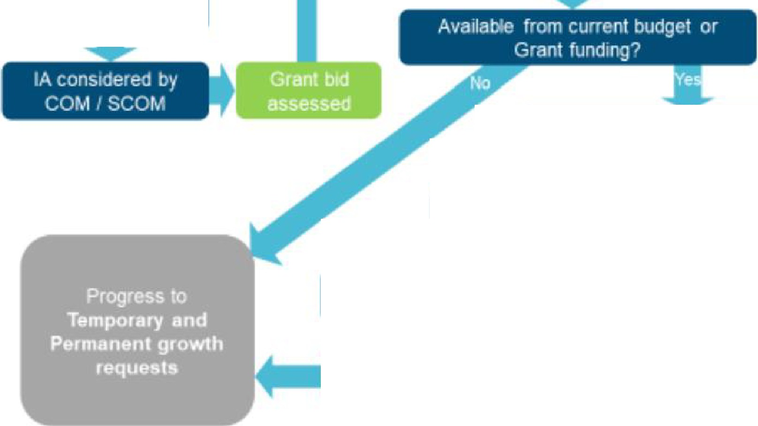


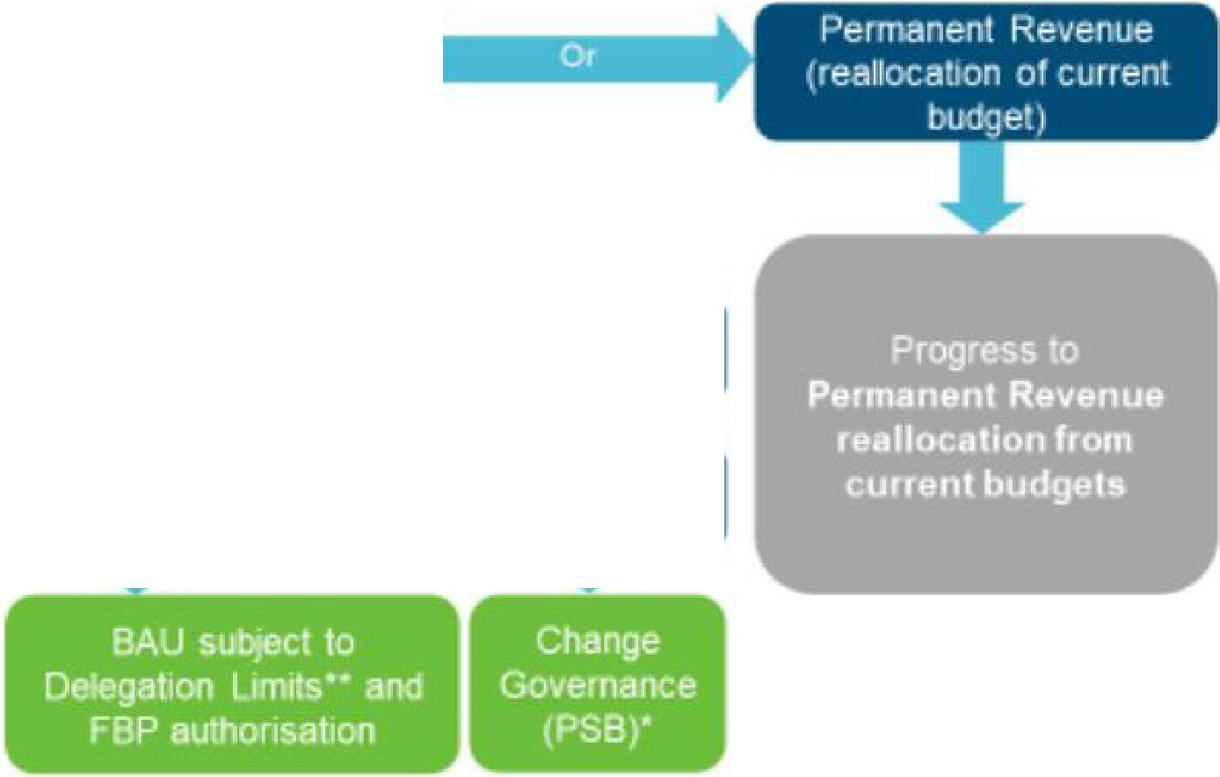
II II 111 11 I 11111111 Ii 11111
sud e Bumess Chan. • 
Bi bse u r
_ • S 1Qf I. .
(Change Work A.sses:sment procedure a
C:h - n , - Go..,e-ma111Jce - I' ·for r - - )

Temporary Re,1enue
for BAU or Change aci1vrty

Available lrom current ye.ar uniderspen<I
(temporary virements)

Underspend rec1um� One-o'lf underspend or Grant

Savings given via Tacllcal
Savings WorkJng Group
Underspends reviewed at Tactical
Sav,ings Worl<1ng Group

Summary ,of Au horisation Leve

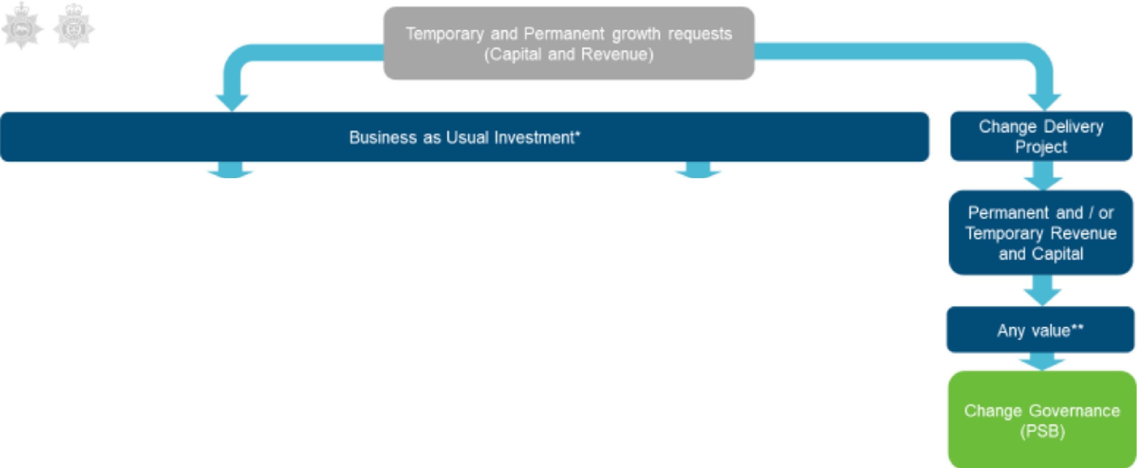
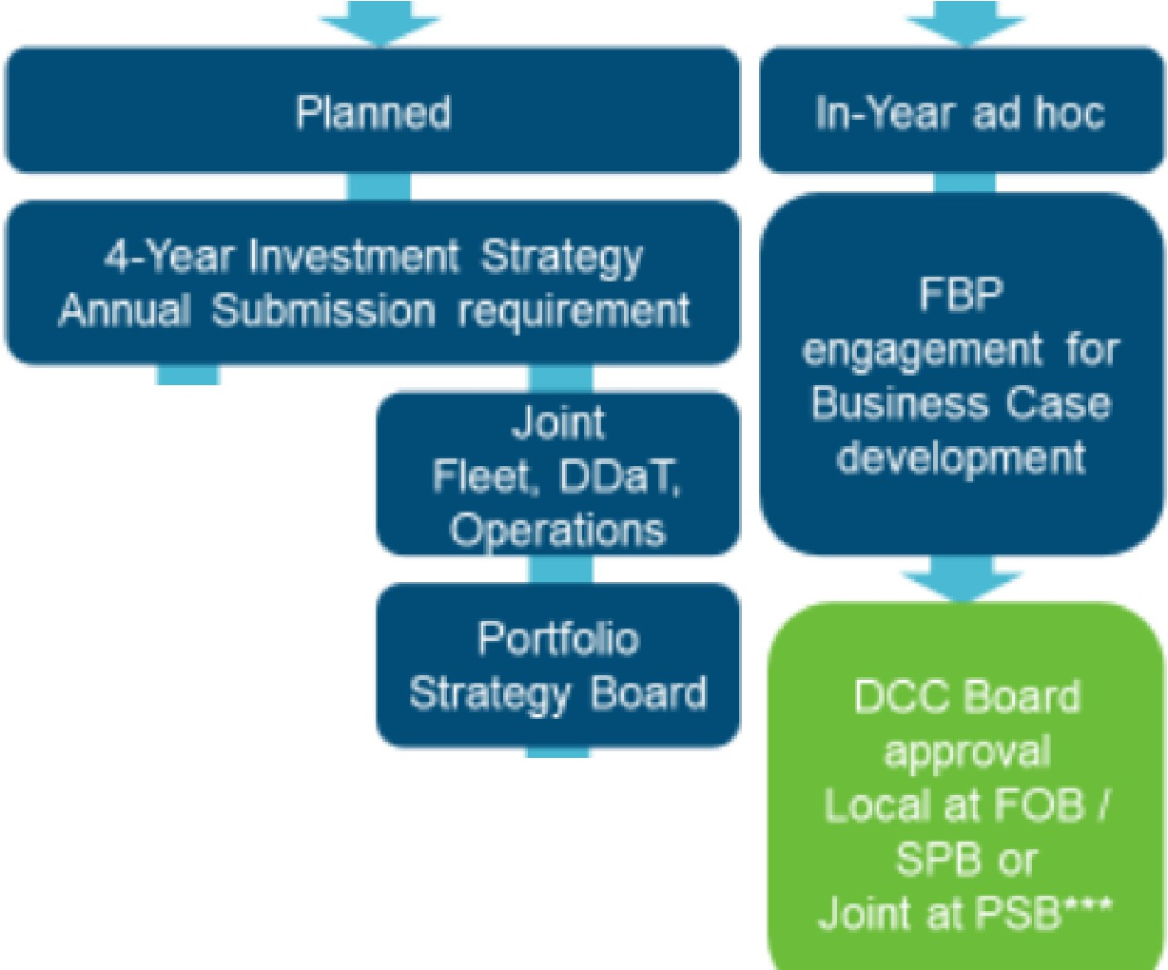
Capital
Revenue

Permanent and / or Tempo,rar�

Obl1gate<I Cos'ls ln-'Year ad hoc..

Estates I
-- --

Local Estates I
Boards
Annual Ull8voidable Costs
Bid process
(FBP supported)

DCC Board approval Local at F B or
Joint ,at Pse···
OB / SP

ver1·SOO

Annual

Capital Bid submission

(FBP supported)
. ion)
, or
re e ta 1,"M

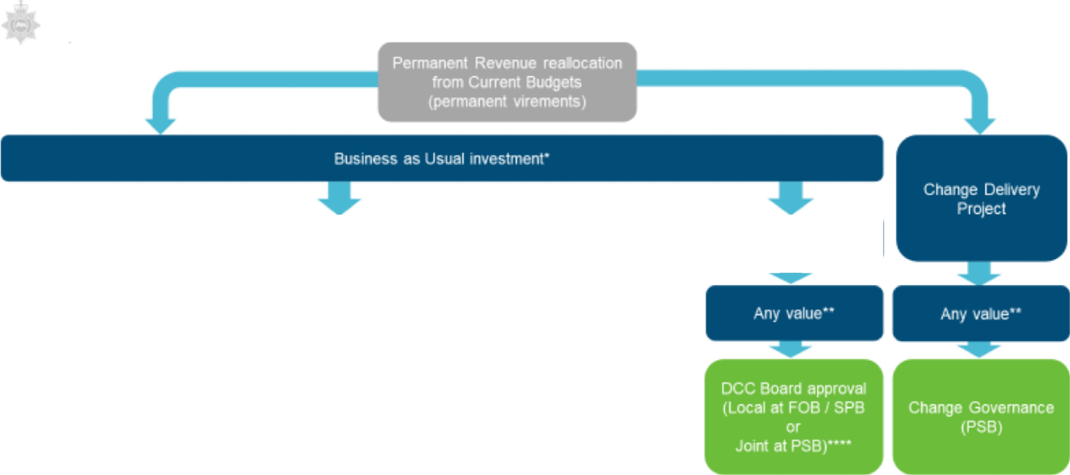
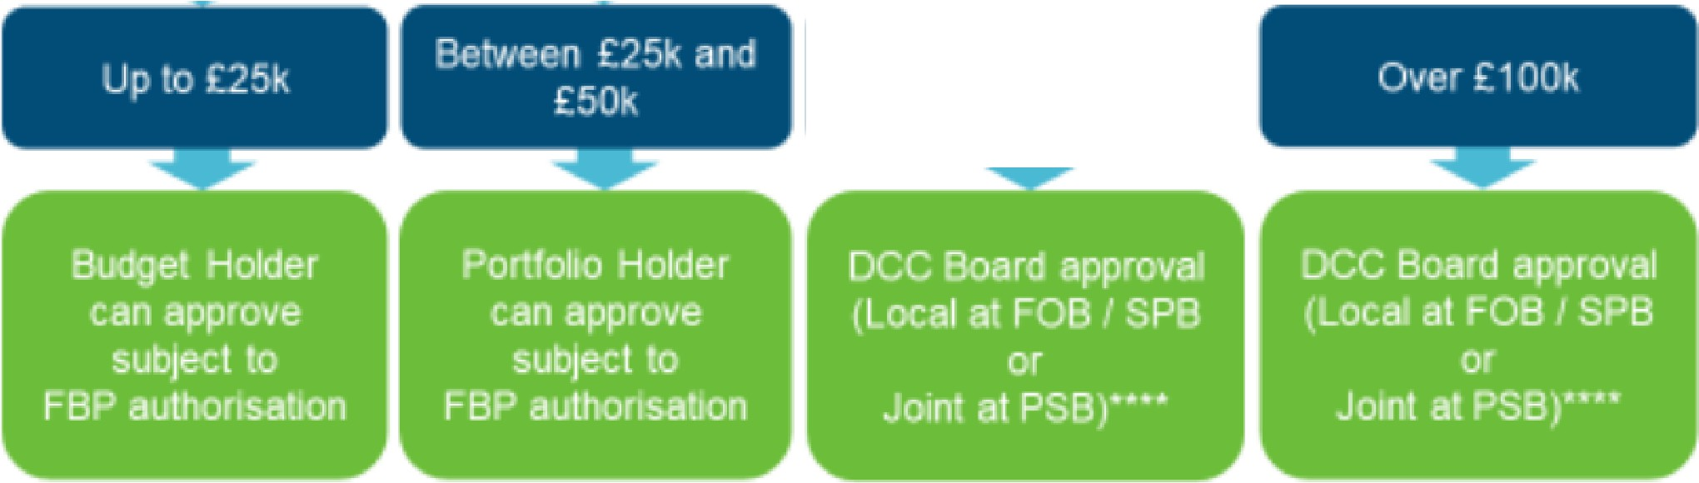
Noni-Pay and De4egaled Slaff Pay•u
Police Pay•0

and
Non-D�egated
Bel\'lleen £50k
£100k

Bud. e, iHI W __- _ _ _ _O!'I ro-1 Pdie"y
C _nt Reg
0

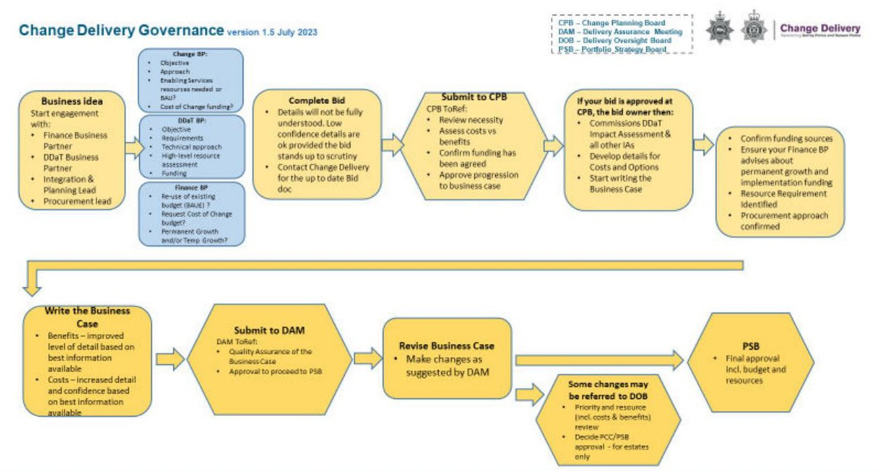
Chief Constables Scheme of Delegation (January 2026)

Appendix A (partial) for information



