


Capital Strategy

The Police and Crime Commissioner for Surrey

2026/27 – 2030/31

March 2026

Contents
1. INTRODUCTION 4
2. OBJECTIVES 4
3. CAPITAL EXPENDITURE - DEFINITION 5
4. CAPITAL VERSUS TREASURY MANAGEMENT INVESTMENTS 5
5. GOVERNANCE OF THE CAPITAL PROGRAMME 6
5.1 Governance process 6
6. LINKS TO OTHER CORPORATE STRATEGIES AND PLANS 7
7. THE CAPITAL BUDGET SETTING PROCESS 8
7.1 Introduction 8
7.2 Force Collaboration & Wider Sector Engagement. 8
7.3 Identifying Capital Expenditure / Investment Requirements 8
7.4 Affordability and Financial Planning. 9
7.5 Capital Sustainability 9
8. MONITORING OF THE CAPITAL PROGRAMME 13
9. FUNDING STRATEGY AND CAPITAL POLICIES 13
9.1 Government Grant 13
9.2 Capital Receipts 13
9.3 Revenue Funding 13
9.4 Prudential Borrowing 13
9.5 Reserves and balances 14
9.6 Third party capital contributions 14
9.7 Leasing 14
9.8 Procurement and Value for Money 15
10. PARTNERSHIPS AND RELATIONSHIPS WITH OTHER ORGANISATIONS 15
11. MANAGEMENT FRAMEWORK 16
12. RISK MANAGEMENT 16
12.1 Funding Capacity Risk 17
12.2 Credit Risk 17
12.3 Liquidity Risk 17
12.4 Interest Rate Risk 17
12.5 Exchange Rate Risk 18
12.6 Inflation Risk 18
12.7 Legal and Regulatory Risk 18
12.8 Fraud, Error and Corruption 18
13. OTHER CONSIDERATIONS 18
14. ECONOMIC BACKGROUND 19
15. Capital Programme 2026/27 – 2030/31 27
16. Funding Capital Programme 2026/27-2030/31 28

SURREY POLICE
CAPITAL STRATEGY

INTRODUCTION

The Chartered Institute of Public Finance and Accountancy (CIPFA) Prudential Code requires local authorities to produce a capital strategy to demonstrate that capital expenditure and investment decisions are taken in line with desired outcomes and take account of stewardship, value for money, prudence, sustainability and affordability.
The Capital Strategy is a key document for the Police and Crime Commissioner (PCC) and Surrey Police and forms part of the authority’s integrated revenue, capital and reserves planning. It provides a high level overview of how capital expenditure, capital financing and treasury management activity contribute to the delivery of desired outcomes. It also provides an overview of how associated risk is managed and the implications for future financial sustainability. It includes an overview of the governance processes for approval and monitoring of capital expenditure.
The Capital Programme is developed through a set governance route of approval. This will consist of a capital requirement owner producing a 5-year costed capital plan to set out the requirement, and/or individual business cases for specific capital projects. These will be scrutinised by finance for the purposes of financial planning and affordability, presented at the CFO Approval Board, before being submitted to the Force Organisation Board for Chief Officers approval. There will be two Capital Approval FOB Boards per year. There are three main areas which feature within the Capital Programme; Fleet, ICT and the Estate strategy, all have independent strategies in place which demonstrate the requirements from each individual area. Change Management and Operational Equipment will also have capital plans that are made up of the sum of the component part business cases.
Throughout this document the term Surrey is used to refer to the activities of both the PCC and the Force.

OBJECTIVES

The CIPFA Prudential and Treasury Management Codes (2021 edition) require that for 2026/27, all local authorities will produce a Capital Strategy Report, which will provide the following:

- a high-level long term overview of how capital expenditure, capital financing and treasury management activity contribute to the provision of services
- an overview of how the associated risk is managed
- the implications for future financial sustainability

The aim of this capital strategy is to ensure that the PCC fully understands the overall long-term policy objectives and resulting capital strategy requirements, governance procedures and risk appetite.
The key aims of the Capital Strategy are to:
- provide a clear set of objectives and a framework within statutory legislation that proposes new capital expenditure to be evaluated to ensure that all new capital investment is targeted at meeting the Force priorities;
- set out how the Force identifies, programmes and prioritises capital requirements and proposals arising from business plans submitted through a stringent gateway appraisal mechanism comprising of Business cases;
- consider options available for funding capital expenditure and how resources may be maximised to generate investment in the area and to determine an affordable and sustainable funding policy framework, whilst minimising the ongoing revenue implications of any such investment;
- identify the resources available for capital investment over the medium term finance plan planning period;
- ensure the strategy has an overall balance of risk on a range on investments over timespan, type of investment and rate of return;
- establish effective arrangements for the management of capital expenditure including the assessment of project outcomes, budget profiling, deliverability, value for money and security of investment, and,
- deliver projects that focus on delivering the long term benefits to policing in Surrey.

CAPITAL EXPENDITURE - DEFINITION

Capital expenditure is incurred on the acquisition/creation of assets, or expenditure that enhances/adds to the life or value of an existing fixed asset. Fixed assets are tangible or intangible assets that yield benefits to Surrey generally for a period of more than one year, e.g. land and buildings, ICT, business change programmes, equipment, and vehicles. This contrasts with revenue expenditure which is spending on the day to day running costs of services such as employee costs and supplies and services.
The capital programme is Surrey’s plan of capital works for future years, including details on the funding of the schemes.

CAPITAL VERSUS TREASURY MANAGEMENT INVESTMENTS

Treasury Management investment activity covers those investments which arise from the organisation’s cash flows and debt management activity, and ultimately represent balances which need to be invested until the cash is required for use in the course of business.
For Treasury Management investments the security and liquidity of funds are placed ahead of the investment return. The management of associated risk is set out in the Annual Treasury Management Strategy Statement.
The CIPFA Treasury Management Code recognises that some local authorities are entitled to make investments for policy reasons outside of normal treasury management activity. These may include service and commercial investments. However, like all police forces in England and Wales, Surrey Police does not have a General Power of Competence, which gives councils the power to do anything an individual can do provided it is not prohibited by other legislation. As such, Surrey Police is prevented from entering commercial investment activities.

GOVERNANCE OF THE CAPITAL PROGRAMME

Governance process
Governance processes are in place along with contract standing orders and financial regulations to ensure that available resources are allocated optimally and deliver value for money, and that capital programme planning is determined in parallel with the service and revenue budget planning process within the framework of the Medium-Term Financial Plan. These include:
- The PCC is ultimately responsible for approving the overall Capital Budget. Although this is included in the annual Precept Proposal presented to the Surrey Police and Crime Panel this is for information only.
- The Portfolio Strategy Board (PSB) reviews and approves joint force (in collaboration with Sussex) business cases for all change delivery projects where funding has been identified (ie from the change management reserve) or is already included in the revenue and capital budgets. Recurring capital projects such as IT replacement programmes, vehicle replacement programme and operational equipment programme will be approved in line with their capital plans and strategies.(PSB Board replaces “Strategic Change Board”)

- The CFO Board oversees and scrutinises business cases for capital investment and 5-year rolling capital strategies ahead of approval.

The Surrey Deputy Chief Constables Force Organisational Board (FOB) will approve the Surrey capital strategies and plans each year, and any individual capital business case for Surrey only requirements prior to being submitted to the PCC for approval.

- The PCC Estates Board enables the Police & Crime Commissioner (PCC) to develop strategies for estates and facilities management, to monitor progress and ensure that it is delivering value for money and effectively supporting an estate provision, for the delivery of local policing, (also regional policing and national eg ROCU and CT etc) in accordance with the approved governance framework. Also work in partnership with other public sector and blue light as per legislation. It also enables the monitoring of the MOU Estates which states - The provision of services by individuals within the Estates Department to enable the Commissioner to effectively and efficiently manage the land and premises and other fixed assets remaining in the PCC’s ownership/control, including office services, asset and facilities management, estate management (including identifying savings, environmental issues, maintenance and improvements); project management (including the delivery of capital and revenue funded works) and the management of any contractual arrangements associated with these activities.

LINKS TO OTHER CORPORATE STRATEGIES AND PLANS

The PCC produces her Police and Crime Plan, the current version covers the period 2025-2028.
Police and Crime Plan | Police & Crime Commissioner for Surrey
The Chief Constable of Surrey launched “our plan” in 2023 to complement the Police and Crime Plan.
Our Plan | Surrey Police
To support these overarching documents a number of interrelated strategies and plans are in place, such as Medium Term Financial Plan which includes the capital programme, the Capital Strategy, Treasury Management and Annual Investment Strategy.
The operation of all these strategies and plans is underpinned by the Scheme of Governance which shows how the OPCC and the Chief Constable comply with the principles of ‘good governance’ and sets out the arrangement in place for effective governance and financial management. The Scheme of Governance comprises:
- Surrey Code of Corporate Governance: This describes how the PCC and Chief Constable achieve the core principles of ‘good governance’.
- Framework of Decision-Making and Accountability: This describes how the PCC will make/publish key decisions and fulfil his/her responsibilities to hold the Chief Constable to account. It also sets out the role of the Audit Committee.
- Surrey-Sussex PCC Scheme of Delegation: This sets out the key roles of the PCC/Chief Constable and those functions they delegate to others.
- Memorandum of Understanding (MOU): The MOU describes how the PCC and Chief Constable will work together and ensure sufficient support in areas such as estates management, procurement, finance, HR, communications and corporate development.
- Financial Regulations: These set out the framework for managing the PCC’s financial affairs.
- Contract Standing Orders: These describe the rules for the procurement of goods, works and services. Contracts are issued in the name of the PCC and the Chief Constable operates within the parameters of Contract Standing Orders.

THE CAPITAL BUDGET SETTING PROCESS

Introduction
Surrey Police is committed to rolling medium term revenue & capital plans that usually extend for 4 years, setting out the anticipated level of expenditure and the associated funding. The plans are drawn up, reassessed and extended annually and, if required, re-prioritised to enable the aims and objectives established in the Force Business Plan to be achieved, along with the Force Commitment to support national drivers like the National Policing Vision for 2026.
The Medium Term Financial Plan provides the infrastructure and major assets through capital investment, enabling Surrey Police to strengthen and streamline core assets and systems, and provides the framework for delivering innovative policing with a lower resource profile.
Key focuses of the Capital Programme:
- To ensure the estate remains fit for purpose, identifying opportunities to streamline assets and develop the estate infrastructure; maintaining core sites and progressing the Estate Strategy.
- To ensure provision is made for ICT & Business Change Technology to maintain and develop the existing infrastructure and invest in the core technologies required to provide innovative digital policing services, as per the ICT Strategy.
- To ensure provision is made for transport within the Joint Transport service across Surrey and Sussex as per the Joint Transport Services Asset Management Plan.
- The maintenance and replacement of other core assets where necessary, e.g. communication infrastructure.
The plan acknowledges the financial position of Surrey Police and maximises both the available financial resources and the capacity that Surrey has to manage change projects.

Force Collaboration & Wider Sector Engagement.
Although Surrey Police has its own Capital Strategy and Medium Term Financial Plan the natural drivers that encourage local and regional forces to collaborate, such as cost and resource sharing, along with structured collaborations and national plans, can have a significant influence on local decision making.
One of the focal points therefore of the Surrey Capital Strategy is to acknowledge regional and national partnership working, both with other forces and in a the wider context of engagement with Local Authorities & Councils, and other Emergency Services, to improve overall service to the public.

Identifying Capital Expenditure / Investment Requirements
The capital programme is supported by the respective strategies for the Estate, Fleet, ICT and business led requirements. The revenue impact of any such proposals are also included in the medium term financial planning model where the revenue account, if necessary, is charged with corresponding interest payable and “minimum revenue provision” costs when borrowing is required.

Affordability and Financial Planning.
The overall financial position of Surrey Police and hence the scope for future capital expenditure, must take into consideration the combination of the revenue budget, capital programme as well as the position on reserves. The revenue and capital budget positions are intertwined as achieving the Surrey priorities may require revenue expenditure or investment in capital items, depending on what is needed, and one impacts the other.
The revenue Medium Term Financial Plan will identify the potential financial position for Surrey for the next four years and will include forecasts on inflation, committed growth requirements, forecast productivity and efficiency savings, assumptions around grant and council tax funding and any other information introduced during the budget process.
The revenue position influences the capital position in terms of potential affordability of support for Direct Revenue Financing (DRF) of Capital Expenditure or debt charges, both interest and MRP (for external borrowing) whereas the capital bid process influences the revenue position in terms of both revenue consequences of capital programmes and also the requirement to financially support capital investment, either through DRF or external borrowing.
The extent to which the annual revenue budget, through the 4 year forecast, is expected to be able to support the capital programme is a key factor to overall financial planning and is becoming more so as other sources of funding cease to be available. No capital funding is provided by Government to maintain the Forces assets.

Capital Sustainability
The Capital Receipts Reserve contains receipts from the sale of assets which can be used to finance future capital expenditure. Receipts from the sale of property are ringfenced to fund the Surreys Estates program. Other Capital Receipts received in-year will be applied to fund capital expenditure in year.
As we move forward through the next 4 years and beyond, there will be a move away from funding of the capital programme through use of accumulate reserves and into a position of funding through either DRF and external borrowing for specific projects.
The capital financing approach remains to maximise the use of Capital Receipts to support the capital programme whilst maximising the overall benefit in underpinning the Revenue budget.
The strategy is focused around the type of asset that needs to be financed, with the aim that short life assets such as vehicles and IT will be financed from DRF whereas long life assets such as buildings, where necessary, are financed by borrowing. Any borrowing though has to be affordable in that both interest and MRP have to be covered.
The Surrey Police Strategy is therefore to invest in core infrastructure now that will not only offer overall service improvements to the public, but also maximise revenue savings into the future through more efficient and mobile use of police personnel, enabled by improved Information and Communication Technology systems and other core infrastructure, for example, a connected vehicle fleet and building assets.
The Surrey strategy will also be influenced by and take account of national visions for policing, regional and local priorities.

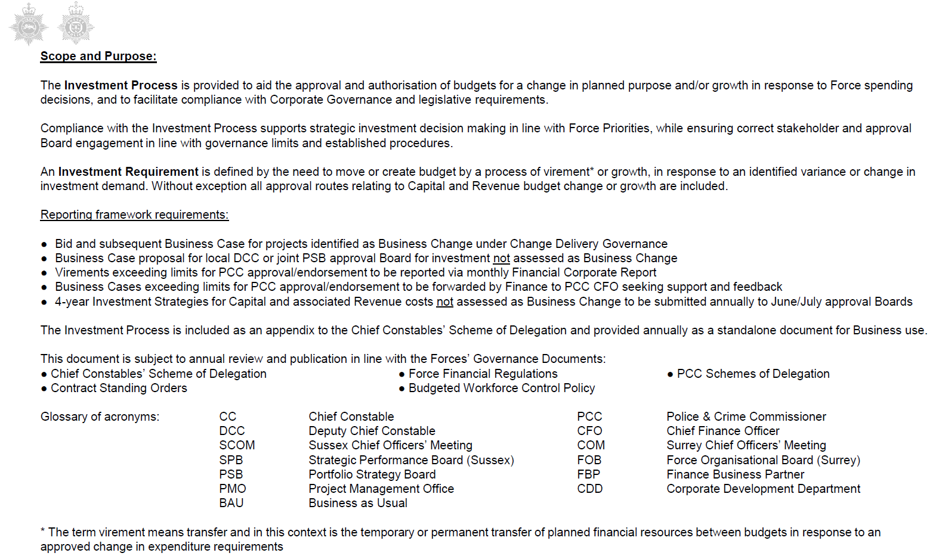

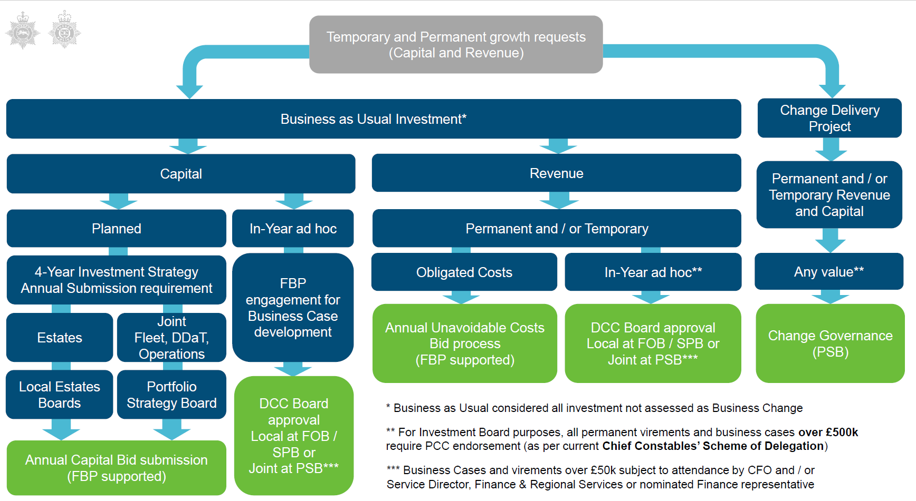

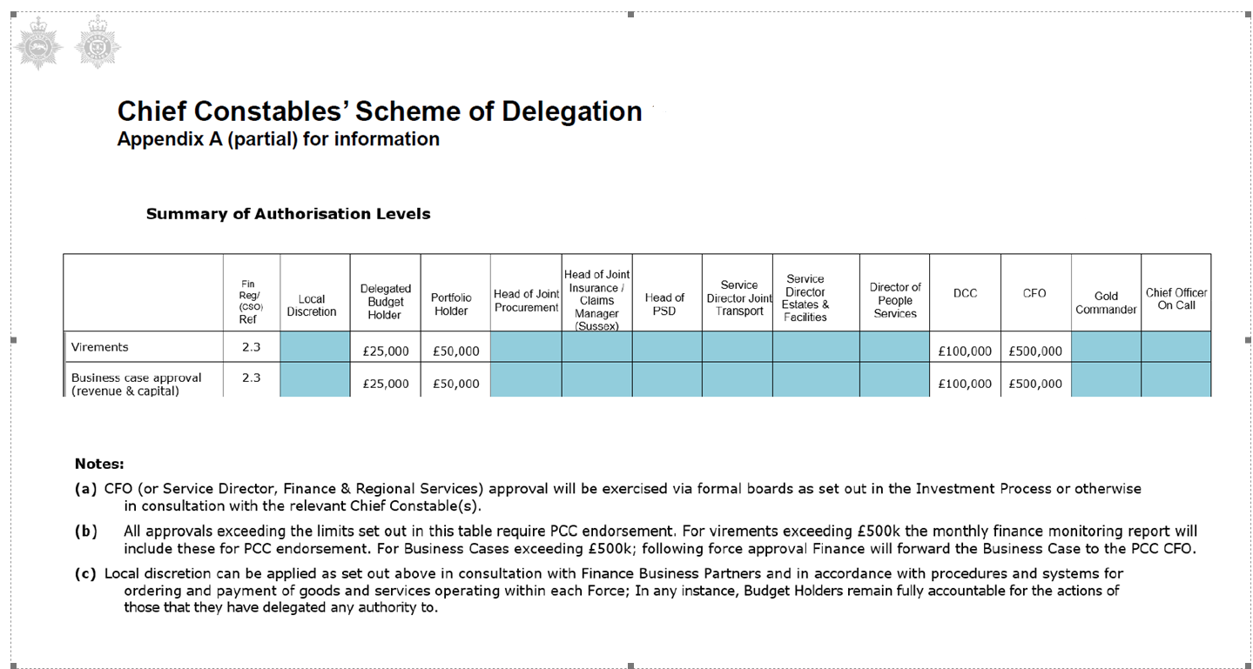

MONITORING OF THE CAPITAL PROGRAMME

Capital monitoring reports are submitted to both the Chief Constables Management Team and the PCC on a regular basis throughout the year. These reports are based on the most recently available financial information, showing spending to date and compare projected expenditure with the approved capital budget.
The Force request the PCC to approve the carry forward any capital budget slippage which is presented as a two year programme. This enables the Force to run a flexible programme allowing schemes to be deferred where there are genuine reasons for a delay, and also allows schemes that have made good progress to bring forward future allocations into the current year.

FUNDING STRATEGY AND CAPITAL POLICIES

This section sets out Surrey policies and priorities in relation to funding capital expenditure and investment.

Government Grant
The Government has ceased providing an annual grant to support the capital and investment programme from 2022/23. Hence Forces are responsible for funding their own capital requirements.

Capital Receipts
A capital receipt is an amount of money which is received from the sale of an item on the fixed asset register. They cannot be spent on revenue items and are used to help finance the capital programme. As the pool of assets available for sale declines the financial support from these receipts will diminish (see 7.5 Capital Sustainability).

Revenue Funding
Recognising that the pool of assets available for sale is declining direct revenue contribution is seen as a sustainable funding alternative. An appropriate provision for this is included in both the annual revenue budget and the medium term financial plan. As Surrey moves forward this is understood to become the limiting factor for capital investment as it balances annual revenue funding priorities with long term capital investment strategies.

Prudential Borrowing
Local Authorities, including the Police, can set their own borrowing levels based on their capital needs and their ability to pay for the borrowing. The levels will be set by using the indicators and factors set out in the Prudential Code. The borrowing costs are not supported by the Government so Surrey Police needs to ensure it can fund the repayment costs. The Surrey Minimum Revenue Provision Statement sets out a prudent approach to the amount set aside for the repayment of debt.

Reserves and balances
Unspent capital grant and capital receipt monies can be carried forward in the Balance Sheet until they are required to fund the capital programme.
Surrey has also set aside earmarked revenue reserves to help fund capital expenditure, most notably the PCC Estate Strategy Reserve.
HM Treasury guidance on capital projects recognises that there is a potential for projects costs to exceed the initial assessment. This is called Optimism Bias and relates to any project type, although it can have a particularly high impact when relating to the development of complex ICT or business change programmes. Surrey Police does not currently have an Optimism Bias Reserve but may consider this in the future.

Third party capital contributions
On occasion Surrey will receive income from a third party (usually a local authority) who have agreed to contribute towards an asset (e.g. ANPR cameras) that Surrey will own.

Leasing
Surrey may enter into finance leasing agreements to fund capital expenditure. However, a full option appraisal and comparison of other funding sources must be made and both the Chief Constable’s Chief Finance Officer (CFO) and the PCC’s Chief Finance Officer (CFO) must be satisfied that leasing provides the best value for money method of funding the scheme before a recommendation is made to the PCC.
Under the Prudential Code finance leasing agreements are counted against the overall borrowing levels when looking at the prudence of the authority’s borrowing.

IFRS 16 Leases

The major change is that under IFRS 16 there will no longer be any distinction between operating and finance leases in the financial statements of lessees.
Currently, local authorities account for an item as an operating lease if most of the risks and rewards have not transferred to them. In this case, they simply record a rental expense on a straight-line basis over the lease term, with no long-term asset or liability recorded. This accounting treatment will cease to exist, except in the case of low-value items, or for short-term leases (under 12 months).
This means that local authorities will be required to include a right-of-use asset and an equivalent liability, at the present value of lease payments.
For many local authorities, this will mean that a significant amount of assets and liabilities that were previously not recorded and shown only in the lease commitments disclosure note will now be included in the statement of financial position.

The standard has no impact on the actual cash flows of the Surrey PCC. However the standard requires the capitalisation, and subsequent depreciation of costs that are currently expenses as paid which impacts disclosures of cash flows within the cash flow statement. The amounts currently expensed as operating cash outflows which will instead be capitalised are presented are financing cash outflows.
The introduction of the IFRS 16 lease accounting standard in April 24 increased the level of assets and liabilities, therefore increases will be required for the capital finance requirement, the operational boundary, the authorised limit and the ratio of financing costs to net revenue stream.
The re-measurement of lease liabilities for changes in inflation and the expected term are counted as capital expenditure in the near future. The capital programme budget will therefore need to be adjusted for the estimated cost of this expenditure in 2026/27.

Procurement and Value for Money

Procurement is the purchase of goods and services. Surrey has a Procurement Department that ensures that all contracts, including those of a capital nature, are legally compliant and best value for money.
It is essential that all procurement activities comply with prevailing regulations and best practice as set out in the Scheme of Governance, which includes Contract Standing Orders and Financial Regulations. Guidance on this can be sought from the Procurement team.
The main aim is to hold ‘value for money’ as a key goal in all procurement activity to optimise the combination of cost and quality.

PARTNERSHIPS AND RELATIONSHIPS WITH OTHER ORGANISATIONS

Wherever possible and subject to the usual risk assessment process Surrey will look to expand the number of capital schemes which are completed on a partnership basis and continually look for areas where joint projects can be implemented. In support of this initiative:
- Surrey has a joint ICT Department with Sussex Police and a number of ICT and business change programmes are being delivered collaboratively.

- Other capital schemes, most notably new technology programmes, are being delivered across the SE region is support of the SE Regional Information Technology Programme (SERIP) strategy.

MANAGEMENT FRAMEWORK

The PCC owns all assets, including short life assets, such as ICT, equipment and vehicles.
Although the PCC owns all land and buildings, on a day to day basis, the Head of Property or equivalent role, manages the estate on their behalf.
The Chief Constable’s CFO manages the medium term capital plan and the annual capital budget and provides regular updates to the Finance Planning and Performance Board who, collectively, maintain oversight of planned expenditure.
The PCC’s CFO is responsible for developing and then implementing the Treasury Management Strategy Statement, which includes the Annual Investment Strategy.
Having approved the medium term capital plan and the annual capital budget in February each year the PCC formally holds the Chief Constable to account for delivery of capital projects.

RISK MANAGEMENT

The PCC’s Treasury Strategy and investment policy has regard to the following to manage risk:
- MHCLG’s Guidance on Local Government Investments (“the Guidance”)
- CIPFA Treasury Management in Public Services Code of Practice and Cross Sectoral Guidance Notes 2017 (“the Code”)
- CIPFA Treasury Management Guidance Notes 2018

The PCC’s investment priorities will be security first, liquidity second, then yield (return).
Risk is the threat that an event or action will adversely affect Surrey’s ability to achieve its desired outcomes and to execute its strategies successfully.
Risk management is the process of identifying risks, evaluating their potential consequences and determining the most effective methods of managing them and/or responding to them. It is both a means of minimising the costs and disruption to the organisation caused by undesired events and of ensuring that staff understand and appreciate the element of risk in all their activities.
The aim is to reduce the frequency of adverse risk events occurring (where possible), minimise the severity of their consequences if they do occur, or to consider whether risk can be transferred to other parties. The corporate risk register sets out the key risks to the successful delivery of Surrey’s corporate aims and priorities and outlines the key controls and actions to mitigate and reduce risks, or maximise opportunities.
To manage risk effectively, the risks associated with each capital project need to be systematically identified, analysed, influenced and monitored.
It is important to identify the appetite for risk by each scheme and for the capital programme as a whole, especially when investing in complex and costly business change programmes.
Surrey Police accepts there will be a certain amount of risk inherent in delivering the desired outcomes of Police and Crime Plan and will seek to keep the risk of capital projects to a low level whilst making the most of opportunities for improvement. Where greater risks are identified as necessary to achieve desired outcomes, Surrey will seek to mitigate or manage those risks to a tolerable level. All key risks identified as part of the capital planning process are considered for inclusion in the corporate risk register.
The Chief Constable’s CFO and the PCC’s CFO will report jointly on the deliverability, affordability and risk associated with this Capital Strategy and the associated capital programme. Where appropriate they will have access to specialised advice to enable them to reach their conclusions.

Funding Capacity Risk
This is the risk that identified project costs are either understated or escalate during the project lifecycle, for example if project scope changes. This risk is mitigated as far as possible by the identified monitoring process and controls.

Credit Risk
This is the risk that the organisation with which we have invested capital monies becomes insolvent and cannot complete the agreed contract. Accordingly, Surrey will ensure that robust due diligence procedures cover all external capital investment. Where possible contingency plans will be identified at the outset and enacted when appropriate.

Liquidity Risk
This is the risk that the PCC might not have funds available to meet its commitments to make contracted payments on time or that the timing of any cash inflows from a project will be delayed, for example if other organisations do not make their contributions when agreed. This is also the risk that the cash inflows will be less than expected, for example due to the effects of inflation, interest rates or exchange rates.
The PCC manages its liquidity position through the risk management procedures above (the setting and approval of prudential indicators and the approval of the Treasury and Investment Strategy reports), as well through a comprehensive cash flow management system, as required by the Code of Practice. This seeks to ensure that cash is available when it is needed.
Whilst the Public Works Loan Board provides access to longer term funds, it also acts as a lender of last resort to authorities (although it will not provide funding to an Authority or PCC whose actions are unlawful nor will it lend for revenue expenditure). The PCC is also required to provide a balanced budget through the Local Government Finance Act 1992, which ensures sufficient monies are raised to cover annual expenditure. There is therefore no significant risk that it will be unable to raise finance to meet its commitments under financial instruments.

Interest Rate Risk
This is the risk that interest rates will move in a way that has an adverse effect on the value of capital expenditure or the expected financial returns from a project. Interest rates will be reviewed as part of the ongoing monitoring arrangements to identify such adverse effects. As far as possible our exposure to this risk will be mitigated via robust contract terms and when necessary contract re-negotiations.
There is also a risk that external interest rates will rise which may impact on the cost of borrowing externally. This risk will be managed by the Chief Constable’s CFO and PCC’s CFO by reviewing interest rates when borrowing is required and consult with Treasury Management advisors when required. Interest rate risk on borrowing can be mitigated by fixing rates at the date of inception

Exchange Rate Risk
This is the risk that exchange rates will move in a way that has an adverse effect on the value of capital expenditure or the expected financial returns from a project. Where relevant, exchange rates will be reviewed as part of the ongoing monitoring arrangements to identify such adverse effects. As far as possible our exposure to this risk will be mitigated via robust contract terms and when necessary contract re-negotiations to ensure costs are all denominated in sterling.

Inflation Risk
This is the risk that rates of inflation will move in a way that has an adverse effect on the value of capital expenditure or the expected financial returns from a project. Rates of inflation will be reviewed as part of the ongoing monitoring arrangements to identify such adverse effects. As far as possible our exposure to this risk will be mitigated via robust contract terms and when necessary contract re-negotiations. This could include allowances for inflation and contingencies built in to capital estimates

Legal and Regulatory Risk
This is the risk that changes in laws or regulation make a capital project more expensive or time consuming to complete, make it no longer cost effective or make it illegal or not advisable to complete. Before entering into capital expenditure or making capital investments, Surrey will understand the powers under which the investment is made. Forthcoming changes to relevant laws and regulations will be kept under review and factored into any capital bidding and programme monitoring processes.

Fraud, Error and Corruption
This is the risk that financial losses will occur due to errors or fraudulent or corrupt activities. Officers involved in any of the processes around capital expenditure or funding are required to follow the agreed Code of Corporate Governance. Surrey has a strong ethical culture which is evidenced through our values, principles and appropriate behaviour. This is supported by the national Code of Ethics and detailed policies such as Anti-Fraud and Corruption and Declaration of Interests. In addition internal and external audit conduct sudits of systems and controls and report back to management on their findings

OTHER CONSIDERATIONS
Capital Schemes must comply with legislation, such as the Disability Discrimination Act, the General Data Protection Regulations (GDPR), building regulations etc.

ECONOMIC BACKGROUND

- The first half of 2025/26 saw:
- A 0.3% pick up in GDP for the period April to June 2025. More recently, the economy flatlined in July, with higher taxes for businesses restraining growth, but picked up to 0.1% m/m in August before falling back by 0.1% m/m in September.
- The 3m/yy rate of average earnings growth excluding bonuses has fallen from 5.5% to 4.6% in September.
- CPI inflation has ebbed and flowed but finished September at 3.8%, whilst core inflation eased to 3.5%.
- The Bank of England cut interest rates from 4.50% to 4.25% in May, and then to 4% in August (and subsequently to 3.75% in December).
- The 10-year gilt yield fluctuated between 4.4% and 4.8%, ending the half year at 4.70% (before falling back to 4.43% in early November).
- From a GDP perspective, the financial year got off to a bumpy start with the 0.3% m/m fall in real GDP in April as front-running of US tariffs in Q1 (when GDP grew 0.7% on the quarter) weighed on activity. Despite the underlying reasons for the drop, it was still the first fall since October 2024 and the largest fall since October 2023. However, the economy surprised to the upside in May and June so that quarterly growth ended up 0.3% q/q (subsequently revised down to 0.2% q/q). Nonetheless, the 0.0% m/m change in real GDP in July, followed by a 0.1% m/m increase in August and a 0.1% decrease in September will have caused some concern. GDP growth for 2025 - 2028 is currently forecast by the Office for Budget Responsibility to be in the region of 1.5%.
- Sticking with future economic sentiment, the composite Purchasing Manager Index (PMI) for the UK increased to 52.2 in October. The manufacturing PMI output balance improved to just below 50 but it is the services sector (52.2) that continues to drive the economy forward. Nonetheless, the PMIs suggest tepid growth is the best that can be expected in the second half of 2025 and the start of 2026. Indeed, on 13 November we heard that GDP for July to September was only 0.1% q/q.
- Turning to retail sales volumes, and the 1.5% year-on-year rise in September, accelerating from a 0.7% increase in August, marked the highest gain since April. On a monthly basis, retail sales volumes rose 0.5%, defying forecasts of a 0.2% fall, following an upwardly revised 0.6% gain in August. Household spending remains surprisingly resilient, but headwinds are gathering.

- Prior to the November Budget, the public finances position looked weak. The £20.2 billion borrowed in September was slightly above the £20.1 billion forecast by the OBR. For the year to date, the £99.8 billion borrowed is the second highest for the April to September period since records began in 1993, surpassed only by borrowing during the COVID-19 pandemic. The main drivers of the increased borrowing were higher debt interest costs, rising government running costs, and increased inflation-linked benefit payments, which outweighed the rise in tax and National Insurance contributions.

- Following the 26 November Budget, the Office for Budget Responsibility (OBR) calculated the net tightening in fiscal policy as £11.7bn (0.3% of GDP) in 2029/30, smaller than the consensus forecast of £25bn. It did downgrade productivity growth by 0.3%, from 1.3% to 1.0%, but a lot of that influence was offset by upgrades to its near-term wage and inflation forecasts. Accordingly, the OBR judged the Chancellor was going to achieve her objectives with £4.2bn to spare. The Chancellor then chose to expand that headroom to £21.7bn, up from £9.9bn previously.

- Moreover, the Chancellor also chose to raise spending by a net £11.3bn in 2029/30. To pay for that and the increase in her headroom, she raised taxes by £26.1bn in 2029/30. The biggest revenue-raisers were the freeze in income tax thresholds from 2028/29 (+£7.8bn) and the rise in NICs on salary-sacrifice pension contributions (+£4.8bn). The increase in council tax for properties worth more than £2.0m will generate £0.4bn.

- The weakening in the jobs market looked clear in the spring. May’s 109,000 m/m fall in the PAYE measure of employment was the largest decline (barring the pandemic) since the data began and the seventh in as many months. The monthly change was revised lower in five of the previous seven months too, with April’s 33,000 fall revised down to a 55,000 drop. More recently, however, the monthly change was revised higher in seven of the previous nine months by a total of 22,000. So instead of falling by 165,000 in total since October, payroll employment is now thought to have declined by a smaller 153,000. Even so, payroll employment has still fallen in nearly all the months since the Chancellor announced the rises in National Insurance Contributions (NICs) for employers and the minimum wage in the October 2024 Budget. The number of job vacancies in the three months to November 2025 stood at 729,000 (the peak was 1.3 million in spring 2022). All this suggests the labour market continues to loosen, albeit at a slow pace.

- A looser labour market is driving softer wage pressures. The 3m/yy rate of average earnings growth excluding bonuses has fallen from 5.5% in April to 4.6% in September (still at that level in November). The rate for the private sector has slipped just below 4% as the year end approaches.

- CPI inflation remained at 3.8% in September but dropped to 3.2% by November. Core inflation also fell to 3.2% by November while services inflation fell to 4.4%. Nonetheless, a further loosening in the labour market and weaker wage growth may be a requisite to UK inflation coming in below 2.0% by 2027.
- An ever-present issue throughout recent months has been the pressure being exerted on medium and longer dated gilt yields. The yield on the 10-year gilt moved sideways in the second quarter of 2025, rising from 4.4% in early April to 4.8% in mid-April following wider global bond market volatility stemming from the “Liberation Day” tariff announcement, and then easing back as trade tensions began to de-escalate. By the end of April, the 10-year gilt yield had returned to 4.4%. In May, concerns about stickier inflation and shifting expectations about the path for interest rates led to another rise, with the 10-year gilt yield fluctuating between 4.6% and 4.75% for most of May. Thereafter, as trade tensions continued to ease and markets increasingly began to price in looser monetary policy, the 10-year yield edged lower, and ended June at 4.50%.
- More recently, the yield on the 10-year gilt rose from 4.46% to 4.60% in early July as rolled-back spending cuts and uncertainty over Chancellor Reeves’ future raised fiscal concerns. Although the spike proved short lived, it highlighted the UK’s fragile fiscal position. In an era of high debt, high interest rates and low GDP growth, the markets are now more sensitive to fiscal risks than before the pandemic. During August, long-dated gilts underwent a particularly pronounced sell-off, climbing 22 basis points and reaching a 27-year high of 5.6% by the end of the month. While yields have since eased back, the market sell-off was driven by investor concerns over growing supply-demand imbalances, stemming from unease over the lack of fiscal consolidation and reduced demand from traditional long-dated bond purchasers like pension funds. For 10-year gilts, by late September, sticky inflation, resilient activity data and a hawkish Bank of England kept yields elevated over 4.70% although by late December had fallen back again to a little over 4.50%.
- The FTSE 100 fell sharply following the “Liberation Day” tariff announcement, dropping by more than 10% in the first week of April - from 8,634 on 1 April to 7,702 on 7 April. However, the de-escalation of the trade war coupled with strong corporate earnings led to a rapid rebound starting in late April. As a result, the FTSE 100 ended June at 8,761, around 2% higher than its value at the end of March and more than 7% above its level at the start of 2025. Since then, the FTSE 100 has enjoyed a further 4% rise in July, its strongest monthly gain since January and outperforming the S&P 500. Strong corporate earnings and progress in trade talks (US-EU, UK-India) lifted share prices and the index hit a record 9,321 in mid-August, driven by hopes of peace in Ukraine and dovish signals from Fed Chair Powell. September proved more volatile and the FTSE 100 closed September at 9,350, 7% higher than at the end of Q1 and 14% higher since the start of 2025. Future performance will likely be impacted by the extent to which investors’ global risk appetite remains intact, Fed rate cuts, resilience in the US economy, and AI optimism. A weaker pound will also boost the index as it inflates overseas earnings. In early November, the FTSE100 climbed to a record high just above 9,900. By late December, the index had clung on to most of those gains standing at 9,870 on 23 December

MPC meetings: 8 May, 19 June, 7 August, 18 September, 6 November, 22 December 2025
- There were six Monetary Policy Committee (MPC) meetings held between April and December. In May, the Committee cut Bank Rate from 4.50% to 4.25%, while in June policy was left unchanged. In June’s vote, three MPC members (Dhingra, Ramsden and Taylor) voted for an immediate cut to 4.00%, citing loosening labour market conditions. The other six members were more cautious, as they highlighted the need to monitor for “signs of weak demand”, “supply-side constraints” and higher “inflation expectations”, mainly from rising food prices. By repeating the well-used phrase “gradual and careful”, the MPC continued to suggest that rates would be reduced further.
- In August, a further rate cut was implemented. However, a 5-4 split vote for a rate cut to 4% laid bare the different views within the Monetary Policy Committee, with the accompanying commentary noting the decision was “finely balanced” and reiterating that future rate cuts would be undertaken “gradually and carefully”. Ultimately, Governor Bailey was the casting vote for a rate cut but with the CPI measure of inflation expected to reach at least 4% later this year, the MPC was wary of making any further rate cuts until inflation begins its slow downwards trajectory back towards 2%.
- With wages still rising by just below 5%, it was no surprise that the September meeting saw the MPC vote 7-2 for keeping rates at 4% (Dhingra and Taylor voted for a further 25bps reduction). Moreover, the Bank also took the opportunity to announce that they would only shrink its balance sheet by £70bn over the next 12 months, rather than £100bn. The repetition of the phrase that “a gradual and careful” approach to rate cuts is appropriate suggested the Bank still thought interest rates will fall further.
- At the 6 November meeting, Governor Bailey was once again the deciding vote, keeping Bank Rate at 4% but hinting strongly that a further rate cut was imminent if data supported such a move. By 22 December, with November CPI inflation having fallen to 3.2%, and with Q2 GDP revised down from 0.3% q/q to only 0.2% q/q, and Q3 GDP stalling at 0.1%, the MPC voted by 5-4 to cut rates further to 3.75%. However, Governor Bailey made it clear that any further reductions would require strong supporting data, and the pace of any further decreases would be slow compared to recent months. The markets expect Bank Rate to next be cut in April.

PWLB RATES 01.04.25 - 30.09.25

HIGH/LOW/AVERAGE PWLB RATES FOR 01.04.25 – 30.09.25

CORPORATE MARKETS INTEREST RATE FORECAST

PWLB forecasts shown below are based on PWLB certainty rates (the standard rate minus 20bps) which has been accessible to most authorities since 1 November 2012.

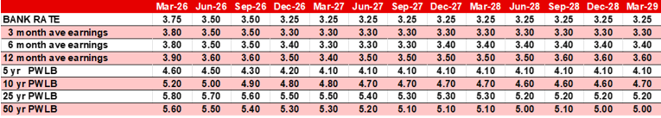

- Our last interest rate forecast update was undertaken on 11 August. Since then, a combination of tepid growth (0.2% q/q GDP for Q2 and 0.1% q/q GDP for Q3), falling inflation (currently CPI is 3.2%), and a November Budget that will place more pressure on the majority of households’ income, has provided an opportunity for the Bank of England’s Monetary Policy Committee to further reduce Bank Rate from 4% to 3.75% on 18 December.
- Surprisingly, to most market commentators, the recent steep fall in CPI inflation in one month from 3.6% to 3.2% did not persuade most “dissenters” from the November vote (Lombardelli, Greene, Mann and Pill) to switch to the rate-cutting side of the Committee. Instead, it was left to Bank Governor, Andrew Bailey, to use his deciding vote to force a rate cut through by the slimmest of margins, 5-4.
- Given the wafer-thin majority for a rate cut it was not unexpected to hear that although rates would continue on a “gradual downward path”, suggesting a further rate cut or cuts in the offing, MPC members want to assess incoming evidence on labour market activity and wage growth. Indeed, with annual wage growth still over 4.5%, the MPC reiterated that the case for further rate cuts would be “a closer call”, and Governor Bailey observed there is “limited space as Bank Rate approaches a neutral level”.
- The forecast has been revised to price in a rate cut in Q2 2026 to 3.5%, likely to take place in the wake of a significant fall in the CPI inflation reading from 3% in March to 2% in April (as forecast by Capital Economics), followed by a short lull through the summer whilst more data is garnered, and then a further rate cut to 3.25% in Q4.
- As in August, nonetheless, threats to that central scenario abound. What if wage increases remain stubbornly high? There are, after all, several sectors of the domestic economy, including social care provision and the building/construction industries, where staff shortages remain severe. Moreover, by May 2026, following the local elections, we will have a better handle on whether or not the Starmer/Reeves team is going to see out the current Parliament or whether they face a Leadership challenge from within their own party If so, how will gilt markets react to these variables…and will there be additional geo-political factors to also bake in, particularly the Fed’s monetary policy decisions in 2026 and the ongoing battle to lower rates whilst inflation remains close to 3%.
- Accordingly, our updated central forecast is made with several hefty caveats. We are confident, as we have been for some time, that our forecast for Bank Rate and the 5-year PWLB Certainty Rate is robust, and we have marginally brought forward the timing of the next rate cut(s). But for the 10-, 25- and 50-years part of the curve, the level of gilt issuance, and the timing of its placement, will be integral to achieving a benign trading environment. That is not a “given”, and additionally, the inflation outlook and political factors domestically and, crucially, in the US, are also likely to hold sway. Matters should be clearer by June in the UK, but the US mid-term elections are scheduled for November.
- Our revised PWLB rate forecasts are based on the Certainty Rate (the standard rate minus 20 bps) which has been accessible to most authorities since 1 November 2012. Please note, the lower Housing Revenue Account (HRA) PWLB rate started on 15 June 2023 for those authorities with an HRA (standard rate minus 60 bps) and is set to prevail until at least the end of March 2026. Hopefully, there will be a further extension to this discounted rate announced in January.
- Money market yield forecasts are based on expected average earnings by local authorities for 3 to 12 months.
Gilt yields and PWLB rates
The overall longer-run trend is for gilt yields and PWLB rates to fall back over the timeline of our forecasts, but the risks to our forecasts are generally to the upsides. Our target borrowing rates are set two years forward (as we expect rates to fall back) and the current PWLB (certainty) borrowing rates are set out below: -
PWLB borrowing | Current borrowing rates as at 22.12.25 p.m. | Target borrowing rate now (end of Q4 2027) | Target borrowing rate previous (end of Q4 2027)
 | % | % | %
5 years | 4.81 | 4.10 | 4.20
10 years | 5.39 | 4.70 | 4.70
25 years | 6.01 | 5.30 | 5.30
50 years | 5.78 | 5.10 | 5.10
Borrowing advice: Our long-term (beyond 10 years) forecast for the neutral level of Bank Rate remains at 3.5%. As all PWLB certainty rates are still above this level, borrowing strategies will need to be reviewed in that context. Overall, better value can be obtained at the shorter end of the curve (<5 years PWLB maturity/<10 years PWLB EIP) and short-dated fixed LA to LA monies should also be considered. Temporary borrowing rates will, generally, fall in line with Bank Rate cuts.

Our suggested budgeted earnings rates for investments up to about three months’ duration in each financial year are set out below.
Average earnings in each year | Now | Previously
 | % | %
2025/26 (residual) | 3.80 | 3.90
2026/27 | 3.40 | 3.60
2027/28 | 3.30 | 3.30
2028/29 | 3.30 | 3.50
2029/30 | 3.50 | 3.50
Years 6-10 | 3.50 | 3.50
Years 10+ | 3.50 | 3.50

We will continue to monitor economic and market developments as they unfold. Typically, we formally review our forecasts following the quarterly release of the Bank of England’s Monetary Policy Report but will consider our position on an ad-hoc basis as required.
Our interest rate forecast for Bank Rate is in steps of 25 bps, whereas PWLB forecasts have been rounded to the nearest 10 bps and are central forecasts within bands of + / - 25 bps. Naturally, we continue to monitor events and will update our forecasts as and when appropriate.

March 2026

Capital Programme 2026/27 – 2030/31

 | Surrey Capital Programme Summary | Year 1 | Year 2 | Year 3 | Year 4 | Year 5 | Total
 | DESCRIPTION | Capital  2026/27  Total | Capital  2027/28  Total | Capital  2028/29  Total | Capital  2029/30  Total | Capital  2030/31  Total | Capital  2026/31  Total
 |  | £'000's | £'000's | £'000's | £'000's | £'000's | £'000's
 | DDaT | 2.5 | 1.5 | 1.2 | 1.0 | 2.0 | 8.3
 | JTS | 6.4 | 5.8 | 5.6 | 5.5 | 6.1 | 29.3
 | Operational Command | 1.3 | 1.2 | 1.1 | 1.0 | 1.0 | 5.5
 | Specialist Crime | 0.0 | 0.0 | 0.0 | 0.0 | 0.0 | 0.0
 | Cost of Change | 2.3 | 0.0 | 0.2 | 0.0 | 0.0 | 2.5
 | Surrey Estates & Facilities | 2.6 | 2.1 | 1.7 | 0.3 | 0.0 | 6.7
 | Surrey Estate Strategy | 37.1 | 30.9 | 34.8 | 57.6 | 18.4 | 178.8
 | Total | 52.1 | 41.5 | 44.5 | 65.4 | 27.5 | 231.1

Funding Capital Programme 2026/27-2030/31

 | Surrey Capital Programme Funding | Year 1 | Year 2 | Year 3 | Year 4 | Year 5 | Total
 | DESCRIPTION | Capital  2026/27  Total | Capital  2027/28  Total | Capital  2028/29  Total | Capital  2029/30  Total | Capital  2030/31  Total | Capital  2026/31  Total
 |  | £'000's | £'000's | £'000's | £'000's | £'000's | £'000's
 | Government & Other Grants | 0.0 | 0.0 | 0.0 | 0.0 | 0.0 | 0.0
 | Reserve - DDAT | 0.0 | 0.0 | 0.0 | 0.0 | 0.0 | 0.0
 | Reserve - Cost of Change | 2.3 | 0.0 | 0.2 | 0.0 | 0.0 | 2.5
 | Reserve - SSRP | 0.4 | 0.4 | 0.3 | 0.4 | 0.4 | 1.9
 | Revenue Contributions Received in-year | 8.1 | 9.1 | 10.1 | 11.1 | 12.1 | 50.5
 | Revenue Contributions TMS Receipts | 1.5 | 1.0 | 0.0 | 0.0 | 0.0 | 2.5
 | Borrowing for Short Term Assets | 0.2 | -2.0 | -2.6 | -4.0 | -3.4 | -11.7
 | Borrowing for Long Term Assets - Estates & Facilities | 2.6 | 2.1 | 1.7 | 0.3 | 0.0 | 6.7
 | Capital Receipts | 10.7 | 14.1 | 12.4 | 7.8 | 0.0 | 44.9
 | Reserve - Surrey Estates Strategy | 0.0 | 0.0 | 0.0 | 0.0 | 0.0 | 0.0
 | Borrowing for Long Term Assets - Surrey Estates Strategy | 26.4 | 16.8 | 22.4 | 49.8 | 18.4 | 133.8
 | Total Funding Applied | 52.1 | 41.5 | 44.5 | 65.4 | 27.5 | 231.1

