PART ONE Item 12

To: Joint Audit Committee

Date: 16th March 2026

By: Alison Bolton, Chief Executive, OPCC

Title: Local Government Reform and Transfer of Policing Governance

___________________________________________________________________

Purpose of Report/ Issue:

To update the Committee on latest developments in LGR and the transfer of policing governance in Surrey.
___________________________________________________________________

Main Report:

A report was provided to the Committee in December 2025 on the plans for Local Government Reform in Surrey and transfer of Policing Governance. This report updates on any significant changes since December.

Local Government Reorganisation in Surrey

Planning is taking place between Surrey councils for the elections to the new unitary authorities in April 2026. The East Surrey and West Surrey Authorities will be shadow bodies until April 2027, at which time Surrey Council Council and the borough and districts will cease to exist.

Voluntary Joint Committees for East and West have begun, with first two meetings in January and February. Meeting papers can be found on the Surrey County Council website. An implementation project is in place, also detailed within the meeting papers and summarised below. Implementation of the changes is branded under ‘Future Surrey’.

To date, partnerships have not been involved in the implementation programme, although it is early days. The OPCC is working with the SCC implementation team on how and when Surrey Police and Surrey OPCC should be involved. Community Safety comes under the Housing and Communities workstream.

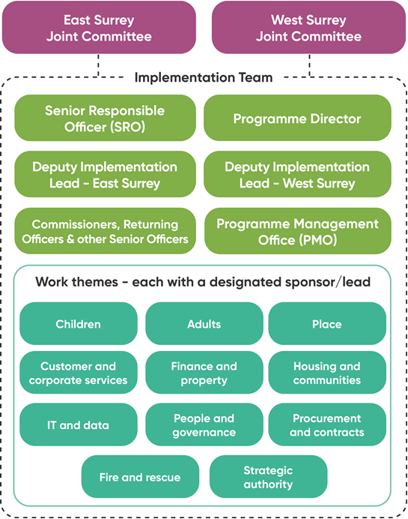

Policing Governance

The White Paper: From National to Local – a New Model for Policing, was published in January 2026. The paper confirmed the announcement that PCCs would no longer exist from May 2028. Most PCC areas know whether they will move to a Mayoral Governance Model or a Local Policing and Crime Board. Surrey do not know which model will be in place. The SCC LGR implementation Team are in discussions with Government as to whether Surrey can expect a Mayor in 2028. The Surrey OPCC team are currently planning for either scenario.

The White Paper also discusses a potential change to local and national policing governance responsibilities. This includes more involvement from the Home Office in hiring and dismissal of Chief Constables and more centralised targets and performance management for policing.
The White Paper also sets out an expectation that future policing governance will cost less and make savings. Some of those savings will come from there not being elections for PCCs. There is also an expectation that governance across different areas will be more consistent in terms of responsibilities and staffing. There are no further details on what this means in practice.

Extract from the White Paper:
“We will: Set out what functions Policing and Crime Boards and their supporting secretariats should have. This will reduce the cost of corporate governance and bring greater consistency as Offices of Police and Crime Commissioners have grown based upon PCC wishes”.
As more details are known on the functions of a new governance model, the OPCC will work to determine staffing and secretariat support needed.

The OPCC Chief Executive and project manager for governance continue to attend national meetings and meet regularly with SCC colleagues. Detailed engagement with the new Unitary structure won’t be expected until after the elections and initial council transition work has taken place.

Project Management

The first meeting of the Project Working Group took place in December. The next meeting is in April 2026.

___________________________________________________________________

Recommendation

The Committee is asked to note the update to LGR and Policing Governance.
________________________________________________________________

Contact details:

Name: Johanna Burne
Job Title: Senior Strategic Project Officer
Telephone number: 01483 630200
Email address: Johanna.burne@surrey.police.uk

