 | Surrey Joint Audit Committee  16 March 2026  Paper
Security Classification |  | Official
Handling information if required:
Suitable for publication: |  | Yes
Title:
Version: |  | 1.5
Purpose: |  | Annual update on health and safety management in Surrey Police.
Strategic Lead: |  | Anthony Croxford.
Date created: |  | 18/02/26

AUTHOR:
Name: | Matt Green
Job Title: | Head of Health and Safety Service
Telephone number: | 07557 817412
Email address: | matthew.green@sussex.police.uk

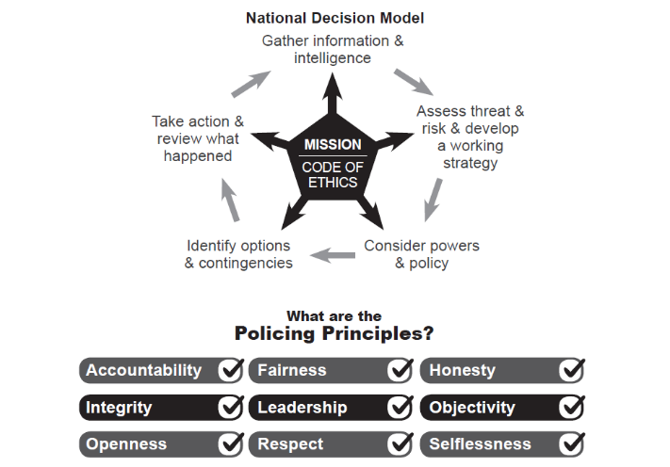

- Purpose of the Paper
  - This paper provides Surrey Audit Committee with an update on health and safety management within Surrey Police. This forms part of the assurance process to ensure that arrangements are scrutinised and effective.

- Strategic Intention
  - To comply with health and safety legislation and to ensure the health and safety of officers, staff, detainees and the public affected by police activities.

- Delivery Plan
Effectiveness of Surrey Police’s safety policies and arrangements
  - The Health and Safety Policy and Arrangements are implemented and subject to risk-based assurance through the new Health and Safety Management System ‘Safety Responsibilities and Risk Based Assurance.’ Audit Committee have had site of papers previously on how this system functions, but in essence it involves risk profiling the organisation and focussing help and support on the highest risk areas. Core to the approach is the ‘Eight Safety Responsibilities,’ which explain to heads of department what their responsibilities are, with high-risk departments being expected to assess their compliance with them. Where there are gaps, the Health and Safety Service offers help and support. When the new system is fully rolled out, management information will be available showing where safety risk exists and how well it is being managed, this will be known as the ‘Strategic Health and Safety Threat Assessment.’ Detailed information on the roll out is outlined in the Health and Safety Service Business plan update below.

  - The Force Health and Safety Policy and Arrangements is due for consultation again during 2026. As the policy includes responsibilities of the Office of Police and Crime Commissioner pertaining to the Police Estate, a report outlining the proposed changes to the policy is included as Appendix 1, a draft policy with track changes is Appendix 2 and a draft policy with the track changes removed is Appendix 3 (easier to read).

Effectiveness of health and safety training

Mandatory Minimum Health and Safety Training

  - Basic health and safety training is delivered through College Learn (from the College of Policing). It is accepted by the Health and Safety Service that the course content is poor in some cases, although legally compliant. The College of Policing is going out to tender for new course content; the Health and Safety Service is also considering making use of course content that is being developed by the Metropolitan Police, which is police specific as well as developing internal content.

  - There are three mandatory minimum health and safety training courses which are listed in the table below. Considering the courses are on a periodic refresher (3 years), we aim for a completion rate above 80%.

  - Responsibility for ensuring compliance with health and safety training rests with heads of department / heads of service who are responsible for checking the College Learn compliance reports, which are produced by Learning and Development and published on the intranet. In addition to this, the Health and Safety Service publish the College Learn compliance data at the Strategic Health and Safety Board. Other than raising awareness, specific actions of departments are not currently required, the reasons being is The College of Policing are currently updating their NCALT Health and Safety package. The Health and Safety Service are waiting for the new content before pushing completion rates. However, should this not be published by April 2026 the current available content will be pushed and action taken against departments with poor compliance (below 80%). After this date it’s proposed that health and safety compliance is added to the Strategic Health and Safety Board.

  - The Health and Safety Service will be developing our own health and safety training in future to ensure that training is of higher quality and Surrey / Sussex Police specific.
Course title | Course purpose | Completed | Incomplete | Not completed
Display Screen Equipment
This course explains the risks associated with using computers, laptops and mobile devices and explains how to manage the risk.  Learning outcomes:  - Outline what Display Screen Equipment (DSE) is.  - Understand the risks related to the use of DSE or poorly designed workstations.  - Identify problems in the working environment.  - Put measures in place to reduce risks in the working environment.  - Maintain a comfortable workstation and promote health and safety. |  | 80% | 1.1% | 18.9%
Health and Safety in the Workplace
This module looks at health and safety policy and the legal requirements for both employees and employers. It also covers how to implement health and safety measures while at a workstation and how to spot potential incidents, undertake risk assessments and first aid. It then moves on to spotting potential fire hazards, what to do when discovering a fire, lone working and the actions needed to ensure safety.  Learning outcomes:  - Why health and safety legislation is needed at work and common workplace risks.  - What employers and employees need to do to comply with the law  - Good health and safety practices at a workstation.  - How to identify and address potential accidents, fire and environmental hazards in the workplace.  - How to recognise and address stress in the workplace. |  | 60.6% | 4.1% | 35.2%
Health and Safety Level 1 – Introduction to Health and Safety
(Line managers only)
This module is designed to give the necessary knowledge and skills to ensure a safe and healthy work environment. It explores the legislation that outlines health and safety responsibilities for all organisations, identify the key components of an effective health and safety policy, communicate it to employees, and implement techniques to foster a positive safety culture.  Learning outcomes:  - Current legislation on health and safety.  - Why we need a health and safety policy.  - Why everyone needs to know their responsibilities when it comes to health and safety.  - The specific responsibilities of managers when it comes to health and safety. |  | 70.3% | 4.2% | 24.6%

  - Compliance with training is monitored at the Strategic Health and Safety Board.
Job specific Health and Safety Training
  - Health and safety management in Surrey Police, including written risk assessment is based upon the National Decision Model (NDM). This is to ensure that safety is integral to decision making, not an adjunct to it. Officers receive training in the NDM as core part of their initial training, structuring how they make and justify decisions. Compliance with this training is managed by Learning and Development.
Figure 1: Section 6.18 Health and Safety Policy and Arrangements:
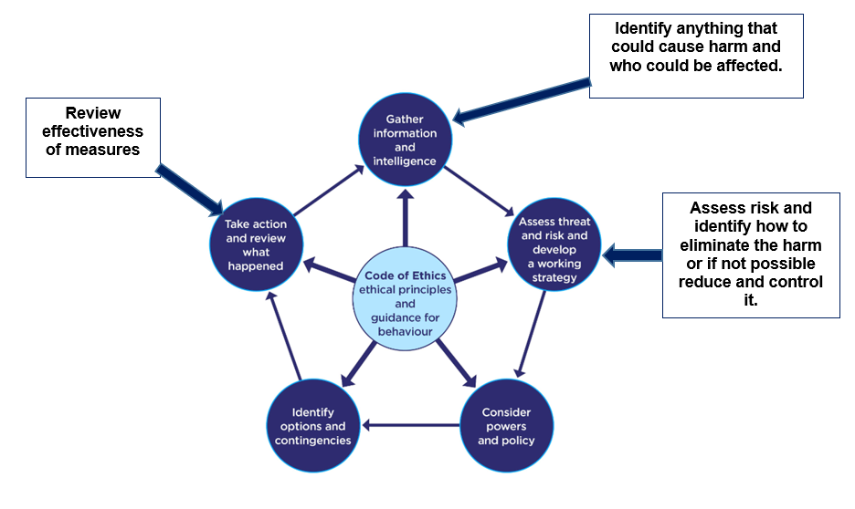
  - Identifying health and safety training in addition to the basic / foundation health and safety training outlined above is the responsibility of line managers, through the process of Job Role Risk Assessment. Training is identified this way as the Management of Health and Safety at Work Regulations, in particular The General Principles of Prevention (Schedule 2), requires that control measures (including training) are considered in relation to identified threats and in a particular order specified in the regulations. So, this must be done on a case-by-case basis.

  - The Health and Safety Service does not maintain specific records of compliance with health and safety training identified in Job Role Risk Assessments. However, as part of the risk-based auditing that is carried out as part of the health and safety management system, Job Role Risk Assessments are examined, and checks are undertaken to see if managers are completing this process correctly. There is also comprehensive guidance available on how to undertake Job Role Risk Assessment on the intranet.
Health and safety statistical information
  - Appendix 4 to this report contains the safety statistical information for Surrey Police for 2024/25. Please note, the Sussex data has been removed. This is because no meaningful comparison can be drawn between the two data sets, due to significant variations in recording. The two data sets are presented in one report at the Strategic Health and Safety Board as the meeting scrutinises but does not compare both sets of data.

  - Due to the significant seasonal variations we see in the data, it is recommended to look at a full year’s data to draw accurate conclusions. Assaults and conflict training are the two most significant causes of injury. Both areas have been subject to considerable scrutiny by the Health and Safety Service and are commented on below.

  - Considering the number of injuries sustained during conflict training (in Surrey and Sussex), the Health and Safety Service carried out a review which was presented to the Strategic Health and Safety Board in June 2025. Anecdotally, other forces across the UK have seen increases in injuries since the training was changed by the College of Policing to be scenario based. The review considered the available data, views of officers / trainers as well as observing training. The review concluded that there was no obvious single cause for the number of injuries but was reflective of the new scenario-based training being more ‘hands on.’ The Health and Safety Service continues to take a pragmatic view that officers and staff need realistic training that prepares them to deal with real world violence. However, we continue to work with the training teams, Police Federation and Unison to see what else can be done to ensure training remains realistic but avoids serious injury such as fractures and dislocations. This will remain under review.

  - In response to the rising number of assaults against officers and staff, the Health and Safety Service launched the Assaults Working Group, which included key stakeholders. The actions of this group were shared with Audit Committee in the last report. The monitoring of assaults in detail was then passed to Op Hampshire, a group of stakeholders with a remit based around the national project looking at officer and staff assaults.

  - It was discussed in detail at the Strategic Health and Safety Board that STRJ4173 ‘Increasing Officer and Staff Assaults’ should be archived and passed to business as usual following an acceptable external review. This review has now been completed by Southern Audit Partnership and provided a Reasonable level of assurance.

  - Consideration was given to the archiving of STRJ4173 again at the Strategic Board in January 2026 following receipt of the internal audit report and it is considered that sufficient work has been completed to pass this back to business-as-usual monitoring at the Strategic Health and Safety Board and Op Hampshire. The data is also now suggesting a more stable picture.

2024/25 Health and Safety Service Business Plan - update
  - The Health and Safety Service operates on a business plan which is published at the beginning of each financial year, the current version being delivered is 2025/26. The business plan identifies the areas of greatest significance that require attention, this is in addition to the re-active work that the Health and Safety Service delivers, namely the c4000 safety incident reports received each year across both forces. These reports relate to custody adverse incidents, near misses / injuries to officers, staff, detainees and members of the public affected by policy activity.

  - The full delivery plan is attached as Appendix 5. Below is an update on the most significant elements of that plan and progress to date.
Objective | Activity | Progress
New safety management system  Roll out the new safety management system, ‘Safety Responsibilities and Risk Based Assurance’ across Surrey Police and Sussex Police. | Write the new standard operating procedure for Safety Responsibilities and Risk Based Assurance. | Delivered – SOP written and agreed.
 | Design and write a new self-assessment tool for heads of department to self-assess their compliance against the Eight Safety Responsibilities. | Delivered – New self-assessment tool in Microsoft Forms written, tested and delivered. A tool is also available in Excel when people prefer to use this.
 | Train health and safety advisors in the implementation of the new safety management system and compliance with the new standard operating procedure. | Delivered – All health and safety advisors have been trained in the new SOP.
 | Develop and present management information on where safety risk exists within Surrey Police / Sussex Police and how well it is managed to the Strategic Health and Safety Board, Audit Committees, and chief officers. | In progress: We are entering this stage now by departments carrying out self-assessments where applicable. It is anticipated that self-assessments will be completed over the next 6 months.  This process has been significantly slowed due to being short staffed (comment in risk section below) and unprecedented enforcement action during 2025.
Workforce Agreements and Working Time Regulations  Re-negotiate the Workforce Agreements (Working Time Regulations) with The Police Federation (Surrey / Sussex) and Unison (Surrey / Sussex).  Come to an agreement with the Supt’s Association. | Engage and seek agreement with both Deputy Chief Constables on the parameters for negotiation. | Delivered – Meeting took place with both DCCs and the and parameters were agreed.
 | Engage and seek agreement with the Director of People Services on the parameters for negotiation. | Delivered - Meeting took place with the Director of People Services and the parameters were agreed.
 | Engage with Unison and The Police Federation to agree the Workforce Agreements for a further 12 months. | Delivered – agreements were re-signed in Summer 2025.
 | Engage and seek agreement with both Deputy Chief Constables on the parameters for negotiation with the Supt’s Association. | Delivered – A draft agreement has been sent to the Director of People Services for agreement.
 | Engage and seek agreement with the Director of People Services on the parameters for negotiation with the Supt’s Association. | Delivered – A draft agreement has been sent to the Director of People Services for agreement.
 | Continue to raise awareness of the need for risk assessment for night workers, including health assessments. | Delivered – A new intranet page has been set up dedicated to carrying out the risk assessments and explaining the Workforce Agreements. A draft night work risk assessment has been developed for heads of department to use.  The Health and Safety Service continues to work with The Police Federation and Unison to raise awareness.  Occupational Health are actively advertising and offering night work health assessments.
Raise profile of safety risk amongst chief officers.  Improve the visibility of the management of safety risk amongst Chief Officers in order to drive improvement to its management. | Agree a regular slot at Surrey chief officer meeting. | Not delivered yet: Due to the delay in rolling out the safety management system (staff shortage), this has meant the new management information isn’t available yet to present. We anticipate this will be start being available within the next 3 months.
 | Deliver regular management information updates to chief officers outlining where safety risk exists and how well it is managed. | Not delivered yet: Due to the delay in rolling out the safety management system (staff shortage), this has meant the new management information isn’t available yet to present. We anticipate this will be start being available within the next 3 months.
 | Publish and present the Strategic Health and Safety Threat Assessment at Chief Officer meetings in Surrey Police and Sussex Police. | Not delivered yet: Due to the delay in rolling out the safety management system (staff shortage), this has meant the new management information isn’t available yet to present. We anticipate this will be start being available within the next 3 months.
 | Write and deliver a paper to chief officers on the S22A Collaboration Agreement and its implications for liability. | In progress: Detailed discussions have taken place with Weightmans and legal advice on this issue has been received. The nuances of how the S22A Collaboration agreement affects health and safety responsibilities is complex, hence the need for this advice. A paper is in the process of being written.
Recruitment  Recruit for the new Senior Specialist Health & Safety Advisor Post, maintaining and improving support for operational policing following Rob Mann’s flexible retirement. | Develop and present a business case to Portfolio Strategy Board explaining the need for the need for the new post. | Delivered: This was approved by both DCCs.
 | Identify funding for the additional post, increasing the Health and Safety Service capacity by 0.5 FTE following Rob Mann’s flexible retirement. | Delivered: Agreement was reached with the Chief Operating Officer that this would have to be funded out of existing budgets.
 | Advertise post | Delivered:
 | Interviews. | Delivered:
 | Recruit to post. | On going: We are now on our second recruitment campaign. There is a significant skills shortage of people with the necessary competence to provide health and safety advice in policing. We are seeing 2 or 3 viable applications per campaign.
Manage enforcement activity  Have oversite of and support departments with enforcement activity from the Health and Safety Executive and Fire Service. | 2025 saw unprecedented levels of enforcement activity taking place from the Health and Safety Executive, with inspections affecting custody, neighbourhood policing and evidential property.  Enforcement activity was in both forces related to a national programme of inspections on search failures and concerns raised in evidential property. This meant resources had to be flexed to support each force. | Delivered: All enforcement activities were delivered successfully in Surrey and without formal enforcement action (prohibition / improvement).
Update corporate policy  Update the Health and Safety Policy and Arrangements. | The policy has been re-written and consulted on through the Strategic Health and Safety Board. | Delivered: As the policy includes responsibilities on the PCC, a draft is included as an appendix to this report for feedback from Audit Committee.
Replacing 12/2 in Surrey  The replacement of the 12/2 safety incident reporting system in Surrey. | The 12/2 safety incident reporting system has been successfully replaced with Origin and now forms part of People Services Self Service platform. | Delivered: The new system has been rolled out and 12/2 is being de-commissioned.

- Risks
  - The main risk that affects the Health and Safety Service’s ability to deliver its business plan and manage health and safety effectively is staffing levels and a lack of competence within the labour market to deliver advice in a policing context. The Health and Safety Service establishment across Surrey Police and Sussex Police is 7 FTE (roughly 3.5 FTE per force) and is currently operating 5.5 FTE due to a vacancy and an employee moving to flexible retirement (to avoid losing their skills).

  - Policing is a high risk and complex operation, and health and safety law must be balanced effectively against the need to keep the public safe. It’s not as if policing has the luxury of saying some things are too hazardous to deal with, so solutions must be found. Little advice and guidance exist on complying with health and safety law in a policing context, so significant weight must be placed on the competence of health and safety advisors to come up with solutions which are pragmatic but legally defendable.

- Governance
  - Governance of health and safety matters takes place through the Strategic Health and Safety Board, chaired by the Chief Operating Officer. This meeting also forms the formal consultation mechanism on safety matters with The Police Federation and Unison and has a basis in statute. The meeting is well engaged with by all sides and is positive.

- Chief Officer Assurance

  - This paper is an accurate summary of our state of play and the progress against our delivery plan for Health and Safety, recognising the roll out of the new safety management system and replacement of the 12/2 safety incident reporting system.

- Appendix
- Appendix 1: Report outlining changes to the Health and Safety Policy and Arrangements.
- Appendix 2: Draft Health and Safety Policy and Arrangements (with track changes).
- Appendix 3: Draft Health and Safety Policy and Arrangements (track changes turned off).
- Appendix 4: Health and Safety Statistical Information for 2024/25.
- Appendix 5: 2025/2026 Health and Safety Service Business Plan.

