 | Surrey Joint Audit Committee  Paper
Security Classification |  | Official
Handling information if required:
Suitable for publication: |  | Yes
Title: |  | Surrey Police amended approach to managing risk
Version: |  | 1.1
Purpose: |  | To brief JAC of changes to and ongoing improvement of the force’s approach to managing risk.
Strategic Lead: |  | DCC McEwan
Date created: |  | 17th February 2026

AUTHOR:
Name: | Louise Parker
Job Title: | Head of Corporate Development
Telephone number: | 07967 987175
Email address: | louise.parker@surrey.police.uk

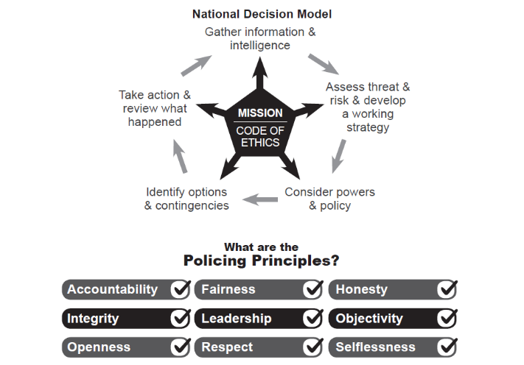

- Purpose of the Paper
  - To brief JAC members on the force’s new approach to managing risks.

- Strategic Intention
  - Surrey Police is bound by statutory responsibilities to have effective mechanisms to manage risks and performance through robust internal control. The force intends to improve its risk management governance to more robustly assure that operational and organisational risks are anticipated, controlled in line with our risk appetite and, where these materialise into issues, the impact is effectively controlled, limited and resolved.

- Delivery Plan
  - The Organisational Reassurance Board transitioned to a Force Assurance Board in 2025. This will be replaced by the Risk Assurance Board in an inaugural meeting on 24th February 2026.
  - The Risk Assurance Board exists as a governance mechanism for operational and organisational risk matters. Its purpose is to inform Chief Officers of significant matters of risk, and to be assured that risk management activity led by Chief Officers is set to the appropriate risk appetite, with appropriate and effective controls, plan, oversight and resolution. As well as surfacing and connecting risks at force level, the Board will oversee related organisational learning, policy amendments, process improvements, and similar. The focus will be both retrospective when something has already happened (issues), and prospective to risks where we can act soonest with a position and/or control measures.
  - Although the force has had mechanisms in place to govern risk management and for assurance of such, the new Board will look at the totality of and inter-play between risks, and the adequacy of risk management, as well as scrutinising the highest risks and issues in more detail.
  - The Risk Assurance Board is essential to the force’s effective participation within external assurance mechanisms for risk management, learning and policy, as is exercised through PCC Governance (Resources and Efficiency Meeting) and JAC.
  - Scope: operational and organisational risks and issues including (but not necessarily limited to):
    - Corporate risks and issues (i.e. those on Keto)
    - External inspections
    - Internal audit
    - Gold Groups
    - Critical incidents (where not managed through a Gold Group)
    - Workforce matters (e.g. conduct, employment tribunals, grievances, workforce engagement and wellbeing)
    - Post-incident matters (e.g. death and serious injury, health and safety matters)
    - Court matters (criminal, civil and coroners, and including legal proceedings settled out of court)
    - Other political, economic, social, technical, environmental, legal matters.
  - The Risk Assurance Board places an obligation on Chief Officers to oversee risks and issues within their area of responsibility through their respective Accountability Boards (or similar)
  - Inputs: The force’s Corporate Development Department is responsible for collating and publishing summary information as detailed below. Chief Officers are accountable for the matters that are within their portfolio and for providing verbal comment and context in the meeting.
  - CDD will submit ahead of the meeting:
    - Top 10 risks/issues plus other risks and issues by exception (e.g. nomination from Chief Officer). Areas of focus:
      - Does the appetite and treatment match the force appetite
      - Are controls appropriate for the appetite, score, urgency?
      - Are controls working? How do we know?
      - What’s the plan if controls don’t work, work soon enough, or something gets worse?
      - Overall, is what we’re doing now delivering what’s required, or ought we try a different approach?
    - Internal Audit
        - New reports with no or limited assurance
        - Follow up reports from earlier reports giving no or limited assurance
        - Overdue (high priority) actions
        - Diagnostics, causation, plan and actions, oversight
    - HMICFRS and other external inspections: AFIs and Recommendations
    - New force specific reports
    - New thematic reports linked to existing or previous risk, issue, AFI/REC, SIAP (those where we think what’s been found elsewhere has been found in Surrey before, and/or likely to be found now)
    - Overdue but self-certifiable AFIs/Recs
    - Diagnostics, causation, assessment, plan and actions, oversight
  - Chief Officers are responsible for identifying and raising into the meeting those risks as listed under 3.5.4 – 2.5.8, as relevant to their portfolio area. These are matters not on Keto or managed within CDD but are managed independently within CO portfolios.
  - CDD will scope and develop a mechanism to look across all these areas to identify patterns, themes, bigger risks that appear in isolation, rising tide matters, etc.

- Risks
  - Until a mechanism is in place to collate and assess risks not managed through KETO (those listed under item 3.5.4-3.5.8), there is no single place where these are reviewed collectively to identify connections, patterns, duplication.
  - The scoping exercise is underway to assess what relevant information is held where, by each of our chief officers as part of their oversight and assurance mechanisms.
  - Costed options for solutions will follow. It is expected that this will include technical solutions such as AI. The relative merits for options will be assessed with due regard for the risks, costs, and benefits.

- Governance
  - The Terms of Reference is being written. This will reflect the above delivery plan, and will include annual review. It is expected and accepted that this Board will develop, with accompanying amendments to the Terms of Reference as required between formal review periods.
  - DCC McEwan has met with JAC member Rachel Evans and gratefully accepts her offer to assist us to improve our risk management practices and governance.

- Chief Officer Assurance (Statement of DCC McEwan)
  - On my arrival into the force I suspended the ordinary force level governance meetings for Organisational Development and Risk Management and incorporated these instead to the overall Operation Solve Gold Group.
  - In parallel I introduced a new template for reporting from Chief Officers, to more precisely and concisely provide information for accountability purposes.
  - I am confident that the mechanisms I have set in place for setting and embedding new forms of reporting will complement the new meeting structures and expectations for accountability.
  - Although I have some confidence that at force level we will have improved visibility of portfolio-held operational risks through Chief Officers reporting on what they currently oversee locally, this is reliant upon matters held being escalated. I have limited confidence that this will surface and connect all risks that, when taken in total and viewed top-down, the force should be aware of. The current discovery work to scope the information held will in due course provide costed options to resolve this. An update on this work will be provided in subsequent reporting into JAC.

