



Retail Crime Report
Surrey 2025
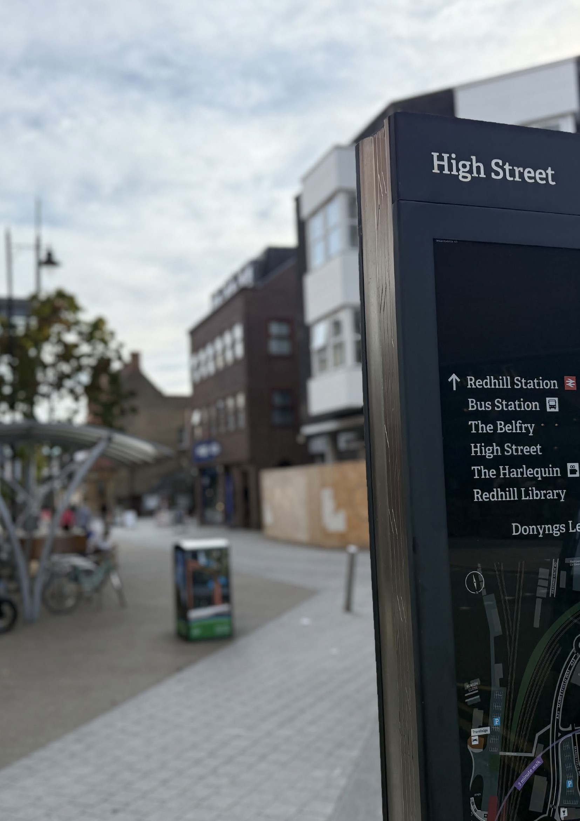




Contents

Police and Crime Commissioner’s
introduction 4
Chief Constable’s introduction 5
Our retail crime commitment 6
Surrey Police’s retail crime strategy 7
Survey responses 8
What you told us 10
How national chains are helping to
win the fight against retail crime 11
More criminals brought
to justice in Surrey 12
How one Surrey PC brought down
an OCG 13
Clear, Hold, Build 14
Safer Streets Summer 15
How to report a crime 16




3


Police and Crime Commissioner’s Introduction

It is no exaggeration to say that, across the country, retail crime has reached unprecedented levels.

An astonishing 530,643 shoplifting offences were recorded in the year to March 2025, according to the Office for National Statistics. This is the highest level since current police recording practices began in the year to March 2003.
Of course, those in the business community will already be aware that the true figure is likely to be far higher.
While Surrey remains one of the safest counties in the UK, we are not immune from this. However, I would like to note here that Surrey Police recorded far fewer shoplifting crimes than our neighbouring forces – 6,622, compared with, for example, 16,014 in Hampshire or 20,048 in Thames Valley.
As Surrey’s Police and Crime Commissioner, I am in a unique position to work alongside police, the
Government and business-owners as part of efforts to respond to the challenges retail crime poses.
As a result, earlier this year, and in tandem with Surrey Police, I launched a wide-ranging retail crime strategy specifically aimed at those in the business community.
I wanted to hear about the impact of retail crime – financially, strategically, and of course, emotionally. I wanted to understand how the business community feels about the policing response to this crime type, and what can be done better.
We had a range of responses, for which I thank all those who took the time to complete an in-depth and fairly lengthy survey. These responses are
summarised and shared in the pages after this, along with Surrey Police’s commitment to tackling retail crime, and some recent success stories.
It is clear there are many reasons for the surge in this type of offending, and that a policing response is not the sole answer to some of these issues. This is a complex, societal crime that, contrary to popular
opinion, knows no class or sex restrictions. The criminal justice system, local authorities, politicians and every
member of the public must band together with officers to treat retail crime with the seriousness it deserves.
Retail crime does not exist in a vacuum. It goes hand- in-hand with other serious criminality, including abuse, threats and violence, as well as organised criminality, which poses a rising threat to retailers, as well as society at large.
In the pages to come, you can read about how one Guildford-based officer brought down an organised criminal group, or OCG, after being tasked to investigate a single shoplifting incident at Tesco.
But perpetrators can come from any background, and misconceptions around retail crime are common. This is not a ‘victimless’ crime – far from it. Its victims include every one of us impacted by rising costs, as well as entire local communities who feel less safe.
There is also a pernicious and entrenched rumour that police will only attend in cases where items worth
£200 or more have been stolen. This is something I have heard time and again, including from the mouths of politicians who should know better.
While this isn’t true, and I have been at the arrest of a shoplifter who stole an item worth £7.50 from a Redhill supermarket, it is clear that retail crime has
slipped from being a priority crime for police across the country. This is not a situation we are prepared to tolerate, and both Surrey Police’s Chief Constable,
Tim De Meyer, and I are committed to changing this in our lovely county.

We haven’t always got it right. But we are determined to do everything we can to support victims, protect property, and bring to justice those who target businesses.


Chief Constable’s Introduction

Policing plays an important role in enabling the economic prosperity that we all need.

Public bodies such as ours rely on a thriving economy to make the money which funds the services we provide.
But it is difficult for businesses to thrive where there is the threat of crime. Therefore, it is important that we do all we should to enable businesses such as local shops to serve their communities, provide employment and contribute to the economy.
In my early policing career, one of the ways we learned to investigate crime was by dealing with lots of straightforward cases of theft and deception in local shops.


We made lots of arrests, interviewed lots of suspects and put together lots of files. It was a good way
of learning the basics of investigation and criminal justice and of becoming familiar with the criminal fraternity.
Over the years, we in policing shifted our attention to different crime types such as those targeting vulnerable people.
Understandable though this was, it meant we paid rather less attention to crimes such as shoplifting –
perhaps in the mistaken belief that such offending did not really feature any victims.
But while one individual case of shoplifting might not seem that serious, if left to spread, this crime has
an extremely bad effect on individual people and on community life.
Our shops provide community services. They feed us and equip us for life. They kept going during the pandemic. Shop workers are paid very little, and, like the police, they work irregular hours. They should not have to do so in fear of witnessing crime or, worse still, being a victim of physical violence.
Where the honest person sees a thief stealing without any consequences it diminishes their confidence
in us and as more become aware of it, public confidence declines.
Shops should be a place where people feel safe, and money is exchanged for goods so that jobs are created and communities flourish.
They should not be a place to be exploited by organised crime groups dispatching gangs to steal from our stores.
This is why I am so pleased to see Surrey now leading the way in tackling shoplifting.
By encouraging reporting, responding faster, investigating better and applying problem-solving skills, police are reducing shoplifting in our county and in so doing helping businesses and communities

to thrive in a way that benefits us all.



Our retail crime commitment

The impact of retail crime on direct victims, the retail sector, and our wider communities is significant, and tackling this criminality is a priority for Surrey Police.
From shop owners who have spent years building up their independent business to a 16-year-old working a Saturday shift at their local store and an elderly woman who fears going to the shop for a paper, the breadth of those affected by criminals out to target our retail premises is vast.
It is simply incorrect to say that retail offences are ‘victimless’ crimes. In reality, this type of offending creates fear and unease, and it is the duty of police to investigate crimes where they occur, reassure communities, and pursue offenders to get justice.
As a Force, Surrey aims to achieve the values set out in both the Commissioner’s Police and Crime Plan and the Chief Constable’s Our Plan. Both set stock in ‘back-to- basics’ policing, with a focus on preventing crime, problem- solving, thorough and careful investigations, and the relentless pursuit of criminals.
Retail crime, such as shoplifting, often comes with a level of intimidation and threat from the offender, leaving people frightened in their own workplace or community.
Addressing spikes in this type of offending is a Force-wide effort, and over the coming pages, you’ll read about some of the work done by officers based in Neighbourhood Policing Teams to bring criminals to justice.
Earlier this year, Surrey Police unveiled its new retail crime strategy for the county.
The strategy is based around:
Responding appropriately Investigating thoroughly
Working with retailers to prevent crime where possible
It incorporates feedback from the business community which was given as part of the retail crime survey.
It isn’t unusual for organised crime groups, or OCGs, to be complicit in retail crime alongside other types of criminality, all of which directly impact society in a number of harmful ways.
By tackling retail crime head on, it is hoped that our officers and investigation teams can also prevent other OCG- related crime from happening across our county.
It is about building a wider picture of retail crime, gathering vital intelligence, investigating and responding in order to shut down lines of criminality.
Police must work with communities and businesses to prevent retail crime from happening in our town centres – places everyone should be able to enjoy, and where they should feel safe.

Surrey Police’s retail crime strategy

Surrey Police’s objectives are to:
Attend where there is a call for service. Surrey Police will use THRIVE – Threat, Harm, Risk, Investigation, Vulnerability, Engagement – to assess all calls for service and make deployment decisions. The opportunity of following investigative lines of inquiry should be a priority, and if further information comes to light, the Force will re-THRIVE. Prioritised incidents include those where violence has been threatened or used; where an offender has been detained; or where evidence needs to be secured that can only be done so by police.
Follow all reasonable lines of inquiry. For example, where there is CCTV or other footage, this will be recovered and used as evidence where possible; where there are strong forensic and evidential opportunities, officers will use this appropriately to build a case; and where property is stolen with unique features, police will seek to recover it.
Target repeat offenders. A majority of retail crime in Surrey is committed by a few offenders. A proactive approach to identifying and targeting resources towards these individuals will help significantly in preventing retail crime. The Force will also work alongside other agencies to address repeat offenders, including making referrals for drug, alcohol and mental health support.
Work with partners to tackle organised retail crime. Operation Opal is the National Intelligence Unit for Serious and Organised Acquisitive Crime, and this initiative is supported by the Force.
Surrey Police also supports Project Pegasus, a partnership between business and policing that improves the way retailers can share intelligence.
Four things make the most significant difference to getting a positive outcome for victims:
An early victim statement
Arresting the suspect at the first opportunity A quality, recorded investigation plan
Meaningful reviews by supervisors in the Force




7

Survey responses

The Police and Crime Commissioner and the Chief Constable launched their retail crime survey in the spring of 2025.
The survey aimed to take responses directly from those immediately impacted by retail crime, most likely through their work.
It allowed space for both ticked answers and longer-form replies.
Of those to respond, 64 per cent worked in retail, and 20 per cent worked in ‘other’ (including security, retired,
receptionist and estate agents). Others worked in licensed premises, in food service, and in administrative capacities.

73.22% reported experiencing crime relating to their workplace in the past 12 months
26.78% had not experienced a crime relating to their workplace

68.52% per cent reported that offence to Surrey Police
31.48% did not report the offence







43% say they have experienced 10 or more crimes relating to their workplace

38.10% would report a crime to 999 33.33% would report a crime to 101 38.10% would report a crime via digital 101
7.14% would report a crime via the Suspicious Activity Portal
18.45% said ‘other’



54.7% were victims of threatening or abusive behaviour
19.88% were victims of assault
19.30% were victims of a hate crime
45.80% said the value of the items stolen over the past 12 months was £1,000 or more

73.22% are currently taking measures to prevent retail crime, with these measures including:


Hiring security staff Using CCTV cameras





Enhanced cyber-security

Moving higher-value items out of easy reach
Using security alarms

What you told us

“We had an overnight break-in – the store was closed for six hours.”
“Shoplifting from charity shops doesn’t seem to be a priority.”

“The business had to close to replace damaged equipment.”
“The response I received from PCSOs in Staines was outstanding.”

“It’s led to a high turnover of staff.”

“I get shoplifters at least once a week at my store.”

“We have local PCSOs who are doing their best but it’s not sufficient.”

“The response has definitely improved, but there have been occasions that were dealt with poorly.”

“Police can be slow to respond.”
“We’ve seen an increase in insurance premiums.”

“We felt like the police had more important work to do.”

“Shops can do nothing to protect themselves.”

“Our PCSO, Aaron, has been very proactive, and the procedures we’ve been involved with led to one prosecution.”





10



How national chains are helping with the fight
against retail crime

National chains have teamed up with police to lead the fight against retail crime.
Two prolific shoplifters have been jailed after security staff at the Boots CCTV Monitoring Centre in Beeston,
Nottinghamshire contacted police with reports of criminality.
The first, a 22-year-old man from Ashford, was jailed for two years after 19 connected reports were made.


He later admitted stealing items worth more than £60,000 from Boots, Sainsbury’s, Tesco and Co-op stores in Surrey, Thames Valley, Kent, London, Cleveland, Cheshire and Durham.
Just a few months later, staff at the hub worked with officers once again to secure a conviction for a 25-year-old man from Slough.
The suspect, who stole items worth £34,000 during a six- week spree, targeted nicotine, healthcare and cosmetics products from Boots, Tesco and Co-op stores across the south-east.
He was arrested at Harwich International Port trying to flee the country under a false identity and sentenced to 22 months in prison.
The Boots CCTV Monitoring Centre receives hundreds of alerts a day from its UK shops. Staff can press alarms for central support and live monitoring if they have suspicions about a customer.
The facility features 18 screens displaying live CCTV feeds, while a team of security specialists respond in real time, either taking over a store’s loudspeakers to deter shoplifters, or warning the suspect that they’re being watched.
Police are also notified.
In Surrey, 30 of the county’s 36 Boots stores have reported an incident to Auror, a crime reporting network connecting retailers and local police forces, in 18 months.
The top stores to report are in Walton-on-Thames and Farnham.

More criminals brought to justice in Surrey



Over the past year, Surrey Police has achieved a four-fold increase in the number of charges for shoplifting across the county, amounting to more than 800 cases.
The Force’s arrest rate for these crimes has more than doubled, from around 10 per cent previously to around 24 per cent this year, and the solved outcome rate is around
23.5 per cent, up from 16 per cent last year, and 11 per cent the year before.
The Force’s lead for retail crime, Chief Inspector AndyHill, of Surrey Police, said: “Our strategy sets out clear guidelines for our response to retail crime and our local teams are embedding this in their operational work.
“Retail crime is simply not fair. It can be volatile, dangerous, and fuels local illicit activities.
“Through clear cooperation and partnership working, the figures can be improved.
“We have made positive strides in this area, but there is more to do.”
In Surrey, neighbourhood policing teams:
Visit retailers during proactive patrols Identify repeat locations and suspects
Provide additional advice and reassurance to communities
Work with businesses to review security measures
Here are some recent convictions secured by the Force.
A 37-year-old man, of Enfield in London, was jailed for 32 months and two weeks after admitting stealing around
£100,000-worth of alcohol from supermarkets across Surrey.
The defendant, who was a member of an organised crime group (OCG), pleaded guilty to 19 counts of conspiracy to commit theft.
The OCG travelled up and down the country committing offences. They would enter stores repeatedly, stealing between £500- and £7,000-worth of alcohol at a time.
The defendant acted as a look-out during the thefts.
Police in Surrey worked with the heads of security for Tesco and Sainsbury’s, who identified that the defendant had been involved in another 34 offences across the UK. These were taken into consideration when he was sentenced.
While the defendant actively took part in thefts totalling around £100,000, it is believed that the OCG was responsible for thefts totalling almost £500,000.
During a single raid on a Tesco in Ashford, alcohol worth
£8,500 was stolen. Stanwell and Reigate branches suffered a £5,000 loss to the group.
The Surrey officer who investigated the thefts said the successful outcome was thanks to the partnership forged between the police team in Staines and managers at Tesco and Sainsbury’s, alongside Op Opal, the national intelligence unit focused on serious organised acquisitive crime.
Two brothers who spent five months on a shoplifting spree across Surrey were also recently jailed for more than two years. The brothers worked together to visit various shops and target high-value alcohol, often stuffing their jackets or backpacks with bottles.
During a single incident at Waitrose in West Byfleet, they stole an estimated £1,050-worth of alcohol.
In total, they were charged with 55 offences, including 29 separate incidents of theft and four charges of assault on shop staff or security.
One, 35 and of Addlestone, was sentenced to two years in prison, while his older brother, 37 and of Addlestone, was sentenced to two years and eight months in prison.
A prolific shoplifter who targeted businesses in Runnymede was handed a two-year Criminal Behaviour Order.
The 32-year-old, who lives in Addlestone, targeted shops for a year.
The order has a number of conditions, including that he must not enter Waitrose in Addlestone, Aldi or Sainsbury’s in Chertsey, or any shop or retail premises he has been barred from. He must also produce a receipt when asked.
The order is in place until September 2027, and if he does anything to contravene it, he is liable upon conviction to imprisonment or a fine.

How one Surrey PC brought down an OCG
Back in 2023, Surrey Police officer PC Ben Marshall was assigned what seemed to be a straightforward case – two reports of shoplifting at a branch of Tesco in Guildford, where suspects had filled trollies with goods before brazenly walking off.
But the initial threads of this investigation would unravel a criminal network responsible for the theft of more than
£130,000-worth of goods across 13 police force areas.
The OCG was stealing everything from toilet roll to alcohol, nappies to cleaning products, and selling them on at
cut-down rates. They targeted shops in Suffolk, Surrey, Somerset and Cornwall to avoid detection.
As PC Marshall began investigating, he found links between the offence in Guildford and others in different counties.
Noticing that the group often targeted Tesco branches, he reached out to the supermarket’s security hub.
With their help – and access to information from all Tesco stores in the country – PC Marshall exposed a sprawling web of offences. He plotted out every offence he could link to the group over a two-year period, and eventually identified six thieves, all of whom were living in Essex.
Knowing the odds of being able to arrest all six at once weren’t high, he instead took a bold step and issued the group with an ultimatum – a letter to say they were under investigation and had two weeks to come in voluntarily or face arrest.
The plan worked, and a solicitor representing all six contacted the officer to arrange an interview day. With colleagues, PC Marshall travelled to Essex to conduct six back-to-back interviews over the course of a 17-hour day.
In total, his painstaking work allowed the CPS to charge all six with conspiracy to commit theft from a shop.

The criminals are:
A 50-year-old woman of Colchester stole 231 trollies of goods with a value of £116,163. She was sentenced to two years in prison, suspended for 18 months.
A 50-year-old man of Stanford Le Hope stole 152 trollies of goods with a value of £76,436. He was sentenced to three years in prison
A 41-year-old man of Colchester stole 143 trollies of goods with a value of £71,910. He was sentenced to three years in prison.
A 30-year-old woman of East Tilbury stole 116 trollies of goods with a value of £58,332. She was sentenced to two years in prison, suspended for 18 months.
A 29-year-old woman of Basildon stole 27 trollies of goods with a value of £13,576. She was sentenced to 20 months in prison, suspended for 12 months.
PC Marshall said: “I’m incredibly pleased these individuals have now been held to account for years of deliberate and targeted offending.
“I knew I had something when I linked the first few similar offences, but I had no idea at the start of this how far and wide this ‘simple’ shoplifting case in Guildford would eventually go.
“These criminals assumed they could hide the breadth of their offending by travelling far and wide across the south of England – but they were wrong.”


13


Neighbourhood crime cannot be solved by policing alone – and across Surrey, partnership working is crucial to the Force’s success.

Clear, Hold, Build
Back in June 2024, the Safer Redhill scheme was announced between Surrey Police, Reigate and Banstead Borough Council and the YMCA.
The scheme, which was part-funded through the Office of the Police and Crime Commissioner, has resulted in a significant drop in offences.
This year, reports of shoplifting in the town had decreased by 16 per cent.
Safer Redhill adopts the College of Policing’s Clear, Hold, Build framework.
The three-stage approach involves police relentlessly pursuing criminals to ‘clear’ an area, maintaining a hold over the location to prevent further offending, and then working in tandem with partners to build resilience so it is less likely to be targeted in the future.
Clear, Hold, Build will now be rolled out in more Surrey towns, including Epsom and Ashford, and Police and Crime Commissioner Lisa Townsend has made available funding for the programme.

In Redhill, retail crime isn’t the only type of offending to see a decrease. Reported sexual assault has decreased by 19 per cent, grievous bodily harm by 43 per cent and robbery by 56 per cent.
More than 150 arrests have been made, including for retail crime, and 30 years of prison time handed down to offenders.
Police have also engaged with children and young people to build relationships, encourage reporting of offences, and prevent criminality.
Stats don’t matter to communities in Surrey. It’s about how safe residents feel on their streets and in their towns. In Redhill, trust in policing has increased by 8.4 per cent, and we are determined to replicate that success in other areas.


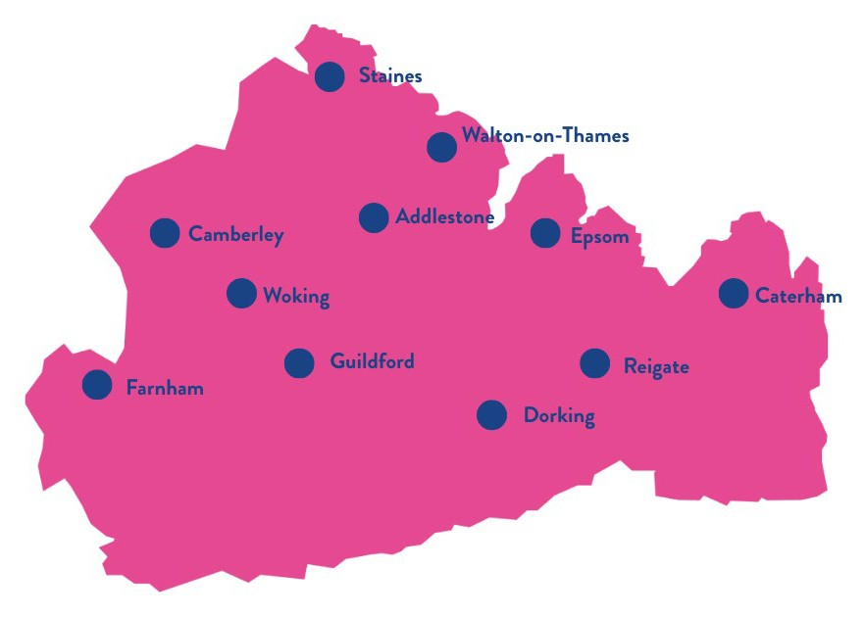
Safer Streets Summer
Neighbourhood crime has also been targeted through the Safer Streets Summer Initiative, which was delivered by police forces around the country as part of the Government’s Neighbourhood Policing Guarantee.
Surrey Police, working with local partners, worked together to coordinate activity and initiatives to address crime, shop theft, street theft and anti-social behaviour (ASB) in our town centres during summer 2025.
The roll-out was led by Surrey’s Safer Neighbourhood Teams, who are targeting resources to meet the demands of 11 town centres.
Additional, visible patrols took place in town centre ‘hotspots’, while themed operations tackled specific offences.
A series of successful outcomes have been recorded across 2025.
In Guildford, youth-related anti-social behaviour and crime has dropped by 75 per cent on weekends through Op Colt, which was continued as part of Surrey’s Safer Streets Summer. The campaign saw police and partners mount additional patrols, run targeted adverts, and ask takeaway venues to play classical music and cover charging points.
In Woking town centre, police recorded six consecutive days without a crime report during the summer, as well as 48 hours shortly after that. PCSOs have been assigned specific shops to visit weekly, while Meet the Beat sessions were held at eight local retailers in the borough. Across these eight stores, retail crime dropped by a total of 60 per cent.

In Dorking, police on patrol heard a disturbance in St Martin’s Walk. They swiftly intervened, arresting two people within moments for shoplifting. Police also investigated a series of shoplifting offences in the town, identifying two suspects from London who were arrested in the capital shortly afterwards.
Other types of criminality were also targeted, including anti- social behaviour, anti-social driving, and the sale of vapes and alcohol to underage customers.
In Epsom, Surrey Police conducted one of its largest-ever multi-agency roads policing operations after concerns about vehicle crime and anti-social driving. In a single day, there were 90 traffic stops, 12 arrests, including three
arrests for immigration and fraudulent document offences, and five weapons and drugs seizures.
The programme also aimed to engage with young people across the borough, with mentoring at a local boxing club in Epsom, summer holiday activities in Camberley and free swimming sessions in Walton.
Designing Out Crime Officers worked with businesses to deter criminals and offer advice, while police cadets marked property so it can be returned if it’s stolen.

How to report a crime

There are various ways you can contact Surrey Police should you wish to report a crime.
Call 999 in emergency situations such as: There is an immediate danger to life
Someone is using violence or threatening
violence
A road traffic collision where lives are at risk or a road is blocked
A crime is happening right now, such as a burglary or theft
If you accidentally call 999, stay on the line and tell the operator that you are safe, and that no crime has occurred.
Call 101 for non-emergency enquiries.
Our live chat function is available 24 hours a day, seven days a week and can be accessed via our website www.surrey.police.uk You can use this to report crime and get advice and information.
If it’s not an emergency, then the easiest way to contact us is online via www.surrey.police.uk where you will see the ‘report it’ button on the front page. Your report will be sent direct to our control room where it will be reviewed by the same team who answer our calls.
If you’re a social media user, you can also contact us via Facebook @SurreyPolice and X @SurreyPolice
If you have hearing or speech impairments, and you’ve pre-registered with the Emergency SMS Service (a link to which you can find on our main website), you can use our textphone service 18000 or text us on 999.
You can also report any suspicious activity via our Suspicious Activity Portal which you will find on the main Surrey Police website. Here we ask Surrey residents to help us reduce the number of burglaries in the county
by submitting video footage (such as CCTV, dashcam or smart doorbell footage) and photographs that may show any suspicious activity happening in your area. Every clip helps feed into our understanding of the bigger burglary picture in Surrey.
The portal is for circumstances where no crime has been reported, but you are concerned the suspicious behaviour could potentially be related to a burglary, theft of vehicle or anti-social behaviour, as well as any other forms of criminality.
If you would prefer to remain anonymous, you can call Crimestoppers on 0800 555 111.



16

