PART ONE Item 09

To: Joint Audit Committee

Date: 17th December 2025

By: Alison Bolton, Chief Executive, OPCC

Title: Local Government Reform and Transfer of Policing Governance

___________________________________________________________________

Purpose of Report/Issue:

To update the Committee on latest developments in LGR and the transfer of policing governance in Surrey.
___________________________________________________________________

Main Report:

A report was provided to the Committee in September 2025 on the plans for Local Government Reform in Surrey and Mayoral devolution. This report updates on number of significant changes since September.

Local Government Reorganisation in Surrey

In October 2025, it was confirmed by Government that Surrey councils will be re-organised into two unitary authorities – East and West Surrey.

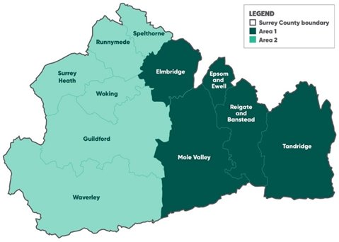

Elections to the new unitary authorities will take place in May 2026.The new unitaries will then exist as shadow authorities with the Borough and Districts and Surrey County Council having their existing responsibilities up until 31st March 2027 when they will be dissolved. The new unitaries will be fully in place on ‘vesting day’ on 1 April 2027.

It was expected when the Government announced the number of unitary authorities for Surrey, they would also announce timescales for Mayoral elections in Surrey. A Mayor would have taken on the role of the Local Policing Board, taking on all PCC powers. However, no indication was given as to when there might be a mayor for Surrey. It is still the Government ambition for all areas to be covered by Strategic Mayors.

Policing Governance

In November 2025 the Government announced that PCCs would no longer exist after their current term of office, May 2028.

Where there is a mayor in place in a police force area, they will take on the PCC functions. A Deputy Mayor will be appointed to take on the functions and responsibilities on a day to day basis. OPCC staff, assets and statutory functions would move over to the Mayor.

Where there is no mayor in place, local Police and Crime Board will be established. This board will be made up of elected representatives from the Unitary Authorities and co-opted members. A ‘Policing and Crime Lead’ will be employed by the Board to assist. All Statutory Functions of the PCC will transfer to the Board as well as all policing assets. It would be expected that the OPCC staff will transfer to the employment of the Board to fulfil these Statutory Functions. It is not yet known how this will be done and whether all staff will be transferred.

Where a Board takes on Police and Crime Governance, it will expected that over time a mayor will be in place to take over these functions.

Which of these two options will be in place for Surrey in 2028 is unknown.

Further legislation will be put forward to provide the details of the transfer of functions and staff.

Many of the impacts of a change in policing governance remain the same as provided to the Audit Committee in September. The main change is increased uncertainty for OPCC staff.

Project Management

To manage this significant change in the body for Policing Governance in Surrey as well as council reorganisation, the OPCC has formally set up a project. The Project Sponsor is the Chief Executive, Alison Bolton and Project Manager is Johanna Burne. Surrey Police are fully involved. Regular meets are also being held with Surrey County Council colleagues involved in the wider county transitional arrangements.

The first meeting of the Project Working Group in October was postponed due to delayed Government announcement on the unitary authorities. The group met on 15th December 2025.

___________________________________________________________________

Recommendation

The Committee is asked to note the update to LGR and Policing Governance.
________________________________________________________________

Contact details:

Name Johanna Burne
Job Title: Senior Strategic Project Officer
Telephone number: 01483 630200
Email address: Johanna.burne@surrey.police.uk

