Independent Custody Visiting Scheme

Annual Report April 2024 – March 2025


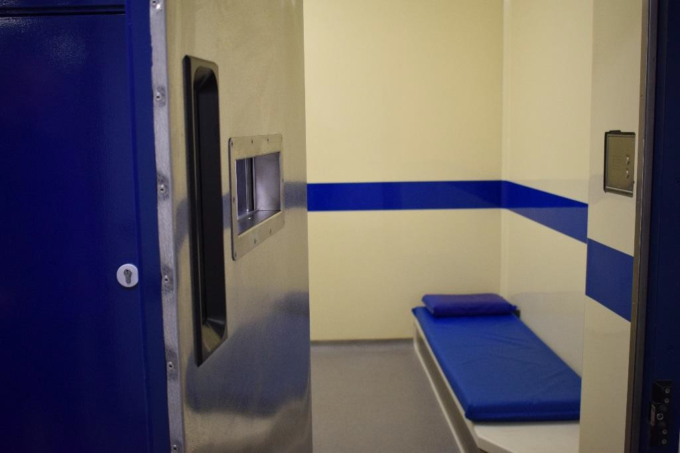



Foreword from Lisa Townsend

Upholding the highest standards of policing in Surrey is vital in maintaining the confidence of the communities that we serve across the county.

That is why I am proud to present the Independent Custody Visiting Annual Report for 2024/25 which shines a spotlight on the essential role volunteers play in ensuring the fair treatment of people in custody in our county.

Our Independent Custody Visitors (ICVs) give up their time to make random, unannounced visits to our three police custody suites in Guildford, Staines and Salfords to check on the welfare of those who have been detained.

Custody is a busy part of daily policing that is hidden from public view where our officers and staff deal with some of the most vulnerable people in our society.

I am so grateful to every one of our volunteers who last year made a total of 176 unannounced visits and spent over 320 hours in custody suites across Surrey over the last year.

Being detained in custody can have a huge effect on people, but the impartial approach offered by our ICVs can help reduce that impact.

By speaking to an Independent Custody Visitor, a detainee is able raise concerns that might not be otherwise recorded which are then shared with senior offices to learn and make changes where needed.
Their recommendations cover everything from ensuring that there are enough blankets in winter, to safeguarding someone who is experiencing a mental health crisis.

The ICV scheme remains such a valuable part of the work of my office does to champion transparency in policing and hold the Chief Constable to account.

This is only made possible by the passion invested in the scheme by every one of our volunteers, and by the ICV Scheme Manager Erika Dallinger.

I would like to thank all our volunteers for their continued service and commitment and Erika Dallinger, our ICV Scheme Manager, for the passion and dedication she puts into making it a continued success.

I look forward to meeting the volunteers again over the next year and continuing the support my office provides for the scheme in Surrey.
Lisa Townsend
Police and Crime Commissioner for Surrey

What is Independent Custody Visiting?
Independent Custody Visiting is a national requirement, detailed in a Home Office Code of Practice and supported by the Independent Custody Visiting Association (ICVA), whereby specially trained members of the public make random and unannounced visits to custody suites to check on the welfare of detainees and the conditions they are being held in. Locally, Independent Custody Visiting is under the remit of the Police and Crime Commissioner who has authority for running and maintaining the scheme in their force area.

Independent Custody Visiting provides protection to detainees and the police, and reassurance to the wider community. Volunteers from Independent Custody Visiting (ICV) Schemes across the UK check on the welfare of detainees who may be feeling vulnerable or confused, providing independent scrutiny of their treatment and the conditions in which they are being held. Independent Custody Visiting Schemes exist to provide reassurance to local communities they can have confidence in the way in which the police treat people who are held in their custody.

Independent Custody Visiting allows the police to demonstrate their commitment to transparency and provides public reassurance that policing in their area is fair and in accordance with statutory legislation and guidance. The aim of this Annual Report is to ensure that this information is available in the public domain.

When asked why they felt the ICV role was so important, one volunteer recently commented: “As a critical friend to the custody team we can, as another set of eyes and ears, highlight those detainees who we believe are most vulnerable and prioritise their health and welfare needs”. Another volunteer adds: “ICVs are critical friend to the custody staff as well as providing support to the detainees by checking on their welfare”.

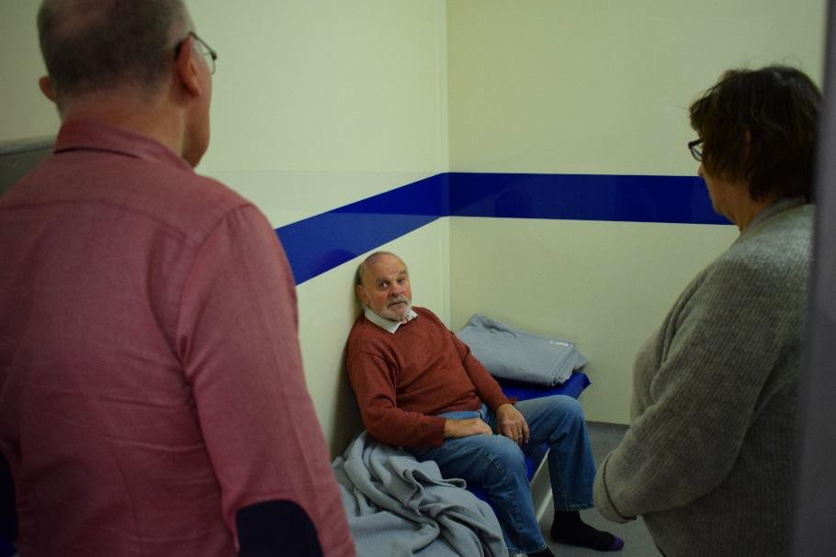

How the Scheme is Organised in Surrey?

Surrey Police operates from three custody suites at Guildford, Staines and Salfords (located in the Reigate area).

The cell capacity is as follows:-
- Guildford (24 cells)
- Salfords (24 cells)
- Staines (19 cells)

Each of the three custody suites has its own team of ICVs. The team is responsible for organising the visiting rota and undertaking the visits.

During a routine custody visit Independent Custody Visitors (ICVs) enter police cells and seek permission from the detained individual to speak to them. Conversations with detainees focus on welfare needs and the provision of rights and entitlements under the Police and Criminal Evidence Act (PACE). With permission from the detainee, they will also review the notes kept on their treatment during detention. ICVs are not concerned with the identity of the detainee or with the reason for their detention. Any issues raised are discussed as appropriate with custody staff. ICVs also inspect and comment on the general condition and facilities of the custody suite including the kitchen, medical room and showers.

ICVs look, listen, observe and at the end of each visit, report back to the Office of the Police and Crime Commissioner on their findings. The Commissioner takes any issues raised seriously and highlights them to Surrey Police in the appropriate way, keeping ICVs informed of feedback and actions agreed.

Recruitment & Demographics

ICVs are independent volunteers and must have no direct involvement in the criminal justice system. They come from a variety of backgrounds, must be over 18 and live or work within the Surrey Police area. During 2024/25, a total of 40 people volunteered their time to the scheme, with 35 active Independent Custody Visitors working within Surrey at the end of the year.

Exploring the composition of the volunteer team during the reporting period shows the following:
- Our volunteers gender mix remains unchanged from the previous reporting period 67% female, 33% male. The census data from 2021 shows within Surrey, 51% of the entire 1,132,000 population is female, 49% male.
- The average age of our volunteers is 64. The youngest volunteer is 24, the eldest 83. (Full details on the age breakdown are indicated in the bar chart). The ONS Community Life Survey of 2021 identified that the over 65 year old age group is more active volunteering nationally than younger citizens which falls in line with the experience of ICVs here in Surrey.
- The average length of service is slightly under 7 years with 274 years of combined service! 55% of volunteers have completed over 5 years of service, with our longest serving member having over 29 years of experience.
- 10% of all volunteers come from a known BME or Non-British background. Whilst ideally the scheme is looking to increase participation in this sector, overall this is broadly representative of Surrey’s population which in 2021 was 85% white.

Age Spread of ICV Volunteers
16
14
12
10
8
6
4
2
0
<30 30-39 40-49 50-59 60-69 >70
Age of Volunteers

Routine ICV Visits

Visits provide a snapshot of what is going on in custody at the time of the visit and are undertaken across all days of the week and on a 24-hour basis. Each ICV team aims to complete one regular weekly visit between the hours of 6am and 11pm and one monthly ‘out of hours’ (OOH) visit (between 11pm and 6am). This is crucial to ensure that visits do not become predictable and do not occur at set times.
When looking at the number of visits between the 1st April 2024 to 31st March 2025, the following can be established:
- Surrey’s ICVs conducted a total of 176 unannounced, random visits across Surrey’s custody suites.
- Surrey ICVs spent approximately 323 hours monitoring custody during the year, which given ICVs
always visit in pairs and occasionally 3’s, this equates to over 700 hours of volunteer time.
- Visits were spread over the entire week and hours of the day, thus helping keep ICV visits unpredictable. However, weekend visits are still considerably less frequent across the estate than weekday visits due to availability of volunteers.
- The average visit lasted 1 hour 53 minutes, a notable decrease year on year (down by 32 minutes) – this is helped by the embedding in of the electronic reporting which increased visiting times in the last 2 reporting periods as ICVs adjusted to new systems.

ICV Visit Statistics

70

60

50

40

30

20

10

0
Guildford Salfords Staines
Day Visits (6am-11pm) Overnight Visits (11pm-6am)
Spread of ICV Visits by Day
40

35

30

25

20

15

10

5

0
Sunday Monday Tuesday Wednesday Thursday Friday Saturday

ICV & Welfare Checks
During the 2024/25 reporting year, a total of 14,633 people were held in Surrey custody centres, which was a significant increase of 5.6% from the previous year. At the time of the ICV visits a total of 1,140 detainees were in custody (7.8% of overall annual custody population compared to 8.8% the year before). This sample size overall is, whilst a decrease year on year, is in line with the trends from the last 5 years with the previous reporting period being an anomaly. Of these 1,140 people:

- 830 detainees were randomly selected by ICVs for welfare checking during their visit. The remaining 310 were not selected due to time pressures for completing the visit (ICVs aim to keep visits to under 3 hours).
- Of these 830 detainees, 407 or marginally under half were available to talk to the ICVs. The remaining 51% of detainees were not available to the ICVs for justifiable reasons such as sleeping, being in interview or being booked in or out by the police or where a visit could significantly harm a volunteer, an officer or the detainee themselves.
- 399 (98%) of the 407 available detainees when asked by ICVs if they were willing to discuss their treatment in police custody agreed to do so.
- Only 8 (2%) detainees refused both the opportunity to talk to an ICV and for them to review their custody records.
- ICVs have noticed a significant, pleasing decrease in the number of detainees present in custody who are under the age of 18. During this reporting period, only 6% were children as opposed to 10% in the previous 12 months. This can be attributed to the work Surrey Police are currently doing to keep children out of custody and when they are in, keeping their detention times as short as possible.
- 197 (24%) of detainees in custody during ICV visits were female – this is a 1% increase year on year. ICVs always strive to see all children and females in custody, where practicable.

45%

7%
1%

47%
During visits, Surrey ICVs assume access to the anonymised custody records of detainees who are not available to them to have an overview of the welfare and treatment of as many detainees as possible. Taking this into account, ICVs had some form of direct welfare access to 822 of the detainees in custody at the time of their visit. This amounts to 72% of detainees in custody during an ICV visit or over 6% of the entire custody population. This level of oversight has increased when compared to the previous reporting period. Whilst Guildford notably checks the lowest percentage of detainees, this has increased year on year and the suite is typically the busiest.
Detainees agrees to ICV interview

Detainee refused ICV interview but explicitly accepted records check
Detainees refuses all ICV interaction

Detainee wasn't available for ICV interview, but ICV checked custody record

ICV Interaction with Detainees
 | Surrey Wide 2022-  23 Performance | Guildford | Salfords | Staines
Number of detainees in custody during ICV visits | 1,140 | 410 | 382 | 348
Number of detainees interviewed by ICVs | 399 | 127 | 128 | 144
Number of detainees refusing both interview & records check | 8 | 1 | 6 | 1
Number of detainees where an  interview wasn’t possible, but records checked | 410 | 114 | 134 | 162
Number of detainee refusing ICV interview but accepting records check | 13 | 6 | 2 | 5
Number not selected for sampling | 310 | 162 | 112 | 36
Percentage of detainees in custody receiving some form of direct welfare  check by an ICV | 72% | 60% | 69% | 89%

Disproportionality & Custody Visiting
 | Detainees Checked by ICVs | Overall Custody Population
White | 76% | 76%
Black | 4% | 6%
Asian | 10% | 8%
Mixed | 4% | 4%
Not Stated / Other | 7% | 6%

Issues around disproportionality are always explored when analysing data from visits. In the reporting period the ethnic mix of all detainees welfare checked by ICVs was broadly representative of the overall custody popu- lation.

Overall, these are felt to be very positive results, showing that detainees when they have the opportunity are happy

to engage with ICVs and in turn ICVs can check on the welfare of a significant proportion of detainees in custody on behalf of their local community and the Police and Crime Commissioner. This can be attributed largely to the professionalism and flexibility of the volunteers and the police’s continued commitment to and support of the scheme.

ICV Feedback

Independent Custody Visitors (ICVs) always address minor welfare concerns raised by detainees directly with custody staff during their visit. Wherever possible, they debrief with a custody sergeant before leaving, allowing both sides to clarify any outstanding matters. Issues that cannot be resolved in custody or over the phone to senior management are referred to the ICV Scheme Manager, who logs and follows them up with the Force. Outcomes are then shared with all ICVs to encourage discussion at panel meetings and promote cross-panel learning.

During the reporting period, 68% of visits raised no concerns—a 4% increase on the previous year—with ICVs generally reporting calm, well-managed custody suites. In over a quarter of visits (29%), ICVs identified issues that could be resolved on site. These typically related to detainee welfare—such as requests for a shower, food, or drink—or the accuracy of custody records (for example, ensuring the rationale for a strip search was fully documented or that detention reviews were communicated appropriately). By addressing such

0%
3%
29%
68%

No issues witnessed whilst in custody

All issues or concerns resolved whilst ICVs in custody. ICV Scheme Manager follow up requested
Serious issue or concern remains - Escalated to an Inspector during visit & formal written report into issue required
matters, ICVs directly improve detainees’ experiences in custody and support custody officers in
maintaining accurate records.
In only 3% of visits did ICVs request follow-up from the Scheme Manager. These concerns focused on:

- Staffing pressures – Several visits raised concerns over staff shortages, leading in some cases to custody suites closing to new detainees, or staff appearing stressed due to capacity issues. While the number of detentions has significantly increased in recent years, staffing levels have remained largely unchanged. ICVs have questioned whether this could impact detainee welfare. The matter is regularly discussed with senior custody management, who maintain a strong focus on recruitment and retention.
- Women in Custody leaflet – Introduced in the previous financial year, this leaflet provides important information for female detainees, including details on sanitary protection, and reinforces conversations with an assigned female custody officer. ICVs routinely check for its presence and ask female detainees whether they have received it. Several visits noted instances where it was not given out. Once brought to custody’s attention, the issue was promptly addressed, and no further concerns have been reported.
- Food provision – A national food contamination issue during the reporting period led to the withdrawal of many ambient ready meals from custody. This temporarily reduced options for detainees. ICVs commended Surrey Police for their cautious approach, which ensured no allergic reactions occurred, and for officers’ willingness to source suitable alternatives to meet detainees’ dietary needs or beliefs.

ICVs also continue to regularly commend the exceptional standard of care provided by custody staff. They consistently highlight staff’s strong commitment to detainee welfare and their efforts to ensure people leave custody in a better position than when they arrived. One ICV recently commented “the custody teams seem to be working well on whichever shift permutations. It would appear that detainees are handled with respect - in some cases almost beyond the call of duty”. Another ICV added that Custody Officers “have a challenging role which is generally delivered with compassion empathy and professionalism”. Feedback such as this is consistently fed back to Surrey Police and passed on to officers.

Training & Development

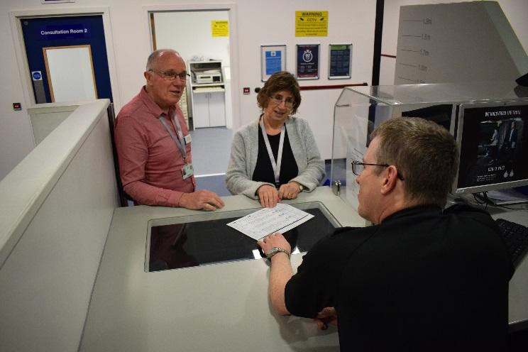
The most effective custody visiting schemes have well-trained and well-informed visitors. We take our responsibility to keep Surrey’s ICVs up to date with developments in the custody environment very seriously.

Alongside quarterly panel meetings—which provide valuable opportunities for networking and training—we offered a series of dedicated training sessions during 2024/25. These included a full-day conference in November 2024, featuring both internal and external speakers on topics such as neurodiversity, domestic abuse, personal safety, and local custody-specific issues.

Additionally national ICV training resources were used and both ICVA’s Scheme Manager and Volunteer
events were attended.

Regional Collaboration and ICVA


The South-East Regional ICV Scheme Managers (Hampshire, Sussex, Surrey, Kent, and Thames Valley) maintain an informal network to exchange information and share best practice.

Surrey’s ICV Scheme continues to play an active role in the Independent Custody Visiting Association (ICVA). Erika, Surrey’s Scheme Manager, served as an ICVA Director throughout 2024/25. ICVA provides valuable training for ICVs at all levels, alongside guidance, resources, and support for scheme managers.

Looking Ahead
ICVs continue to report well-run custody suites, managed by officers who value their visits. However, challenges and opportunities remain. Our main priority for 2025/26 is to maintain the Scheme’s Platinum Status for a further two years. ICVA will reassess all schemes during the year, and for Surrey this means ensuring new best practices are adopted, and that we continue to be among the leading schemes nationally in monitoring detainee care and making a positive difference for both detainees and custody officers. A particular focus will be the renewal of all volunteer management processes and procedures.

ICVs will also continue to support custody teams in key areas to ensure detainee care remains excellent, these include:

- Data-led improvements – Providing feedback from visits to help maintain high standards, such as comments on suite cleanliness, which support the management of cleaning contracts.
- Detainee dignity – Ensuring respect for detainees in all circumstances, from female-specific care to checking that any strip search is proportionate, justified, and properly recorded.
- Reducing detention times for children – Supporting Surrey’s initiative to minimise the time children spend in custody, influencing national practice by prioritising children during visits, monitoring their care, and ensuring cases are progressed as quickly as possible.

Volunteer & Make a Difference
If you are interested in finding out more about Independent Custody Visiting, please contact us. We would like to hear from you if you:

- Are over 18
- Live, work or study within the Surrey Police borders
- Can communicate well with a diverse range of people
- Can work as part of a team
- Are flexible and reliable
- Are a good listener
- Are objective and non-judgemental
- Can maintain confidentiality
- Have lived in the UK for the past three years
- Are willing to commit, where possible, for 2 years plus

An application pack can be downloaded from our website at http://www.surrey-pcc.gov.uk/independent-custody-visiting/

Contact Details
Erika Dallinger
ICV Scheme Manager
Office of the Police and Crime Commissioner for Surrey PO Box 412
Guildford Surrey GU3 1BR

Telephone: 01483 630200
E-Mail: surreypcc@surrey.police.uk Website: www.surrey-pcc@gov.uk

"1111111
OFFICE OF THE POLICE &
SURREY
R
A
►
CRIME COMMISSIONER FO
◄" ,..
�....11
--:.

0 surreypcc@surrey.police.uk C9 1483 630200
0
@surreypcc n 't# @ 0 O

