

* Update on the Dog School Income Generation Audit Action Plan *
Required for: | Joint Audit Committee September 2025
Security Classification: | Official
Handling information if required: | For meeting attendees only?
Suitable for publication: | Yes
Title: | Update on the Dog School Income Generation Audit Action Plan
Version: | V1.0
Purpose: | Progress Update
ACPO / Strategic Lead: | ACC Stephen Rayland
National Decision Model compliance: | Yes
Date created: | 29/07/2025
Date to be reviewed:

AUTHOR:
Name: | Daniel Gutierrez
Job Title: | CI
Telephone number:
Email address: | Daniel.gutierrez@surrey.police.uk
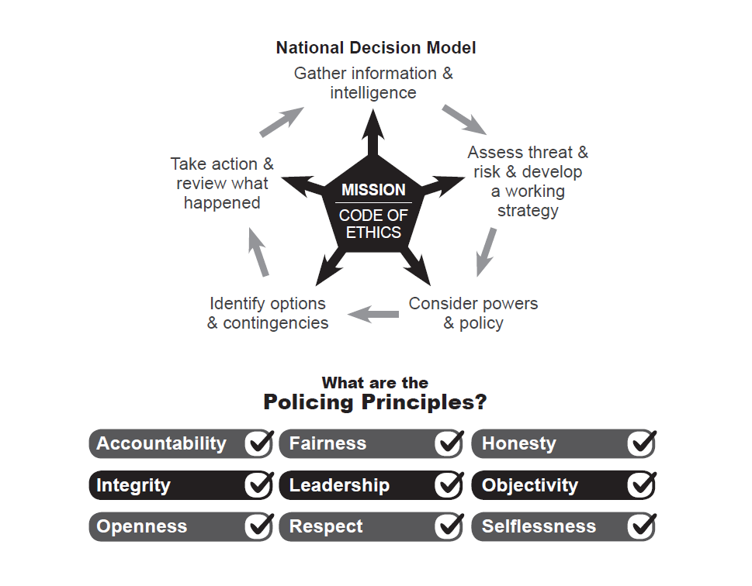

Introduction
In December 2024, the Business Development Team (BDT) was tasked with conducting an interim review of the Dog School. This review resulted in two interim reports identifying key areas for improvement. The terms of reference for this work were established by Chief Superintendent Graham Barnett, Head of Operations Command.
Subsequently, the Southern Internal Audit Partnership (SIAP) initiated an independent audit of the Dog School. Their final report, shared with Operations Command on 19 May 2025, identified 11 high-priority and 6 medium-priority actions. These findings primarily relate to external course income generation, structural and procedural compliance with National Police Crime Commissioner (NPCC), Foreign Commonwealth and Development Office (FCDO), and internal governance frameworks.

Southern Audit

- Commissioning and Scope: Assistant Chief Constable Rayland commissioned SIAP to validate the findings of the internal review and to ensure no risks had been overlooked given the internal findings, a ‘no assurance’ outcome was anticipated, and the additional scrutiny was welcomed.
- Audit Process: The audit scope was agreed upon at the start of 2025. The testing phase progressed rapidly, with weekly update meetings held between Louise Clarke (SIAP), Matt Cowling, and Chief Inspector Gutierrez.
- Engagement: SIAP conducted interviews with Dog School personnel, including the manager and office administrator. The final engagement with the Dog School Manager occurred on 18 March 2025.
- Audit Alignment: The audit followed terms of reference closely aligned with those used in the initial internal review.

Identified Risks/ Issues of the internal review:

3.1 International Training and Risk Assessments
- Risks related to international training and associated risk assessments were consolidated into a single issue on the risk register (KETO reference: STRJ5420). Remedial actions were led by Acting Inspector Songhurst and Sergeant Jones, ensuring all Overseas Security Justice Assistance (OSJA) assessments are current and processed appropriately.
3.2 Section 26 Authorisation
- The issue concerning the Section 26 authorisation for a 2024 visit to Uzbekistan has been resolved.
3.3 Governance and Process Improvements
- KETO is regularly updated to reflect progress against SIAP recommendations.
- The second component of the issue recorded on KETO pertains to the creation and management of Risk Assessments (RAs). PC Laura Heathcote, having completed Institution of Occupational Safety and Health (IOSH) Vital Skills training in Health & Safety, has taken responsibility for developing and maintaining these assessments. All Health & Safety RA activity has been subject to oversight by a Senior Specialist Health & Safety Advisor, ensuring that the Dog School is now fully compliant.
- New processes have been implemented to mitigate risk and enhance assurance. These are being embedded to support long-term improvement and influence future command-level policy development.
- While there is currently no formal Operations Command policy in place, a robust scrutiny and process framework has been established to ensure full compliance with the overarching Surrey & Sussex Financial Regulations, as well as all relevant legal requirements. This is currently being drawn in to Standard Operating Procedure (SOP).
- A formal meeting structure has been established to ensure appropriate levels of scrutiny and governance. The External Course Monthly Oversight Meeting, initiated on 27 June 2025, will report into the Finance and HR Meeting (FaHRM) and subsequently feed into the ACC Accountability Meeting.

This oversight meeting will provide updates on key areas, including:
- Courses delivered
- Evaluation outcomes and feedback
- Planned future courses
- Approval of external enquiries
- Review of OSJA requirements for international clients
- Confirmation of OSJA process accountability, with all records maintained in a single location to ensure full transparency and auditability.

- Work is ongoing to ensure that all income generation streams within Operations Command are subject to audit by the BDT. A dedicated Operations Command policy is being developed to encompass the diverse range of income streams, aligning with the Surrey & Sussex Financial Regulations.
3.4 Legal Pricing Structure
- A compliant pricing structure for courses, dogs, and associated equipment has been implemented, aligned with the NPCC National Policing Guidelines on Charging for Police Services (NPGCPS).
- This ensures transparency, legitimacy, and ethical charging practices. Each course will now be reviewed under the NPGCPS model.
- This provides us with that assurance that we can demonstrate the legitimacy of the pricing in a transparent way. It also provides assurance of an ethical charging process.

  - Governance Oversight
- Since June 2025, a monthly External Course Oversight Meeting has been established, chaired by the Chief Inspector for Police Dogs.
- This forum provides a single decision-making point for external course approvals and monitors legal and financial compliance.
- The meeting reports to the Operations Command Finance and Human Resources Meeting (FaHRM), the ACC Accountability Board, and the Operational Support Portfolio Lead.

Conclusions:
- SIAP’s findings were consistent with those identified in the internal BDT review.
- Previous processes for international client engagement lacked consistency and auditability These deficiencies have now been addressed following structured procedures.
- The BDT prioritised the international training workstream due to its potential reputational risk to Surrey Police.
- Ongoing collaboration between the BDT, Dog School, and wider Operations Command ensures continued focus on lawful and consistent income generation.
- Engagement with international clients remains appropriate, provided that all activity is transparent, consistent, and compliant with established processes.
- In addition to NPCC guidance, local oversight by Operations Command will enhance scrutiny, consistency and compliance across all training provisions.
- Since the internal review and SIAP’s final report (dated 19 May 2025), significant progress has been made in resolving issues related to External and international contracts and associated governance. The recommendations will remain open for a further period of 3 months to ensure that the new working practices have been embedded prior to sign off.

