

Local Government Reorganisation and Devolution Working Group
DRAFT Terms of Reference
Purpose:
To oversee the change to Local Government in Surrey in respect of:
- changes needed in Surrey OPCC to take account of new Surrey Local Government Authority structures
- Changes needed in Surrey Police to take account of the new Surrey Local Government Authority Structures
- Ensuring a smooth transition of Surrey Police Governance from a PCC model to a Strategic Mayor model
Aim
The working group will examine, coordinate and advise on arrangements relating to Local Government reorganisation and, in future, a move to a Mayoral Combined Authority (MCA).
The project will be in two phases:
1) Local Government Reorganisation
2) Move to a Mayoral Strategic Authority

Phases:
Phase 1 will include the following considerations:
- How the change from 1 county and 11 B&Ds to 2 unitary authorities will affect the Surrey Police Operating model
- Partnership arrangement changes for the OPCC and Surrey Police
- Changes to the estate
- Other considerations
Timeline: May 2025 to April 2027. The full change to a unitary council model in Surrey is due to take place in April 2027, with a shadow structure set up from May 2026.

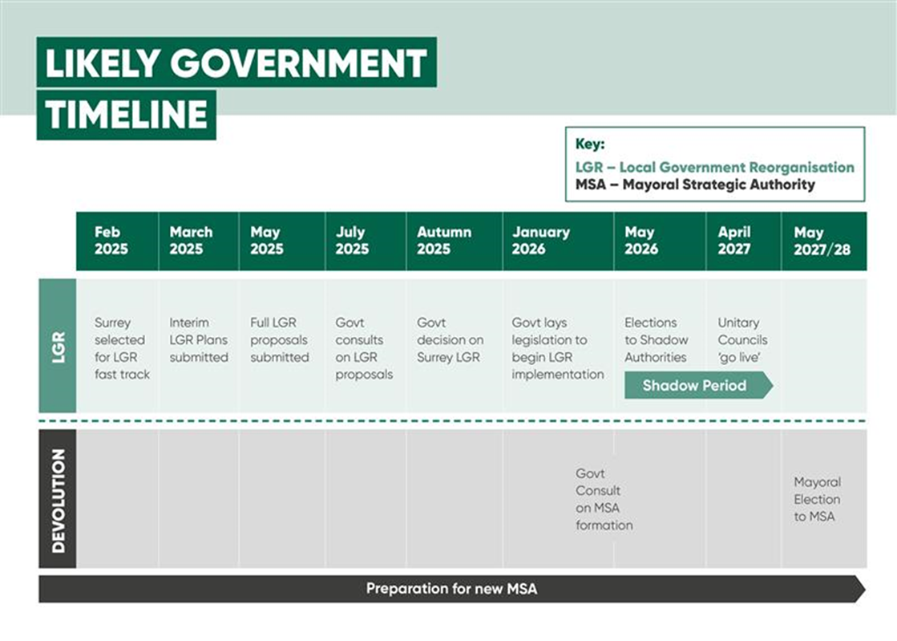
Phase 2 will include the following considerations:
- HR – transfer of OPCC staff to a MSA. Any transfer of Surrey Police roles. Training. Morale and welfare. Pay and pension transfers. Policies and procedures. Vetting.
- Governance and legal – to ensure transfer of statutory functions are undertaken in accordance with the relevant legislation and that a new scheme of governance in put in place
- Finance – ensuring that the policing budget is identified and created ahead of the introduction of the MSA. Ensuring finance reporting systems are in place
- Procurement – ensure all OPCC commissioning and procurement transfer arrangements are in place and existing contracts are moved over
- Estates, Fleet and Captial assets – these will move over to the MSA therefore there is a need for a full inventory and legal transfer arrangements. OPCC staff accommodation arrangements.
- DDaT and Information Management – to identify what systems OPCC staff will need and who will provide them. Transfer of any information to ensure continuity of business. Training on any new systems
- Communication and engagement – for OPCC staff, Surrey Police relevant staff, partners and public.
- Project management and oversight – to ensure project resources are in place to deliver the change, oversee a risk register, make decisions as needed.
- Other considerations as they arise.
Timeline: May 2026 to April 2028. It is currently unclear when a mayoral strategic authority will be in place or whether there will be shadow arrangements and then when the OPCC would move over to supporting a Mayor/ Deputy Mayor. But it is likely to be in May 2028. Work to do transfer of staff and responsibilities will mostly take place in the two years running up to this change, with engagement with partners starting from May 2025.

Membership:
Alison Bolton, OPCC Chief Executive, Chair
Johanna Burne, OPCC Project Manager
Sarah Haywood, OPCC Lead for Partnerships and Community Safety
Kelvin Menon – OPCC Finance Director
Ch Sup Mark Offord – Surrey Police
Claire McDonnell – Chief of Staff– Surrey Police
Lou Sutton – Head of Strategic Planning, Surrey Police
Peter Appleton – Chief Finance Officer, Surrey and Sussex Police
Anthony Croxford – Chief Operating Officer, Surrey and Sussex Police
Adrian Rutherford – Head of People Services

