PART ONE Item 11

To: Joint Audit Committee

Date: 29th September 2025

By: Johanna Burne, OPCC

Title: Local Government Reform and Devolution Project

___________________________________________________________________

Purpose of Report/Issue:

To inform the Audit Committee of the changes to Policing Governance that will be brought about by Local Government Reform and Devolution.
To inform the Audit Committee of the project being set up by the OPCC to manage the changes and ask for Audit Committee oversight.

___________________________________________________________________

Main Report:

Overview

The Government published a White Paper in December 2024 followed by the English Devolution and Community Empowerment Bill on 10th July 2025. This sets out an intention that over the next few years all areas in the country will have elected Mayors with Devolved powers in 7 main areas of council business. Devolvement will bring more local funding and decision making. To have a Mayor, an area must have single tier (unitary) local councils covering sizes of broadly around 500k residents.

Surrey currently has a two-tier council model with 11 Borough and Districts providing some local services and Surrey County Council providing County wide services. Surrey councils have agreed that they wish to see unitary authorities put in place to be followed by a Mayor for Surrey. Although the number of Unitary authorities is debated. There is a timetable for Local Government Reorganisation and then Mayoral elections in Surrey.

There are far-reaching impacts for both policing and policing governance from these changes. Not least the move of policing governance from a PCC to a Surrey Mayor. The OPCC has set up a project to understand the impact and manage these changes.

This paper seeks to update the JAC on the changes and the project and to ask for independent oversight of the project as it progresses.

Local Government Reorganisation in Surrey

Surrey currently has a two-tier council structure, with some local services being delivered by 11 Borough and District Councils and Surrey-wide services being delivered by Surrey County Council. The Government White Paper sets out an aim for all councils to become unitary. Surrey County Council has been campaigning for devolution of powers for some time. Unitary authorities must be in place for Mayor to be put in place together with a Mayor Strategic Authority (MSA) and unlock devolved powers.

The benefits of unitary authorities are set out by the Government as:

- Streamlined services
- Greater efficiencies
- Enhanced partnership working
- Simpler for the public to understand who provides services
- Ability to have a Mayor and unlock devolution

Some areas of the country already have Mayors, and they can proceed with devolvement of powers. Some areas already have upper tier authorities in place (which can them take on becoming unitary authorities and move to having a Mayor). This includes Sussex and Hampshire. Surrey does not but councils have agreed that they wished to proceed with Local Government Reorganisation (LGR) and then mayor elections as part of the government ‘accelerated programme’ for LGR.

In February, the Minister for Local Government invited Surrey Councils to submit proposals for unitary local government. All 12 local authorities will be abolished and replaced by 2 or 3 unitary authorities. In 2025 SCC elections were postponed for Surrey to be able to focus on the changes.

​Work on LGR has commenced in Surrey, led by SCC who will not exist after LGR. Interim plans were developed in March 2025 and final proposals submitted to Government in May 2025. SCC (and Elmbridge BC and MVDC) propose a 2 unitary structure for Surrey. ​ The other 9 Surrey Borough and Districts support a 3 unitary structure​ The Government issued consultation on both proposals in Surrey – ending 5th August. The PCC has responded in support of the 2 unitary model which fits well with Surrey Police plans for divisional reorganisation.

The services provided by 12 councils will be moved into 2 or 3 unitaries. Some services will be aggregated from 11 local councils into the unitaries. SCC led services will be disaggregated into 2 or 3. Part of the LGR/ Devolution project at SCC is a ‘Programme of Discovery’, which will be scoping out all council services currently provided and what should sit where in the future.
​
There is a Government requirement to retail the ‘local’ throughout reorganisation and to establish ‘neighbourhood governance.’ In Surrey initial work has started on new Neighbourhood Area Committees (NACs). There are likely to be around 22 of these. The OPCC and Surrey Police are engaged in this work.

Proposed models for Surrey

SCC two unitary model:

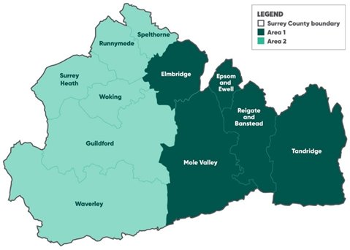

Three Unitary Model
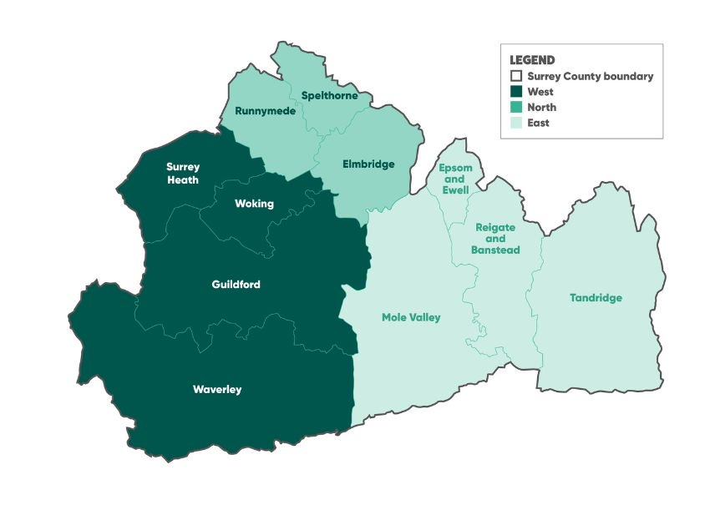

Source: Surrey County Council

Regardless of the number of Unitary Councils, the broad proposal for services from SCC is as follows:

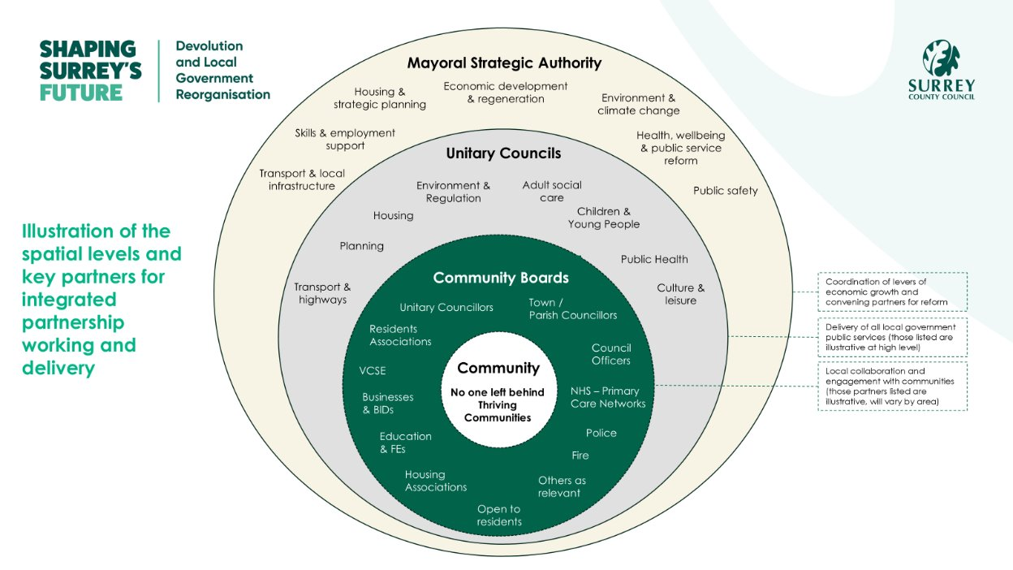
Source: Surrey County Council

Timeline for Surrey

In terms of LGR, the new structure should be confirmed by the Government in Autumn 2025. Elections for councillors to the new model will take place in May 2026. There will then be a transitional period between May 2026 and April 2027 where both the old council structure and new unitary structure will be in place, with a gradual move over of powers. From 1 April 2027, SCC and the 11 Borough and Districts will cease to exist.

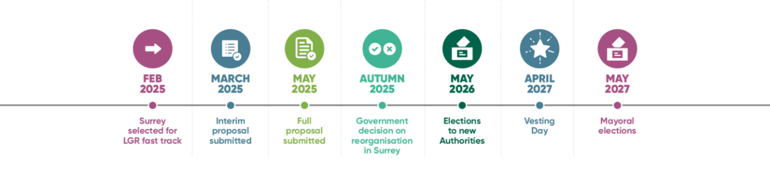
Source: Surrey County Council

Impact of LGR on Surrey Police and Surrey OPCC

There are several far-reaching impacts on policing and policing governance. These include:

- ​Policing and partnership structures that are based on a D&B footprint will need to change​
- Some partnerships will see fewer structures (e.g. a reduction in the current 11 Community Safety Partnerships
- Some will see more e.g. 2x children's services, 2 x highways authorities etc​
- Police estate based on current borough/district boundaries will need to change – there are currently some police bases in local council buildings
- Alignment of police divisional boundaries to fit new structures – link to current Surrey Police Op Solve operational policing plans
- Commissioning of victim services and other services may be affected
- Working with the new hyper-local structures
- People and relationships will change​
- Police & Crime Panel continues, but panel make-up will change ​
- Distraction from business as usual – ensuring vulnerable people are safeguarded and don’t fall through structural gaps etc

Mayoral Model and Devolution

Following on from LGR, the plan in Surrey is to move to election of a Mayor, supported by a Mayoral Strategic Authority, MSA. Under devolution there would be more local funding and decision-making powers given to a Mayor in 7 areas of competence:​
​
- Transport & infrastructure​
- Skills & employment​
- Housing & strategic planning​
- Economic development & regeneration​
- Environment & net zero​
- Health, wellbeing & public service reform​
- Public safety (which will include the responsibilities that a PCC currently has)

The Mayor would appoint Commissioners to assist in discharging their duties. In legislation they will also be required to have Deputy Mayor for Policing, who would carry out the day-to-day functions of policing governance. The Deputy Mayor for policing could also take on a wider remit in public safety – for example Fire and Rescue governance and wider Community Safety.

The Mayor will be part of the Strategic Authority, which will also include members of the constituent local authorities in Surrey.

All the functions currently carried out by the PCC would be moved over to the Mayor, who would then pass responsibilities to the Deputy Mayor for Policing. At least initially, it would be expected that the OPCC staff would be transferred over to the Mayor’s Office. These functions include:

- Hiring (and in some cases firing/ holding misconduct hearings) the Chief Constable
- Setting the Policing and Crime Plan, to meet local needs – a document which then the Chief Constable uses to set their strategy
- Holding the Chief Constable (and thereby force) to account for performance
- Overseeing finances and setting the precept
- Ownership of all capital assets (estates, IT, vehicles etc) – usually (but not always) given over to the Chief Constable to manage as part of the Scheme of Governance
- Oversight of procurement and contracts
- Commissioning of all victim services (from Victim Support services through to specialist provision), Community Safety fund and reducing reoffending
- Partnerships such as Criminal Justice, Social services, road traffic etc.
- Being the link between the police and the public – informing the public, consulting and addressing concerns
- Complaints oversight and review
- Managing the ICV scheme
- Oversight of misconduct cases

As shown in the timeline above, it is expected that a Surrey Mayor will be elected in May 2027. It is not yet known when the MSA will be set up, but potentially this could be 1 April 2027, to support the incoming Mayor. The current PCC term runs until May 2028. It is yet unknown when the formal transition of powers will take place. However, in Sussex (which is a year before Surrey) transition of powers are taking place the April after the Mayoral election. If a similar timeline is followed in Surrey, transfer of powers would take place on 1 April 2028.

Impact of Mayoral Elections and Devolution on Surrey Police and Surrey OPCC

The main impacts on the Surrey OPCC are:

- PCC will no longer be a post in Surrey with powers transferred to a Mayor / Deputy Mayor
- Staff transfer to the new MSA – unsure how this will work yet or whether the Mayor will want a distinct ‘policing governance’ team or part of a wider mayoral support team – issues of uncertainly and morale for staff
- Potential new base for the staff – unsure whether they will be based at Mount Browne or near a mayoral base
- New partnership arrangements/ new staff in Surrey new council arrangements
- All business transferred over
- Assets including all estate (HQ, other buildings), IT and vehicles to be transferred over
- Managing business as usual during transfer – including precept setting, holding Chief Constable to account, Commissioning services, dealing with complaints etc.
- Opportunities to develop joint working with fire and other public safety services
- Opportunities to look at joint assets
- Opportunities from greater devolved powers

The main impacts on Surrey Police are:

- Transfer of assets – uncertainty of a mayor strategy for ownership of all Surrey assets
- New partnership arrangements
- New arrangements for holding to account and governance
- Relationships between a Mayor and a Deputy Mayor for Policing
- Opportunities for better joint working in Surrey
- Uncertainly for collaboration arrangements – particularly with Sussex. Sussex will be getting a Mayor in May 2026, and this may also impact on collaboration.

Project Management

To manage this significant change in the body for Policing Governance in Surrey as well as council reorganisation, the OPCC has formally set up a project. The Project Sponsor is the Chief Executive, Alison Bolton and Project Manager is Johanna Burne. Surrey Police are fully involved.

A workshop was held between the OPCC and Surrey Police with senior leaders from both organisations present. This was to set the scope of the project and ask for input on people to be involved, the Terms of Reference for a Working Group and the main Risks and Opportunities.

The first meeting of the Project Working Group is on 20th October 2025. The group will then meet every other month. This group will co-ordinate the project strands and ensure that both the OPCC and Surrey Police are carrying out actions to best manage the change.

Draft Terms of Reference for the Working Group are attached.

The JAC has no formal role in the project, however with it being such a significant change it is requested that the JAC keeps an oversight role and acts as a ‘critical friend.’ It is recommended that this is done via reports to each JAC meeting. Following transfer of powers, the JAC will be a Joint Audit body for Surrey Police and the Mayor/ Deputy Mayor for Policing.

___________________________________________________________________

Recommendation

The Committee is asked to:
- Note the changes being brought about to Surrey’s council boundaries and the impact on policing and the OPCC
- Note the changes from a PCC to an elected Mayor
- Note the project plans to manage the changes
- Agree to act as a ‘critical friend’ throughout the project

Attachment: Appendix A –Draft Working Group Terms of Reference

Further information:

Surrey County Council website for LGR/ Devolution

https://www.surreycc.gov.uk/council-and-democracy/lgr

Local Government Briefing on the Bill:

https://www.local.gov.uk/parliament/briefings-and-responses/english-devolution-and-community-empowerment-bill-lga-policy#part-two-functions-of-strategic-authorities-and-mayors-

________________________________________________________________

Contact details:

Name Johanna Burne
Job Title: Senior Strategic Project Officer
Telephone number: 01483 630200
Email address: Johanna.burne@surrey.police.uk

