

SURREY POLICE POLICY MANAGEMENT UPDATE
Required for: | Joint Audit Committee September 2025
Security Classification: | Official
Handling information if required: | N/A
Suitable for publication: | Yes
Title: | Update on Policy Management
Version: | V2
Purpose: | To provide an update to the JAC on the Force policy management arrangements
ACPO / Strategic Lead: | Anthony Croxford
National Decision Model compliance: | Yes
Date created: | 20th August 2024
Date to be reviewed:

AUTHOR:
Name: | Helen Bayliss
Job Title: | Department Head
Telephone number: | 07967988379
Email address: | helen.bayliss@surrey.police.uk
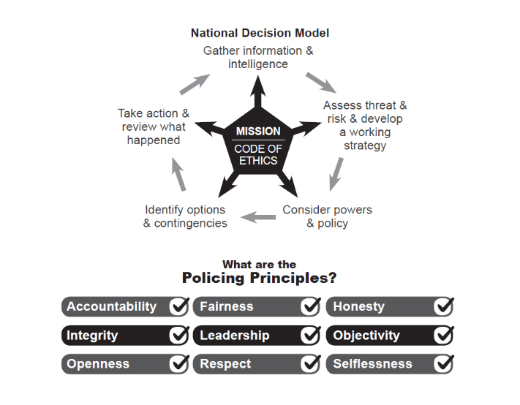

Policy Management  Surrey Police Policy Management Arrangements  To: Joint Audit Committee  From: Helen Bayliss  Date: 20 August 2025 | 

- Introduction
Policy, Authorised Professional Practice (APP) and the National Decision Model (NDM). Policy and Procedure govern most of the tasks the Force undertakes to carry out its roles.

- A policy is a short statement of Surrey Police’s intention and/or goal; a 'what' document

- A procedure describes the major tasks required to achieve the objective/goal outlined in the policy. They contain mandatory instruction describing what processes need to be followed. A procedure is the 'how' document. It is quite normal to have more than one procedure sharing the same policy.

The Forces hold Policy & Procedure documents in two categories.
- Where they are required through Acts of Parliament e.g.

    - UK General Data Protection Regulations (UKGDPR)
    - Data Protection Act 2018
    - Health & Safety at Work Act 1974
    - Freedom of Information Act 2000

- Where they are required by the Forces to explain what the Force must and must not do to minimise risk.

APP-
Where APP is available it will be followed by the Forces unless there is deviation. In this instance the Forces will write their own policies. Where APP is referred to it must be hyperlinked, sections of text must not be copied.
NDM-
Where policies are not available through the respective Forces’ database and guidance not available on the intranet, officers and staff must use the NDM along with appropriate risk assessments e.g. THRIVE (Threat, Harm, Risk, Investigation, Vulnerability and Engagement), SCARF (Single Combined Assessment of Risk Form) / DASH (Domestic Abuse, Stalking and Harassment) / SST (Risk Identification Checklist for use in Stalking and Harassment Cases) / HARA (Hate & ASB Risk Assessment).
- Ownership
Policy and Procedure documents are owned by the Chief Constables of the Forces with maintenance devolved to the risk owner of the area of business. New documents and those requiring review must be considered for collaboration. If documents cannot be collaborated there must be sufficient rationale as to why. All standalone documents must be approved by the Head of Information Management.

- Creation and Review
The Policy Framework process for creation, consultation and review has changed slightly since last year, with the introduction of sunsetting policy and procedures that have not had a review in 6+ months (of the required review date), with the issue being transferred to the Keto Risk Management system for the relevant department head to manage until retirement or reinstatement of the Policy and Procedure. This will allow for officers and staff to be confident that they are relying on current an up-to-date information whilst executing their duties.
Following the update from the last year, it remains the position that the Force (in conjunction with Sussex Police) have had approval to use the Microsoft 365 platform for Policy Management moving forward. This will automate the process for authors and reviewers and providing a common platform for Policy Management. This new tool will help mobilise Policy and Procedure making more accessible and reportable on, allowing for authors to consideration if further communication options are required aside from Routine Orders to promote its use/awareness of. It will also allow for the Force to have much more oversight and grip of the use/frequency of use of its policies. The user requirements and IT impact assessment have been completed, and we are waiting development time to be scheduled within DDaT.
- Use of and Assurance

Policy and Procedures are accessible to everyone through the Forces Intranet on a standalone SharePoint on premise provision that allows for the documents to be linked and referenced without compromising the integrity of version control.
The Force has several indicators to ensure the of use of (policy) and assurance or adherence of the same, examples being:

4.1 Op Falcon, addressing investigative standards, through from correct template use, adherence with crime recording standards, investigative frameworks, to the application of the correct outcome, with direct feedback being issued.
4.2 Force Audit Team is in place to audit against the strategic crime plan, signed off yearly at the Strategic Crime and Incident Review Group chaired by the Deputy Chief Constable (DCC), the audit areas will reference back for adherence to policy, as per the targeted review area of focus, with feedback provided via the Force Performance Teams or directly for specialist units.
4.3 External Audit will audit against Surrey Police’s more corporate suite of Policies i.e. risk management for assurance and monitored via the Organisational Reassurance Board, again chaired by the DCC.
4.4 Risk Management more broadly will also consider Policy requirements when dealing with risks and issues as well as areas for improvements and recommendations. When Policy forms part of the response or mitigation it is further considered via the risk assurance process.
4.5 Inspectorate regimes across Policing, this can be from His Majesty’s Inspectorate of Constabulary and Fire & Rescue Services (HMICFRS), to Investigatory Powers Commissioner's Office (IPCO), the Information Commissioner's Office (ICO), Ofsted, Biometrics and Surveillance Commissioner, this is not an exhaustive list, will utilise the Force’s policies as the backdrop for any inspection activity to assess against reality verses expectation and requirements, again with findings managed through the Keto Risk Management system until sign of and assurance.
4.6 People data presented to the DCC, i.e., from People Services (complaints, civil claims) through to Professional Standards Department (PSD) data (complaints, litigation, investigations), all serve to provide a thematic view of Policy compliance and deviation from policy, either in the positive or otherwise.
4.7 Across Surrey Police, the Force have the annual integrity check with line managers having bespoke conversations around work-based behaviours as well as the Focus assessment process and annual vetting assurances. Whilst it is incumbent on everyone to read Routine Orders weekly, where policy updates are published as part of their contracted personal responsibility, this will be supported by line management structures, ensuring key updates are disseminated to staff as appropriate.
4.8 Some policies have trialled a ‘sign up’ process i.e. the Domestic Abuse Policy, where officers were asked to verify, they had read and understood the policy. This is not appropriate in every instance of policy management but is a method that is available to the Force in the right circumstance i.e., a focused prioritisation. Further examples being the Security Matters Policy. These however are usually ‘one-time’ events. On an annual basis there is a suite of mandatory College Learn packages, these relate to the Force agreed mandatory areas of priority linked to policy (Data Protection, PSD policies as examples). This is tracked and reported into Senior Management Teams (SMT) via the Human Resources (HR) Business Partners to ensure compliance and also serves as an additional pathway to enable policy requirements to be read, understood, and monitored.

- Compliance and Assurance
As can be evidenced above, the assurance mechanisms, whilst useful as indicators for compliance with policy are piecemeal and do not serve to proactively provide assurance, more over they test compliance, after the fact.
The functionality of the new Policy Management system will therefore unlock the potential route of proactive compliance monitoring to both assure and drive performance improvements.
This will be a pillar within the Assurance and Compliance Framework and the mobilisation of Information Management through a Knowledge Management workstream currently being scoped and developed under the Chief Operating Officers portfolio.
The development work for this new provision is currently at number 57 on the internal change prioritisation list and will be enacted once resource is available or the server for the on premise SharePoint is decommissioned, whichever comes first for the Force.

- Summary
The design documentation for the new Policy and Procedure offering will be made available to the Joint Audit Committee and we would welcome comments and suggestions before development starts.

