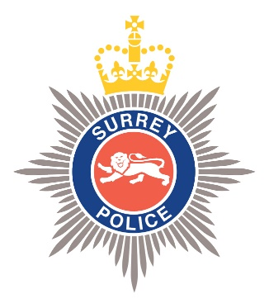

SURREY RISK MANAGEMENT UPDATE
Required for: | Joint Audit Committee Sept 25
Security Classification: | Official
Handling information if required: | Suitable for publication
Suitable for publication: | Yes
Title: | Surrey Police Risk Management Arrangements
Version: | V1
Purpose: | Risk Management Governance Arrangements
ACPO / Strategic Lead: | Louise Sutton
National Decision Model compliance: | Yes
Date created: | 2nd September 2025
Date to be reviewed:

AUTHOR:
Name: | Strategic Governance Team
Job Title: | Corporate Development Department
Telephone number: | 07967 988856 (Sandra Gammon - Strategic Governance Manager)
Email address: | strategicgovernance@surrey.police.uk
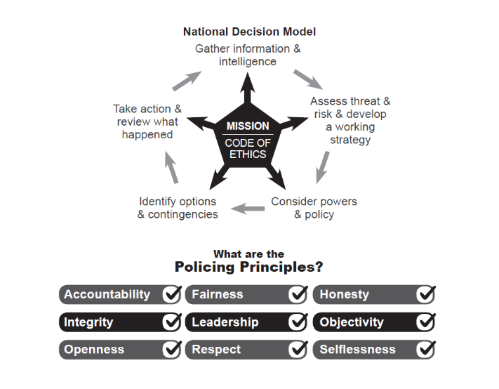

Risk Management  Surrey Police Risk Management Arrangements  To: Joint Audit Committee  From: Strategic Governance Manager, CDD  Date: 2nd September 2025 | 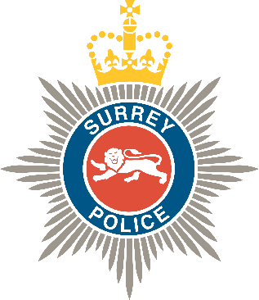

1.0 Introduction
Surrey Police launched the joint risk register KETO with Sussex Police in 2022. The system has been live for over 3 years. The KETO risk management framework has enabled the Force to put the following mechanisms in place;
- Risk Assurance Days (Joint Surrey and Sussex and Surrey - March/April 2025)
- Assurance reporting – i.e. exception reporting via the platform
- Risk dashboards for owners
- Metric products and dashboard views
- Ability to ‘split’ risks for owners to assign mitigations across Force/Depts
- Board reporting built into the system (to view risks that may span across multiple boards i.e. information security, the SIRO may require sight of information risks being managed by another department).
The DCCs as Chairs of the Organisational Reassurance Boards (ORB) have retained the responsibility on behalf of their respective Chief Constables for ensuring that robust risk management practices are adhered to. From September 2025 the Surrey ORB will be the Surrey Force Assurance Board (FAB) and will be held monthly. Yearly risk assurance days support this by deep diving into portfolio risks (regardless of whether they are Strategic or Departmental).
Chief Officers are responsible for the identification and management of all risks that are relevant to their portfolio which may affect the delivery of the portfolio’s objectives. Chief Officers will ensure that these risks are reviewed on a regular basis at their portfolio/strategic board meeting, together with the Force top strategic risks.
Divisional Commanders and Departmental Heads are responsible for the identification and management of risk in their areas of control and for ensuring that identified risks are recorded using the joint risk management system. They must identify and review their risks, issues and recommendations on a monthly basis at Command/Senior Management Team Meetings and ensure identification of risks that should be escalated to portfolio/strategic board meetings.
Risk Coordinators are responsible for working with their chief officer or division/departmental command teams to identify, record, score and track risks on the risk management system. They must ensure the risks recorded for their division/department or portfolio area are reviewed and updated regularly.
2.0 Assurance
The Head of Service Improvement and Strategic Governance Team in Surrey Police will:
- Take forward the Risk Management Strategy and lead, advise and report on risk management.
- Jointly own and manage the ongoing development of the risk management system.
- Advise senior officers and business leads in relation to risk management
- Work closely with nominated risk coordinators.
- Independently review risk management and control strategies
- Prepare reports for the strategic boards detailing the top strategic risks for scrutiny.
- Create a quarterly report for the Joint Audit Committees, enabling the Committees’ role in providing assurance that the risk management arrangements that are in place in each Force are adequate to effectively manage organisational risk and to monitor progress in addressing risk related to issues reported to the Committees.
- Department level risks may be closed at a management meeting by the Head of Department – once it is agreed that the risk no longer applies. Strategic level risks may only be closed once reviewed by the chief officer responsible for the portfolio to which they relate.
- Assurance (evidence to support the closure) must be articulated in the closure statement for all risks.
The risk management process is subject to both internal and external audit review. Audit activity is coordinated to avoid duplication and is reported to the JACs. A Risk Management Audit was conducted in Quarter 4 2023 and received ‘Reasonable’ assurance.
To ensure that lessons learnt from managing risks are captured and communicated, key learning points are recorded on the risk register at the time of archiving.
3. OPCC Arrangements
The identification and management of the risks that relate to the PCC for Surrey will be dealt with separately within the Offices of the Police and Crime Commissioners. Currently monitored through their risk review meetings via their risk register (spreadsheet).
The PCCs have a statutory duty to scrutinise their respective Forces’ risks and control measures. Each PCC must be satisfied that sound systems of internal control for the management of risk are in place. In order to enable this, risk management processes within each Force will be reported to the PCC on a regular basis, the OPCC are regular invitees to ORB/FAB.

4. Conclusion
Arrangements across the OPCC and Surrey Police changed during 2021, however have remained consistent since, with the continuation of risk assurance days and new enabling technology. JAC will continue to be sighted on the development of these products moving forward.

Paper for information.

