
Surrey Police
Medium Term Financial Plan
2025-2029
March 2025

Achieving financial excellence | finance department
Official

Contents
- Summary
- Context
- Introduction
- Funding
- High level Budget Planning & Strategy
- Investments and Commitments
- Force Fit for the Future
- Savings Programme
- Headcount Impact
- Capital Strategy
- Assumptions
- Risks
- Reserves
- Appendices
A – Medium term financial forecast
B – Savings plan
C – Financial assumptions
D – Capital programme & financing
E – Risk analysis
- Glossary

Contacts

Document Owner
Peter Appleton
Executive Director of Commercial & Finance Services
Document Editor
Bev Foad
Head of Business Partnering and Support

- Summary
The Medium-Term Financial Plan supports the delivery of the Police and Crime Commissioner’s Police and Crime Plan, the Chief Constable’s Force Plan and the Force Management Statement priorities. The assumptions used are based on a prudent assessment of the future but are only a prediction. A base scenario had been prepared based on these assumptions, the base scenario, but the plan also includes an illustration of the financial impact of changes in these assumptions.

Since the approval of the 2025/26 budget, which is reflected in this document, there have been some significant changes in the budgeted savings along with additional in-year cost pressures identified. The profile of some anticipated savings has changed due to delays in the implementation of a new system. The result of the system delays and the additional cost pressures is that the force will need to identify alternative savings during the year to close the budget deficit. This position will be closely monitored during the year through the monthly budget monitoring process.

- The funding settlement for 2025/26 and forward outlook;
The financial settlement for Policing for 2025/26 was announced by the Government on 30th January 2025, the key elements were;
    - Nationally the financial settlement provided a total of up to £19.6 billion for policing in 2025/26, an increase of £1.1bn on the 2024/25 funding settlement.
    - Available funding to Police and Crime Commissioners (PCCs), and hence to Forces, would increase by up to an additional £986.9 million in 2025/26, provided that Council Tax was increased by £14 on band D – the maximum allowed without a referendum. This represented an increase in PCC funding in cash terms of 6.0% on top of the 2024/25 police funding settlement.
    - The funding settlement included an amount for officer pay awards for 2024/25.
    - This settlement also included funding for the recruitment and redeployment of more neighbourhood police and PCSOs. An additional £200m was provided in 2025/26 to kickstart the first phase of the recruitment of an additional 13,000 neighbourhood officers, PCSOs and special constables.
    - Funding for counter-terrorism continued with £1 billion for 2025/26 to support ongoing counter- terrorism policing investigations to keep the country safe and including funding for both armed policing and the counter-terrorism Operations Centre.
    - The settlement also included £230.3m to partially compensate forces for the increase in employer’s National Insurance Contributions from 2025/26.
    - The Government expect the police to deliver efficiencies and drive forward improvements to productivity. To enable this, the Home Office have launched the Commercial Efficiencies and Collaboration Programme which will initially focus on national buying frameworks and cost recovery from provided services.
    - The Home Office expected policing to approach the 2025/26 financial year with a focus on the Government’s key priorities:
        - Increasing the number of officers, PCSOs and special constables in neighbourhood policing teams.
        - Tackling violence against women and girls.
        - Reducing knife crime.
        - Tackling antisocial behaviour.
By doing these things, it hopes to increase public confidence in policing.
- In 2025/26, funding for areas including Arms-Length Bodies, Cyber Crime, Forensics, Fraud, Police Productivity and Innovation and Tackling Exploitation and Abuse (including Violence against Women and Girls) will be decided as part of the Home Office’s wider budget allocation process, with funding arrangements for specific programmes confirmed in due course.

The efficiency savings requirement;
As costs are rising at a faster rate than resources the Force will need to find savings to enable it to deliver a balanced budget. Any savings required will need to take account of the continued challenges facing policing such as maintaining the capacity to meet new crime threats in public protection such as domestic abuse, child sexual exploitation and vulnerable adults. Investment is also needed to enable opportunities from digital ways of working and to meet the threat from the growth in digital crime.
For the planning period 2025/26 to 2028/29 it is estimated that savings of £18.5m will be required with £3.6m needed for 2025/26.
The efficiency plan;
The Force continues to develop a robust and achievable saving plan to balance the budget. Work is ongoing to identify savings against the pressure of having to recruit officers to maintain uplift numbers and deliver the neighbourhood guarantee being implemented for 2025/26.
  - Transformation Programme
  - The Force is working on a transformational programme which is looking at the entire operating model. It is anticipated that this should deliver savings as well as operational improvements.

The reserves plan;
This budget for 2025/26 assumed there would be no use of general reserves to balance the budget. It was however planned to use PCC Cost of Change reserve to meet the costs of transformation during the year.
The reserves policy remains maintaining them at a level of 3% of the net annual budget in line with CIPFA guidance.
The capital plan;
Capital reserves from asset sales are being built up in order to partially fund the Estates transformation program. Borrowing will also be required to deliver this but this has to be affordable. Short life assets are having to be funded out of revenue thereby impacting the revenue budget. In order to maintain an affordable capital programme, limits have been set on the level of investment that can be funded and so this has meant that projects have had to be prioritised depending on the business case, organisational need and the ability to deliver savings.
- Context
Inflation
Over the last few years prices of both goods and services have risen sharply leading to an increase in the rate of inflation. For Policing we have seen this impact in areas such as fuel, IT licenses, forensics and services. The rate of increase in our funding from taxpayers and the Government has not kept pace with inflation and in particular the increase in wages which is our biggest cost. This fundamentally has led to the increasing budget gap over time which can only be addressed by finding savings.
As an illustration to the change in inflation the Consumer Prices Index including owner occupiers' housing costs (CPIH) rose by 3.7% in the 12 months to February 2025, down from 3.9% in the 12 months to January. The last 5 years are shown in the graph below:
Table CPIH Inflation 5 Years – Source ONS
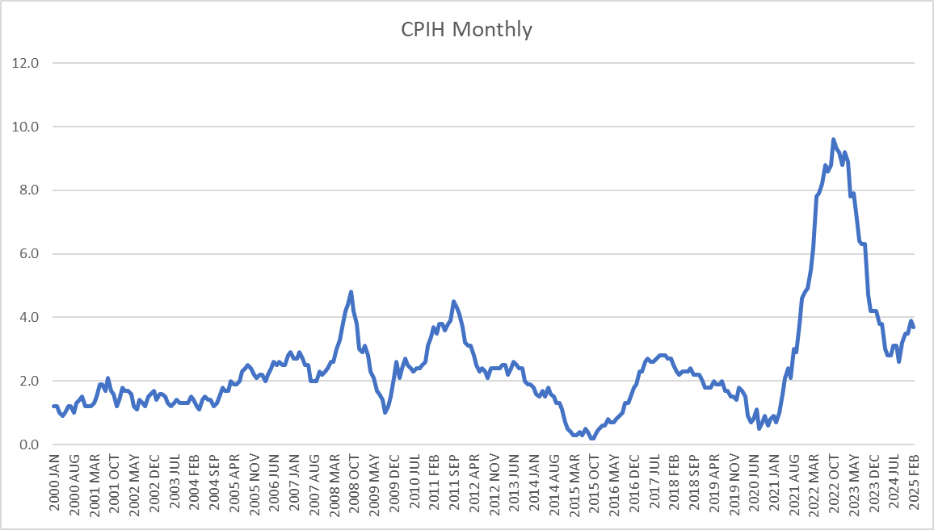
Inflation (and hence the rise in pay) continues to be of particular concern as we plan for the next 4 years with the Bank of England’s prediction of a Consumer Prices Index (CPI) figure of over 3.75% in 2025 an increase of 0.75% from last year; December CPI was 2.5%. These risks have been considered and are included in the financial risk assessment in Appendix E.
Demand and Productivity
Surrey Police continues to focus on making Surrey a county that is safe and feels safe. The Chief Constable plan entitled “Our Plan” sets out the force’s strategy and its commitment to our communities, our force and our people. The Force will use this framework to focus activity over the next four years:
- Surrey Police fights crime and protects people.
- We strive to earn the trust and confidence of all our communities.
- Here for everyone who needs us, we put service before self.
- We prevent crime and solve problems.
- We investigate crime thoroughly.
- We pursue criminals relentlessly.
This strategy has started to deliver dividends in terms of increases in the number of criminal apprehended and charged. However the volume and complexity of crime of crime continues to increase and so even though improvements are made the demand continues to rise.
Funding Formula
The previous Government commissioned a review of the national funding formula in order to make it “fairer”. Unfortunately, due to the election they were unable to consult on any changes and so work does seem to have stalled. Both the National Audit Office and the Public Accounts Committee have both criticised the Home Office for their lack of understanding of police demand and that the current funding formula doesn’t reflect policing needs. That said any formula will only looks at relative rather than absolute demand when compared with other Forces. Given Surrey is relatively safe this could result in less rather than more funding for the Force. The fundamental issue which no formula review can address is that there simply is not enough money in Policing to meet demand.
- Introduction
This paper provides the latest projections on the financial position for each of the financial years up to 2028/29. It also goes on to summarise progress with the Force’s strategic efficiency saving programmes and the likely effect this may have on employee numbers throughout the period.
This version incorporates unavoidable costs from 2024/25, pay inflation and other unavoidable cost pressures, such as funding for IT licences, national charges, salary increments, fuel and utility increases, increase in SEROCU contributions. Forensic fees, legal fees, Estates Strategy funding costs and the revenue contribution need to fund capital costs.
An estimated phased capital programme has been included in this document however the timing may change over time as the program is reviewed. The Police Capital grant from Government to individual PCC’s ceased in 2021/22 and was instead used on national programs as follows:
2024/25 | Police Capital | 2025/26
£m |  | £m
13.1 | Police Aviation | 11.5
4.0 | Arm's Length Bodies | 0.0
111.6 | Police Technology Programmes | 111.6
128.7 | Total | 123.1

- Funding
Council Tax

The Medium Term Financial Plan (MTFP) contains a number of assumptions around income. A key assumption is the level of precept increase that can be expected in future years. Each year the Government sets an upper level of increase over which a referendum is required. In 2025/26 this was set at £14 for a Band D taxpayer. The Police and Crime Commissioner following a consultation with Surrey residents and a discussion with Chief Constable on the operational impact of a lower increase decided to increase the precept by the maximum amount. This was in line with government expectations and virtually all PCCs and Mayors across the country. This resulted in the Council Tax requirement and the Collection Fund per District as set out in the table below.

55% of the core funding for Policing in Surrey comes from residents through Council Tax with only 45% funded by direct Government Grant. This is the lowest proportion of government funding for Policing in the country.

As a result of Surrey has amongst the lowest level of Government funding per head and the highest level of Council Tax in England. This is shown in the graphs below:
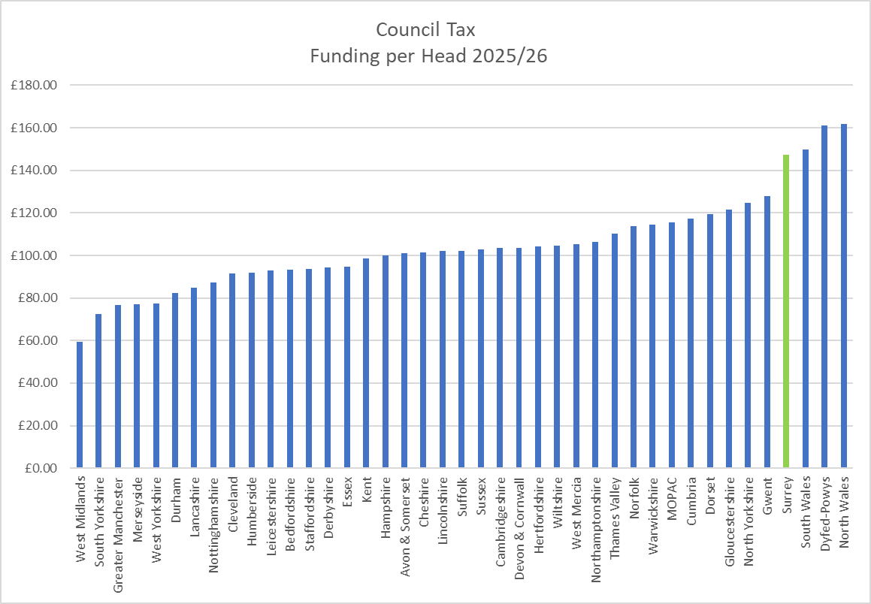
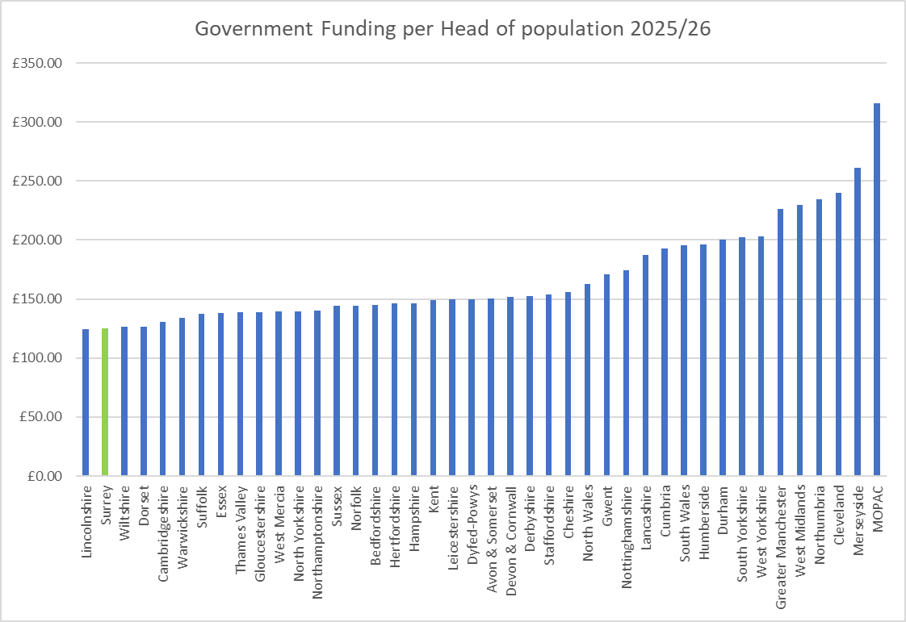

If Surrey were to receive the average level if funding from Government given to other county forces (i.e. excluding the highly populated cities) this would provide the Force with an additional £29.2m which is far larger than the savings we need to find and leave money over to improve services. This does illustrate the inequitable position of police funding from a Surrey perspective. Any change to this situation is highly unlikely and the burden will therefore have to continue to fall on Surrey residents. It has therefore been assumed for the MTFP that Government funding will remain static and that Council tax will continue to increase by 2% per annum.
Real Terms Funding Reduction
Surrey Police had experienced a real terms funding reduction of 8.2% over the previous 10 years (2010/11 to 2020/21) which the Force has filled with savings whilst trying to maintain front line service delivery. The chart below demonstrates the reduction in government grant until recently and the compensating effect of the precept increases over the latter years, whereby the precept makes up 55% of the Forces funding.
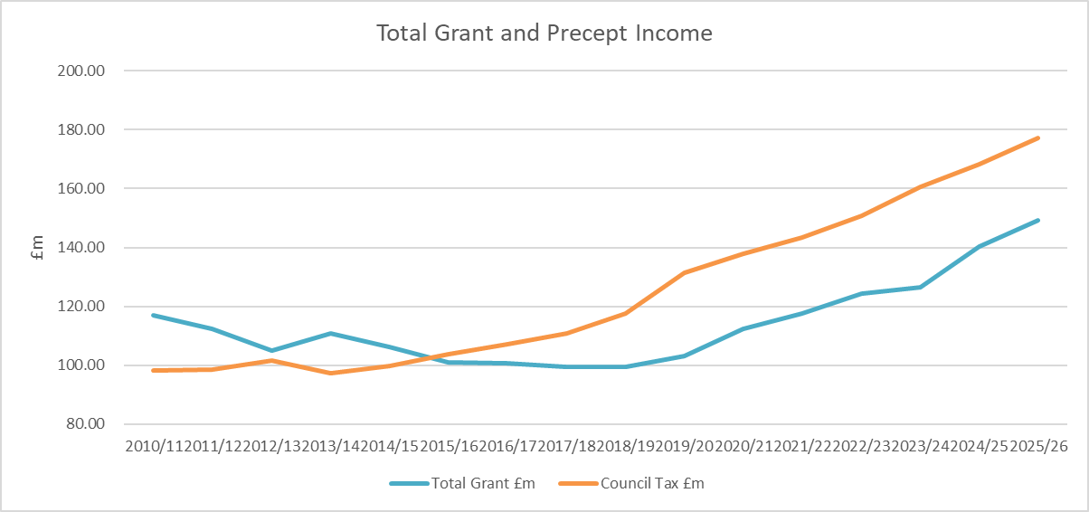
Financial Settlement 2025/26
This MTFP incorporates the police grant settlement for 2025/26 as laid before Parliament on 30th January 2025. This included an increase in Neighbourhood Policing Grant by £100m taking the total size to £200m. The Settlement also confirmed that PCCs would have the option to increase council tax precept by £14 which would provide an additional £329.8m nationally when compared to 2024/25. In Government funding announcements it was assumed that the maximum precept increase would be taken.
Table 1 below shows a breakdown of funding for 2024/25 and 2025/26 based on the announcements made. This assumes an increase in precept of £14 coupled with the increase in core and neighbourhood Policing grant.

Table 1

Nationally the Home Office top sliced or made reallocations of the Police allocation by £914.3m in 2025-26, a reduction of £123.7m including the new capital reallocations of £123.1. This is set in Table 2 below.
Table 2

The national funding is being used as follows:
- The Police Technology Programmes caters for the new Emergency Services Network which will provide 4G access to officers that will bring productivity and operational benefits, Home Office Biometrics and National Law Enforcement Police database.
- Arms Lengths Bodies includes the Independent Office for Police Conduct, the HMICFRS PEEL Inspections, the College of Policing Direct Entry scheme and the Gang Masters Labour and Abuse Authority.
- Regional Organised Crime Units – funding to support the specialist regional functions.
- Serious Violence Strategy – to tackle issues such as knife crime.
- The Police Special grant caters for national events or incidents that require additional police support.
Whilst there has been considerable investment in policing there is also significant focus on how policing can improve the outcomes it delivers for the public. A review was conducted on policing productivity, commissioned in 2022, to help identify and deliver tangible improvements to the frontline; the changes already agreed in terms of how policing responds to mental health calls and how crime is recorded are freeing up over one million hours. The Home office believes that further productivity gains can be achieved and so for 2025/26 it confirmed £11.0m of funding for Police Productivity and Innovation.
Funding beyond 2025/26
For the period from 2026/27 to 2027/29 it is more difficult to predict what the funding could be as the Government, has not so far, announced funding settlements in advance. Given that the Government has said that public expenditure will be tight it has been assumed that Government funding will remain cash flat or static for the remainder of the MTFP period. In respect of Council Tax is has been assumed that increases will be capped at 2%, the historical cap. There is a risk that the Government may reduce the level of the grant, say by offsetting perceived efficiency gains, or alternatively permit a larger than 2% increase in Council Tax, which has been the case in recent years. The impact of these changes is included in the sensitivity analysis later in this document. The table below shows the estimated future funding for the PCC Group

Table 2

*The Op Uplift performance grant has been reduced to £4.5m for 2025/26 plus £1.2m for overachieving by 10 officers.

- High level budget planning and strategy
The budget projection for the MTFP period has been prepared based on a number of assumptions as set out in Appendix C. This has led to a savings requirement of £18.5m over the whole period and this is set out in Appendix A and B.
The Force Fit for the Future set out the ambition of the Force to meet demands and priorities identified in the Force Management Statement and a step towards that ambition has been made possible from the Operation Uplift and the precept funding.
The Force is continuing to seek out efficiencies to redirect resources into priority areas and will also have to consider further wide ranging cashable efficiencies to bring about a sustainable financial position. In 2024/25 the Force identified additional savings of £1.4m which have been used to offset the savings requirement for the 2025/26. These additional savings came from a review of budgets and contract renegotiations. Additional savings totally £2.3m were taken out at 2025/26 budget setting came from the Tactical Savings Working Group, Joint Force Change programmes, Business Development Workshops and Change Delivery. Additional savings requirements have been slipped into 2025/26 as recorded in the Medium Term Financial Plan. (See section 7 Savings Programme for more detail).
The Estates Strategy, of which the replacement of the headquarters at Mount Browne is the largest part, continues to be developed. The MTFP includes the current estates strategy which was formally approved to enter RIBA stage 3 in January 2024. The Estate Board is due to meet during Q1 of 2025/26 to review the next steps for the overall Estate Strategy Programme and so this may have an impact on the MTFP.
An integral part of the MTFP is the need for capital spend and how this can be funded. As there is no capital grant and capital receipts are being used for estates this can only come from revenue funding thereby increasing financial pressures. Borrowing can be used to fund the Estate Strategy but this will incur interest and repayment costs which impact revenue albeit over a longer period.
Transformation of service delivery is seen as the main way savings can be delivered. This seeks to align the Force’s resources with its strategic priorities by improving skills and professional capabilities, the ability to exploit digital technology and address the changing shape of the force (higher ratios of officers to staff). This should ensure future resources are in the right place and savings can be delivered.
- Budget Gap
The MTFP has a total budget gap of £18.5m. This is based on the following assumptions:
- Flat Grant over the four year period.
- Precept – £14 for 2025/26 then 2% increase each year over the four year period.
- Pay inflation – 4.75% in 2025/26 then 2% each year over the period.
- Non-pay inflation – 2.2% in 2024/25 then 2% each year over the period
The savings of £3.6m have been identified for 2025/26 which included £1.4m of overachieved savings from 2024/25. The profile of savings are after deploying reserves in 2025/26 to manage the budget gap over the planning period as shown in the table below:

- Investment
Government Priorities

The Government has said it has provided significant investment into policing over the previous four years and expects the police to continue to build on the progress made on improving efficiency and productivity in return for the significant increase in investment.

The Minister set out his expectations for this investment as follows:
“In return for this significant investment, it is imperative that policing continues to deliver on driving forward improvements and reducing inefficiencies to maximise productivity, freeing cashable savings and officer time to reinvest in frontline activities. Forces need to participate in the Commercial Efficiencies and Collaboration Programme starting by forces signing up to national approaches to buying energy, vehicles, fuel, temporary staff and software licences and reforming cost recovery. The Government will work with policing to develop this programme to unlock immediate cost savings and laying the foundations to deliver hundreds of millions of pounds of efficiency savings.”

The Government’s key priorities are:

- Maintaining 20,000 additional officers (148,433 officers in total nationally) through to March 2026.
- Continuing to deliver on the opportunities presented by new technology and innovation to deliver improvements in productivity and drive forward efficiencies, therefore maximising officer time and service to the public.
- Meet the requirements of the neighbourhood policing guarantee
- Improving the visibility of police officers and focusing on providing a targeted approach to tackling crime and antisocial behaviour to make neighbourhoods safer, which should be a priority for all forces.”

The Force must continue to maintain its officer headcount number. Failure to do this will result in the Force suffering a financial penalty in that the Government will claw back part of the grant paid. The numbers are set out in the table below:

Force Priorities – Our Plan

During 2024/25 the Chief Constable set out his vision and ambition for the Force entitled into ‘Our Plan’. This strives to improve trust and confidence in Surrey Police through purposeful action to fight crime and protect people, focusing on being here for our communities when they need us. Already it has resulted in improved arrest and charging rates for a number of crimes that matter most to the public such as VAWG and shoplifting

Other Investments
Over the planning period the following investment plans have been incorporated into the MTFP;
- The Estate Strategy, which includes the redevelopment of the headquarters at Mount Browne.
- The ICT Strategy which sets out the plans for investment in IT and will be revisited periodically.
- The Fleet Strategy which is predominantly the capital investment for replacements and future enhancements to vehicles such as telematics and cameras. Project Thrifty will be adopted which will see the rationalisation and increased utilisation of vehicles.
There are some commitments or unavoidable costs that the Force has provided for, with the new police constable pay scales there has been an expectation for a cost pressure from incremental salary growth and an amount is included to mitigate this risk.
The next Force Management Statement and the results of the PEEL inspection could lead to re-engineering or moving resources to meet new priorities and conversely reducing them in others.
- Savings and Efficiency Plans
The multi-year change programme delivered savings during 2024/25 through transformation across Surrey Police during 2024/25 and this will need to continue into future years.
The table below shows the planned efficiency savings for the period of the MTFP grouped by risk of delivery category.

2024/25 | Risk | 2025/26 | 2026/27 | 2027/28 | 2028/29 | 4 Year Total
£m |  | £m | £m | £m | £m | £m
0.0 | Red | 0.0 | 0.0 | 0.0 | 0.0 | 0.0
0.0 | Amber | -1.0 | -3.1 | 0.0 | 0.0 | -4.1
-3.8 | Green | -2.6 | -0.2 | -0.1 | 0.0 | -2.9
-3.8 | Total | -3.6 | -3.3 | -0.1 | 0.0 | -7.0
-3.8 | MTFS Efficiencies Required | -3.6 | -6.8 | -3.8 | -4.2 | -18.4
0.0 | Net Efficiencies Required over MTFS | 0.0 | -3.5 | -3.7 | -4.2 | -11.4

The Force identified a savings plan for 2024/25 to achieve a balanced budget which continues for 2025/26. Work is continuing to identify further savings whilst seeking to minimise the impact on operational policing.
Further cost pressures and a reassessment of the deliverability of some of the 2025/26 savings is likely to mean an increasing gap in the budget for 2025/26 which will need to be addressed during he remainder of the year.
Transformation Programme
There are single force programmes and joint force programmes, all aiming at providing more efficient and effective operating practices, aligning to the forces' priorities.
A service transformation programme was set up in 2022 aimed at identifying opportunities for transformation to play its part in delivering the savings gap. A number of areas were identified, and work has begun on a phased approach to savings in areas such as Enabling services, Contact, CJ and Custody, with the aim to deliver opportunities reviews using similar methodology in due course to other areas of the force to identify the next areas for transformation.
The initial scope was:
- To address the funding gap
- To deliver against the Force’s priorities, and the priorities of its communities
- To maintain the Force’s identity
- To deliver change and benefits in a sustainable and adaptive manner.
Savings can only come from reducing the cost of services and reducing staffing numbers. Officer numbers could not be reduced as it was a condition of the Government uplift grant that numbers be maintained.
Work is also being done across the Surrey and Sussex to reduce predicted spend and cost pressures in arears such as fleet and estates. This has been complemented by business review workshops and the delivery of tactical savings thereby allowing more time for the transformation and change programmes to be worked through.
The savings plan has been structured into four main strands which are in the following table.

Joint Force Change Programmes include savings in enabling services of £0.7m with £1.4m within operation areas.
The Overachieved savings are savings identified during 2024/25 financial year in excess of those required to balance the budget.
The table below shows savings categorised by how they are going to be delivered – if this has been identified. Later years are still to be addressed.
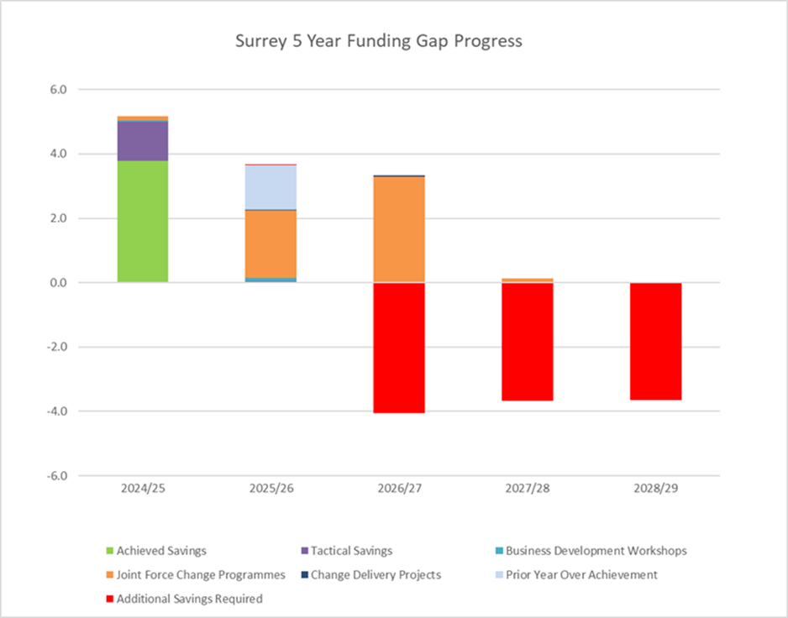
The Force will continue to identify efficiency savings, both cashable and non-cashable in order to invest into the priorities and improve service to the Surrey residents.
The chart below shows that savings of £45.2m have been achieved during the last 10 years (2015/16 to 2024/25). Given the savings already found the scope for finding new savings, as set out in the blue bars, is becoming increasingly difficult.
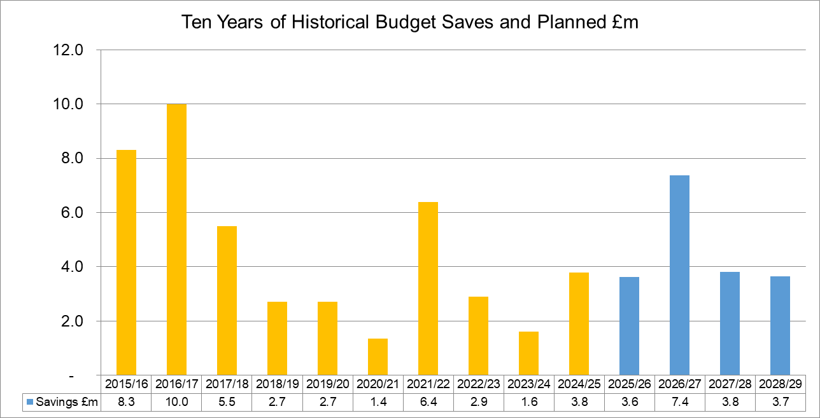

- Headcount Impact
Payroll costs account for over 80% of the Force budget. As a consequence, significant savings can really only be delivered by reducing headcount. As Officer numbers have to be maintained as a condition of the Government uplift grant this reduction can only come from Police Staff.
The graph below assumes that all of the savings will come from Police staff whereas in reality some will come from savings in non-employee costs such as through contract reductions, so this modelling must be viewed as worse case. The FTE (full time equivalent) could change in future years as the savings from transformation projects progresses.
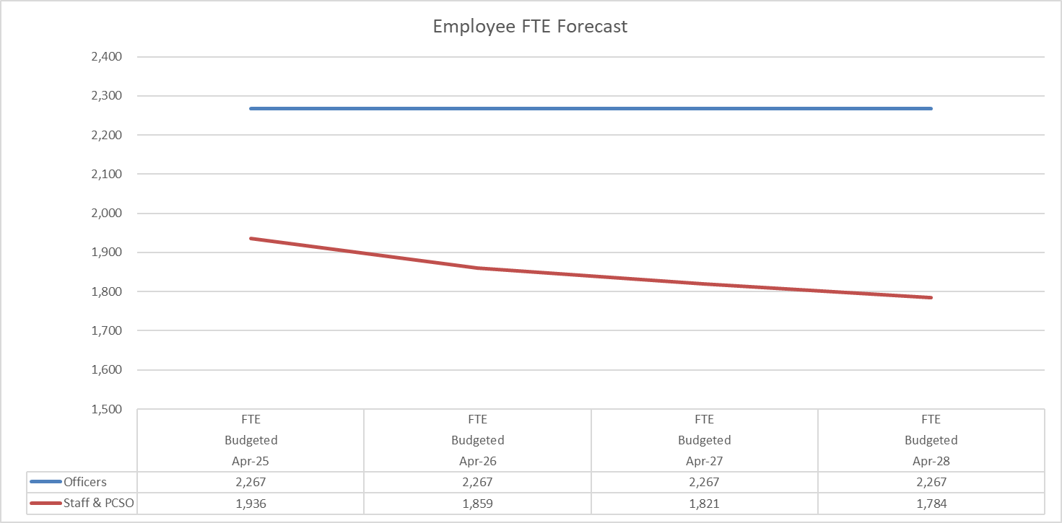
- Capital Strategy
The proposed capital programme for 2025/26 along with how it will be funded is provided at appendix D. In order to maintain investment in core assets borrowing and or revenue funding will be required which may impact on the resources required for frontline service delivery.
To maintain an affordable capital programme limits have been set on the level of investment and ensuring that the investments meet the capital criteria applied.

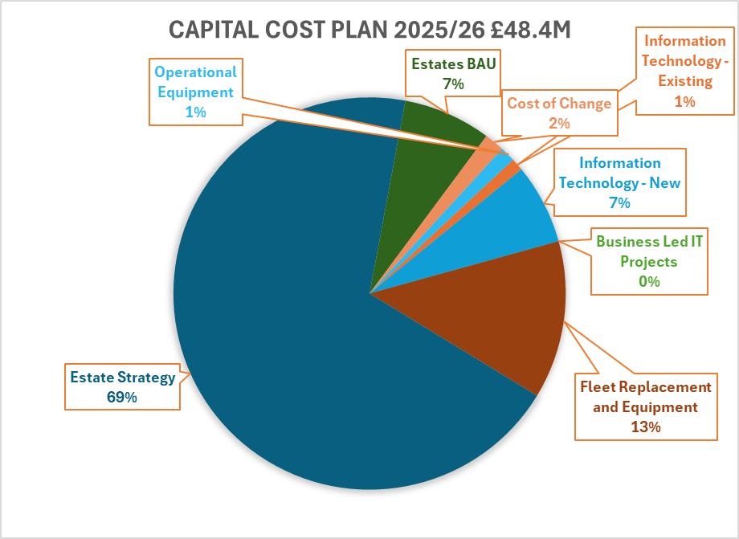
- The capital programme for 2025/26 includes the main areas of DDaT (previously called ICT), Fleet, Estate Strategy and operational capital equipment.

- The Surrey Estates Strategy (previously called “Building the Future Project”) is a future commitment which has been reflected in the above table from 2025/26.

- The DDaT schemes are predominantly refresh or upgrade of existing with a couple of new schemes including Database tools and Cloud storage projects.

- The Fleet Replacement is supported by a detailed Asset Management Plan and takes into account the benefits from telematics.
The funding of the capital programme is from grants, capital receipts, revenue budget or borrowing. Based on the proposed capital plan, as previously signalled, there will be a requirement to borrow for both the Estate Strategy and to support the capital expenditure programme.
The PCC currently has external borrowing from the PWLB for the purchase of land and has used internal borrowing for some short-term assets. The table below shows that the revenue contribution increases over the MTFP period thereby adding to the pressures on the revenue budget and the savings required. How capital is actually funded would be agreed by the Chief Finance Officer and be considered as part of the monitoring regime during the year.

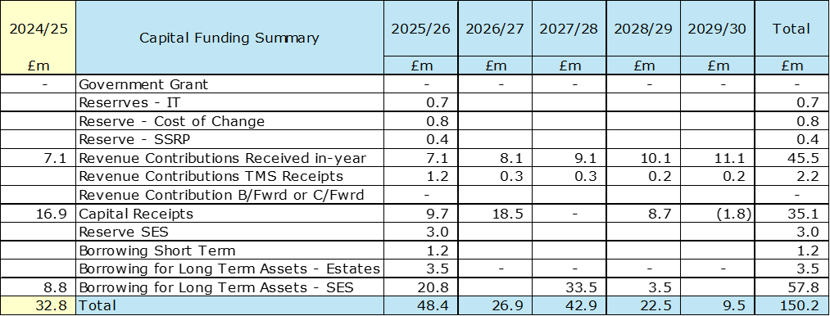

Other Points to note;
- The funding for the Change Programme has not been decided yet but borrowing and use of reserves may be considered.
- The Surrey Estates Strategy is planned to be funded from borrowing and capital receipts, the revenue implications of borrowing are included within the revenue budget. The borrowing requirement is £20.8m in 2025/26, £33.5m in 2027/28, and £3.5m in 2028/29. The revenue impact for debt repayment (MRP) and interest is circa £4.426m for 2025/26. (5.17% interest rate for long term borrowing and 4.91% for short term borrowing)
- It is an option to reduce the level of revenue used for capital, thereby helping the revenue budget gap, by borrowing instead. Whilst this has a short-term revenue benefit the Force ends up paying more in the end as interest costs have to be factored in. As interest rates are 4.5% (Bank of England base rate in March 25) this is quite a cost over the life of the asset and would all on the revenue budget.
- The form of the additional borrowing is a decision of the Chief Finance Officer whether it can be internal borrowing, subject to cash flow, or external borrowing.
- Assumptions
Assumptions used in the MTFP are set out in Appendix C. Some of the key ones are detailed below;
- The core government grant is increased by 7.3% for 2025/26, 0.7% in 2025/26 and will then remain flat in future years.
- Police officer pension was increased from 31% to 35.3% in 2024/25 with the increase funded and continue to be funded by the Home Office.

- The level of Council Tax benefit given by Council’s remains unchanged.
- The agreed savings plans are realised in delivered in year.
- A Band D Council Tax precept increase of £14 in 2025/26 with increases of 2.0% thereafter. Any surplus on the Collection Fund is directed towards a specific reserve to cater for one off costs. The tax base has an estimated growth rate of 1.2% in 2025/26 and 0.5% thereafter. No surplus or deficit on the collection fund has been assumed. In reality a surplus is used for one of costs and a deficit would add to the savings required
- For pay inflation Staff and Officers were granted an increase of 4.75% in 2024/25 and it has been assumed that pay will rise by 2% in future years. Officer pay is determined by the pay review body and in previous years the Government has provided a grant to fund some of the increase – but this is not guaranteed. Staff pay increases are locally determined by generally are in line with Police officer pay. Generally, these increases are not funded by Government.
- Non pay inflation has been budgeted at 2% for the MTFP period, However one of the financial interventions used in the past has been to ask budget holders to absorb inflation unless there was a contractual commitment in place, this option has been used for 2025/26.
- The police staff pension scheme is part of the Local Government Pension scheme and unlike the Police Officer Scheme is funded scheme which relies on underlying assets to support future liabilities. Any deterioration in asset values may increase the level of contributions and conversely a surplus could lead to a reduction. At the moment it has been assumed that the costs will remain the same. A valuation is due in 2025/26.
- The police officer pension is a pay as you go unfunded scheme in that any difference between the cost of pension paid and contributions collected in any individual year is underwritten by Government. The fund following a valuation process the employers’ contribution rate increased to 31% in 2019/20. The employers’ contribution rate was increased to 35.3% in 2024/25 and the increase was covered by Home Office Grant. The Police Pension Scheme is valued triennially.
- The MTFP is built on the basis that the reserves strategy of maintaining general reserves at no lower than 3% of budget is in place for the planning period.
- The latest estimates in relation to the Surrey Estates Strategy have been incorporated including Agile Working and the re-development of Mount Browne headquarters, both of which have a capital and revenue impact.
- The DDaT Strategy is to be reviewed to ascertain the level of funding required over the planning period. This will be reflected in future revisions of the MTFP if required,
- Risks
There are a number of risks which can impact the MTFP and these are set out below:
- The government have over the last few years employed top slicing to fund national initiatives or growth in national functions. This has been increasing each year and remains a distinct possibility that this approach may result in further reduction on the level of funding to police forces. The Emergency Services Network is due to be implemented during the planning period and the funding required to implement to new service is being drawn from the national police allocation.
- Inflation has been seen as a key risk with significant hikes on fuel and energy prices. The Bank of England expects inflation to rise temporarily this year to 3.7% due to higher energy prices but is expected to fall back again to 2% after that.
- As Surrey is more dependent on local funding than most Forces we could face a higher percentage funding impact if there were any changes to reduce the referendum limit.
- Revaluation of properties for Business rates due to be done in 2026 could result in and increase or decrease in business rates costs.
- Increase in the costs for the Joint Vetting Unit following the outcome of recent HMICFRS review and Angelini reports following Carrick and Couzens cases.
- Overspend in the legal cost budget following the new legal budget contract with suppliers with increase rates of charging and increased levels of demand in legal advice and support across operation and functional areas of the force. This though is being managed through having a tougher gateway process to access legal advice
- Increasing demand on policing with the changing nature of crimes stretching resources. This may mean that resources will need to be prioritised if services are to be maintained at the same level.
- The introduction of national systems and infrastructure changes could result in increased national charges being levied on the Force.
- Government funding for Policing may reduce in the Spending review as national resources are diverted to other areas such as the NHS and defence. The formula review could also result in a reduction in grant.
- A strategy is being developed through the joint Surrey and Sussex Environmental Board with the aim of making the organisation carbon-neutral. This is unlikely to be achieved without incurring additional costs - at least in the short term.
A full financial risk analysis schedule is provided at appendix E. This is reviewed and updated during the year as new risks become apparent during the year.
- Reserves
Reserves are held by the PCC to cover contingencies, deal with unbudgeted expenditure and also for specific projects and activities
The general reserves strategy is to maintain the level at a minimum of 3% of annual revenue budget. In reality the general reserve is maintained slightly above 3% to allow a contingency in case there is a delay in savings being delivered. This contingency also allows the Force to cover any in-year budget pressures which may arise.
The chart below shows the general reserve level is forecast to be at 3.6 % in April 2026 and reducing to 3.5% by 2028/29, there is no use of general reserve to support the funding position however specific reserves are in place to manage future financial risks. The PCC has approved the general reserve strategy will be maintained plus specific reserves have also been created to assist the financial plan over the next few years. The full reserves strategy is on the PCC website.
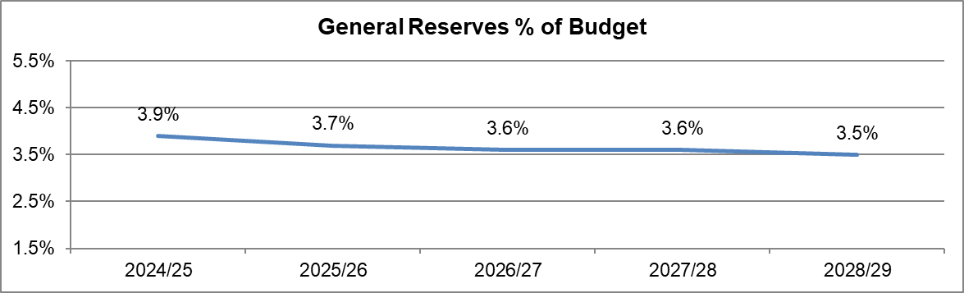
There are specific reserves in place to fund specific projects, activities and liabilities. These are set out below:

Planned use of reserves has been allowed for in the MTFP as required.

- Scenario Planning
The MTFP has been prepared based on the most prudent assessment of a number of parameters that are included within the assumptions.
The table below shows the impact of changes in some of these assumptions
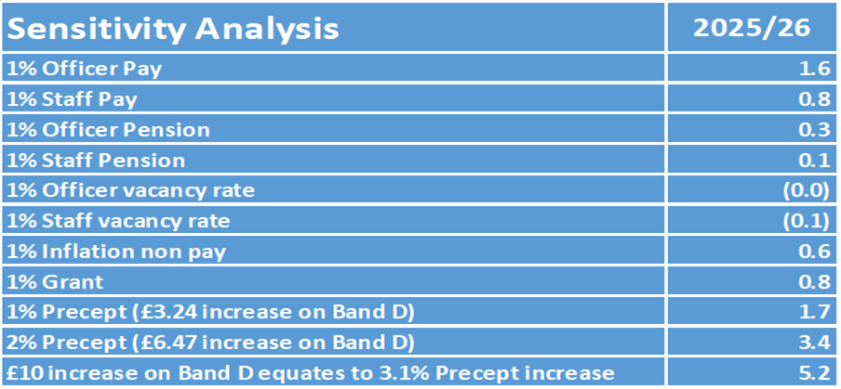
As can be seen a small change can have a large impact on the level of savings required.
- Appendices - Appendix A
Base Scenario Medium Term Revenue Financial Forecast

Appendix B - Efficiency Savings Plan

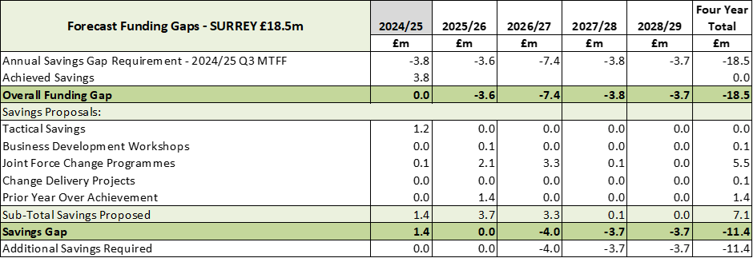

Appendix C – Financial Assumptions

Appendix D – Capital Programme (Funding)

Appendix D – Capital Programme (Expenditure)

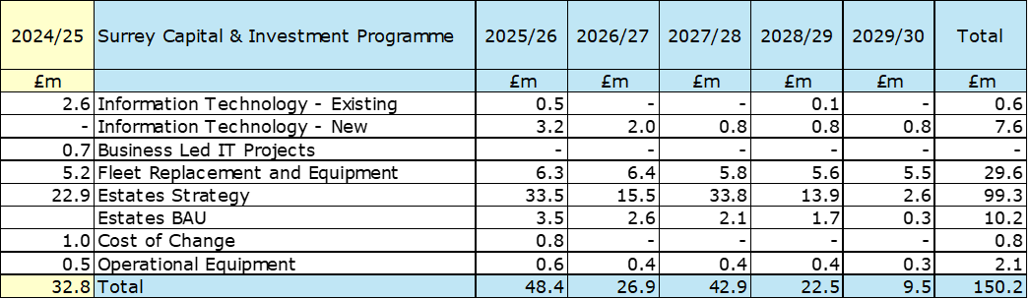

Appendix E Surrey Financial Risk Analysis

Title | ASSUMPTION | COMMENT
Title | SURREY | COMMENT
Pay and price budgets and establishment control  [Top 5 Risk – No. 1]  Including:  Uplift Performance Grant | Provision for Officer national pay awards of 2% for 2025/26 and future years with a contingency of 0.8% for 2025/26  Provision for Staff pay awards of 2% for 2025/26 and future years with a contingency of 0.8% for 2025/26  Staff turnover and increments based on detailed analysis of current staff profile and trends. | Risk of pay requirements exceeding the budget provision.  Officer pay is determined by the pay review body and so the Force has not control over it. Staff pay is determined locally but is usually in line with officers.  In the past officer increases over 2.5% have been funded by Government but there is no guarantee this will continue.  The costs of Police staff could fall overtime due to reduction in headcount in order to achieve savings.
Uplift Performance Grant | Full performance grant will be received | Risk of loss of or reduced grant due to not achieving and maintaining required Uplift targets. Risk of loss of or reduced grant due to not achieving and maintaining required Uplift targets.  The forces have to meet their headcount target at September 24 and March 25 to receive 50% of the grant at each point. For each officer below the headcount at each point £40k will be withheld (one officer below at both points is £80k) up to 1.5% of the target or 30 officers whichever is greater, if more than 1.5% below or 30 officers target all the grant will be withheld.  Surrey 2,253 plus Batch 1 of 10 and Batch 2 of 12, total headcount target 2,275  The Surrey 2024/25 workforce plan as at January 2024 is designed to achieve the target in Sept 24 and March 25.  Surrey Op Uplift Performance Grant £6.0m
Non-Pay Inflation  [Top 5 Risk – No. 2] | Current inflation planning is 2% over the medium term plan | Risk of non-pay inflation exceeding the budget provision.  In December 2024 inflation was reported at 2.6% an increase of 0.2% from November. The Bank of England have an inflationary target of 2%.  Any significant fluctuation in costs will be monitored through the monthly forecasting process and at the Financial Risk Meetings attended by the PCC CFO's.  Utilities are expected to reduce with cost reductions of 22% for electricity and 32% on gas.  Cleaning contracts will increase in-line with the Government announcement to increase the minimum wage.  Risk of third (3rd) party suppliers ability to deliver on contracts. Due to the current economic market there is a risk that 3rd party suppliers are unable to deliver services or goods contracts. Organisations facing increasing costs, such as fuel and source material national shortages, alongside a labour market buoyancy leading to potential staff shortages, these factors could lead to inability to service contract requirements or demand to the force/s.
Savings Plan  [Top 5 Risk – No. 3] | Budget includes savings | Risk the MTFF savings requirement is not met.  Recognising the need for future savings the Force has set up a Service Transformation Programme to review and identify where saving can be made. In addition to this the Tactical Savings Working Group continues to review other areas where savings can be generated.  The savings planned in the first year of the four-year plan are within the reserves available but would be exceeded in subsequent years if not delivered.
Interest rates, investment and borrowing  [Top 5 Risk – No. 4] | Interest rates assumptions  Borrowing at fixed rates. | Forecasts of investment income for 2025/26 onwards are based on estimated cash balances and interest rate forecasts as set out in the treasury management strategy. A prudent position has been adopted about anticipating future increases in interest rates, to address the risk of interest rates being lower than expected, from a very low base.  The risk of investment fund loss due to collapse of the financial institution where the deposit is placed, is limited by controls within the Treasury Management Strategy which focus on security rather than returns. Potential impact is mitigated by a diverse portfolio with top credit rated institutions.
Threat to the sum of core government funding received by the PCC following a change in the police funding formula  [Top 5 Risk – No. 5] | Review and initial consultation expect in the future | A review of the grant distribution method, known as the ‘formula review’, has been in planning for several years. Significant work has already been undertaken by PCCs and police to provide the body of evidence that will be required to convince HM Treasury of the financial requirements for policing bodies. The Home Office has now opened the review again. No assumptions regarding a change to grant levels has been included as it is expected that transitional arrangements will be implemented by the Home Office to manage any changes to allocated grant resources.
Police Pension | McCloud and Sergeant Implementation  Pension Scheme valuation change – cost neutral | Risk that the cost to the Force for the Police Pension scheme increase - The police officer pension employers rate increased to 35.3% from 2024/25, with forces funded for the increase from the Home Office. It has been assumed this will continue  Police pensions along with many public sector pensions were reviewed to ensure a fairer balance between public purse and pensioners. The scheme was changed to a Career Average Revalued Earnings (CARE) scheme which included transitional arrangements. These arrangements were challenged and accepted by the tribunal. This has resulted in potentially additional costs which may or may not be covered by Government.
Maintaining & improving service performance levels | Resources sufficient to meet targets and priorities in the Police and Crime Plan and Chief Constable Priorities | There is a risk that the Force is unable to maintain & improve service performance levels  The Chief Constables believe that there are sufficient resources to deliver future Police & Crime Plan priorities, Chief Constable Priorities and Strategic Policing Requirement. However there remains risk from the cost of major operations including counter-terrorism, major incidents including pandemics, particularly if these are not fully funded nationally. Reserves though are held in order to fund these on a one off basis if needed in an emergency  A Home Office productivity review may top slice anticipated savings
Limits to Precept Increases | £14 in 2025/26  Future precept planning assumption of a 2% increase. | There is a risk that precept funding increase is capped below the 2% assumed by Government or the PCC.  That said the limit may be increased by Government above 2%, as has been the case in past years, to provide more funding for Forces – however this would need to be implemented by the PCC.
Grant Levels | Main police revenue grant | 2024/25 was the final year of the current three-year settlement, while total funding was announced at the national level, individual allocations to each force were only provided for a year at a time. The funding for 2025/26 was part of a one year spending review.  In 2025 the Government is planning to announce a 3 year spending review which should set out overall funding for Forces and thee be an indication of how funding may change.
Council Tax | Collection rates advised by individual billing authorities | The risk of council tax collection rates being lower than expected could impact on the collection fund balances and reduce surpluses or increase deficits for the PCC. Billing authorities’ factor in prudent collection rates to mitigate this risk. The PCC works closely with billing authorities to monitor their key collection rates and contributes financially towards the costs of reviews of discounts, including the single person discount, and exemptions.  The tax base is normally expected to increase during the MTFS period, but the assumptions could be impacted by changes to the mix of dwellings, discounts and the impact of unemployment numbers within billing authorities council tax reduction schemes or changes to the proportion of support provided.  Future tax base increase assumptions are included in the MTFS at 0.5%.
Budget Estimates (Expenditure) | Provision for specific on-going cost pressures | The budget estimates including all identified additional costs for 2025/26, supported by input and review by the Chief Financial Officers.  All cost pressures are scrutinised internally by the Chief Finance Officers and also the DCC Strategic Planning Board / Force Organisational Board before inclusion in the financial plan.  Risks of budget overspend are mitigated by the monthly budget monitoring process and formal monitoring reports to the PCC.
Levels of Reserves | Forecast to reduce over the term of the MTFS  To mitigate this risk, the General Reserve is kept at a minimum of 3% of revenue expenditure. | Risk that reserves levels are inadequate  An annual review of all reserves is undertaken at budget setting along with a post year-end review and update to the MTFS. General reserves limits have been set in line with CIPFA guidance to deal with unexpected expenditure and contingencies. Specific reserves are used to address future liabilities, say for insurance, or for large projects such as estates.  A reserve by its nature can only be employed as a one off cash injection The savings planned in the first year of the four year plan are within the reserves available but would be exceeded in subsequent years if not delivered.
LGPS Pension | LGPS reform changes | The latest triannual valuation was included in the budget commencing for 2023/24.  The value of the assets and liabilities in the fund can impact the level of contributions required whether negatively or positively  Other challenges to LGPS funds and administration include the impacts of McCloud underpin implementation, SAB and HMT cost sharing schemes, Goodwin (survivor payment equality) remedy and the alignment of LGPS valuation cycles with other government schemes e.g. police officer schemes.
Overtime | Additional cost of overtime and associated costs | Whilst action will be taken to mitigate the overtime and other additional costs relating to policing public order operations, significant costs may be incurred in-year. This is being managed by an oversight board.
Capital Programme | Latest plans | There is a risk of the capital programme being understated, or that over spending occurs, resulting in insufficient funding being available as planned. This is mitigated by regular review of capital expenditure  Slippage may also impact on operational demands. The capital plan is reliant on several sources of funding including capital receipts which are at risk of not being achieved either in quantum or timing. These risks are mitigated by regular review of all major projects including the Estates Strategy and DDaT projects, focus on key priorities agreed in advance, together with monthly budget monitoring and regular monitoring reports to the PCC.
Capital Financing | MRP is calculated on an asset by asset basis | This Capital Financing risk is of charges being greater than budgeted. This is mitigated by considering revenue and capital implications of major project spend within the capital and investment planning process and inclusion within the MTFF. The MRP debt repayment provision is calculated on individual assets and 100% of borrowing has fixed term rates, thus will not be impacted by changes in interest rates. Borrowing is planned to finance the capital programme within this MTFS.
Regional Partners | Investment plans | Regional partners may agree investment that increases the financial pressures on individual forces.
NPAS | Latest plans | There are ongoing discussions on the provision of this service which may result in additional costs for Forces.
National ICT Programmes | Latest plans | Delays in the implementation or the overrunning of costs on national ICT projects can lead to extra direct and indirect costs for Forces.  There is also a risk that budget for national ICT programmes will increase in the future resulting in a higher level of top slicing.
Local ICT Programmes | Project transition | There is a risk of local ICT Programmes being underestimated or implementation being delayed.
Digital Forensic Costs | Outsourcing costs will increase by c25% | Increasing demand is creating a large cost pressure
Physical Forensic Costs | Forensic fees will increase by c10% | There is a risk of Physical Forensics costs increasing as the market is very restricted
Business Rates Revaluation | Revaluation of properties | Risk that police premises could see an increase or decrease in business rates due to a revaluation.
Increased cost of vetting | 2024/25 budgets for legal fees have been increased through the unavoidable process | Risk that costs in Joint Vetting increase due to the impact of the Carrick case at the MET and HMICFRS report into the Wayne Couzens case
IFRS 16 | No provision | IFRS 16 will need to be implemented in April 2024, the financial implications of this accounting standard are currently being accessed and will need to be included as part of the 2024/25 budget setting process.  The current assumption is that this will be cost neutral and covered by the current revenue budget provision.
Dogs & other seized Animals | No additional provision | Issue raised of increasing kennelling costs for seized animals - The budget was increased for both forces in 2024/25 to address this budgetary issue however both forces are still overspending, the daily kennelling cost for dangerous animals also increased in November 2024.
Riot Compensation Act 2016 | No additional provision | Threat of potential claims for compensation being received under the Riot Compensation Act 2016 following the recent civil unrest and the lack of an established infrastructure in place to manage and administer these payments and the financial resources to meet claims costs.  • Although the Riot Compensation Act has been in legislation since 2017, it was not known about by the majority of PCCs. The recent summer riots have highlighted the financial liability, alongside the need to quickly establish systems and processes to process any claims received.  • The Sussex PCC CFO is currently leading on the PACCTS approach to the claims and will feed his knowledge and learning into the mitigations for Sussex.
Firearms Training | No additional provision | The federation have raised an issue where officers can claim mileage and overtime when attending firearms training.

- Glossary
PCC – Police and Crime Commissioner
ICT – Information Communication Technology
DDaT – Digital Data and Technology
HMICFRS – Her Majesty’s Inspectorate of Constabulary & Fire and Rescue Services
SOCU – Serious Organised Crime Unit
FTE – Full Time Equivalent
FMS - Force Management Statement
MTFP – Medium Term Financial Plan
PEEL – Police Efficiency, Effectiveness & Legitimacy
NCA – National Crime Agency
ROCU – Regional Organised Crime Unit
CPS – Crown Prosecution Service
ESN – Emergency Services Network
ESMCP – Emergency Services Mobile Communication Programme
NPCC – National Police Chiefs Council
NLEDS – National Law Enforcement Data Service
CT – Counter Terrorism
CIPFA – Chartered Institute Public Finance Accountants

