

Chief Constable Expenses

Required for: | Joint Audit Committee (JAC) June 2025
Security Classification: | Official
Handling information if required: | For publication
Suitable for publication: | Yes
Title: | Chief Constable Expenses
Version: | 1.0
Purpose: | To report to JAC the Chief Constable Expenses
ACPO / Strategic Lead: | Chief Constable
National Decision Model compliance: | Yes
Date created: | 3 June 2025
Date to be reviewed:

AUTHOR:
Name: | Claire McDonnell
Job Title: | Chief of Staff
Telephone number:
Email address: | claire.mcdonnell@surrey.police.uk
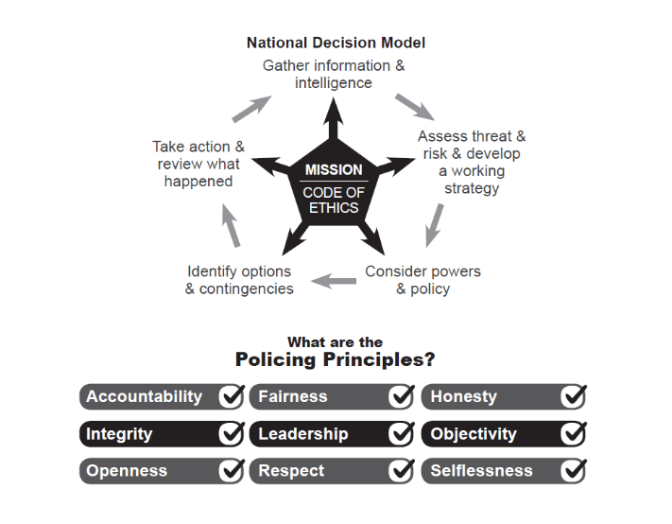

Chief Constable Expenses

To: Joint Audit Committee
Date: 23rd June 2025
By: Chief Constable

Title: Chief Constable’s Expenses
___________________________________________________________________

Purpose of Report/Issue:

To update the Committee on any expenses incurred by the Chief Constable in 2024/25 and any hospitality received.

It is a standing item on the agenda of the Joint Audit Committee that the Chief Constable present his expenses.
The table below shows expenses claimed between 01 April 24 and 31 March 2025 and submitted for approval via Exclaim to the Office of the PCC.
___________________________________________________________________

Expenses Claimed:

Date | Details | Amount (£)
11/07/24 | Taxi Paddington to Olympia | £18.60
11/07/24 | Parking Wokingham Station | £8.00
12/07/24 | Parking Wokingham Station | £8.00
12/07/24 | Taxi Paddington to Olympia | £18.90
12/07/24 | Taxi Olympia to Paddington | £18.90
30/09/24 | Meal M&S Glasgow | £9.20
30/09/24 | Taxi Glasgow National Memorial | £36.40
30/09/24 | Taxi Glasgow National Memorial | £40.00
11/10/24 | Parking Wokingham Station - BLSO | £8.00

___________________________________________________________________

Recommendation

The Committee is asked to note and agree the expenses:
__________________________________________________________________

Contact details:

Name Claire McDonnell
Job Title: Chief of Staff to the Chief Constable
Telephone number: 07967986979
Email address: claire.mcdonnell@surrey.police.uk

