
Required for: | Joint Audit Committee
Security Classification: | Official
Handling information if required: | n/a
Suitable for publication: | Yes
Title: | 2024/25 year end Treasury Management Report
Version: | n/a
Purpose: | To report on the performance of the treasury management for the year and compliance with the Prudential Indicators
ACPO / Strategic Lead: | PCC
National Decision Model compliance: | Yes
Date created: | 6th June 2025
Date to be reviewed:
AUTHOR:
Name: | Kelvin Menon
Job Title: | PCC Treasurer
Telephone number: | 07270 378553
Email address: | Kelvin.Menon@surrey.police.uk


Recommendation(s) -

The JAC is asked to note and comment on the report.

Summary:

This report includes a summary of treasury management performance for 2024/25 as well as compliance with the Prudential Indicators for the year. It is intended to fulfil the requirements of the CIPFA Treasury Management Code of Practice (the Code of Practice).

Conclusions

The PCC has achieved a return on investments in line with bank rates without exposing funds to undue levels of risk. The Prudential Indicators for the 2024/25 have also all been complied with

Legal Implications

The PCC is required to comply with requirements of the CIPFA Prudential Code. This paper demonstrates compliance for 2024/25,

Equalities Implications

There are no equalities implications arising from this report.

Risks

Risks are minimised by undertaking all Treasury Management activity during the year in accordance with the approved Treasury Management Policy Strategy. The Policy prioritises risk over return and this is reflected in the contract with SCC. Pooling funds with SCC and making only short-term overnight deposits minimises risk whilst achieving a reasonable return.

Appendices

1 – Commentary on PWLB Rates
2 – Economic Update
3 – MRP Statement
4 – Compliance with Prudential Indicators

Background papers –
This document has been prepared with due regard to:-
PCC Treasury Management Strategy
CIPFA Prudential Code for Capital Finance in Local Authorities – 2018 edition
CIPFA Treasury Management in the Public Services: Code of Practice

Contact details -
Name: Ricardo Herrera-Delgado
Job Title: Head of Financial Accounting
Email address: ricardo.herrera-delgado@surrey.police.uk

Treasury Management – Statutory Requirements

- It is a requirement under The Local Authorities (Capital Finance and Accounting) (England) Regulations 2003 that bodies comply with the CIPFA Code of Practice for treasury Management. This is to ensure that comprehensive policies and practices are in place for the effective management and control of treasury management activities, including the effective management and control of risk.

- Treasury management is defined in the Code of Practice as “the management of the organisation’s investments and cash flows, its banking, money market and capital market transactions; the effective control of the risks associated with those activities; and the pursuit of optimum performance consistent with those risks.

- One of the requirements of the Code is an annual report on the performance of the Treasury Management as well as whether the authority has complied with the Prudential Indicators it set for the year. This report is intended to fulfil that requirement.

Treasury Management Transactions for 2024/25

- The Police and Crime Commissioner (PCC) operates a balanced revenue budget, which means its income (and hence its cash received) will be equal to its expenditure (cash paid out). However, due to timing differences between when cash received and paid out this can lead to surplus cash being held. The PCC also has reserves which also results in surplus cash. Treasury management operations ensure firstly there is adequate cashflow available to meet liabilities and secondly that this cash is invested to provide a return for the PCC. The priority however is to ensure security and liquidity before considering optimising investment return.

Short Term Investment
- The PCC has a service level agreement with Surrey County Council (SCC) for the provision of Treasury Management Services. Surplus cash held by the PCC is lent at the end of each working day to SCC who then pool it with their own surplus funds for investment in overnight money market deposits. The cash is then returned to the PCC each morning. Currently SCC only invest in low-risk counterparties for short overnight deposits. Risks are pooled with SCC in that were a counterparty to default the loss to the PCC would be in the ratio of PCC funds against total funds invested. There have been no defaults during the year and all funds have been returned to the PCC as agreed.

Investment Returns
- As part of the agreement SCC guarantees to pay to the PCC interest quarterly equivalent to the higher of:
- SCC weighted average quarterly investment rate.
- SONIA minus 0.1082%
- Bank of England Base rate

During the year 254 individual loans were made to SCC for which interest of £2.929m was paid giving an average interest rate of 4.87%. This compares with £2.571m interest at an average rate of 5.06% for 2023/24. This decrease in returns reflects the reduction in the Bank of England Base rate during the year which has then fed through to investment rates and hence returns. The chart below shows the change in the Bank of England base rate over time:

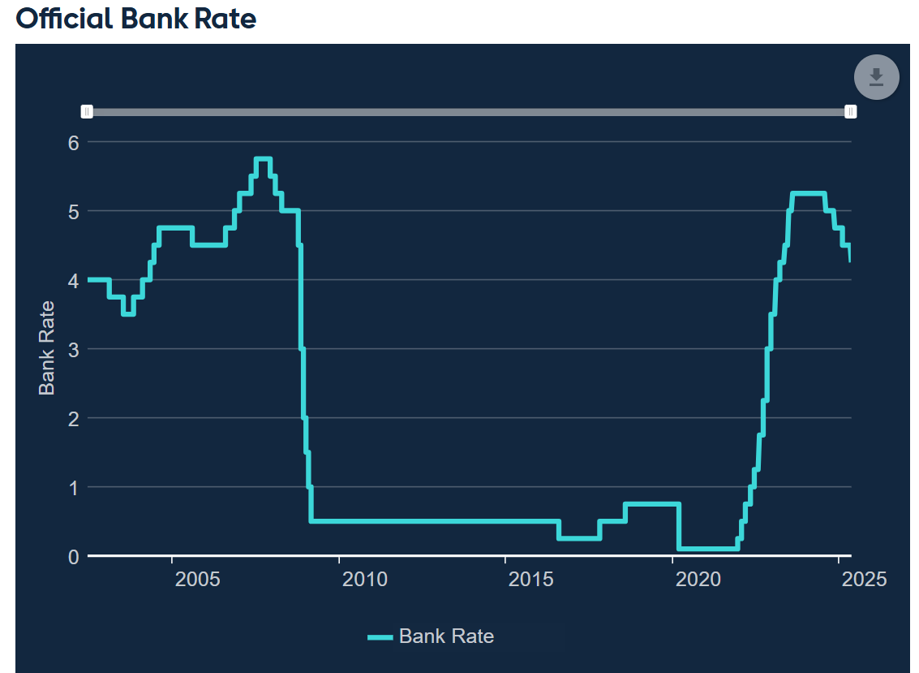

In the future returns are likely to reduce further as the bank base rate continues to fall and the level of cash held also reduces as it is used on projects such as the new HQ.

- The tables below show the % interest rate returns and actual returns over a number of years.

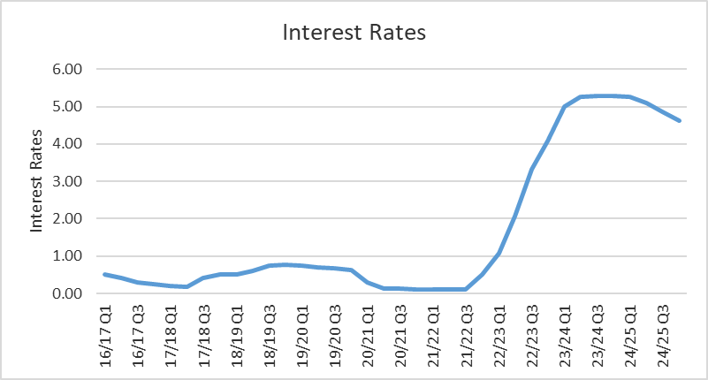

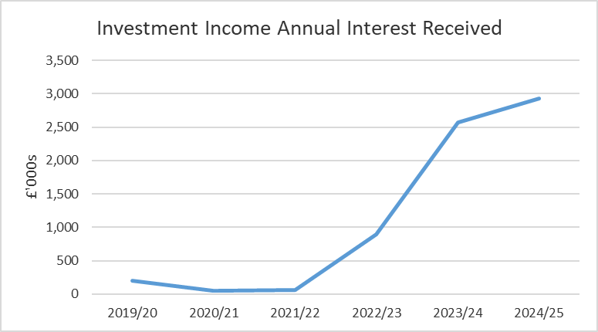

Treasury Management Costs
- SCC recharged a proportion of the costs of its treasury management team for the provision of the service. This amounted to £22,500 for 2024/25 and covered the daily sweeping of accounts, investing of surplus funds and return of funds each morning. Twice yearly contract monitoring meetings were also held during the year with SCC treasury officers. No brokers fees were paid during the year as all Treasury Management activity was undertaken by SCC on the PCC’s behalf.

External Short Term Borrowing
- No external short-term external borrowing was required during 2024/25 as the PCC had adequate cash balances to meet its liabilities. Internal borrowing was undertaken to manage capital spend during the year.

Long Term Borrowing
- No new long-term loans were taken out during the year. In March 2019 the PCC took out a 30-year loan from the Public Works Loan Board (PWLB) at a fixed interest rate of 2.34% to supports the Estates strategy. This is repaid in equal instalments over the term of the loan and the balance at the 31st of March 2025 was £12.479m

Future Borrowing Requirements
- The delivery of the Estates strategy, and in particular the new HQ, is likely to lead to a requirement for additional borrowing. This has been reflected in the borrowing limits in the Prudential Indicators. The PCC is likely to fund this borrowing using a mixture of internal borrowing and longer term PWLB loans. Any longer-term borrowing will need to be affordable and strike a balance between lower interest rates and cost certainty over the term of the loan.

- Lowest and highest PWLB interest rates over the year for various terms of loans are shown in the table below. A commentary from Treasury Advisors on how PWLB rates are set and possible trends is attached as Appendix 1

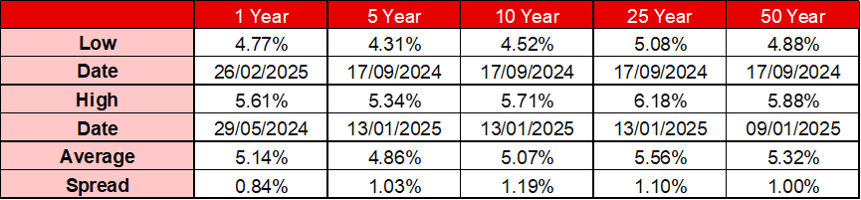

Compliance with Prudential Indicators

- The PCC approved the prudential indicators for 2024/25 early in 2024. These set out the parameters for Minimum Revenue Payment (MRP), Investments and borrowing.
- For 2024/25 MRP has been provided on borrowings in accordance with the Prudential Code and information on this is set out in Appendix 3. Appendix 4 sets out the compliance with the Prudential Indicators during the year and indicates that all the Prudential Indicators were complied with for 2024/25

Economic Update

- A review of economic performance to date and outlook prepared as background information by Treasury advisors is attached as Appendix 2.

Risks

- Risks are minimised by undertaking all Treasury Management activity during the year in accordance with the approved Treasury Management Policy Strategy. The Policy prioritises risk over return and this is reflected in the contract with SCC. Pooling funds with SCC and making only short-term overnight deposits minimises risks whilst achieving a reasonable return.

APPENDIX 1 – Commentary on PWLB Rates
- PWLB rates are based on gilt (UK Government bonds) yields through HM Treasury determining a specified margin to add to gilt yields. The main influences on gilt yields are Bank Rate, inflation expectations and movements in US treasury yields. Inflation targeting by the major central banks has been successful over the last 30 years in lowering inflation and the real equilibrium rate for central rates has fallen considerably due to the high level of borrowing by consumers: this means that central banks do not need to raise rates as much now to have a major impact on consumer spending, inflation, etc. This has pulled down the overall level of interest rates and bond yields in financial markets over the last 30 years. Indeed, in recent years many bond yields up to 10 years in the Eurozone turned negative on expectations that the EU would struggle to get growth rates and inflation up from low levels. In addition, there has, at times, been an inversion of bond yields in the US whereby 10-year yields have fallen below shorter-term yields. In the past, this has been a precursor of a recession.
- However, since early 2022, yields have risen dramatically in all the major developed economies, first as economies opened post-Covid; then because of the inflationary impact of the war in Ukraine in respect of the supply side of many goods. In particular, rising cost pressures emanating from shortages of energy and some food categories have been central to inflation rising rapidly. Furthermore, at present the Fed, ECB and Bank of England are all being challenged by levels of persistent inflation that are exacerbated by tight labour markets and high wage increases relative to what central banks believe to be sustainable.
- Gilt yields have been volatile through 2024/25. Indeed, the low point for the financial year for many periods was reached in September 2024. Thereafter, and especially following the Autumn Statement, PWLB Certainty rates have remained elevated at between c5% - 6% with the exception of the slightly cheaper shorter dates.
- At the close of 31 March 2025, the 1-year PWLB Certainty rate was 4.82% whilst the 25-year rate was 5.98% and the 50-year rate was 5.67%.
- Regarding PWLB borrowing rates, the various margins attributed to their pricing are as follows:
      - PWLB Standard Rate is gilt plus 100 basis points (G+100bps)
      - PWLB Certainty Rate is gilt plus 80 basis points (G+80bps)
      - Local Infrastructure Rate is gilt plus 60 basis points (G+60bps)
      - HRA Borrowing rate is gilt plus 40 basis points (G+40bps)

- There is likely to be a fall in gilt yields and PWLB rates across the whole curve over the next one to two years as Bank Rate falls and inflation (on the Consumer Price Index measure) moves lower. As a general rule, short-dated gilt yields will reflect expected movements in Bank Rate, whilst medium to long-dated yields are driven primarily by the inflation outlook.
- The Bank of England is also continuing on a process of Quantitative Tightening. The Bank’s original £895bn stock of gilt and corporate bonds will gradually be sold back into the market over several years (currently c£623bn). The impact this policy will have on the market pricing of gilts, while issuance is still markedly increasing, and very high in historic terms, is an unknown at the time of writing.

APPENDIX 2 – Economic Update
- The following economic update has been prepared by Treasury advisors by way of background information.

UK Economy
- UK inflation has proved somewhat stubborn throughout 2024/25. Having started the financial year at 2.3% y/y (April), the CPI measure of inflation briefly dipped to 1.7% y/y in September before picking up pace again in the latter months. The latest data shows CPI rising by 2.8% y/y (February), but there is a strong likelihood that figure will increase to at least 3.5% by the Autumn of 2025.
- Against that backdrop, and the continued lack of progress in ending the Russian invasion of Ukraine, as well as the potentially negative implications for global growth as a consequence of the implementation of US tariff policies by US President Trump in April 2025, Bank Rate reductions have been limited. Bank Rate currently stands at 4.5%, despite the Office for Budget Responsibility reducing its 2025 GDP forecast for the UK economy to only 1% (previously 2% in October).
- Moreover, borrowing has becoming increasingly expensive in 2024/25. Gilt yields rose significantly in the wake of the Chancellor’s Autumn Statement, and the loosening of fiscal policy, and have remained elevated ever since, as dampened growth expectations and the minimal budget contingency (<£10bn) have stoked market fears that increased levels of borrowing will need to be funded during 2025.
- The table below provides a snapshot of the conundrum facing central banks: inflation pressures remain, labour markets are still relatively tight by historical comparisons, and central banks are also having to react to a fundamental re-ordering of economic and defence policies by the US administration.
 | UK | Eurozone | US
Bank Rate | 4.50% | 2.5% | 4.25%-4.5%
GDP | 0.1%q/q Q4  (1.1%y/y) | +0.1%q/q Q4 (0.7%y/y) | 2.4% Q4 Annualised
Inflation | 2.8%y/y (Feb) | 2.3%y/y (Feb) | 2.8%y/y (Feb)
Unemployment Rate | 4.4% (Jan) | 6.2% (Jan) | 4.1% (Feb)

- The Bank of England sprung no surprises in their March meeting, leaving Bank Rate unchanged at 4.5% by a vote of 8-1, but suggesting further reductions would be gradual. The Bank of England was always going to continue its cut-hold-cut-hold pattern by leaving interest rates at 4.50% but, in the opposite of what happened at the February meeting, the vote was more hawkish than expected. This suggested that as inflation rises later in the year, the Bank cuts rates even slower, but the initial impact of President Trump’s tariff policies in April 2025 on the financial markets underpin our view that the Bank will eventually reduce rates to 3.50%.
- Having said that, the Bank still thinks inflation will rise from 2.8% in February to 3¾% in Q3. And while in February it said “inflation is expected to fall back thereafter to around the 2% target”, this time it just said it would “fall back thereafter”. That may be a sign that the Bank is getting a bit more worried about the “persistence in domestic wages and prices, including from second-round effects”. Accordingly, although we expect a series of rate cuts over the next year or so, that does not contradict the Bank taking “a gradual and careful” approach to cutting rates, but a tepid economy will probably reduce inflation further ahead and prompt the Bank to cut at regular intervals.
- From a fiscal perspective, the increase in businesses’ national insurance and national minimum wage costs from April 2025 is likely to prove a headwind, although in the near-term the Government’s efforts to provide 300,000 new homes in each year of the current Parliament is likely to ensure building industry employees are well remunerated, as will the clamp-down on immigration and the generally high levels of sickness amongst the British workforce. Currently wages continue to increase at a rate close to 6% y/y. The MPC would prefer a more sustainable level of c3.5%.
- As for equity markets, the FTSE 100 has recently fallen back to 7,700 having hit an all-time intra-day high 8,908 as recently as 3rd March. The £ has also endured a topsy-turvy time, hitting a peak of $1.34 before dropping to $1.22 in January and then reaching $1.27 in early April 2025.

USA Economy.
- Despite the markets willing the FOMC to repeat the rate cut medicine of 2024 (100 basis points in total), the Fed Chair, Jay Powell, has suggested that the Fed. Funds Rate will remain anchored at 4.25%-4.5% until inflation is under control, and/or the economy looks like it may head into recession as a consequence of President Trump’s tariff policies.
- Inflation is close to 3% and annualised growth for Q4 2024 was 2.4%. With unemployment just above 4%, and tax cuts in the pipeline, the FOMC is unlikely to be in a hurry to cut rates, at least for now.

EZ Economy.
- The Eurozone economy has struggled throughout 2024 and is flat lining at present, although there is the promise of substantial expenditure on German defence/infrastructure over the coming years, which would see a fiscal loosening. France has struggled against a difficult political backdrop, but with a large budget deficit it is difficult to see any turn-around in economic hopes in the near-term.
- With GDP currently below 1% in the Euro-zone, the ECB is likely to continue to cut rates, although the headline inflation rate is still above 2% (2.3% February 2025). Currently at 2.5%, a further reduction in the Deposit Rate to at least 2% is highly likely.

APPENDIX 3 – MRP Statement

TOTAL MRP 2023/24 – 2028/29
- Total MRP payments for the period to 2028/29, with the outturn position for 2024/25 and incorporating borrowing incurred prior to 1 April 2008 (option 1 method), along with actual and planned borrowing post 2008 (option 3 method), are summarised below.
MRP Summary Table | 2023/24 | 2024/25 | 2025/26 | 2026/27 | 2027/28 | 2028/29
MRP Summary Table | Outturn | Outturn | Estimate | Estimate | Estimate | Estimate
MRP Summary Table | £000's | £000's | £000's | £000's | £000's | £000’s
MRP using Option 1 | 168 | 162 | 155 | 149 | 143 | 137
MRP using Option 3 (Actual) | 908 | 908 | 908 | 818 | 818 | 818
MRP using Option 3 (Estimated) | 0 | 0 | 1,463 | 1,463 | 3,139 | 3,313
MRP – IFRS 16 Leases |  | 979 | 1,022 | 1,051 | 914 | 787
Total Minimum Revenue Provision | 1,076 | 2,049 | 3,548 | 3,481 | 5,014 | 5,056

MRP Relating to Borrowing to Finance Capital Expenditure Incurred Before 1 April 2008

- As at 31 March 2025, the PCC had £3.882m of internal borrowing outstanding relating to capital borrowing undertaken before 1 April 2008, prior to introduction of the 2004/05 Prudential Code. Option 1 is used to calculate MRP in relation to this debt, in accordance with the former 2003 regulations.

MRP payments relating to this debt are summarised in the table below.

MRP Option 1 Table | 2023/24 | 2024/25 | 2025/26 | 2026/27 | 2027/28 | 2028/29
MRP Option 1 Table | Outturn | Outturn | Estimate | Estimate | Estimate | Estimate
MRP Option 1 Table | £000's | £000's | £000's | £000's | £000's | £000's
Start of Year Balance for Capital borrowing incurred before 1/4/08 | 4,212 | 4,044 | 3,882 | 3,726 | 3,577 | 3,434
MRP in year | (168) | (162) | (155) | (149) | (143) | (137)
End of Year Balance for Capital borrowing incurred before 1/4/08 | 4,044 | 3,882 | 3,727 | 3,577 | 3,434 | 3,297
MRP - Self-Financed Borrowing incurred After 1 April 2008 and Planned External Borrowing

- As at 31 March 2025, the PCC had £25.55m of internal and external borrowing outstanding relating to capital borrowing incurred after 1 April 2008. MRP relating to this debt is calculated using Option 3 (charging MRP over the life of the asset on a straight line basis). The table below reflects further planned borrowing, including Estate Strategy requirements and IFRS 16 Leases.

The MRP payments relating to this debt are:-

MRP Option 3 Table | 2023/24 | 2024/25 | 2025/26 | 2026/27 | 2027/28 | 2028/29
MRP Option 3 Table | Outturn | Outturn | Estimate | Estimate | Estimate | Estimate
MRP Option 3 Table | £000's | £000's | £000's | £000's | £000's | £000's
Internal borrowing > 1/4/08 | 6,588 | 6,201 | 5,813 | 5,426 | 5,129 | 4,832
External borrowing actual >1/4/08 | 13,521 | 13,000 | 12,479 | 11,958 | 11,436 | 10,916
External borrowing estimate >1/4/08 | 0 | 0 | 0 | 24,075 | 25,127 | 52,800
IFRS 16 Lease Liability |  |  | 7,257 | 6,236 | 5,185 | 4,271
Start of Year Balance for Capital borrowing incurred after 1/4/08 | 20,109 | 19,201 | 25,550 | 47,695 | 44,363 | 73,005
IFRS 16 Leases Recognition |  | 8,236
Additional Borrowing in year |  |  | 25,538 |  | 33,513
MRP in year | (908) | (908) | (2,371) | (2,281) | (3,957) | (4,132)
MRP – IFRS 16 Leases |  | (979) | (1,022) | (1,051) | (914) | (787)
End of Year Balance for Capital borrowing incurred after 1/4/08 | 19,201 | 25,550 | 47,695 | 44,363 | 73,005 | 71,584

APPENDIX 4 – Compliance with Prudential Indicators 2024/25

Prudential Indicators – Affordability
- The measure of affordability is determined by a judgement about acceptable Council Tax levels

No. | Indicator | Definition | ACTUAL |  | ESTIMATES
 |  |  | 2024/25 | 2025/26 | 2026/27 | 2027/28 | 2028/29
1 | Ratio of financing costs to net revenue stream | Financing costs / net revenue stream * 100% | 1.15% | 1.05% | 1.32% | 2.12% | 2.44%

- These numbers are small because the provision to pay internal borrowing (MRP) and interest payable on borrowing, less any interest receivable represents a small proportion of the net revenue stream (total budget). Increasing ratios indicate rising interest costs on additional borrowing to fund the planned capital programme. As these %ages are relatively small in relation to the total resources available the indicators has been complied with.

Affordability Indicator 2 is the incremental impact of capital investment decisions on the council tax precept:

No. | Indicator | Definition |  |  | ESTIMATES
 |  |  | 2024/25 | 2025/26 | 2026/27 | 2027/28 | 2028/29
2 | Estimate of the incremental impact of capital investment decisions on the council tax precept | (i) Forecast total budgetary requirements for the PCC based on the existing capital programme less (ii) Forecast total budgetary requirement for the PCC with the changes to the capital programme included in the calculation. (iii) Take the difference between (i) and (ii) and calculate the addition or reduction to Council Tax that would result | £3.99 | £1.66 | £0.85 | £4.32 | £1.48

- This ratio assesses the incremental impact of borrowing on council tax, which illustrates the effect of the planned borrowing for the Estate Strategy which then reduces as less borrowing is taken out and debt is being repaid. As these numbers are small in relation to current Council Tax and anticipated Council Tax increases the indicator has been complied with

Prudential Indicators – Prudence
- The PCC must ensure that net external borrowing does not, except in the short term, exceed the total capital financing requirement in the preceding year, plus the estimates of any additional capital financing requirement (CFR) for the current and next 2 financial years and ensures that net borrowing is for capital purposes only.

No. | Indicator | ACTUAL |  | ESTIMATES
 |  | 2024/25 £'000 | 2025/26 £'000 | 2026/27 £'000 | 2027/28 £'000 | 2028/29 £'000
1 | Borrowing and the capital financing requirement | ü | ü | ü | ü | ü
 | Investments | (45,084) | (25,522) | (19,585) | (18,000) | (15,000)
 | External borrowing | 12,478 | 36,032 | 34,048 | 63,903 | 63,565
 | Gross external borrowing requirement/investment(-) | (32,606) | 10,510 | 14,463 | 45,903 | 48,565
 | CFR | 29,431 | 51,421 | 47,940 | 76,439 | 74,881
 | Net external borrowing > total CFR? | NO | NO | NO | NO | NO
 | Management action required | None | None | None | None | None

- The external borrowing increases over time to reflect the estimated cashflow requirement for the estates strategy. As borrowing was less than the CFR for 2024/25 and is projected to be looking forward this indicator has been complied with.

Prudential Indicators – Capital Expenditure
- There are two prudential indicators associated with capital expenditure.

- Capital Expenditure Indicator 1 is the total capital expenditure incurred:

No. | Indicator | ACTUAL |  | Estimated Future Year Targets
 |  | 2024/25 £'000 | 2025/26 £'000 | 2026/27 £'000 | 2027/28 £'000 | 2028/29 £'000 | 2029/30 £'000
1 | Total Capital Expenditure | 15,533 | 48,358 | 26,866 | 42,897 | 22,484 | 9,519

- This is based on the estimated capital program including the estates strategy. This may however be subject to slippage and does not commit the PCC to actually incurring this expenditure.

- Capital Expenditure Indicator 2 is the capital financing requirement (CFR):

No. | Indicator |  |  | Estimated Future Year Targets
 |  | 2024/25 £'000 | 2025/26 £'000 | 2026/27 £'000 | 2027/28 £'000 | 2028/29 £'000 | 2029/30 £'000
2 | Capital Financing Requirement | 29,431 | 51,421 | 47,940 | 76,439 | 74,881 | 70,008

- This reflects the underlying need to borrow based on the total value of assets after allowing for revaluation and depreciation. It is there to ensure that borrowing costs do not exceed the net value of all fixed assets and investments. The capital financing requirement (CFR) reduces each year by the Minimum Revenue Provision (MRP) contribution as debt is repaid and increases as more assets are acquired.

Prudential Indicators – External Debt
- Both the authorised limit and the operational boundary for external debt are consistent with the PCC’s capital expenditure and financing plans, and the treasury management policy.
- The operational boundary provides sufficient latitude to fund the current capital programme externally in the event that any anticipated capital receipts or capital grants that have not yet been confirmed or committed are not received. The authorised limit has been set to provide for a figure 10% in excess of the Operational Boundary for borrowing to meet any potential cash flow fluctuations.
- The actual external debt is the PWLB loan taken out during 2018/19 for the Building the Future Estates Strategy. As the actual external debt is less than the authorised limit for 2024/25 the prudential indicator has been complied with

No. | Indicator | ACTUAL |  |  | ESTIMATES
 |  | 2024/25 £'000 | 2025/26 £'000 | 2026/27 £'000 | 2027/28 £'000 | 2028/29 £'000 | 2029/30 £'000
1 | Authorised Limit | 26,831 | 54,674 | 51,734 | 87,324 | 86,391 | 81,591
2 | Operational Boundary | 24,391 | 49,704 | 47,031 | 79,386 | 78,537 | 74,173
3 | Actual External Debt | 12,479 | 11,958 | 11,437 | 10,916 | 10,394 | 9,872

Prudential Indicators – Treasury Management
- The first Treasury Management indicator is to show that the Treasury Management function is being carried out in accordance with good professional practice.
- Surrey CC have complied with Treasury management practices as per their own regulations and so indicator has been complied with

No. | Indicator | ACTUAL | ESTIMATE | ESTIMATE | ESTIMATE | ESTIMATE |  | ESTIMATE
 |  | 2024/25 | 2025/26 | 2026/27 | 2027/28 | 2028/29 |  | 2029/30
1 | Treasury Management | YES | YES | YES | YES | YES |  | YES

- The next indicator sets limits on exposure to fixed and variable interest rates. This is managing the risks associated with variable interest rates. The indicators set give a wide latitude in this area and as a result have been complied with. In reality all exiting borrowings have been made at fixed rates and all investments have been made at daily fixed rates.

No. | Indicator | ACTUAL | ESTIMATE | ESTIMATE | ESTIMATE | ESTIMATE
 |  | 2024/25 | 2025/26 | 2026/27 | 2027/28 | 2028/29
2a | Upper Limit On Variable Interest Rate Exposure | 0% - 100% | 0% - 100% | 0% - 100% | 0% - 100% | 0% - 100%
2b | Upper Limit on Fixed Interest Rate Exposure | 0% - 100% | 0% - 100% | 0% - 100% | 0% - 100% | 0% - 100%
 | Projected interest payable on borrowing (£000s) | £1,496 | £1,278 | £1,789 | £2,505 | £3,232
 | Projected interest receivable on investments (£000s) | -£2,929 | -£1,500 | -£1,000 | -£500 | -£200

- The table sets parameters for maturity dates on borrowing to ensure that the risks of refinancing, if required, are spread. For 2024/25 no loans were taken out and so the indicator has been complied with. For years going forward it has been assumed that long term loans will be taken out to fund the estates project with maturities of between 20 and 25 years as this is the assumption within the financial model The actual length of the loans will depend on a number of factors such as prevailing and future interest rates, affordability, life of assets etc and so the indicators may be amended by the PCC in the future based on advice from professional treasury advisors.

No. | Indicator | ACTUAL | ESTIMATE | ESTIMATE | ESTIMATE | ESTIMATE |  | ESTIMATE
3 | Treasury Management  Debt Maturity | 2024/25 | 2025/26 | 2026/27 | 2027/28 | 2028/29 |  | 2029/30
 | 26-30 years | 100% | 0% | 0% | 0% | 0% |  | 0%
 | 20-25 years | 0% | 100% | 100% | 100% | 100% |  | 100%
 | 15-20 years | 0% | 0% | 0% | 0% | 0% |  | 0%
 | 10-15 years | 0% | 0% | 0% | 0% | 0% |  | 0%
 | 5-10 years | 0% | 0% | 0% | 0% | 0% |  | 0%
 | 1-5 years | 0% | 0% | 0% | 0% | 0% |  | 0%

- The Treasury Management Strategy allows for longer term investment, however at this time all current and planned investments are limited to a maximum of 364 days. In reality all investments have been for 1 day and so the indicators has been compiled with for 2024/25

No. | Indicator | ACTUAL | ESTIMATE | ESTIMATE | ESTIMATE | ESTIMATE | ESTIMATE
 |  | 2024/25 | 2025/26 | 2026/27 | 2027/28 | 2028/29 | 2029/30
4 | Principal Sums Invested For Periods Longer Than 364 days (£000's) | £0 | £0 | £0 | £0 | £0 | £0

