

OFFICE OF THE POLICE & CRIME COMMISSIONER FOR SURREY & SURREY POLICE

Internal Audit Progress Report June 2025

Contents:
- Purpose of report 3
- Performance dashboard 4
- Analysis of ‘Live’ audit reviews 6
- Rolling work programme 9

Purpose of report
Internal audit reviews culminate in an opinion on the assurance that can be placed on the effectiveness of the framework of risk management, control and governance designed to support the achievement of management objectives of the service area under review.
CIPFA have recommended standardising the terminology and definitions used in internal audit engagements across the whole of the public sector and have published a standard set of opinions and supporting definitions for internal audit service providers to use. To ensure we continue to conform to the best practice principles, we have adopted the standard definitions. The assurance opinions are categorised as follows:
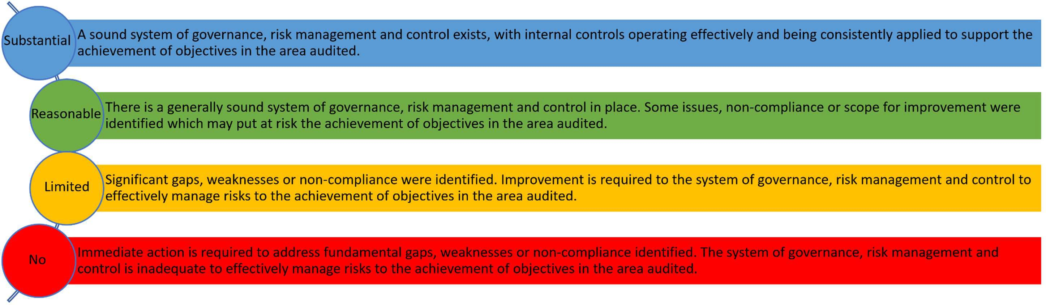

* Some reports listed within this progress report (pre 2020/21 audit plan) refer to categorisations used by SIAP prior to adoption of the CIPFA standard definitions, reference is provided at Annex 1.

Performance dashboard


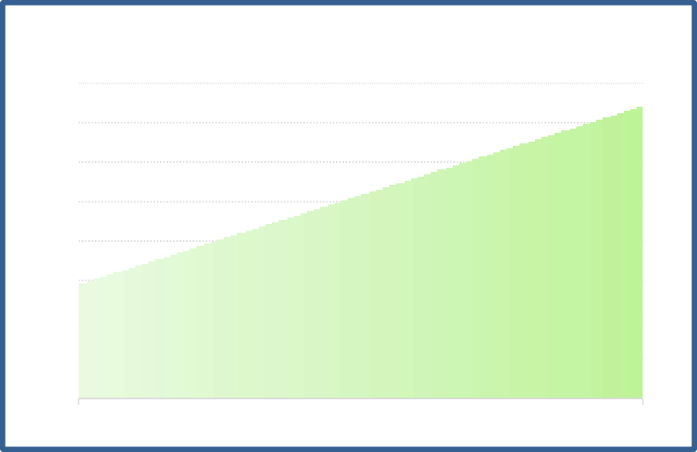
68%
Complete
95% of
revised plan delivered to to least draft report
32%
Work in Progress
0%
Yet to Commence
Stakeholder Satisfaction Survey Results
100%
98%
96%
94%
92%
90%
88%
86%
84%
Target
Actual

Days Delivered

 | Surrey 2024/25 plan | Joint Sussex and Surrey  2024/25 plan
Original Plan Days | 103 | 350
Revised Plan Days | 103 | 263
Days delivered | 103 | 263
Percentage of revised  plan delivered | 100% | 100%

Compliance with Public Sector Internal Audit Standards
An External Quality Assessment of the Southern Internal Audit Partnership was undertaken by the Institute of Internal Auditors (IIA) in September 2020. The report concluded:
‘The mandatory elements of the IPPF include the Definition of Internal Auditing, Code of Ethics, Core Principles and International Standards. There are 64 fundamental principles to achieve with 118 points of recommended practice. We assess against the principles.
It is our view that the Southern Internal Audit Partnership conforms to all 64 of these principles.
We have also reviewed SIAP conformance with the Public Sector Internal Audit Standards (PSIAS) and Local Government Application Note (LGAN).
We are pleased to report that SIAP conform with all relevant, associated elements.’
- Analysis of ‘Live’ audit reviews (as at 9 June 2025)
Audit Review | Report Date | Audit Sponsor | Assurance Opinion | Total Management  Action(s) | Not Accepted | Not Yet Due | Complete/ Retired** | Overdue
 |  |  |  |  |  |  |  | L | M | H
ERP – Legacy IT Risks Oracle People Solutions | Sep 22 | COO | No Assurance | 11 | 0 | 0 |  |  |  | 6
Strategy and arrangements for delivery of training to meet future  need | Aug 22 | DPS | Reasonable | 4 | 0 | 0 | 3 |  | 1
Duty Resource Planning | Sep 22 | ACC | Limited | 9 | 0 | 0 | 7 |  | 1 | 1
Operating Systems Management | Dec 22 | COO | Limited | 17 | 0 | 0 | 16 |  | 1
Vulnerability Management | Jul 23 | COO | Reasonable | 12 | 0 | 0 | 11 | 1
Database Management | Sep 23 | COO | Limited | 21 | 1** | 0 | 18 |  | 2
SSP Vehicle Recovery Process | Jan 24 | ACC | Limited | 11 | 0 | 0 | 9 | 2
SSP Armouries (storage and  management) | Feb 24 | ACC | Limited | 13 | 0 | 1 | 11 |  | 1
SSP Business Continuity (SAP/ Oracle) | Feb 24 | CFO | Limited | 14 | 0 | 0 | 13 | 1
Surrey Payroll | Feb 24 | CFO | Reasonable | 5 | 0 | 1 | 4
Surrey RoadSafe Partnership | Apr 24 | ACC | Reasonable | 11 | 0 | 0 | 3 | 2 | 5
SSP Estates and Facilities Management | May 24 | CFO | Limited | 16 | 0 | 0 | 11 | 1 | 3 | 1
SSP Contract Management – Capital* | May 24 | CFO | Reasonable | 3 | 0 | 0 | 3
SSP IT Major Incident Management | Jun 24 | COO | Reasonable | 6 | 0 | 0 | 4 |  | 2
SSP Learning & Development  Mandatory Training 2023/24 | June 24 | DPS | Limited | 6 | 0 | 2 | 2 |  | 1 | 1
Surrey Perpetrator Pathways – Domestic Abuse – Governance and  Roles & Responsibilities | Jul 24 | ACC | Reasonable | 3 | 0 | 0 | 0 |  | 3

SSP Supply Chain Security  Management | Jul 24 | COO | Reasonable | 14 | 0 | 1 | 13
Surrey - Data Storage and Backup | Jul 24 | COO | Reasonable | 5 | 0 | 0 | 2 | 2 | 1
SSP Legacy Application Management* | Nov 24 | COO | Reasonable | 4 | 0 | 0 | 4
SSP NPAS - National Air Helicopter  Service – Use of Allocated Hours | Feb 25 | ACC | Reasonable | 5 | 0 | 3 | 1 |  | 1
SSP Management of Fleet Vehicles* | Feb 25 | CFO | Reasonable | 2 | 0 | 0 | 2
SSP Crime Management – Organised  Crime Groups Processes | Feb 25 | ACC | Reasonable | 6 | 0 | 0 | 6
SSP Business Continuity – Longer Term  Planning | May 25 | ACC | Limited | 9 | 0 | 9 | 0
SSP Joint Procurement | May 25 | CFO (CC) | Reasonable | 3 | 0 | 3 | 0
SSP Dog School Income Generation | May 25 | ACC | No | 17 | 0 | 7 | 10
SSP Recruitment | May 25 | ACO | Reasonable | 6 | 0 | 6 | 0
OPCC – PCC General and Statutory  Duties* | May 25 | CFO (PCC) | Substantial | 0 | 0 | 0 | 0
Adult Abuse Investigation –  Governance and Reporting | June 25 | ACC | Reasonable | 3 | 0 | 3 | 0
Total |  |  |  |  |  |  |  | 9 | 22 | 9
* Denotes audits where all actions have been completed since the last progress report.
** Denotes where actions are retired/pending retirement.

Audit Sponsor (Director)
Chief Finance Officer | CFO
Deputy Chief Constable | DCC
Assistant Chief Constable | ACC
Chief Operating Officer | COO
ACO Director People Services | DPS

Rolling Work Programme

2023/24 Audit Plan – Remaining Audits

Audit Review | Audit Sponsor | Scoping Terms of  Reference Issued | Fieldwork Draft  Report Issued | Final Report Issued | Assurance Opinion | Comment / Previous Opinion
Shared Plan with Sussex Police
Data Protection Impact Assessments | DCC | ✓ ✓ | - 12.08.24 | 17.10.24 | Reasonable
Legacy Application Management | COO | ✓ ✓ | - 20.11.24 | 28.11.24 | Reasonable

2024/25 Audit Plan

Audit Review | Audit Sponsor | Scoping | Terms of Reference  Issued | Fieldwork | Draft Report  Issued | Final Report  Issued | Assurance Opinion | Quarter | Comment / Previous Assurance Opinion
Collaborated Plan
Use of Air Support (Drones) -  Governance | ACC | 17.06.24 | 02.08.24 | 04.11.24  16.12.24 | 21.01.25 | 30.01.25 | Substantial | Q1
NPAS - National Air Helicopter Service –  Use of Allocated Hours | ACC | 02.08.24 | 09.09.24 | 07.10.24  18.11.24 | 9.12.24 | 03.02.25 | Reasonable | Q2
Management of Fleet Vehicles | CFO | 01.08.24 | 05.08.24 | 09.09.24  18.11.24 | 15.11.24 | 10.02.25 | Reasonable | Q2
Transformation Savings Governance | CFO | 31.07.24 | 18.09.24 | 19.12.24  03.02.25 | 07.02.25 | 11.02.25 | Substantial | Q2

Audit Review | Audit Sponsor | Scoping | Terms of  Reference Issued | Fieldwork | Draft  Report Issued | Final  Report Issued | Assurance Opinion | Quarter | Comment / Previous Assurance Opinion
Crime Management – Organised Crime  Groups Processes | ACC | 27.08.24 | 09.09.24 | 17.10.24  06.01.25 | 15.01.25 | 26.02.25 | Reasonable | Q2
Business Continuity Planning | DCC | 24.10.24 | 26.11.24 | 16.12.24  07.03.25 | 18.03.25 | 09.05.25 | Limited | Q3 | Delays were due to the late receipt and subsequent agreement of management actions.
Counter Fraud Work  - Advisory | ACC | 28.10.24 | 09.01.24 | 03.03.25  28.03.25 | N/A | 12.05.25 | N/A | Q3
Dog School – Income Generation | ACC | 02.12.24 | 17.12.24 | 24.01.25  21.03.25 | 03.04.25 | 19.05.25 | No | Q3
Armouries – Storage and Management | ACC | 19.12.24 | 06.02.25 | 10.03.25  04.04.25 | 14.05.25 |  | N/A | Q4 | Factual accuracy of report agreed.
Recruitment | DPS | 14.11.24 | 17.12.24 | 13.01.25  10.03.25 | 09.04.25 | 22.05.25 | Reasonable | Q4
Joint Procurement | CFO | 08.01.25 | 07.03.25 | 03.04.25  25.04.25 | 29.04.25 | 13.05.25 | Reasonable | Q4
Collaborated Plan - IT
Software Licensing | COO | 07.06.24 | 22.08.24 | 13.12.24  13.05.25 |  |  |  | Q1 | Delays to delivery caused by audit team.  First Review
Service Transition | COO | 21.06.24 | 05.09.24 | 12.12.24  26.05.25 | 28.05.25 |  | Reasonable | Q1 | Factual accuracy of report agreed.

Audit Review | Audit Sponsor | Scoping | Terms of  Reference Issued | Fieldwork | Draft  Report Issued | Final  Report Issued | Assurance Opinion | Quarter | Comment / Previous Assurance Opinion
Data Centre Facilities and Security | COO | 22.01.25 | 06.03.25 | 31.03.25  09.05.25 | 16.05.25 |  | Reasonable | Q2 | Factual accuracy of report agreed. Draft final report issued 05.06.25.
Application Management NICE Investigate | COO | 06.02.25 | 26.02.25 | 19.03.25  22.04.25 | 12.05.25 |  | Limited | Q3 | Factual accuracy of report agreed. Draft final report issued 09.06.25.
Surrey Plan
Estates Strategy - Redevelopment of  Mount Browne | CFO | 14.05.24 | 02.07.24 | 08.10.24  16.12.24 | 21.01.25 | 10.02.25 | Substantial | Q1
Management Information – Dashboard Development and  Use | DCC | 20.05.24 | 22.08.24 | 23.09.24  24.10.24 | 13.11.24 | 14.01.25 | Reasonable | Q1
Missing Person Compliance | ACC | 23.05.24 | 18.06.24 | 16.12.24  02.05.25 | 19.05.25 |  | Limited | Q1 | Factual accuracy of report agreed.
Violence Against Women and Girls - Relentlessly  Pursuing Offenders | ACC | 10.09.24 | 08.10.24 | 22.11.24  19.12.24 | 29.01.25 | 26.02.25 | Substantial | Q2

Audit Review | Audit Sponsor | Scoping | Terms of  Reference Issued | Fieldwork | Draft  Report Issued | Final  Report Issued | Assurance Opinion | Quarter | Comment / Previous Assurance Opinion
Right Care, Right Person | ACC | 28.10.24 | 05.12.24 | 03.03.25  02.05.25 | 14.05.25 |  | Substantial | Q3 | Factual accuracy of report agreed.
PCC General and Statutory Duties – Assurance  Framework | CFO (OPCC) | 04.11.24 | 11.12.24 | 31.03.25  18.04.25 | 01.05.25 | 12.05.25 | Substantial | Q3
Adult Abuse Investigation – Governance and  Reporting | ACC | 16.01.25 | 24.02.25 | 14.04.25  08.05.25 | 16.05.25 | 02.06.25 | Reasonable | Q4

2025/26 – Quarter 1

Audit Review | Audit Sponsor | Scoping | Terms of Reference Issued | Fieldwork  1.Start 2. complete | Draft Report Issued | Final Report Issued | Assurance Opinion | Quarter | Comment (to include close of audit date if draft not issued / flag if management response  20 days +)
Collaborated Plan
Health and Safety | DCC | 17.10.24 | 24.02.25 | 07.04.25 | Q1 |  |  |  | Moved from the 2024/25 plan.  Close of audit meeting 26 June.

Audit Review | Audit Sponsor | Scoping | Terms of Reference Issued | Fieldwork  1.Start 2. complete | Draft Report Issued | Final Report Issued | Assurance Opinion | Quarter | Comment (to include close of audit date if draft not issued / flag if management response  20 days +)
Estates and Facilities – Recovery Plans | CFO | 23.12.24 | 11.02.25 | 27.04.25 | Q1 |  |  |  | Moved from the 2024/25 plan.  Close of audit meeting 13 June.  First review
Duty of Care Risk Assessments | ACC | 23.12.24 | 03.02.25 | 01.04.25 | Q1 |  |  |  | Moved from the 2024/25 plan. Delays in obtaining DOCRAs for testing, provided on 9 May.  Close of audit booked for 24 June.  First Review
Firearms and Explosives Licensing Processes | ACC | 29.04.25 |  |  | Q4 |  |  |  | Deferred from Q1 to Q4 at the request of the Force due to work underway in this area.
Driver Training | ACC | 01.05.25 | 06.06.25 |  | Q1 |  |  |  | First Review
Triaging of
Intelligence - | ACC | 17.04.25 | 02.06.25 |  | Q1 |  |  |  | First Review
Process and
Governance
Physical Security Arrangements | COO | 02.05.25 | 28.05.25 |  | Q1 |  |  |  | First Review
Occupational Health  - Psychological Safety Screening | ACO -PS | 05.06.25 |  |  | Q1 |  |  |  | Moved to Q1 on 13 May to replace the Q1 Firearms audit which has been deferred to Q4.

Audit Review | Audit Sponsor | Scoping | Terms of Reference Issued | Fieldwork  1.Start 2. complete | Draft Report Issued | Final Report Issued | Assurance Opinion | Quarter | Comment (to include close of audit date if draft not issued / flag if management response  20 days +)
First Review
Collaborated Plan - IT
IT Disaster Recovery and IT Service Continuity | CD&IO | 26.11.24 | 5.12.24 | 20.01.25 | Q1 |  |  |  | Moved from the 2024/25 plan.  Audit testing underway  First Review
 |  |  |  |  |  |  |  |  | Moved from the 2024/25 plan.
High Privilege  Access Management | CD&IO | 11.12.24 | 15.01.25 | 25.03.25 | Q1 |  |  |  | Close meetings being arranged for June.  First Review
Surrey Plan
Child Protection | ACC | 14.05.25 |  |  | Q1 |  |  |  | First Review
Custody Compliance | ACC | 14.05.25 |  |  | Q1 |  |  |  | First Review
Contact and  Deployment - Call Grading | ACC | 22.05.25 |  |  | Q1 |  |  |  | First Review

VARIATIONS TO PLAN
The following variations have been made to the 2024/25 internal audit plan since it was presented to the Joint Audit Committee in April 2024 and changes since the last JAC meeting are marked with *.

Collaborated Plan
Audit reviews removed from the plan
Violence Against Women and Girls - relentlessly pursuing offenders | Removed from the SSP plan to be considered under individual force plans due to differences in processes in this area. Propose to undertake Surrey audit in Q3 and undertake Sussex in either Q4 or 2025/26.
Joint Force Vetting | Audit cancelled in October due to clash with HMICFRS inspection, along with the Angiolini Inquiry in Sussex examining some of the same areas. Propose to undertake in 2025/26 with a focus on areas for improvements identified by the inspections.
IT Health Check Remediation | Audit removed from the 2024/25 plan as the Health Check has only just started so there would not be enough to audit at the current time. The audit will be undertaken as part of the 2025/26 audit plan.
Duty of Care Risk Assessments* Health and Safety*  Estates and Facilities – Recovery Plans* High Privilege Access Management*  IT Disaster Recovery and IT Service Continuity* | Following a recommendation from the Sussex JAC, supported by the Surrey JAC and approved by the S151 Officers in the OPCCs and for the Force, these audits had a longer delivery timeframe, so have been removed from the 2024/25 plan and added to the 2025/26 plan, with the 2025/26 plan being reprofiled accordingly.
Audit reviews added to the plan
None

Surrey Police Plan
Audit reviews removed from the plan
None
Audit reviews added to the plan
Violence Against Women and Girls - relentlessly pursuing offenders | Moved from the SSP plan to the Surrey plan due to difference in processes between Surrey and Sussex.

