To: Surrey
Date: Quarter 2: 2024/2025
Title: Health and Safety - General Update and Statistics Report

Contents:
- Safety Incidents for Quarter 2: 2024/25 2
Headcount 2
Total Number of Safety Incident Reports 2
- Graph: 2024/25 Health and Safety Service Reactive Demand Analysis 3
Commentary – Q2 Reactive Demand 3
- Analysis for SURREY Only 4
The Surrey 12/2 Safety Incident Reporting System 4
Surrey Officer and Staff Safety Incident Causation 2024/25 4
Graph: Surrey Safety Incident Headline Causation 2024/25 5
Commentary – Surrey Safety Incident Types 5
Graph: Average Surrey Assault Rate (with Injury) by Financial Year 5
Commentary – Average Surrey Assault Rate (with Injury) by Financial Year 6
Graph: Average Surrey Assault Rate (with injury only) by Month 6
Commentary – Average Surrey Assault Rate (with injury only) by Month 6
Graph: Average Surrey Employee Injury Rate since 2019/20 by Financial Year 6
Commentary – Average Surrey Employee Injury Rate since 2019/20 by Financial Year 7
Graph: Average Surrey Employee Injury Rate since 2019/20 by Month 7
Commentary – Average Surrey Employee Injury Rate since 2019/20 by Month 7
- College Learn Mandatory Minimum Training Compliance 8

Safety Incidents for Quarter 2: 2024/25
Raw data

 | SUSSEX |  |  | SURREY
 | Jul | Aug | Sep | Jul | Aug | Sep
Headcount
No. Officers (incl. Specials) |  |  |  | 2421 | 2412 | 2451
No. Staff (incl. PCSO’s) |  |  |  | 1910 | 1909 | 1916
Total Employees |  |  |  | 4331 | 4321 | 4367
Arrests (Primary) |  |  |  | 1218 | 1249 | 1113
Injuries (employees only) |  |  |  | 51 | 35 | 35
Assaults (with and without injury) |  |  |  | NA | NA | NA
Assaults (with injury only) |  |  |  | 18 | 12 | 7
Near Misses (employees only) |  |  |  | 2 | 4 | 9
Custody Adverse Incidents |  |  |  | 56 | 70 | 52
Injury Rate  (Injuries per 1000 employees) |  |  |  | 11.7 | 8.1 | 8
ASSAULT RATE (With and Without Injury)  (Assaults per 1000 arrests) |  |  |  | NA | NA | NA
ASSAULT RATE (With Injury Only)  (Assaults per 1000 arrests) |  |  |  | 14.7 | 9.6 | 6.2
Total Number of Safety Incident Reports (Safety Service Reactive Demand)
Financial Year | Sussex |  | Surrey |  | TOTAL
2024/25 Q2 | 565 |  | 369 |  | 934
2024/25 Q1 | 544 |  | 425 |  | 970
2023/24 | 2178 |  | 1647 |  | 3825
2022/23 | 1834 |  | 1326 |  | 3160
2021/22 | 1672 |  | 1112 |  | 2784
2020/21 | 1396 |  | 1126 |  | 2522
2019/20 | 1336 |  | 1067 |  | 2403
2018/19 | 1087 |  | 748 |  | 1835
2017/18 | 1067 |  | 668 |  | 1735

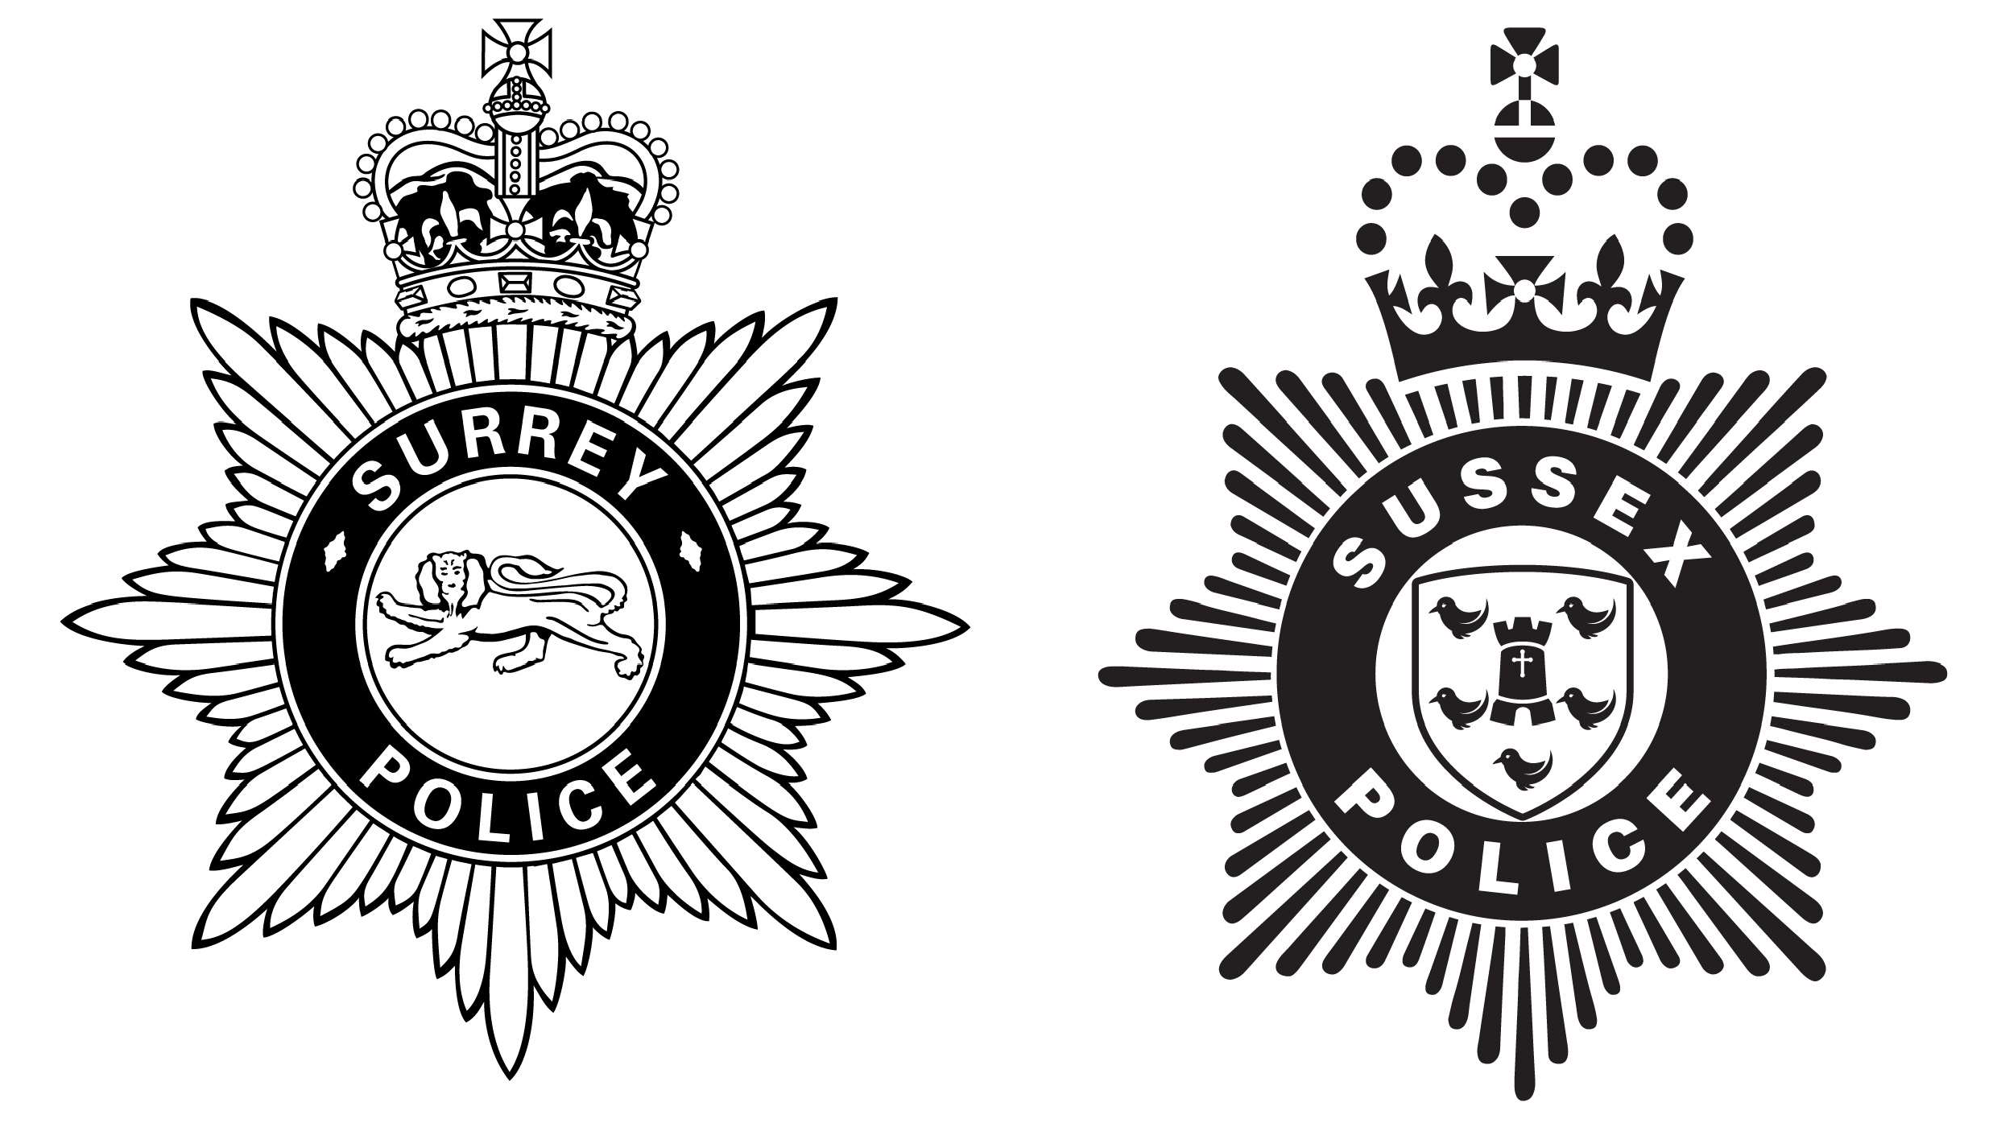

Graph: 2024/25 Health and Safety Service Reactive Demand Analysis
This graph shows the number of safety incidents processed by the Health and Safety Service in Q2 2024/25, for Sussex (blue), Surrey (orange) and collectively (yellow), compared with last year (2023/24) (grey).
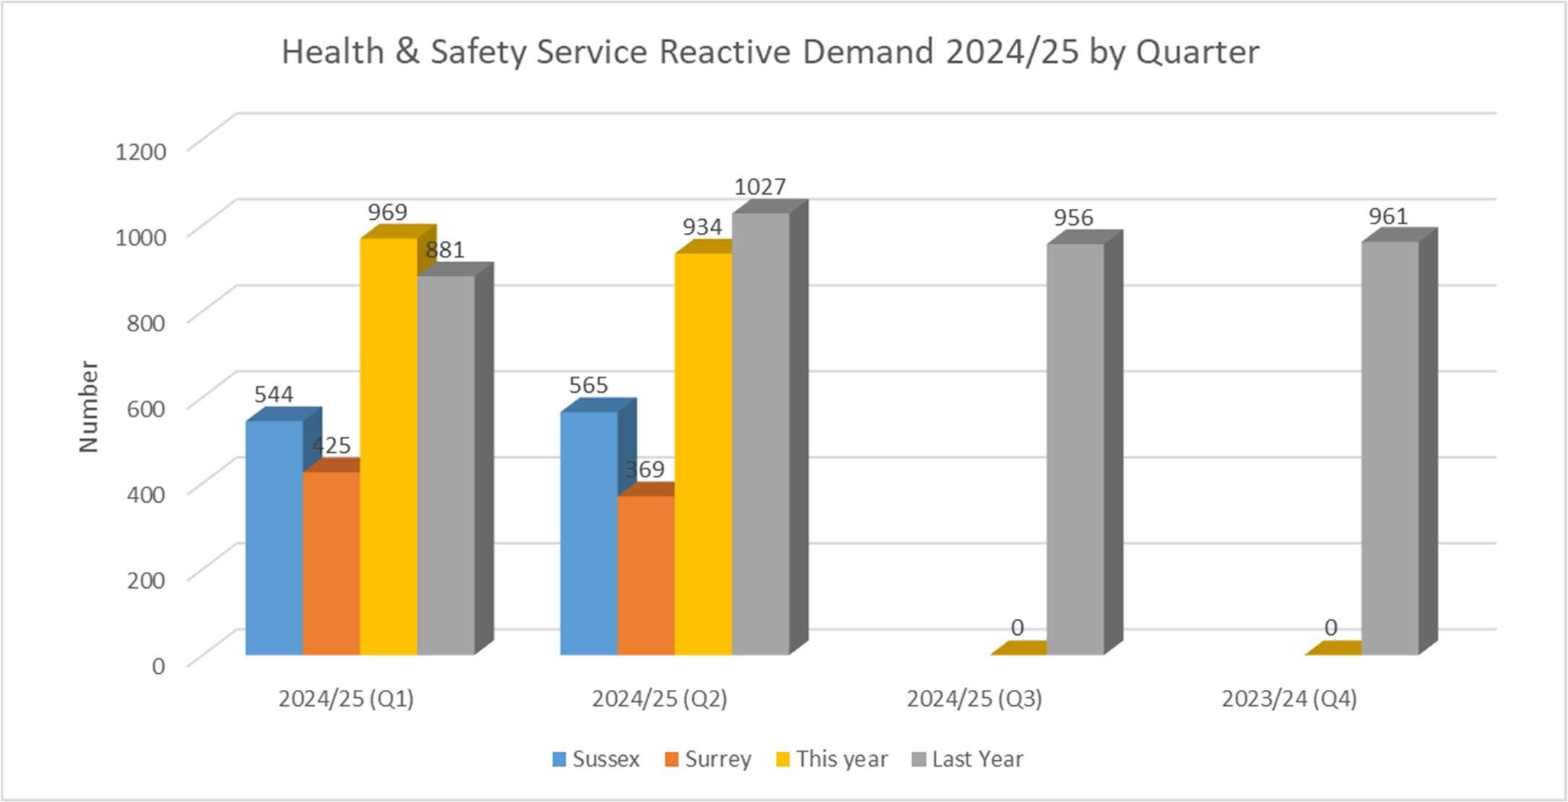

Commentary – Q2 Reactive Demand

    - Reactive demand in Q2 2024/5 was 9% lower than the same period in 2023/24.
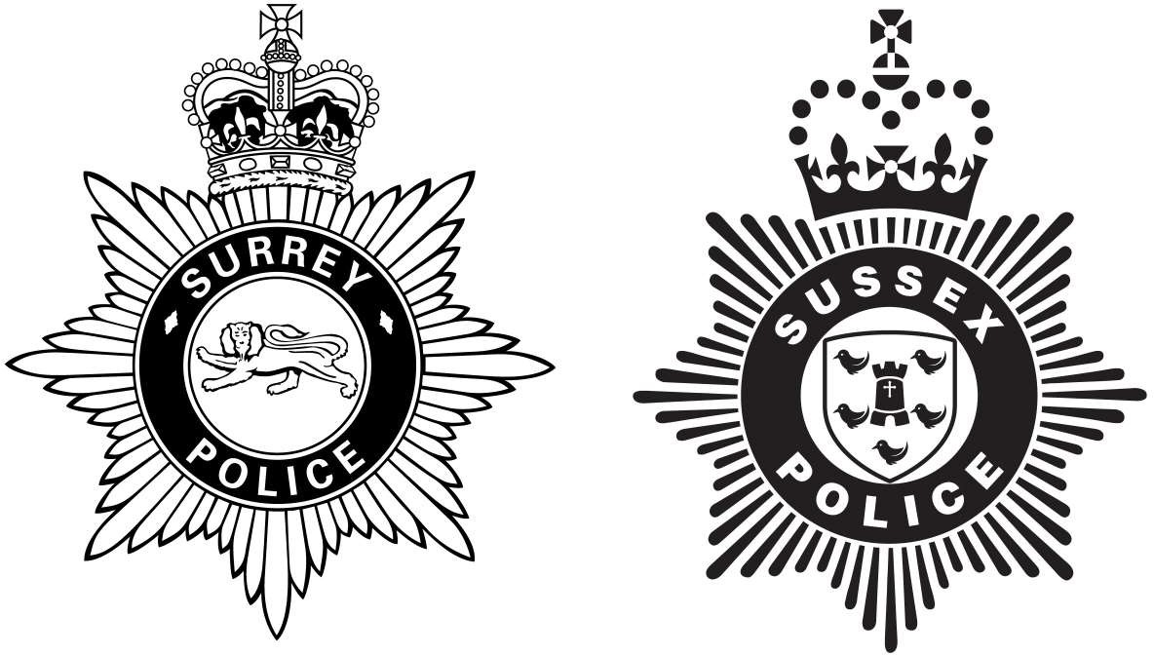

Analysis for SURREY Only

The Surrey 12/2 Safety Incident Reporting System

IT investment in the stability of the system was declined for several years on the basis that the ERP platform would be replacing it. The Health and Safety Service is now represented on the ERP Programme Board and a replacement system has been procured. It is estimated that the new system will be rolled out in 2024 early 2025.

Surrey Officer and Staff Safety Incident Causation 2024/25

Incident Cause | Q1 | Q2 | Q3 | Q4 | 2024/25
Assaulted (with injury only) | 41 | 37 |  |  | 78
Conflict Training | 32 | 19 |  |  | 51
Restraint | 14 | 10 |  |  | 24
Arrest | 15 | 9 |  |  | 24
Other | 10 | 12 |  |  | 22
Slip, trip and fall | 12 | 10 |  |  | 22
By Animal | 4 | 7 |  |  | 11
Handling/Lifting/Carrying | 6 | 2 |  |  | 8
Hit fixed/stationary item | 4 | 3 |  |  | 7
RTC | 4 | 2 |  |  | 6
Training – Other | 4 | 1 |  |  | 5
Hit by a Moving Item | 3 | 2 |  |  | 5
Pursuit | 3 | 1 |  |  | 4
PSU Training | 2 | 2 |  |  | 4
Office Based | 1 | 1 |  |  | 2
Other Driving | 1 | 1 |  |  | 2
Medical | 2 | 0 |  |  | 2
Defective fixtures | 0 | 1 |  |  | 1
Fall from Height | 1 | 0 |  |  | 1
Body Armour | 0 | 1 |  |  | 1

Graph: Surrey Safety Incident Headline Causation 2024/25
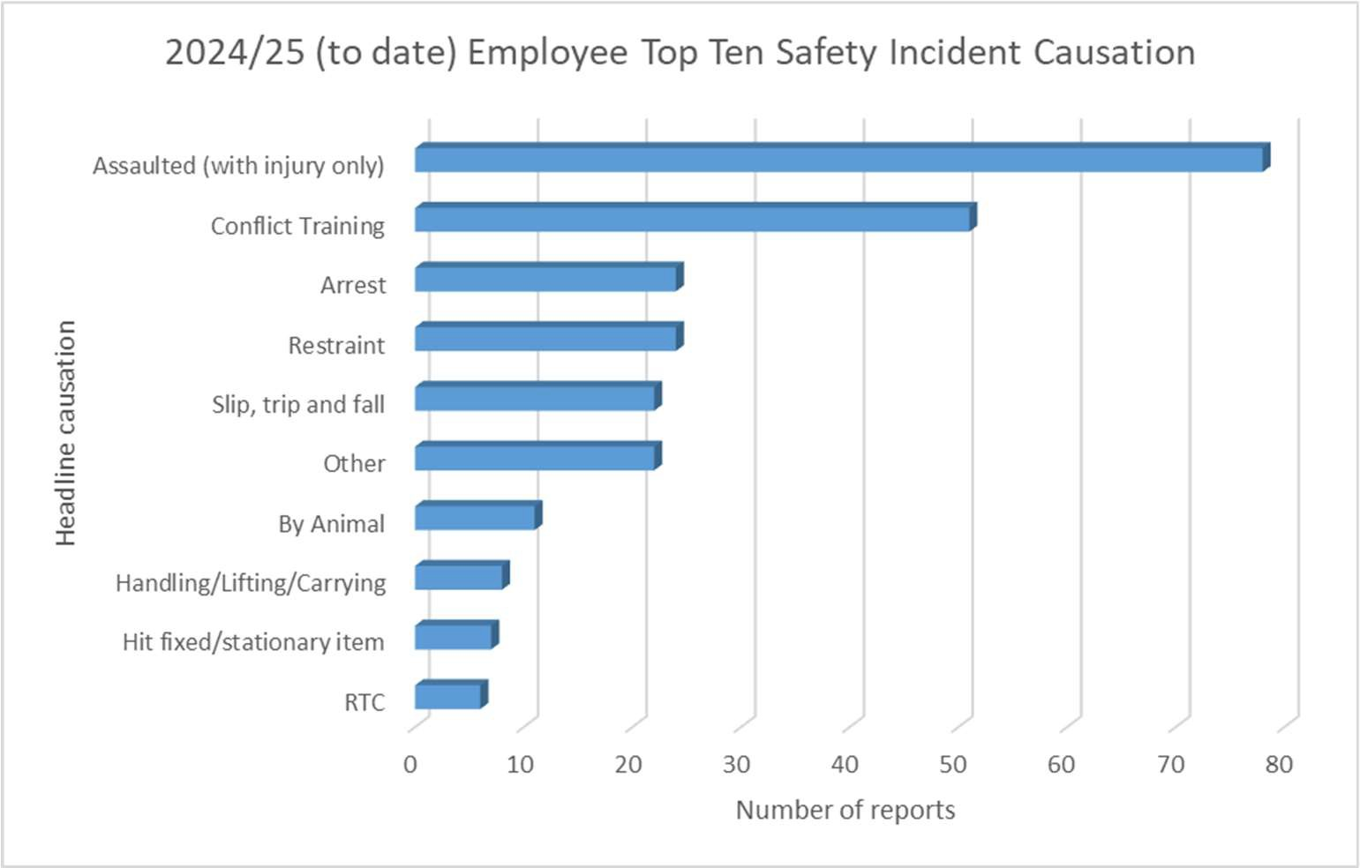

Commentary – Surrey Safety Incident Types
    - As in Sussex, arrests and incidents surrounding arrest remain the largest cause of injury. We continue to see injuries being sustained during conflict training. In the 2024/25 Health and Safety Service Business plan, injuries from conflict training have been selected for review.

Graph: Average Surrey Assault Rate (with Injury) by Financial Year
This graph shows the average number of assaults with / without injury per 1000 arrests by financial year since 2019/20.
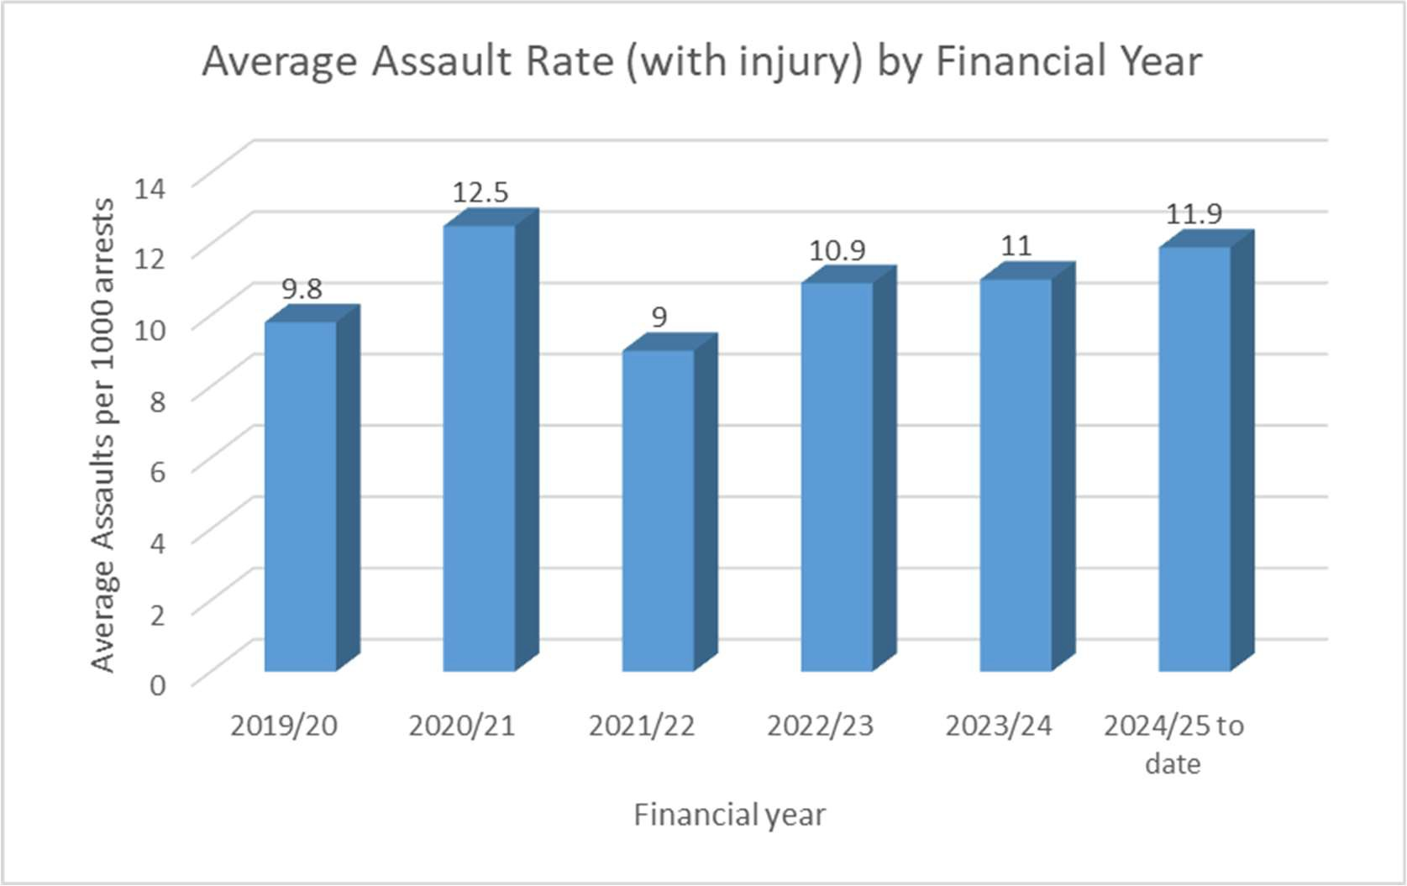

Commentary – Average Surrey Assault Rate (with Injury) by Financial Year

    - The Surrey Assault Rate (with Injury) has shown sporadic movement across the year. In terms of change over time:

Graph: Average Surrey Assault Rate (with injury only) by Month
This graph shows the average number of assaults with injury only per 1000 arrests by month.
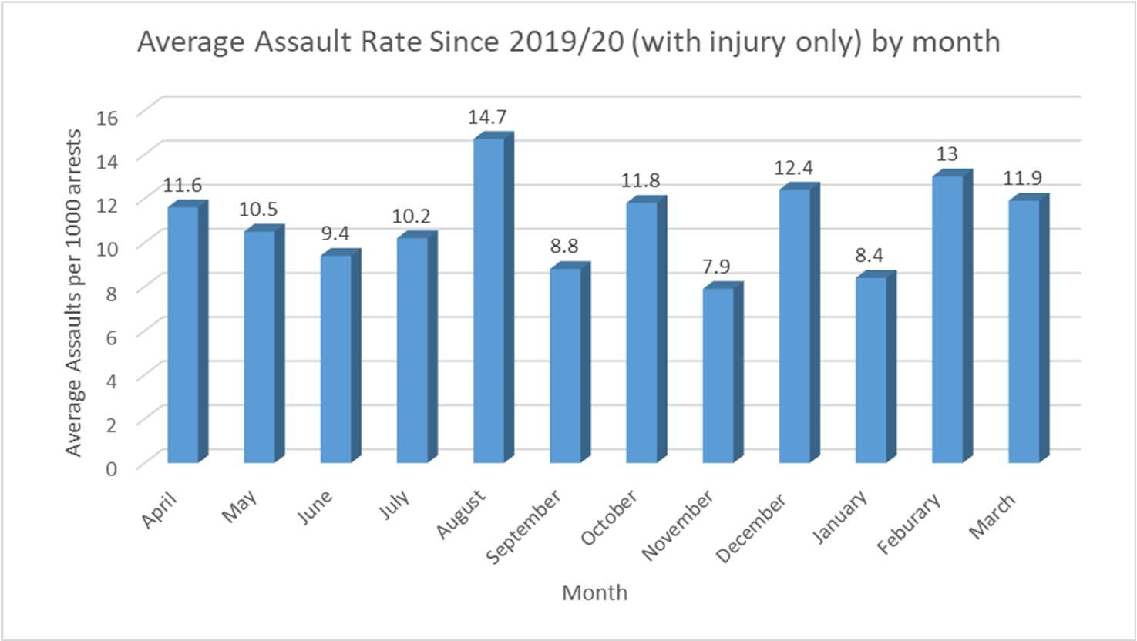

Commentary – Average Surrey Assault Rate (with injury only) by Month

    - No comment at present.

Graph: Average Surrey Employee Injury Rate since 2019/20 by Financial Year
This graph shows the average number of injuries per 1000 employees each financial year since 2019/20.
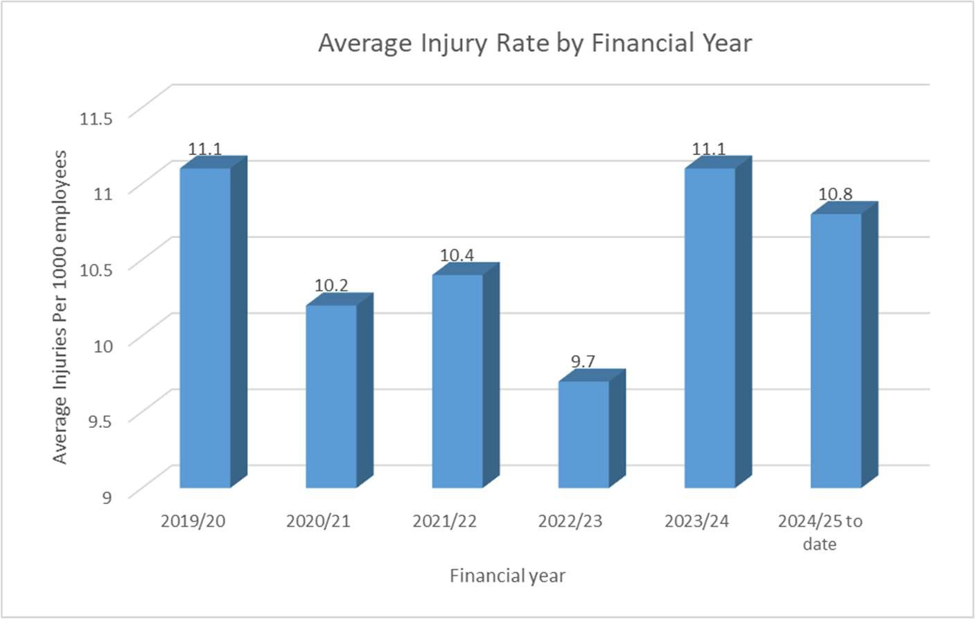

Commentary – Average Surrey Employee Injury Rate since 2019/20 by Financial Year

    - No comment at present.

Graph: Average Surrey Employee Injury Rate since 2019/20 by Month
This graph shows the average number of injuries per 1000 employees each month since 2019/20.
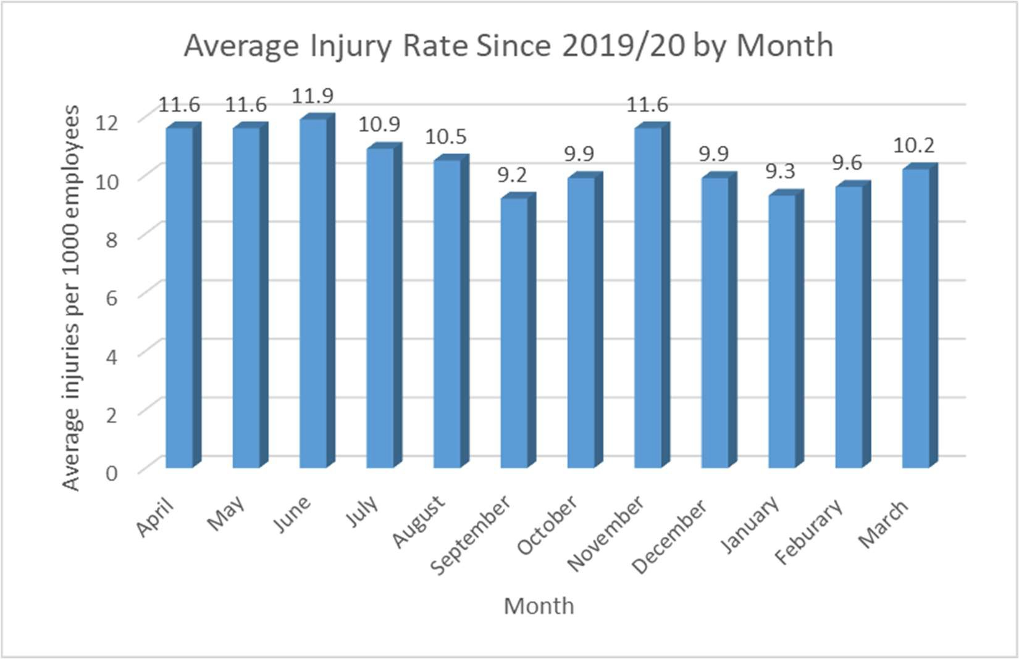

Commentary – Average Surrey Employee Injury Rate since 2019/20 by Month

    - No comment at present.

Health and Safety Service
Surrey Police and Sussex Police

Safety Incident Statistics

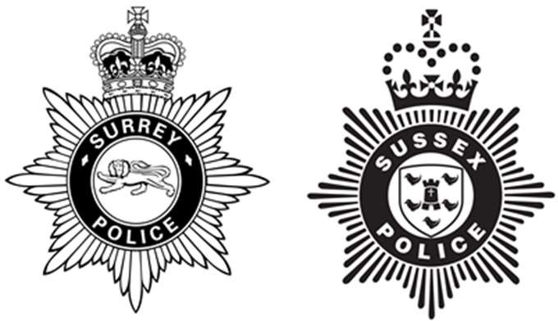
College Learn Mandatory Minimum Training Compliance

SURREY – Dated 30 September 2024 (refreshed date 7 October 2024)


