

Health and Safety Report

Required for: | Surrey Joint Audit Committee (JAC) June 2025
Security Classification: | Official
Handling information if required:
Suitable for publication: | Yes
Title: | Health and Safety Service Update Report
Version: | 1.0
Purpose: | To provide Audit Committee with an update on health and management within Surrey Police.
ACPO / Strategic Lead: | Deputy Chief Constable
National Decision Model compliance: | N/A
Date created: | 04/03/25
Date to be reviewed:

AUTHOR:
Name: | Matthew Green
Job Title: | Head of Health & Safety Service  Surrey Police and Sussex Police
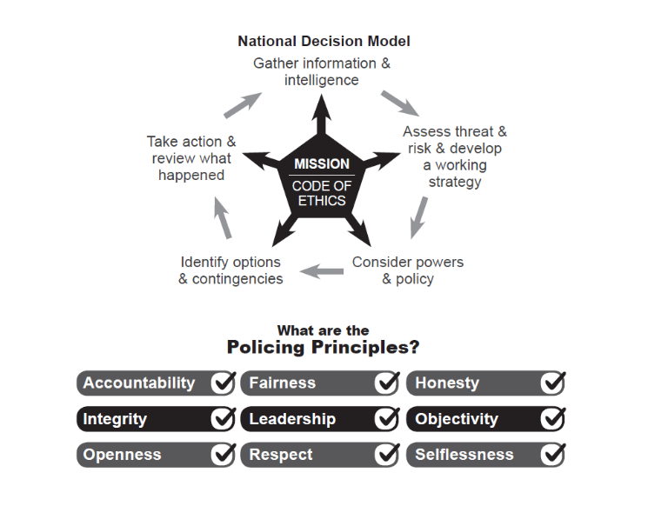
- Purpose of this report

  - This report provides updates on Health and Safety management within Surrey Police. This includes:

- Surrey safety incident stats for Q1 and Q2 2024/25.
- The replacement of the Surrey safety incident reporting system (12/2).
- A new system of health and safety assurance to be rolled out during 2025/26. This will improve the safety risk and assurance information available to Audit Committee as outlined below.
- Health and Safety Executive inspections in Surrey Custody.
- Work of the Assaults Working Group, which has now closed and been merged into Op Hampshire (national project to manage assaults on officers and staff) as business as usual.
- Safety Incident Stats for 2024/25
  - Please find attached the stats for Q1 and Q2 2024/25 as appendix 1 and 2. The Sussex data has been removed as the differences between the data collection methods in each force means that no meaningful comparison can be made. The Health and Safety Service aims to introduce shared safety stats again when the Surrey system (12/2) is replaced. The Q3 2024/25 Safety Incident report was suspended due to significant enforcement demand in both forces but will be produced in time for the summer Strategic Health and Safety Board.
  - Assaults continue to be the most likely way officers are injured at work. Conflict training in Surrey is now showing as the second biggest cause of officer injury. There has always been a balance between training which is realistic and gives officers the skills and confidence to deal with real life situations and the degree of injuries this can cause. This has been subject to review by the Health and Safety Service before and plans are in place to consider it again.
- Replacement of the Safety Incident Reporting System (12/2)
  - The safety incident reporting system (12/2) in Surrey has been obsolete for a number of years and has resulted in poor quality, but legally compliant safety data. The system is now being replaced with a view to roll out in Spring / Summer 2025.
  - The Health and Safety Service and ERP Project Team met with Origin (supplier) on the 18/02/25 to run through how the new system will be able to record Custody Adverse Incidents. The supplier has created a new category to record these, and the view is that the system will be able to adequately record this type of safety incident.
  - A detailed demonstration of the back-office features of the new system hosted by the supplier has been booked in for the 01/04/25.
  - The Health and Safety Service has completed its required configuration values for the new system. There will be meetings with the supplier to specify these.
  - There are now meetings with the ERP team every 2 weeks to monitor progress.
- New Health and Safety Assurance System - Safety Responsibilities and Risk Based Assurance.
  - At the Strategic Health and Safety Board on 24th October 2024 a new safety assurance system was approved. The new assurance system is attached as Appendix 3. The new system seeks to:

- Review where safety risk exists within the organisation so that resource and assurance can be focussed on the highest risk areas.
- Establish the respective roles and responsibilities of the central health & safety team and of individual risk owners (heads of service / department).
- Increase the accountability of risk owners by requiring them to demonstrate how they are managing safety risk.
- Require risk owners to not only confirm they accept and understand their responsibilities but explain how they are managing safety risk effectively.
- Ensure that the force has an auditable trail of health and safety considerations. This will provide chief officers, audit committees and Strategic Health and Safety Board with assurance that senior managers understand their safety responsibilities and that they have been offered the agreed levels of support relevant to risk in their area.
- Force a conversation with risk owners who do not appear to be engaging with their responsibilities (a minority) and put a plan in place for improvement.
- Update chief officers, audit committees and the Strategic Health and Safety Board of significant health and safety threats, through a new Strategic Health and Safety Threat Assessment.
  - The new process is more robust and includes the following elements.

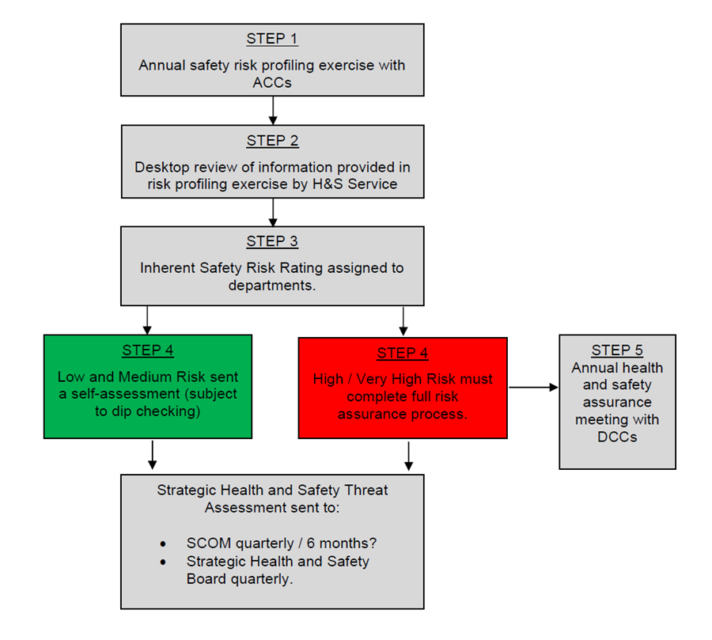
  - Step 1: An annual safety risk profiling exercise. This will involve assistant chief constables (ACCs) identifying the following:

- Which departments fall within their area of responsibility.
- Who heads up that department.
- What safety risk exists within that department with reference to the following risk factors:

- Public contact.
- Threat of violence and aggression.
- Exposure to distressing images or situations.
- Working with hazardous equipment.
- Working with hazardous chemicals.
- Exposure to body fluids or pathogenic substances.
- Risk of fatigue.
- High risk decision making, for example firearms command, firearms officer, driving on blues.
- Significant manual handling of people or objects,
- Dealing with vulnerable persons, for example children or those with mental health illness.
- Managing complex / high risk construction projects.
- Managing the safety of the police estate.
- Lone working.

  - Step 2: Health and Safety Service Desktop Review. The information provided by the ACCs will be assessed and the degree of inherent safety risk that departments pose will be decided. This will determine the degree of help, support and intervention that is appropriate. This will include an assessment of:

- History of safety incidents reported to the Health and Safety Service.
- Complaints or concerns raised.
- Enforcement action.

  - Step 3: Departments will be assigned an inherent safety risk rating. The information provided by the ACCs and the assessment undertaken by the Health and Safety Service will result in departments being given an inherent health and safety risk rating as below.
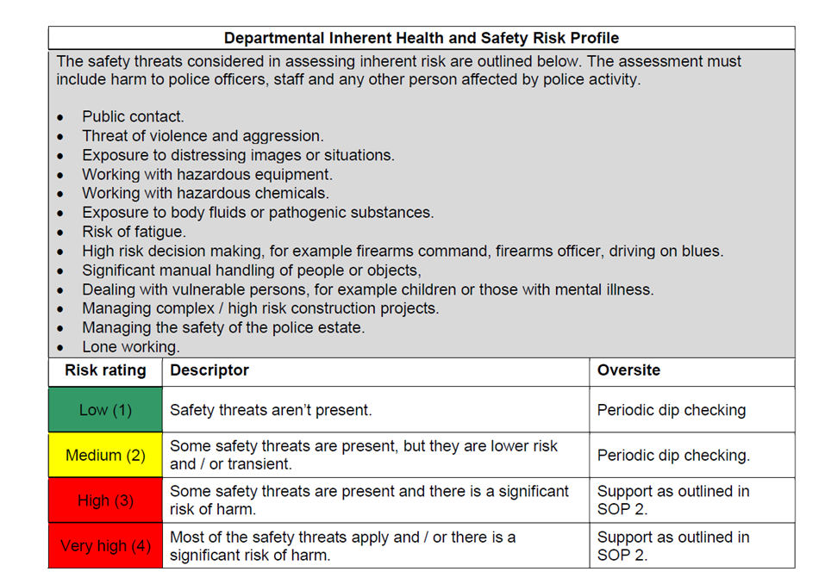

  - Step 4: Departments will go through the annual health and safety assurance process.

- Heads of department will be sent the Safety Responsibilities and Risk Based Assurance assessment to complete (appendix 3). The purpose of this is to:

- Clearly explain responsibilities and expectations.
- Offering support to meet responsibilities and expectations.
- Requiring risk owners to not just say they are meeting the responsibilities and expectations, but to explain how they are.

- The risk assurance document contains two parts.

- Part 1: The service and support that can expected from the Health and Safety Service to meet responsibilities.
- Part 2: The expectations Surrey Police and Sussex Police have of risk owners to keep officers, staff, detainees and any other person affected by your department’s activities, safe.

Proportionality

  - Only departments posing a high / very high inherent health and safety risk will be expected to return the completed document to their dedicated health and safety advisor. They will also be invited to the Annual Risk Assurance Meetings to explain in person how they are discharging their health and safety responsibilities.

  - As is currently the case, low and medium risk departments will be left to self-assess, with periodic dip checking by the Health and Safety Service. They will be expected to have completed the assessment.

The Responsibilities Outlined in the New Assurance Process (appendix 3)

  - Responsibilities of risk owners

- Responsibility 1: You understand what areas you are responsible for.
- Responsibility 2: All planned police operations and activities have an operational risk assessment. For non-operational departments, this responsibility also applies to significant activities that your department undertakes which fall outside the scope of Job Role Risk Assessments.
- Responsibility 3: All job roles (or clusters of similar roles) have a job role risk assessment.
- Responsibility 4: Dynamic risk assessment is used when the circumstances truly justify it.
- Responsibility 5: If anyone is injured as a result of what your department does (or could have been), including members of the public or detainees that it is reported.
- Responsibility 6: Active consultation on safety matters takes place with officers and staff.
- Responsibility 7: Equipment is maintained in a safe condition.
- Responsibility 8: Where you have responsible for the safety of buildings, vehicles and / or structures, that they are maintained in a safe condition.

  - Responsibilities of the Health and Safety Service

- Responsibility 1: Provide you with positive help, support, and guidance to understand and meet your health and safety responsibilities.
- Responsibility 2: Investigate serious safety incidents in your department, affecting officers, staff, detainees, and members of the public affected by police activity and report back to you.
- Responsibility 3: Manage enforcement action from the Health and Safety Executive and the Fire Service.
- Responsibility 4: Based on the risk a department poses, review how well safety is being managed within your department to ensure continual improvement.
- Responsibility 5: Monitor safety incidents within your department, flag serious incidents with you and provide you with management information. (Recorded using 12/2 in Surrey and FIAMS in Sussex).
- Responsibility 6: Manage corporate level consultation on health and safety matters with The Police Federation, Unison and The Superintendents Association.
- Responsibility 7: Establish the minimum health and safety training that officers and staff must complete and report compliance levels to you every quarter.
- Responsibility 8: Keep Chief Officers, audit committees and Strategic Health and Safety Board appraised of safety issues of significant concern, through the production of the Strategic Health and Safety Threat Assessment.

- Health and Safety Executive (HSE) Inspection in Surrey Custody

  - Following the tragic death of a custody sergeant in the Metropolitan Police, where a detainee smuggled a firearm into custody, the Health and Safety Executive (HSE) launched a national campaign of inspections to check what measures forces have in place to prevent this happening.

  - As part of their national campaign of inspections, the HSE visited Salfords Custody suite on the 10th of January 2025 and Guildford Custody Suite on the 31st of January 2025. In both suites, the HSE interviewed the Health and Safety Service, a custody sergeant, a response officer and a response sergeant.

  - The inspections went well, and the Health and Safety Executive gave positive feedback on the pro-active measures Surrey Police are taking to reduce the likelihood of weapons finding their way into custody, while ensure detainee dignity. In particular, the roll out of airport style detector arches in custody to identify concealed items.

  - Two improvements were agreed with the Health and Safety Executive, these were:

- To introduce a new process to review body worn video of searches carried out by officers (a piece of work well underway by Clive Davies) so officers can be given feedback.
- Making an improvement to the custody booking in sheet to establish the degree of search a detainee has already been subjected to (this action is complete).

- Update on the Work of the Assaults Working Group

  - In response to the rising numbers of assaults, the Assaults Working Group was created by the Health and Safety Service and ran for 18 months.

  - Stakeholders included:

- The Police Federation.
- Unison.
- Learning and Development (develop and deliver officer / staff safety training).
- Occupational health.
- The Health and Safety Service.
- Custody.
- Wellbeing.
- Response teams (officers most likely to be assaulted).
- Neighbourhood teams.

  - The Assaults Working Group developed an Assaults Action Plan with the objective to ‘reduce the likelihood and seriousness of assaults.’ The Action plan was structured under the following headings.

- Prevent

- We will identify places where officers and staff are most likely to be assaulted by reviewing the data. We will work to identify why assaults are taking place in these places and reduce the risk.
- We will identify the officers most at risk of assault and repeated assault and support them to reduce the risk.
- We will identify the barriers to officers and staff reporting assaults and work to encourage reporting.
- We will work to ensure officers and staff attend safety training as this gives them the skills to reduce the risk of assaults.
- Pursue

- We will work with CPS on decisions to prosecute those who assault officers / staff and challenge decisions to not pursue.
- Protect

- We will review the support offered to officers and staff to ensure that appropriate support post assault is available and easy to access.
- Prepare

- Where appropriate and legal, the Health and Safety Service will share assaults data and information on what happened during an assault with Learning and Development, so that L&D trainers can assess whether training is being followed, whether current training needs to be modified and also whether officers need refresher / targeted training.
- We will work to improve safety training by integrating situational awareness, particularly in custody and hospitals.
- Where appropriate and legal, the Health and Safety Service is willing to share data with The Police Federation and Unison when one of their members has been injured at work. This includes assaults and enables trade unions to offer their members help and support.

  - Detailed actions taken to meet each of these are outlined in the attached action plan as Appendix 4 (Official Sensitive).

  - The Assaults Working Group has now ended, and work will be passed by to Op Hampshire (operation name for assaults) as business as usual.
- Recommendations

  - The Audit Committee note the progress in managing safety risk within Surrey Police.
- Appendices

- Appendix 1: Health and Safety Stats for Q1 2024/25.
- Appendix 2: Health and Safety Stats for Q2 2024/25.
- Appendix 3: New - Safety Responsibilities and Risk Based Assurance.
- Appendix 4: Assaults Working Group Action Plan.

REPORT END

