

Equality, Diversity and Inclusion Policy (Surrey and Sussex 193)
Abstract

The Public Sector Equality Duty (PSED) was created under the Equality Act 2010 and came into force in 2011.This policy sets out the requirement for Surrey Police and Sussex Police as employers, to actively promote equality, fairness and respect for all police officers, police staff, special constables and volunteers to enable all individuals to reach their full potential and to recruit and retain a workforce that reflects the diversity of the communities it serves. The PSED also requires that Surrey Police and Sussex Police are active in making society fairer by tackling discrimination and providing equality of opportunity for all.

Policy
- Introduction

  - The Equality Act 2010 was introduced to legally protect people from discrimination in the workplace and in wider society. Surrey Police and Sussex Police are required to comply with the Equality Act 2010, and in particular Section 149 the Public Sector Equality Duty (PSED), which requires public bodies to have due regard to the need to eliminate discrimination, advance equality of opportunity and foster good relations between different groups of people when carrying out their activities.

Surrey Police and Sussex Police have a zero-tolerance approach to towards discrimination or discriminatory practices, as defined in section 3.1 of the Equality, Diversity and Inclusion procedure.

Under the Equality Act 2010, there are nine protected characteristics:
    - Age
    - Disability*
    - Gender reassignment** **
    - Marriage and civil partnership
    - Pregnancy and maternity

- Race
- Religion or belief
- Sex
- Sexual orientation
* A person has a disability if (a) they have a physical or mental impairment, and (b) the impairment has a substantial and long-term adverse effect on their ability to carry out normal day-to-day activities.
** A person has the protected characteristic of gender reassignment if the person is proposing to undergo, is undergoing or has undergone a process (or part of a process) for the purpose of reassigning the person's sex. Whilst the Equality Act 2010 refers to ‘gender reassignment’, this is recognised as an outdated term. As such this policy refers to gender identity and expression, and includes individuals using contemporary language to describe their gender identity; for example, trans or non-binary.
1.2 This policy sets out the commitment of Surrey Police and Sussex Police to meet the requirements of the PSED 2011 by providing:

- Equality of opportunity and freedom from unlawful discrimination on the grounds of race, nationality, ethnic origin, gender, gender identity and expression, marital or civil partnership status, disability, religion or belief, pregnancy and maternity, age or sexual orientation. This statement includes unlawful discrimination against multiple aspects of an individual’s identity.
- A framework to identify and address, all forms of unlawful discrimination in the workplace and to create equality of opportunity in an environment where individual differences and the contribution of all members of Surrey Police and Sussex Police are recognised and valued.
- A supportive working environment free from harassment, victimisation or bullying and
- Delivering a public service where all members of the Forces and the wider community we serve are treated with dignity and respect

Scope

  - This policy associated procedure and supporting documents provide an overarching structure that brings all strands of Equality, Diversity and Inclusion together into one document for Surrey Police and Sussex Police as employers and public service providers.

Policy Statement

  - Surrey Police and Sussex Police expect all colleagues to have a zero-tolerance approach towards bullying, harassment, discrimination or discriminatory practices.
Surrey Police and Sussex Police recognise the benefit of a diverse and representative workforce and are committed to promoting equality and ensuring every individual is treated with dignity and respect. All individuals have the right to work in a safe, healthy, fair and supportive environment free from any form of discrimination or victimisation towards a protected characteristic and the supporting procedures will ensure there is a mechanism in place for dealing with all issues raised in a considerate, consistent and timely manner. It is important to note that bullying and harassment is not always related to a protected characteristic. All Surrey Police and Sussex Police Policies are applicable to all police officers, police staff, special constables and volunteers regardless of their personal characteristics or identity.

  - As employers, Surrey Police and Sussex Police recognise one of the key risks is not having a workforce that is representative of the communities we serve. By adhering to this policy our ambition is to enhance the ability to engage with all communities and access a broader range of skills and experience from a more diverse workforce, resulting in improved decision making at both strategic and operational levels.

  - Policies and associated procedures and guidance documents should inform decision making which should consider organisational values, professional judgement (on the context and circumstances of each situation) and ‘policing principles’. Decisions and subsequent action taken should be proportionate, legitimate and ethical as informed by the National Decision Model.

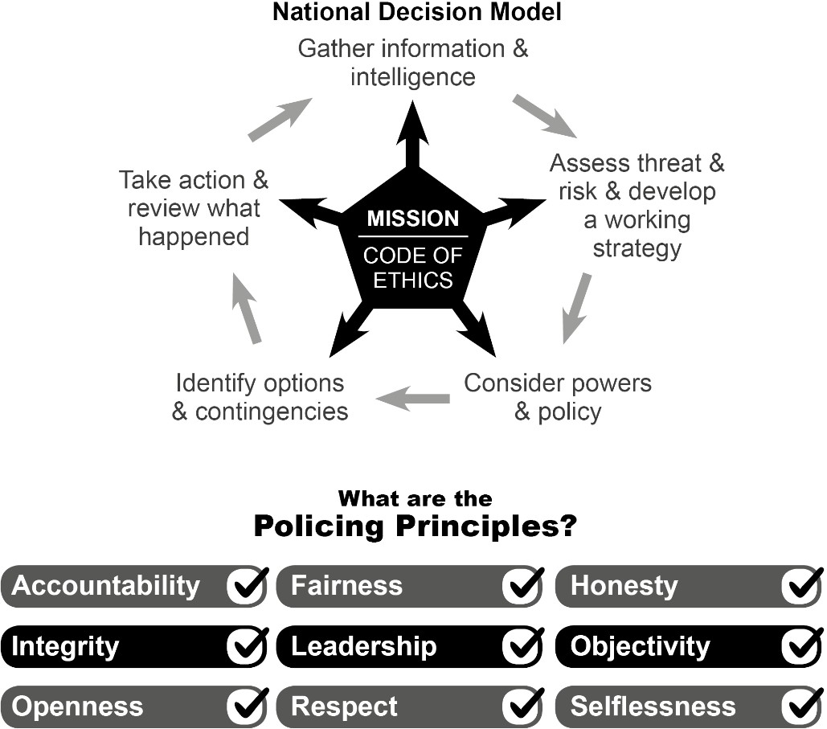
PROCEDURE

Foreword

  - Surrey Police and Sussex Police are fully committed to creating and sustaining a positive, mutual and supportive working environment for both Forces; where police officers, police staff, special constables, volunteers and contractors can work collaboratively and productively and are equally valued and appreciated. To achieve this standard Surrey Police and Sussex Police expect that all colleagues, including others who may be working on behalf of the Forces, will behave in an acceptable manner, ensuring everyone is treated with courtesy, respect and consideration, as well as conducting themselves professionally when interacting with members of the public, and take a zero-tolerance approach to challenge discrimination or discriminatory practices. Unwelcome behaviour that constitutes harassment of any kind is not consistent with the Code of Ethics, the Standards of Professional Behaviour or the Police Staff Council Standards of Professional Behaviour and will not be tolerated in a policing environment. It may result in disciplinary action, or where the threshold is met, criminal or civil proceedings.

The Code of Ethics sets out the principles and standards expected within the Forces. Individuals are required to commit and adhere to its principles, which underpin how we treat the public and each other.

  - Discrimination takes many forms and can have a detrimental effect on individuals. Surrey Police and Sussex Police expects the support of every individual to take a zero-tolerance approach, to challenge and report any incident of discrimination that they become aware of. Failure to comply with this policy may be a disciplinary offence, and unlawful discrimination may constitute a criminal offence and it is therefore expected that every member of Surrey Police and Sussex Police understands the contents of this policy and their obligations under the law.

  - All members of both Forces are required to commit and adhere to the Code of Ethics that underpin how we treat the public and each other.

  - The PSED 2011 requires public bodies to publish information to show their compliance with the Equality Duty at least annually and set and publish equality objectives at least every four years.

  - It requires public bodies to have due regard to the need to:

    - Eliminate unlawful discrimination, harassment, victimisation and any other conduct prohibited by the Act
    - Advance equality of opportunity between people who share a protected characteristic and people who do not share it; and
    - Foster good relations between people who share a protected characteristic and
people who do not share it.

Dignity at Work

  - Surrey Police and Sussex Police are equal opportunities employers and supports a culture where an individual’s dignity at work is considered to be of primary importance. It is the policy of Surrey Police and Sussex Police that everyone is treated with dignity and respect within a working environment that is supportive and free from any form of bullying, harassment, victimisation or intimidation - specifically with regard to protected characteristics.

Types of Discrimination

  - Bullying
Bullying can be defined as words, actions or other conduct which ridicules, intimidates or threatens and affects individual dignity and well-being. It is not always directed towards a protected characteristic and can take many forms and may not be easy to recognise. Reasonable and lawful requests from management, members of the public or colleagues, will not constitute bullying.

Harassment
Harassment can comprise a one-off incident or a course of conduct, unwanted by an individual, which has the purpose or effect of causing them alarm or distress, or violating their dignity, or creating an intimidating, hostile, degrading, humiliating or offensive environment for them. It may be related to ne or more aspects of an individual’s identity (protected characteristic) for example unacceptable conduct towards a Black woman, (which could constitute dual discrimination on the grounds of sex and race).

Harassment is often characterised by more than one incident of unacceptable behaviour (i.e. a "course of conduct"), particularly if it recurs, once it has been made clear by an individual that they consider it offensive. However, harassment can also comprise a single incident and the individual does not have to make it clear that the behaviour is unwanted before it can amount to harassment: the law makes it clear that some types of behaviour will obviously be unwelcome and so it is no defence for the wrongdoer to maintain that the individual had not previously objected. In addition, the question of whether the unwanted conduct causes alarm of distress will be judged from the individual’s perspective: it is typically no defence for the wrongdoer to claim that they meant to harm.

The non-exhaustive examples below give a clear indication of the sorts of actions that constitute bullying or harassment.

Verbal: cruel language, unwanted nicknames, open hostility, offensive jokes, propositions or suggestive remarks, innuendo, wolf whistles, rude or vulgar comments, malicious gossip, offensive songs. An example of this verbal
harassment, would be describing a bi-sexual colleague as ‘greedy’, jokes about gay sex or asking invasive questions about an individual’s gender identity, or derogatory terms relating to an individual’s disability or health condition.

Non-verbal: obscene gestures for example acting in a mock effeminate manner, derogatory gestures relating to an individual’s disability or health condition, sexually suggestive posters/calendars, pornographic material (both paper based and electronic), graffiti, offensive letters/emails, text messages, posting or messaging on social media or other contact on social networking sites

Physical: touching an individual against their will, patting, pinching or brushing against another individual’s body, intimidating and/or aggressive behaviour, physical threats, assault and physical coercion

Coercion: pressure for sexual favours (e.g. to gain a job or promotion, or to avoid dismissal), pressure to participate in groups or activities against an individual’s beliefs or values

Isolation or non-cooperation: deliberate exclusion from communications including group emails, conversations or social activities; setting unrealistic deadlines; substituting responsible tasks with menial or trivial ones; withholding information or giving false information; constantly undervaluing effort

Intrusion: following, pestering, spying, stalking etc.

Bullying and harassment occur regardless of an individual’s age, faith and belief, sexual orientation, gender identity, disability, ethnicity or any other protected characteristic. It is experienced by women and men and within trans and non- binary communities and can be committed by one or more people against one or more individuals.

Victimisation
Victimisation occurs when an individual receives less favourable treatment (including inaction) or a detriment on the grounds of having previously made a complaint of harassment or discrimination.
It is important for colleagues to report any incidents of racist, sexist, homophobic, biphobic or transphobic, ageist, disablist or faith related bullying or harassment. This can be to your line manager, or other manager, through a staff network, Unison or Federation, or through the anonymous reporting systems. And for a counselling service that is inclusive of sexual orientation and gender identity issues, contact the Employee Assistance Programme, where support is available.

In Surrey

    - Staff Networks
    - Anonymous reporting
    - EAP

In Sussex

    - Staff Networks
    - Break the silence - Anonymous reporting
    - EAP

Please refer to Types and Examples of Discrimination in the Workplace which gives an explanation of the different types of discrimination that could occur in the workplace together with examples.

Action to be Taken on Receipt of a Complaint or Allegation

  - Cases of bullying and harassment can be dealt with either informally or formally. All members of the Force are encouraged to resolve issues informally wherever possible as this helps resolve the issue quickly and prevents it escalating into a larger and more complex issue and so helps to foster better working relationships and harmony throughout the Force. Please refer to Action to be Taken Receipt of a Complaint or Allegation guidance for further information.

Hate Crime

  - Surrey Police and Sussex Police recognise the significant impact that experiencing hate whilst providing a public service has on colleagues. Both Forces believe that being attacked while undertaking your duties, being targeted because of who you are and being afraid to be yourself is unacceptable. Both Forces have developed a 7 point plan which demonstrates a commitment that assaults and hate crimes on police officers, police staff, special constables and volunteers must be investigated with the same care, compassion and commitment as an assault on a member of the public. The internal Hate Crime Guidance provides guidelines and accountability for the investigation of internal hate crimes.

Positive Action

  - Positive Action refers to activities which are made lawful within Section 158 and Section 159 of the Equality Act 2010, which would otherwise be unlawful under other sections of the Act. Structures in society mean that not everybody starts from the same position. There may be barriers that prevent people from achieving their potential. Provisions under Section158 and Section 159 of the Equality Act 2010 only apply in very specific and particular circumstances – where people with a particular protected characteristic are underrepresented in employment,
experience a disadvantage or have a specific need connected to that characteristic. To facilitate the appropriate deployment and assessment of Positive Action initiatives, please utilise the Positive Action intervention template. Please contact your Force Equality, Diversity and Inclusion team for further advice and support.

  - Once specific criteria are met, Section 158 of the Act permits Positive Action for minimising or overcoming a disadvantage, meeting a particular need or encouraging participation in an activity where it is disproportionately low - for people who share a protected characteristic. To be lawful, the action has to be proportionate. To operate within the legislation, Positive Action conducted under Section 158 must end once an individual [from the designated group] has applied for a role – demonstrating the disadvantage, need or barriers to participation have been met.

  - Section 159 of the Act relates to Positive Action in recruitment or promotion. Under Section 159, Positive Action allows an employer to favour someone who shares a protected characteristic over someone who does not, providing both people are as qualified as each other. See Furlong v CC of Cheshire Police 2019. Section 159 requires an in-depth objective assessment of each ‘equally qualified candidate’, can only be applied at the end of a selection process and should be publicised to all applicants in the original role advert.

  - For Section 158 and 159 there are a number of detailed requirements and considerations which must be considered and recorded prior to application, an organisation must not have a policy of treating someone more favourably - for more information please refer to the see College of Policing Positive Action guidance or visit GOV.UK and contact your force EDI team

Employment data

  - Surrey Police and Sussex Police collect and process personal data relating to police officers and police staff to manage the employment relationship. It is important that individuals understand how that data is collected and used in order to meet the Forces’ data protection obligations. Further details can be located on the intranet by searching for ‘Privacy Notice’

Supporting Documents/Procedures

    - Public Sector Equality Duty (PSED)
    - Types and Examples of Discrimination in the Workplace guidance
    - Action to be Taken Receipt of a Complaint or Allegation guidance
    - Investigation of Internal Hate Crime Allegations guidance
    - Independent Advisory Group Call-Out Procedure (Surrey only)

Team: Equality, Diversity and Inclusion

