

Health and Safety Report

Required for: | Surrey Joint Audit Committee (JAC) March 2024
Security Classification: | Official
Handling information if required:
Suitable for publication: | Yes
Title: | Health and Safety Service Update Report
Version: | 1.0
Purpose: | To provide Audit Committee with an update on health and safety threats within Surrey Police.
ACPO / Strategic Lead: | Deputy Chief Constable
National Decision Model compliance: | N/A
Date created: | 27th March 2024
Date to be reviewed:

AUTHOR:
Name: | Matthew Green
Job Title: | Head of Health and Safety Service  Surrey Police and Sussex Police
Telephone number: | 07557 817412
Email address: | matthew.green@sussex.police.uk
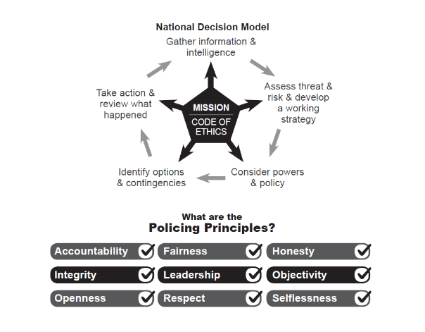

- Purpose of this report

  - This report provides updates on Health and Safety within Surrey Police. This includes:

- Health and Safety Stats for Q2 2022/23 (Q3 hasn’t been published yet).
- OFFICIAL SENSITIVE: Updated Strategic Health and Safety Threat Assessment.
- Details of a new Asbestos Management Policy.
- Safety Stats
  - Please find attached the stats for Q2 2022/23 as appendix 1. The Sussex data has been removed as the differences between the data collection methods in each force means that no meaningful comparison can be made. The Health and Safety Service aims to introduce shared safety stats again when the Surrey system is replaced.
  - Reactive demand which the Health and Safety Service processes increased by 39% compared to the same quarter of 21/22, this is due in part due to improved detainee incident reporting in custody.
  - Assaults continue to be the most likely way officers are injured at work. Conflict training in Surrey is now showing as the second biggest cause of officer injury. There has always been a balance between training which is realistic and gives officers the skills and confidence to deal with real life situations and the degree of injuries this can cause. This has been subject to review by the Health and Safety Service before and consideration is being given to looking at this again as part of the development of the 2024/25 Business Plan.
  - In terms of change over time, the Employee Injury Rate in Surrey remains fairly stable.

- 2023/24 (to date) it was: 11.1 employees per 1000 injured at work.
- 2022/23 it was: 9.7 employees per 1000 injured at work.
- 2021/22 it was: 10.4 employees per 1000 injured at work.
- 2020/21 it was: 10.2 employees per 1000 injured at work.
- 2019/20 it was: 11.1 employees per 1000 injured at work.
- 2018/19 it was: 7.76 employees per 1000 injured at work.
- Strategic Health and Safety Threat Assessment (attached assessment is Official Sensitive)
  - Please find attached the updated Strategic Health and Safety Threat Assessment as Appendix 2. Risk associated with all the identified safety issues are either stable or falling.
  - New threats since the log was last shared with Audit Committee include officer and staff attendance levels at training.
  - Significant progress continues to be made by the Assaults Working Group. This includes identifying assault hot spots and running a number of front-page intranet articles raising awareness amongst officers and staff of where these hot spots are and actions, they can take to reduce the risk. An action plan is being developed which includes 31 actions to meet the aims of the group which are:

- We will identify places where officers and staff are most likely to be assaulted by reviewing the data. We will work to identify why assaults are taking place in these places and reduce the risk.
- We will identify the officers most at risk of assault and repeated assault and support them to reduce the risk.
- We will identify the barriers to officers and staff reporting assaults and work to encourage reporting.
- We will work to ensure officers and staff attend safety training as this gives them the skills to reduce the risk of assaults.
- We will work with CPS on decisions to prosecute those who assault officers / staff and challenge decisions to not pursue.
- We will review the support offered to officers and staff to ensure that appropriate support post assault is available and easy to access.
- Where appropriate and legal, the Health and Safety Service will share assaults data and information on what happened during an assault with Learning and Development so that L&D trainers can assess whether training is being followed, whether current training needs to be modified and also whether officers need refresher / targeted training.
- We will work to improve safety training by integrating situational awareness, particularly in custody and hospitals.
- Where appropriate and legal, the Health and Safety Service is willing to share data with The Police Federation and Unison when one of their members has been injured at work. This includes assaults and enables trade unions to offer their members help and support.

  - The full action plan of the Assaults Working Group will be shared with Audit Committee this year.

- New Asbestos Management Policy

  - Please find attached the draft asbestos management policy as Appendix 3.

  - This should be of particular interest to the PCCs office as the Office of Police and Crime Commissioner is considered to be the owner of the police estate and therefore the ultimate duty owner of asbestos, although this duty is discharged through Estates and Facilities on a day-to-day basis.

  - Following an external review of asbestos compliance, it has been recommended that the Health and Safety Service develop a new asbestos management policy. This has previously been achieved through the Property and People Safety Standards.

  - The new policy establishes the following:

- Scope and situations when officers and staff could come across or disturb asbestos.
- Who will own the policy.
- How the policy will be reviewed.
- How consultation will be achieved.
- How the policy will be audited.
- Minimum training expectations, including new asbestos awareness training for officers and staff who could come across or disturb asbestos.

Roles and responsibilities

- All persons and departments.
- The Health and Safety Service.
- Estates and Facilities.
- Departments carrying out or commissioning work to the police estate.
- Police officers and staff.
- Process for engaging with Estates and Facilities when work to the police estate is commissioned.
- Dealing with emergencies.

  - A working group is being set up involving all departments who have proposed responsibilities in the policy, a representative from the PCCs office and The Police Federation and Unison.

  - The aim of the group will be:

- To review the detail of the policy and agree a final version.
- To have oversite of the implementation of the policy and to report back to the Strategic Health and Safety Board.
- Recommendations

  - The JAC notes the information within this report and appendices and provides feedback as required.
- Appendices

- Appendix 1: Health and Safety Stats for Q2 2022/23 (Q3 hasn’t been published yet).
- Appendix 2: OFFICIAL SENSITIVE: Updated Strategic Health and Safety Threat Assessment.
- Appendix 3: New Asbestos Management Policy.

REPORT END

