
Review of the JAC Terms of Reference
Required for: | Joint Audit Committee (JAC) meeting
Security Classification: | Official
Handling information if required: | n/a
Suitable for publication: | No
Title: | Review of JAC Terms of Reference
Version: | 1
Purpose: | To review the JAC terms of Reference to ensure they comply with latest CIPFA guidance.
ACPO / Strategic Lead: | Kelvin Menon, Treasurer
National Decision Model compliance: | Yes
Date created: | 29/08/2023
Date to be reviewed:

AUTHOR:
Name: | Kelvin Menon
Job Title: | PCC Treasurer
Telephone number: | 07903 860645
Email address: | Kelvin.menon@surrey.police.uk
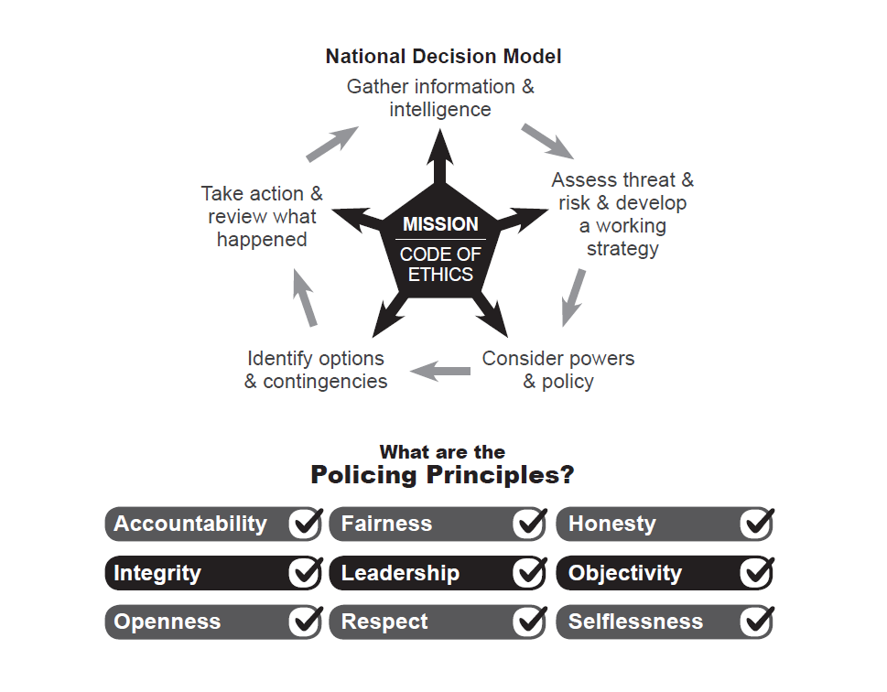
Introduction
Audit committees are a key component of governance. Their purpose is to provide an independent and high-level focus on the adequacy of governance, risk and control arrangements. They play an important role in supporting leadership teams, elected representatives, police and crime commissioners and chief constables.

CIPFA published a new edition of its “Audit Committees: Practical Guidance for Local Authorities and Police” in 2022 to update the guidance it had already published in 2018.
New aspects include legislation changes in Wales and new expectations in England following the Redmond Review. All authorities and police bodies are encouraged to use the publication to review and develop their arrangements in accordance with the Position Statement.
A Model Terms of Reference is included within the publication, and it is this that has been used as the basis of the new terms of reference put before the committee.
Recommendation
The committee is asked to review the proposed terms of reference, make any suggestions as appropriate and then approve.
These will then remain in force until reviewed again
INDEPENDENT JOINT EXTERNAL AUDIT COMMITTEE OF THE SURREY POLICE AND CRIME COMMISSIONER AND THE CHIEF CONSTABLE
DRAFT TERMS OF REFERENCE FOR APPROVAL JULY 2023
Governance

The committee’s position is as an advisory committee to support the Police and Crime Commissioner (PCC) and Chief Constable (CC).

Statement of purpose

The Committee’s purpose is to provide an independent and high-level focus on the adequacy of governance, risk and control arrangements. Its role in ensuring there is sufficient assurance over governance risk and control gives greater confidence to the PCC and CC that those arrangements are effective.

The committee has oversight of both internal and external audit, together with the financial and governance reports, helping to ensure there are adequate arrangements in place for both internal challenge and public accountability.

Governance, risk and control

- To review the PCC and CC Group’s corporate governance arrangements against the good governance framework, including the ethical framework, and consider the local code of governance.
- To monitor the effective development and operation of risk management in the OPCC and force.
- To monitor progress in addressing risk-related issues reported to the committee.
- To consider reports on the effectiveness of internal controls and monitor the implementation of agreed actions.
- To consider reports on the effectiveness of financial management arrangements, including compliance with CIPFA’s Financial Management Code.
- To consider the OPCC’s and force’s arrangements to secure value for money and review assurances and assessments on the effectiveness of these arrangements.
- To review the assessment of fraud risks and potential harm to the OPCC and force from fraud and corruption.
- To monitor the counter fraud strategy, actions and resources.
- To review the governance and assurance arrangements for significant partnerships or collaborations.

Financial and governance reporting

Governance reporting

- To review the AGS prior to approval by the PCC and chief constable and consider whether it properly reflects the risk environment and supporting assurances, including the head of internal audit’s annual opinion.
- To consider whether the annual evaluation for the AGS fairly concludes that governance arrangements are fit for purpose, supporting the achievement of the OPCC’s and force’s objectives.

Financial reporting

- To monitor the arrangements and preparations for financial reporting to ensure that statutory requirements and professional standards can be met.
- To review the annual statements of accounts. Specifically, to consider whether appropriate accounting policies have been followed and whether there are concerns arising from the financial statements or from the audit that need to be brought to the attention of the PCC and CC.
- To consider the external auditor’s reports to the PCC and the chief constable on issues arising from the audit of the accounts.

Arrangements for audit and assurance

To consider the OPCC’s and force’s framework of assurance and ensure that it adequately addresses their risks and priorities.

External audit

- To support the independence of external audit through consideration of the external auditor’s annual assessment of its independence and review of any issues raised by PSAA as appropriate.
- To consider the external auditor’s annual letter, relevant reports and the report to those charged with governance.
- To consider specific reports as agreed with the external auditor.
- To comment on the scope and depth of external audit work and to ensure it gives value for money.
- To advise on commissions of additional work from external audit.
- To advise and recommend on the effectiveness of relationships between external and internal audit and other inspection agencies or relevant bodies.
- To provide free and unfettered access to the audit committee chair for the auditors, including the opportunity for a private meeting with the committee.

Internal audit

- To recommend for approval the internal audit charter.
- To review proposals made in relation to the appointment of external providers of internal audit services and to make recommendations.
- To review the risk-based internal audit plan, including internal audit’s resource requirements, the approach to using other sources of assurance and any work required to place reliance upon those other sources.
- To consider significant interim changes to the risk-based internal audit plan and resource requirements.
- To make appropriate enquiries of both management and the head of internal audit to determine if there are any inappropriate scope or resource limitations.
- To consider any impairments to the independence or objectivity of the head of internal audit arising from additional roles or responsibilities outside of internal auditing and to recommend and periodically review safeguards to limit such impairments.
- To consider reports from the head of internal audit on internal audit’s performance during the year, including the performance of external providers of internal audit services. These will include:
  - updates on the work of internal audit, including key findings, issues of concern and action in hand as a result of internal audit work.
  - regular reports on the results of the QAIP
  - reports on instances where the internal audit function does not conform to the PSIAS and LGAN, considering whether the non-conformance is significant enough that it must be included in the AGS.
- To consider the head of internal audit’s annual report, including:
  - the statement of the level of conformance with the PSIAS and LGAN and the results of the QAIP that support the statement (these will indicate the reliability of the conclusions of internal audit)
  - the opinion on the overall adequacy and effectiveness of the council’s framework of governance, risk management and control, together with the summary of the work supporting the opinion (these will assist the committee in reviewing the AGS).
- To consider summaries of specific internal audit reports as requested.
- To receive reports outlining the action taken where the head of internal audit has concluded that management has accepted a level of risk that may be unacceptable to the OPCC or force, or where there are concerns about progress with the implementation of agreed actions.
- To contribute to the QAIP and in particular to the external quality assessment of internal audit that takes place at least once every five years.
- To consider a report on the effectiveness of internal audit to support the AGS where required to do so by the accounts and audit regulations (see Appendix A).
- • To provide free and unfettered access to the audit committee chair for the head of internal audit, including the opportunity for a private meeting with the committee.

Accountability arrangements

- To report to the PCC and chief constable on the committee’s findings, conclusions and recommendations concerning the adequacy and effectiveness of their governance, risk management and internal control frameworks, financial reporting arrangements and internal and external audit functions.
- To report to the PCC and chief constable on a regular basis on the committee’s performance in relation to the terms of reference and the effectiveness of the committee in meeting its purpose.
- To publish an annual report on the work of the committee, including a conclusion on the compliance with the CIPFA Position Statement.

