
External Audit Report and Audited Financial Statements for 2021/22
Required for: | Joint Audit Committee (JAC) meeting
Security Classification: | Official
Handling information if required: | n/a
Suitable for publication: | No
Title: | External Audit Report and Audited Financial Statements 2021/22
Version: | 1
Purpose: | To present the final audited Financial Statements for 2021/21 for both the Police and Crime Commissioner (PCC) and the Chief Constable (CC) as well as the External auditor’s report for consideration by the Audit Committee.
ACPO / Strategic Lead: | Kelvin Menon Treasurer
National Decision Model compliance: | Yes
Date created: | 12/10/23
Date to be reviewed:

AUTHOR:
Name: | Kelvin Menon
Job Title: | PCC Treasurer
Telephone number: | 07903 860645
Email address: | Kelvin.menon@surrey.police.uk
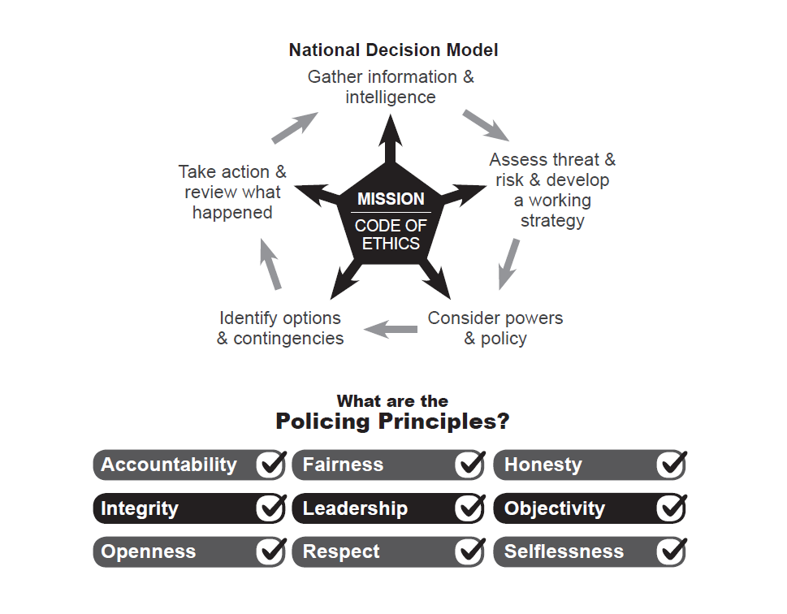
Introduction

The auditors are required to report to those charged with Governance, the PCC, the CC, the CFOs and the Monitoring Office (PCC CFO) their opinion on the Financial Statements and Annual Governance Statement by the 30th November 2022. However due to delays in the resourcing of the audit coupled with additional work being required on key areas such as property and pensions this deadline has been missed. Unlike with Corporate accounts there are no penalties for missing this deadline and indeed a number of public bodies are in the same position. Indeed nationally 456 audit opinions are outstanding for local government and police for years up to 2021/22. There is a requirement to publish a notice on the PCC and Force websites explaining that the audit is ongoing, and this has been complied with. It is anticipated that subject to any last-minute changes the audit opinion will be signed shortly after this meeting.

Based on the work undertaken the auditor expects they will be able to give an unqualified audit opinion on the 2021/22 Financial Statements for both the OPCC and the CC. This is after extensive audit work focussing on risk areas identified in their audit plan and subsequent report. The granting of the opinion is subject to the PCC and CC approving the audited financial statements and the receipt of a signed Letter of Representation.

In respect of Value for Money (VFM) the auditor has undertaken to report back to the committee within 3 months of signing of the audit opinion. However the auditor has stated in their report that there are no matters they wish to report by exception.

Financial Statements

The PCC and CC are separate corporation sole entities and therefore are required to prepare individual Statement of Accounts. The consolidated position for the Group and the PCC’s Statement of Accounts are included within the same document.

The Annual Statement of Accounts and Annual Governance Statement for both the PCC and the CC are prepared as soon as possible after the end of the financial year. An initial set of draft accounts were published on both the OPCC and Force website on the 27th July 2022 subsequent to that.

The 2021/22 PCC and CC Statement of Accounts have been prepared in accordance with the Code of Practice on Local Authority Accounting in the United Kingdom 2021/22, based on International Financial Reporting Standards, issued by the Chartered Institute of Public Finance & Accountancy.

Contained within each of the Statement of Accounts are the PCC’s and CC’s Annual Governance Statement. These statements are intended to provide assurance that both corporation soles have in place governance frameworks that cover the systems, processes, culture and values through which each organisation manages its activities. The preparation of the Annual Governance Statement is a requirement of the Accounts and Audit (England) Regulation 2015 which is also reflected in the Code of Practice on Local Authority Accounting in the United Kingdom 2021/21.

Changes to Unaudited Draft Accounts

The auditors have set out in their report the adjustments that have been made to the financial statements and these will be discussed at the meeting. All material adjustments have been reflected in the financial statements. Non material adjustments have not been madde and these are set out in the letter of representation. The main material changes related to:

- Valuation adjustments for Property Plant and equipment
- Valuation adjustments for Investment Property
- Pension Liability adjustments
- Reclassification adjustments

Auditor’s Results Report on the Financial Statements

The Auditors write a report on the financial statements and any findings. This sets out the risks that they have considered, any financial adjustments required, the results of the audit and several other items required by statute. Their report will be presented at the meeting

Ms Elizabeth Jacks from EY will be available to present the report and answer questions at the meeting.

Letter of Representation

There is a legal obligation senior officers to disclose any information that the auditor may request, or which could have a bearing on their audit opinion. The letter of representation seeks to set out in writing the verbal representation made to them during their audit. This is standard practice for any audit and the letter is of a standard format and content and is required to be signed by the PCC, CC and two CFOs. The draft letter will be presented at the meeting

Ms Elizabeth Jacks from EY will be available at the meeting to answer any questions Members may have on the Letter of Representation.

Recommendation:

It is recommended that the Joint Audit Committee:

- Receive and comment on the Group Audited Financial Statements for 2021/22 and the Chief Constable Audited Financial Statements for 2021/22.
- Receive and comment on the External Auditors Audit Result’s Report.
- Receive and comment on the draft Letter of Representation.

It is further recommended that the Police and Crime Commissioner and the Chief Constable:

- Approve the draft Letter of Representation for 2021/22 included in the auditor’s report.
- Receive the External Auditors Report 2021/22.
- Approve the Group Audited Financial Statements for 2021/22 (which includes the PCC audited financial statements) and the Chief Constable Audited Financial Statements for 2021/22 subject to no change in the reported audit opinion and no further material adjustments are required. If the audit opinion changes and/or material adjustments to the financial statements are required, then the CC and PCC will consult with the JAC Chair prior to approval of the amended financial statements

Appendices
- Reconciliation of the movement between the draft and final financial statements

- Audited Group Financial Statements for 2011/22 (which includes the PCC financial statements and annual Governance Statement)

- Audited Chief Constable Financial Statements for 2021/22 which includes the Annual Governance Statement

- External Auditor’s results report to those charged with Governance for 2021/22 which includes draft audit opinion and Letter of Representation

- Draft letter of Representation for both the PCC and CC

