Appendix 1



OFFICE OF THE POLICE & CRIME COMMISSIONER FOR SURREY & SURREY POLICE
Internal Audit Progress Report July 2023

Contents:
- Purpose of report 3
- Performance dashboard 4
- Analysis of ‘Live’ audit reviews 6
- Rolling work programme 8
Annexe 1 Pre 2020-21 Audit Opinion Definitions 14

1. Purpose of report

Internal audit reviews culminate in an opinion on the assurance that can be placed on the effectiveness of the framework of risk management, control and governance designed to support the achievement of management objectives of the service area under review.

CIPFA have recommended standardising the terminology and definitions used in internal audit engagements across the whole of the public sector and have published a standard set of opinions and supporting definitions for internal audit service providers to use. To ensure we continue to conform to the best practice principles, we have adopted the standard definitions. The assurance opinions are categorised as follows:

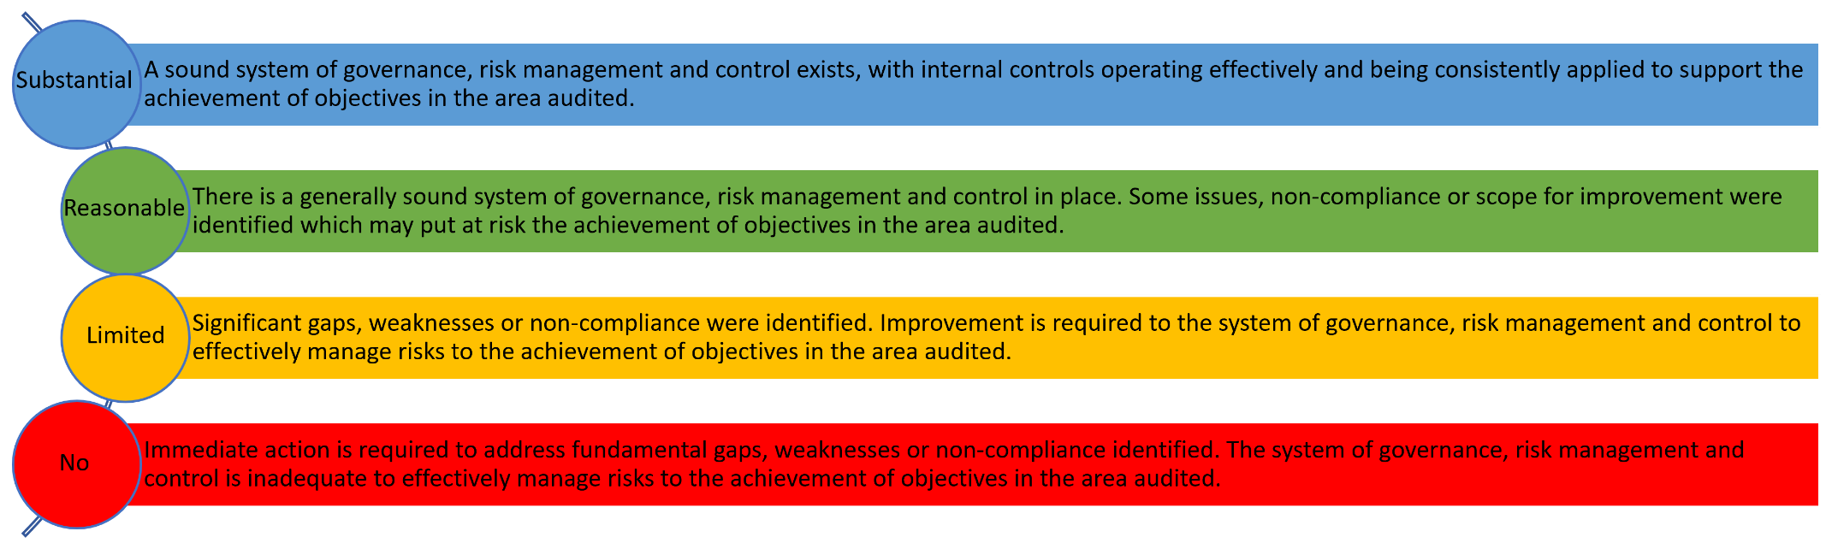

* Some reports listed within this progress report (pre 2020/21 audit plan) refer to categorisations used by SIAP prior to adoption of the CIPFA standard definitions, reference is provided at Annex 1 on page 12.

2. Performance dashboard



% of
100
revised plan
delivered to
to least draft
report
89
%
Complete
0
%
Yet to
Commence
11
%
Work in
Progress
84
%
86
%
88
%
90
%
92
%
94
%
96
%
98
%
100
%
Target
Actual
Stakeholder Satisfaction Survey Results

Days Delivered

 | Surrey 2022/23 plan |  |  | Joint Sussex and Surrey 2022/23 plan
Original Plan Days |  | 120 |  |  | 294
Revised Plan Days |  | 107 |  |  | 282
Days delivered |  | 107 |  |  | 280
Percentage of revised plan delivered | 100% |  |  | 99%

Compliance with Public Sector Internal Audit Standards
An External Quality Assessment of the Southern Internal Audit Partnership was undertaken by the Institute of Internal Auditors (IIA) in September 2020. The report concluded:
‘The mandatory elements of the IPPF include the Definition of Internal Auditing, Code of Ethics, Core Principles and International Standards. There are 64 fundamental principles to achieve with 118 points of recommended practice. We assess against the principles.
It is our view that the Southern Internal Audit Partnership conforms to all 64 of these principles.
We have also reviewed SIAP conformance with the Public Sector Internal Audit Standards (PSIAS) and Local Government Application Note (LGAN).
We are pleased to report that SIAP conform with all relevant, associated elements.’

3. Analysis of ‘Live’ audit reviews (as at 20 June)

Audit Review | Report Date | Audit Sponsor | Assurance Opinion | Total  Management  Action(s) | Not Accepted | Not Yet Due | Complete/ Retired** | Overdue

 | L | M | H

Benefits Realisation from Investment | 10.01.20 | CFO OPCC & EDCFS |  | Adequate |  |  | 4 |  | 0 |  | 0 |  | 2 |  | 2
IT Systems Lifecycle Support and Planning | 10.05.21 | CDIO |  | Reasonable |  |  | 8 |  | 0 |  | 0 |  | 5 | 2 | 1
Transport – Fleet Management | 24.02.22 | CFO OPCC & EDCFS |  | Reasonable |  |  | 6 |  | 0 |  | 0 |  | 5 |  | 1
IT Virtualisation |  | CDIO |  | Limited |  |  | 8 |  | 0 |  | 0 |  | 6 |  | 2
Network Management | 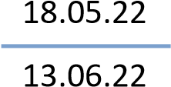 | CDIO |  | Reasonable |  |  | 11 |  | 0 |  | 0 |  | 9 |  | 2
Application Management - Niche | 14.06.22 | CDIO |  | Reasonable |  |  | 5 |  | 0 |  | 0 |  | 4 | 1
ERP – Legacy IT Risks Oracle People Solutions | 07.07.22 | CDIO |  | No Assurance |  |  | 11 |  | 0 |  | 10 |  | 1
Strategy and arrangements for delivery of training to meet future need | 22.08.22 | CFO OPCC & EDCFS |  | Reasonable |  |  | 4 |  | 0 |  | 0 |  | 3 |  | 1
Seized property and cash | 23.08.22 | CFO OPCC & EDCFS |  | Reasonable |  |  | 15 |  | 0 |  | 3 |  | 12
Revenue Contract Management | 23.08.22 | CFO OPCC & EDCFS |  | Reasonable |  |  | 4 |  | 0 |  | 1 |  | 3
Duty Resource Planning | 15.09.22 | CFO OPCC & EDCFS |  | Limited |  |  | 9 |  | 0 |  | 4 |  | 5
Operating Systems Management | 06.12.22 | CDIO |  | Limited |  |  | 17 |  | 0 |  | 1 |  | 16
Pay Projections* | 14.12.22 | CFO OPCC & EDCFS |  | Reasonable |  |  | 4 |  | 0 |  | 0 |  | 4
Strategic Financial  Planning and Budgeting – Capital expenditure* | 19.01.23 | CFO OPCC & EDCFS |  | Reasonable |  |  | 2 |  | 0 |  | 0 |  | 2
IT Resource Management* | 10.02.23 |  | CFO OPCC & EDCFS |  | Limited |  | 10 |  | 0 |  | 0 |  | 10
Uniform Control | 21.02.23 |  | CFO OPCC & EDCFS |  | Limited |  | 3 |  | 0 |  | 1 |  | 2
IT Service Desk |  |  | CDIO |  | Reasonable |  | 5 |  | 0 |  | 2 |  | 3
Firearms Licencing | 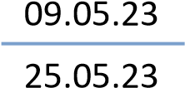 |  | CFO & |  | Reasonable |  | 4 |  | 3 |  |  |  |  | 1
Estates Strategy and Disposals | 26.05.23 |  | CFO OPCC & EDCFS |  | Substantial |  | 0 |  | 0 |  | 0 |  | 0
Risk Management*** | 20.06.23 |  | CFO OPCC & EDCFS |  | Reasonable |  | 12 |  | 0 |  | 12 |  | 0
Mobile Handheld Devices*** | 26.06.23 |  | CDIO |  | Reasonable |  | 3 |  | 0 |  | 3 |  | 0
Accounts Receivable *** | 28.06.23 |  | CFO OPCC & EDCFS |  | Limited |  | 6 |  | 0 |  | 6 |  | 0
Vulnerability Management*** | 03.07.23 |  | CDIO |  | Reasonable |  | 8 |  | 0 |  | 8 |  | 0
Main Accounting | 04.07.23 |  | CFO OPCC & EDCFS |  | Reasonable |  | 0 |  | 0 |  | 0 |  | 0

Total | 4 | 9 | 0
* Denotes audits where all actions have been completed since the last progress report.
** Denotes where actions are retired/pending retirement.
*** Issued after the Force’s recommendations progress report - action update provided by the Force, as at 20 June 2023
Audit Sponsor (Director)
Chief Finance Officer, Surrey OPCC | CFO
Executive Director for Commercial & Financial Services | EDCFS
Chief Digital Information Officer | CDIO

4. Rolling Work Programme

Audit Review | Audit Sponsor | Scoping | Terms of  Reference Issued | Fieldwork | Draft  Report  Issued | Final  Report  Issued | Assurance Opinion | Comment / previous opinion
Audit Plan 2021/22
Shared Plan with Sussex Police
Strategy and arrangements for delivery of training to meet future need | EDCFS | ✓ | ✓ | ✓ | 02.08.22 | 22.08.22 | Reasonable
Operating Systems Management | CD&IO | ✓ | ✓ | ✓ | 29.07.22 | 06.12.22 | Limited
Audit Plan 2022/23
Surrey Police Plan
Decision Making and Accountability | CFO (OPCC) | ✓ | ✓ | ✓ | 18.07.22 | 21.07.22 | Reasonable
Management of establishment / pay projections | CFO (CC) | ✓ | ✓ | ✓ | 30.11.22 | 14.12.22 | Reasonable
Commissioning including - grant Administration and Monitoring | CFO (OPCC) | ✓ | ✓ | ✓ | 26.01.23 | 07.02.23 | Substantial
Main Accounting System | EDCFS | ✓ | ✓ | ✓ | 15.06.23 |  | Reasonable
Accounts Receivable | EDCFS | ✓ | ✓ | ✓ | 27.04.23 | 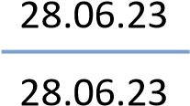 | Limited
Accounts Payable | EDCFS | ✓ | ✓ | ✓ | 04.04.23 |  |  | Ongoing queries regarding  management actions
Payroll | EDCFS | ✓ | ✓ | ✓ |  |  | Reasonable
Estates Strategy and Disposals | CFO (OPCC) | ✓ | ✓ | ✓ |  | 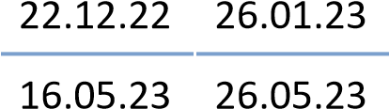 | Substantial

Audit Review | Audit Sponsor | Scoping | Terms of  Reference Issued | Fieldwork | Draft  Report  Issued | Final  Report  Issued | Assurance Opinion | Comment / previous opinion
Shared Plan with Sussex Police
Ill Health Retirements | EDCFS | ✓ | ✓ | ✓ | 21.07.22 |  | Substantial
Agency Staffing | EDCFS | ✓ | ✓ | ✓ | 18.10.22 | 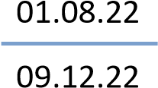 | Limited
Contract Management (Revenue) | EDCFS | ✓ | ✓ | ✓ | 09.08.22 |  | Reasonable
Forensic Investigations | EDCFS | ✓ | ✓ | ✓ | 04.08.22 | 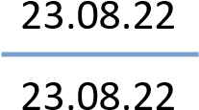 | Reasonable
Strategic Financial  Planning and Budgeting – Revenue expenditure | EDCFS | ✓ | ✓ | ✓ | 6.12.22 | 05.01.22 | Substantial
Strategic Financial  Planning and Budgeting – Capital expenditure | EDCFS | ✓ | ✓ | ✓ | 12.12.22 | 19.01.23 | Reasonable
Project and Programme Management | EDCFS | ✓ | ✓ | ✓ | 28.10.22 |  | Substantial
Uniform Control | EDCFS | ✓ | ✓ | ✓ | 05.01.23 | 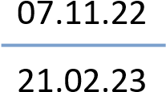 | Limited
Firearms Licencing | EDCFS | ✓ | ✓ | ✓ | 24.02.23 | 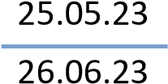 | Reasonable
Forensics - digital | EDCFS | ✓ | ✓ | ✓ | 22.05.23 |  | N/A | Advisory
Pensions Contract Management | EDCFS | ✓ | ✓ | ✓ | 06.07.23 |  |  | Draft issued
Risk Management | EDCFS | ✓ | ✓ | ✓ | 13.04.23 |  | Reasonable
IT Resource Management | CD&IO | ✓ | ✓ | ✓ | 27.09.22 | 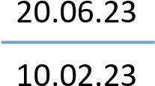 | Limited
Cyber Security – Protective Monitoring | CD&IO | ✓ | ✓ | ✓ | 22.08.22 | 05.09.22 | Substantial
IT Asset Management and Software Licencing (follow up) | CD&IO | ✓ | ✓ | ✓ | 25.10.22 | 15.11.22 | N/A
Service Desk | CD&IO | ✓ | ✓ | ✓ | 31.03.23 | 09.05.23 | Reasonable

Audit Review | Audit Sponsor | Scoping | Terms of  Reference Issued | Fieldwork | Draft  Report  Issued | Final  Report  Issued | Assurance Opinion | Comment / previous opinion
Mobile hand-held devices | CD&IO | ✓ | ✓ | ✓ |  | 26.06.23 | Reasonable
Database Management | CD&IO | ✓ | ✓ | ✓ | 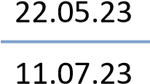 |  |  | Draft issued
Vulnerability Management | CD&IO | ✓ | ✓ | ✓ | 31.5.23 |  | Reasonable
IT Follow-up | CD&IO | ✓ | ✓ | ✓ | 12.05.23 | 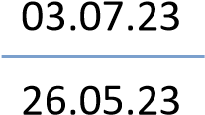 | N/A
Audit Plan 2023/24
Surrey Police Plan
Victims Code Compliance | CFO (CC) & CFO (OPCC) | ✓ | ✓
Unsocial Hours | CFO (CC) | ✓ | ✓ | ✓ |  |  |  | Advisory
Surrey Safer Roads Partnership | CFO (CC) |  |  |  |  |  |  | Q2
Child Exploitation | CFO (CC) |  |  |  |  |  |  | Q2
Annual Governance Statement - OPCC | CFO (OPCC) |  |  |  |  |  |  | Q3
Payroll | CFO (CC) |  |  |  |  |  |  | Q3
Perpetrator Pathways – Domestic Abuse | CFO (CC) |  |  |  |  |  |  | Q3
Management of Sexual or Violent Offenders | CFO (CC) |  |  |  |  |  |  | Q3
Estates Strategy and Disposals | CFO (CC) |  |  |  |  |  |  | Q4
Shared Plan with Sussex Police
Estates and facilities management | CFO (CC) & CFO (OPCC) | ✓ | ✓ | ✓

Audit Review | Audit Sponsor | Scoping | Terms of  Reference Issued | Fieldwork | Draft  Report  Issued |  | Final  Report  Issued | Assurance Opinion | Comment / previous opinion
Forensic Collision Investigation Unit – ISO Accreditation | CFO (CC) | ✓ | ✓ | ✓ | 11.07.23
Health and Safety | CFO (CC) | ✓ | ✓
Leavers process | CFO (CC) | ✓ | ✓ | ✓
Occupational Health Recharging | CFO (CC) | ✓ | ✓ | ✓
PEQF – Protected Learning | CFO (CC) | ✓ | ✓ | ✓
Redundancy process and payments | CFO (CC) |  |  |  |  |  |  |  | Q1
Vehicle Recovery Process | CFO (CC) | ✓ | ✓ | ✓
ICT Assurance Mapping and Coverage Analysis Based on ITIL 4 Practices | CD&IO | ✓ | N/A | ✓
Procurement Cards/ Corporate Credit Cards | CFO (CC) |  |  |  |  |  |  |  | Q2
Flexible Retirements | CFO (CC) |  |  |  |  |  |  |  | Q2
Joint Force Vetting Unit | CFO (CC) |  |  |  |  |  |  |  | Q2
Effectiveness of Collaborative Arrangements | CFO (CC) |  |  |  |  |  |  |  | Q2
Business Continuity Planning | CFO (CC) |  |  |  |  |  |  |  | Q2
IT Contingency for Outcomes of Assurance Mapping | CD&IO |  |  |  |  |  |  |  | Q2 - 4
Learning and Development / Mandatory Training | CFO (CC) |  |  |  |  |  |  |  | Q4
Eye Care Scheme | CFO (CC) |  |  |  |  |  |  |  | Removed from plan
Audit Review | Audit Sponsor | Scoping | Terms of  Reference Issued | Fieldwork |  | Draft  Report  Issued | Final  Report  Issued | Assurance Opinion | Comment / previous opinion
Contract management - capital | CFO (CC) |  |  |  |  |  |  |  | Q4
Change Governance and Benefits Realisation | CFO (CC) |  |  |  |  |  |  |  | Q4
Data Protection Impact Assessments | CFO (CC) |  |  |  |  |  |  |  | Q4

The following variations have been made to the 2022/23 internal audit plan since it was presented to the Joint Audit Committee in April 2022. There are no new variations since the last progress report in April 2023.
Audit reviews removed from the 2022/23 plan
Application Management (application to be agreed) | Removed to accommodate additional request below. The application identified for this audit was assessed as lower risk than vulnerability management as all patching, upgrading is conducted by the supplier (NICE) and is shared with Hampshire and Thames Valley.
OPCC Partnerships | Removed from plan at client request as little to cover.
Mandatory Training | Removed from plan as the implementation of Totara is not as advanced as planned.
Estates and Facilities Management | Moved to Q1 2023/24 due to ongoing restructure within the estates team.
Follow up | Removed from plan as areas to be followed up are being covered by other audit work.
Audit reviews added to the 2022/23 plan
Vulnerability Management | Added at the request of the Security and Information Assurance Manager and agreed by the Chief Digital & Information Officer. Increased cyber security risk with global events and vulnerability management is a key defence.

The following variations have been made to the 2023/24 internal audit plan since it was presented to the Joint Audit Committee in April 2023

Audit reviews removed from the 2023/24 plan
Collaborated Plan - Eye Care Scheme (Q4)  (Joint review) | Removed as data has confirmed this as low risk. Days from this review have been incorporated into the Joint Vetting audit in Q2, subject to discussion with the DCCs regarding scope.
Audit reviews added to the 2023/24 plan
Unsocial Hours (Surrey only review) | Added to the plan in May 2023 as an advisory piece of work to support improving the control environment and to review the approach taken to review unsocial hours claims. Victims Code audit moved to Q2 to accommodate.

Annex 1 - Assurance opinions and definitions used by SIAP prior to adoption of the CIPFA standard definitions
Substantial | A sound framework of internal control is in place and operating effectively. No risks to the achievement of system objectives have been identified
Adequate | Basically, a sound framework of internal control with opportunities to improve controls and / or compliance with the control framework. No significant risks to the achievement of system objectives have been identified
Limited | Significant weakness identified in the framework of internal control and / or compliance with the control framework which could place the achievement of system objectives at risk
No | Fundamental weaknesses identified in the framework of internal control or the framework is ineffective or absent with significant risk to the achievement of system objectives.

