
Surrey Police Performance Report

Required for: | PCC Performance and Accountability meeting May 2023
Security Classification | Official
Handling information if required: | Not applicable
Suitable for publication: | Yes
Title: | Progress against the Police and Crime Plan
Version: | V2
Purpose: | To inform the PCC Performance & Accountability meeting
ACPO / Strategic Lead: | DCC Kem
NDM / OSARA compliance: | Yes
Date created: | 21/04/2023
Date to be reviewed: | NA

AUTHOR: | Strategic Governance Team
Name: | Strategic Governance Team
Telephone number: | 07967988856 (Strategic Governance Manager)
Email address: | Strategicgovernance@surrey.police.uk

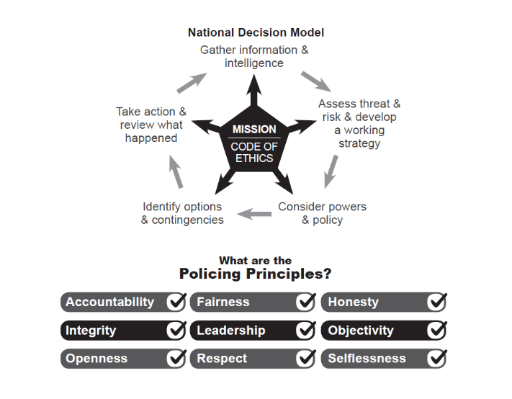

Foreword
Within this paper performance is evaluated over the latest full rolling 12 months (12m) against the same period one year earlier. This enables the Force, at a strategic level, to determine whether the trend in a particular measure is moving in the right direction. For some measures we also include the distinct quarterly or monthly data points to help determine and visualise whether a particular period has impacted the trend.

National comparison data from the Office of National Statistics (ONS) have been included where available, but it is important to note that ONS data is currently only published up to September 2022.

Executive Summary

The ONS figures showed that in September 2022 Surrey had the 4th lowest crime rate nationally (59.7 per 1000 population) across England and Wales, and Surrey continues to have the lowest crime rate in the south-east region. Considering how attractive Surrey is to travelling criminality; with the Metropolitan Police to the north, and excellent road links across the South-East, the continuing position as having the lowest crime rate in the region is significant.

Volume of Recorded Crime
The latest ONS figures for the 12 months ending September 2022 show that total police recorded crime increased by +12.3% in England and Wales. This increase in crime was mainly driven by changes in society after coronavirus lockdown restrictions were put in place. Surrey showed an increase over the 12 months to September 2022, up +6.4% compared to the 12 months to September 2021.
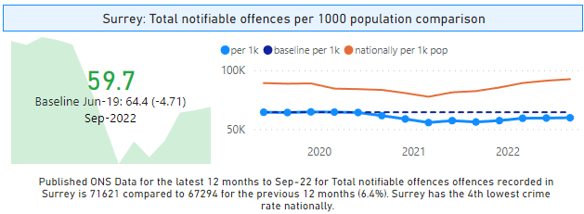
The chart above shows the rolling year comparison of ONS total recorded crime for Surrey against a baseline of the 12 months to June 2019 (pre-COVID). This baseline date range is being used for various national policing measures such as residential burglary and robbery of personal property, so it is useful to include here for all notifiable crime. As can be seen, the latest 12 months to September shows Surrey are still below the baseline.
Analysis of Surrey Police’s own data (which is now six months ahead of the ONS figures) for the 12 months to March 2023 shows that the year-on-year trend in recorded crime has increased compared to last year; up +1.6% to 72,974 crimes recorded.
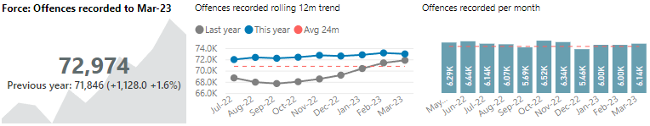
For the 12 months to March 2023 the biggest reductions have been in drug offences. With notable percentage increases in burglary – business and community offences up +18.4% (+149 offences), Fraud and forgery up 20.8% (+27 offences) and Robbery up +19.6% (+77 offences, mainly robbery of personal property). Vehicle crime (in particular theft of motor vehicle) has also seen an increase +11.0%. Theft has seen the largest volume increase up 1,023 offences this mainly relates to an increase in shoplifting (+672) and also “49/10 Theft if not classified elsewhere” (+521) NB: Other areas of theft have seen some reductions such as theft from a person (-21 offences), theft of a cycle (-18 offences) and theft of mail (-54 offences).
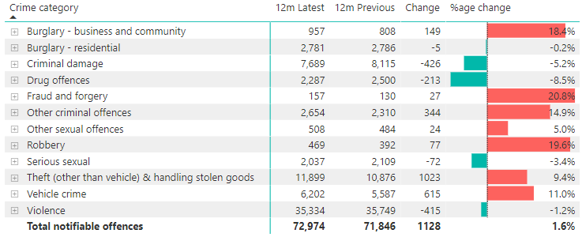

Force: Volume of Solved Outcomes
Home Office Counting Rules require all notifiable offences to have an outcome. For Surrey Police, a ‘Solved outcome’ is a notifiable offence with either a charge, caution, community resolution, or TIC (taken into consideration). From January 2021, outcome 10 where formal action is not in the public interest was included and then in April 2021, outcome 22 was also added to solved outcomes when they are validated ‘Checkpoint’ outcomes (a deferred prosecution scheme for lower-level offences).
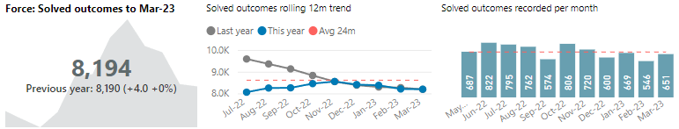
For the 12 months to March 2023 the volume of solved outcomes for notifiable offences recorded was 8,194 (an increase of just +4 solved outcomes) when compared to the 12 months to March 2022, this volume seems to be relatively stable based on rolling year data over the last 24 months. The volume of solved outcomes over the last couple of months has been below the monthly average (based on the last 24 months).
As can be seen from the table below, there have been some large increases in the volume of solved for both Burglary - residential (+87.6%) and vehicle crime (+155.1%), both of these categories have been a focus for the Force Service Board throughout 2022 and into 2023 and is included in the PCC plan. Also increased solved outcomes for “other sexual offences” – in particular solving offence relating to ‘sexual activity involving children under 16’. Drug offences show a large volume reduction but solved outcomes for this crime category are usually generated from targeted operational activity such as stop checks, warrants etc.
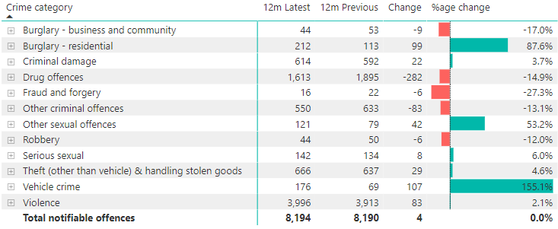

Force: Solved Outcome Rate
Solved outcome rates are calculated using the volume of solved outcomes over a given period divided by the volume of crimes in the same period.
For the 12 months to March 2023 the solved outcome rate for notifiable offences was 11.2% which is a reduction of 0.2 percentage points compared to the 12 months to March 2022 (11.4%) (NB: percentage values have been rounded up and down to the first decimal place).
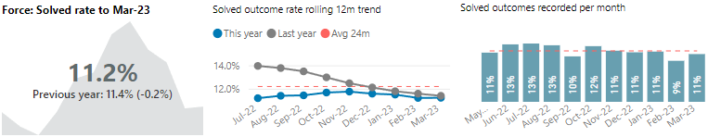

The table below shows the solved rate for each crime category, highlighting the improved solved rate for burglary - residential, other sexual offences, and vehicle crime.
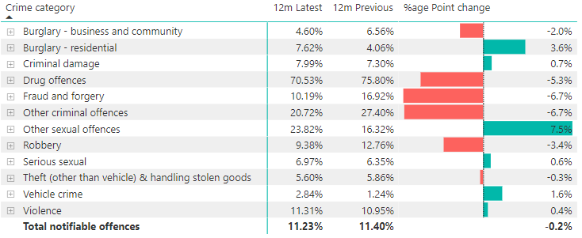

The Force’s performance in solved outcomes (both volume and rate) has broadly tracked the national position. However, the Force continues to aspire to improve, and to that end, has set up a number of structural reviews to undertake a root and branch analysis of how investigations are conducted and how specialist teams are organised to focus on key areas such as domestic abuse, child abuse and serious sexual offences. Performance is given full scrutiny through the Deputy Chief Constable’s Force Service Board (FSB) and the ACCs for Local Policing and Specialist Crime jointly chair a Gold Group with divisional commanders and department heads across the Force to oversee the Force’s investigative capacity and capability in order to ensure that the Force is able to meet its commitment to the public in putting victims first and completing high quality investigations in order to bring more offenders to justice.

The following sections set out the Force performance against the Police and Crime Commissioner’s Plan.

Violence against Women and Young Girls (VAWG)

1.1 Perception of safety after dark for female respondents

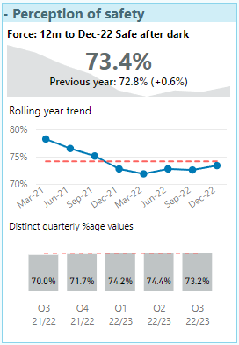
The Joint Neighbourhood Survey asks respondents to consider how safe they feel after dark. The latest result for the 12 months to December 2022 is 73.4% of female respondents say they feel ‘very safe’ or ‘fairly safe’ after dark. This is 0.6%age points higher than in 2021. The quarterly average over the last 2 years is 73.1% with all quarterly results in 2022 being above this result.

The force plans for the public spaces VAWG safety work continues to be progressed, a divisional Detective Chief Inspector (DCI) is leading the public safety initiatives in night time economy, and local Borough Commanders are supporting staffing patrols with third sector support as well as identifying locations as places of safety.

1.2 Serial Domestic Abuse (DA) perpetrators

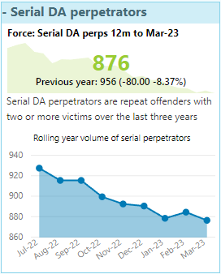
Surrey monitors the volume of serial domestic abuse perpetrators. This has been defined together with East Surrey Domestic Abuse Services (ESDAS) as the volume of repeat offenders that have committed offences against two or more victims over the last three years. Management of serial domestic abuse perpetrators also forms part of the Prevent element of the Surrey VAWG strategy which is led by a DCI.

Currently the volume of perpetrators has reduced by 80 over the last year; a reduction of 8.4%.

1.3 Satisfaction - Domestic abuse (DA) satisfaction
In the latest financial year to date (to Qtr.3 22/23) satisfaction for victims of DA is 84.1%, down – 2.9% points from Year End 21/22. Satisfaction with first contact with the police, remains high at 94.6% this FYTD, which is an increase on the previous year end, however satisfaction with “kept informed” has decreased this FYTD to 78.7%. The majority of victims this FYTD agree that the officers that went to see them treated them with respect (97.0%), took their case seriously (96.6%) and listened carefully to what they had to say (92.3%).

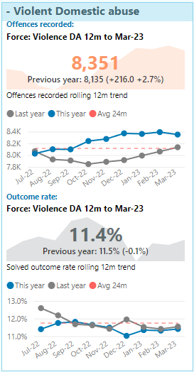
1.4 Violent domestic abuse (DA)
The volume of offences marked as DA has increased over the last year. The latest volume for the 12 months to March 2023 shows that Surrey Police recorded 216 more violent DA offences (up 2.7 percentage points) when compared to the 12 months to March 2022. Violent DA has seen some increase from a change in policy from October 2022 regarding the recording of Coercive and Controlling Behaviour (CCB) offences.
The solved outcome rate for violent DA offences has declined by 0.1 percentage points over the 12 months to March 2023 however the volume of solved outcome has increased slightly +14.

Also now included within the force scorecard is a breakdown of violent DA into those offences with known victim and offender having an intimate or previously intimate relationship.

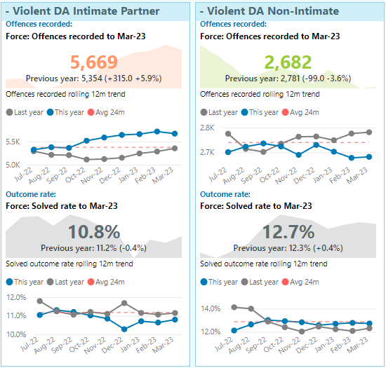
Intimate Partner: The latest volume for the 12 months to March 2023 shows that Surrey Police recorded 315 more offences where the relationship is intimate (up 5.9 percentage points) when compared to the 12 months to March 2022. The solved outcome rate for this measure has declined by 0.4 percentage points.
Non- Intimate Partner: The latest volume for the 12 months to March 2023 shows that Surrey Police recorded just -99 less offence where the relationship is non-intimate (down 3.6 percentage points) when compared to the 12 months to March 2022. The solved outcome rate for this measure has increased by 0.4 percentage points.

The force continues to focus on the improvement of identification and better recording of CCB, for which Surrey is now in step with national recordings and with that improved identification the forces CCB charges have doubled compared to last year.
A tactical DA improvement group has commenced and will feed into a newly established Vulnerability Strategy group led by the Public Protection Chief Superintendent. The improvement group will give oversight of the management plan, the new strategy and updated policy and procedure, both of which have had Outreach review and feedback. In addition, the learnings and improvement work from Op Falcon (improving investigative standards) will be overseen here as well as other task and finish activity and pilots across the force.

A range of activity is ongoing to improve the force response to DA including a DA Matters review and refreshed Continuous Professional Development (CPD), the Grade 2 DA Enquiry car (2 per division across early and late turn) to service appointments, exploring Rapid Video Response for non-urgent calls for DA service, oversight of the DA Act implementation work and improving applications of ancillary orders.

1.5 Serious sexual offences (SSO)
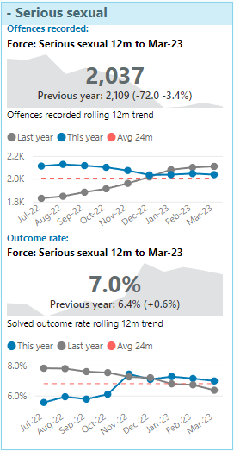
The volume of serious sexual offences has decreased over the last year. The latest volumes for the 12 months to March 2023 show that Surrey recorded -3.4% fewer serious sexual offences (down -72) when compared to the 12 months to March 2022. Offences did decline over the 2020 lockdown periods and the Force then saw a steady increase over 2021 reaching a high in June 2022. Monthly volumes since June 2022 have been below or around the 24-month average.

Latest ONS data to September 2022 show that all sexual offences (the nearest comparable ONS classification for serious sexual offences) are up 16.4% across England and Wales. The national crime rate for sexual offences for the 12 months to September 2022 was 3.3 per 1000 population. With 2.15 crimes per 1000 population Surrey has the lowest crime rate across England and Wales for serious sexual offences (which includes rape).

The solved outcome rate for serious sexual offences has increased by 0.6 percentage points over the 12 months to March 2023.

Surrey Police remains committed to improving investigation quality and service delivery to victims of rape and sexual abuse. The force has taken a cautious approach to Operation Soteria (national response to transformational change in the police’s response to rape and other sexual offence investigations), recognising both the financial and resource implication associated. The Force will remain engaged with the National Learning Network and will continue to review the full adoption of the Op Soteria model as more information became available. The force continues to work closely with Op Soteria and partners e.g. Crown Prosecution Service and 3rd sector in established improvement groups which have good governance.

The Sexual Offence Investigation Team (SOIT) continue to face staffing challenges however it’s in an improved position than last year, with 21 Detective Constables compared to 9. The strategic group to address investigative resources has been in place since February 2022.

Prevention and education work remains a key strand of the Rape and Serious Sexual Offences (RASSO) portfolio with events planned at both the University of Surrey and Royal Holloway University freshers fayres. The force is also engaging with university staff to deliver first responder training.

Commissioned services providing targeted psychological support to the Sexual Offence Liaison Officers has now commenced and although in its infancy the initial findings are positive with staff reporting the benefits of additional support for roles submerged in vicarious trauma. A formal review of the programme is to be carried out towards the end of the calendar year.

1.6 Child abuse
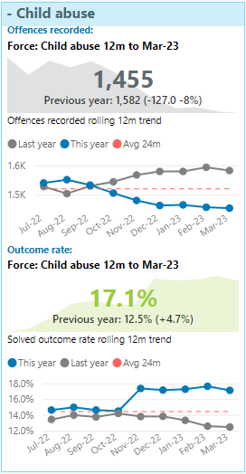
The volume of offences marked as child abuse has decreased over the last year. The latest volumes for the 12 months to March 2023 show that Surrey recorded -8.0% less child abuse offences (down -127) when compared to the 12 months to March 2022. Offences did decline over the 2020 lockdown periods but from March 2021 to March 2022 monthly volumes were above average. Monthly volumes since April 2022 have been below or around the 24-month average of 122 apart from June 2022 which saw a particular spike of 184 offences and November 2022 (131 offences) which was slightly above the average.

There is no national comparison data available for this crime category.

The solved outcome rate for child abuse offences has increased by 4.7 percentage points over the 12 months to March 2023. There were higher than average volumes of solved in June (53), July (35) and November 2022 (50).

The Public Protection Support Unit (PPSU) have now completed an in-depth review into Section 47 strategy meetings and have made several recommendations for improvement which will now form part of the child abuse improvement action log.

The Operation Makesafe campaign was successfully re-launched in March 2023 with new posters and training cards developed and handed out by Neighbourhood SPOCS (Single Point of Contact) to hotels, taxi firms, pubs and restaurants. A new Operation Makesafe training film (on YouTube) has been developed for staff in these premises to view to learn about the signs of both sexual and criminal exploitation and what action they need to take to keep children safe.

Police Protection leaflets have now been created for parents / carers and children to demystify what happens next when police invoke these powers, and a child is taken in Police Protection.

Neglect is a priority of the Surrey Safeguarding Children Partnership (SSCP) and the most common form of child abuse, estimated to affect one in ten children. In order to improve the response to Neglect training has begun for all the staff working in the Police Single Point of Access (PSPA) on understanding and identifying Neglect. An expert speaker has been commissioned to deliver this training which will cover what Neglect is, the different forms it can take and what the warning signs are to equip staff with the skills to identify Neglect.

To help the force provide a consistent, professional approach to responding to and dealing with incidents concerning Neglect a training film on Neglect is planned to be developed to be shown to all officers and staff. The training will be delivered in the style of a documentary; educational and informative and will include both compelling and shocking real-life stories to illustrate and reinforce the importance to understanding and identifying Neglect.

A monthly intranet article on the voice of the child is being set up to ensure as a force Surrey Police is listening to children, this will commence with the first article using a profile of a ‘Fabulous Police Officer’ written by children and young people. Through these articles the force can hear direct from children and young people what they aspire police officers to do and to be like which will help the force to improve the way it engages with children and make every contact count.

1.7 Stalking & Coercive and Controlling Behaviour (CCB)

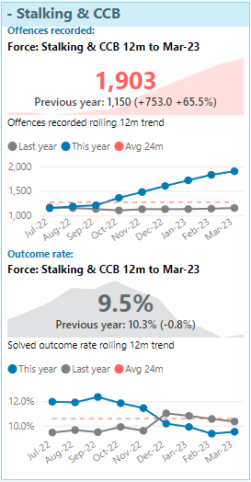
The volume of stalking or CCB recorded has increased over the last year. The latest volumes for the 12 months to March 2023 show that Surrey recorded 65.5% more offences in this category (up +753) when compared to the 12 months to March 2022. All cases where a course of conduct is reported between a victim and their former partner must be recorded as stalking unless the police are satisfied that the matter amounts to harassment in law only. This category has seen an increase from a change in policy from October 2022 regarding the recording of CCB offences.

The monthly chart below shows the volume of CCB offences recorded over the last 11 months.
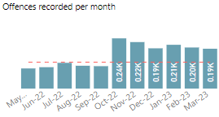

Latest ONS data to September 2022 shows that stalking and harassment figures are up +4.1% across England and Wales, with Surreys ONS data to September 2022 decreasing by -2.7%. The national crime rate for stalking and harassment for the 12 months to September 2022 was 12.1 per 1000 population. With 6.4 crimes per 1000 population Surrey has the 3rd lowest crime rate across England and Wales for stalking and harassment offences.

The solved outcome rate for Stalking and CCB has decreased by 0.8 percentage points over the 12 months to March 2023.

Stalking training inputs have been provided to security staff at local universities in order to assist in better identifying and reporting of stalking offences in young people and raise awareness of Stalking Protection Orders (SPO). The mandatory stalking training for officers is in the process of being updated and will be rolled out later this year.

At the end of April the stalking clinic will have been running for 2 years and in total 53 cases have been discussed and therefore bespoke actions set in relation to victim safeguarding, lines of enquiry and suspect risk management. The force also continues to use SPOs well, with 37 full SPOs and 5 interim SPOs currently in place.

Protecting People

2.1 Overall victim satisfaction
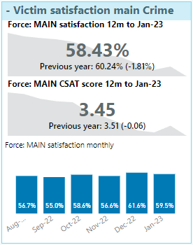
From April 2019 a new methodology was introduced to consult with victims of crime and Anti-Social Behaviour (ASB). Victims are now contacted via text message which brings benefits such as reaching more victims of different crimes, fewer questions resulting in an increased response, and greater insight through victims’ comments. Results are now also received in real time as opposed to the previous lag of 2-3 months between incidents/crimes occurring and results being received.

Overall victims’ satisfaction has decreased by 1.8 percentage points over the 12 months to January 2023.

2.2 Hate crime
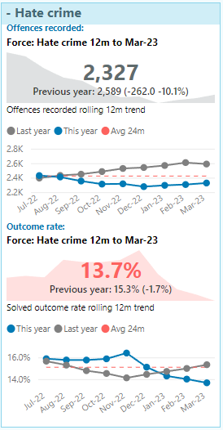
The volume of crime marked as hate crime has decreased over the last year. The latest volumes for the 12 months to March 2023 show that Surrey recorded -10.1% fewer offences in this category (down -262) when compared to the 12 months to March 2022.

There are no national comparison data available for this crime category.

The solved outcome rate for hate crime has decreased by 1.7 percentage points over the 12 months to March 2023.

On Monday 17th April the force hate crime lead met with the Chair of Surrey County Council and received support to hold a Surrey Hate Crime Conference in October which will tie in with National Hate Crime week. The plan is that the conference will be attended by statutory partners, members from voluntary sector and communities and will serve to start a debate around how all parties involved can collectively look to address hate crime in the county, support victims and develop confidence. A community action plan of how the police and partners will achieve this will then be developed, followed by meetings to measure progress, and hold accountability for those in attendance.

2.3 Compliance with Victims Code of Conduct and repeat victimisation of Fraud

Work continues in the collaborative, multi-departmental approach to map the Victim’s Journey across the Criminal Justice Process. Surrey Police has now launched a Digital Receipt for all victims who report a crime. Victims will be sent this receipt in their written acknowledgement, and it provides a comprehensive overview of their rights and entitlements as a victim of crime, and what they might expect from police and criminal justice agencies (https://surrey.police.uk/VictimReceiptBooklet).

The new blended and enhanced audits are showing some valuable insights in Victim Care that divisions are finding helpful in assessing what is working and what is not, putting in place appropriate action plans for improvement. It has been agreed that the audits provide important information and that the Victim and Witness Care Unit (VWCU) will continue to produce these reports on a quarterly basis to divisions, and also supply specialist teams with reports to support Forcewide assessment and improvement.

Staffing in the VWCU continues to be a challenge, and with recent recruitment over half of the team are relative newcomers. The challenge is training and developing staff in complex trail management, which takes time when the workload demand is so very high as a result of ongoing court delays.

The VWCU Fraud casework team have completed a forcewide awareness update and continue to hold awareness chats across divisions to ensure that vulnerable and elderly victims of fraud are referred for support. To help with awareness of challenges, trends and to share best practice, solutions and support available and enhance the service provided the force are introducing peer support with the Sussex Police fraud team.

Work progresses with the enhanced service to young people initiative and scoping work is being completed. The aim is to ensure face-to-face triage assessments are completed with young victims of crime by Youth Engagement Officers (YEO). The scale of the project is too large to consider a pilot but having highlighted a gap in service provision to a vulnerable group, the force is working towards a comprehensive package of appropriate support to meet the needs identified.

Communities

3.1 Residential burglary
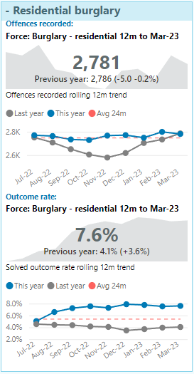
The volume of residential burglary recorded has reduced significantly since COVID19 restrictions were introduced in April 2020. Latest ONS data to September 2022 show that residential burglary has dropped 41% across Surrey compared to the Jul-18 to Jun-19 baseline [pre-Covid]. Surrey is currently ranked 17th nationally with 5.7 residential burglary offences per 1000 households.

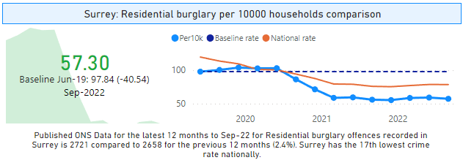

Latest scorecard data to March 2023 shows Surrey has recorded 0.2% less residential burglaries (down 5 offences) compared to the 12 months to March 2022.

Volumes of ‘Burglary – residential’ during the months of October to December 2022 were above average, as expected at this time of year. However, the volumes between January and March 2023 have remained above the 24 month average.

The solved outcome rate for ‘Burglary – residential’ has increased by 3.6 percentage points over the 12 months to March 2023. The monthly volumes of solved outcomes have been relatively high since January 2022, with a steadily increasing solved rate since the beginning of the year as the Force Service Board has made ‘Burglary – residential’ an area of focus, and divisions have implemented a force-wide burglary plan. This focus is reflected in the rolling year data, with the number of solved burglaries increasing by 88% when comparing the latest 12 months to March 2023 to 12 months to March 2022.

The Operation Spearhead public burglary portal, an initiative Surrey Police has setup in order to help capture local residents CCTV, capturing suspicious activity relating to burglary and wider Serious Acquisitive Crime (SAC) was launched in January across Elmbridge for public use. This has resulted in leading officers to identify an offender of acquisitive crime and securing an arrest and charge for vehicle related crime. In February the portal extended to use across the whole of North Division and it is anticipated that it will be available for all Surrey residents from May 2023 to allow for training and educating staff using the system.

Following an increase in offending during the winter months a joint investigative and neighbourhood approach working with partners and other police forces to identify offenders and reduce offences has been initiated.

3.2 Serious violence (Violence with injury)

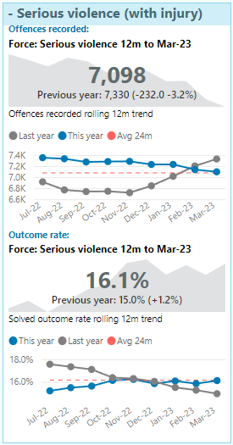
The volume of serious violence (violence with injury which includes homicide) offences recorded has decreased. The latest volume for the 12 months to March 2023 shows that Surrey Police has recorded -3.2% fewer violence with injury offences (down -232) when compared to the 12 months to March 2022.

Latest ONS data to September 2022 show that violence with injury increased 16.1% across England and Wales (Surrey recorded a 7.9% increase). The national crime rate for violence with injury for the 12 months to September 2022 was 9.7 per 1000 population. Surrey has the lowest level of violence with injury nationally with 5.97 per 1000 population.

The solved outcome rate for violence with injury has increased by 1.2 percentage points over the 12 months to March 2023. The volumes of solved is relatively stable with the latest rolling year volume up just 48 compared to the year before.

Surrey Police have been assessed by Crest Advisory (criminal justice strategy and communications consultancy) for its readiness for the implementation of the Serious Violence Duty. The Force was assessed as “preparing” and the various partners are working to ensure that the Force is moving forward for the implementation of the duty.

3.3 All Knife crime
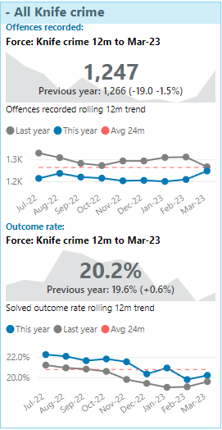
The volume of knife crime has shown a decrease over the last 12 months. The latest volume for the 12 months to March 2023 shows that Surrey recorded 1.5% fewer offences flagged as blade or sharp instrument when compared to the 12 months to March 2022 (down 19 offences).

National concern over the rise of knife crime led to the development of a national system to help improve the recording of knife crime. The National Data Quality Improvement Service (NDQIS) work has been implemented within Surrey Police, using an algorithm to check the offence’s free text in order to determine the likelihood that the offence should be flagged a knife crime or not.

The solved outcome rate for knife crime has increased, up 0.6
percentage points compared to last year.

3.4 Vehicle crime
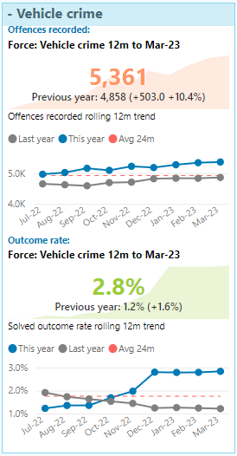
The latest volume of vehicle crime recorded for the 12 months to March 2023 shows that Surrey Police has recorded 10.4% more vehicle offences (up 503) when compared to the 12 months to March 2022.

Latest ONS data to September 2022 show that vehicle crime increased 14.2% across England and Wales. The national crime rate for vehicle crime for the 12 months to March 2022 was 6.6 per 1000 population. Surrey is ranked 20th nationally with 4.9 per 1000 population (NB: ONS crimes per population for vehicle crime are skewed by a small number of forces with extremely high rates).

Over the summer of 2022 the solved rate of vehicle crime was brought into focus within the Force Service Board. The solved outcome rate has increased by 1.6 percentage points over the 12 months to March 2023. The average volume of solved vehicle crimes over the last 24 months is 9 per month, the volumes of solved for October (23), November (22) and December (45) were above this average. For 2023 so far, the monthly volumes have been closer to the average of 9 per month.

The force corporate communications department are in the process of designing new social media assets and literature for vehicle crime. It is expected to include a concentrated period of activity to target three key strands of vehicle crime; keyless car theft, theft from vehicles and catalytic converter theft. This will be supported by new leaflets and signage for every borough to capture the attention of those most at risk of the three strands. There will also be a focus on providing geo-targeted awareness and prevention advice via social media for individual boroughs according to crime trends. The force’s prevention advice for keyless car theft is being refreshed, with a focus on owners understanding they have a keyless car, what the risks are and the simple steps they can take to deter it, with support of the problem-solving team and Designing Out Crime Officers (DOCO).

A Crimestoppers ‘Chop Shop campaign’ has been signed off and they have put aside £1,500 for this campaign. A chop shop is a business, often mimicking a body shop, that illicitly disassembles stolen motor vehicles and sells their parts. The campaign will start small and social media focused, the force will also ask partners to reshare the posts. There will also be geo-targeted adverts which will run for at least a week in postcodes surrounding places the force thinks there may be chop shops operating. The social media posts / adverts will link to a page on the Crimestoppers website containing further information.

The vehicle crime webinar, an online 14-minute video that goes through current modus operandi and terminology has been rolled out forcewide and circulated on all local channels on each division. It is available to all Surrey and Sussex officers and staff.

3.5 Victim satisfaction for Anti-social behaviour (ASB)
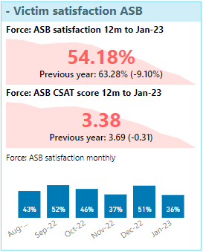
Latest overall satisfaction for ASB is currently 54.18% for the 12 months to January 2023; down 9.1 percentage points compared to last year.
Since April 2022, a continuing decrease has been seen in ASB satisfaction. All comments received during that period have been analysed to look for themes, and to try and provide some answers for the decreases seen. As text messages are currently sent to callers/victims of all ASB incidents, the Force is seeing an increased number of people who are unhappy that the service they were provided with did not meet their expectations. In a lot of these cases, these incidents would not routinely be dealt with by the police and therefore the dissatisfaction is not down to something that could have been done differently or be improved on. Prior to starting the text-based survey, only callers/victims of ASB incidents dealt with by the police were contacted, which was something the Home Office mandated. From March 23, the methodology has returned to only sending messages to certain ASB incidents, with incidents routinely dealt with by other agencies (such as abandoned vehicles) being removed from the sample. These results will be available from the end of April 23.
The Surrey resident ASB survey has closed and received 1968 submissions. In regard to ‘To what extent are any of the following a problem in your local area?’ the greatest major problems were Anti-social driving/speeding, littering and Anti-social/inconsiderate driving. Work is now ongoing with the OPCC to look at the survey report and to organise face-to-face focus groups which will happen on the 22nd and 23rd of June.
The ASB training input given to Safer Neighbourhood Teams (SNT) is being refreshed and will now have a section on supporting victims of ASB, shorter versions are also being looked at for the Contact Centre (CTC) and Neighbourhood Policing Teams (NPT).

Road safety

Killed or Seriously Injured (KSI)

Overall Surrey KSIs for the January to March period shows 2023 is on a par with the previous 5 year average and slightly down on this point last year. The position for fatal casualties so far this year is consistently below the 5 year average. Powered Two-Wheelers (P2W) KSIs are 20% over the 5 year average so far in 2023 but in line with last year.

The gender split with regards to fatalities always shows a greater number of males however the proportion in 2022 was much closer, so far in 2023 the data has reverted to more usual proportions.
Fatal casualties are generally small in number therefore the vehicle / age split in the early part of the year does not necessarily reveal a great deal. It is possible to say however that so far this year almost half of fatalities have occurred with individuals who are over 70.

Relationships

5.1 CSEW Confidence
The national confidence measure from the crime survey for England and Wales relies on face-to-face interviews. Due to Covid-19, these interviews stopped and have not yet restarted so the latest data available is still the 12 months to March 2020 where Surrey was ranked 7th nationally with 78.7% confidence.
5.2 Confidence from Joint Neighbourhood survey
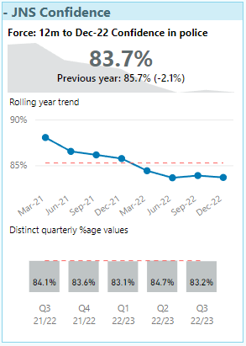
The latest 12 months to December 2022 show confidence is down 2.1% percentage points compared to the same period last year.
The decreases seen in confidence are not only being seen in Surrey, but also by a number of other forces within England and Wales. A national user group has been established to discuss the confidence surveys conducted in forces, and to look at results further.

5.3 Contact 999
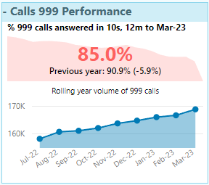
999 calls answered within 10 seconds have reduced by 5.9 percentage point to 85.0% in the 12 months to March 2023. Although the percentage answered in 10 seconds has dropped below 90% it should be noted that 90% are answered within 12 seconds and 95% answered within 30 seconds.

5.4 101 average time to answer
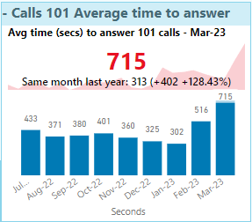
The average time to answer 101 calls in March 2023 was 11 minutes and 55 seconds which is the highest recorded (up from 5 minutes and 13 seconds recorded in March 2022). The current rolling year values (not shown) is 5 minutes 46 seconds (up from 3 mins 58 seconds a year ago).
The volume of 101 calls has been declining year on year (down 16.5% in the 12 months to March 2023 compared to the 12 months to March 2022). Other digital 101 channels have also decreased. Total 101 calls and digital (digital 101, live chat and online) has decreased 16% in the latest 12 months to March 2023.

5.5 Time taken to respond to Grade 1 (emergency)
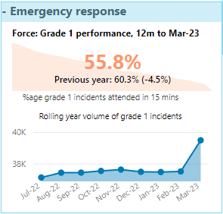
Grade 1 response in 15 minutes has shown a decline over recent months (as the volume of Grade 1 incidents increased) and, at 55.8% attended in 15 minutes, this is now the lowest it has been for over two years. The median response time is also starting to increase moving from 13 minutes a year ago to 14 minutes in the 12 months to March 2023. Monthly median time to respond to Grade 1 has been closer to 14 minutes over the last six months – March 2023 was 17 minutes.
Volumes of Grade 1 incidents have increased by 9% in the 12 months to March 2023 compared to the same period last year.
Surrey Police Contact Centre (CTC) has been experiencing a reduction in performance for some time relating to 999 contact which has been caused by a number of factors including retention of call handlers, an increase in demand (which has been seen nationally) and the introduction of a new computer system within Contact and Deployment (C&D).

The contact centre has an establishment of 188 Full Time Equivalent staff, spread across 5 rotas although there are a large number of staff who work a flexible working pattern.

The staffing situation has been a force risk for some time and is managed through the Contact and Deployment Staffing Gold Group, chaired by the ACC Local Policing. To provide greater oversight and support to C&D a Chief Superintendent has been moved to lead the department for at least 12 months. In the last six months, C&D has completely restructured its recruitment processes, modernising the application process to include new recruitment platforms such as LinkedIn, introduced insights days for prospective candidates to visit the centre, designed and implemented a targeted recruitment advertising campaign on multiple platforms (radio, internet, flyers, job fairs, etc). This process has been very successful, and the force have seen an increase in applicants to the role.

The number of new starter courses has been increased to 6 per annum, the initial course has been streamlined into a modular structure and the mentoring process has been redesigned with the implementation of the Tutoring ‘Pod’, a dedicated training process for onboarding new starters. A large amount of work has also been completed on the culture and environment of the CTC. The room has been redecorated, equipment updated, repaired and replaced and a cultural audit report will be available shortly, which will form the basis of the CTC Cultural Action Plan. All supervisors have already attended a supervisor’s day, giving CPD on staff performance and welfare management.

Remuneration has also been addressed, both at a force level with uplifts in Unsocial Hours, and locally with new staff now receiving their first pay increment at 6 months rather than the original 12 and tutor payments have been doubled to £200 per 166 hrs of contact training.

In September 2022 the CTC had a strength of 151.15 staff, that number has fluctuated but as of April 2023 it is 151.42. Retention remains an issue; however, the majority of leavers from the CTC move to other parts of the business, with a large number becoming police officers in Surrey, or other forces.

On 28 February 2023, SmartStorm was launched. This is a new system for Surrey, whilst the implementation process went relatively smoothly, there remain a number of launch ‘bugs’. A software patch for SmartStorm is due to be launched at the end of April which should reduce, but not eliminate, some of the bugs. Staff familiarity with SmartStorm is also increasing and the dedicated support for the project has been further extended to allow for continuing on-site advice and guidance to staff.

A decision was made recently by Chief Officers to second approximately 30 police officers into the CTC and Force Control Room (FCR). These are a mix of ex-Contact staff and also officers who are currently unable to deploy on frontline duties. It is hoped the majority of these should be trained, deployed and independent by the end of April.

The force has also made changes to some of its processes to streamline them and ensure that the ability to answer 999 calls is not inhibited by other factors.

Defined as the number of total notifiable offences recorded within Surrey as defined by the Home Office Counting Rules (HOCR)

