
Chief Constable’s Expenses

Required for: | Surrey Joint Audit Committee (JAC) October 2022
Security Classification: | Official
Handling information if required:
Suitable for publication: | Yes
Title: | Chief Constable’s Expenses
Version:
Purpose: | To inform the JAC of any expenses incurred by the Chief Constable this reporting period and any hospitality received.
ACPO / Strategic Lead: | DCC Kemp
National Decision Model compliance: | N/A
Date created: | 20th September 2022
Date to be reviewed:

AUTHOR:
Name: | Inspector Neil Lancaster
Job Title: | Staff Officer to Chief Constable
Telephone number: | 07720043053
Email address: | neil.lancaster@surrey.police.uk
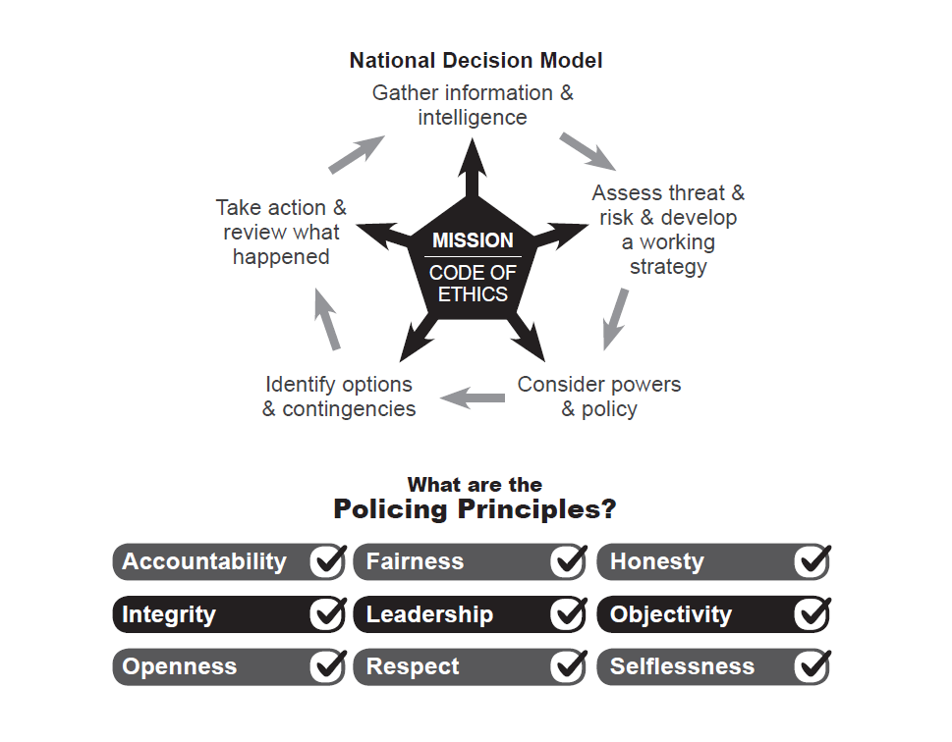

Chief Constable Expenses Item 8b

To: Joint Audit Committee
Date: 17th October 2022
By: Chief Constable

Title: Chief Constable’s Expenses
___________________________________________________________________

Purpose of Report/Issue:

To update the Committee on any expenses incurred by the Chief Constable this reporting period and any hospitality received.

It is a standing item on the agenda of the Joint Audit Committee that the Chief Constable presents his expenses.

The table below shows expenses claimed between September 2021 and August 2022 and submitted for approval via Exclaim to the Office of the PCC.
___________________________________________________________________

Expenses Claimed:

Date | Details | Amount (£)
22/03/2022 | Parking in York for 2-day Chief Constable Council | 30.00
27/03/2022 | Parking Liverpool week National Leadership Course | 84.75
01/04/2022 | M6 Toll Road Travel back from Liverpool | 7.10
19/04/2022 | Parking Dorking Halls Conference | 9.32
29/04/2022 | Parking Dorking Halls Conference | 9.32
12/05/2022 | Train Darlington – London – SPNAC. | 55.50
16/05/2022 | Parking Dorking Halls – PCC Event | 4.32
08/06/2022 | Accommodation and Meal, annual Finance Directors/Treasurers | 172.80
28/07/2022 | M6 Toll, Memorial Service Staffordshire | 5.10
29/07/2022 | Parking Dorking Halls Conference | 8.32
___________________________________________________________________

Recommendation

The Committee is asked to note and agree the expenses.

__________________________________________________________________

Contact details:

Name Inspector Neil Lancaster
Job Title: Staff Officer to Chief Constable Stephens QPM
Telephone number: 077200 43053
Email address: neil.lancaster@surrey.police.uk

