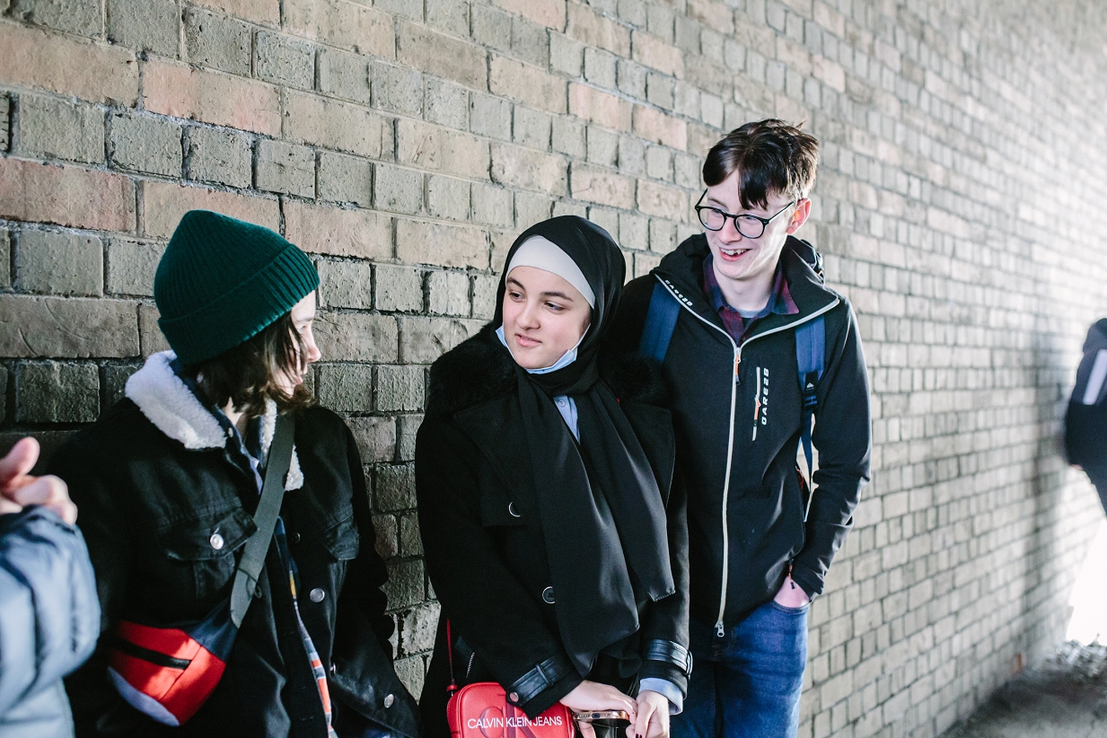

Application Form
Surrey Youth Commission
on Police and Crime

Surrey Youth Commission on Police and Crime: Application Form

Application Deadline: 16th December 2022

We are looking for applications from 14–25-year-olds who are currently residents of Surrey.

Section 1: Your details

NAME:

DATE OF BIRTH:

HOME ADDRESS:

POST CODE:

EMAIL:
LANDLINE:
MOBILE:

CURRENT OCCUPATION (Student at school, college, university, in work, unemployed, out of education):

NAME OF YOUR SCHOOL/ COLLEGE/ UNIVERSITY/ YOUTH ORGANISATION/EMPLOYER:

NAMED PROFESSIONAL WHO WOULD SUPPORT YOUR APPLICATION AND THEIR ORGANISATION (This could be a teacher, youth worker, tutor, manager):

If you are under 18 years old, please ask your parent/guardian/carer to provide the following details too. We will require written permission from them before we can confirm your place.

NAME OF PARENT/GUARDIAN/CARER:

HOME ADDRESS:

POST CODE:

EMAIL:

LANDLINE:
MOBILE:

Section 2: More about you

- Why do you want to join the Surrey Youth Commission on Police and Crime?

- Why do you think you should be selected for the Surrey Youth Commission on Police and Crime?
For example, you might have specific skills, knowledge or life experiences that you’d like us to know about.

- Please tell us about yourself. Use up to 50 words to sum up your personality, interests, experiences or strengths. (Please stay within the word limit.)

Section 3: Your availability

We will be holding the first Youth Commission Members meeting on Saturday 21st January 2023

Are you available to attend? Yes [ ] No [ ]

We will be holding the second Youth Commission Members meeting on Saturday 18th February 2023

Are you available to attend? Yes [ ] No [ ]

Section 4: Diversity monitoring information

Leaders Unlocked and the Office of the Police and Crime Commissioner for Surrey are committed to promoting equality and diversity. We invite you to complete this section of the application form so that we can monitor and analyse information about the diversity of the people who submit an application.

Leaders Unlocked will treat any information you provide as strictly confidential. It will not be shared or used by anyone not directly involved in the selection process. We will transfer all the information provided into a database and then destroy all individual forms. No information will be published or used in any way that allows any individual to be identified.

You are not obliged to answer the questions on this form.

Please tick or fill out all boxes that apply. If you feel uncomfortable about any questions, feel free to not answer.

- Your Sex (please put an X in the appropriate box)

Male Female Prefer not to say

- Your sexual orientation (please put an X in the appropriate box)

Bisexual Gay man Gay woman/lesbian

Heterosexual Pansexual Asexual Other

- Your religion or belief (please put an X in the appropriate box)

None Buddhist Christian

Hindu Jewish Muslim

Sikh Any other Prefer not to say

- Your ethnic origin (please put an X in the appropriate box)

White

British English Welsh Scottish

Northern Irish Gypsy or Irish Traveller Other

Mixed/multiple ethnic background

White and Black Caribbean White and Black African

White and Asian Any other/ multiple ethnic background

Asian/Asian British

Bangladeshi Chinese Indian Pakistani

Any other Asian background

Black/African/Caribbean/Black British

African Caribbean

Any other Black/African/ Caribbean background

Other ethnic backgrounds - Please state your ethnic background:

- Do you consider yourself to have additional needs (including physical, mental, cognitive, learning, emotional)?

Yes No Prefer not to say

Due to your additional needs will you need any extra assistance from us to help you engage fully?

Yes No

If yes, how can we help?

Application Deadline: 16th December 2022

Section 5: When will I hear back?

We will conduct interviews with shortlisted candidates on the phone shortly after the closing date.

If you have any other questions about the application process, please email Emily Blavins at emily@leaders-unlocked.org
Section 6: How will you protect my privacy?
Your privacy is really important to us. By filling in the Surrey Youth Commission application form, you are consenting to Leaders Unlocked using your personal information to keep in touch with you over the course of the project. If your application is not successful, or you decide to withdraw your application, we will delete your personal data from our files.

If you want to withdraw your consent at any time you can contact the Data Protection officer at info@leaders-unlocked.org and if you would like to see our full Privacy Notice you can do so here: http://leaders-unlocked.org/privacy-notice/

We look forward to receiving your application!

