

Required for: | Guidance
Security Classification: | Official
Handling information if required: | N/A
Suitable for publication: | Yes
Title: | Surrey Police’s Response to Her Majesty’s Government’s ‘End-to end rape review report on findings and actions’
Version: | 1
Purpose: | Briefing
ACPO / Strategic Lead: | ACC Macpherson
NDM / OSARA compliance: | Yes
Date created: | 05/08/2021
Date to be reviewed: | N/A

AUTHOR:
Name: | - Tatton
Job Title: | T/DCI – Central Public Protection Command
Telephone number: | 01483 6(32114) / 07967986175
Email address: | Adam.Tatton@surrey.pnn.police.uk

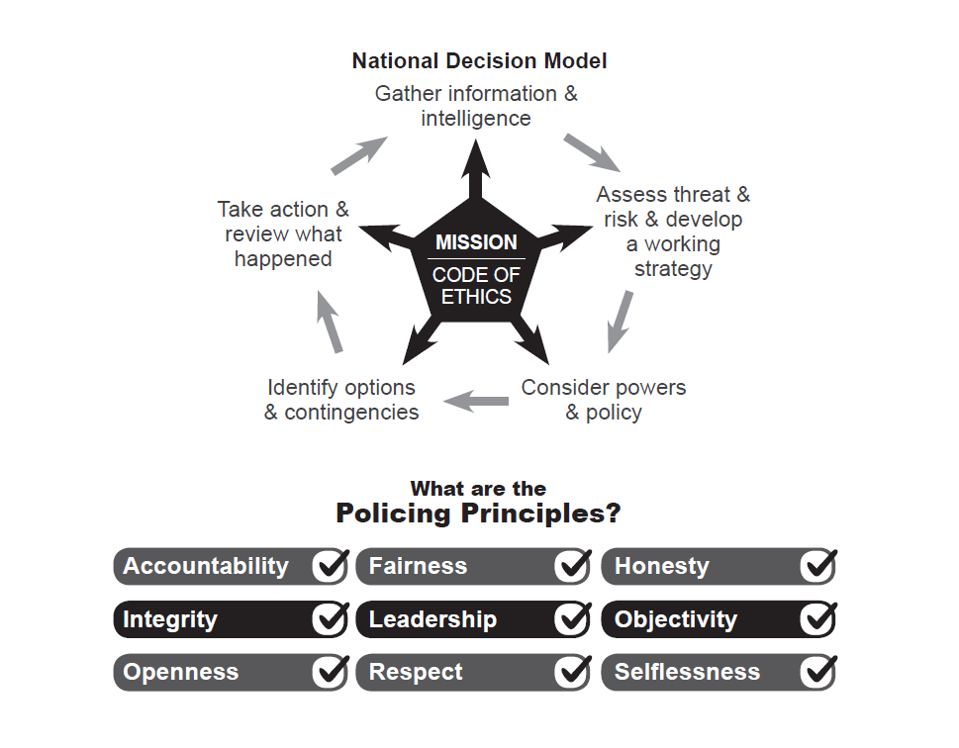
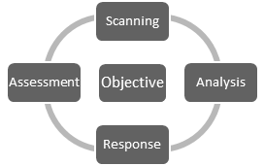

- Introduction
  - This report has been commissioned to provide an update on Surrey Police’s response to Her Majesty’s Government’s ‘End-to end rape review report on findings and actions’ published in June 2021.

  - The review commenced in March 2019 taking an evidence based approach across the system, from reporting to the police to outcomes in court, to understand what is happening in cases of adult rape and serious sexual offences being charged, prosecuted and convicted in England and Wales.

  - Although analytical research has shown that the prevalence of rape and serious sexual violence has not changed over the last 5 years, what has changed is the sharp decline in the number of prosecutions since 2015/16. The review has shown that the criminal justice system has not pursued investigations and prosecutions causing the decrease in cases being bought to court. Whilst reported cases of adult rape have increased by 55.78% between 20015/16 to 2019/20, only 3% of those cases assigned a police outcome in 2019/20 received an outcome of charged or summonsed. This is a 10% reduction from the 13% receiving a positive outcome in 2015/16. In addition to the positive outcome rate, conviction rates for adult rape have also fallen by 47% since 2015/16.

  - Within this review it is widely accepted that the entire criminal justice system is failing victims of rape and serious sexual offences, for which public apologies have been made. Whilst it is accepted that the reasons for these failings are often complex and wide-ranging, it highlights key areas in need of urgent improvement including an increase in personal digital data being requested, delays in investigative processes, strained relationships between different parts of the criminal justice system, a lack of specialist resources and inconsistent support offered to victims.

  - The review acknowledged the bravery of those victims of rape and sexual abuse that are prepared to come forward and seek justice, however it was that strength that makes a system described as ‘painful’, ‘frustrating’ and ‘exhausting’ totally un-acceptable. With 57% of all adult victims withdrawing nationally during the course of the criminal justice process, it highlights that we must do better now.

- Report’s Aims
  - Whilst the review seeks to address issues across the entire criminal justice process, this report details the ambitions of HM Government for the police and Crown Prosecution Service detailing what we will do to transform the way in which we investigate and prosecute cases.

  - Ambition 1 - A new approach to investigations is rolled out that recognises that patterns of behaviour are a significant feature of rape and sexual offences, and ensures that there is an early and robust assessment of suspect behaviour and offending patterns; helping ensure decision-making is based on evidence, rather than subjective judgements of victim credibility.

  - Ambition 2 - There is a change of practice and longer-term cultural change in the police and CPS that enables an increase in volumes of rape cases reaching court to return to pre-2016 levels, with a corresponding ambition for police referrals and cases charged by the CPS.

  - Ambition 3 - No victim is left without a phone for more than 24 hours, with an ambition that victims have their own phones returned within this period, with replacement phones being provided in a minority of cases, and victims are not asked for information unless it is necessary and proportionate in pursuit of a reasonable line of inquiry.

- Actions & Our Response
  - Action 1 - A new approach to investigations that recognises that patterns of behaviour are a significant feature of rape and sexual offences, and ensures that there is an early and robust assessment of suspect behaviour and offending patterns; helping ensure decision-making is based on evidence, rather than subjective judgements of victim credibility.

Operation Soteria & Bluestone - As highlighted within the ‘End-to-End’ review, ‘Operation Bluestone’ is currently being piloted by Avon & Somerset Police under T/CC Sarah Crew who is the NPCC lead for adult rape and serious sexual offences.

This pilot has been rolled out across four other forces under ‘Operation Soteria’. Using these pathfinders as innovation laboratories and test beds they are seeking to produce an evidence based blueprint with which all forces can restructure their response to rape and serious sexual offences.

The pilot is in the very early stages and revolves around 5 pillars of improvement including:

- Pillar 1 – Suspect focused investigation
- Pillar 2 – Targeting and disrupting repeat offenders
- Pillar 3 – Victim engagement utilising a procedural justice approach
- Pillar 4 – Officer/Staff learning, development & welfare
- Pillar 5 – Use of data and performance management

The project is being managed by a conglomerate of police and criminal justice experts and academics with the aim of transforming our approach to RASSO investigations. Surrey Police adopts a number of the early findings including the existence of a specialist rape and serious sexual offence department and the investment of dedicated staff to support victims. However, ‘Operation Soteria’ seeks to go much further and we look forward to updating the force with the projects findings and recommendations over the coming months/year.

Specialist Training & Development - Surrey Police continue to support the need for specialist RASSO investigators and have developed the Serious Sexual Assault Investigator’s Development Programme (SSAIDP) in partnership with the College of Policing. Although delayed during 2020 as a result of the pandemic, this course has returned in 2021 and is a requirement for all RASSO investigators to attend. Focussing on both a trauma-informed approach to victims and suspect centric approach to the investigation, the course seeks to re-focus traditional investigative practices towards the latest evidence-based structure.

Learning is considered a key element of Surrey Police’s investigation culture resulting in the adoption of rape scrutiny panels hosted by experienced investigators, prosecutors and Independent Sexual Violence Advisors (ISVAs) to review and challenge those rape and serious sexual offence cases where a decision has been taken to take no further action. Learning from these panels is extracted and disseminated across the force to educate individual investigators and departments.

File Submission Quality - A national file standard between the police and CPS has been agreed and implemented through the Attorney General’s Guidance 6th edition. Although this has been introduced to improve case file quality, the case building process has become sizable, complex and in some instances duplicitous. The case build and submission process is further hindered by the technology introduced to share information between agencies with a large number of file submission failures credited to technical issues. The average time taken to carry out case file builds has grown substantially thereby delaying justice for victims. Surrey Police is examining the impact in detail based on specific case studies, however it is predicted that the current position will make it improbable for positive outcome rates to return to pre 2015/16 rates, as laid out in the Government’s Ambition 2, under the current process.

  - Action 2 – A cultural change in the police and CPS that enables an increase in volumes of rape cases reaching court to pre-2016 levels, with corresponding expectation for police referrals and cases charged.

Capability & Capacity – Rape and serious sexual offences reported to Surrey Police are managed across four departments, including the Sexual Offence Investigation Team (SOIT), Child Abuse Teams (CAT), Domestic Abuse Team (DAT) and Criminal Investigation Departments (CID). The SOIT remains a central based team providing investigation support across the county, whilst investigations managed by the three divisional departments are allocated based upon the nature and geographical location of the offence.

It is accepted that investigative resources are significantly reduced across all investigation departments and that this reduction is impacting upon performance and service delivery. However, within the SOIT ‘Operation Resilience’ has been launched which has introduced a number of temporary measures to support the investigation of rape and serious sexual offences including the recruitment of 5 Investigating Officers using Government surge funding following the impact of Covid-19. Longer term resilience plans are in place to address reduced accredited detective numbers including external recruitment and the development of trainee Detective Constables under the close supervision of RASSO specialist coaches. However, it is acknowledged that the pathway to resourcing with specialist officers within each of the RASSO departments is long term and challenging.

Increased Effective Joint Working - Working with the Crown Prosecution Service as part of a prosecution team is essential. Effective collaboration between investigators and prosecutors at the outset of an investigation ensures that the right evidence is recovered, proportionate and targeted digital opportunities are considered and complex disclosure issues are managed.

Since 2017 Surrey Police and the South East Crown Prosecution Service RASSO Unit have been working in partnership with the aim of reducing the disparity between the number of rapes and serious sexual offences reported and those convicted. We have invested in a dedicated RASSO Liaison Officer (RLO) embedded between both the police and CPS to improve the quality of file submissions and deliver RASSO case building training.

On 21 October 2020 the Rape Improvement Group was established in partnership with South East Crown Prosecution Service, Surrey Police, Sussex Police and Kent Police with the aim of achieving the following agreed objectives:

- To work collaboratively to improve performance by narrowing the disparity between rape reports and criminal justice outcomes.
- To reduce delay between report of case to the police and charge through early engagement between investigators and prosecutors and thereafter effective police governance of the timely progression of the investigation and CPS governance of the timely progression of prosecution.
- To increase the number of Code-compliant rape cases submitted to the CPS for a charging decision.
- To reduce the number of Full Code Test pre-charge consultations per individual case through effective pre-submission police reviews, pre-charge case progression clinics and Early Advice.
- To monitor and measure progress and outcomes by ensuring that the appropriate governance and reporting arrangements are in place.
- By working collaboratively, it is intended that public confidence, particularly around the reporting, investigation and prosecution of rape cases will be improved.

To achieve these, a suite of measures has been introduced including Early Advice, Pre-Charge Case Progression Clinics, NFA Scrutiny Panels and CPS Action Plan Reviews. The Rape Improvement Plan Group meets on a monthly basis and reports to the commissioners on progress, identified issues, solutions sought and outcomes on a quarterly basis.

Victim Support - In April 2019, the OPCC supported the creation of a team of victim focused investigating officers, using money from the council tax precept increase. The SOLOs (Sexual Offence Liaison Officers) concluded their initial investigative training in September 2020.

The SOLOs are victim focussed Investigating Officers, collecting the victim's evidence and acting as their single point of contact for the duration of an investigation through to trial. This provides improved victim care, standard of evidence obtained and maintains consistent victim support and interaction throughout the investigation and any subsequent trial. It also allows for investigators to undertake a suspect focused approach to their investigations when securing and reviewing evidence.

Although the SOLOs are only available to those adult victims whose investigations are carried out within the Sexual Offence Investigation Team, a structural review is taking place as part of the 2021/22 RASSO Improvement Plan and ISR2 to assess how RASSO investigations are allocated across the force. It is our ambition to offer enhanced victim support to all those affected rape and serious sexual violence.

Since the SOLO’s introduction, initial findings and feedback from victim support services and victims themselves have been largely positive.

  - Action 3 - No victim is left without a phone for more than 24 hours, with an ambition that victims have their own phones returned within this period, with replacement phones being provided in a minority of cases, and victims are not asked for information unless it is necessary and proportionate in pursuit of a reasonable line of inquiry.

Digital capability and disclosure remains a key challenge and risk to the force. Maintaining the balance between the rights to one’s privacy and the needs of the investigation remain embedded with the Joint National Action Plan. Providing our staff with both the technological solutions to retrieve and review vast quantities of data in a timely and efficient way, whilst meeting all legal obligations is a key objective of the force’s 2021/22 RASSO Improvement Plan.

The apprehension experienced by a victim of rape or serious sexual assault when being asked to hand over their digital device is completely understandable. Within Surrey, electronic devices are sought with the victim’s expressed permission, at a time that is within their control and only once a full explanation of the data sought and supporting rationale has been given and understood. Parameters set around the recovery of data, relating to both time and application, is applied to ensure that any data extraction and review process is targeted in support of the investigation. These parameters are often agreed in partnership with the Crown Prosecution Service as part of the joint investigation strategy set during an ‘Early Advice’ consultation between the investigation officer, their supervisor and the prosecutor.

Surrey Police currently offer replacement mobile devices to victims of rape and serious sexual assault. Unfortunately these devices rarely meet the high specifications of those (smartphone) devices provide by the victims and their long-term custody continues to cause unnecessary inconvenience and anxiety.

Currently, Tier 2 DFT have a set target within their SLA to turn victim’s phones around in 48 hours from receipt. This target was set at 48 hours rather than 24 hours in order to account for increasing data size, unexpected download failures and quality assurance checks. This timescale can be impacted further by the quality of the submissions including satisfactory completion of DPNs, PIN locks etc. A working group, consisting of Surrey and Sussex Police staff from the Digital Forensic Team, DDaT and RASSO investigation teams is being established to develop and implement a solution to expedite the forensic examination of victim’s mobile devices further to meet the government target of 24 hours. Both Surrey and Sussex Police have already been successful in bidding for technological solutions through the NPCC Transforming Forensics Rape Review Response Project. ISO accredited mobile digital forensic examination terminals, capable of being deployed to victims at the SARC, VRI suites or to their home address will be acquired as a result.

These steps seek to underpin our commitment to meet the Government’s aim to reduce the time a victim is without their mobile device during the course of the investigation.

- Decision[s] Required

No decision required.

- Attachments / Background Papers

  - Surrey Police 2021/22 RASSO Improvement Strategy

