
Mental Health demand

Required for: | PCC Performance meeting
Security Classification: | OFFICIAL
Handling information if required:
Suitable for publication: | Yes
Title: | Mental health related demand
Version: | 1
Purpose: | PCC performance meeting
ACPO / Strategic Lead: | T/ACC Fiona Macpherson
NDM / OSARA compliance: | Yes / No
Date created: | 24/08/21
Date to be reviewed: | N/A

AUTHOR:
Name: | Lee Sawkins
Job Title: | Mental health strategic lead
Telephone number: | 07967986388
Email address: | Lee.sawkins@surrey.pnn.police.uk

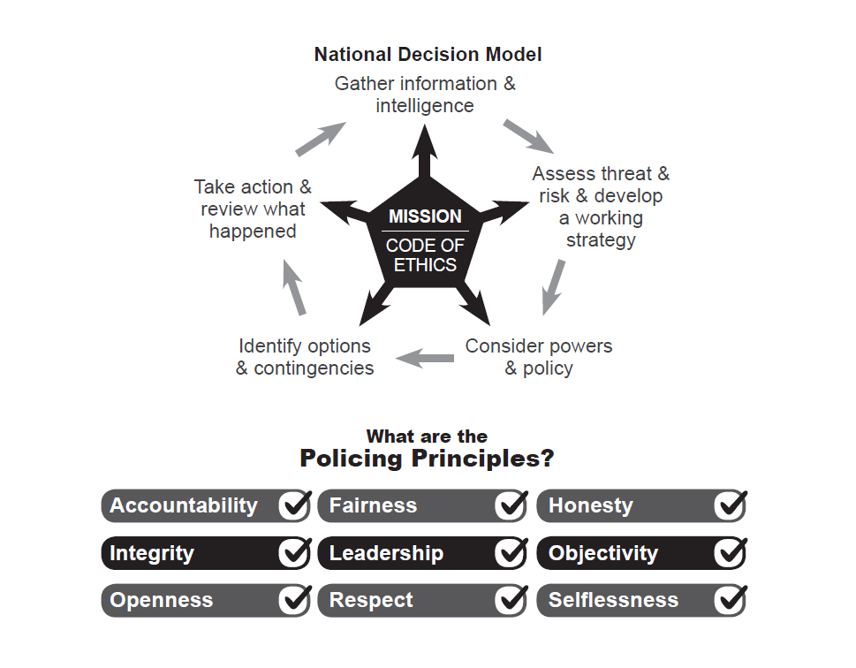
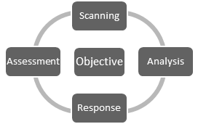

- Background

The PCC of Surrey is the national Mental health lead for Police and Crime Commissioners. This report has been requested to form part of the force performance profile in Surrey and to identify key issues in relation to policing and mental health in the county.

- Mental Health demand
  - Mental health performance –

The force reviews mental health data consistently via its force performance team and public protection performance structures. Oversight of this performance is held by the force mental health strategic lead and this is reviewed alongside key statutory partner agencies on a weekly basis. Much of the data available to police is based on the use of the Mental Health Act including s135 and s136. Other data available includes mental health related calls into the force contact centre and mental health incidents. Currently the key performance measures are –
- The use of s136
- The use of s136 for under 18’s
- Mental health conveyance in police vehicles
- The use of custody as a place of safety
- The number of mental health incidents reported to police
- The number of mental health incidents attended by police

The force continues to develop its understanding of mental health related demand and is constantly evaluating data to identify key themes and concerns. This has led to additional performance measures which are reviewed monthly and include –
- The use of s135
- The connection between s136 and substance misuse
- The average time of each s136 detention (from attendance to handover to the place of safety)
- The use of appropriate diversion services i.e. AMHP
- Missing person incidents from mental health settings
- The number of incidents reported to the force mental health operational issues log

  - Data analysis headlines -

- Following a 4-year period of declining use of s136 the force has identified that since April 2019 the number of s136 detentions has increased with notable significant increases during the Covid-19 pandemic. Diagram A highlights the increase over the last 12 months (Aug 20 – July 21). Diagram B highlights the use of mental health act powers by officers over the last 6 years.

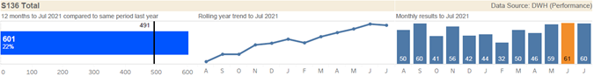
Diagram A

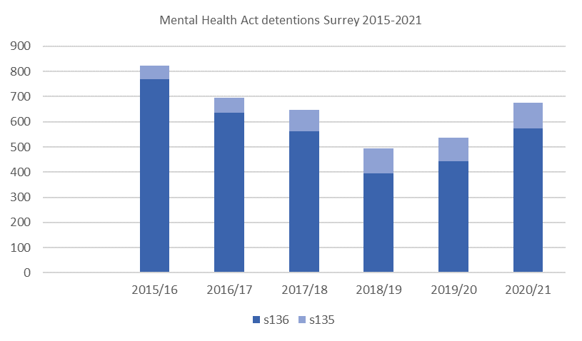
Diagram B

- An upward trajectory of mental health incidents reported to Surrey Police clearly begins from April 2019 and has continued with notable increases from May 2020 (Diagram C).
- Custody has been used as a place of safety on 3 occasions in Surrey since 2017. Two of these occasions have taken place in the 2021/22 financial year
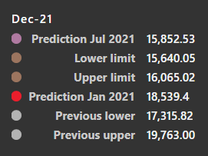
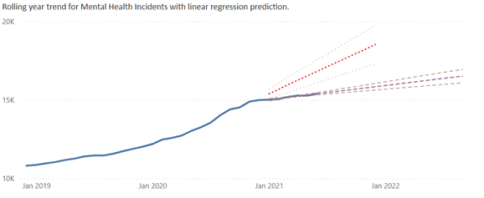
Diagram C

- The average time for police officers to complete a s136 from arrival at the incident to handover to the POS has increased from an average of 2 hours 40 minutes in 2020 to 4 hours in 2021/22.
- There has been a significant increase in young people being detained under s136 during 2020/21 (+73%) and this uplift correlates to the start of the Covid-19 pandemic.
- Conveyance in police vehicles has increased by 33% over the past 12 months.
- Officers are increasingly using A&E as the first place of safety due to the high levels of demand and challenges accessing Mental Health Act assessment suites.
- All relevant services agree that during the Covid-19 pandemic mental health presentations have been more complex and there is a recognised increase in presentation by people not previously known to services. Data is being sought through the MH trust and other agencies to evidence this.
- Mental health and crisis services are reporting increasing demands on their services. This includes record numbers of contacts with the NHS mental health crisis line and peak pressures on ambulance services and acute hospital emergency departments.

  - Operational challenges –

During periods of high demand there are often challenges and delays in accessing support from mental health services. These challenges in Surrey have been particularly acute during the Covid-19 pandemic where delays in accessing timely mental health services has impacted on police resources. This includes:
- Barriers to accessing Mental Health Act assessment suites following a s136 detention which leads to officers spending extended periods of time with a person who is unwell and requiring health treatment. This includes officers using alternative places of safety such as acute hospitals A&E departments (often) and custody (rarely).
- Lack of available mental health inpatient beds which places delays on the limited number of Mental Health Act assessment suites. There have been situations where assessment suites have been blocked and unusable for a number weeks due to the lack of available mental health beds.
- Delays in accessing mental health support from custody. This relates to those in custody that require a Mental Health Act assessment and transfer from custody to a health-based place of safety.
- Lack of timely access to ambulance services when conveyance of a person detained under s136 is required. This leads to the persons delay in accessing mental health/health services and places demand on police resources when conveyance in a police vehicle is needed.
- Access to mental health services out of hours. ¾ of all s136 detentions in Surrey take place out of hours and there is limited provision across mental health services to support police in managing crisis incidents.

  - Response to the demand –

The force is working alongside a range of partner agencies to meet the identified increase in demand. This focuses on a preventative, problem solving approach to the demand issues using performance data to understand local demand and service issues. The challenges being faced by services has been recognised by senior leaders and a mental health summit led by Surrey County Council in November 2020 highlighted the need to review services across Surrey. This has led to the Strategic Mental Health Partnership Board and subsequent Mental Health Delivery Board which is aiming to deliver long term improvement to mental health services in Surrey. Surrey Police is represented at these forums by the force mental health strategic lead.

Surrey Police is also focused on implementing change at an operational level to support those in crisis to access appropriate services. This has led to the identification of priority work streams which aim to help the force meet the increased levels of mental health related demand whilst supporting its delivery of the NPCC national mental health and policing strategy. These are –
• Education and training (front line)
• Understanding demand including repeat demand
• Partnership working and problem solving

Within these priority areas the following are examples of work being undertaken by the force –

- The Surrey High Intensity Partnership Programme (SHIPP) has been a permanent unit within Public Protection since February 2019 and contains a team of police officers and mental health practitioners who work with individuals identified as high and/or intensive users of services (Diagram D). SHIPP has expanded its resources (3 police officers and 3 band 7 MH nurses) and increased capacity during 2021 and has proven extremely successful in ensuring that the most appropriate care and support is in place for some of the most vulnerable people in Surrey whose primary concerns relate to their mental health or behavioural problems. The reduction in repeat demand on police and health services has been significant whilst improved life outcomes for the person has been key to SHIPP’s success through its trauma informed, person centred approach.
- A mental health force advisor role has been established in force and from July 2021 this role will support the force mental health lead in meeting force mental health operational demand. Priority areas of work for this role will include supporting custody, supporting front line response teams, and developing police access to mental health support services such as safe havens.
- A review of force mental health education and training provision has been conducted during 2020/21. This has led to the implementation of a Surrey and Sussex police Mental Health Act NCALT training package and the production of mental health CPD lesson plans which will include lived experience and mental health professional’s input. The force is also undertaking a programme of trauma informed training working alongside colleagues from the NHS and academia to help embed a trauma informed culture across the service.
- A bank of mental health resources is available in force for staff and officers. This includes access to a revised mental health guide via their handheld mobile data terminals (MDT’s) which details information on mental health services in Surrey, guides on MHA legislation and force policy and procedure.
- The force has developed new key performance measures in relation to policing mental health. This includes national measures such as mental health incidents, the use of s135 and s136, the use of custody as a place of safety and police conveyance. The force is also now working with partner agencies to measure police access to diversion services such as AMHP’s, crisis line and safe havens and analysing data relating to areas of high demand such as missing people from health settings, MHA powers in custody and the impact of substance misuse in mental health incidents.
- Surrey Police are an integral member of Surrey Adults Matter (SAM) which is focused on supporting adults with multiple disadvantage prioritising vulnerabilities relating to mental health, homelessness, and substance misuse. This has seen the introduction of the Joint Response Unit (ambulance and police unit), a SAM case management support system and ‘Bridge the gap’ which provides dedicated outreach to SAM clients.
- Surrey and Borders Partnership NHS Trust (SABP) have launched a professional’s line as part of their mental health crisis line provision. This service was launched initially for Surrey Police and has been expanded to other emergency services. This professional’s line is increasingly being used by police to support decision making and allow improved access for members of the public in crisis to access the most appropriate service. A warm transfer process between Surrey Police contact centre and the professional’s line is being developed.
- Surrey Police are well positioned at a strategic level to influence the commissioning of services including investment outlined in the NHS long term plan. The force is represented at the Surrey mental health partnership board which is reviewing all mental health services in Surrey and implementing a system wide approach to improve mental health services across the county. Surrey Police are also an integral member of the Surrey Crisis Care Concordat.

  - Suicide Prevention -

The force has recruited a suicide prevention force advisor since July 2020. This post has been funded by Public Health Surrey and has been introduced to support the force in understanding suicide and responding to its suicide prevention responsibilities outlined in the Surrey suicide prevention strategy. Within its dedicated portfolio the role has successfully established a suicide prevention real time surveillance data system which has allowed the force to collate detailed data on suspected and attempted suicide for the first time (Diagram D). The role has also introduced a more consistent and effective approach to the force suicide bereavement process and is working alongside public health to identify the link between suicide and other areas of public protection such as domestic abuse.

 | Jan | Feb | Mar | Apr | May | Jun | Jul | Aug | Sep | Oct | Nov | Dec | Total
2020 | 7 | 11 | 9 | 11 | 9 | 11 | 11 | 9 | 4 | 5 | 6 | 5 | 98
2021 | 4 | 6 | 12 | 6 | 8 | 10 | 2 |  |  |  |  |  | 48
Diagram D

- Conclusion

  - Risks and vulnerabilities –

There continue to be some risk to those in crisis due to reduced services (Covid-19 impact for example) and the significant pressure being placed on services from high levels of demand. This in the main relates to those in crisis not being able to access the right service at the right time. Short term the demand on police resources and the involvement of police in responding to high risk mental health incidents is expected to continue during the current climate. The force is committed to working alongside partner agencies and the communities of Surrey to meet this demand and the work outlined above is aimed at supporting this response.

Processes are in place to review and assess incidents of concern and the force is well placed to escalate concerns relating to its own response and the response of mental health services in Surrey. Operational meetings are well established across acute hospitals and with SABP and these multi-agency mechanisms have the ability to conduct systematic reviews of specific incidents. The newly established mental health force advisor role will play a key role in this process.

Both the Surrey Safeguarding Adults and Children’s Executive Boards are aware of the vulnerabilities and they are embedded within the mental health partnership process. SABP have held a weekly emergency response group meeting throughout the pandemic at which Surrey Police are represented and areas of risk and vulnerability are prioritised through a process of data analysis, escalation themes and priority work streams. The operational demand on police resources is also placed on the Public Protection risk register alongside the force mental health portfolio plan and force management statement (HMICFRS).

- Decision[s] Required
  - None – for information only

- Attachments / Background Papers

5.1 None

