

RURAL CRIME PORTFOLIO

Required for: | PCC Performance Meeting September 2021
Security Classification: | OFFICIAL
Handling information if required: | N/A
Suitable for publication: | Yes
Title: | Rural Crime Portfolio Update
Version: | 1.0
Purpose: | To provide a portfolio update
ACPO / Strategic Lead: | T/ACC Barlow
National Decision Model compliance: | Yes
Date created: | 03.09.2021
Date to be reviewed: | 07.09.2021

AUTHOR:
Name: | Helen Bayliss
Job Title: | Head of Information Management
Telephone number: | 01483 632312
Email address: | helen.bayliss@surrey.pnn.police.uk

INCLUDEPICTURE "cid:image001.png@01D312A9.8E469640" \* MERGEFORMATINET INCLUDEPICTURE "cid:image001.png@01D312A9.8E469640" \* MERGEFORMATINET 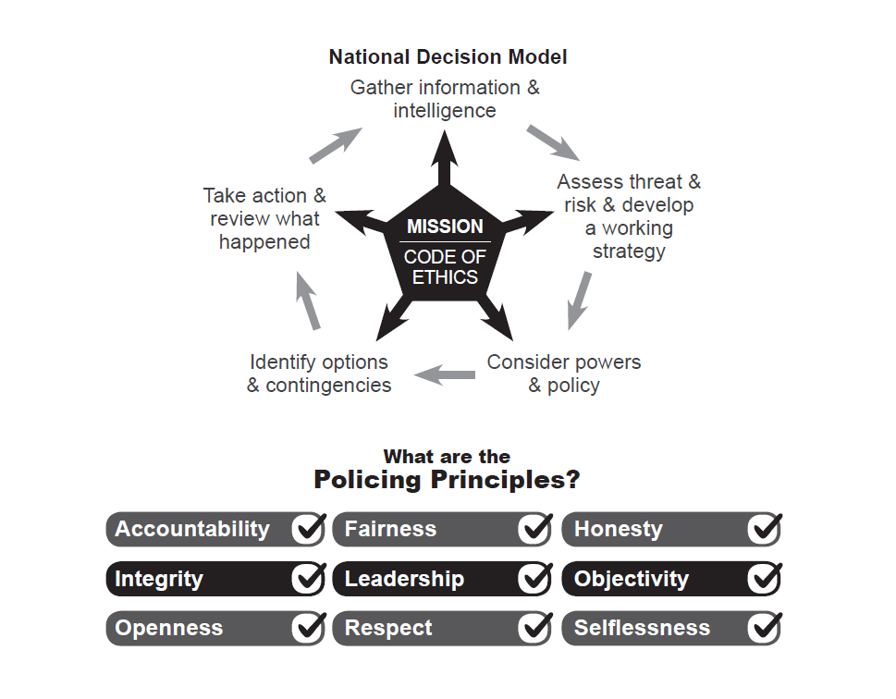

- Background
This paper has been created at the request of the PCC’s Office to highlight the current ‘as is’ status on rural crime matters.

- Current Position

Rural Crime Team - Introduction
The portfolio is supported by C/Inspector Hodder as the Rural Crime Lead and consists of currently PC Iribar and PC Rowley within the Problem Solving team and supported by 11 Rural Crime PCSOs. All staff have dedicated training annually on rural crime matters.
The portfolio is supported by the rural crime delivery plan, which, in line with NPCC objectives broadly sets out the commitment to improve confidence in policing in rural communities and keeping rural communities safe. To this end we have worked on increasing resourcing to tackle rural crime and will soon be adding a third dedicated PC to the team in December 2021.
The team have made a strong start this financial year and particularly in the areas of organised crime, reducing the risk of crime (supported by the Designing out Crime Officers) and in our work with partners, for example, reducing problems such as fly tipping.
Despite the challenges of the pandemic the team, have continued to hold and chair the Community Rural Advisory Group (CRAG), which sits quarterly and comprises of locals agencies and partners, who all come together to discuss and support the rural crime agenda.

Recent Activities
PCSO Fitzcosta in Spelthorne recently ran a very successful Wildlife Photography completion, raising awareness of wildlife crime and encouraging respect for wildlife among young people. There were a very impressive 80 entries and first place was won by Chloe Letton with her picture ‘Ants View’. Chloe was the lucky recipient of a GoPro Hero 8, funded by Spelthorne Borough Council.
On the 10th August our rural crime officers joined forces with the NFU and the National Trust at Polesden Lacey to encourage dog walkers to #TakeTheLead on livestock worrying. The team had seen an increase in reports of livestock worrying since the lockdowns, with local people taking advantage of the Surrey countryside. Livestock worrying can have devastating impacts for farmers, so the event aimed to raise awareness and encourage responsible dog ownership when walking in the countryside. In attendance were litter U from our dog school, who were extremely popular on the day.

Following reports from residents to disturbance and damage to a local wildlife pond and the habitat of the Greater Crested Newt, a Corporate Community Resolution Order was served to a developer who had been working in Dunsfold. This order was issued to cease further damage and make rectifications and was the first order of this nature to be issued in Surrey.
During the summer, working with colleagues in Hampshire Police, Officers have been tackling the theft of Quad Bikes and All Terrain Vehicles (ATVs), as a result a number of stops were made, x2 vehicles seized, x1 air rifle and a crackdown on fly tipping in the cross border area.
Following previous successful years rural crime week (10th to 15th August), this year’s whilst more reflective of the pandemic, was never the less very eventful, supported online with #RuralCrimeMatters. Activities across the county ranged from saddle marking, providing signage, targeted patrols, including river ways and canals, environmental surveying with the environment agency and work with our partners across a range of aspects of rural crime policing.

- Victim Satisfaction – Rural Crime
We have been tracking victim satisfaction for rural crime offences using our text survey facility. This collates both satisfaction ‘figures’ as well as real time actionable feedback.
Chart: Victim Satisfaction for Rural verses All Crime
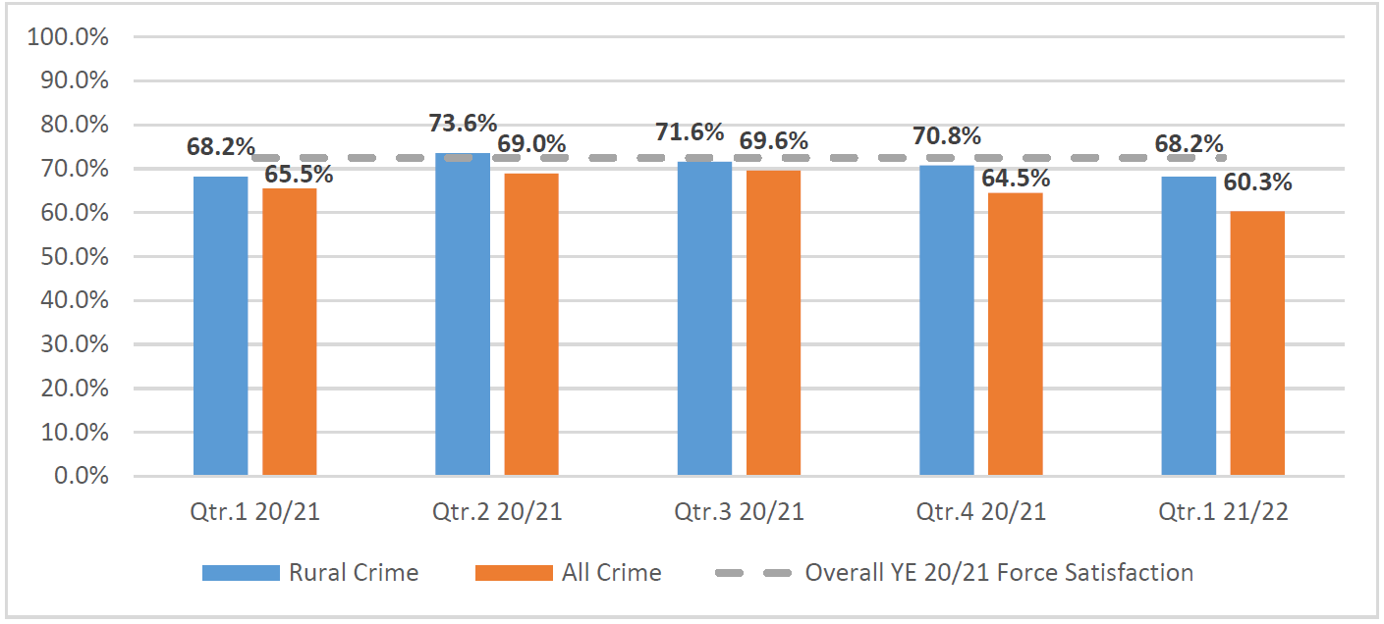
You will see that satisfaction for rural crime continues to track above total notifiable offences, reflective of the focus on rural crime and in particular the efforts of our Rural Crime PCs and PCSOs.

- Decision[s] Required
None, this paper is for information only.

