
PSAA AUDIT TENDER CONSULTATION

Required for: | Joint Audit Committee July 2021
Security Classification: | Official
Handling information if required:
Suitable for publication: | Yes
Title: | PSAA Consultation on local auditor appointments rom April 2023
Version: | 1.0
Purpose: | For information for JAC
ACPO / Strategic Lead: | Kelvin Menon
National Decision Model compliance: | N/A
Date created: | 01/07/21
Date to be reviewed:

AUTHOR:
Name: | Kelvin Menon
Job Title: | Surrey OPCC Treasurer
Telephone number: | 07870 378553
Email address: | kelvin.menon@surrey.pnn.police.uk

INCLUDEPICTURE "cid:image001.png@01D312A9.8E469640" \* MERGEFORMATINET INCLUDEPICTURE "cid:image001.png@01D312A9.8E469640" \* MERGEFORMATINET 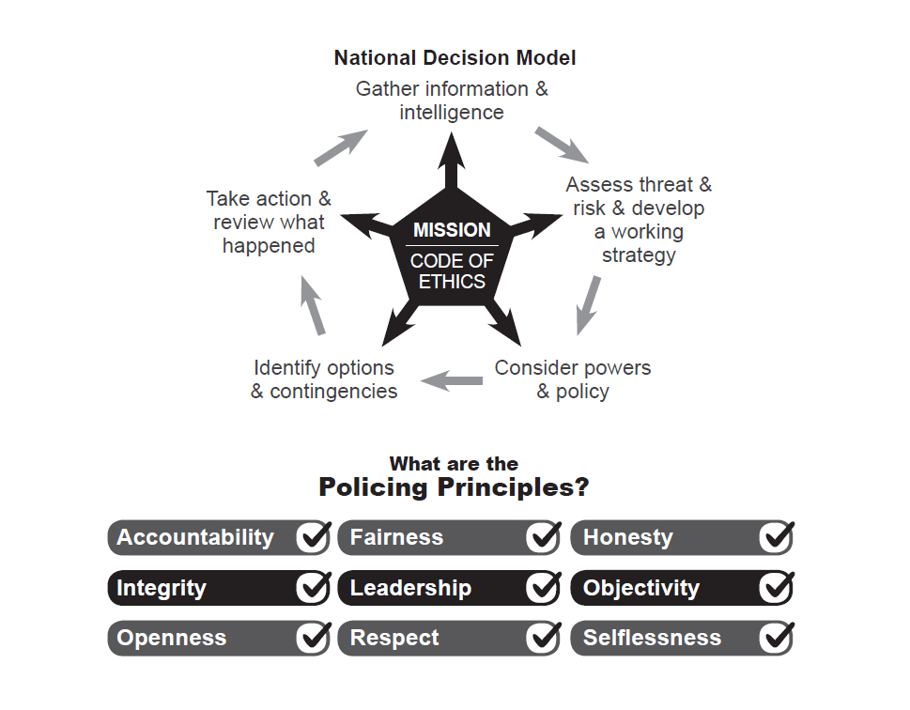

Introduction

- In July 2016, the Secretary of State specified Public Sector Audit Appointments (PSAA) as an appointing person for principal local government and police bodies for audits from 2018/19, under the provisions of the Local Audit and Accountability Act 2014 and the Local Audit (Appointing Person) Regulations 2015. Acting in accordance with this role PSAA is responsible for appointing auditors and setting scales of fees for relevant principal authorities that have chosen to opt into its national scheme, overseeing issues of auditor independence and monitoring compliance by the auditor with the contracts we enter into with the audit firms. At the moment 98% of local government and police bodies arrange their external auditor appointment through the PSAA.

- During the autumn of 2021 all local government and police bodies will need to decide upon their external audit arrangements for the period commencing from the financial year 2023/24. Local Bodies can arrange their own procurement and make the appointment themselves or do it in in conjunction with other bodies, or they can join and take advantage of the national collective scheme administered by PSAA. Irrespective of current arrangements bodies will need to formally “opt-in” to the PSAA arrangements if the so wish and for PCC this will be done by way of a PCC decision. In terms of PCC appointing their own auditor the rules are very prescriptive and only firms with the right experience can be selected.

- The attached consultation sets out the challenges that public audit has faced over the last few years in respect of delayed opinions and rising fees. It also sets out the case as to why going with PSAA is seen as the best option going forward and the improvements it intends to make in the audit market.

Consultation

- In June 2021 the PSAA commenced a consultation on the forthcoming audit procurement from 2023/24 and how it will operate in the future. The suggested responses are set out in Annexe A. As the closing date was Thursday 8th July 2021 these were discussed with the Chairman of the Committee before submission.

Recommendation

- The Committee is asked to note the suggested responses

Background Papers

- The full PSAA report has been attached to this agenda

Appendix A

Response to Consultation from PSAA on Auditor Appointments 2023/24

- Is PSAA right to prioritise the awarding of new longer term contracts with firms, based on realistic market bid prices, mitigating the risks of a less than fully successful procurement by holding in reserve the option to extend one or more of the existing audit services contracts for up to two years if required?

5 years strikes a good balance for being long enough for firms to recover their set up costs but not so long that the relationship between the auditor and client may become blurred. The option to extend is sensible to avoid bodies being without an auditor if a procurement is unsuccessful

- Is five years an appropriate term for bodies to sign up to scheme membership?

5 years is a reasonable period not only for the reasons set out above but also recognises the cost of the procurements and tendering process.

- Is five years with the option to extend for up to two years subject to the supplier’s agreement an appropriate term for the next audit services contracts?

Most contract extensions are at the option of the customer. I.e. Supplier agreement is not usually a condition although terms may be renegotiated. It is difficult to see why this would be a condition here since if the market is so poor that a procurement fails then an existing supplier would probably be unwilling to continue.

- Is PSAA right to evaluate tender submissions on the basis of 80% quality and 20% price to align with market expectations and other recent public sector audit procurements?

Given audit is a statutory function performed to professional standards it is difficult to understand what “Quality” means in this context? Is there a suggestion that some auditors are able to offer a better quality audit than others? Surely the issue is not so much around quality but more about delivery i.e. ensuring that audits are conducted at the right time and are adequately resourced. Quality should be restricted to an assessment of capacity and resource. In addition an 80:20 split as suggested will encourage auditors to over resource to meet the “quality” measure knowing that a high price will not have much of an impact on their tender rating and leading to signifcant cost increases. Hence it would be better to retain the 50:50 split as this provides a better balance between price and quality

- Is PSAA right to seek to encourage market sustainability within the local audit market by accepting bids from firms that are currently proceeding through the local audit registration process; by accepting consortia bids which may involve an unregistered firm gaining experience by working alongside a registered firm; and by considering the inclusion of one or two lots specifically aimed at seeking to encourage additional capacity into the market?

Any steps that can be taken to broaden the public audit market are to be encouraged. It is unclear why any firm, which holds the status of registered auditor for limited companies, cannot bid for these audits even if this was restricted to smaller public bodies. Many middle tier firms already audit listed companies, housing associations, schools, regulated bodies such as insurers etc and yet this market is so difficult to enter. Sustainability will only be achieved if barriers to entry to the market are removed. Having smaller lots will reduce some of the barriers for entry – but it is only part of the solution. The whole process of tendering a “basket” of audits across a handful of lots needs to be rethought. Does this method maximise or minimise the number of tenderers? Maybe a more targeted approach, smaller lots, classes of organisation may achieve more entrants to the market.

- Is PSAA’s proposed approach to social value appropriate given the services to be procured will be delivered across the whole of England? Are there any alternative approaches that should be considered?

Given that lots are being offered on a geographical basis surely social value could be linked to that particular area. Offering apprenticeships to deprived individuals (rather than residents of deprived areas) for Social Value has been very successful and should be continued. That said it is difficult to see how you will be able to differentiate between tenderers since they are all already doing this.

- Is PSAA right to carry out research and to consider setting a minimum audit fee in the next appointing period, recognising the increasing level of audit work now required and the risk that smaller scale fees may not be sufficient to cover the actual cost of the audit? What would be the key issues for PSAA to consider in the event that it opts to set a minimum fee for a Code-compliant audit?

A minimum few should not be researched or set. Surely it is for tenderers to determine the cost of providing the service when they prepare their tender? Surely a professional accounting practice should be able to cost in the end take account of the reporting and risk requirements in their audit tender? If a minimum fee is to be set the PSAA needs to take account of the financial pressures that audited bodies are working under as well as the profitability of audit firms.

- In the context of the recent NAO report, should PSAA and other market participants strive to prioritise the timeliness of audit opinions in the next appointing period? What actions should PSAA or other market participants take in order to avoid delayed opinions blighting the next period?

The PSAA needs to ensure that it is a contract condition that auditors adequately resource and to enable them to meet statutory reporting deadlines. However this also involves working with a number of other bodies to bring some realism in to audit for example:
- Working with Government to reporting Government to ensure that reporting deadlines are realistic given the demands of area such as the NHS;
- A recognition of the pressures that finance departments in bodies are under in terms of resources and technical expertise
- Working with CIPFA to ensure that the accounting standards do not add unnecessary complexity to accounts which can cause confusion and delays;
- Working with the FRC to ensure that the inspection of audit firms in relation of their audit of public bodies is proportionate to the risk.

In respect of what can be done to avoid delayed opinions impacting future audits this can only be resolved with additional resources being provided both by the auditors and audited bodies. Unfortunately audits have to be completed sequentially and so any delay in one year will impact the next until everyone has effectively caught up. It is unclear what happens if this crosses the expiry of one audit contract and the granting of another.

- Which specific benefits of the national scheme are most valuable to you? Are there other benefits we should strive to develop?

The saving on procurement and admin costs coupled with the opportunity to apply more leverage to the market are very attractive. The PSAA together with CIPFA should be more of a voice for the whole public audit sector. The PSAA also needs to ensure that it responds to queries, such as fee requests, in a timely manner.

- What are the key issues which will influence your decision about scheme membership for the second appointing period?

The key issue is whether joining PSAA represents value for money both in efficiency and monetary terms. However there is a benefit in having all of the administration of the audit procurement, including fee variations, being handled by an outside body.

- To inform the further development of our procurement approach, please indicate whether or not you anticipate that your organisation is likely to opt into our scheme

More likely than not but depends on the terms of the procurement being offered and what else is available in the market i.e. the appointment of other appointing bodies

