
***Progress against the Police and Crime Plan***

Required for: | OPCC Performance Meeting March 2021
Security Classification: | Official
Handling information if required: | Not applicable
Suitable for publication: | Yes
Title: | Progress against the Police and Crime Plan
Version: | 1.1
Purpose: | OPCC Performance Meeting Paper
ACPO / Strategic Lead: | DCC Kemp
National Decision Model compliance: | Yes
Date created: | 12th March 2021
Date to be reviewed: | N/A

AUTHOR:
Name: | CI 2125 Mason
Job Title: | Head of Strategic Planning
Telephone number: | 01483 630129
Email address: | strategicplanning@surrey.pnn.police.uk

INCLUDEPICTURE "cid:image001.png@01D312A9.8E469640" \* MERGEFORMATINET INCLUDEPICTURE "cid:image001.png@01D312A9.8E469640" \* MERGEFORMATINET 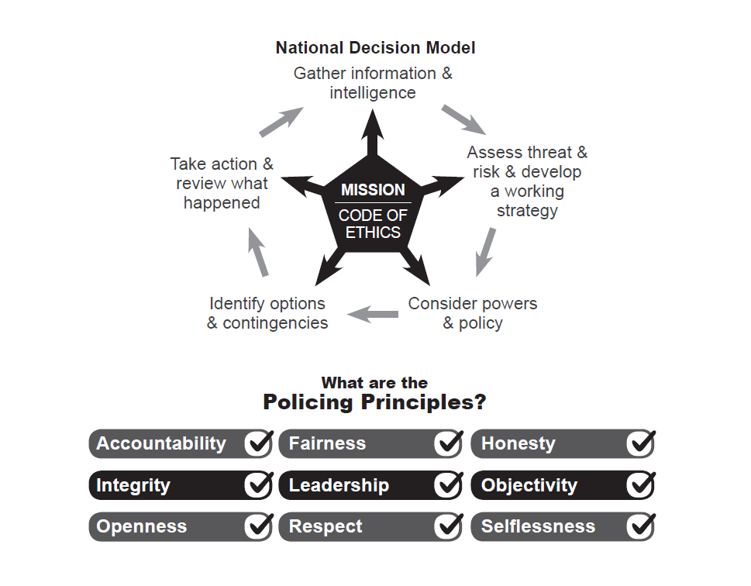

To: Office of Police and Crime Commissioner
Performance Meeting

Date: 12th March 2021

By: Strategic Planning

Title: Progress against the Police and Crime Plan

Purpose of Report: The purpose of this paper is to provide an update for the Police and Crime Commissioner for Surrey regarding Surrey Police performance against the PCC’s Police and Crime Plan.

1. Tackling Crime and Keeping Surrey Safe

Force Recorded Crime and Positive Outcomes:
Force: Volume of Recorded Crime
The volume of recorded crime is defined as the number of total notifiable offences recorded within Surrey as defined by the Home Office Counting Rules (HOCR).
The latest ONS figures for the 12 months ending September 2020 show that total police recorded crime decreased by -6.6% in England and Wales. This decrease in crime was mainly driven by changes in society after coronavirus lockdown restrictions were put in place. Surrey reduction over the 12 months to September 2020 was -4.1%.
The ONS figures showed that in September 2020 Surrey had the 5th lowest crime rate (61.5 per 1000 population) across England and Wales, and Surrey continues to have the lowest crime rate in the south-east region. Considering how attractive Surrey is to travelling criminality; with the Metropolitan Police to the north, and excellent road links across the South East, the continuing position as having the lowest crime rate in the region is significant.
Latest Surrey Police data for the 12 months to February 2021 show that the year on year trend in recorded crime has continued to decline, down -14.2% to a significant low of 66,433 crimes recorded.
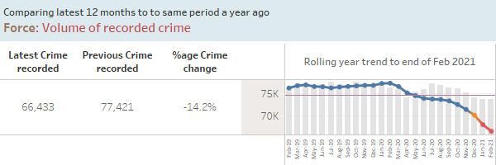
Lockdown restrictions throughout April and May 2020 saw some of the biggest reductions in crime. The second national lockdown during November 2020 also saw notable reductions. The introduction of tier-level restrictions in December 2020 and a further national lockdown in January 2021 resulted in recorded crime being below the monthly average. For the 12 months to February 2021 the biggest reductions have been within the burglary, theft, vehicle crime and criminal damage crime categories. The only notable increases have been within Violence without injury (mainly relating to harassment) and also drug offences (mainly possession).
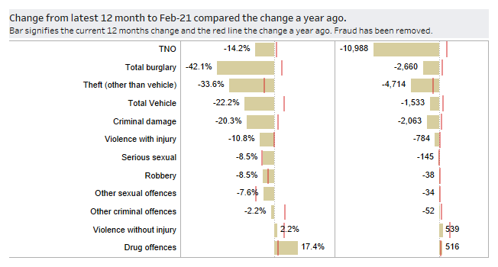Force: Volume of Solved Outcomes
Home Office Counting Rules require all notifiable offences to have an outcome. For Surrey Police, a solved outcome is a notifiable offence with either a charge, caution, penalty notice, drug warning, community resolution, TIC (taken into consideration) and more recently the addition of outcome 10 where formal action is not in the public interest.
For the 12 months to February 2021 the volume of solved outcomes for notifiable offences recorded was 9,964 which is down -7% compared to the 12 months to February 2020 (10,709). Performance in this measure over a rolling 12-month period had improved in the months February to May 2020, but the latest 12 months to February 2021 represents a relative low.
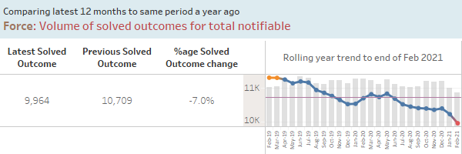

Force: Solved Outcome Rate

Solved outcome rates are calculated using the volume of solved outcomes in a given period divided by the volume of crimes in the same period.
For the 12 months to February 2021 the solved outcome rate for notifiable offences was 15.0% which is an increase of 1.2 percentage points compared to the 12 months to February 2020 (13.8%) (NB: percentage values have been rounded up and down to the first decimal place). The chart below shows a noticeable up-tick in the solved outcome rate since the beginning of the calendar year; reflective of the focus on this area.
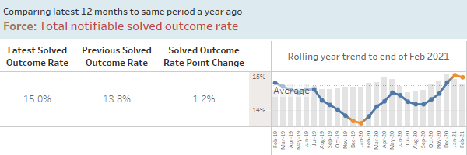

Force: High harm solved outcome rate

High harm offences comprise of the following types of crime: serious sexual offences, domestic abuse related offences involving violence, child abuse offences and hate crime offences.

For the rolling 12 months to February 2021 the solved outcome rate for high harm offences was 13.4% which is up slightly +0.3 percentage points compared to the 12 months to February 2020.
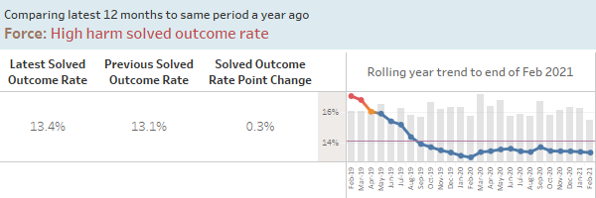

Problem Solving Occurrences

The 12 months to February 2021 show the volume of problem solving occurrences recorded as 438 which is an increase of 51.6% compared to the 12 months to February 2020 (289). Volumes over the last two months have been above the two year average.

The Force has created a central Prevention and Problem Solving Team from 2019/20 precept investment, led by a Chief Inspector, with two problem solving tactical advisors and two analysts who are assisting teams across the Force with detailed analytical support and research of national best practice.

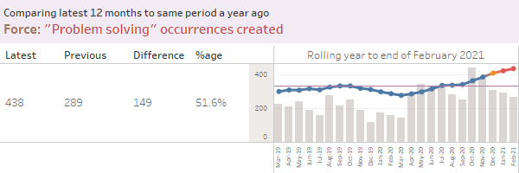

Dealing with ASB and Crime

Joint Neighbourhood Survey results for the 12 months to December 2020 show that 71.3% of respondents agree that Surrey Police are dealing with anti-social behaviour and crime issues that matter in their area. This represents a decrease of -1.2%pts compared to last year. The latest quarter (Oct-Dec 2020) shows no change to quarter Jun-Sep 2020. Latest quarter is a decrease of 4.6%pts compared to Oct-Dec 2019.

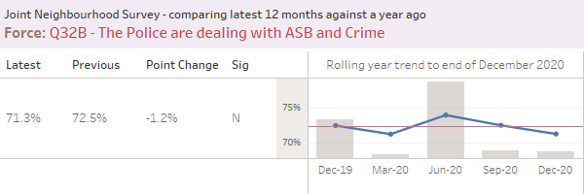

Call Handling and Deployment

Force: Calls for Service Performance
999 call handling performance remains strong and is always given priority. Data for the latest 12 months to February 2021 shows 93.2% of 999 calls are answered within CTC target of 10 seconds, which is a drop of -1.8%pts compared to the 12 months to February 2020. The Force Performance Board focused on contact centre performance during September 2020. 999 performance in August was impacted by high levels of contacts during the late turn in particular however throughout August 75% of 999 calls were answered within 2 seconds and 95% answered within 18 seconds. Latest performance for the months of October to January 2021 sees %age answered within target returning to normal levels.

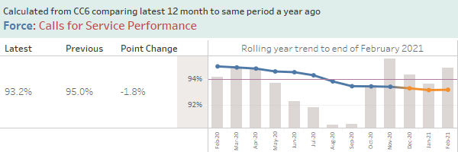

Force: Average time to answer 101 calls

101 call handling performance sees a greater degree of variation than 999 performance mainly due to a number of factors including continued prioritisation of 999 emergency calls over 101 calls, and the greater volume of calls experienced during the summer months or following a significant incident. The Force Performance Board focused on contact centre performance during September 2020.

The average time to answer 101 calls had seen increases over the summer months, returning to more normal levels in November 2020. The increases over the summer months are believed to be due to a combination of factors:

- Due to Covid-19 restrictions, the CTC has been working from five rooms rather than its normal one to ensure that staff members have sufficient space between desks, making communication between, and supervision of, staff more challenging.
- Demand for 101 calls is seasonal, with an increase in summer months. This year, the usual seasonal demand increase has coincided with easing of Covid-19 restrictions and a further increase in calls.
- In late June, the Digital 101 initiative was introduced, further increasing demand in the CTC.
- Covid-19 restrictions have affected the recruitment and training of staff.

Demand within the CTC, and the factors affecting performance, are constantly reviewed by the Contact and Deployment SMT, and work is ongoing to address these issues as Covid-19 restrictions ease.

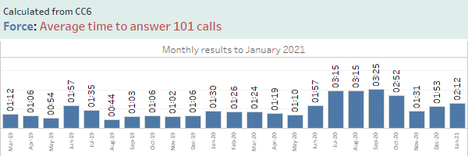

Force: Emergency Response Performance

Grade 1 & 2 response performance is measured as the percentage of incidents attended within 15 minutes and 60 minutes respectively. The latest 12 months to February 2021 shows Grade 1s attended in target has improved slightly by 0.2%pts compared to the 12 months to February 2020. Grade 2 is showing a reduction in the latest 12 months; down -2.8%pts compared to previous year. This is an issue experienced by many forces, as the actions required of officers at incidents become more complex, taking more time per incident.

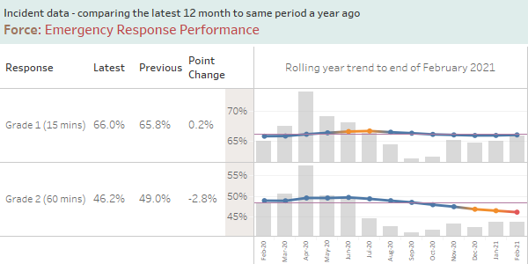

Counter Terrorism (CT)

Since the last report the number of Prevent referrals in the county has increased and is now broadly in line with pre-pandemic levels. The Force has continued to actively promote Prevent and new national campaign material via both its internal and external communication channels which has assisted in increasing referral numbers and officers’ awareness of this critical area of business.

Recent technological developments: the Prevent MDT application, designed to increase officer understanding of radicalisation and vulnerability, has been well received by front line staff with promising usage data captured for the last 3 months.

The Force Prevent Team is currently working with colleagues in Public Protection to ensure that risk of radicalisation and extremism is identified as a form of vulnerability, in line with HMICFRS recommendations, and are in the final stages of capturing this detail into relevant systems and processes. This is a significant positive step in identifying those at risk of radicalisation and referring them to appropriate support before they embark on criminal activity. This work will be completed early in the next financial year.

Following publishing of this year’s Counter Terrorism Local Profile for Surrey the Force is working with Sussex Police to improve internal processes for monitoring emerging community tensions. Each Force submits a regular, national return on community tension but local submissions currently rely too heavily on crime data and do not capture granular incidents of note or the professional judgement of key internal stakeholders e.g. Borough Commanders and Public Order Commanders. A joint task and finish group has been established to ensure this community intelligence is captured, recorded and shared with Counter Terrorism HQ to better inform the national position.

2. Building Confident Communities

Force: Crime Survey for England and Wales (CSEW) Confidence

For the 12 months up to March 2020, Surrey Police has moved 3 places to 7th for the Crime Survey for England and Wales measure for public confidence. The latest results show an increase of 1.1 %pts over the last quarter to 78.7%. The national face-to-face Crime Survey for England and Wales (CSEW) was suspended on 17 March 2020 because of the coronavirus (COVID-19) pandemic. A telephone-operated version of the CSEW was used but did not include the questions on public perceptions by police force area.
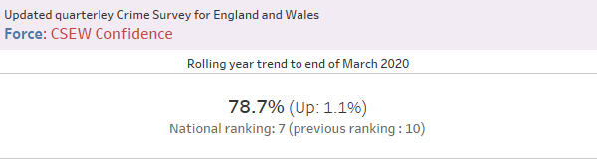

Force: Q19 – Confidence in Neighbourhood Police

Surrey County Council and Surrey Police survey over 6000 residents a year as part of the Joint Neighbourhood Survey (JNS).

In the 12 months to December 2020, of those asked, “taking everything into account, how confident are you in your neighbourhood police?”, 87.9% said they were very or fairly confident. This represent a small reduction of -0.3% points compared to the same period a year ago.

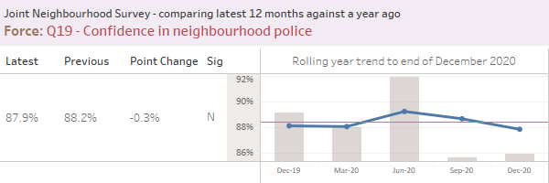
3. Supporting Victims

From April 2019 a new methodology was introduced to consult with victims of crime and ASB. Victims are now contacted via text message which brings benefits such as reaching more victims of different crimes, fewer questions resulting in an increased response, and greater insight through victims’ comments. Results are now also received in real time as opposed to the previous lag of 2-3 months between incidents/crimes occurring and results being received.

When presenting the results, although percentages will be shown, a customer satisfaction score (CSAT Score) is also provided. This is based on the satisfaction questions, where respondents are asked to provide a response between 1 - 5 (Dissatisfied to Satisfied) to the satisfaction question they are asked (Initial Contact, Kept Informed, Actions Taken or Treatment).

As with last month, initial contact (-6.6% points to 70.2%) had the highest workflow satisfaction this month despite a decrease. Actions taken (+1.3% points to 65.9%) and treatment (-0.3%points to 68.4%) both present high satisfaction results this month, and were similar to the initial contact result. Kept informed displayed a large decrease this month (-8.7% points to 60.5%). Overall satisfaction decreased -4.2% points to 66.8% this month.

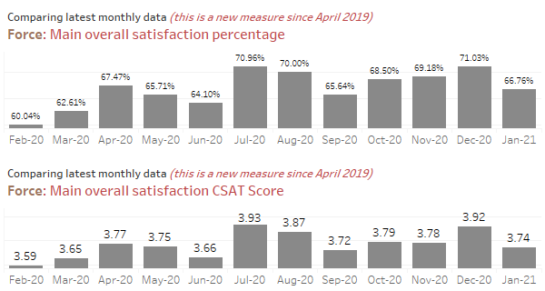

Force: Total ASB User satisfaction

ASB Overall satisfaction in January 2021 is 65.7%. The ASB CSAT score for January 2021 is 3.77.

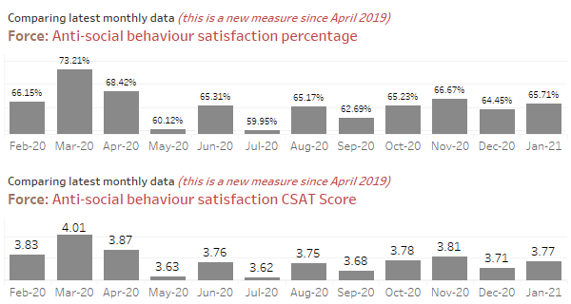
4. Preventing Harm

Force: Repeat Vulnerable Missing Individuals

The volume of vulnerable missing individuals over the last 12 months to February 2021 is 430, a decrease of -230 on the volume recorded in the 12 months to February 2020. As seen in the chart below, this continues the excellent downward trajectory of the last year; a result of greatly improved partnership working and the embedding of the Surrey High Intensity Partnership Programme (SHIPP). The new balanced scorecard now uses repeat missing individuals as a whole.

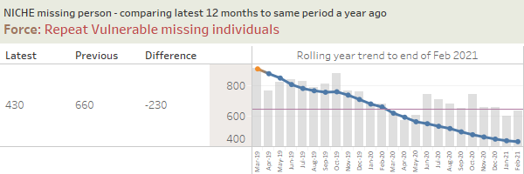

Force: Repeat Domestic Abuse (DA) offenders over the last three years

The 12 months to February 2021 shows the force has 1,035 repeat serial DA offenders which is up 10.2% compared to the 12 months to February 2020 (939).

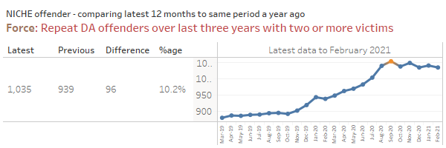

The correct identification and recording of repeat DA perpetrators / victims has been a focus for the force. The increase in repeat DA perpetrators can be associated to improved reporting, better understanding and identification by officers and improved data integrity and linking of crimes. Activity across the force to address DA offending includes the following.

Enhanced focus on DA investigations; focus on outstanding DA suspects through daily management meetings; focus on those serial perpetrators identified due to offending levels; use of the Multi Agency Referral Assessment Conference (MARAC) process to address repeat offenders coming to notice to agencies; problem solving plans to address repeat offending and/or chronic problems where appropriate; new domestic abuse specialists employed in the quadrants within the new family safeguarding model in Police Single Point of Access (P-SPA) helping to identify and support those repeat callers/perpetrators with children; new Chula Vista style warning notices now served on all DA perpetrators issued with a Domestic Violence Protection Notice (unannounced visits introduced); focus on bail checks of DA perpetrators; use of the ‘Respect’ helpline/ website to help DA perpetrators address their behaviour/repeat offending; use of the Domestic Violence Disclosure Scheme (DVDS) to manage disclosures; serving of Stalking Protection Notices/Orders (SPO’s) to deal with those that present significant risk.

The High Harm Perpetrator Unit (HHPU) manages high-harm offenders, which includes known DA offenders who sit within the Integrated Offender Management (IOM) / High Harm Perpetrator (HHP) cohorts; some of these are IOM offenders adopted for serious crimes but also have DA offending history. A close working relationship has been built with outreach partners to share information and, where appropriate, the seven pathways, which include referrals to other agencies, is used to address DA re-offending. The Probation Service (KSSCRC) are also working with DA perpetrators convicted and sentenced to a post-conviction DA behaviour change programme by the courts. Face to face visits are still being carried out on those high risk DA perpetrators being managed by the National Probation Service (NPS).

Mental Health

The below data has been taken from the Force’s Public Protection performance report.

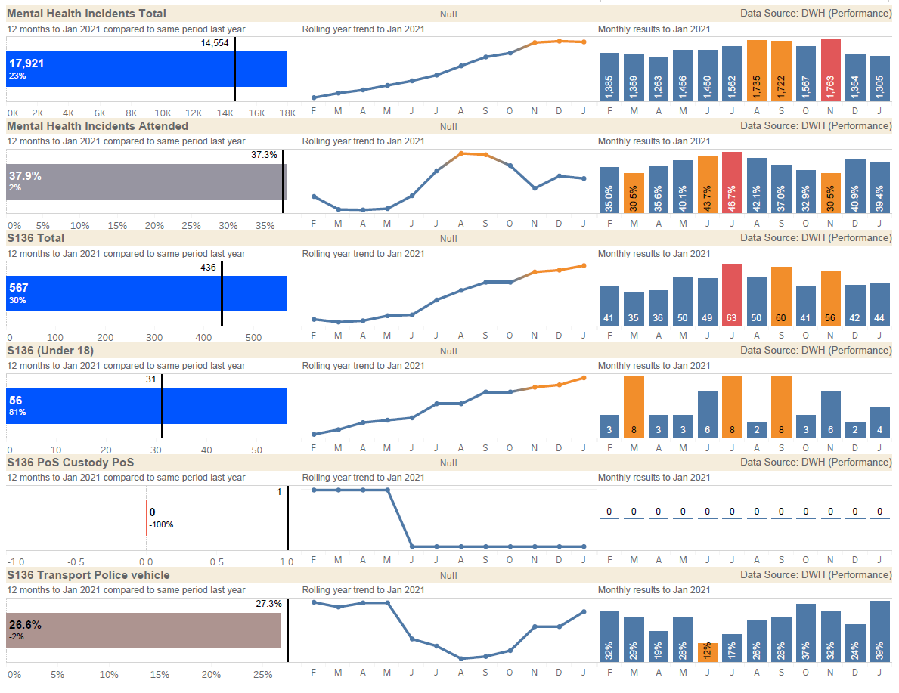

Following a surge in mental health demand during the Covid-19 pandemic, numbers of calls into the police contact centre that require a mental health flag have plateaued in recent months. Despite this, demand levels remain high with a 23% increase against the same period last year. Police attendance at these incidents has remained consistent with the previous 12 months.
The increase in the use of s136 of the Mental Health Act continues to increase with a 30% increase on the previous 12 months. Following analysis of the available s136 documentation it has been identified that during the Covid-19 pandemic officers are attending more incidents where members of the public are suffering mental health crisis. These have been more complex in nature and in general have been assessed as higher risk. It has also been identified that services are seeing an increase of young people in crisis and have seen an increase in presentations by people not previously known to services.
Surrey Police is committed to supporting those suffering mental health crisis in the most appropriate way and is working closely with the mental health trust, Surrey Clinical Commissioning Group and Surrey County Council to explore alternative, multi-agency options when police officers are faced with a person in crisis. A number of existing initiatives are in place to reduce this area of demand and others, such as the adoption of under 18’s within the Surrey High Intensity Partnership Programme and extended opening hours of Surrey Safe Havens, are currently being proposed.
Custody has not been used as a place of safety since July 2015 and previous data errors have been corrected.
The use of police vehicles to convey a patient to a place of safety has increased during the past 3 months and is reflective of the pressures being placed on ambulance services.
5. Making Every Pound Count

Financial Monitoring at 31st January 2021.

The total budget for Surrey is £250.0m 2020/21, against this the forecast outturn position is £249.1m resulting in an under spend totalling £0.9m.
Surrey | 2020/21 PCC Budget £m | 2020/2021Operational Delivery Budget £m | Total 2020/21 Budget £m | 2020/21 Total Forecast £m | Variance £m
Month 10 | 2.1 | 247.9 | 250.0 | 249.1 | (0.9)

The operational response to the COVID-19 pandemic has resulted in additional unplanned costs which consist of the salary costs of police officers and staff, employee overtime, premises, lost income and supplies & services, the most significant cost being for Personal Protective Equipment (PPE). The notification from the Home Office is that Forces can recover the costs of PPE, lost income and additional Covid relief, which is currently £4.2m in the forecast. The Home Office have announced that Surrey will receive £388k from the £30m Covid Surge Fund allocated to police forces.

The total costs for the response to the COVID-19 pandemic are shown in the table below, this assumes costs until the end of the financial year.

The Minister for State for Crime and Policing, Home Office has announced an additional £58m for policing to meet the costs of the pandemic. The Surrey allocation is £750,644 of the unconditional grant. (This is not included in the figures within the report.)

 | Surrey
Expenditure | £'000
National PPE | 2,275
Local PPE | 506
Other Local Costs | 3,747
Total Forecast Costs | 6,527
Forecast Income | -4,211
Net Forecast | 2,316
Total PPE | 2,781

The Force has mitigated the additional costs with savings across the Force, which includes savings in training and staff travel where costs have been lower for the year to date.

There are variances within the budget. Pay is forecasting an over spend overall with non-pay underspending to offset against this.

Police officer numbers are increasing as the recruitment plan delivers and police staff budget is forecast to overspend.

For Police Officers the financial plan assumed an inflationary increase of 2% which was actually 2.5%, this additional cost pressure is included in the forecast.

The non-pay costs including income are underspent in total with costs attributable to Op Apollo being offset by the assumed income.

The precept & uplift investment was for an additional 156.5 posts, the current forecast is that Surrey Police will recruit to these posts by March 2021.

The efficiency plan to save £1.4m has been removed from the budget, however there is a risk that savings within ICT will not be achieved and this is reflected in the forecast.

The Force agreed to continue funding Investigative Assistant posts within Local Policing which is estimated to cost £0.5m, this cost pressure is included in the forecast.

The capital plan is forecast to underspend by £0.9m. For the 2020/21 financial year a new Capital & Investment Gateway To Proceed process has been introduced for existing planned schemes. This step will firm up on the proposals put forward during the budget build and also allow the funding position to be checked prior to giving the go ahead.

Surrey | 2020/21 Capital Budget £m | 2020/21 Capital actual £m | 2020/21 Capital Forecast £m | Variance £m
Month 10 | 13.9 | 8.7 | 13.0 | (0.9)

The Force, with the additional government support, is forecast to under spend against the annual revenue budget.

The following options are proposed to allow consultation with the Police & Crime Commissioner and PCC Chief Finance Officer to ensure a planned year end position.

A measured bid process was instigated by the Force which will need to be taken into account. Further expenditure is expected in respect of the patrol activity to ensure compliance with the Covid19 regulations.

The two major projects in the Force are Building the Future and Equip, and it is recommended that any surplus funds are directed to the Cost of Change Reserve (Equip) and the Estates Strategy Reserve (BTF). At this stage both of these projects are anticipated to have future costs that may not be entirely funded, further clarification will not be known for some weeks.

Please see attached paper - Force Financial Report Month 10 2020/21.

6. A Force Fit for The Future

Estates Strategy

As the Building the Future (BTF) Programme gained pace it became clear that there were a number of interdependent strands of work that needed to be moved forward to ensure that the totality of the Estate supports the Building the Future Programme.
A draft Surrey Estates Strategy was prepared late 2020, and senior consultation meetings started with a view to obtaining feedback, thoughts and agreement to proposals by the end of February 2021. The Estates Strategy is being presented to ECOG in March 2021 for agreement, after which it will go to the BTF Board in April 2021.
The BTF Programme is still running at pace, and the other workstreams in the Estates Strategy are also progressing well.
_______________________________________________________________

Recommendation(s)/Future Activity: The Police and Crime Commissioner is asked to note the contents.

Risks: Performance risks are addressed through the Force Performance Board chaired by the Deputy Chief Constable.

Attachments/ Background Papers: Force Financial Report Month 10 2020/21

Contact details
Name: Strategic Planning Team
Job Title: Strategic Planning Team
Telephone number: 01483 630129
Email address: strategicplanning@surrey.pnn.police.uk

