
Financial Monitoring at: 31st January 2021
Required for: | PCC Performance Meeting March 2021
Security Classification: | Not Protectively Marked
Handling information if required:
Suitable for publication: | Yes
Title: | Financial Monitoring at 31st January 2021
Version: | 1
Purpose: | To provide the latest revenue and capital financial update
ACPO / Strategic Lead: | Pete Gillett - Executive Director of Commercial & Financial Services
National Decision Model compliance: | Yes
Date created: | 24/2/2021
Date to be reviewed:

AUTHOR:
Name: | Bev Foad
Job Title: | Joint Finance Manager
Telephone number: | 07967987548
Email address: | Beverly.Foad@surrey.pnn.police.uk

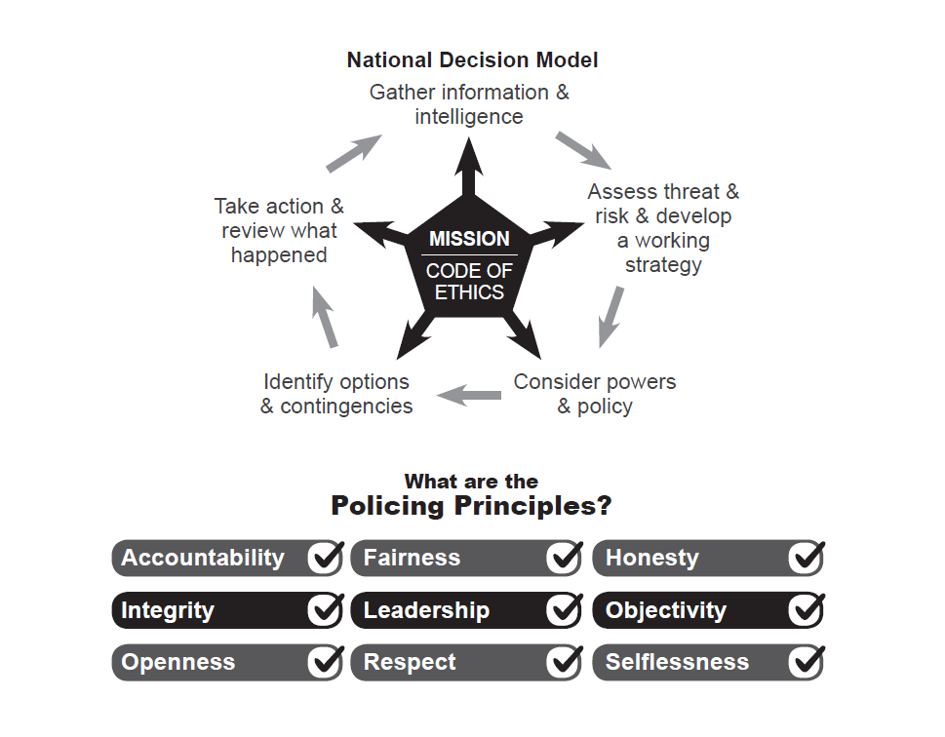



Force: Surrey
Financial Monitoring at: 31st January 2021
Finance Department
- Introduction
  - This report provides the force budget and capital position for Surrey Police as at 31st January 2021.

- Summary
  - The total budget for Surrey is £250.0m 2020/21, against this the forecast outturn position is £249.1m resulting in an under spend totalling £0.9m.
Surrey | 2020/21 PCC Budget £m | 2020/2021Operational Delivery Budget £m | Total 2020/21 Budget £m | 2020/21 Total Forecast £m | Variance £m
Month 10 | 2.1 | 247.9 | 250.0 | 249.1 | (0.9)
  - The operational response to the COVID-19 pandemic has resulted in additional unplanned costs which consist of the salary costs of police officers and staff, employee overtime, premises, lost income and supplies & services, the most significant cost being for Personal Protective Equipment (PPE). The notification from the Home Office is that Forces can recover the costs of PPE, lost income and additional Covid relief, which is currently £4.2m in the forecast. The Home Office have announced that Surrey will receive £388k from the £30m Covid Surge Fund allocated to police forces.
  - The total costs for the response to the COVID-19 pandemic are shown in the table below, this assumes costs until the end of the financial year.
  - The Minister for State for Crime and Policing, Home Office has announced an additional £58m for policing to meet the costs of the pandemic. The Surrey allocation is £750,644 of the unconditional grant. (This is not included in the figures within the report.)

 | Surrey
Expenditure | £'000
National PPE | 2,275
Local PPE | 506
Other Local Costs | 3,747
Total Forecast Costs | 6,527
Forecast Income | -4,211
Net Forecast | 2,316
Total PPE | 2,781

  - The Force has mitigated the additional costs with savings across the Force, which includes savings in training and staff travel where costs have been lower for the year to date.
  - There are variances within the budget. Pay is forecasting an over spend overall with non-pay underspending to offset against this.
  - Police officer numbers are increasing as the recruitment plan delivers and police staff budget is forecast to overspend.
  - For Police Officers the financial plan assumed an inflationary increase of 2% which was actually 2.5%, this additional cost pressure is included in the forecast.

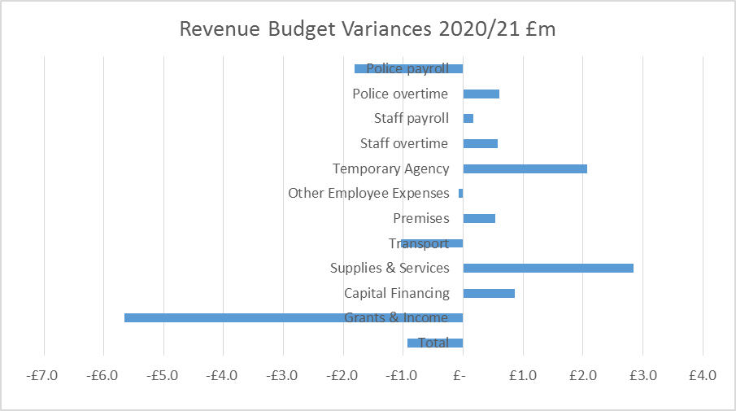

  - The non-pay costs including income are underspent in total with costs attributable to Op Apollo being offset by the assumed income.
  - The precept & uplift investment was for an additional 156.5 posts, the current forecast is that Surrey Police will recruit to these posts by March 2021.
  - The efficiency plan to save £1.4m has been removed from the budget, however there is a risk that savings within ICT will not be achieved and this is reflected in the forecast.
  - The Force agreed to continue funding Investigative Assistant posts within Local Policing which is estimated to cost £0.5m, this cost pressure is included in the forecast.
  - The capital plan is forecast to underspend by £0.9m. For the 2020/21 financial year a new Capital & Investment Gateway To Proceed process has been introduced for existing planned schemes. This step will firm up on the proposals put forward during the budget build and also allow the funding position to be checked prior to giving the go ahead.

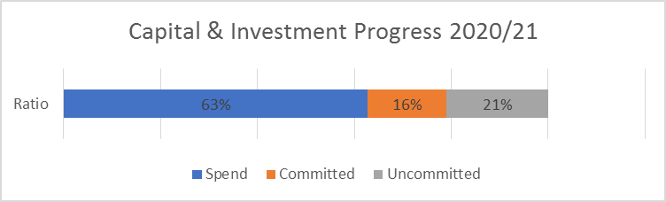

Surrey | 2020/21 Capital Budget £m | 2020/21 Capital actual £m | 2020/21 Capital Forecast £m | Variance £m
Month 10 | 13.9 | 8.7 | 13.0 | (0.9)

  - The Force, with the additional government support, is forecast to under spend against the annual revenue budget.
  - The following options are proposed to allow consultation with the Police & Crime Commissioner and PCC Chief Finance Officer to ensure a planned year end position.
  - A measured bid process was instigated by the Force which will need to be taken into account. Further expenditure is expected in respect of the patrol activity to ensure compliance with the Covid19 regulations.
  - The two major projects in the Force are Building the Future and Equip, and it is recommended that any surplus funds are directed to the Cost of Change Reserve (Equip) and the Estates Strategy Reserve (BTF). At this stage both of these projects are anticipated to have future costs that may not be entirely funded, further clarification will not be known for some weeks.

- Recommendations

  - The Police and Crime Commissioner is asked to:

    - Note the net revenue budget forecast for the police fund as at 31st January 2021.
    - Note the capital budget forecast is as at 31st January 2021.
    - Approve the proposal to direct any underspend towards the Estates Strategy Reserve and the Cost of Change Reserve to mitigate future financial risk from these complex projects.

- Revenue Budget Position
  - The Force’s revenue outturn position for 2020/21 is forecast to be underspent as summarised in the table below:
  - The 2020/21 revenue budget was approved by the PCC in February 2020 at £250.0m, during the year agreed budget virements have been processed within the operational delivery budget and OPCC budget, with the overall budget remaining at £250.0m as shown in the table below:
  - Appendix A provides further details of the operational delivery budget showing budget and forecast both by budget holder portfolio and the main categories of expenditure.
  - Pay Costs - Total pay is overspent by £1.5m as summarised in the table below.

  - In Surrey employee numbers are monitored in detail throughout the year within a workforce plan by People Services. The following table illustrates the variances between the average forecast number of employees (employee strength) compared with the budgeted number of employees (employee establishment), expressed as FTE (full time equivalent) roles.

  - Police Payroll - The police officer pay is forecast to be underspent by £1.5m.

  - Police Officer pay is a non-delegated cost and is shown on a separate line within the budget by function (Appendix A) with departmental variances reflecting their delegated budgets.

  - The pay forecast indicates an average of 1989 FTE officers for the year, compared to the budget of 2024 FTE.

  - The above calculations shows the force is averaging 35 officers under budget which is resulting in a volume underspend of £2.1m (£54.9k per FTE), with a rate overspend of £0.5m relating to officer rates being higher than budgeted. A vacancy factor of 2% (£2.5m) is assumed for police officers which is part of the rate variance along with the mix of officers.

  - Police staff pay is forecast to be overspent by £0.2m. The current projection is for the number of staff working in the force to remain under establishment until the end of the financial year, when the predicted number of FTE’s is 1886. The vacancy rate for 2020/21 has been increased by 1% to 6%.
  - The month 10 pay forecast shows an average of 1802 FTE staff for the year, compared to the average budget of 1946 FTE.

  - The shortfall of 143 staff FTE’s results in a £5.3m volume underspend for pay, NI and pension (£36.4k per FTE), that is being offset by a rate overspend of £4.4m. A vacancy factor of 6% (£4.6m) is assumed for police staff which is part of the rate variance along with the mix of pay grades, the above calculation is an average.

  - Staff enhancements and holiday pay have underspends due to being under establishment. The rate and volume variances are based on all posts having these allowances and therefore is not representative of entitlement.

  - Overtime for both officers and staff by department is shown on Appendix B, with officer overtime forecast to overspend by £0.6m and staff overtime forecast to overspend by £0.6m.

  - The Force’s police officer overtime working group continues to monitor spend and provide guidance to reduce spend in this area, the tables below shows spend for both officer and staff overtime over the past four years.

  - The charts below show Police Officer and Staff overtime by division/department. Appendix B shows the monthly profile of this spend.

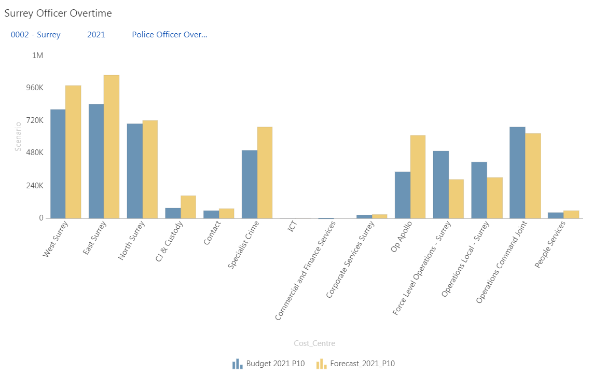
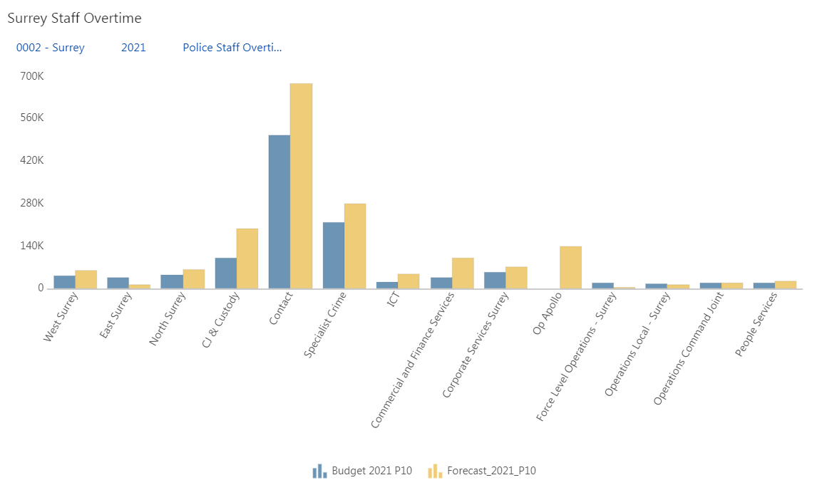

  - Agency costs
    - Agency is forecasting an over spend of £2.1m. The majority of this relates to an overspend on agency costs within Local Policing (£0.5m) for 30 investigative assistants across 3 divisions, along with Op Apollo costs for returning officers and Op Igil. Equip is showing an over spend of £1.1m, offset by an under spend in Supplies & Services, further detail is provided at appendix E.

  - Training & restructuring costs
    - Training & restructuring is forecasting an under spend of £0.5m mainly within People Services.

  - Other Staff Costs
    - There is an over spend in Other Staff Costs totalling £0.4m some of which relates to Local PPE for Op Apollo. There is also an over spend for the apprenticeship levy where this is offset by income.

  - Non Pay Budgets
    - Non pay cost budgets are forecast to underspend by £2.5m as shown in the table below. These budgets include costs for premises, transport, supplies & services, financing and income.

  - Premises
    - Premises is forecasting an overspend of £0.5m although there are small underspends within Surrey Corporate Services and Specialist Crime offsetting small overspends in ICT and Operations. Estates have increased their forecast spend due to essential health and safety work needing to be undertaken together with a reduction in rent income due to COVID-19.

  - Transport
    - Transport are forecasting an under spend of £1.0m relating to a reduction in insurance premiums and savings in fuel costs.

  - Supplies & Services
    - There is a forecast overspend of £2.8m. Specialist Crime are overspent due to increased Forensic fees. Legal fees are also causing an over spend within Corporate Services. ICT are showing overspends on software licences/support and maintenance costs and consultancy.

  - Financing
    - Financing costs are forecast to overspend by £0.9m this relates to revenue contributions to capital to fund the Smart Storm project and for additional ICT spend.

  - Income
    - Income budgets relate to government grants, reimbursed services, secondments and mutual aid arrangements with other police Forces. This income is in addition to the main sources of funding from the core policing grant and council tax precept income.

    - There is an overachievement of income forecast of £5.7m. Operations have an overachievement of income relating to the Covid Surge Fund and local PPE as well as an increase in Surrey Camera Partnership income. Specialist Crime are forecasting higher than expected income for Surrey officers posted to regional units. Within People Services there is an over recovery for Secondments along with income received from new HQ site tenants and other property rentals within Corporate Services.

  - Departmental Narrative
This section gives a narrative on the divisions & departments, note the figures relate to delegated budgets only.
- Local Policing overall forecast an over spend of £2.2m on delegated budget on number of areas. Firstly, forecast overspend of £1.0m Police Staff Pay as divisions were operating over-establishment on PCSO functions to ensure some of the PCSO will join the force as regular Police officers throughout the year and to manage the current demand. Secondly, forecast overspend of £0.275m in Police Staff overtime in a number of areas i.e. Contact Centre and Detention Centres and Victim and Witness Care due to a shortage of regular staff as a result of COVID, within Contact centre overspend of £0.18m related to investing hours in supervisor roles as Contact were operating 50% down for few months and to cover the vacancy shortfall. Further overtime hours were incurred to accommodate the shortfalls of resources due to isolating staff and this will continue for the remainder of the year. There is an over spend in agency costs for investment of £0.5m on Investigative Officers in NPT funded from force overall underspend. Finally, within both Supplies and Services and Grant income forecast over £0.5m spend on Supplies and an offsetting income in grant for the Safer Street grant in North Surrey.
- Operations Command are showing a forecast underspend of £1.0m. This is due to the effects Covid has had on the ability to attend external training courses, and a reduction in spend on specialist equipment. Areas that are forecast to overspend within the portfolio are Op Apollo, £1.8m and the Camera partnership, £0.23m, which will be covered from the reserve.
- Specialist Crime position is forecast to under spend by £2.5m – a favourable movement from last month of £0.1m, most of which is in income and relates to the review of Surrey officers to be recharged to Sussex for Border Policing. The significant risks is within outsourcing, both in Physical and Digital Forensics, which is a reflection of the increase in officers, and thus submissions, due to Uplift funding. An overspend in overtime is also expected and the SEROCU contribution is higher than budgeted, including new investments agreed by CCs & PCCs across the region, however the bottom line still remains favourable.
- Corporate Services continues to be a forecast an over spend which had reduced to £0.5m. This is mainly as a result of Legal and Claims fees being higher than budgeted £0.6m which is being offset by an increase in costs recovered of £0.1m.

- ICT are currently forecasting an over spend of £0.2m which is comprised of an over spend of £0.7m relating to increased IT associated costs and temporary staff/consultants costs. These increased areas of spend have been partially offset by an under spend of £0.5m relating to Police Staff pay where vacancies are being held.

- People Services – The forecast is for an under spend of £1.0m with the significant variances being an over achievement of income of £0.7m, combined with an under spend in police staff pay of £0.1m and an under spend in restructure, training and conferences of £0.2m. The income relates to secondments and apprenticeship levy income, whilst the pay underspend is driven by vacancies in Surrey Local. The centralised training budget underspend is due to the impact of Covid- 19 on the ability to attend external training courses. This reduction has reduced the impact of the costs relating to fees payable to Police Now for graduate recruitment and training of probationary officers whom joined the force in June and a further cohort due to join in January, together with higher education institute fees now payable for DHEP (Degree Holder Entry Programme) probationers.

- Equip – The Equip programme is forecast to be overspent by £1.4m. The forecast is as provided by the Programme Manager.
- Commercial and Finance Services – The forecast overspend has increased to a total of £0.9m. There has been a significant reduction in the Vehicle insurance costs of £0.8m, underspends on employee costs of £0.2, increase in income from the sale of vehicles, which has been offset by an increase to the Capital Programme £0.9m which has been funded from revenue budgets, reduced interest income £0.1m, extra works required on Premises in Estates £0.6m.

- Precept & Uplift Investment
  - The precept and uplift investment approved for 2020/21 allowed for the increase in police officers and police staff, the following table represents the forecast position against the precept investment.
Expected increase at March 2021 | Investment provided | Forecast  At 31/3/21
Employee Group | FTE | FTE
Police Officers – Uplift growth | 78 | 78
Police Staff – Uplift growth | 0 | 0
Police Officers – Precept growth | 26 | 26
Police Staff – Precept growth | 52.5 | 52.5
Total | 156.5 | 156.5

- Savings Performance

  - All planned 2020-21 savings were taken at the beginning of the financial year, irrespective of their RAG status. Budget holders unable to make any of these savings are required to detail the reasons in an exception report for consideration and approval. The Strategic Change Board reviews the savings profile over the medium term on an ongoing basis, a summary of the 5 year savings schedule is shown in the table below.
  - Whilst the savings have been incorporated into the budget setting process and removed at the beginning of the year there is a risk that ICT will not achieve their savings totalling £0.5m which need to be identified.

- Financial Provisions and Reserves Transfers
  - A summary of movement between provisions and reserves are shown below.

- Treasury Management
  - At the end of January £13.5m was held for investment by Surrey County Council under the SLA.
  - Surrey County Council are currently borrowing internally for investment purposes and therefore calculating their interest rate payable as the higher of; the London Inter-Bank BID rate, the Bank of England Rate or the average rate achieved by Surrey County Council.
  - In March 2019, the PCC entered into an external loan with PWLB for £15.6m in order to purchase land for Building the Future.
  - All cash balances are lent overnight allowing the flexibility to draw on resources.
- POCA Reserve and Allocations

  - The Asset Seizure Reserve is used to earmark money received back from the government as part of the Asset Recovery Incentivisation Scheme (ARIS) whereby the force receives a share of amounts recovered under the Proceeds of Crime Act 2002 (POCA). The level of this reserve is currently maintained as a contingency to cover one year of salary costs for the Asset Seizure team within the Economic Crime Unit. At the end of November the reserve balance was £0.8m.
  - In-year POCA receipts cover the cost of the Asset Seizure team. Income is received quarterly, quarter 3 is outstanding for 2020-21.
- Capital & Investments

  - The overall capital & investment position is summarised below and detailed at Appendix D.

  - The capital budget for 2020/21 was approved by the PCC in February 2020 totalling £10.5m with an additional £7.7m capital slippage from 2019/2020 and slippage from 2020/21; together with a transfer of costs from Office 365 to revenue and slippages to 2021/22 totalling £2.8m results in a total capital programme totalling £13.9m. The Force runs a flexible programme, managing schemes over a rolling 2 year period enabling schemes to be bought forward or deferred. During the year agreed budget virements have been processed (including capital carried forward from 2019/20) as set out in the table below.

  - The significant capital projects are ICT and Fleet replacement schemes, Building the Future and the Estate Strategy.
  - The annual forecast spend is £13.0m, resulting in a reported underspend of £0.9m.

  - Capital expenditure is financed from grants received from the Home Office & other contributions, capital receipts from the sale of assets, and revenue funding. If necessary borrowing can also be used to fund capital expenditure as shown in the table below.

- Risks
  - The following risks and issues to the Operational Delivery Budget have been identified.

Risk | Mitigation/Update | Owner
COVID19 | Op Apollo Gold Group has been set up in light of the COVID19 Pandemic. The Pandemic is having an impact on operational resources as well as financial resources which are being regularly monitored to understand the level of spend and how this will be funded. | Gold Commander, Op Apollo
ICT Savings | ICT have a savings target for 2020/21 totalling £0.5m, this has been removed from the budget however the actual savings have yet to be identified. | CIO – Joe Langford until 28.2.21, then CFO Peter Gillett
Capital Receipts | The capital programme is funded from several sources one of which is the planned capital receipts, due to the current pandemic and a review of the estate strategy the achievement of capital receipts is greatly reduced, requiring additional borrowing or a reduction to the capital plan. | CFO Peter Gillett
Equip Programme | The Equip programme is going through a comprehensive review which will focus on the future options for the project including any financial implications. It is clear that there will be a financial impact on the current and future year’s spending plans for both capital and revenue although the extent of the financial consequences are difficult to estimate. | CIO – Joe Langford, until 28.2.21, then Clare Simkin
Physical Forensics Out-sourcing Fees | An increase in submissions and an increase in intoximeter testing is causing a budget overspend of £600k across both Surrey and Sussex. This is likely to be a permanent cost pressure and may require either an increase in budget or change in policy around managing submissions in the future. | ACC Fiona MacPherson

Appendix A

Appendix B
Overtime by Division/Department

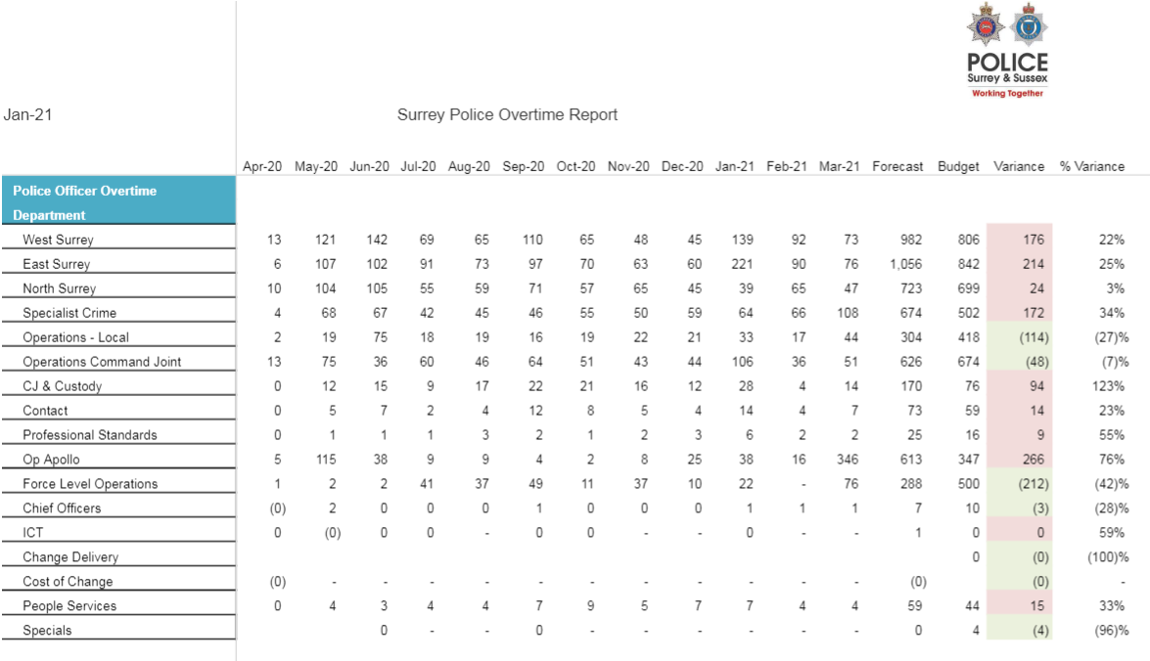
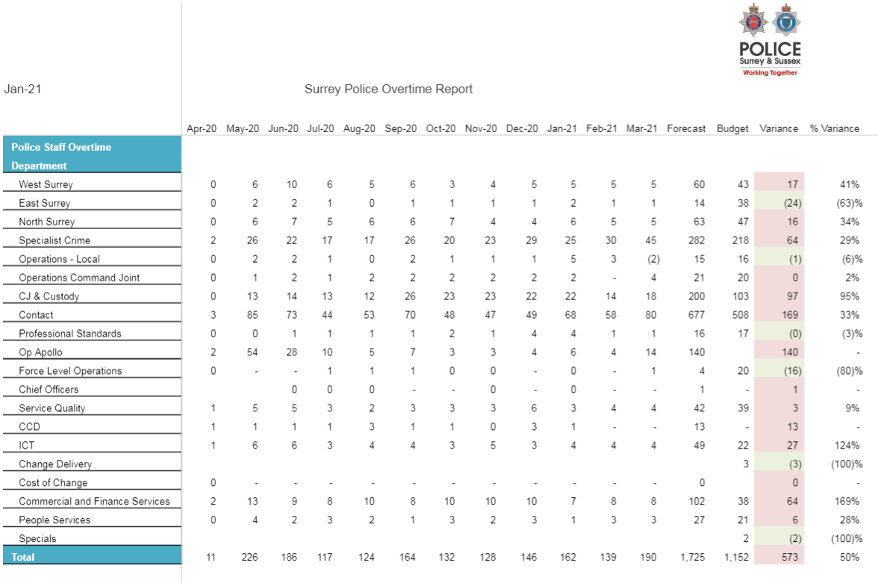

Appendix C
Capital Budget Position at 31st January 2021
Appendix D

Appendix E
Breakdown Agency & Restructuring Costs by portfolio from month 10

Appendix F

Abbreviations
PCC - Police and Crime Commisioner
DCC – Deputy Chief Constable
ICT – Information Communication Technology
PSD – Professional Standard Department
ACPO – Chief Officers
ERP – Enterprise Resource Planning
FTE – Full-time equivalent
DFT – Digital Forensic Team
POLIT – Paedophile Online Investigation Team
ICCS – Integrated Communications and Control System
ANPR – Automatic Number Plate Recognition
APT - Area Policing Team
SERIP – South East Regional Integrated Policing Programme
SOIT - Sexual Offences Investigation Team
RIPA – Regulation of Investigatory Powers Act
PNC/PND – Police National Computer/Police National Database
SEROCU – South East Regional Organised Crime Unit
NPT – Neighbourhood Policing Team

