

Unauthorised Encampments

Required for: | PCC Performance Meeting March 2021
Security Classification: | Official
Handling information if required:
Suitable for publication: | Yes
Title: | Plans for policing of any Unauthorised Encampments (UEs) in 2021
Version: | V2 (updated 5th March 2021)
Purpose: | To provide an update regarding how Surrey Police have responded to UEs in Surrey and what is the focus in 2021
ACPO / Strategic Lead: | T/ACC Alison Barlow
National Decision Model compliance: | Yes
Date created: | 12th February 2021
Date to be reviewed:

AUTHOR
Name: | Bert Dean
Job Title: | Inspector 2934
Telephone number: | 01483 637413
Email address: | Bert.dean@surrey.pnn.police.uk
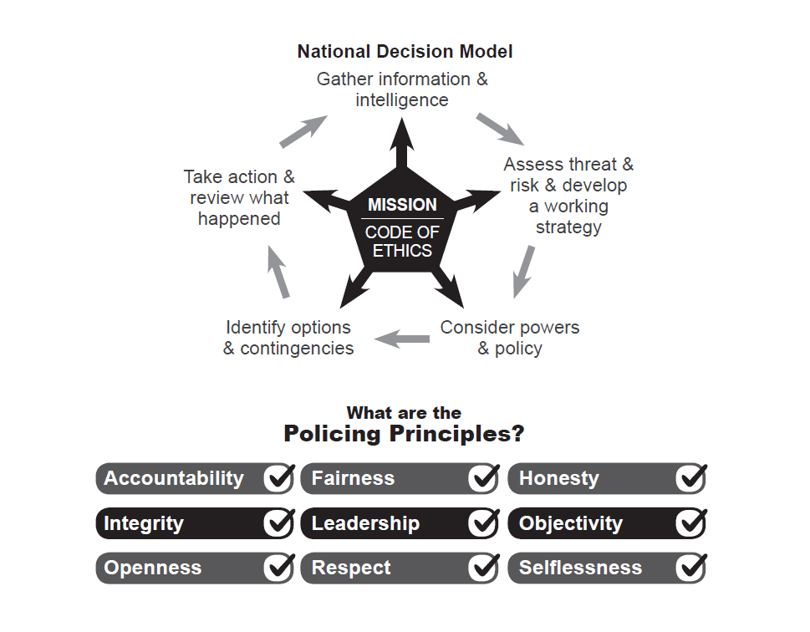

- Background
Surrey Police have continued to maintain clear records of Unauthorised Encampments (UE) within Surrey since April 2018. The impact of UEs, whether perceived or evidential, within the community is known and documented.

- Content
  - Overview of UE data
In 2020, the Force recorded a total of 105 separate Unauthorised Encampments (UEs) on land in Surrey, this was down 17 on the numbers recorded in 2019.
It was observed that 34 groups were responsible for all 105 of all recorded UEs. There were 18 groups who only encamped in Surrey once. As such only 16 groups were responsible for 87 of all Surrey’s reported UEs.
Local Authorities have a clear leadership role in tackling illegal and Unauthorised Encampments and they, and private landowners, have many powers available in dealing with them. However in 2020 police used their powers to direct trespassers under Section 61 of the Criminal Justice & Public Order Act 1994 on 13 occasions (equating to 12%). This was a 1% decrease on the number of occasions in 2019. This is similar to the frequency seen across the region. Private landowners utilised common law powers on 16 (15%) occasions, whilst Local Authorities utilised their powers on 26 (25%) occasions. On all other occasions (50) the groups moved off on their own accord.
Guildford Borough recorded the most UEs (30), whilst Waverley had the fewest (2). 75% of reported UEs were identified as having LOW impact on the community whilst 7% (7 UEs) had a HIGH impact on the community.
Open land was the most favoured site type (30%) then Business Premises (23%), Car Parks (21%), Recreation Grounds (10%) and other (16%).
Privately owned land was most favoured (42%) then Borough Council land (40%), Surrey County Council land (14%) and then other land (4%).

Currently in 2021 six UEs have been recorded. Waverley has recorded half of these (3) which was the same group moving from one location to another. Section 61 has not been used in 2021.

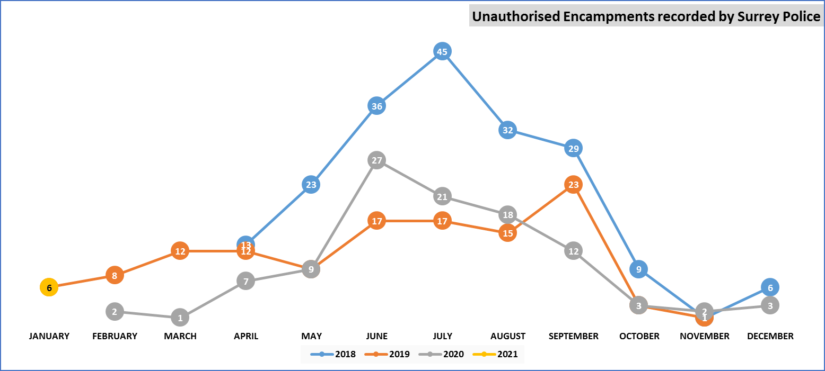
Chart 1: UEs reported in Surrey

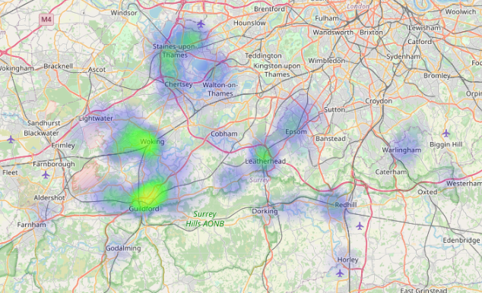
Image 1: Key locations of reported UEs reported in Surrey

2.2 Policing UEs in 2021
Over the past year Superintendent John Davies and Inspector Bert Dean have engaged with Surrey County Council who continue to work with Borough and District Councils with a view to identifying a suitable transit site which would enable police to consider using their powers under Section 62A of the Criminal Justice & Public Order Act 1994.
These discussion continue and are being led by Surrey County Council’s Executive Director for Environment, Transport & Infrastructure, Katie Stewart. Surrey Police will be drafting a Memorandum of Understanding in relation to any future transit site.
There have been a number of media articles in relation to this planned transit site which is being planned in the district of Tandridge, subject to wider consultation and planning authorisation.
A number of Boroughs have removed their injunctions owing to cases heard at the High Court. As a result of this there are only a few Boroughs that have a High Court Injunction that prevents encampments from setting up on their land. This is likely to have an impact across the county and may see an increase in reported encampments in those areas which previously had an injunction but now no longer do.
Regional UE Police Meetings have taken place where best practice and learning have been discussed. Surrey Police have been at the forefront in how it responds to UEs with Inspector Bert Dean speaking at a national level at a Westminster Briefing on ‘Planning for Traveller Sites and Managing Unauthorised Encampments in Your Local Area’.
The overarching policing response to reported UEs in Surrey will not be changing in 2021. The Government are yet to bring in any significant changes following their wider consultation on UEs, although it is anticipated that progress may be made on this in the coming months.
Surrey Police will continue to monitor the developments locally and nationally to ensure that the Force is prepared for any future changes that impact on policing powers.
Inspector Bert Dean regularly appraises senior leaders and local Borough Commanders with the current UE situation in Surrey, changes in guidance and best practice. All new Inspectors receive training on the policing response to Unauthorised Encampments and every member of staff has access to a centralised SharePoint website that provides the latest data to support decision making, training videos and guidance.
- Decision[s] Required: None, this paper is for information only.

DCLG | Home Office | MoJ Document Dealing with illegal and unauthorised encampments
https://www.getsurrey.co.uk/news/surrey-news/surreys-first-traveller-transit-site-19878682

