
Progress Update: Domestic Abuse Portfolio Plan

Required for: | OPCC Performance Meeting March 2021
Security Classification: | OFFICIAL
Handling information if required:
Suitable for publication: | Yes
Title: | Progress update: Domestic Abuse Portfolio Plan
Version: | 1.0
Purpose: | Update
ACPO / Strategic Lead: | T/ACC Macpherson
National Decision Model compliance: | Yes
Date created: | 8th February 2021
Date to be reviewed: | N/A

AUTHOR:
Name: | Matt Barcraft-Barnes
Job Title: | T/Detective Superintendent
Telephone number: | 07855001168
Email address: | Matt.Barcraft-Barnes@surrey.pnnn.police.uk

INCLUDEPICTURE "cid:image001.png@01D312A9.8E469640" \* MERGEFORMATINET INCLUDEPICTURE "cid:image001.png@01D312A9.8E469640" \* MERGEFORMATINET 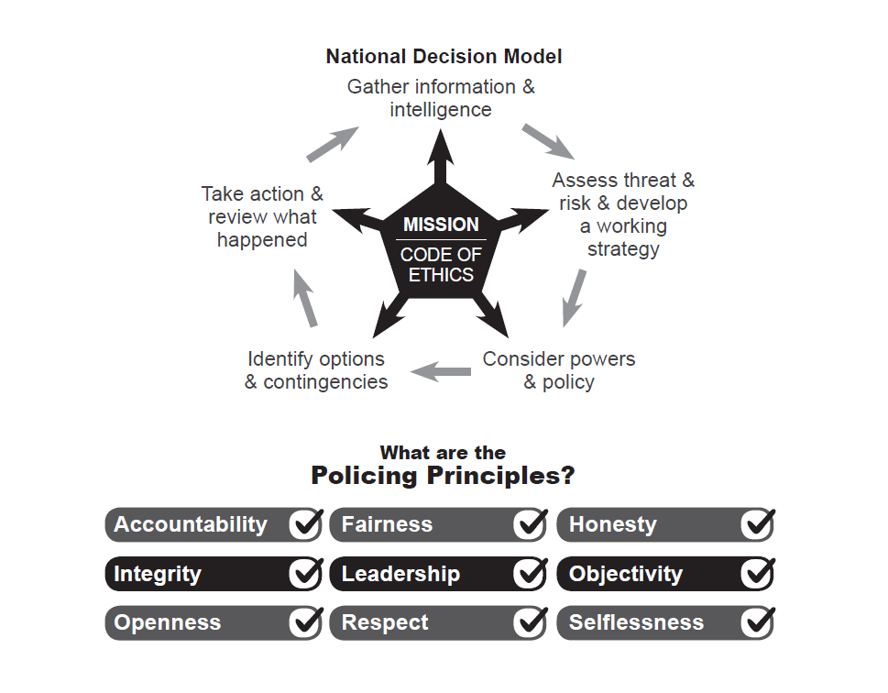

1.0 Purpose

  - This paper provides an update on the progress against the Domestic Abuse (DA) portfolio plan since the last update submitted to the OPCC in July 2020. This is a fifth update on progress against the Domestic Abuse Portfolio Plan as recommended by HMICFRS and requested by the OPCC for a general update on a six monthly basis.

2.0 Background

2.1 To track progress, Central Public Protection maintain a ‘Domestic Abuse Portfolio Plan’ as a live, regularly reviewed and updated document. The plan is overseen by the Force DA advisor within the Public Protection Support Unit (PPSU), and overseen by the Force lead at Detective Superintendent Level. The portfolio plan is formulated of actions, HMICFRS ‘Recommendations’ and ‘Areas for Improvements’ (AFIs) and other statutory improvement requirements i.e IOPC etc.

2.5 As a result of this work, and since the last update, the force has now implemented all the HMICFRS recommendations.

- Actions

3.1 Body Worn Video (BWV)
Implementation of the use of Body-Worn Video (BWV) cameras for front line officers, ensuring their effective usage upon attendance at DA incidents by means of developing clear guidance in line with the College of Policing APP.

- New BWV technology now fully embedded since March 2020 with clear policy on mandated use on DA incidents. BWV panels in place encouraging review with officers and partners in outreach to improve quality of police interactions through learning.

3.2 Investigation of DA and Risk Grading
To improve our response and Investigation capability and to participate and contribute to the Force review relating to how we investigate DA.

- Surrey Police has launched an Investigation Structure Review which on February 22nd goes live as a pilot on East Surrey Division, then disseminating with any learning to West and North Division within three months.
- Previously DA was investigated either within a Safeguarding Investigation Unit or by Neighbourhoods Policing Teams depending on the risk grading through the process around Domestic Abuse, Stalking and Honour Based Violence (DASH).
- The new model places all intimate-partner DA into a dedicated DA Team led by a Detective Inspector. This team has a significant uplift in both police and non-police staff trained at PIIP1 level. The aspiration is that the new team will drive quality and performance.
- A proactive response to the Centre for Women’s Justice super-complaint has been driven through a Gold group chaired by the DCC and supported by the DA wider partnership. Force policy has changed from this for cases where the perpetrator is a police officer and wider related issues. This includes key changes such as allocating a DCI from another Division as the lead decision maker and enhancements being made to special leave awarded to survivors within Surrey Police reporting domestic abuse. This was assessed by HMICFRS recently as the standard other forces should aspire to and the policy is now being retrospectively applied to cases before it was introduced.
- Surrey Police and the wider Surrey Against Domestic Abuse partnership is developing an enhanced understanding of controlling and coercive behaviour. This includes regular joint CCB Improvement meetings focused on understanding, sharing and training, including a recent partnership attendance of senior leaders and practitioners to a world-renowned expert. This has informed the Control Strategy to this year remove Domestic Abuse and focusing specifically on Controlling Coercive behaviour in DA. This will be essential for a drive towards a Controlling Coercive DA Improvement Plan.
A key area of focus for Surrey Police will be the National Vulnerability Action Plan overseen by the DCC. The improvement in understanding of CCB is an essential component to key areas including early prevention, intervention and safeguarding. The proactive approach to the NVAP will spread key changes across all areas of Surrey Police as a force-wide approach.

3.3. Partnerships and Information Sharing
National HMICFRS recommendation: To continue to pursue better ways of working in partnership in relation to appropriate information sharing in order to safeguard the vulnerable and children at risk.

- Surrey Police has invested in a comprehensive review of Multi Agency Referral Assessment Conference (MARAC) with partners. This is already increasing MARAC referrals in line with SafeLives guidance. All MARAC partners contributed at an assessment of effectiveness followed by a detailed victim’s survey to improve quality. Significant improvements in sharing with health and GP services is now in place.
- MARAC meetings have doubled from monthly to bi-weekly with a dedicated MARAC DI post being trialled. The MARAC DI reports monthly into a newly formed MARAC Steering group, co-chaired by SCC and Surrey Police.
- DA suicide review panel. A police initiated multi-agency panel is now operating chaired by both police and outreach services. This panel aims to review all suicides with a DA history, assessing areas including partnership information sharing and learning to increase safeguarding of vulnerable DA victims.
- Covid-19 process for Op Encompass has improved information sharing from police to education. All children identified as witnessing DA during lock-down are offered a school place.
- In response to the `Safe to share?` report on the Liberty and Southall Black Sisters super-complaint on policing and immigration status a partnership group has been created tasked with delivering recommendations and improvements. This group also combines the work being done on hard to reach communities, in particular the BAME community and considers our response to harmful traditional practices. This is informing the current commissioning of bespoke BAME outreach services and referral pathways.

3.4 To embed DASH training as a rolling program.
To ensure that all first responders and specialist teams dealing with DA related risk are DASH accredited and have received the SafeLives/College of Policing ‘DA Matters’ training.

- DASH gradings will no longer determine which team DA investigations are allocated to with the new ISR model. Benefits include alleviating any concern of adverse gradings to align work to team capacity.
- All new recruits receive ‘DA Matters’ and DASH training.

3.5 Positive and Preventative action
National HMICFRS recommendation: Nationally, arrest rates for domestic abuse are falling, with large variations across forces. There are considerable variations in the use of preventative measures. Forces need monitoring processes, supported by accurate data, to ensure that they are taking positive action such as arrest, and are making effective use of powers, for example DVPOs and the DVDS. Where orders or bail conditions are breached, forces need to ensure that there are appropriately robust processes in place to take action.

- Arrest rates in Surrey are amongst the highest in the region at 41%. This is driven by Daily Management Meetings (DMMs) on each division and their focus on DA; Dedicated DA arrest cars; cancelled training days (due to the pandemic) utilised to target outstanding arrests; increased grip at Divisional Performance (monthly) meetings.
- Evidence–led prosecution MG3 template being trialled in Surrey and Sussex.
- Domestic Violence Protection Order (DVPO) daily tracking by senior management teams, driving a weekly visit to victims as well as suspect management. Any breaches raised as a divisional priority to pursue arrest and place before the courts.
- Daily review of DA bail as part of multi-team briefing to co-ordinate visits and arrest for breaches.
- Perpetrators released on bail have a supervisor review every 28 days. Bail checks are conducted at various stages of the bail process.
- DVDS continues to be tracked by central Public Protection and delivered on Divisions with outliers raised to inform resourcing decisions
- The impact of the DA Bill will be co-ordinated across the wider Surrey Against Domestic Abuse partnership reporting into the DA Management Board. This will assess the impact on all partners. The police impact is being monitored through the PPSU in order to have a proactive strategy to introduce any changes.

3.6 Building the investigative case
National HMICFRS Recommendation: Forces need to ensure that there are clear standards and expectations, with effective supervision, for building the best possible case for the victims of domestic abuse whether victims support police action or not.

- There is a DA NFA (No Further Action) panel on all three Divisions where themes and learning is identified and disseminated more widely.
- Clear expectations for supervisory reviews and standards
- Surrey is part of an Early Advice (EA) Pilot with Rape and Serious Sexual Offences (RASSO) where rape cases (including DA) receive advice within 28 to 42 days of report.

3.7 Leadership and Governance of DA.
To review the leadership and governance of DA across all statutory agencies in Surrey, in order to improve outcomes for survivors.

- The Domestic Abuse Management Board (DAMB) co-ordinates the partnership setting of strategy with delivery tracked through the DA Executive Board. The streamlining of the Domestic Abuse Delivery Group into key task and finish groups has driven work in relation to several hard to reach communities including students, sex workers and those with learning disabilities.
- The Vulnerability Board and the DAMB provide strategic governance and oversight to ensure the force are regularly scrutinising and assessing performance and remain committed to continued improvement.

3.8 Review to understand the declining arrest and charge/ summons rate.
National HMICFRS recommendation; to understand the reasons for a decline in DA arrests, charges and summons rate in respect of DA related cases.

- Review of Coercive and Controlling Behaviour (CCB) cases to assess both the charge rate compared to ‘most similar group’ and the standard of MG3 submissions. As a result Surrey is working with CPS to assess the quality which will then inform training both to new recruits and current staff.

3.9 Identification and Management of DA Perpetrators (Control Strategy Priority)
To develop a robust multi-agency response to the perpetrators presenting the greatest risk. To ensure we equip staff with the skills and resources to manage the increasing demand

- With the MARAC review now trialling recommendations the MARAC partnership supports a Multi-Agency Tasking and Co-Ordination (MATAC) approach as previously explored by Surrey Police. This will evolve from the current High Harm Perpetrator Unit (HHPU) meeting into a DA focused approach. Current process is that a Division has access to the Recency, Frequency, Gravity and number of Victims (RFGV) algorithm as well as repeat serial perpetrators. These are subject of focus at the Tactical Tasking and Co-ordination Group (TTCG) and Divisional Performance Meetings. Surrey Police will explore MATAC for consideration of a trial in the summer once the DA teams are embedded.
- Surrey Police, Surrey County Council and OPCC has undertaken a joint commissioning process for a pre-conviction perpetrator programme. This will be an option for the MATAC to refer into.

4.0 Conclusions

The Domestic Abuse Portfolio Plan continues to make good progress and Surrey is a leading force in the region for areas including the MARAC review and the DA suicide work. Performance remain high and all HMICFRS recommendations have embedded plans.

5.0 Decisions required:

None. For noting only.

