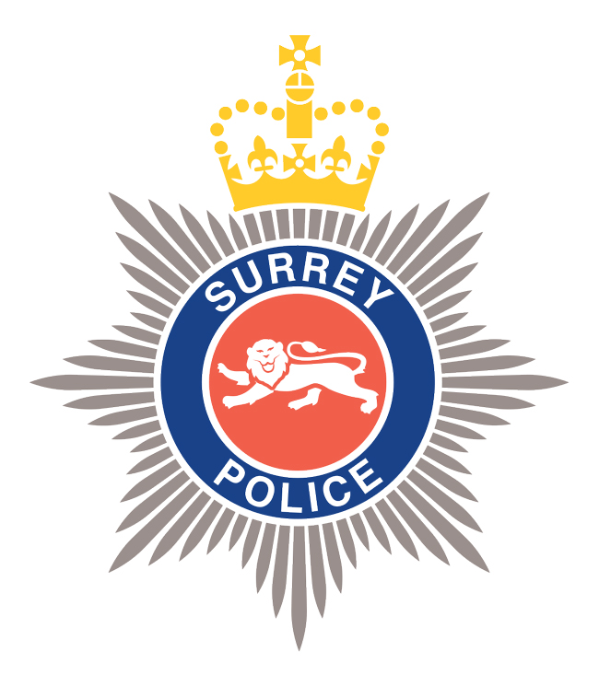
***Net Zero Routemap and Carbon Management Plan***

Required for: | PCC Performance Meeting March 2021
Security Classification: | Official
Handling information if required:
Suitable for publication: | Yes
Title: | Summary of Environmental Plans
Version: | V2
Purpose: | To fully update the PCC
ACPO / Strategic Lead: | Peter Gillett
NDM / OSARA compliance: | Yes
Date created: | 10 March 2021
Date to be reviewed:

AUTHOR:
Name: | Vaughan Williams
Job Title: | Service Director Estates & Facilities
Telephone number: | 07717 700915
Email address: | Vaughan.williams@sussex.pnn.police.uk

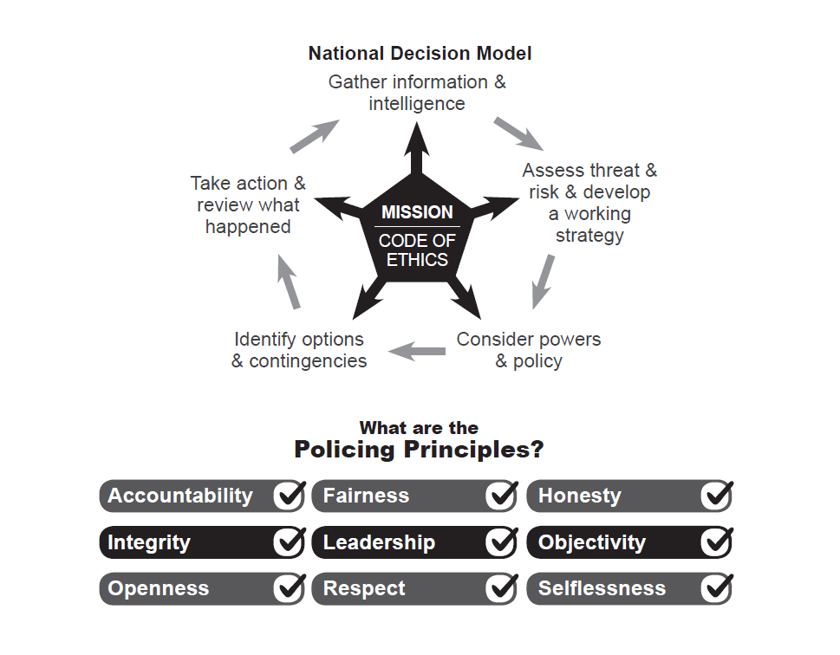
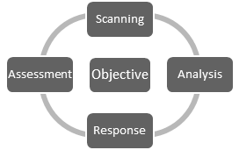

- Introduction

Following the PCC and the Chief Constable’s commitment to Surrey Police becoming a net zero carbon organisation by 2030, Surrey Police commissioned the environmental consultants Ricardo in November 2020 to develop a routemap to set out how this could be achieved. The purpose of the routemap is to establish the scope and boundary of the emissions and set out a strategic routemap with suitable targets for how Surrey Police can achieve net zero.

Surrey Police and Ricardo carried out internal audits, senior key stakeholder engagement workshops, a behavioural change workshop, and one to one meetings with key stakeholders. After careful consideration of all the findings and following industry standards, Ricardo developed a net zero routemap and carbon management plan to deliver the Force’s ambition to become net zero by 2030.

The scope of this is GreenHouse Gas (GHG) emissions from Surrey Police’s operations, primarily focussing on scope 1 (heating and transport), scope 2 (electricity use), along with scope 3 (emissions) the latter of which Surrey Police re more readily able to influence and control, namely: waste, water, business travel and transport and distribution, and ‘well to tank’ emissions of fuel and energy use.

- Summary of the net zero routemap and plan

The following approach was taken to developing the net zero routemap.

- Establish the baseline emissions: Calculate Surrey Police’s GHG emissions from its operations.
- Identify measures: Conduct site audits of key buildings and liaise with the Surrey Police transport team to identify decarbonisation measures.
- Model the business as usual projection: Model what Surrey Police’s emissions could be expected to be in 2030 without a net zero routemap.
- Model the net zero projections: Model the identified emissions reductions to establish a ‘best value’ and ‘full potential’ pathway to net zero, identifying residual emissions associated with each pathway for offset.

The figure below shows Surrey Police’s baseline emissions, based upon FY2019/20 data

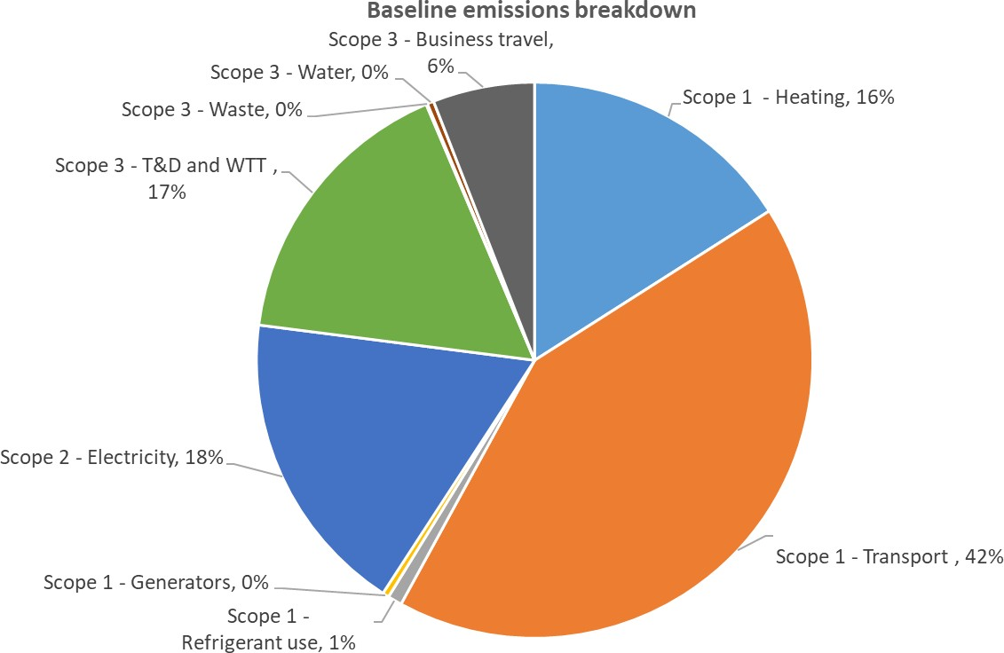

Full set | kWh | tCO2e
Scope 1 – Heating | 7,929,077 | 1,458
Scope 1 – Transport |  | 3,832
Scope 1 - Refrigerant use |  | 76
Scope 1 – Generators |  | -
Scope 2 – Electricity | 6,368,257 | 1,628
Scope 3 - T&D and WTT | 14,297,335 | 1,514
Scope 3 – Waste |  | 7
Scope 3 – Water |  | 34.8
Scope 3 - Business travel |  | 540.1
Total | 28,594,669 | 9,089
Surrey Police baseline emissions, by type

- Recommended Governance Structure:

- Net Zero projections:

Two net zero projections have been modelled, best value and full potential. The building measures have been categorised as best value if they offer a £/tCO2e saved per annum of under £10,000 and full potential where the £/tCO2e is above this, or there is a constraint meaning the measure is less suitable for implementation in the routemap timeframe. The two scenarios for transport are discussed in the transport section of this routemap. The following graph shows the remaining emissions associated with each pathway and the table discusses the potential reduction and costs.

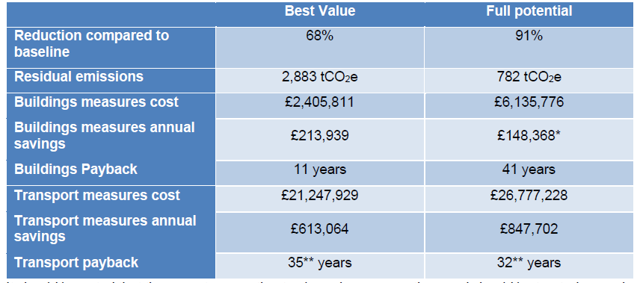

It should be noted that these costs are estimates based on assumptions.

- Conclusions and next steps

The detailed strategic net zero routemap and carbon management plan are attached to this paper which include emissions modelling, recommended decarbonisation measures, financial implications, roles and responsibilities, behavioural change and communication, residual emissions offsetting options with current cost.

The following next steps should be considered to implement the plan and achieve the net zero commitment.

- Communicate a summary of the net zero route map and the carbon management plan to all Surrey Police employees
- Formally establish the net zero governance structure, including the identification of Green single point of contacts (SPOCs) and any new additional representatives
- Form an action plan on how the identified decarbonisation measures can be implemented
- Utilise upcoming property changes to implement building decarbonisation measures
- Conduct a detailed assessment of how the transport fleet can be converted to low carbon vehicles
- Investigate actions that can be taken in emission areas not included in the scope of the net zero commitment.
- Formalise the communication plan
- Formalise the ongoing monitoring process

Attachments:
Surrey Police Net Zero Routemap
Surrey Police Carbon Management Plan

