

**External Audit Report and Audited Financial Statements for 2019/20**

|  |  |
| --- | --- |
| **Required for:** | Joint Audit Committee (JAC) meeting |
| **Security Classification:** | **Official** |
| **Handling information if required:** | n/a |
| **Suitable for publication:** | No |
| **Title:** | External Audit Report and Audited Financial Statements 2019/20 |
| **Version:** | 1 |
| **Purpose:** | To present the final audited Financial Statements for 2019/20 for both the Police and Crime Commissioner (PCC) and the Chief Constable (CC) as well as the External auditor’s report for consideration by the Audit Committee. |
| **ACPO / Strategic Lead:** | Kelvin Menon Treasurer |
| **National Decision Model compliance:** | Yes |
| **Date created:** | 17th November 2020 |
| **Date to be reviewed:** |  |

|  |  |
| --- | --- |
| **AUTHOR:** |  |
| **Name:** | Kelvin Menon |
| **Job Title:** | PCC Treasurer |
| **Telephone number:** | 07870 378553 |
| **Email address:** | Kelvin.menon@surrey.pnn.police.uk |

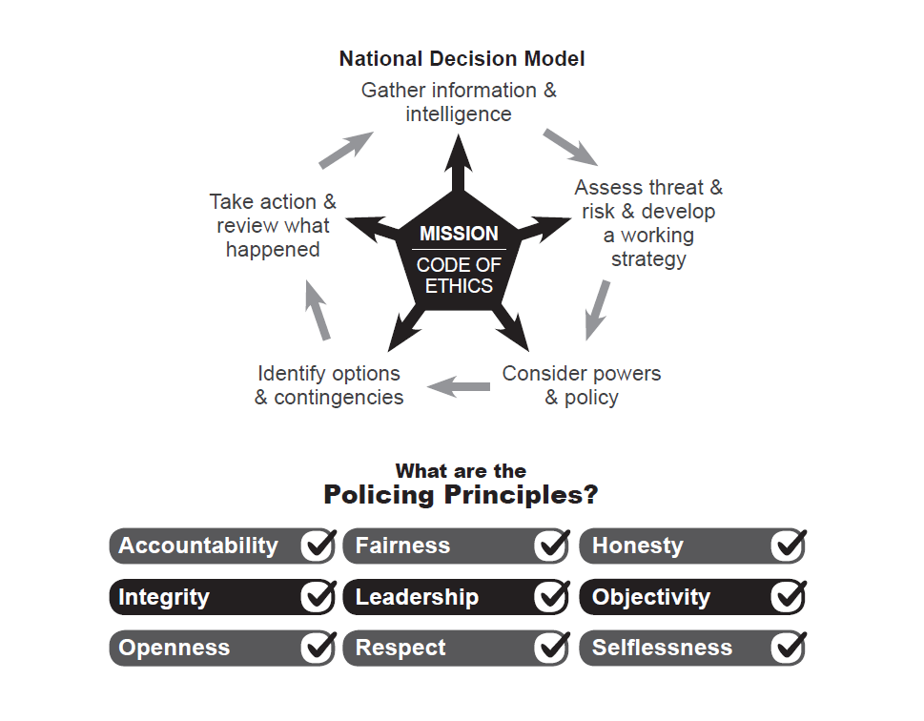

**Introduction**

The auditors are required to report to those charged with Governance, the PCC, the CC, the CFOs and the Monitoring Office (PCC CFO) their opinion on the Financial Statements, Annual Governance Statement and Value for Money normally by the 31st July however this year, due to Covid, the deadline has been extended to the 30th November 2020. This report meets that deadline and fulfils that requirement.

Ernst and Young LLP intend to sign an unqualified audit opinion on the Financial Statements for 2019/20, for both the OPCC and the CC, as well as Value for Money in time for the statutory deadline of 30th November 2020. This is after undertaking extensive audit work with a particular focus on risk areas identified in their report. The granting of the opinion is subject to the PCC and CC approving the audited financial statements and the receipt of a signed Letter of Representation.

Members are reminded that should they wish to discuss matters that would normally be considered Part 2 matters then the meeting will need to move in to a closed part 2 session before these matters can be considered.

**Financial Statements**

The PCC and CC are separate corporation sole entities and therefore are required to prepare individual Statement of Accounts. The consolidated position for the Group and the PCC’s Statement of Accounts are included within the same document.

The Annual Statement of Accounts and Annual Governance Statement for both the PCC and the CC are prepared as soon as possible after the end of the financial year and the draft accounts were published on both the OPCC and Force website on the 30th June 2020.

The 2019/20 PCC and CC Statement of Accounts have been prepared in accordance with the Code of Practice on Local Authority Accounting in the United Kingdom 2019/20, based on International Financial Reporting Standards, issued by the Chartered Institute of Public Finance & Accountancy.

Contained within each of the Statement of Accounts are the PCC’s and CC’s Annual Governance Statement. These statements are intended to provide assurance that both corporation soles have in place governance frameworks that cover the systems, processes, culture and values through which each organisation manages its activities. The preparation of the Annual Governance Statement is a requirement of the Accounts and Audit (England) Regulation 2015 which is also reflected in the Code of Practice on Local Authority Accounting in the United Kingdom 2019/20.

**Changes to Unaudited Draft Accounts issued on 30 June 2020:**

In addition to the changes set out on Page 27 of the external auditors report the following other major changes were made to reflect best practice and as a result of new requirements:

* A preface and updated Narrative Statement
* The Annual Governance Statement updated to reflect the conclusions from Internal Audit
* Change in Pension Liabilities to reflect Government recommendations in respect of the McCloud judgement;
* Updated disclosures in respect of Going Concern;
* Updated disclosures in respect of assets valuations as a result of COVID;

A reconciliation of the movement between the draft accounts as published and the audited accounts is attached as Appendix 1 to this report. IF any further late amendments are required this will be reported at the meeting.

**Results for the year**

Under CIPFA and statutory regulations a number of adjustments are required to be made to the accounts which can make it difficult to ascertain the true financial performance. However as can be seen from the table in the narrative statement, which seeks to remove these adjustments, the Group finished £1.4m under budget prior to transfer to reserves. This represents 0.6% of the total net budget. The PCC also delivered an underspend of 1% against its net budget of £2m. Staff costs continue to be the biggest cost of the Group, representing over 80% of total expenditure.

In terms of capital expenditure for the year this was £11m under budget as some projects particularly in IT and estates span several years. Total assets owned by the Group consisting of buildings, plant, vehicles etc. amounted to £135m and the new Investment Property relates to the site for the new HQ in Leatherhead which, in due course, will become operational. The group held £12.4m in cash and investments at the year end and had total external borrowings from the PWLB amounting to £15m. Total usable reserves were £22.6m at the end of the year of which £8m are not earmarked. This equates to just over 3% of the total net budget for the group.

Pensions are a significant cost for the group with contributions of £50m made during the year. There are different schemes in place for Police Officers and Police Staff. The Police Officer scheme is an unfunded scheme and annual contributions are based on an assessment by the Government actuary of the cost of benefits earned in that particular year. Any shortfall (or surplus) in respect of contributions against pensions paid is underwritten by the Government. Under accounting standards the full actuarial cost of providing Officer Pensions had to be reflected in the balance sheet leading to a creditor of £1.9bn however this is actually the actuarial cost of the future pensions underwritten by Government. Police Staff are members of the Local Government Pension Scheme which is a funded scheme in that it holds investment to provide for future pensions. At the end of the year although there was a reported deficit of £130m reflected in the accounts this was as a result of the valuation method prescribed by CIPFA and it is the actuary’s view that the scheme is almost fully funded.

There is a lot of other information included within the financial statements to further explain the financial performance of the Group for the year.

**Auditors Report on the Financial Statements**

The Auditors report on the financial statements and Value for Money for 2019/20 is attached to this report. This sets out the risks that they have considered, any financial adjustments required, the results of the audit and a number of other items required by statute.

Mr Mark Hodgson, the partner in charge of the audit, will be available to answer questions at the meeting.

**Letter of Representation**

There is a legal obligation senior officers to disclose any information that the auditor may request or which could have a bearing on their audit opinion. The letter of representation seeks to set out in writing the verbal representation made to them during the course of their audit. This is standard practice for any audit and the letter is of a standard format and content and is required to be signed by the PCC, CC and two CFOs

Mr Mark Hodgson from EY will be available at the meeting to answer any questions Members may have on the Letter of Representation.

**Recommendation:**

It is recommended that the Joint Audit Committee:

1. Receive and comment on the Group Audited Financial Statements for 2019/20 and the Chief Constable Audited Financial Statements for 2019/20;
2. Receive and comment on the External Auditors Report;
3. Receive and comment on the draft Letter of Representation.

It is further recommended that the Police and Crime Commissioner and the Chief Constable:

1. Approve the Letter of Representation for 2019/20.
2. Receive the External Auditors Report 2019/20;
3. Approve the Group Audited Financial Statements for 2019/20 (which includes the PCC audited financial statements) and the Chief Constable Audited Financial Statements for 2019/20;

**Appendices**

1. Reconciliation of the movement between the draft and final financial statements
2. Audited Group Financial Statements for 2019/20 (which includes the PCC financial statements)
3. Audited Chief Constable Financial Statements for 2019/20
4. Letter of Representation to the Auditors from the PCC,CC and CFOs
5. External Auditors report to those charged with Governance 2019/20

Appendix 1



