
***Surrey Police Positive Outcomes***

Required for: | Joint Audit Committee
Security Classification: | Official
Handling information if required:
Suitable for publication: | Yes
Title: | Surrey Police Positive Outcomes
Version: | 2.0
Purpose: | Information
ACPO / Strategic Lead: | T/ACC Alison Barlow
NDM / OSARA compliance: | N/A
Date created: | 14/10/2020
Date to be reviewed:

AUTHOR:
Name: | Alison Barlow
Job Title: | T/ACC Local Policing
Telephone number: | 101

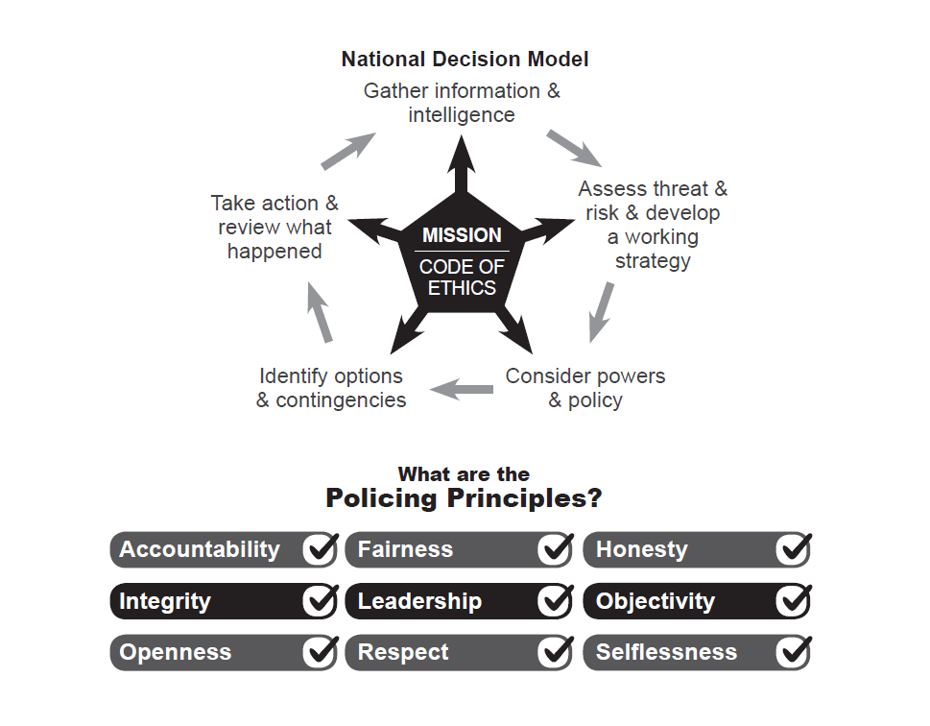
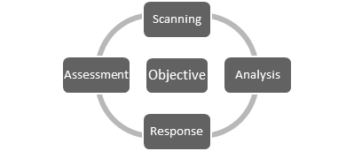

- Background
  - As requested at the Joint Audit Committee meeting of 29th July 2020 this paper provides further information on what constitutes a “positive” outcome and some of the work ongoing to improve the Force outcome rate.
  - Following his review of the Police and Crime Plan in May this year the PCC has also asked the Force to focus on three key areas one of which is that there are “more crimes solved”.

- Positive Outcomes
  - Since April 2013 the term, “detected crime” has not been used in forces as a means of describing the disposal of recorded crime. Instead ‘Recorded Crime Outcomes’ were introduced by the Home Office with the aim of;
- Strengthening police discretion by recognising the full range of possible disposals rather than incentivising police officers to pursue a particular outcome because it is perceived as ‘better’ than others;
- Promoting a more victim-orientated approach, focussing on providing a better service to victims of crime by removing perverse incentives for forces to record and pro-actively pursue certain crimes on the basis of locally-set detection targets; and
- Further increasing transparency in policing and trust in national statistics, by providing the public with a richer picture of crime, and how it is dealt with in their area
  - There are 22 ‘Recorded Crime Outcomes’ (shown at Appendix A) with all forces required to send their returns to the Home Office each month (although the Force currently only send returns for outcomes 1 to 21 as we are not currently able to extract outcome 22 from the Data Warehouse – see below). How forces chose to measure what they deem as “positive” or “solved”, however, is discretionary and means that any direct comparison between forces is not straight forward.
  - Since the introduction of Home Office Recorded Crime Outcomes Surrey Police has measured outcomes 1 to 8 (as per Appendix) and deemed them to be “positive”. These outcomes include crimes where an offender has been charged, cautioned, given a community resolution etc. Several neighbouring forces measure the same set of outcomes but may also include one or two additional categories from the list (e.g. Sussex includes outcomes 1 to 8 and 10). How forces refer to outcomes also differs with some describing them as “solved”, others as “FATs” (Formal Action Taken) or “positive” like Surrey.
  - On 24th September 2020, at the Force Performance Board, Surrey Police made the decision to review its use of the term “positive” and instead refer to outcomes as “solved” – a term which is generally better understood by staff and public alike. The Force has also re-considered the range of outcomes it measures as the current grouping (outcomes 1 to 8) does not take account of the myriad of other good work which is undertaken to resolve crimes in the right way for the victim. An example includes the Force’s Checkpoint Scheme which offers eligible offenders the opportunity to engage in a deferred prosecution for lower level offences. Under this scheme offenders are offered a contract with targeted interventions designed to tackle the reasons for offending along with other agreed actions such as an apology to the victim or compensation. Such diversionary activity is covered under outcome 22 (as per Appendix) and therefore a decision has been made to include Surrey Checkpoint within this outcome and add it to the current measures when calculating the Force’s solved rate. With the work needed to extract this information from the Data Warehouse (mentioned above) it is anticipated to include Checkpoint by the end of the calendar year.

- More Crimes Solved

  - The Force is acutely aware that its solved (outcome) rate during the year 2019/2020 was not as strong as it could have been, particularly for residential burglary. This was largely influenced by a spike in offences during the winter of 2019 with recorded burglaries up 6% compared to the previous year. So far this financial year to date (April – Sept 2020) we have seen an increase in the solved rate for several crime categories including residential burglary, rape and both adult and child abuse. We have also seen a significant reduction in the number of residential burglaries recorded as a consequence of the pandemic. The Force is committed to continuing to improve its solved rate and governance through the Force Performance Board, chaired by the Deputy Chief Constable, ensures that there is due focus where it is required. Other key pieces of work ongoing to support the commitment to improving the Force’s solved rates includes:

Operation Spearhead – a co-ordinated cross departmental/divisional operation overseen by T/ACC Local Policing with a tactical Crime Superintendent lead which focuses on residential burglary - both preventative activity and the targeting of offenders. With detailed data analysis undertaken by the Force’s recently introduced Problem Solving Team, localised plans are in place to address the seasonal spike in offences traditionally seen in the autumn/winter.

Investigation Improvement Plan – lead by a Chief Superintendent and overseen by T/ACC Local Policing this is an overarching programme of work consisting of 3 separate projects all of which are interdependent; the introduction of an Incident Review Team, Volume Crime Investigation Improvement Plan and Investigation Structure Review.

- Incident Review Team – following investment from Operation Uplift the Force will see the introduction of team of officers and staff into the Contact Management Team who will be responsible for dealing with slower time incidents over the phone which are ordinarily tasked to Neighbourhood Policing Teams (NPT). This will free up the capacity of NPT to focus more on their investigations and undertake proactive work and problem solving. The aim is for this team to go live at the end of November this year.

- Volume Crime Investigation Improvement Plan 2 - This plan is focussed on improving the capability of NPT staff when investigating volume crime and follows previous work undertaken in 2017 which focussed on training, leadership, culture, capacity and capability of staff. Whilst much progress has been made since then in terms of the knowledge and confidence of staff to investigate crimes, concerns remain about investigation quality and supervision of investigations by sergeants. This new strand of work is undertaking a more structured review of how volume crime is currently investigated by NPT and is likely to propose the introduction of local investigation support teams in 2021.

- Investigation Structure Review – This project aims to ensure that the Force has the most appropriate workforce model to deal with more serious crime and specifically Adult Sexual Violence, Domestic Abuse and Stalking. A pilot testing the concept of dedicated Child Abuse and Domestic Abuse teams with a separate CID team is to commence in the new year.

Proactive Teams – the ability to undertake proactive work waned during the period of austerity but with renewed focus and investment each division has introduced a proactive team to tackle prolific offenders and crime trends in their communities. This will not only assist in contributing to an improvement in outcome rates but should also improve victim satisfaction as offenders are brought to justice.

- Conclusion[s]
Whilst the Force has faced unprecedented challenges this year with the Covid-19 pandemic it remains focussed on improving the rate of crimes it solves with significant work and investment underway in order to do so. The recently launched Force commitments 2020/25 also make this clear with the “pursuit of offenders and high quality investigations” a commitment the Force has made to its communities.

- Decision[s] Required

  - None, this paper is for information only.

APPENDIX A

Recorded Outcomes

Outcome 1

Charge or Summons

Outcome 2

Youth Caution
Youth Conditional Caution

Outcome 3

Adult Caution
Adult Conditional Caution

Outcome 4

Taken Into Consideration (TICs)

Outcome 5

The Offender has Died (All offences)

Outcome 6

Penalty Notice for Disorder (PND)

Outcome 7

Cannabis Warning

Outcome 8

Community Resolution (CR) without Restorative Justice (RJ)
Community Resolution (CR) with Restorative Justice (RJ)

Outcome 9

CPS Decision – Prosecution not in the Public Interest (All offences)

Outcome 10

Police Decision – Formal Action Against the Offender is Not in the Public Interest

Outcome 11

Named Suspect Identified – Prosecution Prevented – Suspect is below the age of criminal responsibility (at the time of the offence)

Outcome 12

Named Suspect Identified – Prosecution Prevented – Suspect is too ill (physical or mental health) to prosecute

Outcome 13

Named Suspect Identified – Prosecution Prevented – Victim or key witness is dead or too ill to give evidence

Outcome 14

Named Suspect NOT identified – Evidential Difficulties – Crime is confirmed but victim either declines or is unable to support further police investigation to identify the offender.

Outcome 15

Named Suspect Identified – Victim Supports Police Action but Evidential Difficulties Prevent Further Action

Outcome 16

Named Suspect Identified – Evidential Difficulties Prevent Further Action – Victim does not support (or has withdrawn support from) police action

Outcome 17

Prosecution Time Limit Expired. Suspect identified but prosecution time limit has expired

Outcome 18

Investigation Complete - No suspect identified.
Crime investigated as far as reasonably possible. Case closed pending further investigative opportunities becoming available.

Outcome 19

National Fraud Intelligence Bureau Filed (NFIB Only)

Outcome 20

Other Agency Delegations

Further action resulting from the crime report will be undertaken by another body or agency subject to the victim (or person acting on their behalf) being made aware of the action to be taken.

Outcome Type 21

Further investigation, resulting from the crime report, which could provide evidence sufficient to support formal action being taken against the suspect is not in the public interest – police decision.

Outcome 22

Diversionary, educational or intervention activity, resulting from the crime report, has been undertaken and it is not in the public interest to take any further action.

