
Annual Governance Statement and Financial Statements 2019/20
Redmond Review 2020
Required for: | Joint Audit Committee (JAC) meeting
Security Classification: | Official
Handling information if required: | n/a
Suitable for publication: | No
Title: | Update on the audit of the 2019/20 Financial Statements and the Redmond Review on Local Authority Financial Reporting and Audit
Version: | 1
Purpose: | To update the Committee on:  - The progress with the Audit of the Annual Statement of Accounts and Annual Governance Statement for 2019/20 for both the Police and Crime Commissioner (PCC) and the Chief Constable (CC).  - The Redmond Review on Local Authority Audit
ACPO / Strategic Lead: | Kelvin Menon, Treasurer
National Decision Model compliance: | Yes
Date created: | 9th October 2020
Date to be reviewed:

AUTHOR:
Name: | Kelvin Menon
Job Title: | OPCC Treasurer
Telephone number: | 07870 378553
Email address: | Kelvin.menon@surrey.pnn.police.uk
INCLUDEPICTURE "cid:image001.png@01D312A9.8E469640" \* MERGEFORMATINET INCLUDEPICTURE "cid:image001.png@01D312A9.8E469640" \* MERGEFORMATINET INCLUDEPICTURE "cid:image001.png@01D312A9.8E469640" \* MERGEFORMATINET INCLUDEPICTURE "cid:image001.png@01D312A9.8E469640" \* MERGEFORMATINET INCLUDEPICTURE "cid:image001.png@01D312A9.8E469640" \* MERGEFORMATINET INCLUDEPICTURE "cid:image001.png@01D312A9.8E469640" \* MERGEFORMATINET INCLUDEPICTURE "cid:image001.png@01D312A9.8E469640" \* MERGEFORMATINET INCLUDEPICTURE "cid:image001.png@01D312A9.8E469640" \* MERGEFORMATINET INCLUDEPICTURE "cid:image001.png@01D312A9.8E469640" \* MERGEFORMATINET INCLUDEPICTURE "cid:image001.png@01D312A9.8E469640" \* MERGEFORMATINET INCLUDEPICTURE "cid:image001.png@01D312A9.8E469640" \* MERGEFORMATINET INCLUDEPICTURE "cid:image001.png@01D312A9.8E469640" \* MERGEFORMATINET INCLUDEPICTURE "cid:image001.png@01D312A9.8E469640" \* MERGEFORMATINET INCLUDEPICTURE "cid:image001.png@01D312A9.8E469640" \* MERGEFORMATINET INCLUDEPICTURE "cid:image001.png@01D312A9.8E469640" \* MERGEFORMATINET INCLUDEPICTURE "cid:image001.png@01D312A9.8E469640" \* MERGEFORMATINET INCLUDEPICTURE "cid:image001.png@01D312A9.8E469640" \* MERGEFORMATINET INCLUDEPICTURE "cid:image001.png@01D312A9.8E469640" \* MERGEFORMATINET INCLUDEPICTURE "cid:image001.png@01D312A9.8E469640" \* MERGEFORMATINET INCLUDEPICTURE "cid:image001.png@01D312A9.8E469640" \* MERGEFORMATINET INCLUDEPICTURE "cid:image001.png@01D312A9.8E469640" \* MERGEFORMATINET INCLUDEPICTURE "cid:image001.png@01D312A9.8E469640" \* MERGEFORMATINET INCLUDEPICTURE "cid:image001.png@01D312A9.8E469640" \* MERGEFORMATINET INCLUDEPICTURE "cid:image001.png@01D312A9.8E469640" \* MERGEFORMATINET INCLUDEPICTURE "cid:image001.png@01D312A9.8E469640" \* MERGEFORMATINET INCLUDEPICTURE "cid:image001.png@01D312A9.8E469640" \* MERGEFORMATINET INCLUDEPICTURE "cid:image001.png@01D312A9.8E469640" \* MERGEFORMATINET INCLUDEPICTURE "cid:image001.png@01D312A9.8E469640" \* MERGEFORMATINET 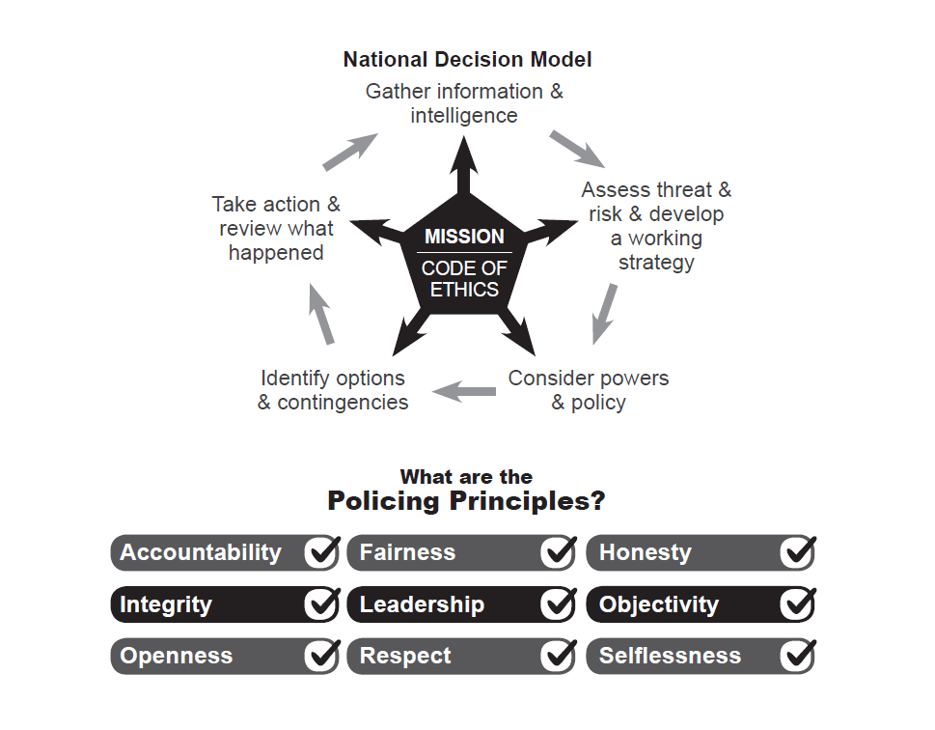

Update for Members on the Audit of the Financial Statements

- This report provides the Joint Audit Committee with an update on the progress with the audit of the Annual Statements of Accounts and Annual Governance Statements for 2019/20 for both the Chief Constable and PCC.

- As a result of the issues caused by Covid the Government moved the deadlines for publication of the draft accounts from 31st May to the 31st August and for the publication of audited accounts from the 31st August to the 30th November.

- Draft accounts and Annual Governance Statements were published on the Police and OPCC websites on the 30th June 2020 and presented to this committee at its meeting on the 29th July 2020.

- Since then a large amount of work has been undertaken by the auditors and this is now virtually complete. However there are a number of areas/actions which are still outstanding as follows:

- Revised actuarial calculations reflecting the impact of the proposed McCloud settlement have only recently been received from the LGPS and this needs to be reflected in the financial statements;

- Completion of a Going Concern review with a specific focus on financial resilience. This is further complicated by the potential delay in the financial settlement and spending review;

- Updated Annual Governance Statement to include the actions to be taken as a result of the limited assurance internal audit opinion, which was presented to this committee in July;

- Review of subsequent events prior to signing by the auditors

- Receipt of Letter of representation from the PCC and CC

- Final review of accounts and audit opinion by Manager and Partner

- The auditors have confirmed that they believe that they can meet the statutory deadline for the delivery of their audit opinion. A supplementary meeting has therefore been set up on the 25th November 2020 so that the Members can receive the External Auditors report and Opinion on the Financial Statements. This will be the only item on the agenda for that meeting.

Update on the Redmond Review on Local Authority Financial Reporting and Audit

Overview
- On 8 September 2020 the Government published the results of an independent review, led by Sir Tony Redmond, into the effectiveness of local authority (which included Police Forces) financial reporting and audit. Local authority and Police accounts are complex and the Review highlights a number of potential weaknesses with the current local audit framework and makes recommendations to address these. This briefing note summarises the key findings and recommendations within the report, as well as implications for the OPCC and Police.

Key Findings:
- The review identified a number of key issues with local audit (Councils and police), including:

- An ineffective balance between price and quality with 40% of audits in 2018-19 failing to meet required reporting deadlines in part due to under-resourcing and lack of experienced staff
- A lack of coordination and regulation of audit activity
- Outcomes not always being effectively considered and presented to members and public
- The technical complexity of statutory accounts limiting public understanding and scrutiny
Recommendations made by Sir Tony Redmond
- As a result of his review Sir Tony made 23 recommendations and the Government will now need to consider how many of the recommendations it decides to implement and when. The key recommendations are outlined below:

- External Audit Regulation and Oversight

- The creation of an Office of Local Audit Regulation to procure, manage and regulate external audits. Some of the existing regulatory responsibilities, which currently sit with other bodies such as the PSAA, to transfer to the new body.
- Revisions to the current fee structure for external audits to ensure adequate resources are deployed.
- Additional skills training for those involved in local audits and the amendment of statute to allow audit firms with the requisite capacity, skills and experience to bid for local audit work.
- The deadline for publication of audited local authority and Police accounts be considered in consultation with the NHS, with a view to extending the deadline from 31 July to 30 September.

- Financial Reporting

- A simplified and standardised financial statement of service information and costs be made available to the public to allow comparison with the annual budget and council tax. This new statement would be prepared in addition to the statutory accounts and would be subject to audit
- CIPFA/LASAAC to look again at the composition of the statutory accounts to see if improvements can be made to simplify their presentation and enhance their usefulness and understandability.

- Governance

- The composition of audit committees be examined to ensure they have the required knowledge and expertise. It was felt that Police and PCC JACs provided good Governance given they were composed of independent members with a good mix of skills. However many Local authority audit committees have no independent members at all and consisted entirely of Councillors.
- To demonstrate transparency and accountability, external audit would be required to submit an annual report to the first full council meeting (for Police to the JAC) after 30 September each year, irrespective of whether the financial accounts have been certified.
- A formal requirement for statutory officers (Chief Executive, Monitoring Officer and Section 151 Officer) to meet, at least annually, with the Key Audit Partner.

- Financial Resilience and Sustainability

- The current framework for seeking assurance on financial sustainability is reviewed by MHCLG to help address the gap between stakeholder expectations and what the auditor is required to do.
- The sharing of key concerns relating to service and financial viability, between local auditors and inspectorates, prior to completion of the external auditor’s report.
- In addition, an update to the NAO’s Code of Audit Practice that will be applicable from 2020-21 will require auditors to provide a narrative statement on the arrangements an authority has in place to secure value for money.

Conclusions and implications for the Police

- Assuming the recommendations are implemented the key implications for the Police are:

- The new standardised financial statement of service information and costs will form part of the audited statements in 2021-22.
- A likely increase in audit fees; with evidence suggesting audit fees collectively are at least 25% lower than required to fulfil current local audit requirements effectively.
- The requirement for the auditor to present an annual report to JAC whether the audit is complete or not.
- A revised timetable, with a change in the reporting deadline from 31 July to 30 September.

Background papers
- The full report can be found at:

https://www.gov.uk/government/publications/local-authority-financial-reporting-and-external-auditindependent-review

Recommendation

- The Joint Audit Committee is asked to:

- Note the progress with the Audit of the 2019/20 financial statements and the areas outstanding;
- Note that the there will be a meeting of the Committee on the 25th November 2020 where Members will receive the External Auditors report;
- Note the findings and potential implications of the Redmond Review on audits and reporting.

