
EU Transition Briefing

Required for: | PCC Performance Meeting September 2020
Security Classification: | Official
Handling information if required:
Suitable for publication: | Yes
Title: | EU Transition 1st January 2021 forward look
Version: | 1
Purpose: | PCC Briefing
ACPO / Strategic Lead: | ACC Dave Miller
NDM / OSARA compliance: | No
Date created: | 13/08/2020
Date to be reviewed:

AUTHOR:
Name: | Daniel Gutierrez
Job Title: | Chief Inspector Operation Department
Telephone number: | 01483637505
Email address: | Daniel.gutierrez@surrey.pnn.police.uk

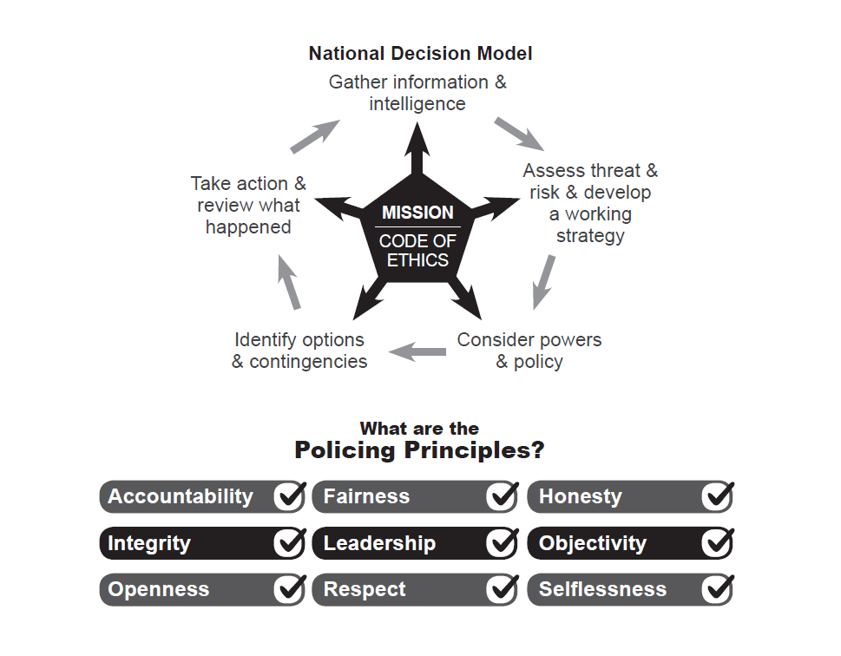
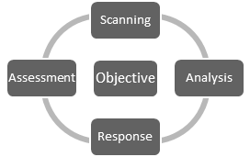

- Background
- Following the decision to Exit the EU, the transitioning and subsequent planning that took place under Operation Merrywood, Surrey and Sussex Police are now planning for the next phase of Transition.
- There has been no communication from the Government in terms of planning assumptions and the Parliament date for return is unknown.

- Command Structure
- The following command structure has been stood up with a dedicated Operations Planner and Emergency planner to manage Surrey & Sussex policing response and to work effectively with our key partners:
  - ACC Dave Miller - Op Merrywood Oversight
  - C/Supt Jane Derrick – Gold shared between Supt Graham Barnett to provide resilience and flex over Christmas
  - Supt Julia Pope – Silver – this is a permanent role for Silver and resilience will be provided by Ops Command Supt’s as required

- Planning
- The first in a cycle of monthly Gold planning meetings commenced on the 6th of August 2020.
- Operation Merrywood has been planned intensively and this plan would be revisited for its relevance in light of COVID 19 and the lessons learned as well as additional scenarios related to localised lockdown contingencies.
- With very little information from central government in terms of planning assumptions, it is difficult to know what the planning assumptions may be. A starting point for Surrey Police, Sussex Police, the regional police forces and the LRF’s is to revisit earlier EU exit plans.
- The Strategic planning meeting cycle has generated a number of initial actions to consider and take forward as more is understood.

- Current information & Assumptions
- Mutual Aid requirements from Hampshire and Kent might change. Southampton is planning for lorry parks and previous plans have been revised. This will continue to change but it is anticipated that Mutual Aid would come from other areas of the UK to support the South East.

- East Sussex County Council is making plans but they are not for as serious scenarios as in October. Newhaven will not have the increase in movements as before and this is made less impactive through restrictions in EU movements due to COVID 19.

- Ministry of Housing, Communities and Local Government (MHCLG) are holding three ‘reasonable worst case’ scenario briefing events over the next week and there is a table top exercise in Kent next month; both will support wider planning assumptions.

- Gatwick is primarily focussed on the movement of passengers. Covid 19 restrictions may affect their operating hours but it is not anticipated that additional cargo will be moved through the airport.

- Clacketts Lane (M25) now has all lanes running and the Bronze Roads Policing Unit (RPU) will review the Op Merrywood plans. Surrey Police has an interest in this and understand the issues around any impact this part of the motorway would cause. Surrey Police is also looking at stacking contingencies close to the A3.

- Road networks and modelling needs to be planned and how to transit round M25 if anything happens in other areas; the traffic will have to stop and this will impact on the whole road network.

- Department for Transport have appointed a DfT lead, which will support a more joined up approach to the policing of the strategic road network; particularly the M25.

- Decision[s] Required

  - None, this paper is for information only.

- Attachments / Background Papers

  - None.

