
***Financial Report June 2020***

Required for: | PCC Performance Meeting
Security Classification: | Official
Handling information if required:
Suitable for publication: | Yes
Title: | Financial Monitoring as at June 30th 2020
Version:
Purpose: | To provide the first quarter financial monitoring position for the Force
ACPO / Strategic Lead: | Peter Gillett
NDM / OSARA compliance: | Yes
Date created: | 6 August 2020
Date to be reviewed:

AUTHOR:
Name: | Paul Bundy
Job Title: | Service Director Finance
Telephone number: | 01483 639302
Email address: | Paul.Bundy@surrey.pnn.police.uk

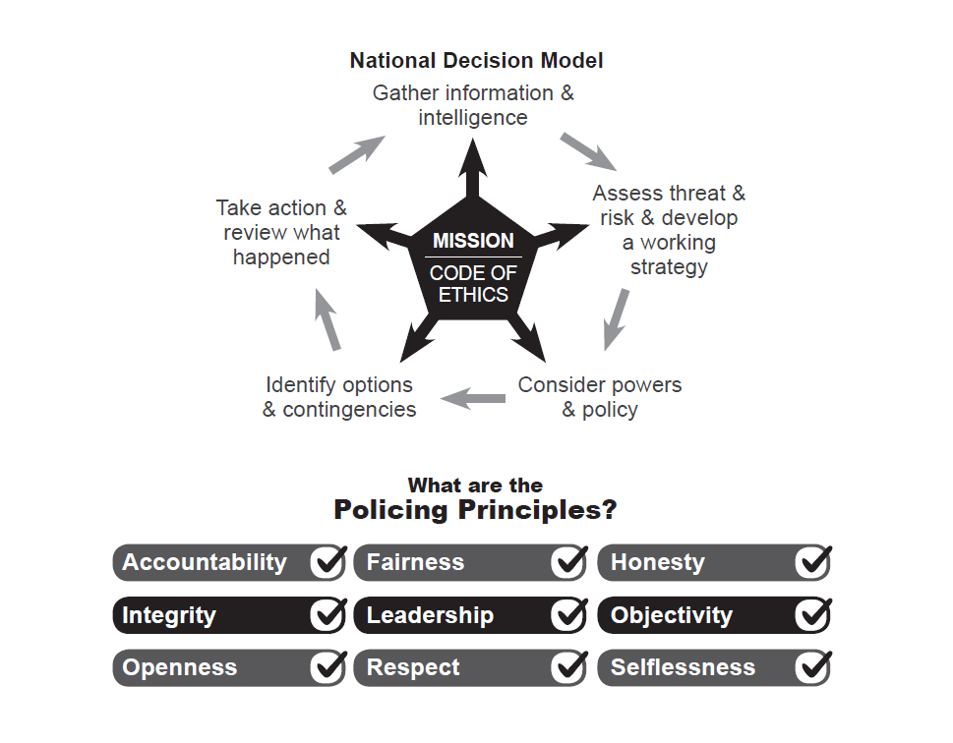
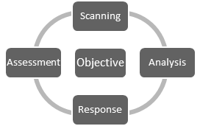



Force: Surrey
Financial Monitoring at: 30th June 2020
Finance Department

- Introduction

  - This report provides the force budget and capital position for Surrey Police as at 30th June 2020.

- Summary
  - The total budget for Surrey is £250.0m 2020/21, against this the forecast outturn position is £249.8m resulting in an underspend totalling £0.2m.
Surrey | 2020/21 PCC Budget £m | 2019/20 Operational Delivery Budget £m | Total 2020/21 Budget £m | 2020/21 Total Forecast £m | Variance £m
Month 3 | 2.1 | 247.9 | 250.0 | 249.8 | (0.2)
  - The Force is forecasting an underspend within the revenue budget of £0.2m for the year. The operational response to the COVID 19 pandemic has resulted in additional unplanned costs which consist of the salary costs of police officers and staff, employee overtime, premises, lost income and supplies & services, the most significant cost is for Personal Protective Equipment (PPE). From a forecasting perspective it has been assumed that all costs for the National Procurement Hub will be reimbursed. The assumption regarding non national procurement spend is that the maximum exposure on COVID 19 expenditure is the equivalent of 1% of the budget, that is £2.5m. The total forecast including the National Procurement Hub expenditure is £6.8m with income expected to be £4.3m.
  - The force is mitigating the additional costs with savings across the force, these include savings in training and staff travel where costs have been lower during the first 3 months of the year.
  - There are variances within the budget, pay is forecasting an overspend overall with a cost pressure on police overtime which reflects the budgeted risk accepted by the force.
  - Police officer numbers are increasing as the recruitment plan delivers and police staff budget is forecast to underspend.
  - For Police Officers the financial plan assumed an inflationary increase of 2% which now looks likely to be 2.5%, this additional cost pressure will be reflected in the month 4 forecast, this is estimated to be £0.4m.

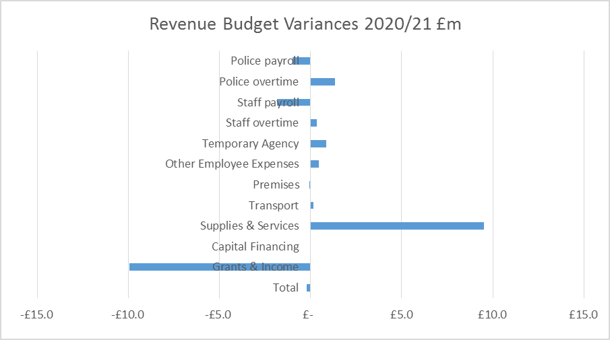

  - The non-pay costs including income are underspent in total with costs attributable to Op Apollo being offset by the assumed income.
  - The precept & uplift investment was for an additional 156.5 posts, the current forecast is that Surrey Police will recruit to these posts by March 2021.
  - The efficiency plan to save £1.4m has been removed from the budget, however there is a risk that savings within ICT will not be achieved.
  - The capital plan is forecast to underspend by £1.3m. For the 2020/21 financial year a new capital & investment gateway to proceed process has been introduced for existing planned schemes. This step will firm up on the proposals put forward during the budget build and also allow the funding position to be checked prior to giving the go ahead.

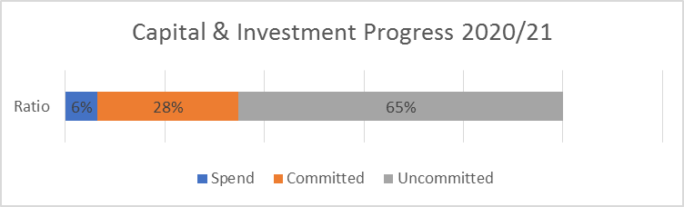

Surrey | 2020/21 Capital Budget £m | 2020/21 Capital actual £m | 2020/21 Capital Forecast £m | Variance £m
Month 3 | 18.0 | 1.8 | 16.7 | (1.3)

- Recommendations

  - The Police and Crime Commissioner is asked to:

    - Note the net revenue budget forecast for the police fund as at 30th June 2020.
    - Note the capital budget forecast is as at 30th June 2020.
    - Approve budget virements on Appendix D.
    - Approve any changes to use of reserves – None to report for month 3.

- Revenue Budget Position
  - The Force’s revenue outturn position for 2020/21 is forecast to be underspent as summarised in the table below;
  - The 2020/21 revenue budget was approved by the PCC in February 2020 at £250.0m, during the year agreed budget virements have been processed within the operational delivery budget and OPCC budget, with the overall budget remaining at £250.0m as shown in the table below:
  - Appendix A provides further details of the operational delivery budget showing budget and forecast both by budget holder portfolio and the main categories of expenditure.
  - Pay Costs - Total pay is overspent by £0.1m as summarised in the table below.

  - In Surrey employee numbers are monitored in detail throughout the year within a workforce plan by People Services. The following table illustrates the variances between the average forecast number of employees (employee strength) compared with the budgeted number of employees (employee establishment), expressed as FTE (full time equivalent) roles.

  - Police Payroll - The police officer pay is forecast to be underspent by £1.0m.

  - Police Officer pay is a non-delegated cost and is shown on a separate line within the budget by function (Appendix A) with departmental variances reflecting their delegated budgets.

  - The pay forecast indicates an average of 1980 FTE officers for the year, compared to the budget of 2040 FTE, noting it will exceed the budget by January 2021.

  - The above calculations shows the force is averaging 61 officers under budget which is resulting in a volume underspend of £3.3m (£54.8k per FTE), with a rate overspend of £2.4m relating to officer rates being higher than budgeted. A vacancy factor of 2% (£2.5m) is assumed for police officers which is part of the rate variance along with the mix of officers.
  - Police staff pay is forecast to be underspent by £1.8m. The current projection is for the number of staff working in the force to remain under establishment until the end of the financial year, when the predicted number of FTE’s is 1868. The vacancy rate for 2020/21 has been increased by 1% to 6%.

  - The month 3 pay forecast shows an average of 1789 FTE staff for the year, compared to the average budget of 1951 FTE.

  - The shortfall of 162 staff FTE’s results in a £5.7m volume underspend for pay, NI and pension (£37.7k per FTE), that is being offset by a rate overspend of £5.8m. A vacancy factor of 6% (£4.6m) is assumed for police staff which is part of the rate variance along with the mix of pay grades, the above calculation is an average.

  - Staff enhancements and holiday pay have underspends due to being under establishment. The rate and volume variances are based on all posts having these allowances and therefore is not representative of entitlement.

  - Overtime for both officers and staff by department is shown on Appendix B, with officer overtime forecast to overspend by £1.3m and staff overtime forecast to overspend by £0.3m.

  - The force police officer overtime working group continues to monitor spend and provide guidance to reduce spend in this area, the tables below shows spend for both officer and staff overtime over the past four years.

  - The charts below show Police Officer and Staff overtime by division/department. Appendix B shows the monthly profile of this spend.

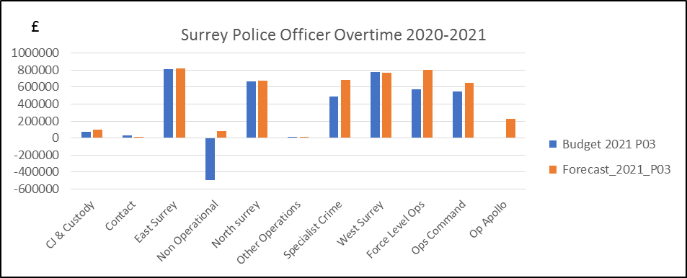

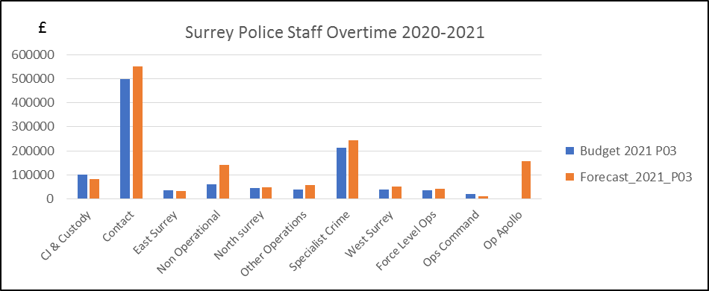

  - Agency costs
    - Agency costs is forecasting an overspend of £0.9m. The majority of this relates to an overspend on agency costs within Local Policing (£0.5m) for 16 investigative officers across 3 divisions, along with Op Apollo costs for returning officers and Op Igil.

  - Training & restructuring costs
    - There is a minimal underspend on training & restructuring costs.

  - Other Staff Costs
    - There is an overspend in Other Staff Costs totalling £0.6m some of which relates to Local PPE for Op Apollo. There is also an overspend for the apprenticeship levy where this is offset by income.

  - Non Pay Budgets
    - Non pay cost budgets are forecast to underspend by £0.4m as shown in the table below. These budgets include costs for premises, transport, supplies & services, financing and income.

  - Premises
    - Premises is forecasting a slight underspend.

  - Transport
    - There is a forecast overspend of £0.2m, relating to an expected increase in insurance premiums.

  - Supplies & Services
    - There is a forecast overspend of £9.5m, of this £3.2m relates to Local PPE for Op Apollo and PPE for the National Hub, £0.9m relates to Equip for consultancy costs. There are also overspends within Specialist Crime due to the contribution to SEROCU being higher than budgeted this relates to additional items being agreed by CCs & PCCs across the region for funding new investments as well as higher costs for digital and physical forensics; Local Policing relating to boarding fees for stray animals, underwater search for missing persons and unlocking phones for operation purposes and; Corporate Services relating to Op Symphony.

  - Financing
    - Financing costs are forecast to be within the budget.

  - Income
    - Income budgets relate to government grants, reimbursed services, secondments and mutual aid arrangements with other police Forces. This income is in addition to the main sources of funding from the core policing grant and council tax precept income.

    - There is an overachievement of income forecast of £9.9m primarily due to Op Apollo (£4.6m), this assumes that the force will be reimbursed for the PPE National Hub. Specialist Crime are forecasting higher than expected income (£1.0m) for Surrey officers posted to regional units. There are also increased cost recovery for Gatwick recharges. Within People Services theres an over recovery for Secondments (0.5m) plus income received from new HQ site tenants and other property rentals.

  - Departmental Narrative
This section gives a narrative on the divisions & departments, note the figures relate to delegated budgets only.

- Local Policing is forecasting an overspend of £1.9m within the divisions – mainly in Police Staff and non-pay areas. The Police Staff overspend is due to running over-establishment with PCSO roles. There is a small overspend within Supplies and Services due to the assumption that Divisions will overspend on unexpected demand for costs such as boarding up dangerous animals, stray animals, underwater searches for missing persons and unlocking phones for operation purposes as they have in prior years.

- Operations Command - Ops Protective services have moved to a slight portfolio underspend now that the a forecast for reimbursement of costs above 1% of the overall Force budget and National PPE have been made for Op Apollo. The main reason for this underspend is the delay in conducting normal tasks as a result of Covid.
- Specialist Crime’s position of a large under-established position continues into 2020/21 for both officers and staff. The latter being somewhat understated due to Surrey officers being posted in Sussex and regional positions, and can be illustrated by referring to the overachieved income balance as these are reclaimed. These pay variances are offset by agency spend, mostly in Public Protection, as well as the significant reliance on outsourcing in digital forensics used to support the low capacity within the team. In addition a notable overspend in overtime is expected, due in part to the reduction in budget following the overtime refresh initiative and is expected to fall short compared to the predicted level of spend. The contribution towards SEROCU is also higher than budgeted to due to additional items agreed by CCs & PCCs across the region for funding new investments.

- Corporate Services is currently forecasting to overspend by £0.4m this partly results £0.1m actual staff costs being higher than budgeted and £0.3m Supplies and Services a forecast overspend on Op Heather.

- ICT are currently forecasting an overspend of £0.5m which is mainly due to staff costs being higher than expected, where additional staff are working on projects.

- People Services – The forecast is for an underspend of £0.6m which relates primarily to an over achievement of income of £0.5m. The majority of the income relates to secondments and relates to recovery of officer and staff pay. Apprentice levy income is also now being received.

- Equip – The Equip programme is forecast to be overspent by £2.28m. The forecast is as provided by the Programme Manager and is based upon a September 20 go-live.

- Commercial and Finance Services – The forecast is for an underspend totalling £1.95m. The majority of this is within Central Corporate with the Precept & Uplift investment funding for Police Staff being held here until posts are filled.

- Precept & Uplift Investment

  - The precept and uplift investment approved for 2020/21 allowed for the increase in police officers and police staff, the following table represents the forecast position against the precept investment.

Expected increase at March 2021 | Investment provided | Forecast  At 31/3/21
Employee Group | FTE | FTE
Police Officers – Uplift growth | 78 | 78
Police Staff – Uplift growth | 0 | 0
Police Officers – Precept growth | 26 | 26
Police Staff – Precept growth | 52.5 | 52.5
Total | 156.5 | 156.5

- Savings Performance

  - All planned 2020-21 savings were taken at the beginning of the financial year, irrespective of their RAG status. Budget holders unable to make any of these savings are required to detail the reasons in an exception report for consideration and approval. The Strategic Change Board reviews the savings profile over the medium term on an ongoing basis, a summary of the 5 year savings schedule is shown in the table below.
  - Whilst the savings have been incorporated into the budget setting process and removed at the beginning of the year there is a risk that ICT will not achieve their savings totalling £0.5m which needs to be identified.
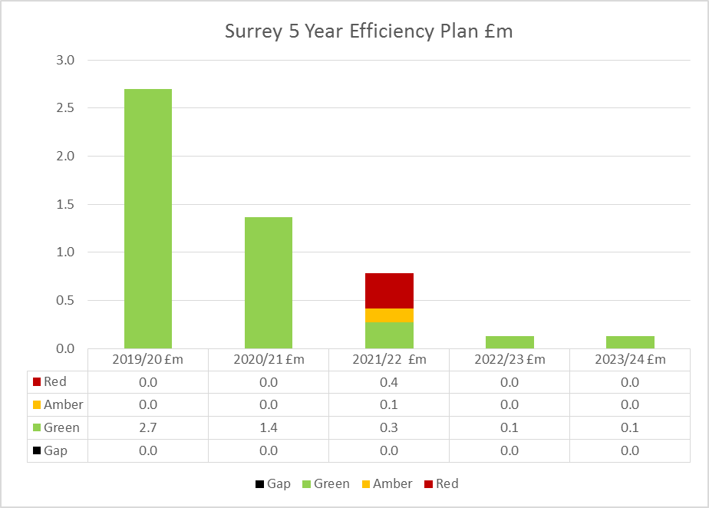

- Financial Provisions and Reserves Transfers
  - A summary of movement between provisions and reserves are shown below.
- Treasury Management
  - At the end of May £18.6m was held for investment by Surrey County Council under the SLA.
  - Surrey County Council are currently borrowing internally for investment purposes and therefore calculating their interest rate payable as the higher of; the London Inter-Bank BID rate, the Bank of England Rate or the average rate achieved by Surrey County Council.
  - In March 2019, the PCC entered into an external loan with PWLB for £15.6m in order to purchase land for Building the Future.
  - All cash balances are lent overnight allowing the flexibility to draw on resources.
- POCA Reserve and Allocations

  - The Asset Seizure Reserve is used to earmark money received back from the government as part of the Asset Recovery Incentivisation Scheme (ARIS) whereby the force receives a share of amounts recovered under the Proceeds of Crime Act 2002 (POCA). The level of this reserve is currently maintained as a contingency to cover one year of salary costs for the Asset Seizure team within the Economic Crime Unit. At the end of May the reserve balance was £0.7m.
  - In-year POCA receipts cover the cost of the Asset Seizure team. Income is received quarterly, quarter 4 is still outstanding for 2019-20.
- Capital & Investments

  - The overall capital & investment position is summarised below and detailed at Appendix D.

  - The capital budget for 2020/21 was approved by the PCC in February 2020 totalling £10.5m with an additional £7.5m capital slippage from 2019/2020 resulting in a total capital programme totalling £18.0m. The force runs a flexible programme managing schemes over a rolling 2 year period enabling schemes to be bought forward or deferred. During the year agreed budget virements have been processed (including capital carried forward from 2019/20) as set out in the table below, as at month 3 no budget has been slipped into 2021/22.

  - The significant capital projects are ICT and Fleet replacement schemes, Building the Future and the Estate Strategy.
  - The annual forecast spend is £16.7m, resulting in a reported underspend of £1.3m.

  - Capital expenditure is financed from grants received from the Home Office & other contributions, capital receipts from the sale of assets, and revenue funding. If necessary borrowing can also be used to fund capital expenditure as shown in the table below.

- Risks
  - The following risks and issues to the Operational Delivery Budget have been identified.
Risk | Mitigation/Update | Owner
COVID19 | Op Apollo Gold Group has been set up in light of the COVID19 Pandemic. The Pandemic is having an impact on operational resources as well as financial resources which are being regularly monitored to understand the level of spend and how this will be funded. The current assumption is that maximum exposure on COVID 19 expenditure is the equivalent of 1% of the budget, that is £2.5m. | Gold Commander, Op Apollo
Overtime | The Force has increased the overtime budget for officers and staff by £0.6m with no funding to back this therefore creating a financial risk. Overtime spend is reported through the overtime working group and the force monthly financial report. | DCC Strategic Planning Board
Equip Project | The forecast includes the current understanding of the cost for the project in the current year, however as the programme is in a period of review there is a risk that the cost in the current year may increase. | CIO – Joe Langford
ICT Savings | ICT have a savings target for 2020/21 totalling £0.5m, this has been removed from the budget however the actual savings have yet to be identified. | CIO – Joe Langford

- Decisions Required

  - Financial regulations require the PCC to approve revenue budget transfers greater than £0.5m and the Chief Constable’s Chief Finance Officer to approve transfer between £0.1m and £0.5m. The transfers requiring approval are shown on Appendix D.

  - Financial Regulations require the PCC to approve all changes to the capital budget, these changes are shown on Appendix D – there are none for month 3.
Appendix A

Appendix B
Overtime by Division/Department

Appendix C
Capital Budget Position at 30th June 2020

Appendix D
Revenue Virements

Capital Virements

No virements to report in Month 3

Appendix E

Abbreviations
PCC - Police and Crime Commisioner
DCC – Deputy Chief Constable
ICT – Information Communication Technology
PSD – Professional Standard Department
ACPO – Chief Officers
ERP – Enterprise Resource Planning
FTE – Full-time equivalent
DFT – Digital Forensic Team
POLIT – Paedophile Online Investigation Team
ICCS – Integrated Communications and Control System
ANPR – Automatic Number Plate Recognition
APT - Area Policing Team
SERIP – South East Regional Integrated Policing Programme
SOIT - Sexual Offences Investigation Team
RIPA – Regulation of Investigatory Powers Act
PNC/PND – Police National Computer/Police National Database

