
***Progress against the Police and Crime Plan***

Required for: | OPCC Performance Meeting September 2020
Security Classification: | Official
Handling information if required: | Not applicable
Suitable for publication: | Yes
Title: | Progress against the Police and Crime Plan
Version: | 1.1
Purpose: | OPCC Performance Meeting Paper
ACPO / Strategic Lead: | DCC Kemp
National Decision Model compliance: | Yes
Date created: | 20th August 2020
Date to be reviewed: | N/A

AUTHOR:
Name: | CI 2125 Mason
Job Title: | Head of Strategic Planning
Telephone number: | 01483 630129
Email address: | strategicplanning@surrey.pnn.police.uk

INCLUDEPICTURE "cid:image001.png@01D312A9.8E469640" \* MERGEFORMATINET INCLUDEPICTURE "cid:image001.png@01D312A9.8E469640" \* MERGEFORMATINET 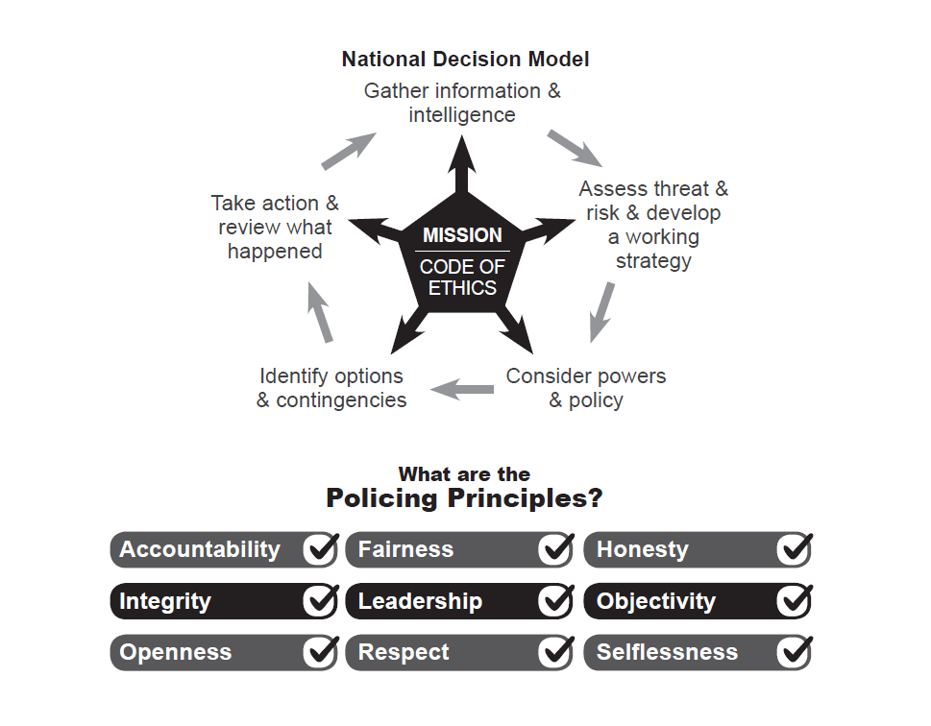

To: Office of Police and Crime Commissioner
Performance Meeting

Date: 20th August 2020

By: Strategic Planning

Title: Progress against the Police and Crime Plan

Purpose of Report: The purpose of this paper is to provide an update for the Police and Crime Commissioner for Surrey regarding Surrey Police performance against the PCC’s Police and Crime Plan.

1. Tackling Crime and Keeping Surrey Safe

Force Recorded Crime and Positive Outcomes:
Force: Volume of Recorded Crime
The volume of recorded crime is defined as the number of total notifiable offences recorded within Surrey as defined by the Home Office Counting Rules (HOCR).
Over recent years there has been a national increase in recorded crime, with the latest Office of National Statistics (ONS) data to March 2020 showing that crime increased nationally by 1.4% year on year. Surrey Police recorded a 0.2% decrease in the 12 months to March 2020 with the South East region recording a 2.2% increase.
The ONS figures showed that in March 2020 Surrey had the 6th lowest crime rate (64.5 per 1000 population) across England and Wales, and Surrey continues to have the lowest crime rate in the south-east region. Considering how attractive Surrey is to travelling criminality; with the Metropolitan Police to the north, and excellent road links across the South East, the continuing position as having the lowest crime rate in the region is significant.
The Surrey Police data to the end of the financial year, showed that for the 12 months to July 2020 the volume of notifiable offences recorded was 73,893; a decrease (-3.2%) from the 12 months to July 2019 (76,336).
April 2020 saw one of the lowest levels of crime recorded in Surrey due to national lockdown in order to deal with COVID19. Volumes of crime have steadily increased over the subsequent months and have now returned to levels similar to those recorded in previous years.
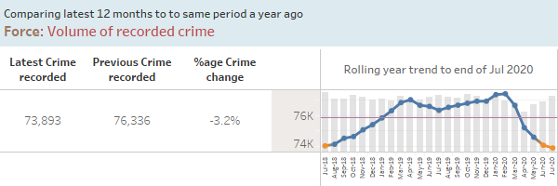
Force: Volume of Positive Outcomes
Home Office Counting Rules require all notifiable offences to have an outcome. For Surrey Police, a ‘positive’ outcome is a notifiable offence with either a charge; caution; penalty notice; drug warning; community resolution or TIC (taken into consideration).
For the 12 months to July 2020 the volume of positive outcomes for notifiable offences recorded was 10,348 which is down 6.9% compared to the 12 months to July 2019 (11,120). Performance in this measure over a rolling 12-month period had improved in the months February to May, but the latest 12 months to July 2020 still represent a relative low.
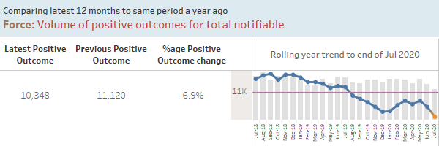

Force: Positive Outcome Rate

Positive outcome rates are calculated using the volume of positive outcomes in a given period divided by the volume of crimes in the same period.
For the 12 months to July 2020 the positive outcome rate for notifiable offences was 14.0% which is showing a drop of 0.6 percentage points compared to the 12 months to July 2019 (14.6%) (NB: percentage values have been rounded up and down to the first decimal place). Again, the chart below shows a noticeable up-tick in the positive outcome rate since the beginning of the year; reflective of the focus on this area. However, with the increase in crime in July 2020 back to normal levels a lower volume of positive outcomes in this month has resulted in a positive outcome rate reduction.
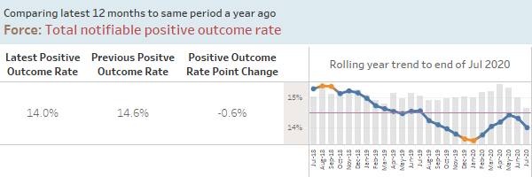

Force: High harm positive outcome rate

High harm offences comprise of the following types of crime: Serious Sexual Offences, domestic abuse related offences involving violence, child abuse offences and hate crime offences.

For the rolling 12 months to July 2020 the positive outcome rate for high harm offences was 13.3% which is down -1.9 percentage points compared to the 12 months to Jul 2019 (16.2%). However, the month of March 2020 saw the highest positive outcome rate for high harm offences for over a year.
The decline in positive outcome rate for domestic abuse (which is an element of high harm offences) has been the focus of several Force Performance Boards since October 2019, and the significant improvement in March and improvement in rolling 12-month data seen since the beginning of the year is indicative of the work in this area. The Force expects to see an increase in domestic abuse reports as Covid-19 restrictions are eased (reflecting trends seen internationally) and has prepared for this internally and with partners.
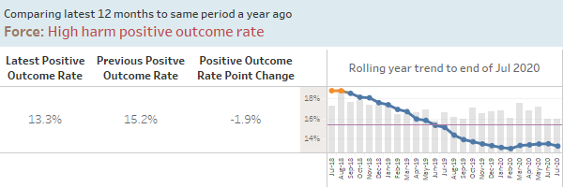

Problem Solving Occurrences

The 12 months to July 2020 show the volume of problem solving occurrences recorded as 333 which is an increase of 6.1% compared to the 12 months to July 2019 (314). Volumes over the last four months have been above the two year average.

The Force has created a central Prevention and Problem Solving Team from 2019/20 precept investment, led by a Ch Insp, with two problem solving tactical advisors and two analysts who are assisting teams across the Force with detailed analytical support and research of national best practice.

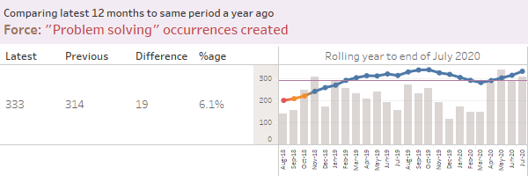

Dealing with ASB and Crime

Joint Neighbourhood Survey results for the 12 months to March 2020 show that 71.3% of respondents agree that Surrey Police are dealing with anti-social behaviour and crime issues that matter in their area. While the latest quarter (Jan-Mar 2020) shows a drop of 5.1%pts compared to the previous quarter (Oct-Dec 2019), this is a decrease of just 0.3%pts on the previous year.

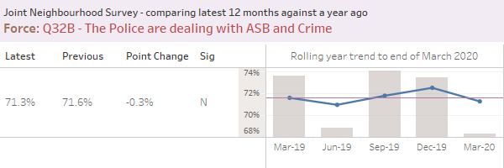

Call Handling and Deployment

Force: Calls for Service Performance
999 call handling performance remains strong and is always given priority. Data for the latest 12 months to July 2020 shows 94.3% of 999 calls are answered within target, which is just a slight drop (-1.5%pts) compared to the 12 months to Jul 2019. This is an excellent result, as call volumes have increased and staffing efficiencies have been made within the department.

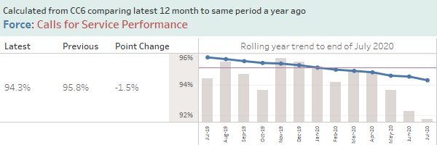

Force: Average time to answer 101 calls

101 call handling performance sees a greater degree of variation than 999 performance mainly due to a number of factors including continued prioritisation of 999 emergency calls over 101 calls, and the greater volume of calls experienced during the summer months or following a significant incident. .

Average time to answer 101 calls has increased over recent months. Last month the average time to answer a call in July 2020 was 3 minutes 15 seconds; a significant increase based on monthly results over the last two years. This is believed to be due to a combination of factors:
- Due to Covid-19 restrictions, the CTC has been working from five rooms rather than its normal one to ensure that staff members have sufficient space between desks, making communication between, and supervision of, staff more challenging.
- Demand for 101 calls is seasonal, with an increase in summer months. This year, the usual seasonal demand increase has coincided with easing of Covid-19 restrictions and a further increase in calls.
- In late June, the Digital 101 initiative was introduced, further increasing demand in the CTC.
- Covid-19 restrictions have affected the recruitment and training of staff.
Demand within the CTC, and the factors affecting performance, are constantly reviewed by the Contact and Deployment SMT, and work is ongoing to address these issues as Covid-19 restrictions ease.

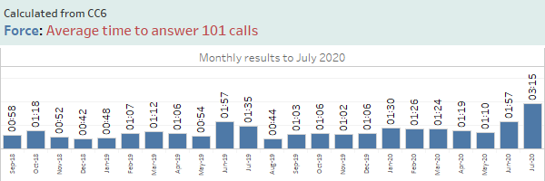

Force: Emergency Response Performance

Grade 1 & 2 response performance is measured as the percentage of incidents attended within 15 minutes and 60 minutes respectively. The latest 12 months to Jul 2020 shows Grade 1s attended in target has increased 0.5%pts compared to the 12 months to Jul 2019. Grade 2 is showing a reduction in the latest 12 months; down 1.9%pts compared to previous year. This is an issue experienced by many forces, as the actions required of officers at incidents become more complex, taking more time per incident.

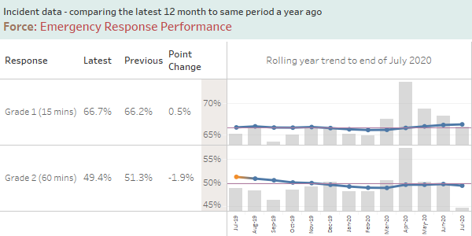

Counter Terrorism (CT)

During the Covid 19 pandemic the Prevent team and Counter Terrorism Policing South East has had to adapt working practices to ensure that they can continue to deliver a resilient service. The number of Prevent referrals has decreased in line with the national trend as statutory agencies have less face to face contact time with their service users. Considerable work has been undertaken to use other means of promoting vulnerability e.g. “Let’s Talk About It” media campaign to ensure that the most vulnerable are supported.

The Counter Terrorism Local Profile has now been published which identifies the CT risks and challenges within the county and allows for focused activity over coming months to mitigate and develop the intelligence picture. The recommendations made are being reviewed and progressed by the local partnership with oversight and scrutiny provided by the County Prevent Executive Group.

The Force Prevent Team, working with the Mobile Data project, is in the process of finalising a dedicated Prevent App for the Mobile Data Terminal (MDT) to allow front line officers and staff direct access, whilst policing within their communities, to the latest national guidance to assist in identifying the signs of radicalisation. This innovative use of technology will assist in raising awareness and driving Prevent referrals.

2. Building Confident Communities

Force: Crime Survey for England and Wales (CSEW) Confidence

For the 12 months up to March 2020, Surrey Police has moved 3 places to 7th for the Crime Survey for England and Wales measure for public confidence. The latest results show an increase of 1.1 %pts over the last quarter to 78.7%.
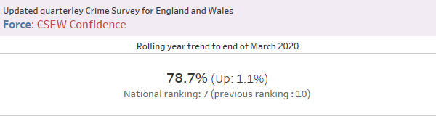

Force: Q19 – Confidence in Neighbourhood Police

Surrey County Council and Surrey Police survey over 6000 residents a year as part of the Joint Neighbourhood Survey (JNS).

In the 12 months to March 2020, of those asked, “taking everything into account, how confident are you in your neighbourhood police?”, 88.1% said they were very or fairly confident. While a reduction of -1.2% points this quarter, this represents a small improvement from the 12 months to March 2019 and broadly mirrors the confidence results from the national crime survey for England and Wales highlighted above.

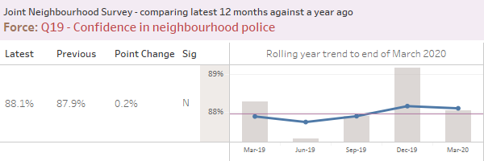
3. Supporting Victims

From April 2019 a new methodology was introduced to consult with victims of crime and ASB. Victims are now contacted via text message which brings benefits such as reaching more victims of different crimes, fewer questions resulting in an increased response, and greater insight through victims’ comments. Results are now also received in real time as opposed to the previous lag of 2-3 months between incidents/crimes occurring and results being received.

From April 2019 to June 2020 a total of 47,449 (Main: 30,707, ASB: 16,742) texts were sent with 11,635 (Main: 6584, ASB: 5051) responses received, giving a response rate to date of 21.4% and 30.2% for Crime and ASB respectively.

When presenting the results, although percentages will be shown, a customer satisfaction score (CSAT Score) is also provided. This is based on the satisfaction questions, where respondents are asked to provide a response between 1 - 5 (Dissatisfied to Satisfied) to the satisfaction question they are asked (Initial Contact, Kept Informed, Actions Taken or Treatment).

Overall satisfaction in June has seen a slight decrease (-1.7% points), however remains high at 64.4%. The CSAT score for June 2020 is 3.67.

Increases in satisfaction are seen for initial contact (+1.5% points) and treatment (+1.8% points) this month. However, a large decrease is seen for kept informed this month (-14.5% points) to a low 44.9%, with a smaller decrease seen for actions taken (-4.7% points) to 62.0%.

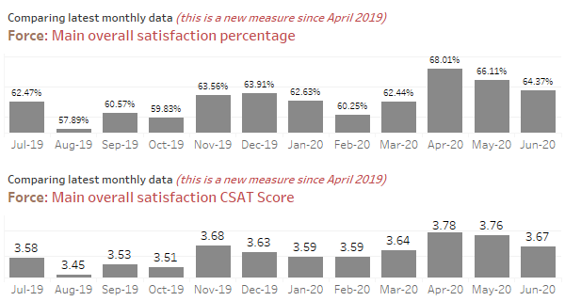

Force: Total ASB User satisfaction

ASB Overall satisfaction in Jun 2020 is 66.19%. The ASB CSAT score for June 2020 is 3.78.
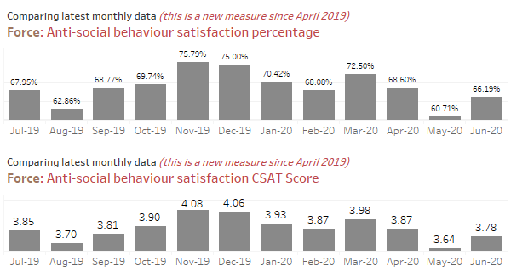

Force: Rolling quarterly results for Victim Contact Compliance

The methodology for victim contact compliance has changed significantly since the measure was first put in place. The chart below shows the compliance results for each department reviewed over the last 12 months.

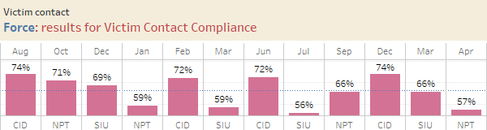

Whilst it’s difficult to draw generalisations about the causes of these variations in compliance, because each investigation, in each sample set is subjective, some informed observations can be made:

Methodology and Audit Sample: due to high number of staff (OICs) in NPT and SIU, and high volumes of crime allocation to both areas, only a dip sample of crimes and staff can be audited each month. The sample set changes for each audit, to ensure that as many staff as possible are reviewed over the course of the audit year. This inevitably has an effect on compliance levels. In principle, it should not matter who is included in each sample set, however it is clear to see from the results there are significant variations between investigators within teams, and comparatively between departments depending on knowledge and experience of the Victims Code of Practice (VCoP).

The number of crime types allocated for investigation, also differs between departments and within sample sets, due to the nature of a ‘dip check’. Notably, some crime types tend to have higher rates of compliance than others; e.g. acquisitive crime tends to see lower levels of VCoP compliance. The inclusion of more or less of certain crime types will influence the overall compliance. This cannot be controlled with a random dip check methodology. The numbers of crimes audited per investigator also varies; whilst the intention is to audit 4 crimes per OIC, sometimes this is not able to fulfil due to differing workloads, and particularly so for CID.

Investigative responsibility: all three departments audited hold responsibility for investigations of differing natures. The type and severity of crimes investigated can impact on VCoP compliance. Whilst the entitlements and requirements are consistent for every crime, (with enhancements for priority victims), different crime types tend to have differing levels of compliance and differing challenges for the OIC. Where investigations are long or complex, or where OICs are managing heavy workloads, compliance levels tend to fall. SIU officers, for example, predominantly manage crimes where victims are entitled to a priority service. This demands more contact in the course of the investigation (often within 24 hours as opposed to 72 hours). The differing levels of service required for victims in each investigation audited will influence the overall compliance. This can vary for each OIC month to month depending on what is on their workload at that given time.

Person vs. business victims of crime: compliance is typically lower where businesses are victims, rather than a person. The inclusion of more or fewer business victims of crime between audits has an impact on the overall compliance. Again, this is not controlled in a random sample dip check.

Seasonal crime: the time of year can also determine a predominance of certain crime types, and this can influence the audit sample and account for differing results, for the same teams, across the year.

Whilst the overall compliance can vary between audits, the breakdown of compliance (the areas audited) tend to be more consistent across and within teams. Compliance with setting contact contracts with victims is the biggest cause for audit failure, followed closely by the compliance with agreed contact contracts when they are set in all three teams.

Typically, a combination of all the above factors with each investigator and investigation causes the fluctuation of compliance levels from month to month within and between teams.

In summary, each audit is different; the OICs audited, the sample set of crimes audited, the subjective level of service required for each investigation, and the investigators’ capacity (that month) and knowledge of VCOP requirements. Identifying trends over time, therefore, is a challenge; but the value of the audits lies in identifying themes and issues from which officers and teams can learn and improve.

4. Preventing Harm

Force: Repeat Vulnerable Missing Individuals

The volume of vulnerable missing individuals over the last 12 months to July 2020 is 534, a decrease of 254 on the volume recorded in the 12 months to July 2019. As seen in the chart below, this continues the excellent downward trajectory of the last year; a result of greatly improved partnership working and the embedding of the Surrey High Intensity Partnership Programme (SHIPP).
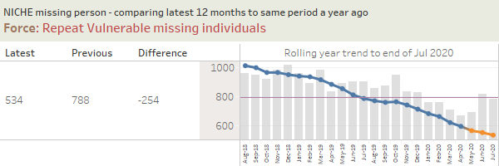

Force: Repeat Domestic Abuse (DA) offenders over the last three years

The 12 months to July 2020 shows the force has 1,152 repeat DA offenders which is up 8.4% compared to the 12 months to July 2019 (1,063).

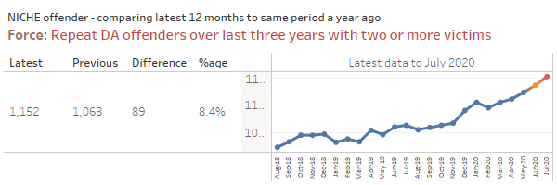

The correct identification and recording of repeat DA perpetrators / victims has been a focus for the force. The increase in repeat DA perpetrators can be associated to improved reporting, better understanding and identification by officers and improved data integrity and linking of crimes. Activity across the force to address DA offending includes the following.

Enhanced focus on DA investigations (ensuring raised quality to increase Criminal Justice outcomes); focus on outstanding DA suspects through daily management meetings (early arrest); focus on those serial perpetrators identified due to offending levels; use of the Multi Agency Referral Assessment Conference (MARAC) process to address repeats coming to notice to agencies; problem solving plans to address repeat offending and/or chronic problems where appropriate; new domestic abuse specialists employed in the quadrants within the new family safeguarding model in Police Single Point of Access (P-SPA) helping to identify and support those repeat callers/perpetrators with children; new Chula Vista style warning notices now served on all DA perpetrators issued with a Domestic Violence Protection Notice (unannounced visits introduced); focus on bail checks of DA perpetrators; use of the ‘Respect’ helpline/ website to help DA perpetrators address their behaviour/repeat offending; use of the Domestic Violence Disclosure Scheme (DVDS) to manage disclosures; serving of Stalking Protection Notices/Orders (SPO’s) to deal with those that present significant risk.

The High Harm Perpetrator Unit (HHPU) manages high-harm offenders, which includes known DA offenders who sit within the Integrated Offender Management (IOM) / High Harm Perpetrator (HHP) cohorts; some of these are IOM offenders adopted for serious crimes but also have DA offending history. A close working relationship has been built with outreach partners to share information and, where appropriate, the seven pathways, which include referrals to other agencies, is used to address DA re-offending. The Probation Service (KSSCRC) are also working with DA perpetrators convicted and sentenced to a post-conviction DA behaviour change programme by the courts. Face to face visits are still being carried out on those high risk DA perpetrators being managed by the National Probation Service (NPS).

The Force is also working with key partners (Surrey County Council, OPCC, SDAP Outreach Services) to review, research and identify a suitably evaluated pre-conviction DA behaviour change programme to address DA offending behaviour. This work is being delivered through a specific worksteam and under the governance of the new countywide DA Executive Group. In the short-term, Surrey Police has also managed to secure a number of free spaces on the KSSCRC “Building Better Relationships” (BBR) programme and HHPU will soon be using this service for those DA perpetrators deemed suitable to qualify pre-conviction.

To improve the way the Force identifies the most dangerous and serial DA perpetrators, it is working on identifying an algorithm that will help narrow down the cohort of DA perpetrators so that those of highest risk based on frequency, gravity and recency of offending are identified. This algorithm is being developed in line with the College of Policing’s eight principles of identification, assessment and management of serial or potentially dangerous DA and stalking perpetrators. It is being developed with academic support and is in early stages of development.

Mental Health

The below charts are provided for the Surrey Public Protection Performance Meeting and refer to mental health data for 2020/21.

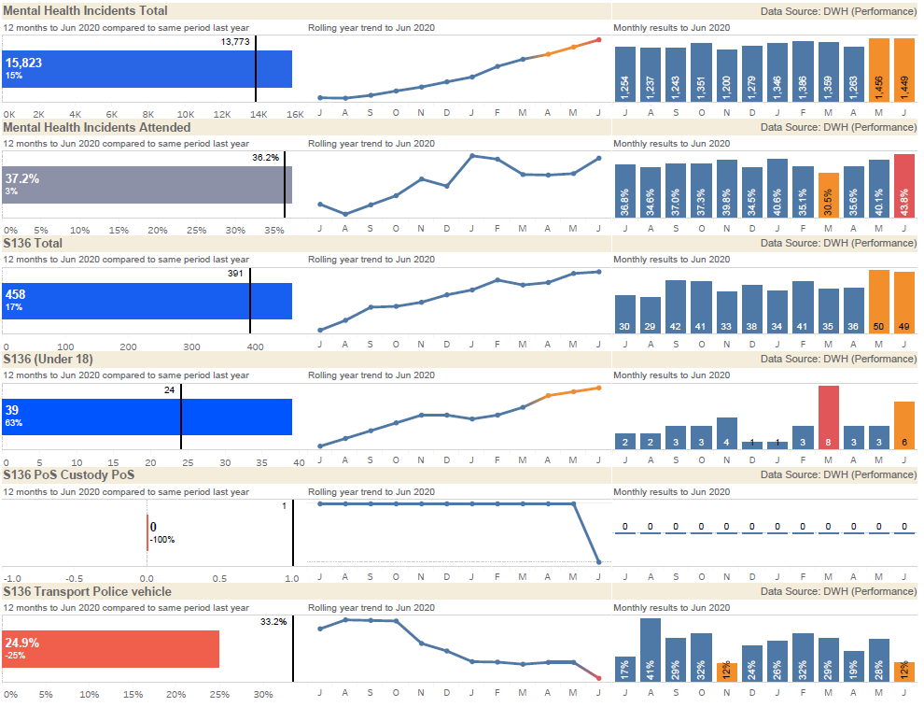

Key Points:
- Surrey Police continues to see an increase in mental health related incidents into its front line including via the contact centre. Police attendance rates for mental health incidents remain static against 2019/20 however there is a visible, steady increase in deployment rates during Covid-19. Surrey Police are working alongside SECAmb and Surrey and Borders Partnership NHS Foundation Trust (SABP) to ensure that those in crisis receive the most appropriate response. This includes closer working relationships with the SABP 24 hour mental health crisis line.

- The 12 month rolling data have identified a 17% increase in the use of s136 detentions against the previous 12 months. This has been significantly higher during May and June with July’s figure not available in time for this report. At the time of writing there have been 52 s136 detentions in July 2020. All agencies are in agreement that Covid-19 is a significant contributing factor to this increase in detentions. Surrey Police continues to be committed to reducing the use of s136 detentions to ensure the most appropriate response to a person in mental health crisis. Surrey Police continues to work with key partner agencies to reduce the use of s136 and initiatives such as the Surrey High Intensity Partnership Programme, Joint Response Unit, and AMHP diversion scheme are recognised as being key tools to manage this demand.

- The rolling 12 month data have also identified a 63% rise in s136 detentions for children and young people in Surrey. Dedicated work streams are being established during 2020/21 to further understand this increase. Surrey Police and SABP are working on proposals to develop opportunities to divert the use of s136 for children and young people using alternative health services.

- Custody has not been used as a place of safety in the last 12 months.

- The conveyance of s136 detentions in police vehicles reduced by 25% during this period. Positive partnership engagement and effective monitoring procedures alongside SECAmb have seen improved joint decision making and risk management during mental health crisis incidents.

- Missing person incidents across hospitals in Surrey continue to decrease. There has been a 63% reduction in missing people from hospitals in Surrey during the financial year to date when compared to this period in 2019. Contributing factors include ongoing multi-agency initiatives, reduced A&E attendance during Covid-19 and social distancing measures introduced within hospitals as a result of Covid-19 (i.e. change in patient leave and smoking policies).

5. Making Every Pound Count

Financial Monitoring at 30th June 2020

- Summary
  - The total budget for Surrey is £250.0m 2020/21, against this the forecast outturn position is £249.8m resulting in an underspend totalling £0.2m.
Surrey | 2020/21 PCC Budget £m | 2019/20 Operational Delivery Budget £m | Total 2020/21 Budget £m | 2020/21 Total Forecast £m | Variance £m
Month 3 | 2.1 | 247.9 | 250.0 | 249.8 | (0.2)

  - The Force is forecasting an underspend within the revenue budget of £0.2m for the year. The operational response to the COVID 19 pandemic has resulted in additional unplanned costs which consist of the salary costs of police officers and staff, employee overtime, premises, lost income and supplies & services, the most significant cost is for Personal Protective Equipment (PPE). From a forecasting perspective it has been assumed that all costs for the National Procurement Hub will be reimbursed. The assumption regarding non-national procurement spend is that the maximum exposure on COVID 19 expenditure is the equivalent of 1% of the budget, that is £2.5m. The total forecast including the National Procurement Hub expenditure is £6.8m with income expected to be £4.3m.
  - The force is mitigating the additional costs with savings across the force; these include savings in training and staff travel where costs have been lower during the first 3 months of the year.
  - There are variances within the budget, pay is forecasting an overspend overall with a cost pressure on police overtime which reflects the budgeted risk accepted by the force.
  - Police officer numbers are increasing as the recruitment plan delivers and police staff budget is forecast to underspend.
  - For Police Officers the financial plan assumed an inflationary increase of 2% which now looks likely to be 2.5%, this additional cost pressure will be reflected in the month 4 forecast, this is estimated to be £0.4m.
  - The non-pay costs including income are underspent in total with costs attributable to Op Apollo being offset by the assumed income.
  - The precept & uplift investment was for an additional 156.5 posts, the current forecast is that Surrey Police will recruit to these posts by March 2021.
  - The efficiency plan to save £1.4m has been removed from the budget, however there is a risk that savings within ICT will not be achieved.
  - The capital plan is forecast to underspend by £1.3m. For the 2020/21 financial year a new capital & investment gateway to proceed process has been introduced for existing planned schemes. This step will firm up on the proposals put forward during the budget build and also allow the funding position to be checked prior to giving the go ahead.
Please see attached paper - Force Financial Report Month 3 2020/21.

6. A Force Fit for The Future

Estates Strategy

As the Building the Future Programme has gained pace it became clear that there were a number of interdependent strands of work that needed to be moved forward to ensure that the totality of the Estate supports the Building the Future Programme. The draft Estates Strategy has been presented to Building the Future Steering Group on 10th August 2020 and is due to be presented at Building the Future Project Board on 19th August 2020.

__________________________________________________________________

Recommendation(s)/Future Activity: The Police and Crime Commissioner is asked to note the contents.

Risks: Performance risks are addressed through the Force Performance Board chaired by the Deputy Chief Constable.

Attachments/ Background Papers: Force Financial Report Month 3 2020/21

Contact details
Name: Strategic Planning Team
Job Title: Strategic Planning Team
Telephone number: 01483 630129
Email address: strategicplanning@surrey.pnn.police.uk

