

Progress against the Police and Crime Plan

Required for: | OPCC Performance Meeting November 2018
Security Classification: | Official
Handling information if required: | Not applicable
Suitable for publication: | Yes
Title: | Progress against the Police and Crime Plan
Version: | 1
Purpose: | OPCC Performance Meeting Paper
ACPO / Strategic Lead: | DCC Gavin Stephens
National Decision Model compliance: | Yes
Date created: | 5th November 2018
Date to be reviewed: | N/A

AUTHOR:
Name: | Strategic Planning Team
Job Title: | Strategic Planning Team
Telephone number: | 101

INCLUDEPICTURE "cid:image001.png@01D312A9.8E469640" \* MERGEFORMATINET INCLUDEPICTURE "cid:image001.png@01D312A9.8E469640" \* MERGEFORMATINET 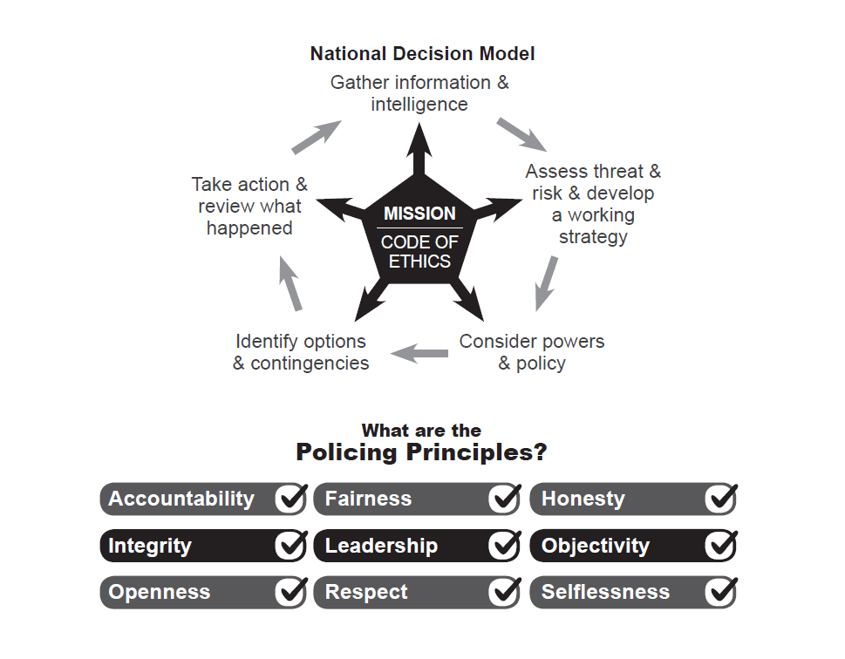

PART ONE

To: Office of Police and Crime Commissioner
Performance Meeting

Date: 21st November 2018

By: Strategic Planning

Title: Progress against the Police and Crime Plan
__________________________________________________________________

Purpose of Report/Issue: The purpose of this paper is to provide an update for the Police and Crime Commissioner regarding Surrey Police performance on the Police and Crime Plan.

Report Detail:

1. Tackling Crime and Keeping Surrey Safe

Force Recorded Crime and Positive Outcomes:

Force: Volume of Recorded Crime
The volume of recorded is crime is the total notifiable offences recorded within Surrey as defined by the Home Office Counting Rules (HOCR).
For the 12 months to October 2018 the volume of notifiable offences recorded was 74,349 which is up 0.1% compared to the 12 months to September 2018 (74,287). Over the last few years there has been a national increase in recorded crime with Surrey matching this increase. There have been increases in crime areas that have been significantly under-reported in the past, for example hate crime, domestic abuse and non-recent sexual abuse. Surrey have worked hard to increase the public’s trust and confidence in us and we are now seeing greater willingness to report these types of crime as a result.
The latest ONS data to the end of June 2018 shows that total crime is up 10% across England and Wales when compared to the 12 months to June 2017. The south east region has recorded an increase of 12%, with Surrey recording an 8% increase. With 61.5 Surrey is recording the eight lowest crimes per 1000 population across England and Wales. Surrey has the lowest rate in the south east region.
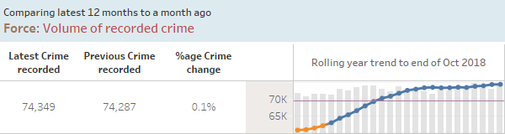
Force: Volume of Positive Outcomes
Home Office Counting Rules requires all notifiable offences to have an outcome. For Surrey, a ‘positive’ outcome is a notifiable offence with either a charge; caution; penalty notice; drug warning; community resolution or TIC (taken into consideration).
For the 12 months to October 2018 the volumes of positive outcomes for notifiable offences recorded was 11,217 which is down -2.2% compared to the 12 months to September 2018 (11,468). This is a slight reduction but recent volumes are within normal variation.
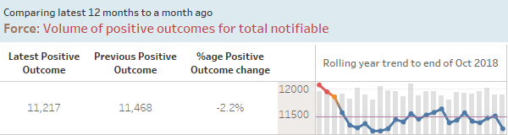

Force: Positive Outcome Rate

Positive outcome rates are calculated using the volumes of positive outcomes in a given period divided by the volume of crimes in the same period.
For the 12 months to October 2018 the positive outcome rate for notifiable offences was 15.1% which is down -0.4 percentage points compared to the 12 months to September 2018 (15.4%).
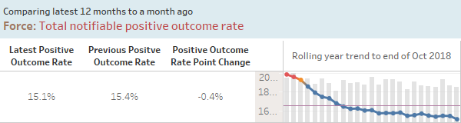

Force: High harm positive outcome rate

High harm offences are comprised of the following types of crime: Serious Sexual Offences, domestic related offences involving violence, child abuse offences and hate crime offences.
For the 12 months to October 2018 the positive outcome rate for high harm offences was 18.5% which is down -0.4 percentage points compared to the 12 months to September 2018 (18.9%).
The decline in positive outcome rate for high harm has over the year been attributed to the notable increase in high harm offences. High harm volumes and associated positive outcome rate continues to be monitored as part of the force’s balance scorecard and feature within the performance framework whereby Assistant Chief Constables (ACC) monitor Chief Superintendent performance.

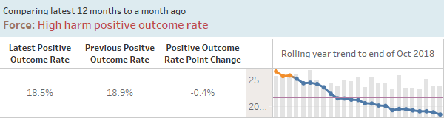
Robbery and Vehicle crime
There has been a noticeable increase in robbery (+24.1% +82) and vehicle crime (+18.2% + 958) offences over the last year.
The majority of the increase in robbery is on West (+60), with Surrey Heath (+26) seeing a significant increase however Elmbridge (+32) on North has seen the biggest volume increase.
North has seen the largest volume increase in vehicle crime (+419), mainly within the boroughs of Elmbridge (+170) and Spelthorne (+241). West has also seen an increase with Surrey Heath (+95) and Waverley (+139) recording some of the highest volumes.
These two crime categories are analysed further below.
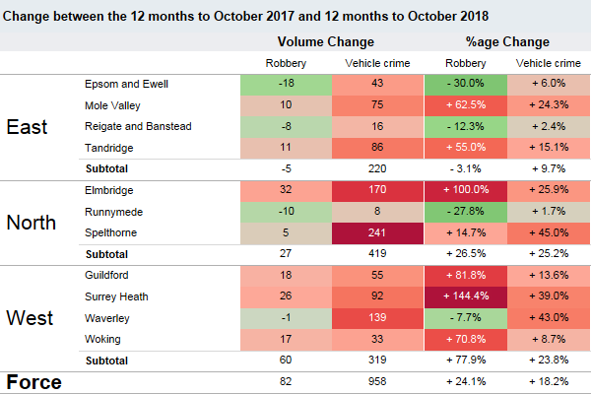

Vehicle crime
For the 12 months to October 2018 the volume of vehicle related offences recorded was 6,232 which is up 0.3% compared to the 12 months to October 2017 (6,211).
ONS data to the end of June 2018 shows nationally that vehicle crime is up 7%, with the south east region showing the largest change up 15% in these types of offences. Surrey is showing the largest increase in the south east region however Surrey has the second lowest rate of vehicle offences per 1000 population (5.1) compared to the south east region 6.2 per 1000 population as a whole.
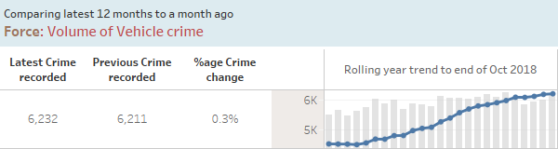
The majority of vehicle offences relate to theft from a vehicle which is up 14.7% (+494 offences) over the last 12 months.
Common themes from divisional dip sampling within these offences highlighted insecure vehicles targeted by offenders where expensive items are left on show within the vehicles. To address the increase safer neighbourhood teams have adopted vehicle crime as a local priority, preparing and owning a problem solving plans with a focus on preventative action.
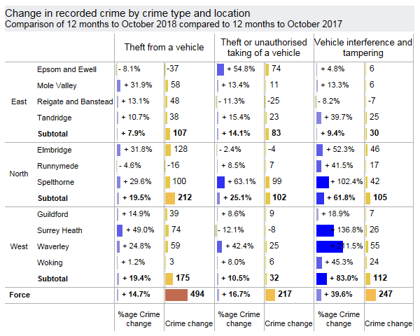

The maps below highlights those areas which have had vehicle offences recorded over the last year. With Epsom & Ewell North recording the highest volumes potentially due to its proximity to the Met border. Epsom & Ewell has seen an increase of theft of mopeds and moped-enabled crimes and has a problem solving plan to deal with this increase.
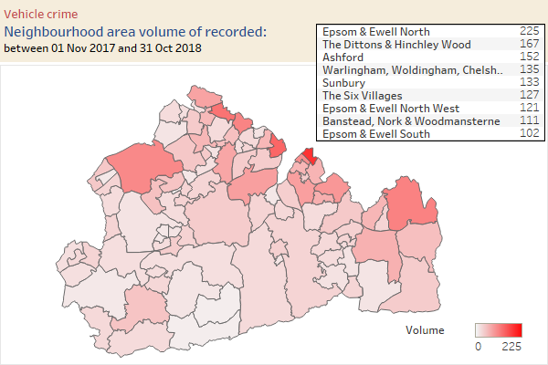
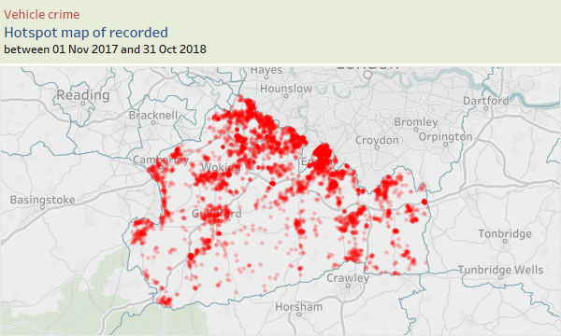

Robbery
For the 12 months to October 2018 the volume of robbery offences recorded was 422 which is down -2.1% compared to the 12 months to October 2017 (431).
In October 2018 there were 36 robberies recorded, the lowest since April 2018 and the trend is now showing signs of a decline.
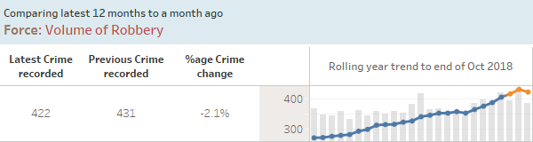
ONS data to the end of June 2018 shows nationally that robbery offences are up 22%, with the south east region showing the largest change up 19% in these types of offences. Surrey has the lowest volume of robbery offences in the south east region and the 7th lowest rate per 1000 population (0.3) compared to the south east region 0.6 per 1000 population and 1.3 per 1000 population nationally.
The neighbourhood map below shows those areas which have had robberies recorded over the last year. With Walton Central recording the highest volumes.
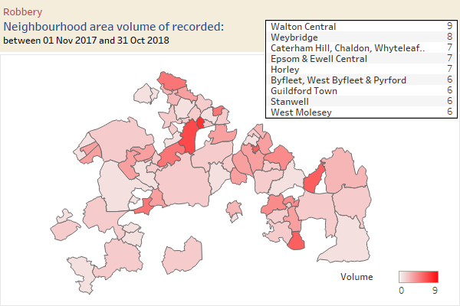
The majority (87%) of robberies over the last 12 months relate to robbery of personal property.

Problem Solving Occurrences

The 12 months to October 2018 show the volume of problem solving occurrences recorded as 209 which is up 3.5% compared to the 12 months to September 2018 (202). Volumes continue to increase as improvements are made to accurately record these occurrences.

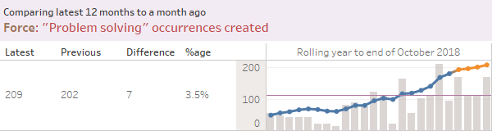

Dealing with ASB and Crime

Joint Neighbourhood Survey results for the 12 months to September 2018 shows that 73.0% of respondents agreed that Surrey Police are dealing with anti-social behaviour and crime issues that matter in their area. This is a further decrease on the previous year (-4.3% points) and the latest quarter (Jul-Sep 2018) results show a decrease of -0.8% points to 70.8%.
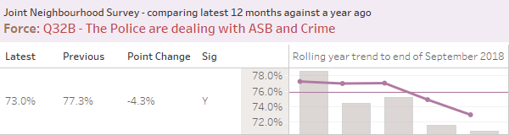

Call Handling and Deployment

Force: Calls for Service Performance
999 call handling performance remains strong and is always given priority. Latest 12 months to October 2018 shows 94.7% which is a continued improvement compared with the 12 months to September 2018.

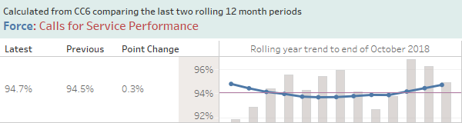

Force: Average time to answer 101 calls

101 call handling performance sees a greater degree of variation than 999 performance mainly due to a number of factors including continued prioritisation of 999 emergency calls over 101 calls, and the greater volume of calls we see during the summer months or following a significant incident.

Performance below shows the latest monthly results are within expected range.
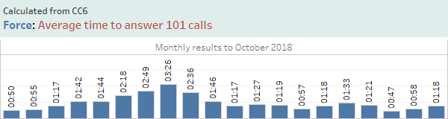

Force: Emergency Response Performance

Grade 1 & 2 response performance has reduced over the last 12 months. The latest 12 months to October 2018 shows grade 1 performance up 0.1 percentage points compared to the 12 months to September 2018. Grade 2 has shown an improvement in the latest 12 months up 0.2 percentage points compared to previous month.

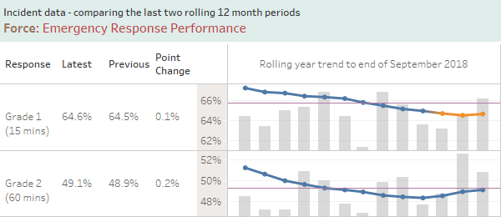

Terrorism

The tragic events of 2017 highlight the evolving and increased threat that the UK faces from both domestic and international terrorism. In June 2018, the Government published an updated and strengthened Counter Terrorism Strategy (CONTEST), to ensure we have the best response to this heightened threat.

Under this strategy, Prevent remains at the forefront of the UK’s fight against extremism, with continued objectives of tackling the causes of radicalisation, and safeguarding and supporting those most at risk. Surrey Police continue to deliver this duty by increasing awareness in front line officers and staff about how to identify and highlight concerns about individuals.

Counter Terrorism Policing South East (CTPSE) retains responsibility for Prevent Practitioners working in Surrey Police, and learning from the Op Air Review into the Parsons Green attack has been embedded into national Prevent processes, including the standardisation of assessments and timescales for progression of cases into the multi-agency Channel process.

The 2017 Counter-Terrorism Local Profile (CTLP) was delivered to the Prevent Executive Group in June and for the first time, this has been shared across Surrey Police to all officers and staff, to ensure an overview of threat areas, as well as the intelligence requirements highlighted in the plan.

Finally in September, Surrey launched the pilot scheme for the new National Prevent Referral form, for statutory agencies to report concerns. To facilitate this, a new referral pathway with the email address of preventreferrals@surrey.pnn.police.uk was created to form a “Front Door to Prevent”. This allows the Counter Terrorism risk to be assessed alongside the safeguarding concerns and not only streamlines the process, but ensures accurate referral data is recorded for the county

2. Building Confident Communities

Please see attached paper ‘Public Confidence’ for the Forces current position in relation to Public Confidence.

Force: Crime Survey for England and Wales (CSEW) Confidence

For the 12 months up to June 2018, the Crime Survey for England and Wales continues to place Surrey 1st for public confidence. Although the latest results show a reduction of 1.7 percentage points to 86.8% compared to the significant high recorded of 88.6% recorded in the 12 months to March 2018. The increase in subscriptions to ‘in the know’ and Surrey’s use of overt communications, keeping the public informed of our activity via social media providing real time feedback, engagement with the local communities, high profile incidents/convictions etc. is likely to have all contributed to this sustained level of confidence in Surrey Police.
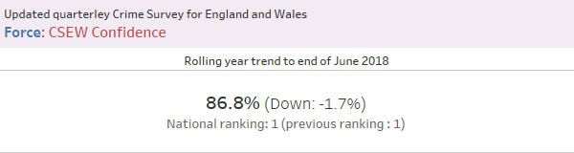

Force: Q19 – Confidence in Neighbourhood Police

Surrey County Council and Surrey Police survey over 6000 residents a year as part of the Joint Neighbourhood Survey (JNS).

In the 12 months to September 2018 those asked, ‘taking everything into account, how confident are you in your neighbourhood police? 87.9% said they were very or fairly confident. This is -2.0% points lower than the 12 months to September 2017 but broadly mirror the confidence results from the national crime survey for England and Wales highlighted above.

The drop in confidence in the latest quarter potentially relates to a decrease in agreement that the police are dealing with the crime and ASB issues that matter in the respondent’s neighbourhood.

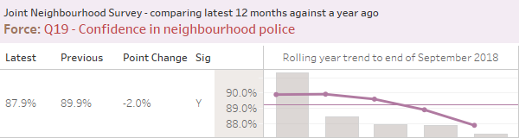

The table below shows the financial year to date borough breakdown of this measure.

Public confidence in their neighbourhood police BOROUGH LEVEL
Very/Fairly Confident (%)
Borough | Year End  17/18 | Quarter 1  18/19 | Quarter 2  18/19 | FYTD  18/19
Elmbridge | 90.1%  (588) | 87.8%  (148) | 87.1%  (147) | 87.5%  (295)
Spelthorne | 86.8%  (590) | 85.0%  (147) | 83.4%  (145) | 84.2%  (292)
Runnymede | 88.2%  (584) | 89.0%  (145) | 90.4%  (146) | 89.7%  (291)
Guildford | 92.9%  (593) | 90.4%  (146) | 84.9%  (146) | 87.7%  (292)
Surrey Heath | 91.0%  (590) | 89.7%  (146) | 87.8%  (147) | 88.7%  (293)
Waverley | 85.7%  (588) | 86.1%  (144) | 82.2%  (146) | 84.1%  (290)
Woking | 91.3%  (588) | 91.2%  (148) | 86.8%  (151) | 89.0%  (299)
Epsom & Ewell | 89.4%  (593) | 91.8%  (146) | 93.2%  (148) | 92.5%  (294)
Mole Valley | 89.8%  (586) | 87.5%  (144) | 87.8%  (148) | 87.7%  (292)
Reigate & Banstead | 92.6%  (591) | 84.8%  (145) | 90.6%  (149) | 87.8%  (294)
Tandridge | 87.8%  (591) | 83.3%  (144) | 85.7%  (147) | 84.5%  (291)

3. Supporting Victims

Force: Burglary and Violence User Satisfaction

The 12 months to September 2018 shows the burglary and violent crime satisfaction as 79.3% which is down 0.5 percentage points compared to the 12 months to September 2017 (79.7%).

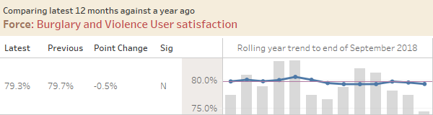

Overall satisfaction has decreased -3.0% points to 74.2% this month, with the FYTD result -0.9% points below the YE 17/18 result at 78.5%. Decreases were seen on all satisfaction indicators this month.
Satisfaction with actions taken has decreased by -3.4% points to 69.7% this month, with the FYTD result falling further below the YE 17/18 result at 74.0% (-3.4% points). Satisfaction with kept informed has also decreased, to 68.2% (-6.1% points), with the FYTD result -1.3% points below the YE 17/18 result at 69.2%.
Satisfaction with treatment decreased by -2.5% points this month to 86.3%, with the FYTD result -2.2% points below the YE 17/18 result at 88.9%.
Overall satisfaction for victims of burglary has decreased to 75.8% this month (-6.5% points), with the FYTD result broadly consistent with the YE 17/18 result at 84.7% (+0.1%). Overall satisfaction for victims of violent crime has decreased by -0.6% points to 72.9% this month, with the FYTD result remaining below the YE 17/18 result at 73.0% (-1.6% points).

Force: Rolling quarterly results for Victim Contact Compliance

Latest results for victim contract compliance are shown below. The 12 months to September 2018 shows the compliance rate of 64.8% down 9 percentage points compared to the 12 months to August 2018 (73.8%). NB: It should be noted however that two months-worth of the data (June/July 2018) is not available and therefore this comparison may not be a fair one.

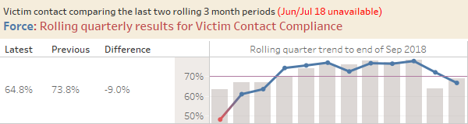

Force: Total ASB User satisfaction

The 12 months to September 2018 shows the Total ASB User satisfaction as 72.3% which shows a slight improvement (+0.4 percentage points) from the 12 months to September 2018 (71.9%).

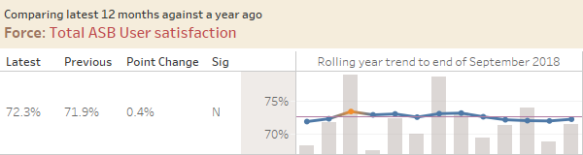

This month overall satisfaction for all call grades increased +2.6% points to 71.5%. The FYTD result is currently -1.8% points below the previous year end result at 71.3%. Overall satisfaction for Grade 1-3 callers increased to 80.3% this month (+8.3% points), whilst overall satisfaction increased to 68.2% (+1.0% points) for Grade 4 callers.

4. Preventing Harm

Force: Repeat Vulnerable Missing Individuals

The volume of vulnerable missing individuals over the last 12 months to October 2018 is 966, a further reduction (-34) on the volume recorded in the 12 months to September 2018.

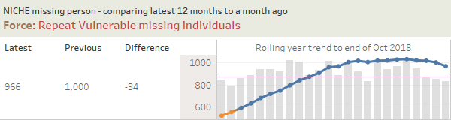

Force: Repeat Victims of High Harm

The 12 months to October 2018 shows the force has a repeat rate of 26.7% for high harm offences which is up 0.5% points compared to the 12 months to September 2018 (26.2%).

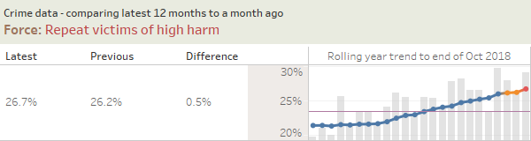

Mental Health Needs

Surrey Police works alongside key partner agencies including Surrey and Borders NHS foundation trust, Surrey County Council and the counties acute hospitals in both a strategic and operational capacity with the aim of providing the best level of service to those with mental health problems.

Surrey Police employs a dedicated Mental Health Portfolio lead who is responsible for overseeing the police role within mental health provision in Surrey. This role represents Surrey Police on the county wide Mental Health Crisis Care Concordat which, in line with Home Office guidance, aims to deliver a high quality, multi-agency response at times when people with mental health problems require support.

Surrey Police plays an integral role in ensuring the multi-agency response to those in crisis is appropriate and supportive. This includes consistent review of policy and procedure, utilising and sharing best practice across national networks, implementing national guidance and frameworks set out by NHS England, the Home Office and the National Police Chief’s Council and utilising innovative projects to provide a more effective response.

Surrey Police aims to learn from performance measures, partner agency working and feedback from those who have lived experiences to develop its response to those in crisis. Overall assessment of the role of police within mental health services is conducted by Her Majesty’s Inspectorate of Constabulary.

5. Making Every Pound Count

Please see attached paper - Force Financial Report Month 6 - 2018/19.

6. A Force Fit for the Future

Estates Strategy

A strategic business case to replace a number of out-dated and costly buildings with modern, fit for purpose estate was approved last year. Sites identified for disposal include the Mount Browne HQ, Woking police station and Reigate police station and a number of potential future estate model options have been under review. In March of this year the Police and Crime Commissioner and the Chief Officer Group approved a recommendation for replacement of these sites with a new combined HQ and East Division hub in the Leatherhead/Dorking area.

Work continues to assess the suitability and feasibility of a number of potential site options. Depending on location the site may also provide a central hub for Roads Policing and Armed Response teams, freeing further sites for disposal. A central HQ location will ensure specialist teams are able to respond effectively to county-wide demand and that the force is well placed to maximise opportunities emerging as a result of increased collaboration with partner forces across the South East.

Consolidating a number of sites into a single new one is cost-effective and will maximise savings in estate running costs. Rationalisation of the estate will be underpinned by widespread rollout of modern, agile working practices supported by appropriate technology. The first agile working pilot went live in June with a number of support departments at Mount Browne now working from modernised working environments and benefitting from more choice over where and when they work. Initial indications are that the impact has been positive in terms of staff morale and performance as well as space use efficiency. Preparations for a second pilot involving a number of operational teams based at Reigate police station are well underway, with the pilot due to go live in December 2018. Learnings from both pilots will be invaluable in informing future plans as estate changes progress and agile working is rolled out more widely.
__________________________________________________________________

Recommendation(s)/Future Activity: The Police and Crime Commissioner is asked to note the contents.

Risks: Performance risks are addressed through the Force Performance Board chaired by the Deputy Chief Constable.

Attachments/ Background Papers:
Public Confidence Report
Force Financial Report Month 6 – 2018/19

Contact details
Name: Strategic Planning Team
Job Title: Strategic Planning Team
Telephone number: 01483 630129
Email address: strategicplanning@surrey.pnn.police.uk

