


MEDIUM TERM FINANCIAL PLAN
2023/24 – 2026/27
February 2023
Achieving Financial Excellence | Finance Department

Achieving Financial Excellence | Finance Department


Contents

- Introduction
- Funding
- High level Budget Planning & Strategy
- Budget Gap and Savings
- Officer and Staff Headcount
- Capital Strategy
- Reserves
- Assumptions
- Risks
- Appendices
A – Medium term financial forecast
B – Savings plan
C – Financial assumptions
D – Risk analysis
- Glossary

Contacts

Document Owner
Anthony Croxford
Temporary Executive Director of Commercial & Finance Services
Document Editor
Sue Eaton
Budget Accountant

- Introduction
Each year the Force is required to produce a three-year Medium Term Financial Plan (MTFP) to forecast the future financial challenges it faces. The plan takes account of the resources required to deliver the:
- Police and Crime Commissioners Police and Crime Plan
- Force Business Plan and;
- Force Management Statement

It requires reasonable and prudent estimates to be made of future costs and income, including some sensitivity analysis, to ascertain whether there is the risk of a financial gap over the MTFP period and then how this can be addressed.

This year has been particularly challenging given the current high levels of inflation, and in particular whether this is short or long term and whether it impacts pay, coupled with uncertainty over future funding – particularly around Uplift and pay. Assumptions have therefore been made taking account of local circumstances but also following discussion with national partners which give a reasonable indication, albeit with some uncertainty, as to the future financial challenges the Force could face.

This incorporates unavoidable costs, including cost brought forward from 2022/23, pay inflation and other unavoidable cost pressures such as funding for IT licences, national charges, overtime due to additional bank holidays, national pension remedy from McCloud decision and unavoidable costs pressures arising from salary increments, fuel and utility increases, increase in SEROCU contributions, legal fees, Estates Strategy, ERP, and revenue contribution to capital financing

Over the period to 2026/27, based on the assumptions made, almost £16m of savings will be required. This is from a Force that has already delivered £53.5m saving over the last 10 years. There is no doubt that this will be a challenge and to that end the Force has engaged external advisors to assist with that process. Whilst every opportunity will be taken to try and ensure there is no impact on services, savings of this magnitude can only be delivered through reductions in headcount – since staffing represents 80% of all costs. As Police Officer numbers are ringfenced by Government this means that Police Staff, of whom a large proportion support the front line, are likely to be where the savings are found.

In addition to the revenue forecast a capital expenditure forecast covering the period to 2026/27 has also been included in this document. This will need regular reviews to ensure that it reflects accurately the timing of individual projects and planned expenditure. The capital grant received previously from the Home Office was withdrawn in order to re-distribute as wider national allocations and so all expenditure has to be funded from assets sales, borrowing and revenue.

Both of these forecasts will be revised during the year as more information becomes available. This will enable the Force to react to any changes required and thus ensure that it can remain financial sustainable and able to deliver services for the foreseeable future.

- Funding
Surrey Police receives its funding for services from a combination of Government grant and Council Tax. The level of grant is determined centrally by Government and distributed by way of a formula – sometimes this may be dependent on the delivery of national objectives such as Uplift. Council Tax levels are able to be set locally by the PCC albeit the Government sets a limit above which any increase is subject to a local referendum.

Government Funding

The Government announced a 3-year settlement for Police in 2022 as part of the spending review but this did not include details for individual forces – these instead are published on an annual basis. The financial settlement for 2023/24 was announced on 31st January 2023 with no changes from the provisional settlement announced on 14th December 2022.
The key elements of the national settlement were;
    - £17.2 billion for policing in 2023/24, an increase of £0.3bn on the 2022/23 funding settlement. However not all of this comes directly to Forces as elements are top sliced for national programs as shown in the table below.
    - Available funding to Police and Crime Commissioners (PCCs) will increase by up to an additional £523 million in 2023/24, including local flexibility to increase council tax precept by £15 on band D which would represent an increase to PCC funding in cash terms of 3.6% on top of the 2022/23 police funding settlement.
    - The Chancellor confirmed at the Autumn Statement that departmental budgets set out at Spending Review 2021 will be maintained to 2024-25. This confirms that, despite the pressures faced by all public services, they are still increasing funding into 2023-24 by providing forces with an increase to government grants of £174 million, £74 million more than announced at Spending Review 2021 (SR21), reflecting the commitments made earlier this year to support the 2022-23 pay award
    - Funding for counterterrorism continues with £1 billion for 2023/24 to support ongoing counter- terrorism policing investigations to keep the country safe and including funding for both armed policing and the counter-terrorism Operations Centre.
    - The settlement stresses the importance of maintaining the additional 20,000 officers funded through the Uplift Programme and have ringfenced £275 million which will be allocated in line with funding formula share. As in previous years this will only be accessible to PCC’s upon demonstrating that they have maintained their overall officer headcount, comprised of their agreed Police Uplift baseline plus their allocation of the 20,000 additional officers.
    - As part of the Spending Review 2021, the Home Office expects to see at least £100 million of cashable efficiency savings delivered from force budgets by 2024/25, achieved through areas such as working with Blue Light Commercial and management of Corporate Functions.
    - £1.1 billion for national priorities, resource, maintaining our focus on cutting crime to make communities safer, we are continuing to invest in critical priority areas. This includes drugs and county lines activity, violent crime reduction, child sexual abuse and exploitations, fraud and modern slavery. This is set out in the table below:

Top Slicing / Reallocations | 2022-23 | 2023-24
 | £m | £m
PFI | 72 | 71.6
Police Technology Programmes | 607 | 526.4
Arms-Length Bodies | 69 | 74.7
Top-Ups to NCA and ROCU's | 33
Police Special Grant | 62 | 50.0
Police Uplift Programme | 12
National Policing Capabilities | 11
National Capabilities Programme | 65 | 69.3
Police & CJS Performance | 13
National operational policing units | 3
Forensics | 26 | 20.6
Police Now | 7
Crime Reduction Programmes | 46
Crime Reduction Capabilities | 13 | 18.4
Fraud | 23 | 18.1
Rape Review | 12
Serious Violence Strategy | 50 | 45.6
Drugs / County Lines | 30 | 30
Regional and Organised Crime |  | 39.5
Counter Terrorism | 32
NPCC Programmes |  | 9.5
Cyber Crime |  | 14.1
Tackling Exploitation and Abuse |  | 21.3
Capital Reallocations | 188 | 104.9
Total | 1,374 | 1,114

- The Police Technology Programmes caters for Airwave, the new Emergency Services Network which will provide 4G access to officers that will bring productivity and operational benefits, Home Office Biometrics and National Law Enforcement Police database.
- Arms Lengths Bodies includes the Independent Office for Police Conduct, the HMICFRS PEEL Inspections, the College of Policing Direct Entry scheme and the Gang Masters Labour and Abuse Authority.
- Strengthening the response to Organised Crime and Top Ups to NCA and ROCU’s - this is funding for the National Crime Agency and Regional Organised Crime Units.
- The Police Special grant caters for national events or incidents that require additional police support.
- Funding to combat serious violence, including Violence Reduction Units and the Grip ‘hotspot policing’ programme. Funding arrangements for specific crime reduction programmes will be confirmed in due course.
- Delivering on the commitments made in the 10-year drug strategy by prioritising funding to clamp down on drugs and County Lines activity which has already achieved over 2,900 county line closures since 2019.
- Continuing to invest in tackling exploitation and abuse, including child sexual exploitation and modern slavery.
- Prioritising Regional Organised Crime Units, ensuring they are equipped with the specialist capabilities and dedicated resource needed to support law enforcement in confronting serious and organised crime.
The Government states that it has provided significant investment into policing over the previous four years and expects the police to continue to build on the progress made on improving efficiency and productivity in return for the significant increase in investment. The Government expects the policing approach in 2023-24 to focus on the following key priorities:
- Ensuring overall police officer numbers are maintained at the agreed Police Uplift baseline plus force level allocations of the 20,000 additional officers.
- Deploying these additional officers to reduce crime and to keep the public safe.
- Delivering improvements in productivity and driving forward efficiencies, maximising the value of the Government’s investment.

The level of funding from government is the lowest in the country per head of population and Surrey receives £105.52 per head of population (of all government funding). This is shown in the graph below:
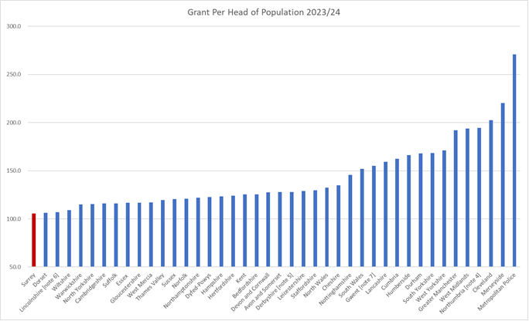
If Surrey were to receive the average in the Southeast region this would provide the Force with over an additional £16.1m, even though this magnitude is not expected it does illustrate the inequitable position of police funding and if a fairer funding position was achieved this could see police officer numbers increase or reduce the tax increases for Surrey residents.
The anticipated review of the police funding formula was consulted upon and ultimately deferred with an expectation it will be addressed as part of any future comprehensive spending review. Due to the uncertainty and range of possible outcomes no assumptions regarding a change to the funding formula have been included in the MTFP.

Local Funding

It is the responsibility of the PCC to set the precept, which is paid by local residents, each year. Although in theory the precept can be set at any level in practice the Government sets an annual referendum limit. If a PCC increases their precept above this limit then they must hold a confirmatory referendum at their own expense. Hence in reality the referendum limit acts as a cap on precept increases.
At the time of the spending review the Government announced that the referendum limit would be £10 for each of the 3 years ending in 2024/25. However, following representation from Forces in relation to spending pressures the Government lifted the referendum limit to £15 for 2023/24 only. For 2023/24 the Police and Crime Commissioner after consulting with Surrey residents, the Chief Constable and considering the operational impact of a lower increase, proposed an increase in the precept by the maximum amount of £15 on Band D properties. The Police & Crime Panel endorsed the PCC’s decision on 3rd February 2023. This resulted in the Council Tax requirement and the Collection Fund per District as set out in the table below.
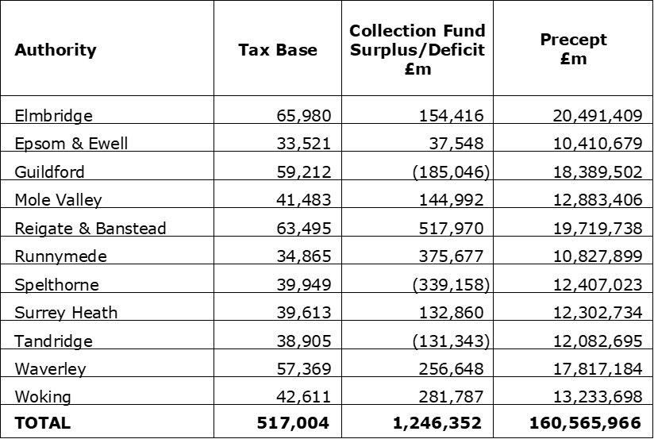
The proportion of funds raised from the precept for Surrey equates to 56% of core funding (Precept, main policing grant, revenue support grant) for 2023/24 – the highest in England.
As a result of Surrey receiving the lowest level of grant per head in England as per the graph shown above, Surrey is more dependent on precept than other forces and accordingly has one on the highest Band D rates (£310.57 for 2023/24) for police forces. The table below illustrates this for the potential 2023/24 if all Forces increased by £15 their Band D rate.
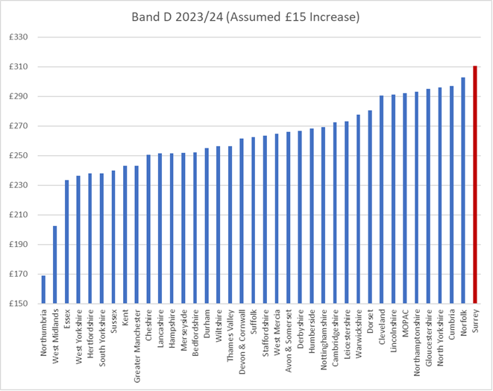

Financial Assumptions

Surrey Police had experienced a real terms funding reduction of 8.0% between 2011-12 and 2019-20 then only increases due to Home Office grant funding for Uplift in years 2020-21 to 2022-23. The chart below shows the reduction in government grant until recently and how this has been compensating for with increases in precept leading to the fact that precept now makes up 56% of the Forces funding.

It is difficult to predict with any certainty Government Funding or precept since this is only announced each year. Given the Government has repeatedly said that public spending is very tight it has been assumed that there will be no cash increase in funding for the MTFP term. If additional funding does become available it is more than likely this will be tied to new policy outcomes desired by the Government rather than for core policing. It has also been assumed that the Uplift Grant will be rolled forward as an incentive to maintain officer numbers. Historically Council Tax increases have been capped 1.99% and so in the absence of any other information this has been taken as the maximum increase available. This leads to the funding as set out in the table below:

- High level budget planning and strategy
Current high inflation and the unpredictability of prices makes it difficult to plan our finances. Unlike many businesses we are unable to increase our income, say by increasing prices, as our total income is set by Government. Conversely we are unable to stop loss making activities or do less as Policing is a demand led public service. Hence the budget can only be balanced by increasing efficiency and focussing on core activities.
The Consumer Prices Index including owner occupiers' housing costs (CPIH) rose by 9.3% in the 12 months to November 2022, down from 9.6% in October. Several factors including supply side shortages, demand and the impact of the war in Ukraine has led to price rising at rates not seen in the UK for decades. The graph below shows the rates over the last 10 years

Table CPIH Inflation 10 Years – Source ONS

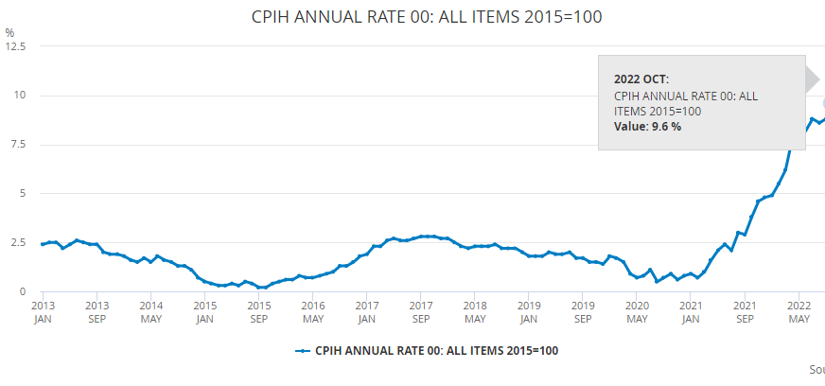
Inflation continues to be of particular concern as we plan for the next 4 years with the Bank of England’s prediction of a Consumer Prices Index (CPI) figure of over 7.4% in 2023 coming down from 9.1% last year; December CPI was 10.7%. Supply issues, particularly from the far east, has also fed through to supply side inflation. These risks have been considered and are included in the financial risk assessment in Appendix E.
Planning work has been continuing throughout the year for the future years of the MTFP period, with some assumptions being made (shown at Appendix C), to enable this document to be prepared. For expenditure is has been assumed that:
- Inflation for staff and Officer Pay is afforded an inflation increase of 2% in 2023/24 and 2% in each future year. It has been assumed that any pay settlement over 2% will be funded by central Government as this exceeds the increase included within the spending review.
- Non pay inflation has been budgeted at 2%. Note one of the financial interventions used in the past was to suppress the budget increase for inflation growth to budget holders unless there was a contractual commitment in place, this option has been used for 2023/24.
The Force Fit for the Future set out the ambition of the Force to meet demands and priorities identified in the Force Management Statement and a step towards that ambition has been made possible from the Operation Uplift and the precept funding in prior years.
The Estate Strategy programme has now been re-evaluated and the preferred option is to upgrade the existing Mount Browne headquarters and make it fit for purpose. Design work has commenced with RIBA Stage 3 due for completion during 2023/24. Main phase construction investment timeline will be dependent on sale of Leatherhead site which is ongoing due to market uncertainty.
An integral part of the financial plan is the capital plan and the sources of funding and as the capital grant has now stopped and the level of capital receipts has diminished there will be great reliance on revenue funding. This has been built into the revenue projections. Long term borrowing is the option employed to fund the Estate Strategy and will only be used for long term assets.

- Budget Gap and Savings
Using the assumptions for both income and expenditure as set out above this results in a budget gap of £15.7m as set out in the table below and in more detail in Appendix A.

For 2023/24 savings of £1.6m are required and these are set out in the chart below:
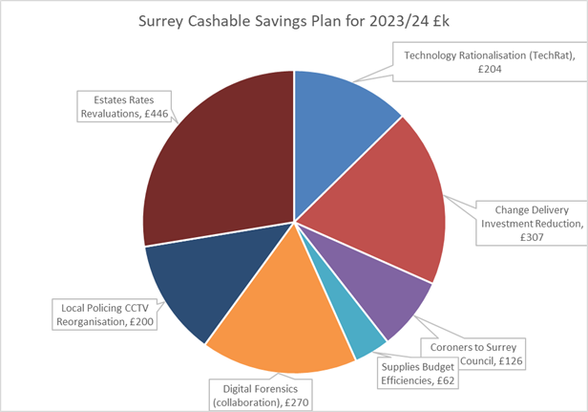

Any additional tactical savings opportunities identified during 2023/24 will be carried forward into later years to address the future funding gaps.
The savings developed for 2023/24 are considered mainly tactical as the lead time to deliver in year was short which requires a concerted effort to move into medium term sustainable cashable efficiency plan.
Efficiency saves schemes as identified by Joint Force Change and the Tactical Savings Working Group (details shown in Appendix B) are categorised into the red, amber & green risk headings. The future efficiency savings plan requires ongoing review and development as it is estimated that £14.1m of additional savings will be required by 2026/27.

The Force will continue to identify efficiency savings, both cashable and non-cashable in order to balance the future budget, invest into the priorities and improve service to the Surrey residents.
However, this is challenging given the scales of savings already delivered. The chart below shows that savings of £53.5m have been achieved during precious 10 years

Recognising this the Force, jointly with Sussex Police, commissioned PA Consulting to assist us in our programme of transformational change. This uses their wide-ranging expertise in public sector transformation and access to industry standard data within a critical, in-depth review of service delivery. This has identified a range of opportunities, which are all grouped together in a “Joint Force Change Programme”, for change and cashable savings, and contribute to the following outcomes:
- A reduced and simplified IT estate with more shared use of systems
- Greater automation that frees up capacity and improves service delivery
- A workforce that has read access to data and technology to do their jobs
- Better ability to manage and understand demand to ensure efficient use of the workforce
- Beneficial collaboration that works for both Forces
- Greater grip of assets and contracts that meet changing demand and are of best value
- A workforce that has clear purpose and the appropriate skills.
  - Joint Force Change Programme (JFCP)
  - It was clear through early investigation that it would not be possible to meet the level of savings required through existing or planned changes, and that a more ‘transformational’ approach was required if it the impact to the public was to be minimised.
  - The scope of the JFCP is wide ranging, with only the protection of police officer numbers being non-negotiable due to the Government Uplift Programme which ring-fences officer numbers and reinforces this with a penalty regime. The Programme has a clear set of working principles:

- To address the funding gap
- To deliver against the Force’s priorities, and the priorities of its communities
- To maintain the Force’s identity
- To deliver change and benefits in a sustainable and adaptive manner.
  - The JFCP plans to tackle the funding gap in four ways:
  - Transformation Projects: These will be where the most significant opportunities lie and potentially up to 75% of the funding gap could be closed from these projects. There are several projects identified under four thematic areas and will be delivered incrementally from 2024 onwards.
  - Planned and Tactical Savings: It is anticipated that 10-15% of savings can be found from projects underway currently and through senior leaders driving efficiencies from within their own business areas.
  - Targeted Reviews: These will be implemented from 2023/24 and will form the biggest cultural change for both organisations. Through regular reviews of business areas, opportunities will be identified to deliver a function at a lower cost. The methodology can be scaled up or down depending on budget pressures and it is anticipated that 25-40% of the savings needed can be found through this process.
  - New Change Management approach: A new joint Force Change model will be implemented during 2023/24 to enable both forces to plan, deliver and realise the true benefits of such a significant Transformational Change Programme.
  - Internal governance arrangements are in place to track achievement of savings and new investments, to monitor the pace of change sufficiently to provide management with early warning should plans not progress as anticipated and ensure any additional action required is undertaken during the year. Detailed business cases to realise savings targets are presented and considered at the Joint Chief Officer Meeting and the Strategic Change Board.
  - Surrey Police continue to review its efficiency savings and future investment plans to ensure quality service delivery is maintained, future financial risks are considered, and funding can be directed to priority areas.

- Office and Staff Headcount
  - The Government has provided significant investment into policing over the previous four years to enable it to recruit an additional 20,000 officers nationally and it expects the police to continue to build on the progress made on improving efficiency and productivity in return for this.
  - During 2022/23 the Force progressed its recruitment plans to fulfil Operation Uplift and is forecast to meet the target by the end of the year. The Government requires the Force to maintain the officer headcount number for at least 2023/24 and to this end a mechanism is in place to claw back some or all of the uplift performance grant of £3.6m if this is not achieved.

Hence in 2023/2024 we plan to maintain our officer numbers by recruiting regularly throughout the year to build a stable workforce. Having grown significantly over the last 3 years we have a high proportion of officers still in probation who we will continue to train and develop to achieve Independent Patrol status and Full Operational Competence. As our capability grows we will be using the Force Management Statement to identify future resourcing requirements to meet demand.
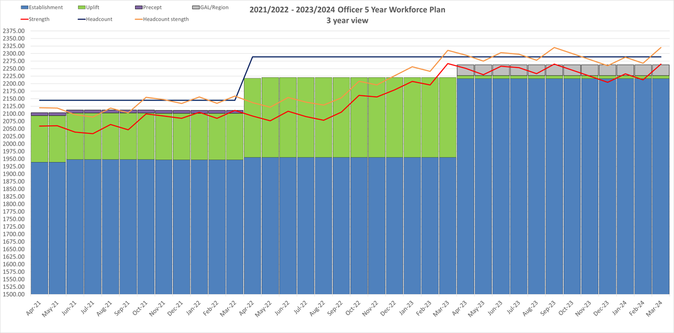

As Police Officer number are effectively ringfenced any savings can really only come from reducing the numbers of Police Staff. At this stage in the development of the four year plan a broad approach has been taken since it is not possible to determine which, or how many, staff may be impacted. However, if we assume that half the savings required will be staffing reductions then using an average rate per staff member a rough reduction in posts can be calculated. This is set out in the chart below:
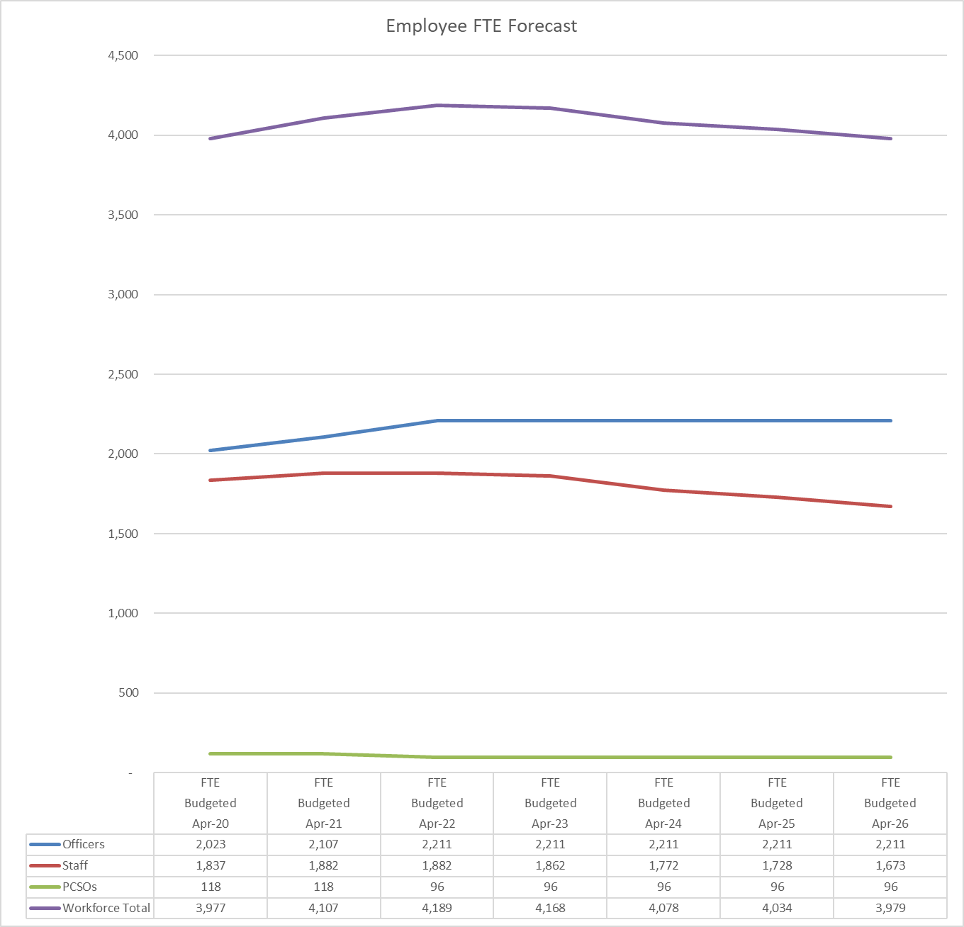
- Capital Strategy
The Force is required to continually invest in its estate, equipment and facilities in order to enable staff and officers to serve the public. The demands and complexity of technology increases the capital requirement along with the need to reduce the Forces carbon footprint adding further pressures. No specific capital grant is provided by Government and hence all capital has to be funded from borrowing, asset sales and revenue sources.

In order to put together a Capital Forecast the following strategies have been used:
- The Estate Strategy sets out the financial plan for the re-development of the headquarters at Mount Browne as well as the disposal of other assets
- The ICT Strategy sets out ICT requirements for the future and sets out a number of external dependencies and will be revisited periodically.
- The Fleet Strategy sets out the capital required for replacements, future enhancements to vehicles such as telematics and cameras as well as plans to enable a transition to net zero by 2035.
A summary of the capital programme is provided in the table below:

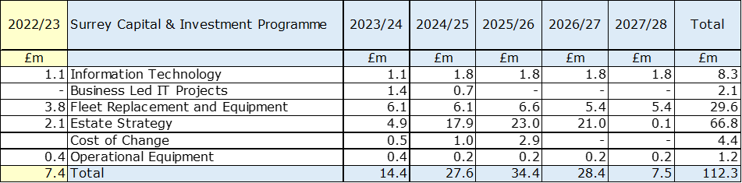
The funding of the capital programme is from grants, capital receipts, revenue budget or borrowing. Based on the proposed capital plan there is a requirement to borrow for both the Estate Strategy and to support the capital expenditure programme. The PCC currently has external borrowing from the PWLB for the purchase of Leatherhead site and has internal borrowing. The route of any future borrowing would be agreed by the Chief Finance Officer to meet expenditure and will be considered as part of the monitoring regime during the year.
A summary of the funding for the capital programme is provided in the table below:

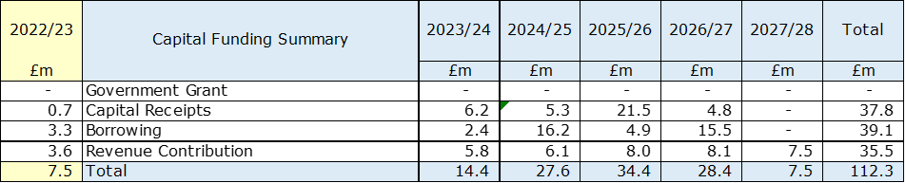

Pressures on the revenue budget may mean that the level of revenue funding for capital is reduced and that more borrowing may be required. However, borrowing only defers the cost to later years and also incurs interest which is chargeable to revenue. Any borrowing has to be authorised by the PCC.
- Reserves
Reserves are required to enable funds to be set aside to for major projects as well as to deal with contingencies and financial uncertainty. Reserves can be general i.e. available for anything or earmarked i.e. for a particular purpose.
It is best practice to maintain the level of general reserves to a minimum of 3% of annual revenue budget. The chart below shows the general reserve level is forecast to be at 4.6 % in April 2023 and 4.5% April 2024 and 4.4% over the remainder of the planning period assuming there is no use of general reserve to support the funding position i.e. all of the savings identified have been achieved.

The specific or earmarked reserves are forecast to be as follows:

The PCC Estate Strategy Reserve is employed to meet additional estate strategy costs in 2023/24 and again in 2026/27 and also to support the 2023/24 revenue budget. The Cost of Change Reserve is being employed to meet approved Transformation activity during 2023/24.

- Assumptions
Assumptions regarding the financial forecast are set out in Appendix C and more detail on these is set out below:
- Government Grants will remain cash limited from 2023/24.
- The agreed savings plans are realised in amount and timing.
- The precept will rise by 2.0% a year from 2024/25. The tax base from which the precept is derived has an estimated growth rate of 0.5% per year.
- Staff and Officer Pay will increase by 2% a year.
- Non pay inflation will increase by 2%. Any increases above this will be absorbed by budget holders unless there is a contractual commitment in place.
- Assumes no change in the level of contributions to the Local Government Pension Scheme as a result of the 2022 revaluation.
- Police Officer Pension Fund: The police officer pension is a pay as you go and is not funded or backed with assets. The fund following a valuation process the employers’ contribution rate increased to 31% in 2019/20. It has been assumed that this rate will not change 2023/24.
- Reserves Strategy: the plan is built on the basis that the reserves strategy of maintaining general reserves at no lower than 3% of budget is in place for the planning period.
- The Surrey Estates Strategy: the latest estimates have been incorporated including Agile Working and the re-development of Mount Browne headquarters, both of which have a capital and revenue impact.
- The DDaT Strategy is to be reviewed to ascertain the level of funding required over the planning period, currently all estimates in the plan and will be periodically reviewed as external dependencies will have an impact.
- Risks
There are a number of risks to our financial position over the planning period. These are summarised below and set out in more detail in Appendix D. This will be continually reviewed so as to identify new risks as they arise
- The government have over the last few years employed top slicing to fund national initiatives or growth in national functions. This has been increasing each year and remains a distinct possibility that this approach may result in further reduction on the level of funding to police forces. The Emergency Services Network is due to be implemented during the planning period and the funding required to implement to new service is being drawn from the national police allocation.
- Inflation is seen as a key risk since the pandemic and because of the Russian/Ukrainian conflict which has seen significant hikes on fuel and energy prices.
- As Surrey is more dependent on local funding than most Forces we could face a higher percentage funding impact if there were any changes to reduce the referendum trigger.
- Employee retention remains a risk for the Force and funding has been included in the base budget to mitigate this.
- Revaluation of properties to be undertaken in 2023 poses a risk that police premises could see an increase in rate costs, but there could also be a potential benefit should rateable values reduce.
- Increase in legal fees due to the impact of the recent Carrick case at the MET and HMICFRS report into the Wayne Couzens case resulting in increased vetting for both Officers and Staff to be checked against the national police database.
- The increasing demand on policing with the changing nature of crime is stretching resources and will require clarity of purpose to ensure the funding of the service is maintained at a level that provides a quality service to the residents of Surrey.
- The introduction of national systems and infrastructure changes are a prevailing risk as a mandated cost increase to the Force.
- The assumption of the level of government funding in future years may be superseded by future announcements increasing the reduction as seen in previous Spending Reviews particularly from the proposed funding formula review.
- Climate Change - Following Surrey County Council declaring a climate emergency the PCC and Chief Constable fully back the move and a strategy is now being developed through the joint Surrey and Sussex Environmental Board with the aim of making the organisation carbon-neutral by 2030. As the strategy is developed the financial implications will become apparent.

- Appendices - Appendix A
Base Scenario Medium Term Revenue Financial Forecast

Appendix B - Efficiency Savings Plan

Appendix C – Financial Assumptions

Appendix D Surrey Financial Risk Analysis – February 2023

Title | ASSUMPTION |  | COMMENT
Title | SURREY | SUSSEX | COMMENT
Pay and price budgets and establishment control | Provision for national pay awards of 2%.  Staff turnover and increments based on detailed analysis of current staff profile and trends.  General price inflation of 2% |  | Risk of pay requirements exceeding the budget provision.  Whilst the number of police officer leavers is difficult to predict, recruitment and promotions are managed during the year across Sussex Police to match staffing need and resources to budget.  Detailed analysis of employee costs is carried out in setting the budget with close monitoring of the overall budget and management action to maintain financial discipline is particularly important to ensure resources are deployed to achieve the most effective and efficient service delivery. The DCC Strategic Planning Board / Force Organisational Board will monitor all aspects of the financial and human resources including the recruitment progress and report to the PCC.  Any increase above the rates budgeted will need to be funded from a combination of use of an earmarked reserves, tactical one-off savings, cashable savings and efficiencies from service changes as there is no further government grant or precept available to meet the costs.  Loss of or reduced grant due to not achieving and maintaining required Uplift targets. Awaiting details of the Home Office grant rules to then articulate the risk and mitigations.
Uplift Performance Grant | Full performance grant will be received |  | Risk of loss of or reduced grant due to not achieving and maintaining required Uplift targets. Awaiting details of the Home Office grant rules to then articulate the risk and mitigations.
Non-Pay Inflation | Current inflation planning is at 2% |  | Risk of non-pay inflation exceeding the budget provision  Bank of England is forecasting that inflation has peaked and will decrease rapidly early in 2023/24. Any significant fluctuation in costs will be monitored through the monthly forecasting process and at the monthly CFO Risk Meeting.  There is also a risk that utility costs will continue to increase due Russian/Ukraine conflict.
Savings Plan | Budget includes savings |  | Risk the MTFF savings requirement is not met.  Recognising the need for future savings the Force has set up a Service Transformation Programme to review and identify where saving can be made. In addition to this Tactical Savings Working Group has been set up to review the outstanding 5% and 10% saving and identify other tactical savings.  The savings planned in the first year of the four-year plan are within the reserves available but would be exceeded in subsequent years if not delivered.
Police Pension | McCloud and Sergeant Implementation  Pension Scheme valuation change – cost neutral |  | Risk that the cost to the Force for the Police Pension scheme increases  Police pensions along with many public sector pensions were reviewed to ensure a fairer balance between public purse and pensioners. The scheme was changed to a Career Average Revalued Earnings (CARE) scheme which included transitional arrangements. These arrangements were challenged and accepted by the tribunal. The assumption is that no further costs will fall on the police fund following the statement below:  James Cartlidge MP, Hansard, Second Bill Reading HoC 5 January 2022  "The cost of the remedy is estimated to increase pension scheme liabilities by £17 billion, so it is the scheme liabilities that increase. However, that liability will be realised over many decades. It also represents a small proportion of the total savings of around £400 billion that will arise from the wider reforms to public service pensions. To be absolutely clear, the liability will fall on the Exchequer. I hope that offers clarification".  The Police Pension Scheme was last valued in 2016 and resulted in a 10% increase in employer pension contributions to 31.8% from the financial year 2019/20. The additional cost was met by a £2.7m government grant. It was anticipated that the next valuation will result in a reduction in the employer contribution and that any cost reduction up to 10% would be netted off the current grant payment and so cost neutral.  This assumption may change due to the impact of McCloud remedy costs and the latest judicial review which is due to conclude early in 2023 regarding cost cap and McCloud implications on members, which if upheld could lead to cost transfer to Employers which may or may not be covered by a further government grant.
Threat to the sum of core government funding received by the PCC following a change in the police funding formula | Review and initial consultation will take place in early 2023. |  | A review of the grant distribution method, known as the ‘formula review’, has been in planning for several years. Significant work has already been undertaken by PCCs and police to provide the body of evidence that will be required to convince HM Treasury of the financial requirements for policing bodies. The Home Office has now opened the review again. No assumptions regarding a change to grant levels has been included as it is expected that transitional arrangements will be implemented by the Home Office to manage any changes to allocated grant resources.  This risk is included on the OSPCC Strategic risk register and is monitored monthly.
Maintaining & improving service performance levels | Resources sufficient to meet targets and priorities in the Police and Crime Plan and Chief Constable Priorities |  | There is a risk that the Force is unable to maintain & improve service performance levels  The Chief Constables believe that there are sufficient resources to deliver future Police & Crime Plan priorities, Chief Constable Priorities and Strategic Policing Requirement. However there remains risk from the cost of major operations including counterterrorism, major incidents including pandemics, particularly if these are not fully funded nationally.
Limits to Precept Increases | £10 in 2023/24.  Future precept planning assumption of a 2% increase. | £15 in 2023/24, £10 in 2024/25.  Future precept planning assumption of a 2% increase. | There is a risk that precept funding is reduced on a permanent basis through precept limits or PCC decisions.  The provisional 2023/24 Police Funding Settlement allow PCC's the flexibility to increase the amount of precept by £15 for 2023/24.  The Localism Act 2011 gives a statutory obligation for council tax referendums to be held should a precept higher than prescribed be approved by the PCC. The Secretary of State for Communities and Local Government set the level above which a referendum would be required.  An increase in excess of the referendum level or precept ‘cap’ would result in the requirement to hold a referendum and the costs met by the OPCC.
Grant Levels | Main police revenue grant  Capital Grant removed |  | Recently the settlements have been one year only settlements but for 2022/23 a three-year settlement was announced at the national level. However only allocations for 2022/23 at Force level have been provided. Whilst we know the values of the settlement for 2024/25, it is not yet known how this will be distributed.  Capital Grant discontinued in 2021/22 and is now replaced through other resources including revenue or borrowing.
Council Tax | Collection rates advised by individual billing authorities | Collection rates advised by individual billing authorities  Tax Base - e.g. a move to 100% scheme as has been seen in 2022/23 by Lewes District Council | The risk of council tax collection rates being lower than expected could impact on the collection fund balances and any surpluses payable to the PCC. Billing authorities’ factor in prudent collection rates to mitigate this risk. The PCC works closely with billing authorities to monitor their key collection rates and contributes financially towards the costs of reviews of discounts, including the single person discount, and exemptions.  The tax base is normally expected to increase during the MTFS period, but the assumptions could be impacted by changes to the mix of dwellings, discounts and the impact of unemployment numbers within billing authorities’ council tax reduction schemes or changes to the proportion of support provided.  The tax base for 2023/24 is as confirmed by the billing authorities along with the collection fund. Future tax base increase assumptions are included in the MTFS at 0.5%.
Budget Estimates (Expenditure) | Provision for specific on-going cost pressures |  | The budget estimates including all identified additional costs for 2023/24, supported by input and review by the Chief Financial Officers.  All cost pressures are scrutinised internally by the Chief Finance Officers and also the DCC Strategic Planning Board / Force Organisational Board before inclusion in the financial plan.  Risks of budget overspend are mitigated by the monthly budget monitoring process and formal monitoring reports to the PCC.  The robustness of the overall budget setting process was reviewed by Internal Audit during 2022/23 receiving a substantial assurance opinion.
National IT System charges | Move to full cost charging without transfer of funding from Home Office. |  | Further potential costs related to the national Home Office charges for IT systems from a grant ratio allocation basis to a Force budget ratio which may lead to additional costs for Sussex Police including changes to training and the creation of the national police college could continue in 2023/24 and beyond. A PCC and Police national group has been established to scrutinise these costs before they are agreed.
Levels of Reserves | Forecast to reduce over the term of the MTFS  To mitigate this risk, the General Reserve is kept at a minimum of 3% of revenue expenditure. | Forecast to reduce over the term of the MTFS  To mitigate this risk, the General Reserve is kept at a minimum of 4% of revenue expenditure. | Risk that reserves levels are inadequate  Currently used to finance the capital and investment programme and major change initiatives. It remains a risk that the level of reserves is adequate to meet unplanned demand and unexpected costs.  An annual review of all reserves is undertaken at budget setting along with a post year-end review and update to the MTFS. Now that our budget is increasing further contributions are required to reserves in order to meet the stated limits over the period of the MTFS. Specific reserves are being employed to reduce the pressure on the revenue budget.  A reserve by its nature can only be employed as a one-off cash injection The savings planned in the first year of the four-year plan are within the reserves available but would be exceeded in subsequent years if not delivered.
Interest rates, investment and borrowing | Interest rates assumptions  Borrowing at fixed rates. |  | Forecasts of investment income for 2022/24 onwards are based on estimated cash balances and interest rate forecasts as set out in the treasury management strategy. A prudent position has been adopted about anticipating future increases in interest rates, to address the risk of interest rates being lower than expected, from a very low base.  The risk of investment fund loss due to collapse of the financial institution where the deposit is placed, is limited by controls within the Treasury Management Strategy which focus on security rather than returns. Potential impact is mitigated by a diverse portfolio with top credit rated institutions.  As part of the borrowing strategy in support of financing long term assets the ability to employ internal and external borrowing has been established which will be instigated by the Chief Finance Officer for the PCC.
Income Assumptions | Income budgets reduced for specific items. |  | Some risk of achieving on-going level of income targets included in Divisional and Department budgets. This will be monitored during the year and appropriate action, or mitigation agreed as necessary. Additional income may be received in-year due to unforeseen events, additional grants from Home Office or other third parties. Budget adjustments will be requested where appropriate.
LGPS Pension | LGPS reform changes |  | The latest triannual valuation is included in the financial plan commencing for 2023/24.  The recent increase in inflation (CPI) could lead to future actuarial valuations increasing the employer contribution rate.  Exit payment restrictions were introduced then withdrawn by the government including special severance payments and a £95k cap replacement scheme. Alternative proposals could be introduced in the future.  Other challenges to LGPS funds and administration include the impacts of McCloud underpin implementation, SAB and HMT cost sharing schemes, Goodwin (survivor payment equality) remedy and the alignment of LGPS valuation cycles with other government schemes e.g., police officer schemes.
Reductions in security grants | Potential reductions security grants. |  | MTFS assumes that grants will continue at current level. If subsequently reduced, savings will be made to cover the reduction outside of core savings targets.
Public Order | Additional cost of overtime and associated costs |  | Whilst action will be taken to mitigate the overtime and other additional costs relating to policing public order operations, significant costs may be incurred on anticipated events in 2023/24. The Force is following nationally agreed guidelines on the policing of events and cost recovery to reduce any impact of supporting other Forces. It is proposed that any in-year over-achieved savings will be used as a first source for funding, otherwise other revenue budget and operational reserve provides potential sources of funding if necessary.
Operational Demands | Public protection |  | Key operational pressures include continuing demand and complexity of public protection cases (domestic abuse and vulnerable children/adults) plus changes in nature/type of evidence collection, with a growing range of digital devices having to be examined requiring additional forensic time/resource and cost to process. The Forensic Capability Network (a national group) are overseeing developments in the Forensic market including digital forensics.
Operational Demands |  |  | https://recruitment-dcp-dp.org/dorset-police-staff/forensic-capability-network/
Capital Programme | Latest plans |  | There is a risk of the capital programme being understated, or that overspending occurs, resulting in insufficient funding being available as planned. Slippage may also impact on operational demands. The capital plan is reliant on several sources of funding including capital receipts which are at risk of not being achieved either in quantum or timing. These risks are mitigated by regular review of all major projects including the Estates Strategy and DDaT projects, focus on key priorities agreed in advance, together with monthly budget monitoring and regular monitoring reports to the PCC.  The Strategic Change Board to review bids on an annual basis
Capital Financing | MRP is calculated on an asset-by-asset basis |  | This Capital Financing risk is of charges being greater than budgeted. This is mitigated by considering revenue and capital implications of major project spend within the capital and investment planning process and inclusion within the MTFF. The MRP debt repayment provision is calculated on individual assets and 100% of borrowing has fixed term rates, thus will not be impacted by changes in interest rates. Borrowing is planned to finance the capital programme within this MTFS.
Regional Partners | Investment plans |  | The risk is that all regional partners are not aware of each partner’s investment plans, estate strategy etc. which can lead to unplanned expenditure within the year. A regional Police lead for SERIP has improved the communication to minimise this possibility, within their scope.
National ICT Programmes | Latest plans |  | There is a risk that delays to the implementation of national DDaT schemes including ESMCP, NLEDS & HOB present significant risk. These risks will be managed by regular review of all these major projects at both the Strategic Change Board and the DCC Strategic Planning Board / Force Organisational Board.
Local ICT Programmes | Project transition |  | Following the delays experienced by the ERP project it has now entered a transition phase to assess the direction the Force wishes to take to further develop the asset, taking into account their priorities, risk appetite and affordability. There is a risk due to the nature of it being a major IT project that costs may be underestimated. The associated risk is the cost of maintaining legacy systems to ensure they remain fully operational.
Risk Management |  |  | Financial consequences could result if all major risks have not been identified when the budget has been set. This is mitigated by robust risk management arrangements in place with formal reporting to the Joint Audit Committee, Organisational Reassurance Board chaired by the Deputy Chief Constable; comprehensive insurance arrangements in place; and an adequate reserves policy and reserves (including the insurance and general reserve balances).
Fuel Costs |  |  | Ongoing global fuel price pressures driven by Covid, Brexit, War in Ukraine, Dollar rates and refinery capacity continue to impact the Force along with the possibility of the Government increasing fuel duty during 2023.  A budget increase has been allocated for 2023/24 to cover fuel increases, the cost of fuel and fleet mileage are monitored as part of the monthly budget monitoring process.  DCC will be introducing new rules on where vehicles should be fuelled to reduce costs.
Raw materials |  |  | Due to high rates of inflation, there is a risk of the cost of materials increasing due to delays with project delivery. The Force monitors project delivery through various Change Governance Boards along with monthly financial monitoring.
Digital Forensic Costs | Outsourcing costs will increase by c25% |  | Contract with current supplier is due for final year extension in January 23. Revised costs are at a 25% increase due to the supplier’s main expenditure being staff, thus they face the same recruitment and retention issues from a limited pool of practitioners nationally. With the investigations Surrey & Sussex face being at a complex level it means competitive salaries are essential for them especially when combined with the current cost of living crisis and inflationary pressures.  In addition, their business model seeks to achieve better margins in non-public sector work and international business opportunities, however the success of this has been slower than they had anticipated, in part due to the current economic state and down-turn in the world economy. Their operating costs have increased and show no signs of reducing in the next year.  Research into other suppliers in this industry indicate that this new figure is still competitive, and information received from other forces show that the current supplier used charges significantly more to them than Surrey & Sussex due to the relationship that has been developed over the past three years of the contract, as well as the consistency of workloads they receive.  There are still procurement steps to take in order to agree this revised pricing structure for the final year of this contract and there is still a significant risk around further future increases as the procurement process to seek a new contract in time for 1st March 2024 is due to start next year, which may be pulled forward dependent on the views of Senior officers.
Physical Forensic Costs | Forensic fees will increase by c20% |  | New physical forensic contracts were awarded earlier in 2022/23 and commenced in July 22. The Business Case was signed off by both PCCs and included projected 20.5% price increases across the consortium, commenting:  “Although this price increase would not be welcome, it is understandable given that Suppliers have been undercharging for a number of years, which recently caused one Supplier to enter Administration and other Suppliers to also demonstrate financial distress. The financial situation of each Supplier will therefore be under constant review during the life of these contracts.”  The projections have potentially underestimated the budgetary impact as average monthly spend Apr-Jun prior to the new contracts was £228k. Average monthly spend Jul-Nov since the new contracts started has been £288k – an increase of 26%.  Projected year end spend is currently £3.27m, based on current submission levels, predicted spend for next financial year is likely to be in the region of £3.5m.
Business Rates Revaluation | Revaluation of properties to be undertaken in 2023 |  | Risk that police premises could see an increase in rate costs. On the other side, a potential benefit that rateable values could reduce.
Increased cost of vetting | 2023/24 budgets for legal fees have been increased through the unavoidable process |  | Risk that costs in Joint Vetting increase due to the impact of the recent Carrick case at the MET and HMICFRS report into the Wayne Couzens case resulting in vetting for both Officer and Staff to be checked against national police database.
Surrey Utilities |  |  | There is an issue in Surrey where some properties have not had a utilities meter reading in over 2 years, this may mean that the force has been either under or over charged during this period.

- Glossary
PCC – Police and Crime Commissioner
ICT – Information Communication Technology
DDaT – Digital Data and Technology
HMICFRS – Her Majesty’s Inspectorate of Constabulary & Fire and Rescue Services
ANPR – Automatic Number Plate Recognition
SOCU – Serious Organised Crime Unit
FTE – Full Time Equivalent
ERP – Enterprise Resource Planning
FMS - Force Management Statement
MTFP – Medium Term Financial Plan
PEEL – Police Efficiency, Effectiveness & Legitimacy
NCA – National Crime Agency
ROCU – Regional Organised Crime Unit
CPS – Crown Prosecution Service
ESN – Emergency Services Network
ESMCP – Emergency Services Mobile Communication Programme
NPCC – National Police Chiefs Council
NLEDS – National Law Enforcement Data Service
CT – Counter Terrorism
PPE – Personal Protective Equipment
CIPFA – Chartered Institute Public Finance Accountants

