To: Surrey Audit Committee
Date: Quarter 4 – 2021/2022
Title: Health and Safety - General Update and Statistics Report
___________________________________________________________________________

Contents:

1. Safety Incidents for Quarter 4: 2021 / 2022 1
Headcount 1
Total Number of Safety Incident Reports 2
2. Graph: Health and Safety Service Reactive Demand – 2017/18 to 2021/22 2
Commentary – Health and Safety Service Reactive Demand by Financial Year 3
3. Graph: 2021/22 Q4 Health and Safety Service Reactive Demand Analysis 3
Commentary – Q4 Reactive Demand 4
4. Analysis for SURREY Only 4
The Surrey 12/2 Safety Incident Reporting System 4
Surrey Officer and Staff Safety Incident Causation (2021/22) 5
Graph: Surrey Top Ten Safety Incident Headline Causation 2021/22 5
Commentary – Surrey Top 10 Safety Incident Types 6
Graph: Surrey Assault Rate (with injury only) by Month against Average 6
Commentary – Surrey Assault Rate (with injury only) by Month against Average 7
Graph: Surrey Employee Injury Rate by Month 7
Commentary – Surrey Employee Injury Rate by Month 8
5. NCALT Mandatory Minimum Training Compliance 8
Surrey – Display Screen Equipment, Office Safety and Safety for Line Managers 8

Safety Incidents for Quarter 4: 2021 / 2022

 | SUSSEX |  |  | SURREY
 | Jan | Feb | Mar | Jan | Feb | Mar

Headcount
No. Officers (incl. Specials) |  |  |  | 2302 | 2285 | 2305
No. Staff (incl. PCSO’s) |  |  |  | 1953 | 1947 | 1933
Total Employees |  |  |  | 4255 | 4232 | 4238
Arrests (Primary) |  |  |  | 919 | 825 | 959
Injuries (employees only) |  |  |  | 44 | 23 | 36
Assaults (with and without injury) |  |  |  | NA | NA | NA
Assaults (with injury only) |  |  |  | 9 | 9 | 10
Near Misses |  |  |  | 1 | 5 | 5
Custody Adverse Incidents |  |  |  | 42 | 51 | 35
Injury Rate  (Injuries per 1000 employees) |  |  |  | 10.3 | 5.4 | 8.49
ASSAULT RATE (With and Without Injury)  (Assaults per 1000 arrests) |  |  |  | NA | NA | NA
ASSAULT RATE (With Injury Only)  (Assaults per 1000 arrests) |  |  |  | 9.7 | 10.9 | 10.4
Total Number of Safety Incident Reports (Safety Service Reactive Demand)
Financial Year | Sussex |  | Surrey |  | TOTAL
2017/18 | 1067 |  | 668 |  | 1735
2018/19 | 1087 |  | 748 |  | 1835
2019/20 | 1336 |  | 1067 |  | 2403
2020/21 | 1396 |  | 1126 |  | 2522
2021/22 | 1672 |  | 1112 |  | 2784

Graph: Health and Safety Service Reactive Demand – 2017/18 to 2021/22
This graph shows the Health and Safety Service’s reactive demand by financial year.

Commentary – Health and Safety Service Reactive Demand by Financial Year

- The reactive demand coming into the Health and Safety Service has grown every financial year since 2017/18. Since 2017/18, demand has increased by 60.5%.
- Compared to the last financial year, reactive demand has increased by 10.4%.

Graph: 2021/22 Q4 Health and Safety Service Reactive Demand Analysis
This graph shows the number of safety incidents processed by the Health and Safety Service in Q4 2021/22, for Sussex (blue), Surrey (orange) and collectively (grey), compared with last year (2020/21) (yellow).

Commentary – Q4 Reactive Demand

- Q4 saw lower demand across Surrey and Sussex compared to previous quarters.
- Compared to Q4 last year, safety incidents reduced slightly from 585 to 572, which indicates a return to ‘normal’ levels of demand.

Analysis for SURREY Only

The Surrey 12/2 Safety Incident Reporting System

The Health and Safety Service is becoming increasingly concerned about the stability and reliability of the 12/2 Safety Incident Reporting System. It does not work on the Microsoft Edge browser or Google Chrome.

IT investment in the stability of the system was declined for several years on the basis that the ERP platform would be replacing it. We now find ourselves in a critical position where Surrey has suffered years of inferior data quality due to the issues with 12/2. The Health and Safety Service is now represented on the ERP Programme Board which is considering options moving forward.

Contingency plans being considered are:

- Switching on the Sussex FIAMS system in Surrey.
- Going to market and procuring a stand-alone system for both forces. This is not a desired option as it will mean significant extra work for officers as a lot of the data, we require can be pulled from HR systems, saving officers time.
- Moving to a manual system if 12/2 fails.

Surrey Officer and Staff Safety Incident Causation (2021/22)

Incident Cause | Q1 | Q2 | Q3 | Q4 | 2021/22
Assaulted (with injury only) | 29 | 23 | 28 | 10 | 90
Restraint | 27 | 15 | 9 | 2 | 53
Arrest | 15 | 18 | 12 | 9 | 54
Conflict Training | 7 | 16 | 14 | 6 | 29
Other | 14 | 9 | 7 | 2 | 32
Slip, trip and fall | 9 | 12 | 18 | 2 | 41
RTC | 6 | 3 | 8 | 0 | 17
Pursuit | 5 | 4 | 1 | 0 | 10
Hit fixed/stationary item | 5 | 3 | 0 | 0 | 8
Handling/Lifting/Carrying | 0 | 7 | 3 | 0 | 10
Training – Other | 2 | 3 | 4 | 2 | 11
Animal | 1 | 3 | 4 | 0 | 8
PSU Training | 3 | 1 | 1 | 2 | 7
Hit by a Moving Item | 2 | 1 | 2 | 0 | 5
Office Based | 1 | 2 | 1 | 0 | 4
Defective fixtures | 1 | 1 | 0 | 0 | 2
Other Driving | 2 | 0 | 2 | 0 | 4
Refreshment/Food preparation | 1 | 0 | 1 | 0 | 2
Fall from Height | 0 | 0 | 2 | 1 | 3

Graph: Surrey Top Ten Safety Incident Headline Causation 2021/22

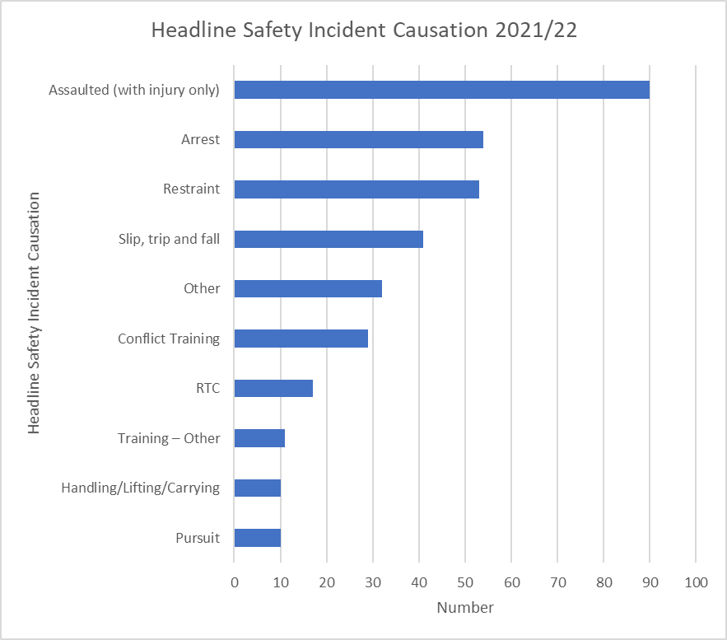

Commentary – Surrey Top 10 Safety Incident Types
- As in Sussex, arrests and incidents surrounding arrest and pursuit remain the largest cause of injury.
- We continue to see injuries being sustained during conflict training. This has been subject to previous investigation which concluded that injuries were proportional to ensuring training was realistic and able to prevent more serious injuries ‘on the street.’

Graph: Surrey Assault Rate (with injury only) by Month against Average
This graph shows the number of assaults with injury only per 1000 arrests.

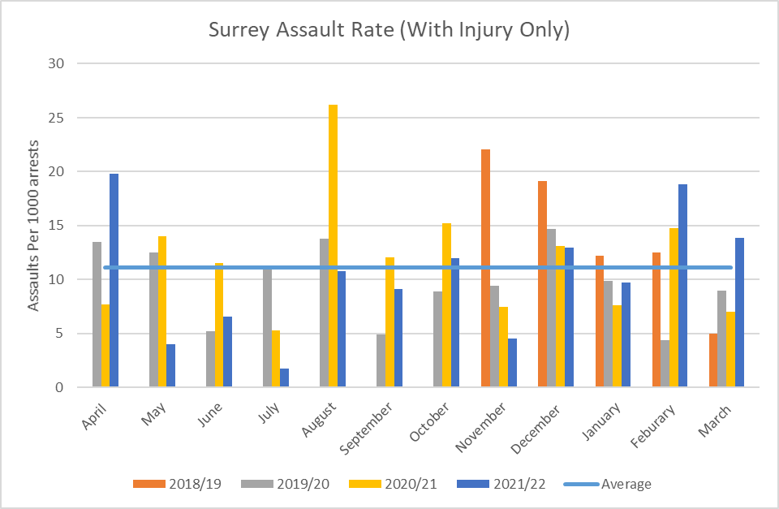

Commentary – Surrey Assault Rate (with injury only) by Month against Average

- The Surrey data has shown a significant drop off compared to last year. We are concerned that due to the issues with the 12/2 system, officer engagement with it is deteriorating.

Graph: Surrey Employee Injury Rate by Month

This graph shows the number of injuries per 1000 employees each month.

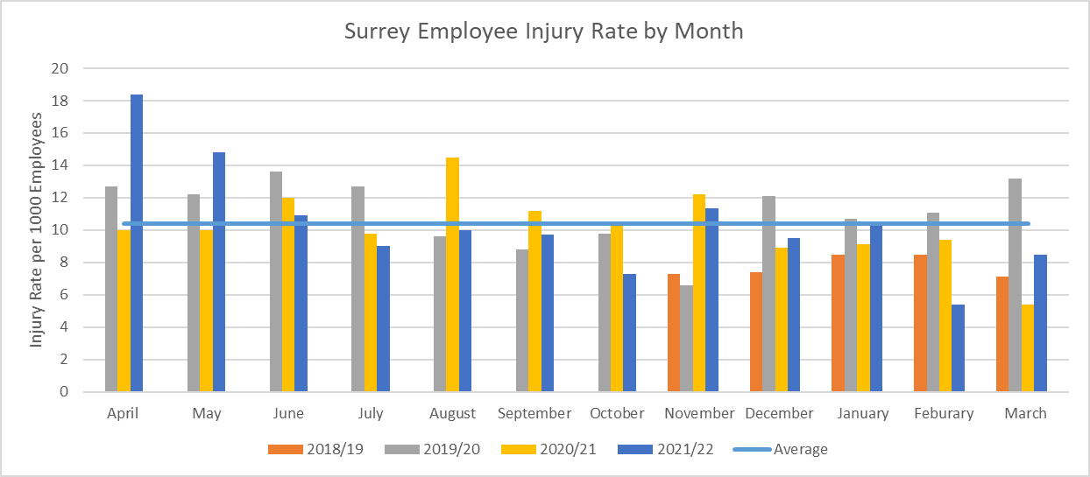

Commentary – Surrey Employee Injury Rate by Month

- The Surrey Employee Injury Rate has shown sporadic movement across the year. In terms of change over time, the Employee Injury Rate in Surrey remains fairly stable.

  - 2018/19 it averaged: 7.76 employees per 1000 injured at work.
  - 2019/20 it averaged: 11.1 employees per 1000 injured at work.
  - 2020/21 to date it averaged: 10.2 employees per 1000 injured at work.
  - 2021/22 to date is 14.7 employees per 1000 injured at work.

NCALT Mandatory Minimum Training Compliance

Surrey – Display Screen Equipment, Office Safety and Safety for Line Managers
(Last refresh date 7th March 2022)

Completion Percentages
 | Display Screen Equipment
Division | Completed | Incomplete | Not Completed
Eastern | 71.7% | 2.2% | 26.1%
Northern | 83.5% | 1.8% | 14.7%
Western | 65.9% | 2.8% | 31.3%
Operations | 51.4% | 1.6% | 46.9%
Specialist Crime | 70.6% | 1.6% | 27.8%
Public Protection | 63.5% | 2.5% | 34.0%
Contact | 75.1% | 0.6% | 24.2%
Criminal Justice & Custody | 79.9% | 2.1% | 18.0%
Finance | 62.5% | 3.1% | 34.4%
People Services | 70.0% | 1.2% | 28.7%
ICT | 64.7% | 1.0% | 34.3%
SBSC | 48.8% | 4.7% | 46.5%
PSD | 84.6% | 2.6% | 12.8%
Corporate Communications | 69.7% | 3.0% | 27.3%
Regional | 22.4% | 0.0% | 77.6%
DCC Portfolio | 68.9% | 0.5% | 30.6%
Corporate Development | 79.2% | 0.0% | 20.8%
ACPO | 38.9% | 5.6% | 55.6%
Volunteers | 5.4% | 0.4% | 94.2%
Office of the Surrey PCC | 66.7% | 5.6% | 27.8%
Force TOTAL | 66.5% | 1.7% | 31.7%

Completion Percentages
 | Health & Safety for Managers*
Division | Completed | Incomplete | Not Completed
Eastern | 81.3% | 2.2% | 16.5%
Northern | 91.3% | 2.5% | 6.3%
Western | 78.3% | 0.0% | 21.7%
Operations | 50.9% | 3.8% | 45.3%
Specialist Crime | 81.6% | 1.3% | 17.1%
Public Protection | 74.4% | 0.0% | 25.6%
Contact | 92.0% | 0.0% | 8.0%
Criminal Justice & Custody | 82.1% | 6.0% | 11.9%
Finance | 56.0% | 0.0% | 44.0%
People Services | 62.5% | 0.0% | 37.5%
ICT | 50.0% | 4.5% | 45.5%
SBSC | 20.0% | 40.0% | 40.0%
PSD | 88.9% | 0.0% | 11.1%
Corporate Communications | 50.0% | 8.3% | 41.7%
Regional | 36.4% | 9.1% | 54.5%
DCC Portfolio | 38.9% | 11.1% | 50.0%
Corporate Development | 62.5% | 6.3% | 31.3%
ACPO | 58.3% | 8.3% | 33.3%
Volunteers | 0.0% | 0.0% | 0.0%
Office of the Surrey PCC | 71.4% | 0.0% | 28.6%
Force TOTAL | 74.3% | 2.6% | 23.1%

Completion Percentages
 | Office Safety (previously Introduction to Health & Safety)
Division | Completed | Incomplete | Not Completed
Eastern | 61.4% | 5.7% | 32.9%
Northern | 77.6% | 5.7% | 16.7%
Western | 56.8% | 8.4% | 34.8%
Operations | 43.7% | 3.9% | 52.4%
Specialist Crime | 63.5% | 2.6% | 33.9%
Public Protection | 56.2% | 3.0% | 40.9%
Contact | 69.1% | 4.5% | 26.4%
Criminal Justice & Custody | 60.2% | 6.7% | 33.1%
Finance | 59.4% | 3.1% | 37.5%
People Services | 47.4% | 3.6% | 49.0%
ICT | 47.1% | 3.9% | 49.0%
SBSC | 41.9% | 2.3% | 55.8%
PSD | 76.9% | 5.1% | 17.9%
Corporate Communications | 57.6% | 9.1% | 33.3%
Regional | 24.5% | 2.0% | 73.5%
DCC Portfolio | 37.8% | 3.3% | 58.9%
Corporate Development | 62.5% | 5.2% | 32.3%
ACPO | 22.2% | 16.7% | 61.1%
Volunteers | 3.6% | 0.0% | 96.4%
Office of the Surrey PCC | 44.4% | 5.6% | 50.0%
Force TOTAL | 56.0% | 4.8% | 39.2%

