

**Surrey Police Performance Report**

|  |  |
| --- | --- |
| **Required for:** | *PCC Performance Meeting September 2021* |
| **Security Classification** | **Official** |
| **Handling information if required:** | Not applicable |
| **Suitable for publication:** | *Yes* |
| **Title:** | Progress against the Police and Crime Plan |
| **Version:** | 1.1 |
| **Purpose:** | OPCC Performance Meeting Paper |
| **ACPO / Strategic Lead:** | DCC Kemp |
| **NDM / OSARA compliance:** | *Yes* |
| **Date created:** | 18th August 2021 |
| **Date to be reviewed:** |  |

|  |  |
| --- | --- |
| **AUTHOR:** |  |
| **Name:** | Tony Fenton – Jones |
| **Job Title:** | Performance Analysis Manager |
| **Telephone number:** | 01483 32653 |
| **Email address:** | [Tony.Fenton-Jones@surrey.pnn.police.uk](mailto:Tony.Fenton-Jones@surrey.pnn.police.uk) |

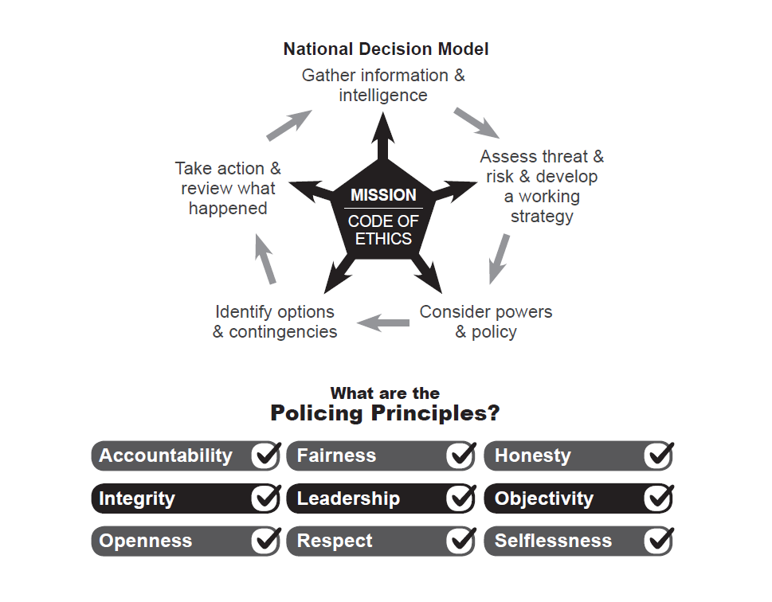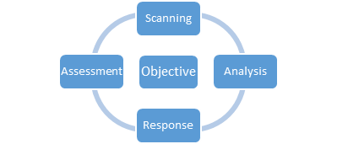

**Force: Volume of Recorded Crime**

The volume of recorded crime is defined as the number of total notifiable offences recorded within Surrey as defined by the Home Office Counting Rules (HOCR). The latest Office of National Statistics figures for the 12 months ending March 2021 show that total police recorded crime decreased by -13.1% in England and Wales. This decrease in crime was mainly driven by changes in society after coronavirus lockdown restrictions were put in place. Surrey’s reduction over the 12 months to March 2021 was -13.3%.

The ONS figures showed that in March 2021 **Surrey had the 4th lowest crime rate nationally** (55.6 per 1000 population) across England and Wales, and Surrey continues to have the **lowest crime rate in the south-east region**. Considering how attractive Surrey is to travelling criminality; with the Metropolitan Police to the north, and excellent road links across the South East, the continuing position as having the lowest crime rate in the region is significant.

Analysis of Surrey Police’s own data for the 12 months to July 2021 shows that the year on year trend in recorded crime has continued to decline, down -7.4% to 68,320 crimes recorded.

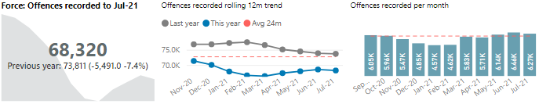

Lockdown restrictions throughout April and May 2020 saw some of the biggest reductions in crime. The second national lockdown during November also saw notable reductions. The introduction of tier level restrictions in December and a further national lockdown in January 2021 resulted in recorded crime being below the monthly average. For the 12 months to July 2021 the biggest reductions have been within the burglary, theft, vehicle crime, theft and criminal damage crime categories. The only notable increases have been within Serious sexual (up 14.6%) which includes rape and sexual assault offences. Also, violence is up 3.8% although the increase relates predominantly to ‘without injury’ offences of harassment which includes the improved recording of stalking and controlling or coercive behaviour offences.

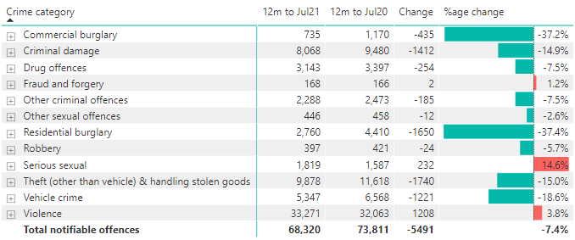

**Force: Volume of Solved Outcomes**

Home Office Counting Rules require all notifiable offences to have an outcome. For Surrey Police, a ‘Solved outcome is a notifiable offence with either a charge; caution; penalty notice; drug warning; community resolution, TIC (taken into consideration)’. From January 2021, outcome 10 where formal action is not in the public interest was included and then in April 2021, outcome 22 was also added to solved outcomes when they are validated ‘Checkpoint’ outcomes.

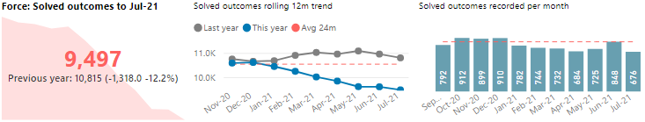

For the 12 months to July 2021 the volume of solved outcomes for notifiable offences recorded was 9,497 down -12.2% (a reduction of 1,318 solved outcomes) when compared to the 12 months to July 2020 (10,815) this is a statistically significant reduction over the last 24 months. The volumes of solved outcomes between January and May 2021 have been below the 24-month average. The volume of solved increased above average in June 2021 but has subsequently returned to below average in July 2021.

As can be seen from the table below most crime types have seen a reduction in solved outcomes over the last 12 months when compared to the year before (apart from serious sexual offences).

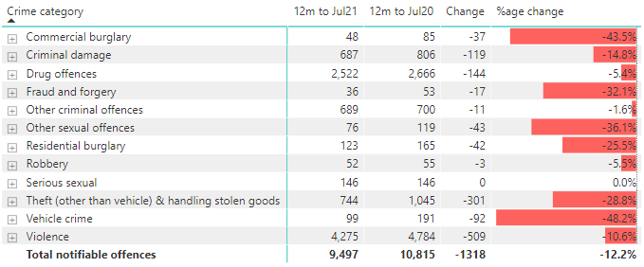

**Force: Solved Outcome Rate**

Solved outcome rates are calculated using the volume of solved outcomes over a given period divided by the volume of crimes in the same period.

For the 12 months to July 2021 the solved outcome rate for notifiable offences was 13.9% which is a reduction of 0.8 percentage points compared to the 12 months to July 2020 (14.7%) (NB: percentage values have been rounded up and down to the first decimal place). The charts below show the impact of the low volumes of solved outcomes over recent months as the volumes of crimes increased over the same period. Despite the significant reduction in solved outcomes the solved outcome rate has remained within normal levels of variation due to the low levels of crime recorded.

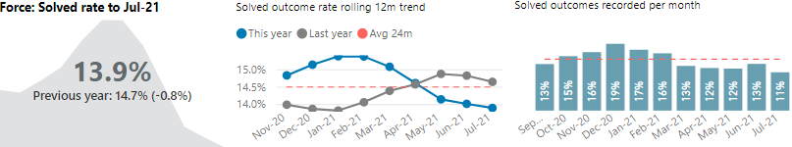

**Force: Residential burglary**

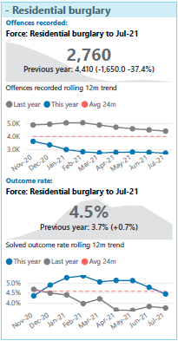The volume of residential burglary recorded has reduced significantly since COVID19 restrictions were introduced in April 2020. The latest volumes for the 12 months to July 2021 show that Surrey has recorded 37.4% fewer residential burglaries (down 1,650) when compared to the 12 months to July 2020.

Latest ONS data to March 2021 shows that residential burglary dropped 26.8% across England and Wales. National crime rate for residential burglary for the 12 months to March 2021 was 7.9 per 1000 households. Surrey is ranked 16th nationally with 5.9 per 1000 households.

The solved outcome rate for residential burglary has increased by 0.7 percentage points over the 12 months to July 2021. There were some above average volumes of solved outcomes in December 2020, April 2021 and May 2021.

Historically, volumes of residential burglary increase during the months of October to December. We may see an increase this year if residents return to places of work.

**Serious violence (Violence with injury)**

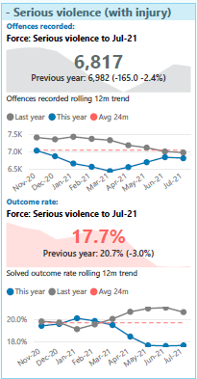The volume of serious violence (violence with injury) recorded has reduced slightly. The latest volumes for the 12 months to July 2021 show that Surrey has recorded 2.4% fewer violence with injury offences (down 165) when compared to the 12 months to July 2020.

Latest ONS data to March 2021 shows that violence with injury dropped 13.9% across England and Wales. National crime rate for violence with injury for the 12 months to March 2021 was 7.8 per 1000 population. Surrey has the lowest level of violence with injury ranked 1st nationally with 5.3 per 1000 households.

The solved outcome rate for violence with injury has reduced by 3.0 percentage points over the 12 months to July 2021. There were some above average volumes of solved outcomes in June 2021 but otherwise the volumes of solved since January 2021 have been below the 24-month average. Most of the reduction in solved outcome within this category relate to ABH offences. Although there has been 4.8% reduction in ABH offences the volume of solved outcomes has reduced by 24.7%.

**All Knife crime**

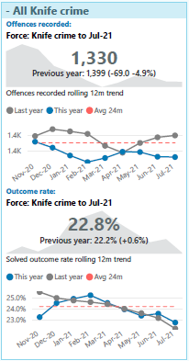The volume of knife crime has remained relatively stable over the last 12 months. The latest volumes for the 12 months to July 2021 show that Surrey recorded 1.5% fewer offences flagged as blade or sharp instrument when compared to the 12 months to July 2020.

National concern over the rise of knife crime has led to the development of national system to help improve the recording of knife crime. NDQIS has been implemented within Surrey Police, using an algorithm to check the offence’s free text in order to determine the likelihood that the offence should be flagged a knife crime or not. There is also manual intervention for those the algorithm is unsure of.

The solved outcome rate for knife crime has improved, up 0.6 percentage points compared to last year.

**Child abuse**

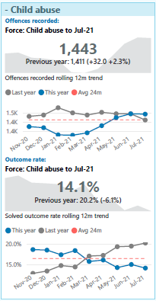Child abuse forms part of Surrey Police’s ‘high harm’ category which monitors the offences committed against the most vulnerable within our society. The volume of offences marked as child abuse has increase slightly over the last year. The latest volumes for the 12 months to July 2021 show that Surrey recorded 2.3% more child abuse offences (up 32) when compared to the 12 months to July 2020. Offences did decline over the 2020 lockdown periods but since March 2021 monthly volumes have been above average.

The is no national comparison data available for this crime category.

The solved outcome rate for child abuse offences has declined by 6.1 percentage points over the 12 months to July 2021.

**Stalking & CCB**

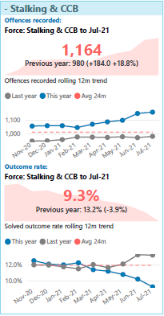The volume of stalking or coercive controlling behaviour recorded has increase significantly over the last year. The latest volumes for the 12 months to July 2021 show that Surrey recorded 18.8% more offences in this category (up 184) when compared to the 12 months to July 2020. Improvements in recording stalking have been in place since April 2020. All cases where a course of conduct is reported between a victim and their former partner must be recorded as stalking unless the police are satisfied that the matter amounts to harassment in law only.

Latest ONS data to March 2021 shows that stalking and harassment figures are up 27.8% across England and Wales. National crime rate for stalking and harassment for the 12 months to March 2021 was 10.6 per 1000 population. Surrey is ranked 4th nationally with 6.2 per 1000 population.

The solved outcome rate for Stalking and CCB has decreased by 3.9 percentage points over the 12 months to July 2021.

**Violent domestic abuse**

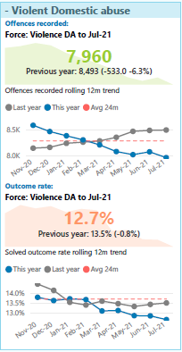Violent domestic abuse also forms part of Surrey Police’s ‘high harm’ category. The volume of offences marked as domestic abuse has reduced over the last year. The latest volumes for the 12 months to July 2021 show that Surrey recorded 6.3% fewer violent domestic abuse offences (down 533) when compared to the 12 months to July 2020. Monthly volumes dropped below average between November 2020 and April 2021; however from May 2021 monthly volumes have been above average, so the current downward trend is likely to stabilise and potentially increase later this year.

The latest ONS data available for comparing Surrey nationally is for the 12 months to March 2020. At that time Surrey had the lowest level of domestic abuse per 1000 population.

The solved outcome rate for violent domestic abuse offences has declined by 0.8 percentage points over the 12 months to July 2021. The volumes of solved outcomes have seen a significant reduction. Monthly volumes since October 2020 have been below the 24-month average with only June 2021 showing higher than average.

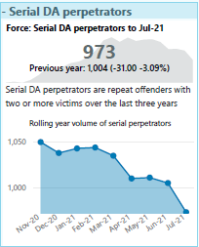Surrey monitors the volume of serial domestic abuse perpetrators. This has been defined together with ESDAS as the volume of repeat offenders that have two or more victims over the last three years. Currently this volume of perpetrators has reduced by 31 over the last year; a reduction of 3%.

**Overall crime victim satisfaction**

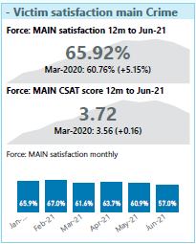From April 2019 a new methodology was introduced to consult with victims of crime and ASB. Victims are now contacted via text message which brings benefits such as reaching more victims of different crimes, fewer questions resulting in an increased response, and greater insight through victims’ comments. Results are now also received in real time as opposed to the previous lag of 2-3 months between incidents/crimes occurring and results being received.

Overall victims’ satisfaction has increased by 5.1 percentage points over the 12 months to June 2021.

Initial Contactdisplays the highest satisfaction result for Qtr.1 21/22 (62.4%) despite experiencing a decrease in results when compared to the Qtr.4 20/21 result (-8.6% points). Actions Taken (-6.8% points to 58.5%), kept informed (-2.7% points to 55.9%) and treatment (-6.0% points to 55.9%) all experienced decreases in results this quarter, and consequently may also have an impact in bringing down the overall score. Overall satisfaction was reasonably high for Qtr.1 21/22 at 60.3%, however also experienced a decrease in satisfaction (-4.2% points).

**Anti-social behaviour victim satisfaction**

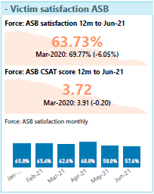Overall satisfaction displayed a fairly large decrease this quarter (-6.5% points, 63.3%), whilst initial contact (-6.2% points, 64.4%) revealed a slightly smaller decrease. This quarter, both overall and initial contact satisfaction performed below the overall force satisfaction for YE 20/21 (67.4%). Inconsistent results suggest respondents are receiving a differing service depending on the quarter.

Treatment (+5.6% points, 68.9%) was the only workflow to increase this quarter. Kept informed displayed the largest decrease (-21.0% points, 36.1%) with actions taken also displaying a large decrease (-11.7% points, 68.3%). The ASB workflow had a fairly large decrease (-7.7% points, 59.0%), this quarter. Of notable concern is the kept informed satisfaction result, where more respondents were dissatisfied than were satisfied with just one in three respondents satisfied with how they were communicated with and kept up to date with during their ASB issue.

**Missing persons**

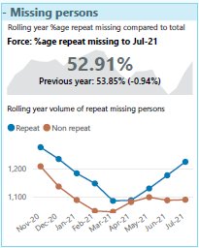The volume of missing persons has been increasing since May 2021 with the volumes of those person missing marked as repeat MISPERS also increasing at the same time.

This increase has resulted in an increasing repeat missing rate which has brought us back to a similar position as last year (down 0.9 percentage points). If these volumes continue then we will see a percentage increase in repeat missing that is higher than last year – particularly as last year values will start to include low volumes of repeat during lockdowns 2 and 3.

**Killed and Seriously Injured**

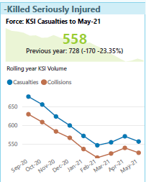Data on killed and seriously injured has been provided by Sussex Safer Roads Partnership to the end of May 2021. The results show that the number of casualties for KSIs is down 23.35% compared to last year.

The months up to May 2021 have been below the two year average but there is potential to see these volumes increase in June, July and August due to the end of COVID19 restrictions and increased travel both for work and holidays.

.

**Contact 999 and 101 performance**

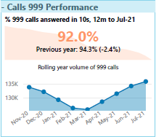999 calls answered within 10 seconds have reduced to 92% in the twelve months to Jul 21.

The %age answered in 10 seconds over the last two months has been below 90%

Since March this year, Surrey Police has seen an increase on 999 calls month on month as restrictions begin to ease, which has negatively impacted our number of calls answered within target (10 secs) with June and July being significantly low. Last month 999 call performance (87.5% within target) is the lowest in 4 years and has dropped year on year from a high of 93.8% in Jul-18.

There has been an increase is displacement of 999 calls from other forces (particularly the MPS) as BT systems automatically transfer 999 calls to other services if not answered within 3 minutes. Anecdotally, callers may move from 101 to 999 in an effort to get through quicker. Within Surrey police 999 calls are prioritised over 101 calls and this increased demand towards 999 has impacted 101 average time to answer measure below.

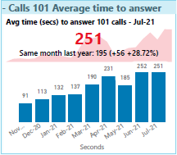The average time to answer 101 calls is up to 4 minutes and 11 seconds in July 2021; an increase of almost a minute compared to July 2020.

The average time to answer has been over 3 minutes each month since March 2021.

Just like with 999 calls, the volumes of calls for 101 have been increasing month on month since March this year, although this July has seen 3000 less 101 calls compared to the last 3 years

**Time taken to respond to Grade 1 (emergency) and Grade 2 (prompt) incidents**

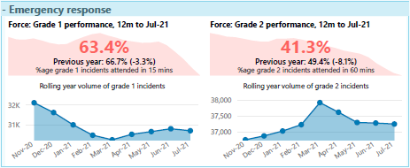Grade 1 response has shown a slight decline over recent months and is now the lowest it has been for over two years, and the median response time is also starting to increase.

After a statistically low January and February this year, we are beginning to see steady increase on monthly volumes for our grade 1 incidents from March and by the end of July, returning to the same levels for July in comparison to the last 3 years

Grade 2 response continues to decline with average time to attend up 12 minutes compared to last year and percentage attended in 60 minutes down to just 41.3%. From March 2020, there has been a significant rise in trend for grade 2 incidents which has continued to March this year. April has seen a the start of a decline in demand and it seems to be heading down with the last 3 months to July 21 registered lower volumes of grade 2 incidents. There has also been a significant drop in performance despite the volumes coming down. Incidents can sometimes take 45 minutes to allocate to a resource meaning attendance within 60 minutes is already under pressure.

**Confidence**

The national confidence measure from the crime survey for England and wales relies on face to face interviews, and due to COVID these interviews stopped so the latest data available is the 12 months to March 2020. Surrey is currently ranked 7th nationally with 78.7% confidence.

**Confidence from Joint Neighbourhood survey**

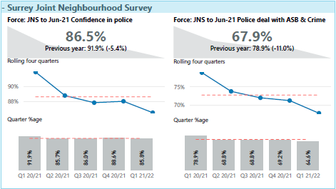

The joint neighbourhood survey shows for the 12 months to June 2021 that confidence in police is currently down 5.4 percentage points compared to the previous year. Public confidence decreased in Apr-Jun 2021 to 85.8% (-2.8% points), which was also lower than both Year End 19/20 and Year End 20/21 results (88.1% and 88.0%, respectively). Confidence across all aspects of the police decreased in the latest quarter with the largest decrease in confidence that the police would catch criminals (-3.0% points to 53.5%), which was also the lowest result.

This quarter, the extent that drug dealers were considered a problematic crime issue saw the largest increase (+5.8% points to 24.4%), whilst the extent that domestic abuse was considered an issue saw the largest decrease (-1.3% to 8.2%). All six ASB issues increased in the extent they were considered an issue this quarter. The largest increase occurred for antisocial driving (+5.5% points to 38.5%). This quarter, a smaller proportion of respondents agreed that the police in their neighbourhood are seen in the places and at the times they are needed compared to the previous quarter (-3.4% points to 41.3%). This quarter, the proportion of respondents who feel safe walking alone in their neighbourhood after dark decreased for the second consecutive quarter (-4.1% points to 80.3%).