

**Annual Governance Statement and Financial Statements 2020/21**

|  |  |
| --- | --- |
| **Required for:** | Joint Audit Committee (JAC) meeting |
| **Security Classification:** | **Official** |
| **Handling information if required:** | n/a |
| **Suitable for publication:** | No |
| **Title:** | Annual Governance Statement & Financial Statements 2020/21 |
| **Version:** | 1 |
| **Purpose:** | To present the Draft Annual Statement of Accounts and Annual Governance Statement for 2020/21 currently being audited for both the Police and Crime Commissioner (PCC) and the Chief Constable (CC) for review by the Audit Committee. |
| **ACPO / Strategic Lead:** | Kelvin Menon, Treasurer |
| **National Decision Model compliance:** | Yes |
| **Date created:** | 13 July 2021 |
| **Date to be reviewed:** |  |

|  |  |
| --- | --- |
| **AUTHOR:** |  |
| **Name:** | Miranda Kadwell |
| **Job Title:** | Corporate Finance Manager |
| **Telephone number:** | 07817 116 030 |
| **Email address:** | Miranda.Kadwell@surrey.pnn.police.uk |

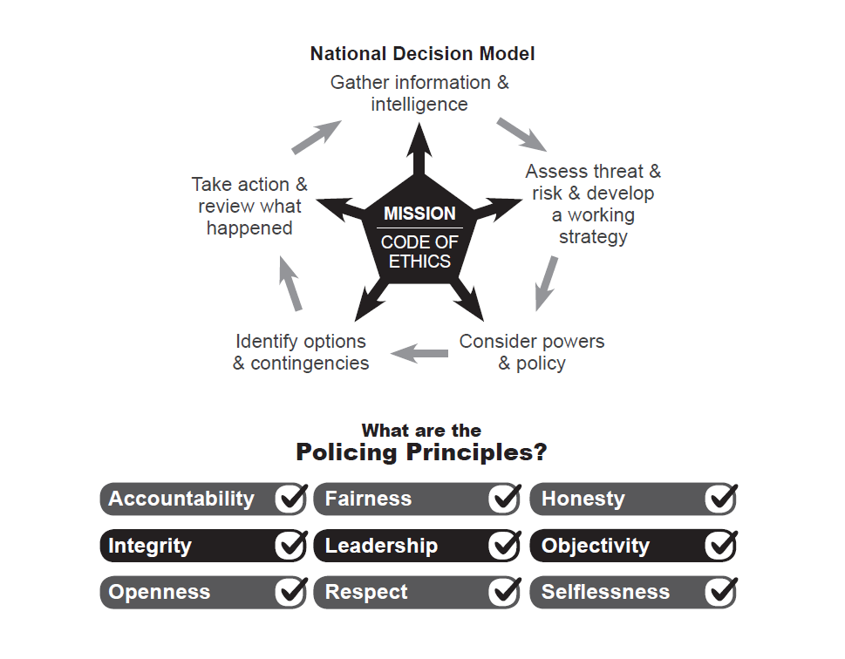

## Introduction

* 1. This report provides the Joint Audit Committee with an update on regulatory changes, production timetable and progress with the Annual Statements of Accounts and Annual Governance Statements for 2020/21 for review by the Audit Committee.
  2. The PCC and CC as separate corporation sole entities are required to prepare individual Statement of Accounts, the consolidated position for the PCC Group is included within the PCC’s Statement of Accounts.
  3. The Annual Statement of Accounts and Annual Governance Statement for both the PCC and the CC are prepared as soon as possible after the end of the financial year.
  4. The 2020/21 PCC and CC Statement of Accounts have been prepared in accordance with the Code of Practice on Local Authority Accounting in the United Kingdom 2020/21, based on International Financial Reporting Standards, issued by the Chartered Institute of Public Finance & Accountancy.
  5. The Annual Governance Statements (AGS) are contained within each of the Statement of Accounts. The AGS documents provides assurance that both corporation soles have in place governance frameworks that cover the systems, processes, culture and values through which each organisation manages its activities. The preparation of the Annual Governance Statement is a requirement of the Accounts and Audit (England) Regulation 2015 which is also reflected in the Code of Practice on Local Authority Accounting in the United Kingdom 2020/21.
  6. Following the external audit of both the PCC & CC financial statements amendments may be made to the accounts as detailed in the Audit Findings Report.

## Executive Summary

* 1. This report provides the Joint Audit Committee with an update on regulatory changes, production timetable and progress with the Annual Statements of Accounts and Annual Governance Statements for 2020/21 for review by the Audit Committee.
  2. There were very few changes to the 2020/21 Code and none of those had any significant impact on Surrey Police.
  3. Local authorities started to see the impacts of the current pandemic back in March 2020. At that time issues were raised for financial reporting and events occurring post balance sheet for 2019/20.
  4. A number of new issues continue to impact on Financial Accounts Reporting in connection with the pandemic. **Necessity to work remotely** continue to impact both internal teams and external partners to find effective ways of communicating and coordinating adequate equipment and access to be able to work from home effectively. For example:
  5. The 2020/21 year has been dealing with the issues generated by the ongoing pandemic including impacts on PPE measurements, Fair Value measurements of investment property, reporting judgements and estimation uncertainty, potential volatility in measurement of pension fund assets and liabilities.
  6. As part of the Covid-19 response, the government announced a range of grant schemes to support businesses. Grants received needed to be assessed as to whether the recipient was acting as principal or agent, for example where an authority is acting as a distribution point for grant monies to other bodies and has no control over the amount of grant allocated to a recipient, then the authority is likely to be acting as agent – e.g. PPE grants.
  7. Where an authority is able to conclude that it has control over the distribution or amounts of the grant it would be deemed to be acting as principal, which the case for most grants received by Surrey Police.
  8. MHCLG issued details on the 75% of 2020/21 irrecoverable losses for council tax and business rates scheme with the provisional settlement documents to be paid to authorities in 2021/22.
  9. Council Tax Collection Fund surplus/deficits for 2020/21 apportionment arrangements were changed for those authorities that calculated a negative exceptional balance allowing that deficit to be spread over the three years to 2023/24.
  10. In August 2020 the Government announced, for local authorities (including Policing Bodies) in England, details of a compensation scheme to compensate for irrecoverable and unavoidable losses from sales, fees and charges income generated in the delivery of services. This was available during the financial year 2020/21 ending 31 March 2021.
  11. Personal Protective Equipment (PPE) stock for police bodies. The national police distribution hub has been supplying PPE free of charge to all Forces. The national PPE cost to Surrey Police during 2020/21 was £2.3m.
  12. The MHCLG put in revised regulations that came into force on 31 March 2021 to extend the statutory audit deadlines for 2020/21 and 2021/22. The publication date for audited accounts moved from 31 July to 30 September 2021 for all local authority bodies.
  13. To give local authorities more flexibility, the requirement for the public inspection period to include the first 10 working days was removed and instead, the public inspection period must commence on or before 1 August 2021. This means that draft accounts must be authorised and published by 31 July 2021.
  14. The following table illustrates the reporting timetable in line with the new statutory deadlines:

|  |  |
| --- | --- |
| **Annual Accounts** | **Deadline**  **2021** |
| Published Draft Statements of Accounts signed by CFO | 31 July |
| Published Draft Annual Governance Statement | 31 July |
| Advertise Public Inspection of Accounts on website | 20 July |
| Accounts Open for Public Inspection for 30 working days | 1 August |
| External Audit on and off site | June-July |
| WGA Cycle 1 – Draft submission (WGA software not yet available) | TBC |
| Accounts Closed to Public Inspection | 13 September |
| Publication of Final Statements of Accounts for 2020/21 | 30 September |
| Publication of Final Annual Governance Statement | 30 September |
| WGA Cycle 2 – Final submission (WGA software not yet available) | TBC |
| IFRS 16 Lease Accounting Implementation | 01 April 2021 |

## Key Risks

* 1. **Risk of not meeting statutory deadlines for 2020/21**

We consider this risk to be low given the extensions to statutory deadlines.

* 1. **Risk of not complying with new disclosures and audit requirements as a result of Covid-19 impacts on 2020/21 accounts**

Some risks encountered during 2019/20 may be less this year because there was a lack of national consensus at that time on some areas e.g. Property valuations basis for current and fair values, however this may be countered by increasingly onerous audit regulations.

* 1. **Risk of audit qualification as ‘adverse’ or ‘except for’**

We aim to avoid qualification and will raise any potential risks with the Chief Finance Officers should they arise.

* 1. **Risk of delay to finalising the accounts due to auditor sign off and/or other issues arising**

There is a risk that EY sign off for the 2020/21 accounts could be complicated by the pressures of available resources for audit work and due to additional time pressures following the introduction of a new Code of Audit Practice for 2020/21 by the NAO. Under the new Code the external auditor will still consider whether the PCC/CC has put in place ‘proper arrangements’ to secure economy, efficiency and effectiveness on its use of reserves but they no longer provide a conclusion. Instead they have to seek sufficient assurance to enable them to report to the PCC/CC a commentary on the arrangements in place to secure economic, efficient and effective use of its resources for the relevant period in terms of financial sustainability, governance and performance. We do not yet fully understand how much additional work this will entail and/or what timescales it will be completed.

## Action underway and due for further action

* 1. The finance team are currently working through the external audit requests and queries across all areas of the accounts and working closely with the external audit team regarding disclosures and accounting treatment.
  2. Chief Finance Officers and Joint Audit Committee members will be kept fully up to date and involved as the accounts and audit progress.

## Impacts on current status of accounts and audit

* 1. Covid-19 impacts continue to slow progress and introduce complexities to the annual accounts and audit for 2020/21.

## Recommendation

* 1. Committee members are asked to consider the issues arising and progress to date for the 2020/21 Annual Statement of Accounts.
  2. In accordance with the JAC terms of reference the committee members are invited to review the draft annual statements of accounts in advance of the final versions which members will be asked to recommend for approval to the PCC and CC. Consider whether appropriate accounting policies have been followed and consider whether there are concerns arising from the financial statements or from the audit of the financial statements that need to be brought to the attention of the PCC and/or CC.